OMS Foil the Flu Survey Screenshots
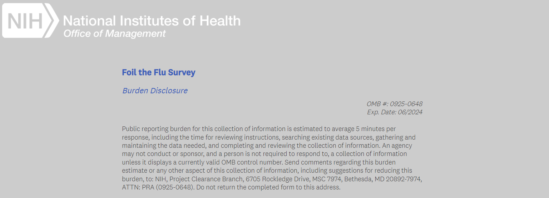

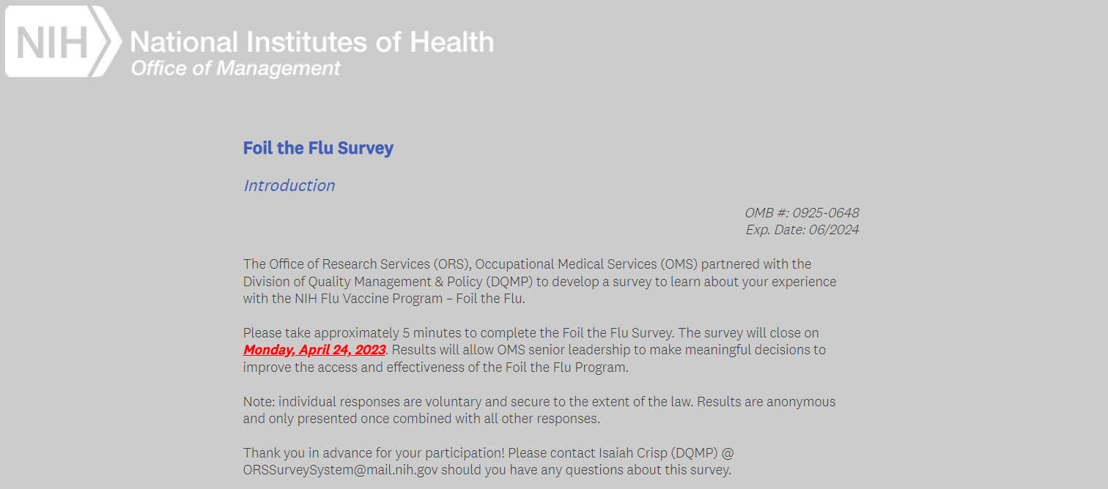

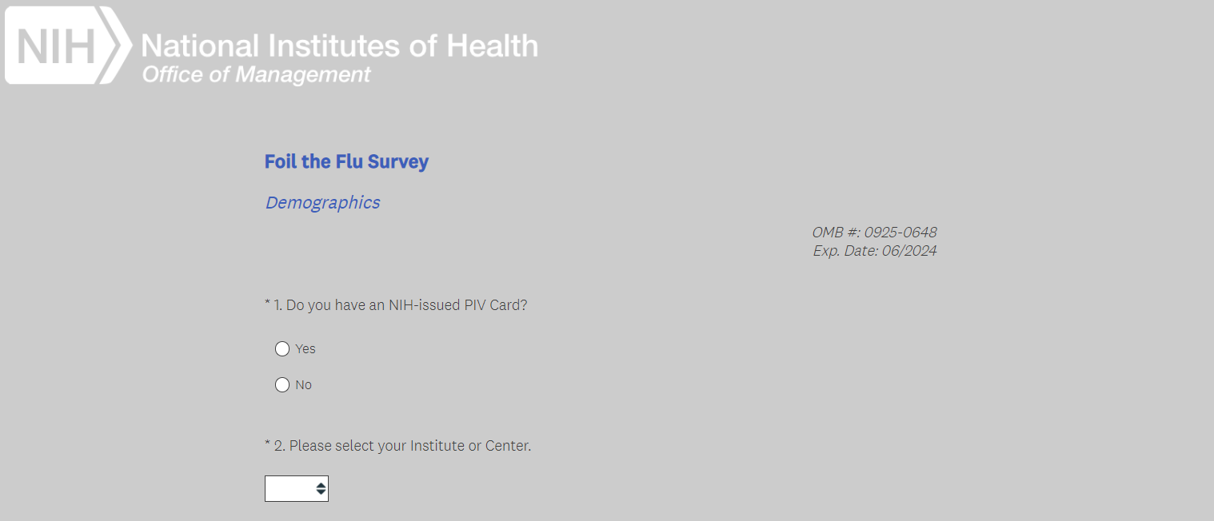

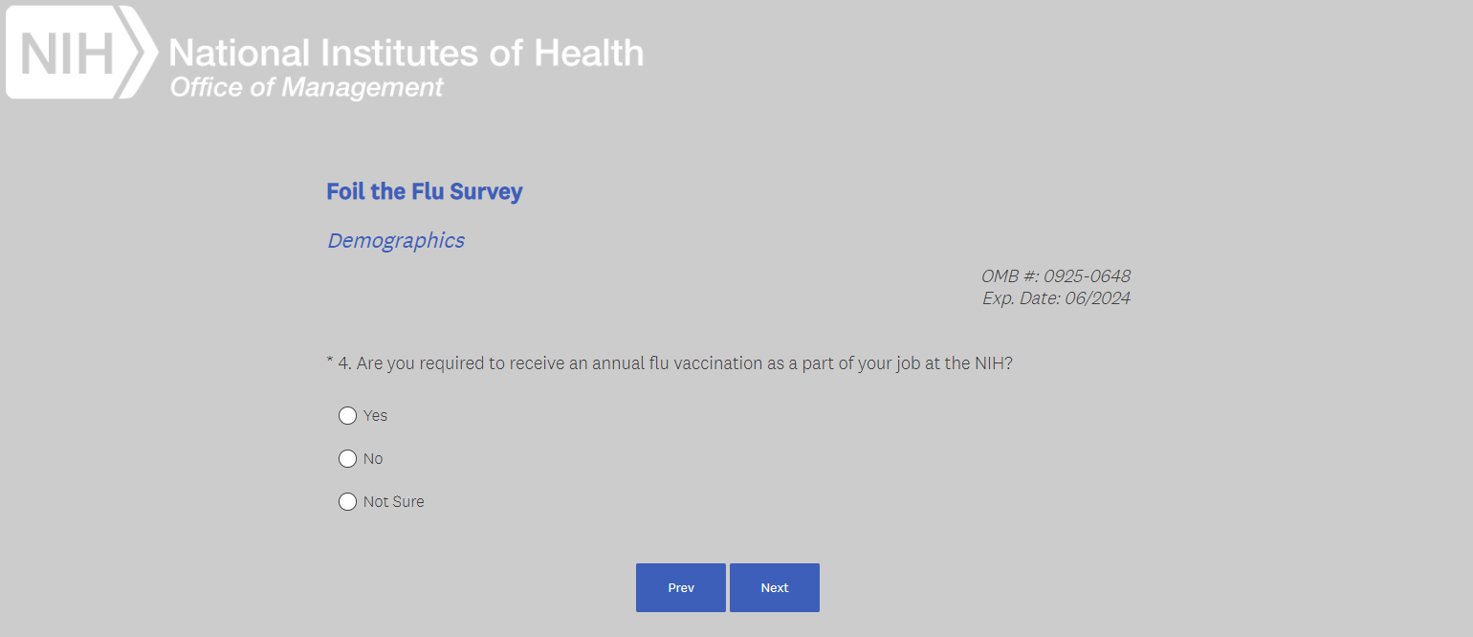

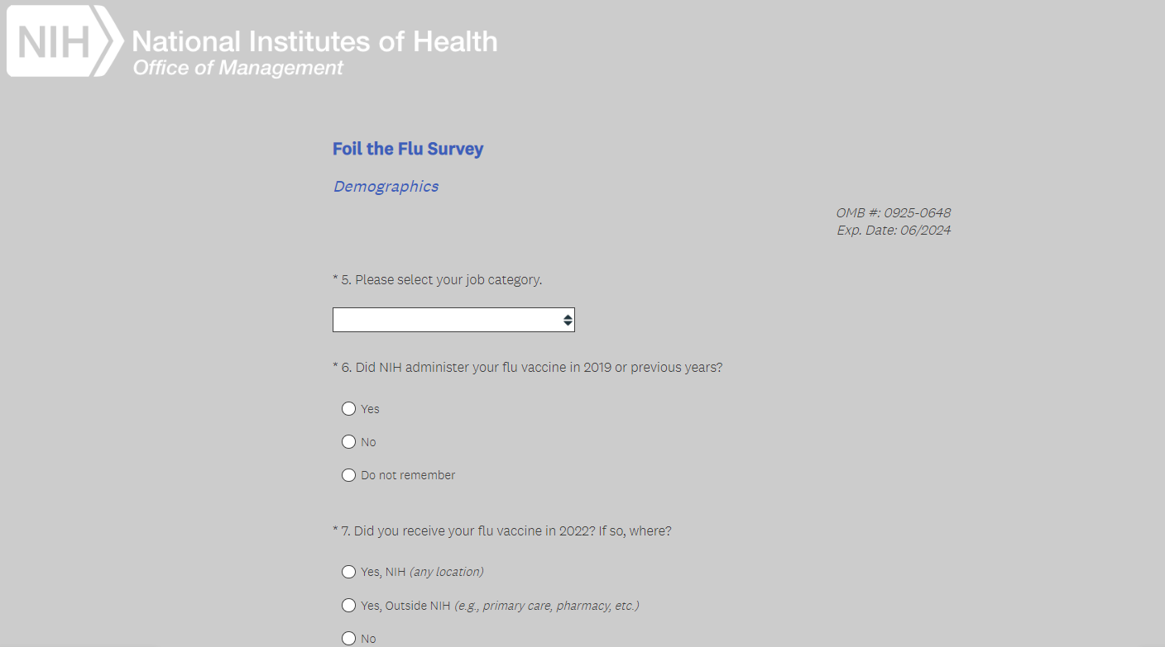

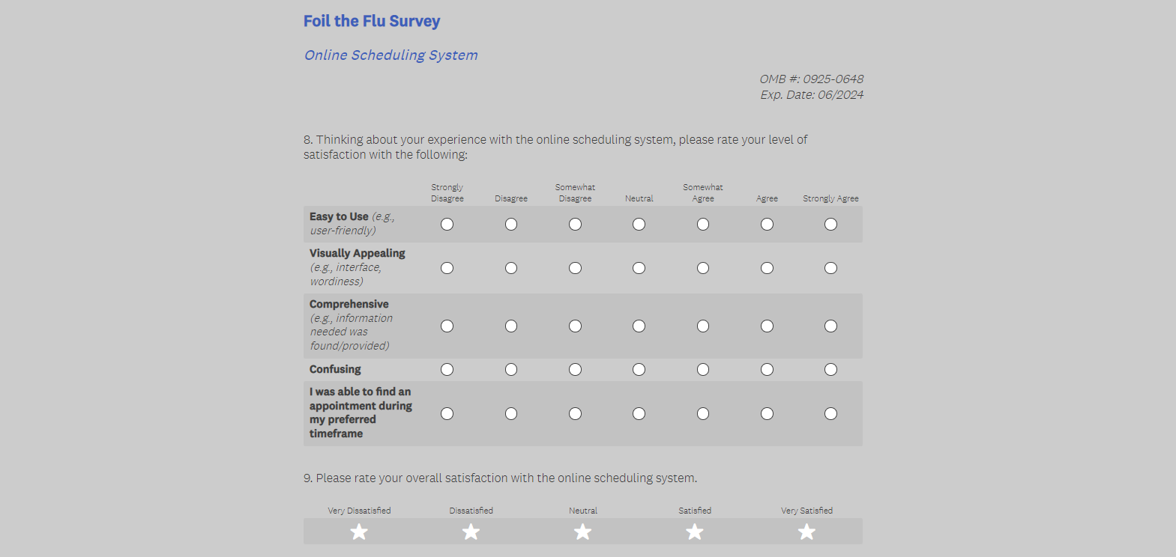

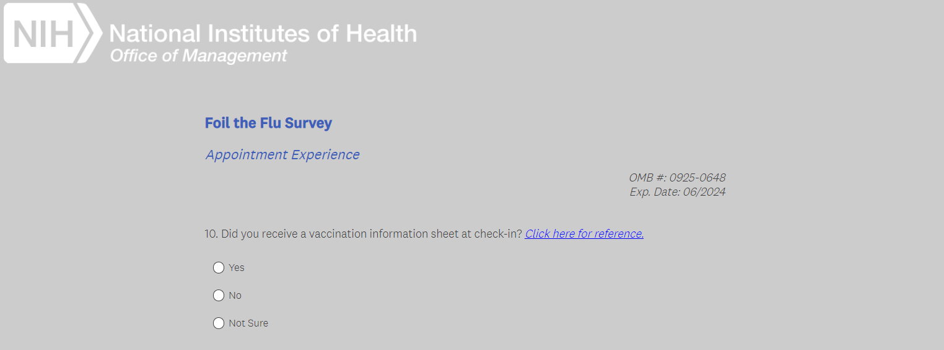
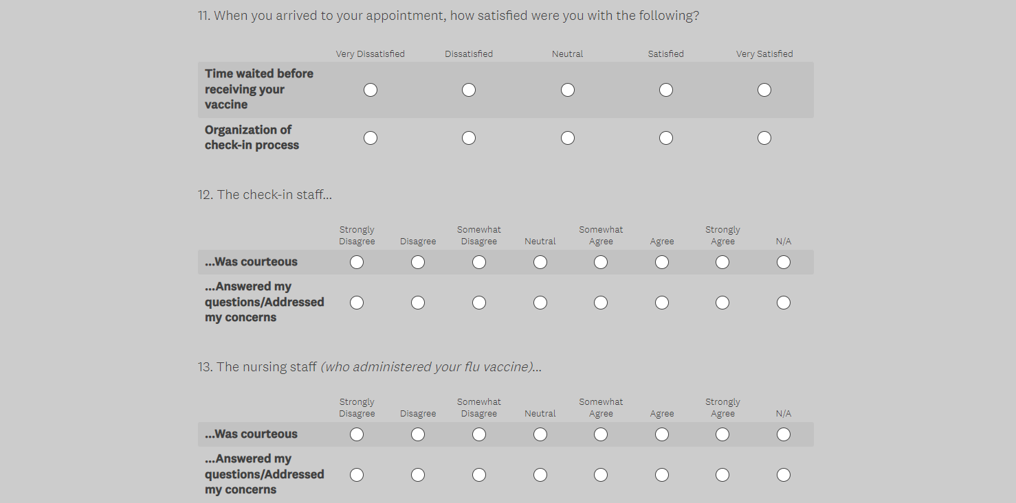
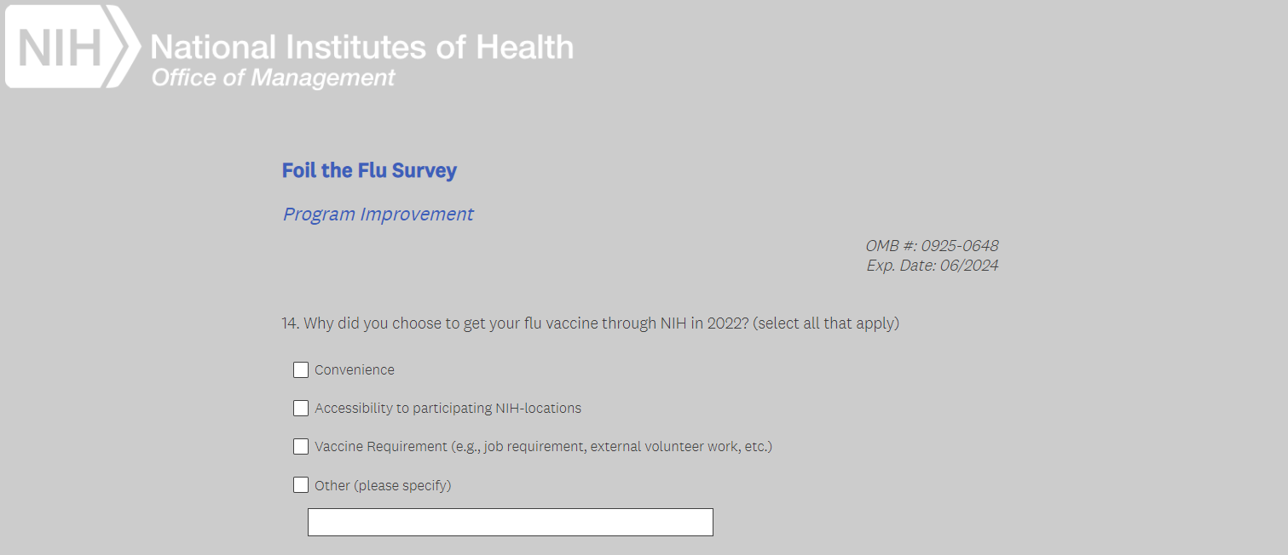
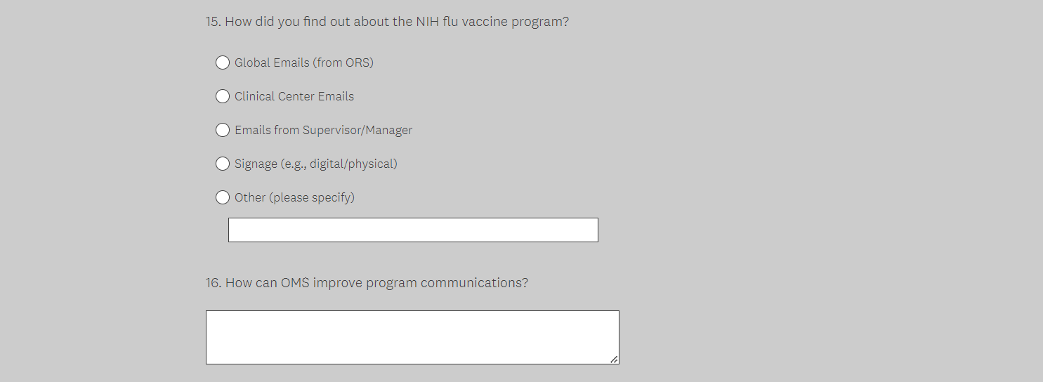
Q14 is shown if “Yes (any NIH location)” is selected from Q7.
ADDITIONAL BRANCHING QUESTIONS
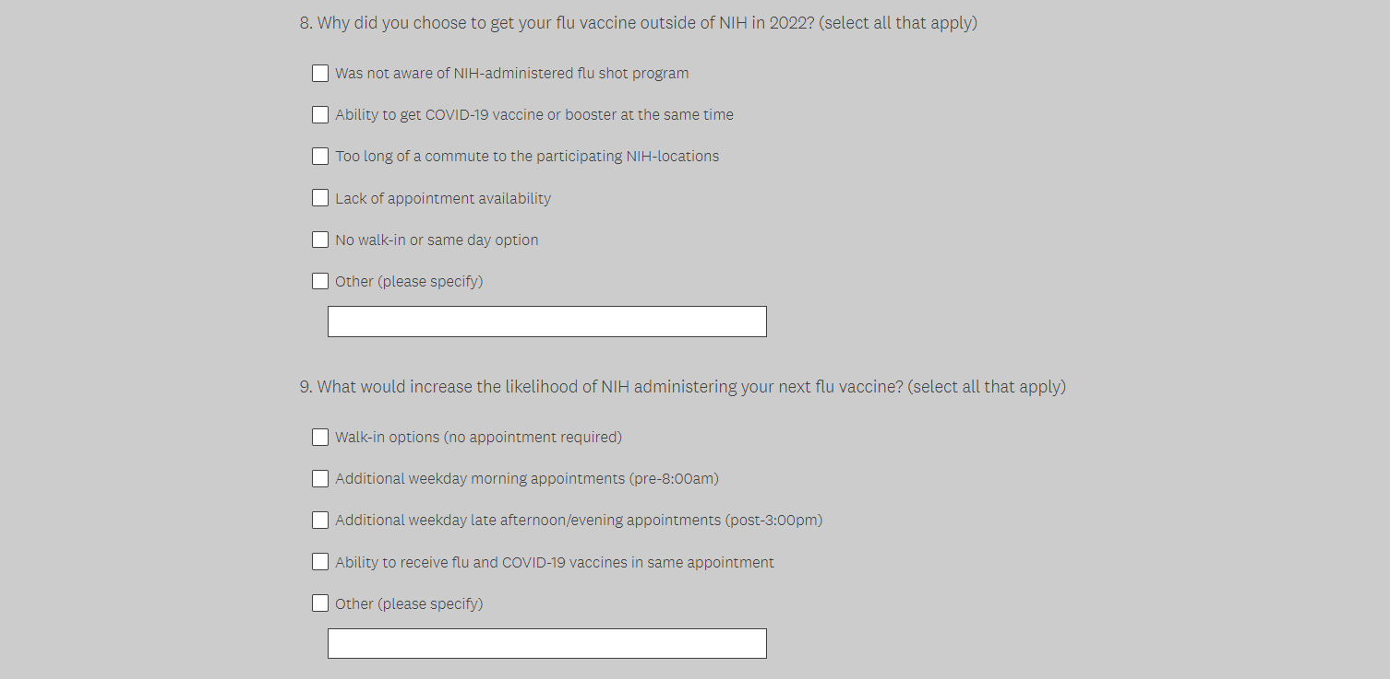
Questions above will only be shown if “Yes (outside NIH)” is selected from Q7. Note: Q14 above won’t be shown and would be replaced with these questions. The numbers shown here (“8” & “9” are arbitrary)

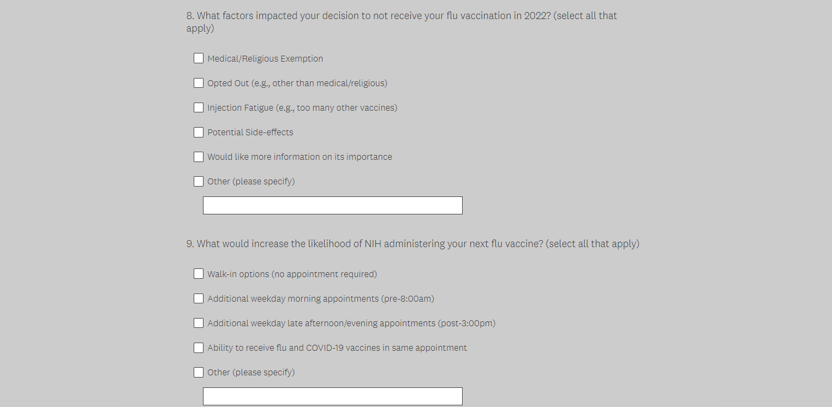
Questions above will only be shown if “No” is selected from Q7. Note: Q14 above won’t be shown and would be replaced with these questions. The numbers shown here (“8” & “9” are arbitrary)

