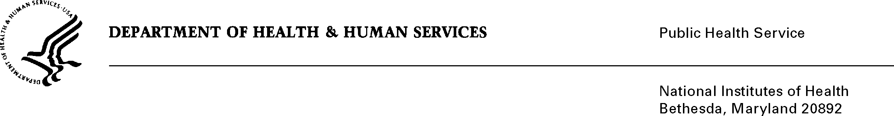

DATE: May 4, 2023

TO: NIH OMB Desk Officer

Office of Management and Budget (OMB)

Reports Clearance Officer, DHHS

FROM: Mikia P. Currie

Chief, Project Clearance Branch

SUBJECT: Request for Approval under the “Generic Clearance for the Collection of Routine Customer Feedback” (OMB#: 0925-0648 Exp., date: 06/2024)

Fast Healthcare Interoperability Resources (FHIR) Capacity Building for IDeA-CTR: Post-Webinar and Post-Workshop Surveys (ODSS/OD)

This is a request for OMB to approve a modification of FHIR Capacity Building for

IDeA-CTR: Post-Webinar and Post-Workshop Surveys (ODSS/OD). The request was

submitted on March 3, 2023. The purpose of the survey was to improve the quality of

future FHIR capacity-building trainings for institutions affiliated with National Institute

of Health’s (NIH’s) Institutional Development Awards for Clinical and Translational

Research (IDeA-CTR).

We are requesting a minor change to clarify one question and corresponding answer choices.

In the original survey, question number 14 did not include Yes/No as possible answers.

Question 14. Are you interested in attending a future workshop on any of the following topics? [select all that apply]

* + Reading and writing FHIR specifications (“implementation guides”) for research
  + Extracting and analyzing FHIR data with a language like R or Python
  + Using REDCap with FHIR
  + Other (please specify): [free response]

We request to split question 14 to questions 14 and question 15 in the attached modified survey.

Question 14. Are you interested in attending a future workshop?  
Possible topics might include:

• Reading and writing FHIR specifications (“implementation guides”) for research

• Extracting and analyzing FHIR data with a language like R or Python

• Using REDCap with FHIR  
  
[select one]

* Yes [continue to question 15]
* No [skip to end]

Question 15. Which potential workshop topics are you interested in? [select all that apply]

* + Reading and writing FHIR specifications (“implementation guides”) for research
  + Extracting and analyzing FHIR data with a language like R or Python
  + Using REDCap with FHIR

Other (please specify): [free response]

This change does not constitute a burden increase.

Your full consideration is appreciated.