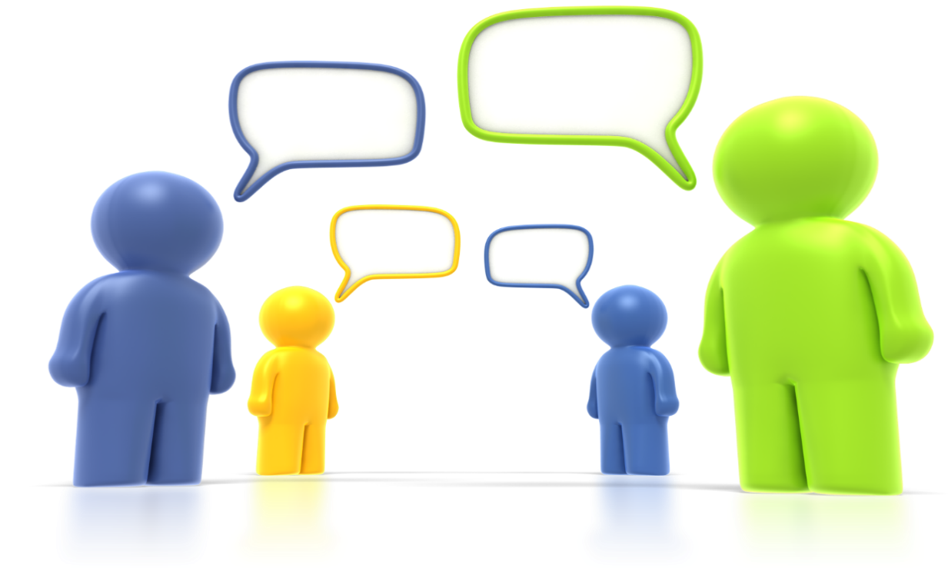
This event is brought to you by your OER Employee Engagement Committee (EEC).
Please direct any questions to OER-EEC@nih.gov.

If you are an OER federal employee* then make plans to join your peers for this virtual discussion about improving OER! (Office/Division Directors and Contractors will not be participating in this event.)
What works? What could be improved?
When: Thursday, March 17
Time: 10:00 – 11:30am
You Must Register by COB, Monday February 28 at https://bit.ly/2022-OERStaffForum.
Pre-event Survey will also be available at …..
Closed captioning and an ASL interpreter will be provided.
.
OER is an amazing place to work… and the work we do is even more amazing!
Communications
Morale Building
Staff Development
Support
OER Staff Forum: Let’s Talk!
Remote Viewing Info Coming Soon.

