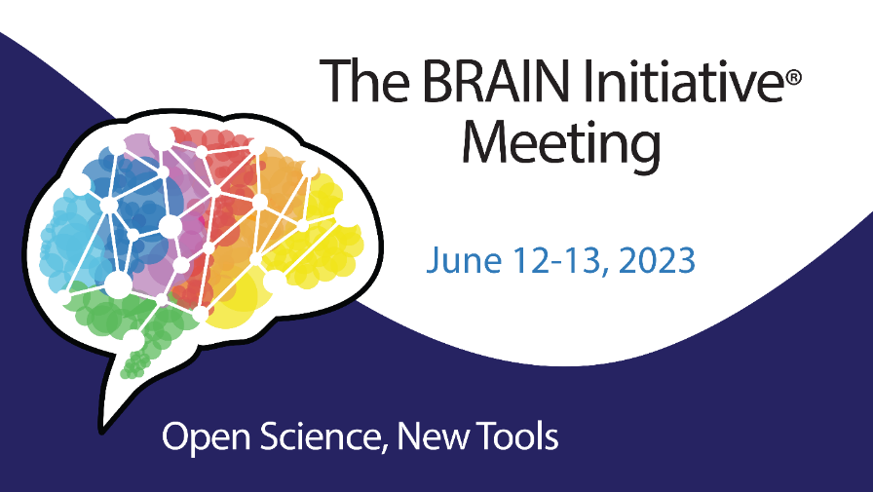

Dear BRAIN Meeting Attendee,
On behalf of the Program Committee, we would like to thank you for your participation in the 2023 BRAIN Initiative Meeting; Open Science New Tools. Please take a moment to answer a few questions and provide comments (optional) regarding your meeting experience in this survey. Questions will automatically display for each session that you attended, in addition to the overall questions. This feedback will help us to plan and improve future meetings.

Thank you for your time.
The 2023 Program Committee

