IRS/SSA Reconciliation Application
OMB Screen Package

Table of Contents
1. Design Specification Document Version Information 5
2. Screen Designs 6
2.1. Employer Wage Reporting Homepage 6
2.2. Reconciliation Home - New Notice 7
2.3. Reconciliation Home - Resume Notice 8
2.4. Reconciliation Home - Action Needed 9
2.5. Reconciliation Home - No Notices 10
2.6. Help Panel - Understanding the Status 11
2.7. Notice Summary – Privacy Act Statement popup 12
2.8. Notice Summary - No Record of Employees’ Earnings 13
2.9. Notice Summary - Discrepancy Between IRS and SSA 14
2.9.1. Status Help Tooltip – New 15
2.9.2. Wage Information Tooltip (“What does this mean?”) 16
2.9.3. Acknowledge Only Confirmation Message 17
2.10. Questionnaire - No Record of Employees’ Earnings 18
2.10.1. Question 1 – Confirm Access 18
2.10.1.1. (Question 1 Variation) Initial 18
2.10.1.2. (Question 1 Variation) No 19
2.10.1.3. (Question 1 Variation) No_Other 20
2.10.2. Question 2 - Confirm Self-Employment Status 21
2.10.2.1. (Question 2 Variation) Initial 21
2.10.2.2. (Question 2 Variation) Yes 22
2.10.2.3. (Question 2 Variation) Yes_Option 1 23
2.10.2.4. (Question 2 Variation) Yes_Not Option 1 24
2.10.3. Question 3 – Confirm Filing Status 25
2.10.3.1. (Question 3 Variation) Initial 25
2.10.3.2. (Question 3 Variation) No 27
2.10.4. Question 4 – Confirm Employer Identification Number 28
2.10.4.1. (Question 4 Variation) Initial 28
2.10.4.2. (Question 4 Variation) Yes 29
2.10.4.3. (Question 4 Variation) No 30
2.10.4.4. (Question 4 Variation) No_Option 1 31
2.10.4.5. (Question 4 Variation) No_Not Option 1 32
2.11. Questionnaire - Discrepancy between IRS and SSA 33
2.11.1. Question 1 – Confirm Access 33
2.11.1.1. (Question 1 Variation) Initial 33
2.11.1.2. (Question 1 Variation) No 34
2.11.1.3. (Question 1 Variation) No_Other 35
2.11.2. Question 2 – Confirm Wage Information 36
2.11.2.1. (Question 2 Variation) Initial 36
2.11.2.2. (Question 2 Variation) Sick Pay_No 38
2.11.2.3. (Question 2 Variation) Sick Pay_Yes 39
2.11.3. Questionnaire Component - Status Help Tooltip 40
2.11.4. Questionnaire Component - Save and Exit Message 41
2.12. Review - No Record of Employees’ Earnings 42
2.13. Review - Discrepancy between IRS and SSA 43
2.14. Next Steps - Acknowledge Only Path 44
2.15. Next Steps - No Record of Employees’ Earnings Path 45
2.15.1. NR1_Contact Us 45
2.15.2. NR2_IRS 46
2.15.3. NR3_Submit 47
2.15.4. NR4_Correction EIN 48
2.15.4.1. Detailed Instructions collapsed 48
2.15.4.2. Detailed Instructions expanded 49
2.15.5. NR5_No Further Action 50
2.15.6. NR6_SSA Calls You 51
2.16. Next Steps - Discrepancy between IRS and SSA Path 52
2.16.1. D1_Contact Us 52
2.16.2. D4a_IRS 53
2.16.3. D4b1_IRS_Sick Pay equals Discrepancy 54
2.16.4. D4b2_IRS_Sick Pay not equal Discrepancy 55
D6_Correction_IRS 56
2.16.5. D7_Correction 57
2.16.6. D8_All Options 58
2.16.7. D9_No Further Action 59
2.17. Next Steps Component - Status Help Tooltip 60
2.17.1. Action-SSA 60
2.17.2. Action-IRS 60
2.18.1. Action 61
2.18.2. No Action 61
2.19. Print Reconciliation Case - No Record of Employees’ Earnings 62
2.20. Print Reconciliation Case - Discrepancy between IRS and SSA 63
2.21. Error Messaging 64
2.21.1. Invalid Entry Errors - Text Exceeded Max Length 64
2.21.2. Invalid Entry Errors - WFID 65
2.21.3. Invalid Entry Errors - EIN 66
2.21.4. Invalid Entry Errors - Sick Pay Provider EIN 67
2.21.5. Invalid Entry Errors - Sick Pay Provider Amount 68
2.21.6. Required Field Errors - Other Reason 69
2.21.7. Required Field Errors - EIN 70
2.21.8. Required Field Errors - Sick Pay Provider 71
2.21.9. System Errors - Invalid URL 72
2.21.10. System Errors - System Failure 72
2.21.11. System Errors - Application Error 72
2.21.12. System Errors - Refresh Data 73
2.22. Page Footer 73
2.22.1. Page Footer – OMB Link_Paperwork Reduction Act Statement 73
3. Appendix A - UXG Contact Information for Analysts, Developers and Others 74

- Design Specification Document Version Information
The first release of this design specifications document as a project deliverable is numbered 1.0.
Subsequent revisions are numbered 1.1, 1.2, 1.3, etc. Content revisions are listed below with corresponding page numbers.

Version  Number | Date | Content Revisions | Page  # | Revised by
- (First Release) | 10/03/2022 |  | N/A | N/A
1.1 (First Revision) | 01/05/2023 | Updated per OGC requests made Nov 2022. Updated language in Privacy Act Statement. Added blue notice language to the Resource section’s “Contact SSA” on the Next Step pages. | 12, 44-49,52-58 | Emily Ficner
1.2 (Second Revision)

- Screen Designs
  - Employer Wage Reporting Homepage
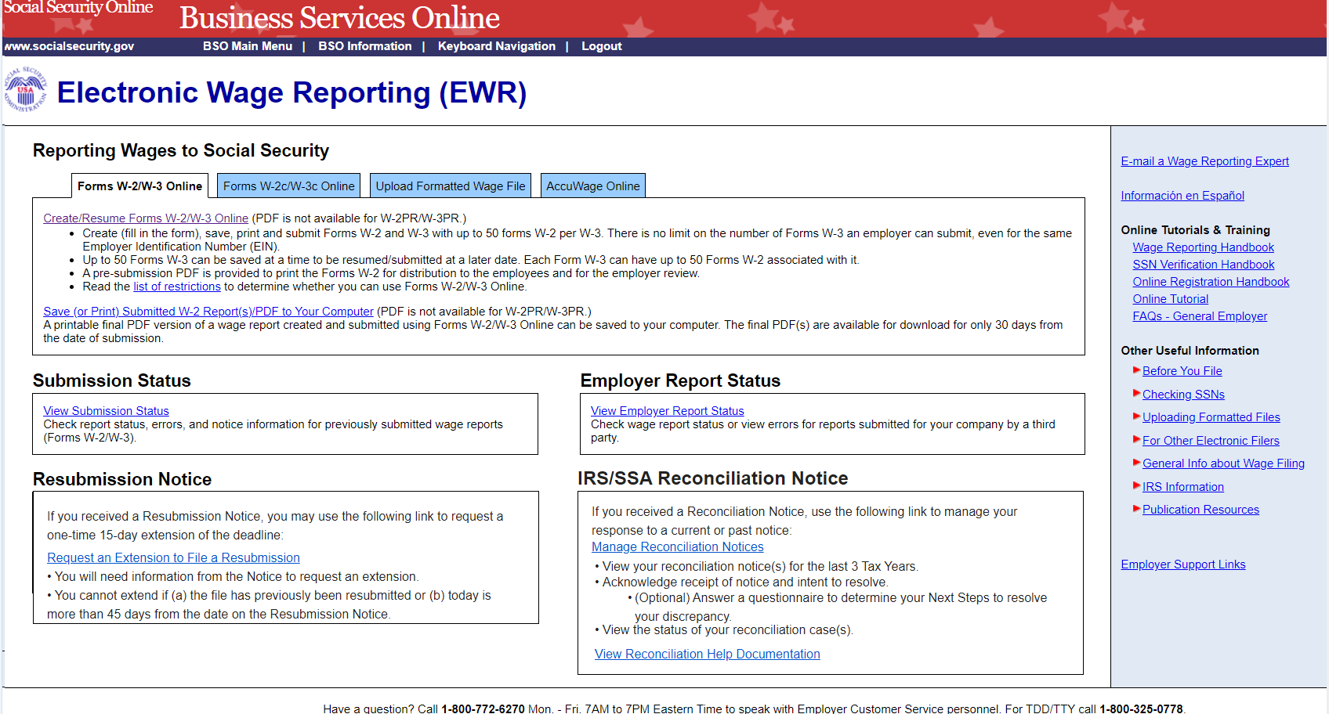
  - Reconciliation Home - New Notice
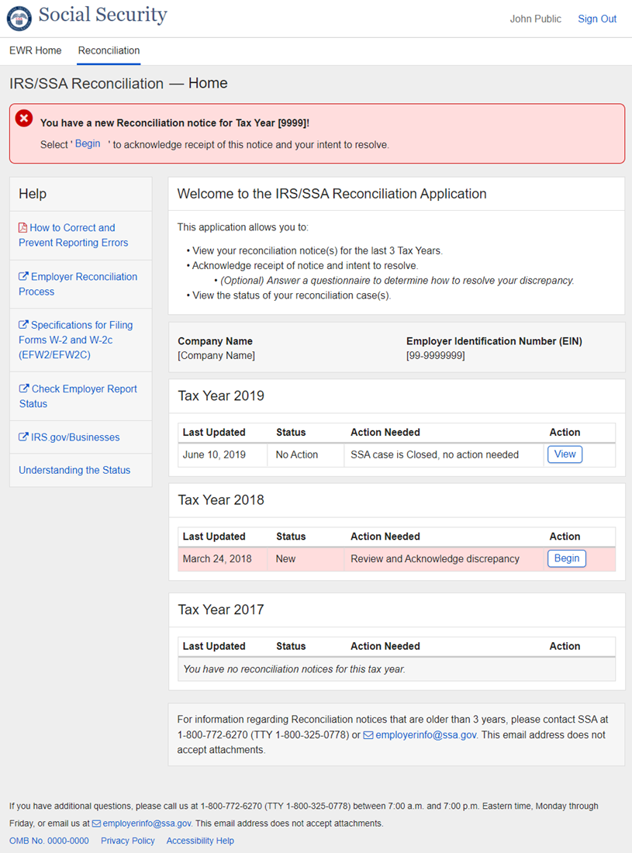
  - Reconciliation Home - Resume Notice
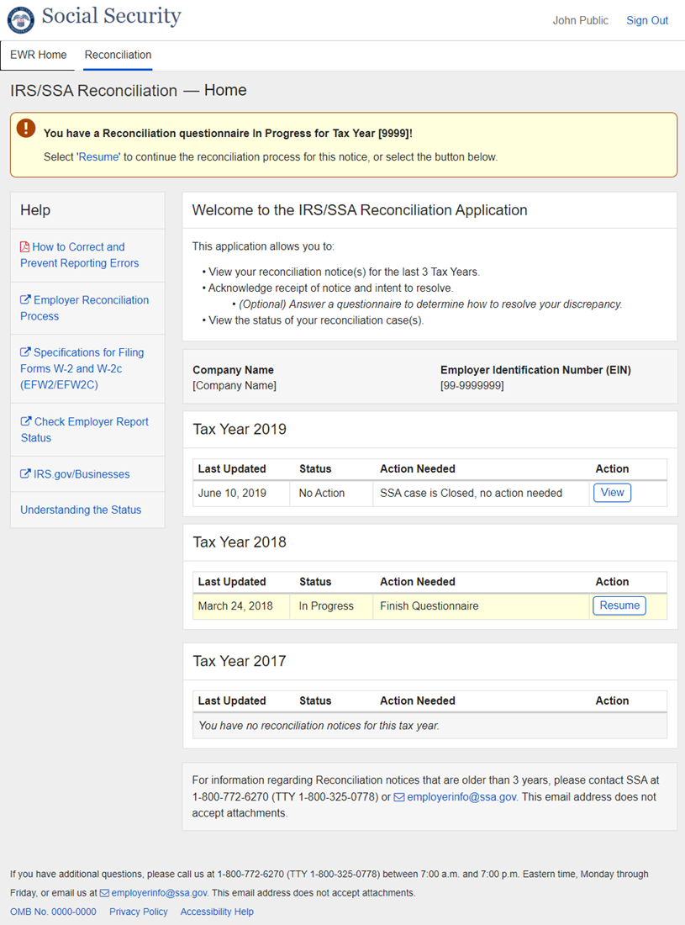
  - Reconciliation Home - Action Needed
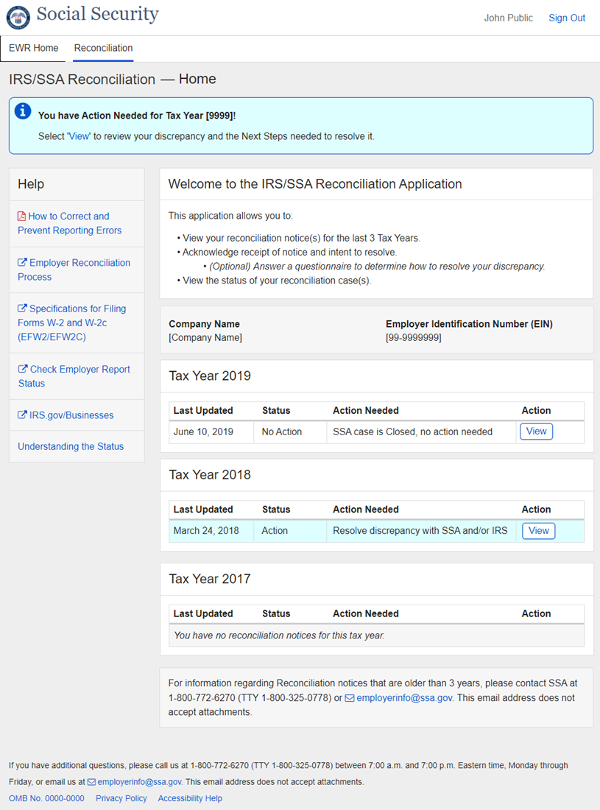
  - Reconciliation Home - No Notices
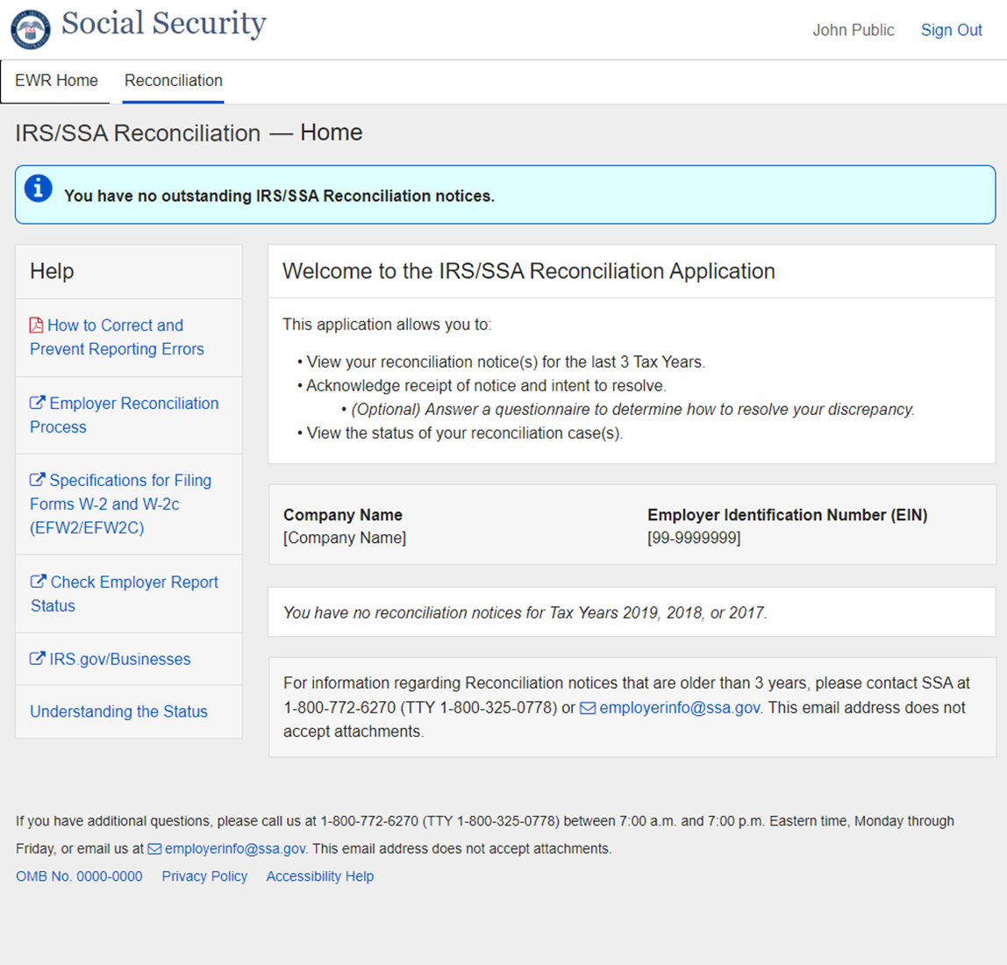
  - Help Panel - Understanding the Status
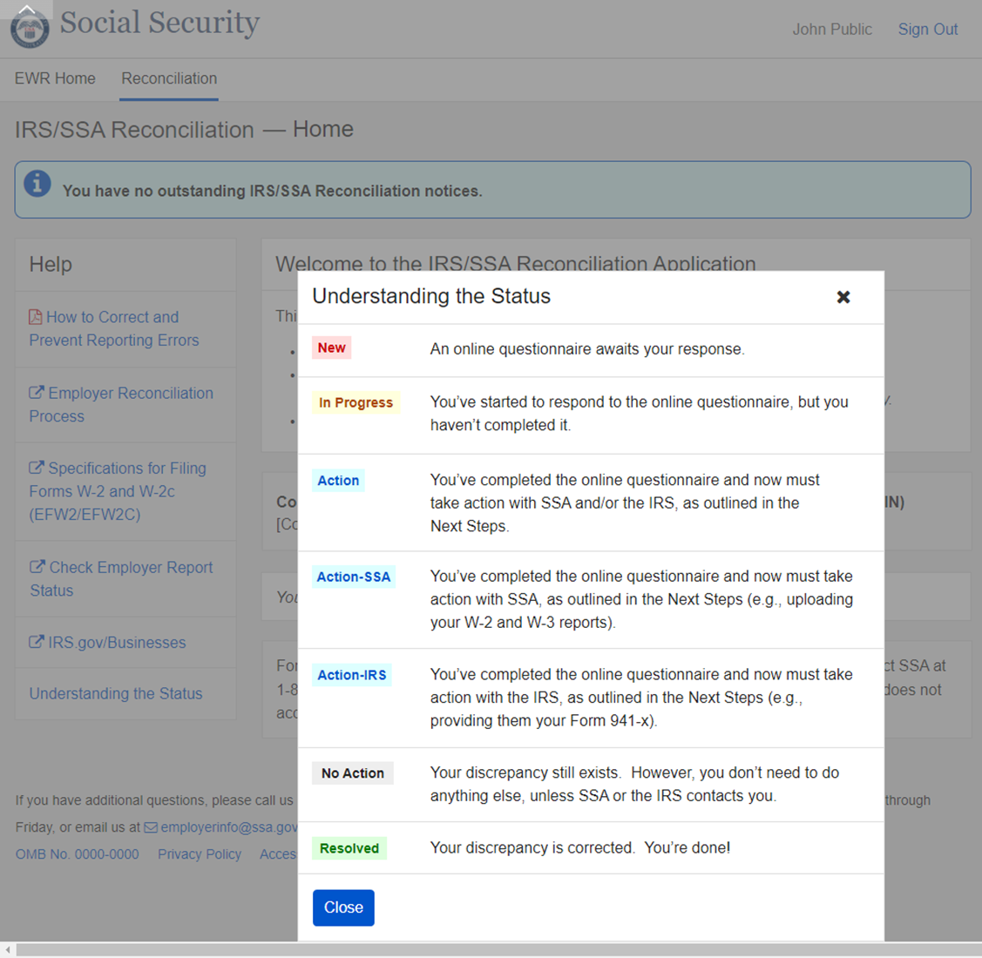

  - Notice Summary – Privacy Act Statement popup

  - Notice Summary - No Record of Employees’ Earnings
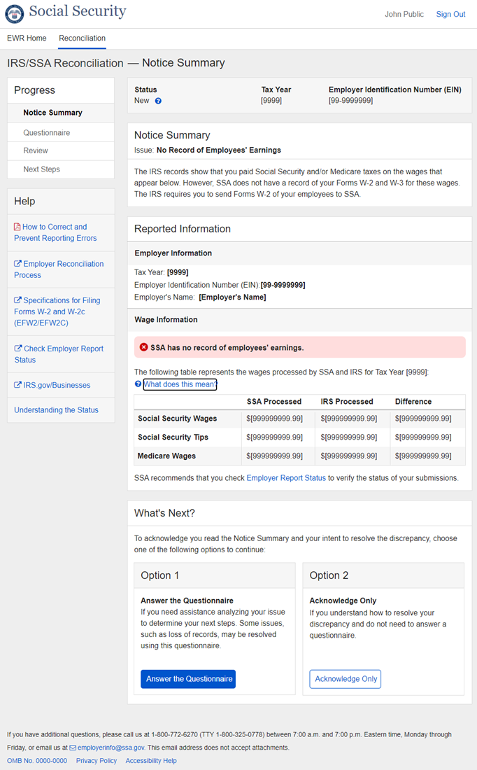
  - Notice Summary - Discrepancy Between IRS and SSA
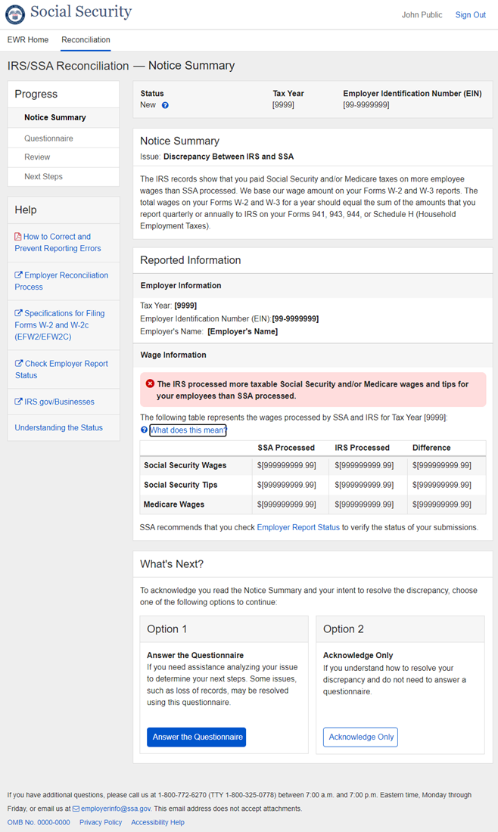
    - Status Help Tooltip – New
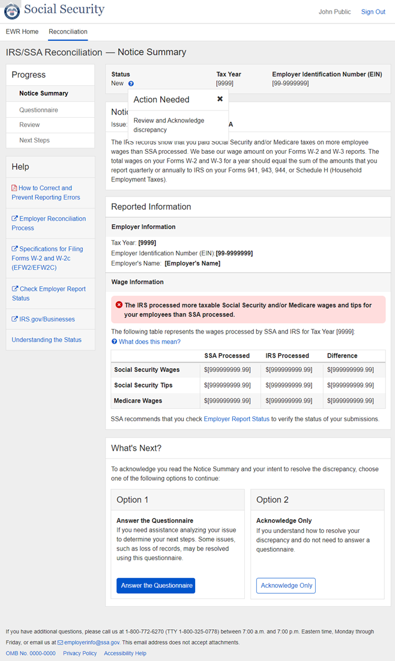
    - Wage Information Tooltip (“What does this mean?”)
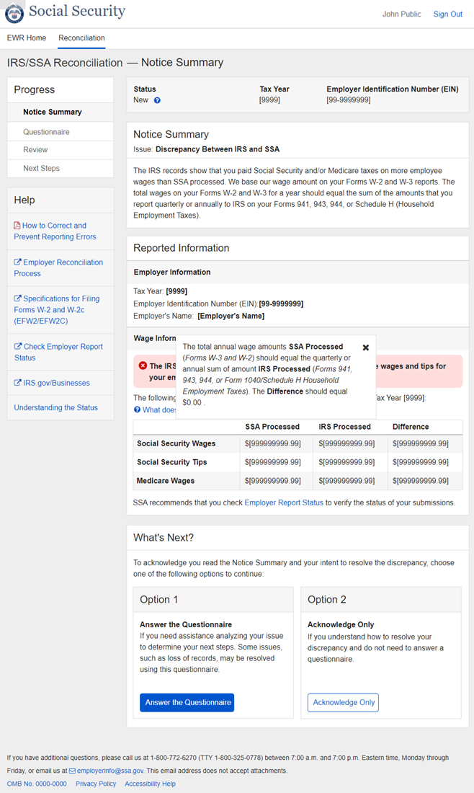
    - Acknowledge Only Confirmation Message
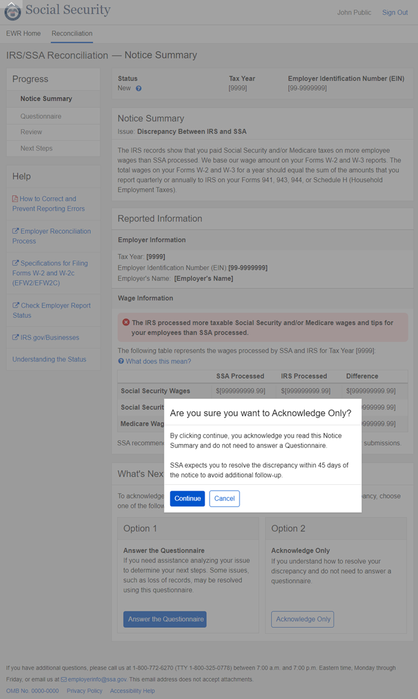
  - Questionnaire - No Record of Employees’ Earnings
    - Question 1 – Confirm Access
      - (Question 1 Variation) Initial
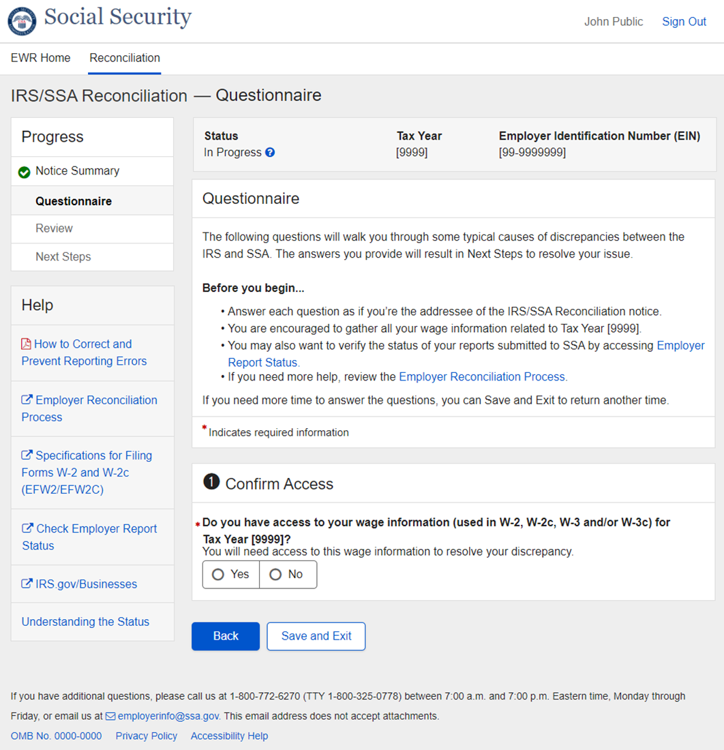
      - (Question 1 Variation) No
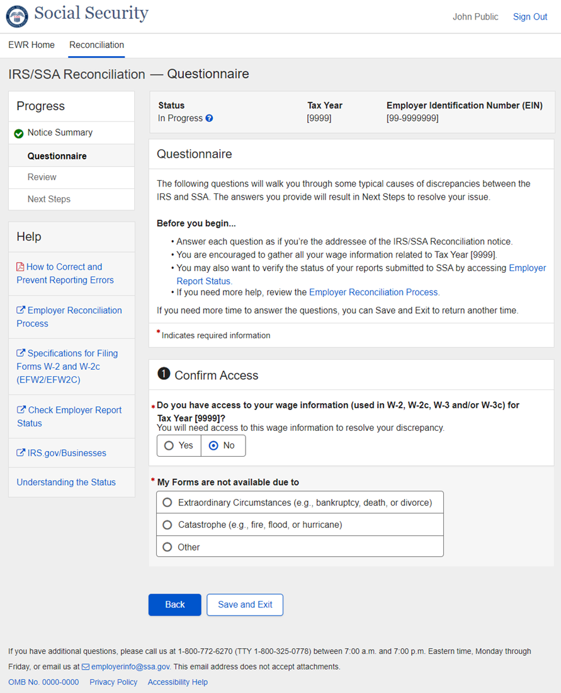
      - (Question 1 Variation) No_Other
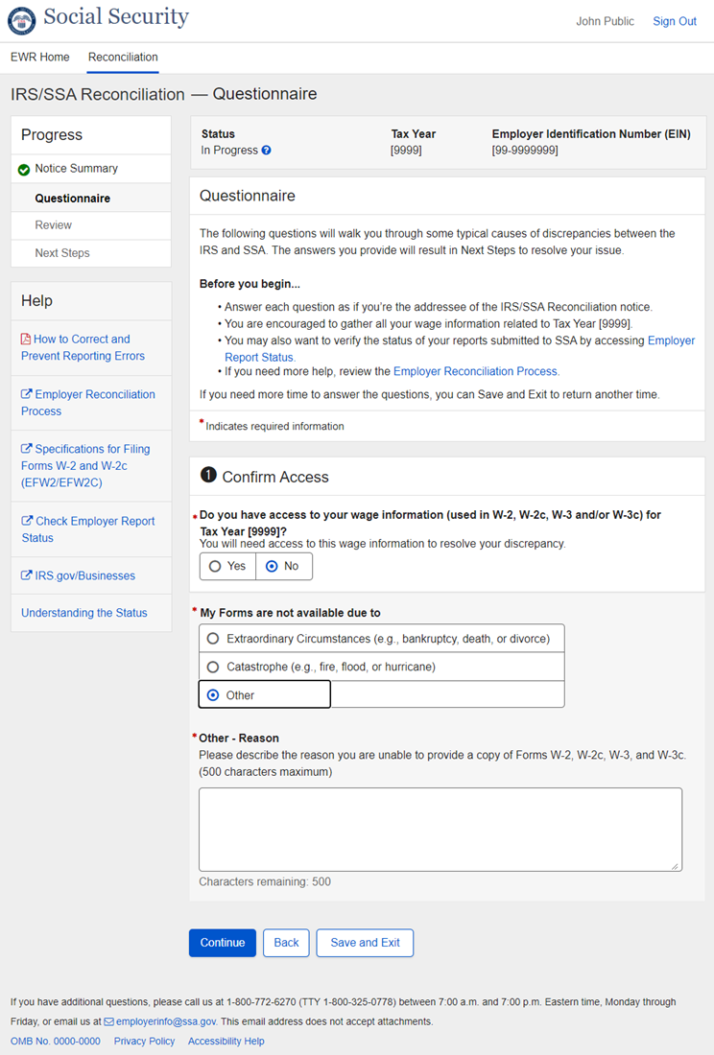
    - Question 2 - Confirm Self-Employment Status
      - (Question 2 Variation) Initial
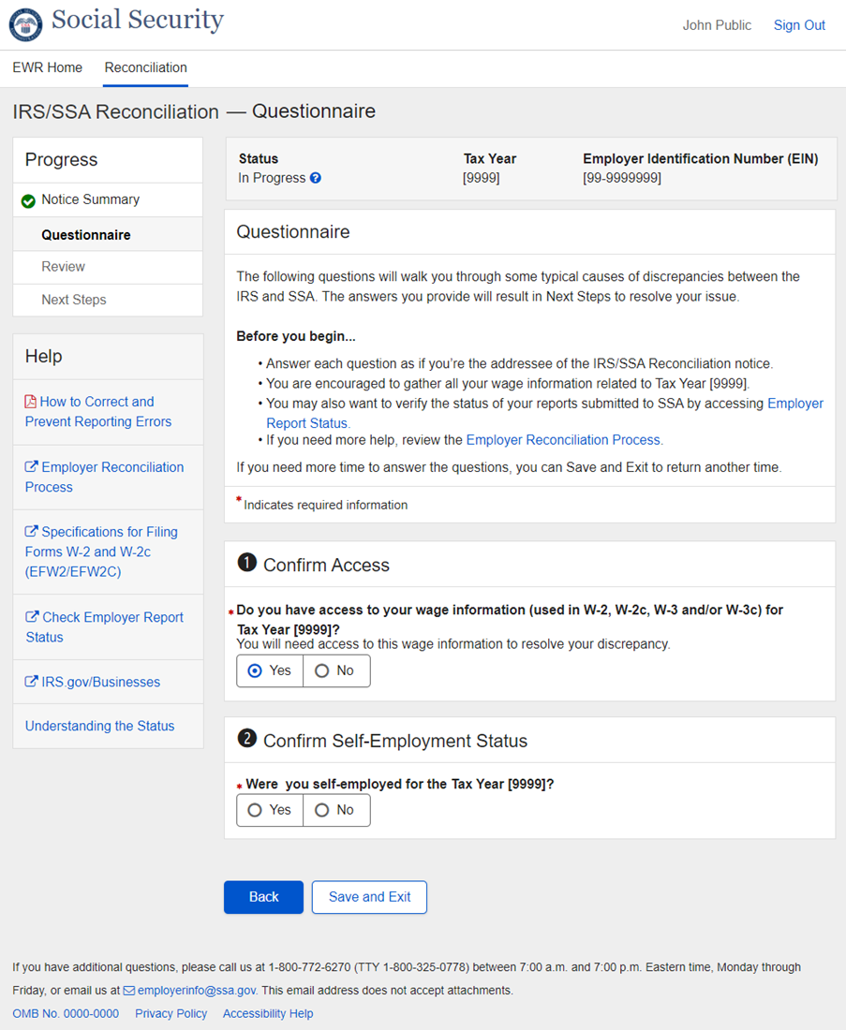
      - (Question 2 Variation) Yes
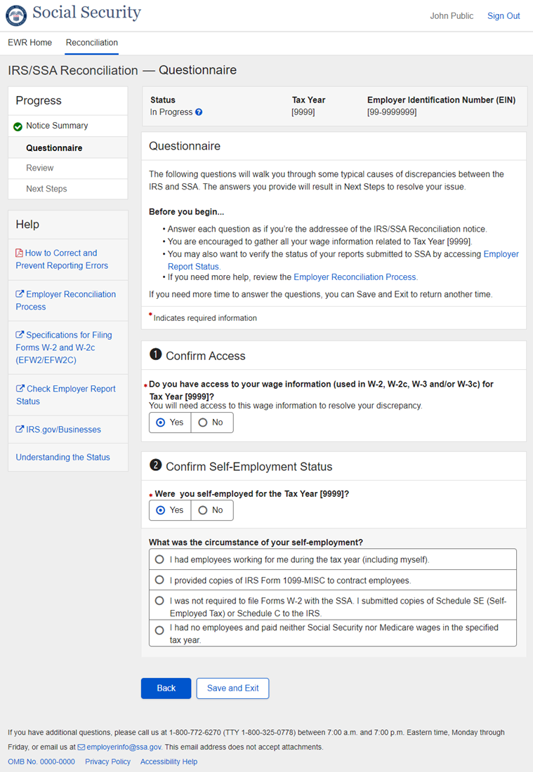
      - (Question 2 Variation) Yes_Option 1
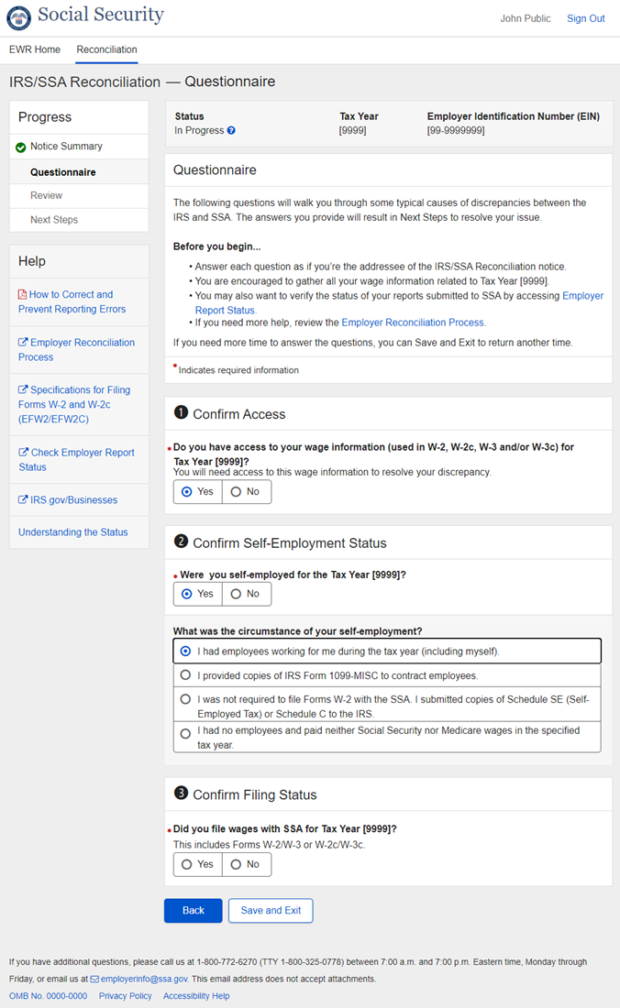
      - (Question 2 Variation) Yes_Not Option 1
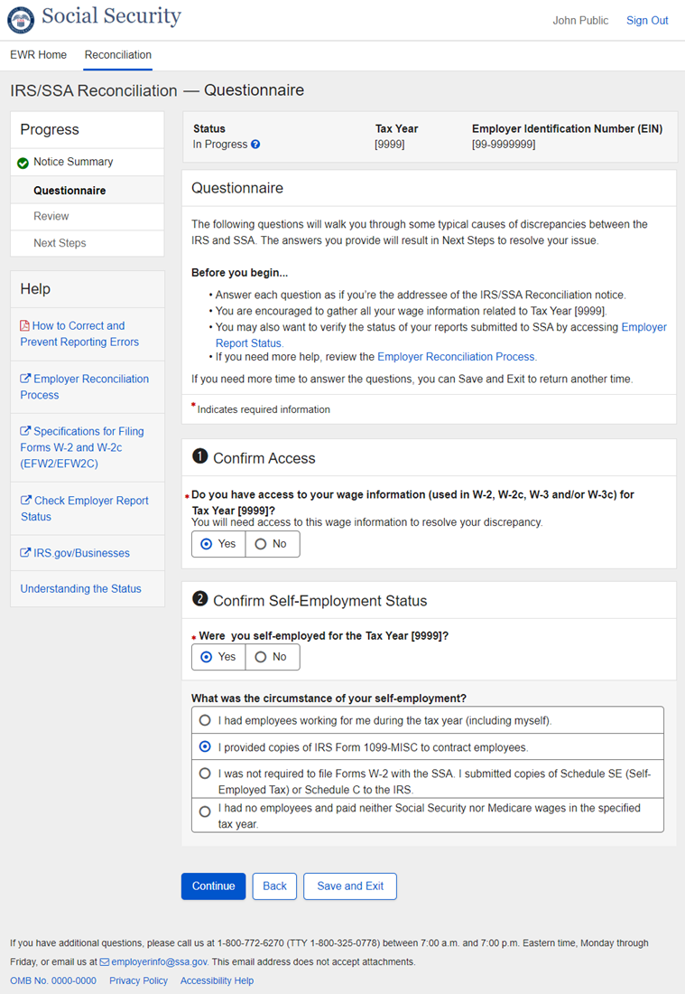
    - Question 3 – Confirm Filing Status
      - (Question 3 Variation) Initial
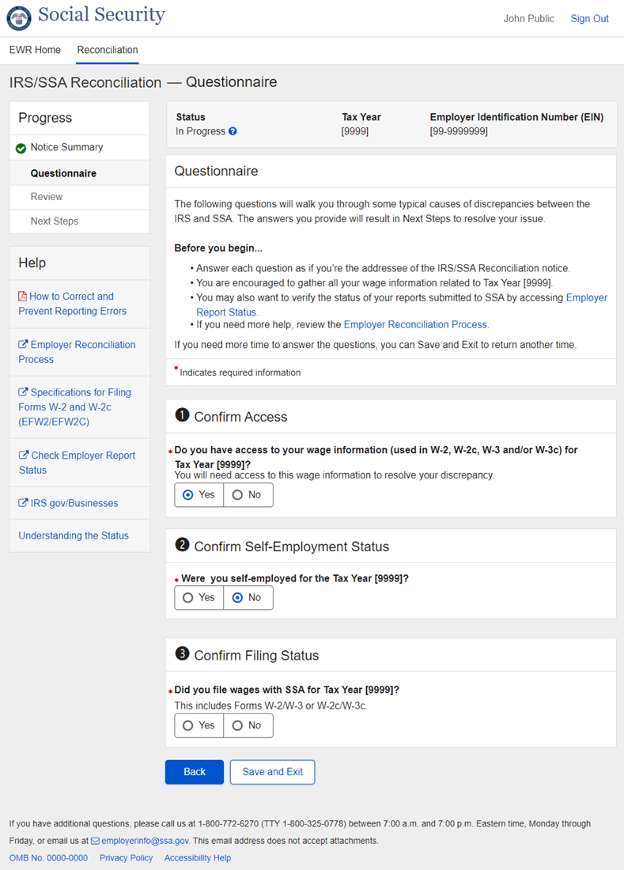
      - (Question 3 Variation) No
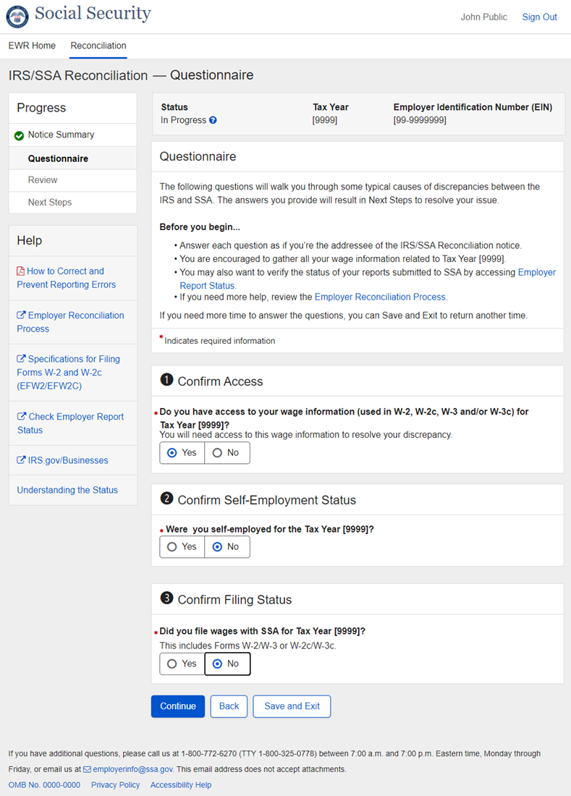
    - Question 4 – Confirm Employer Identification Number
      - (Question 4 Variation) Initial
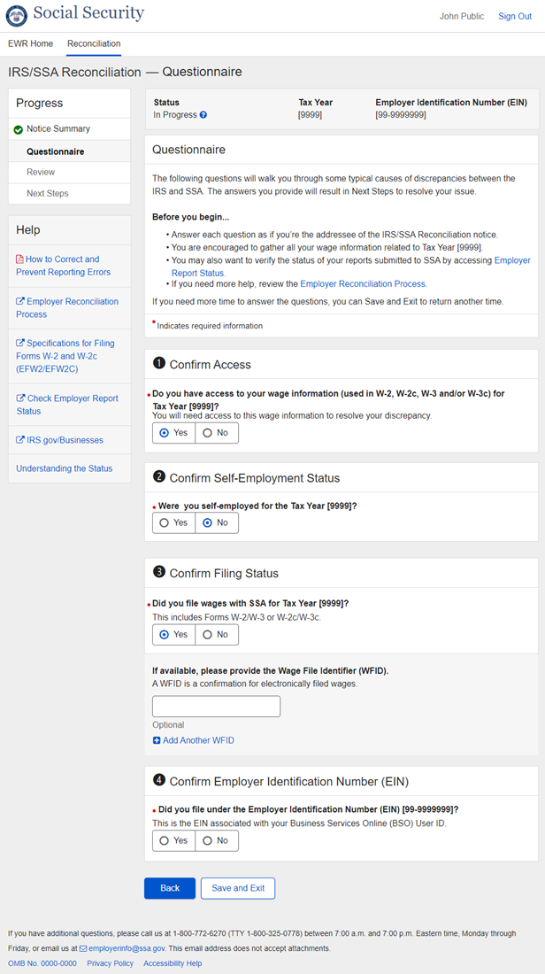
      - (Question 4 Variation) Yes
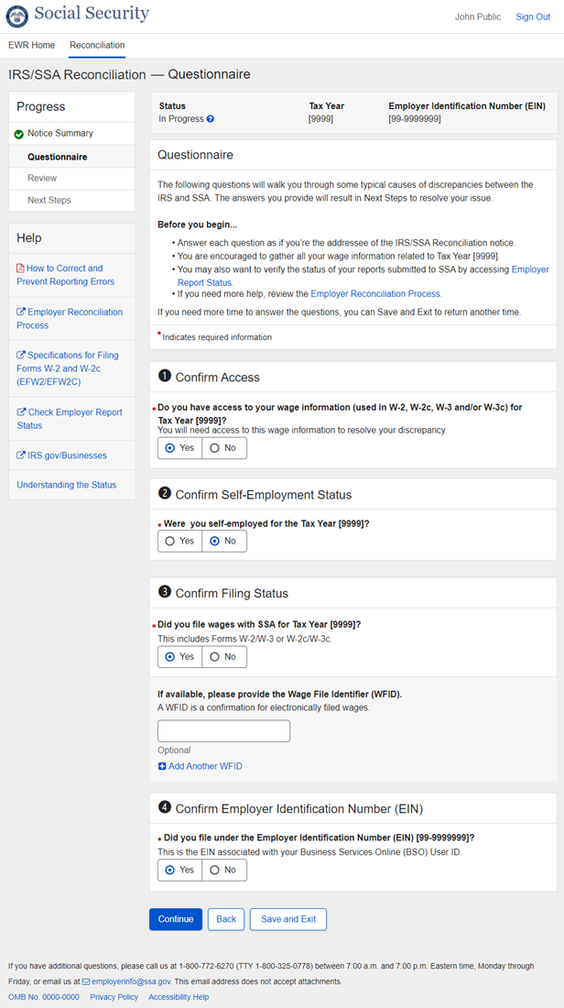
      - (Question 4 Variation) No
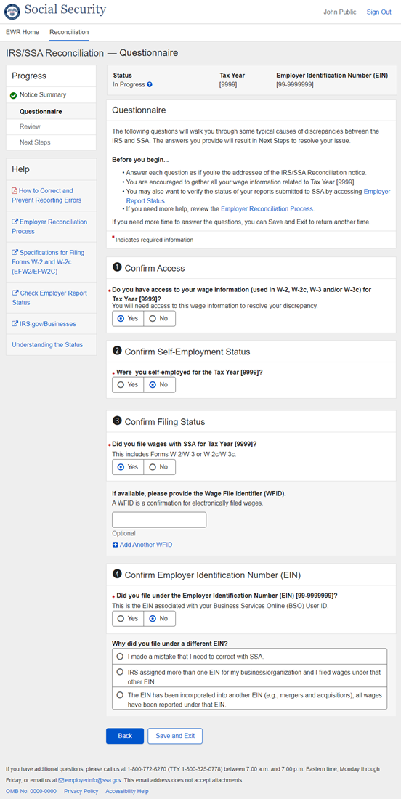
      - (Question 4 Variation) No_Option 1
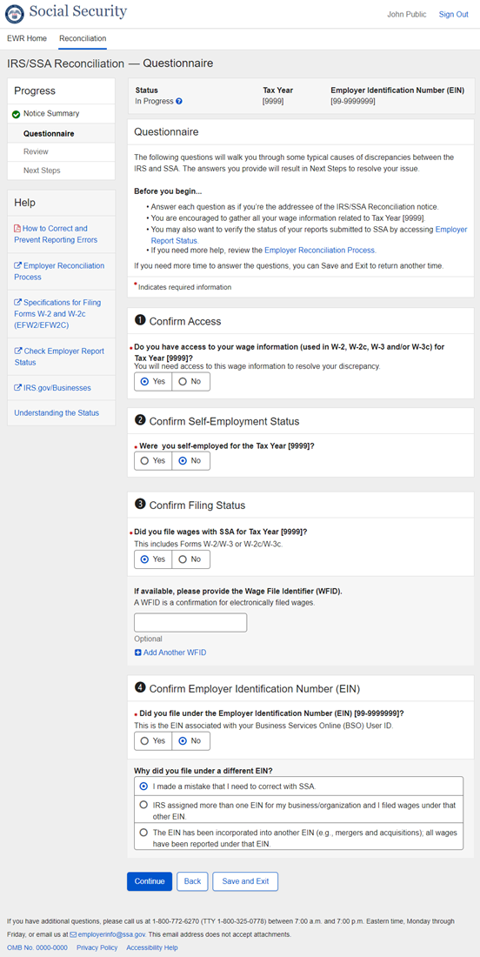
      - (Question 4 Variation) No_Not Option 1
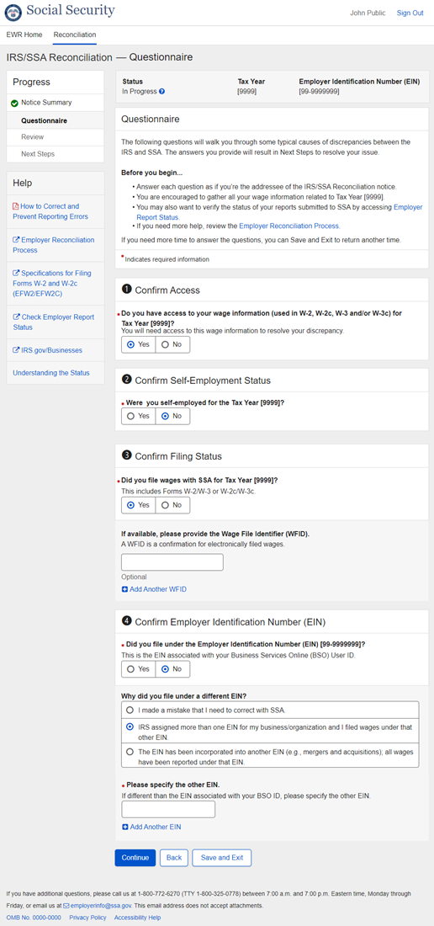
  - Questionnaire - Discrepancy between IRS and SSA
    - Question 1 – Confirm Access
      - (Question 1 Variation) Initial
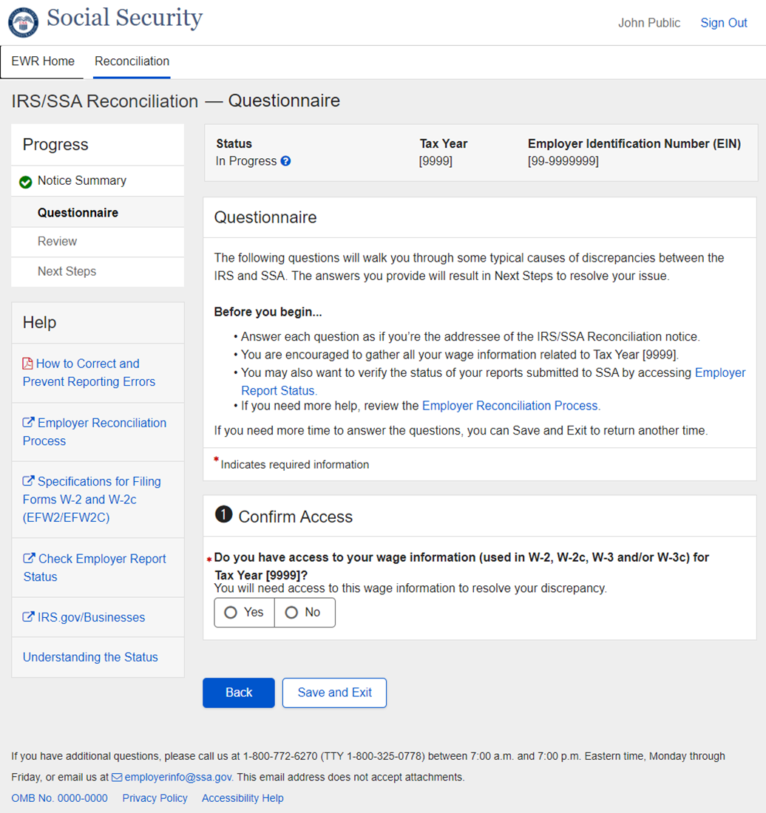
      - (Question 1 Variation) No
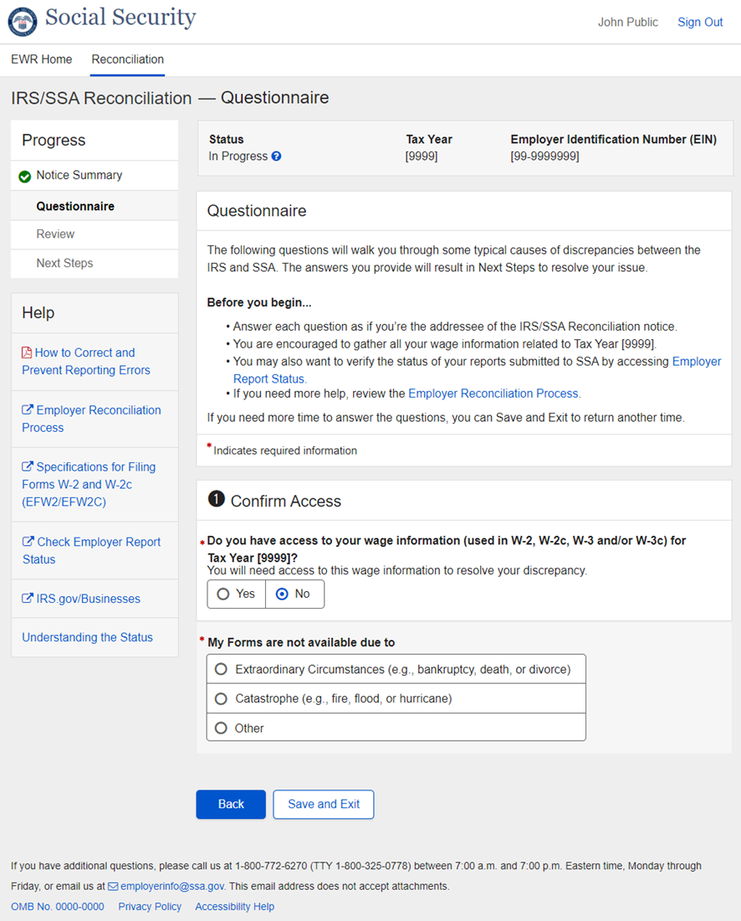
      - (Question 1 Variation) No_Other
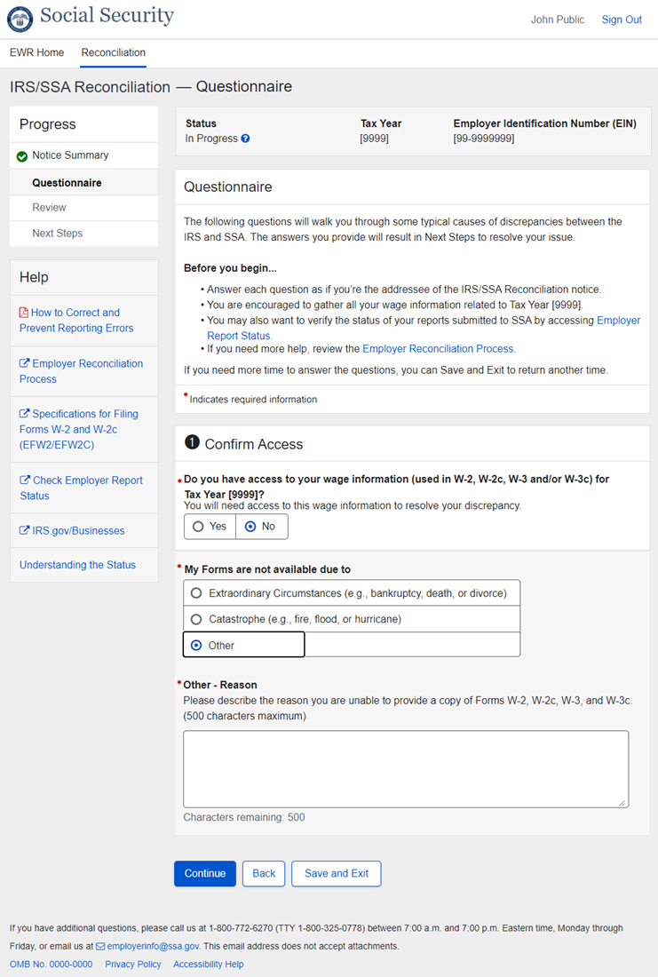
    - Question 2 – Confirm Wage Information
      - (Question 2 Variation) Initial
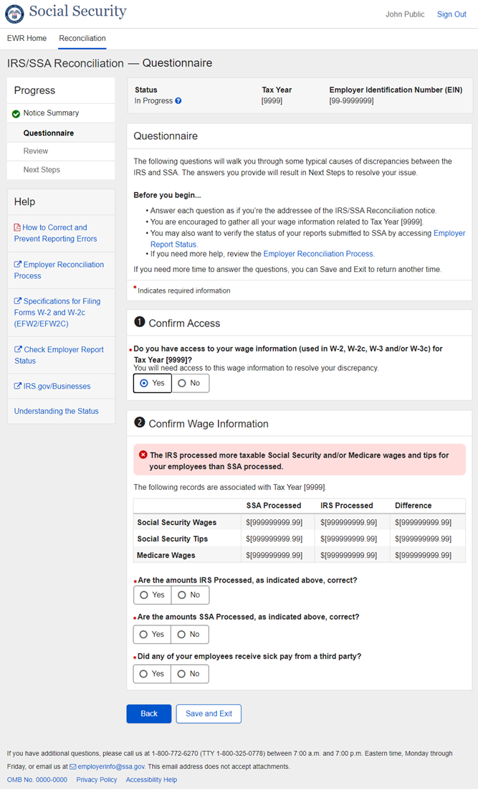
      - (Question 2 Variation) Sick Pay_No
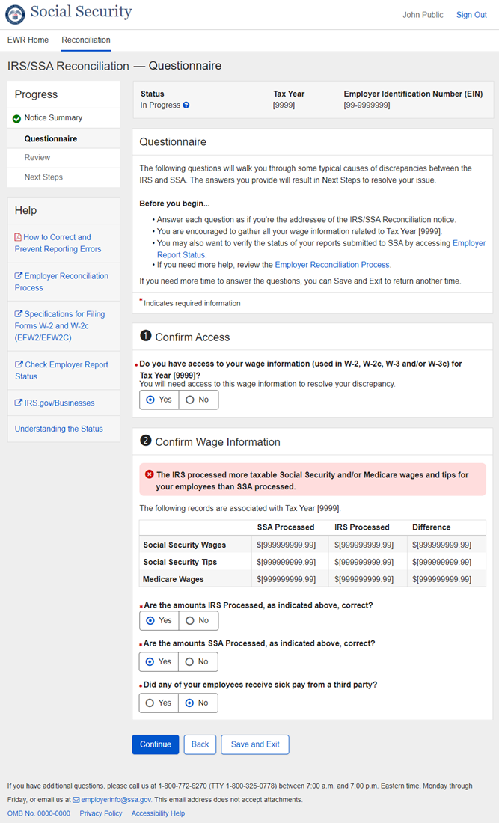
      - (Question 2 Variation) Sick Pay_Yes
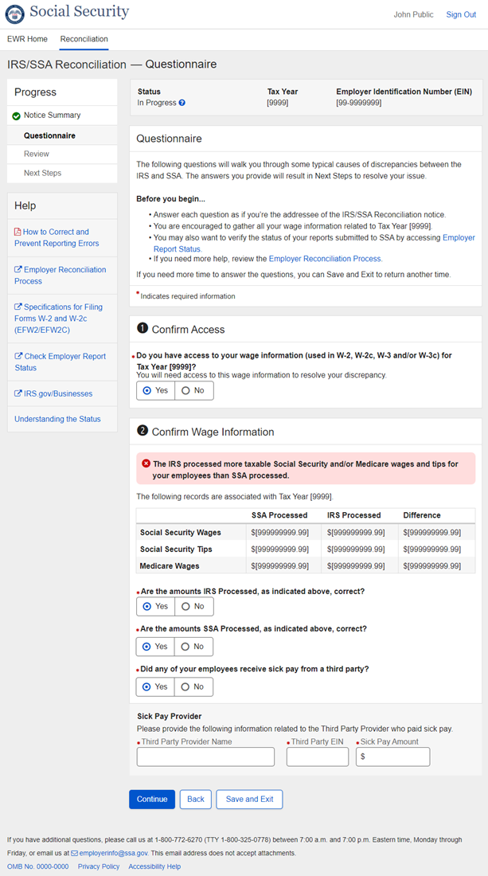
    - Questionnaire Component - Status Help Tooltip
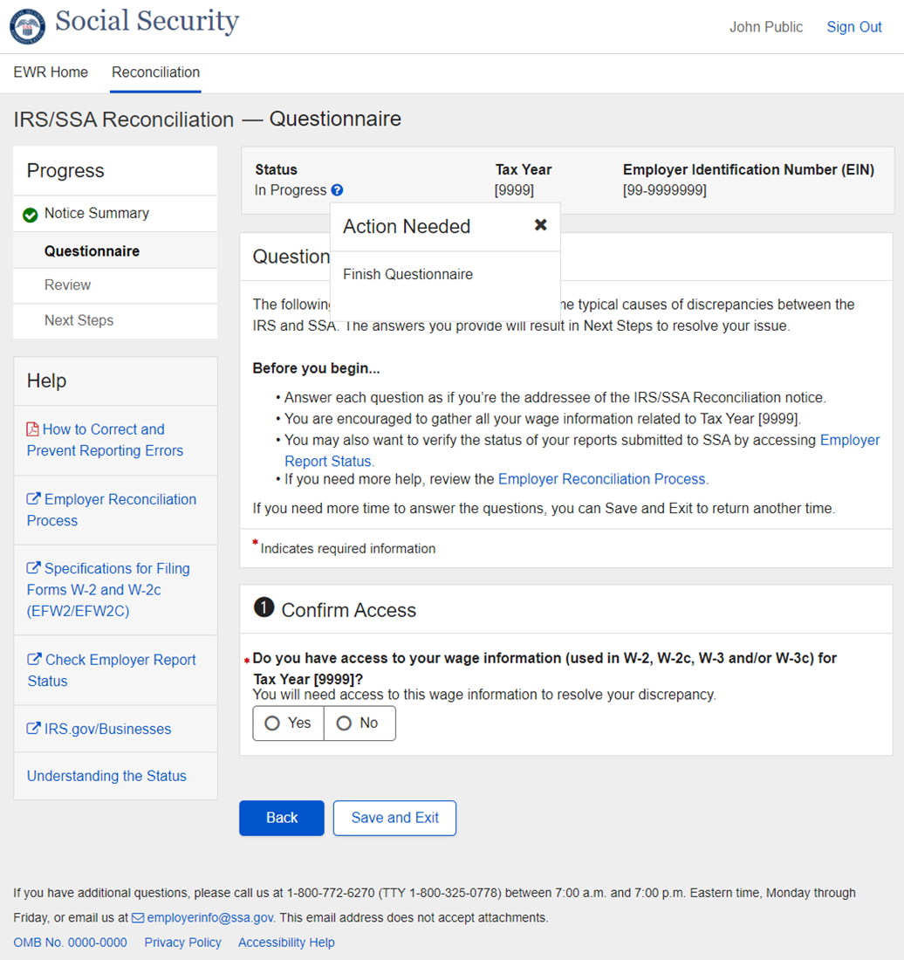
    - Questionnaire Component - Save and Exit Message
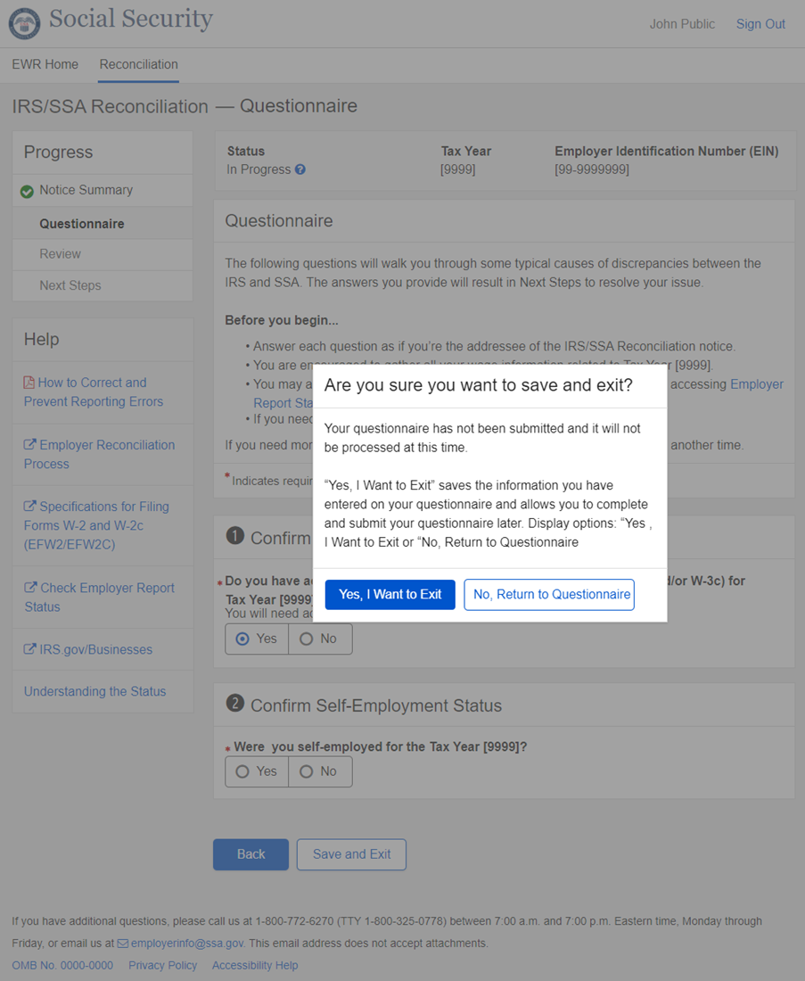
  - Review - No Record of Employees’ Earnings
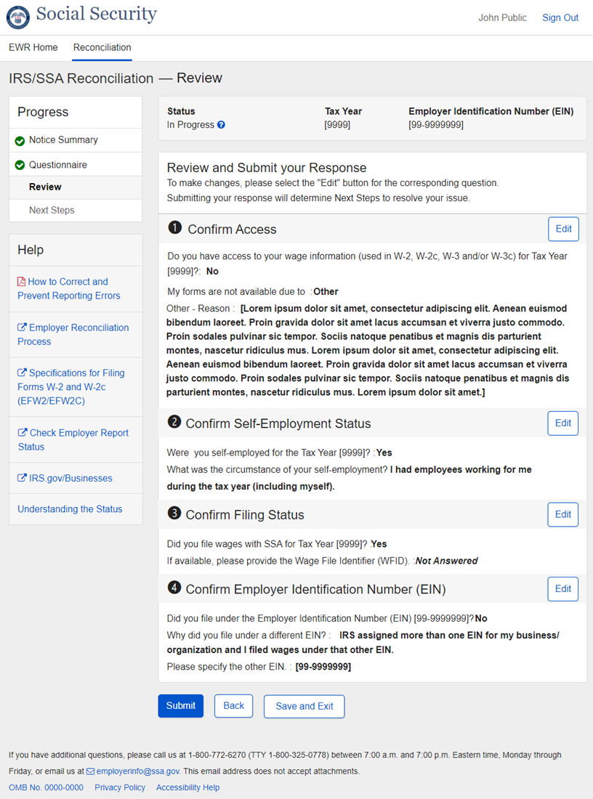
  - Review - Discrepancy between IRS and SSA
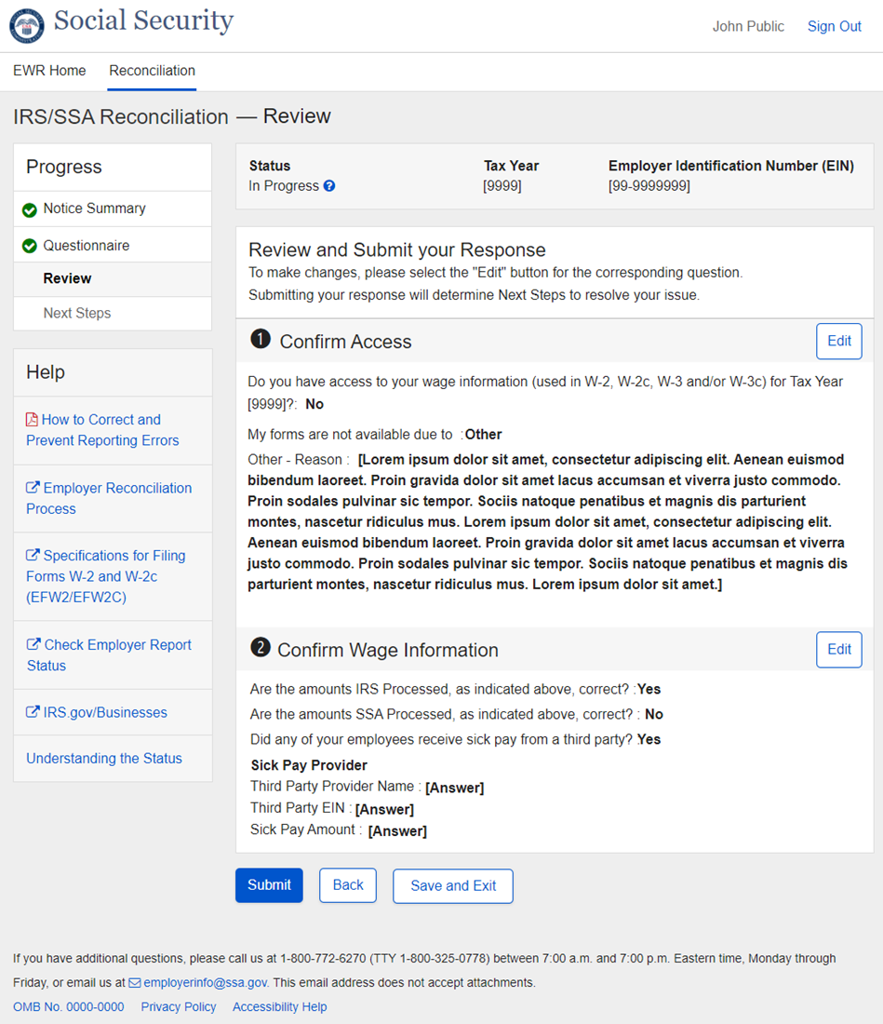
  - Next Steps - Acknowledge Only Path
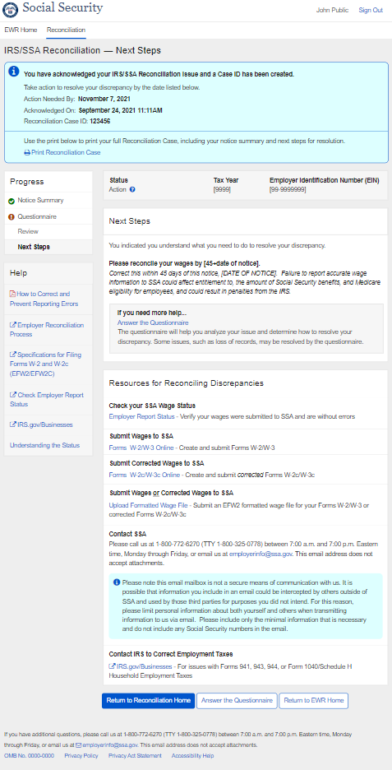
  - Next Steps - No Record of Employees’ Earnings Path
    - NR1_Contact Us
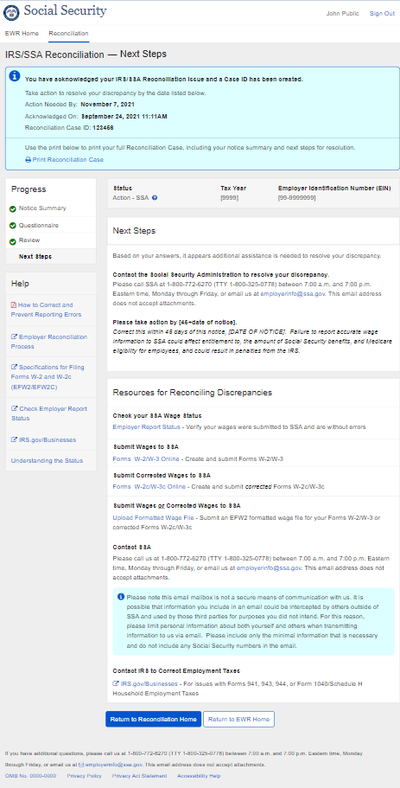
    - NR2_IRS
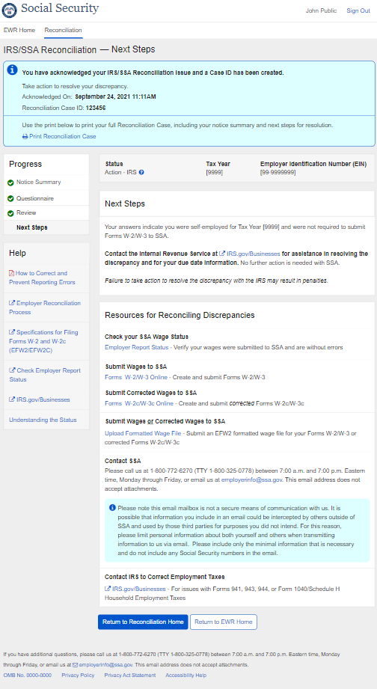
    - NR3_Submit
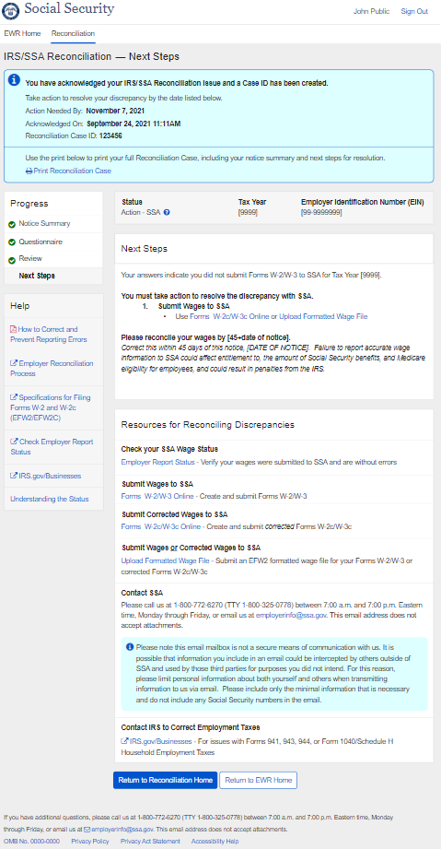
    - NR4_Correction EIN
      - Detailed Instructions collapsed
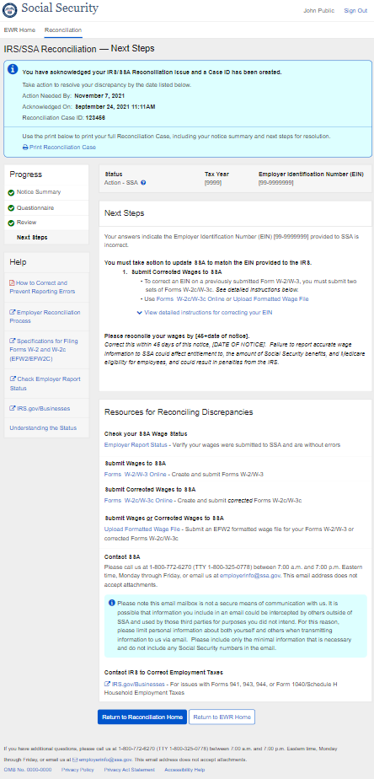

      - Detailed Instructions expanded
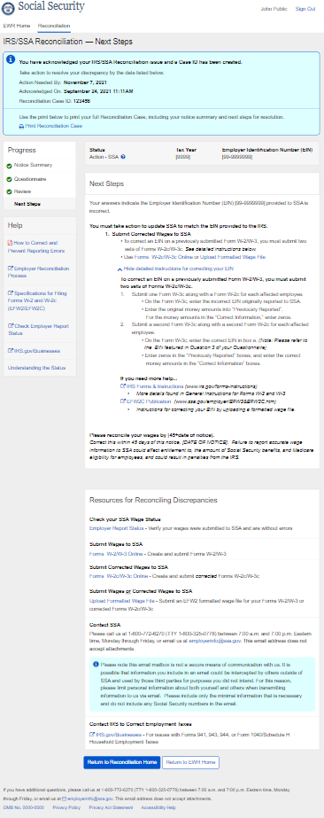
    - NR5_No Further Action
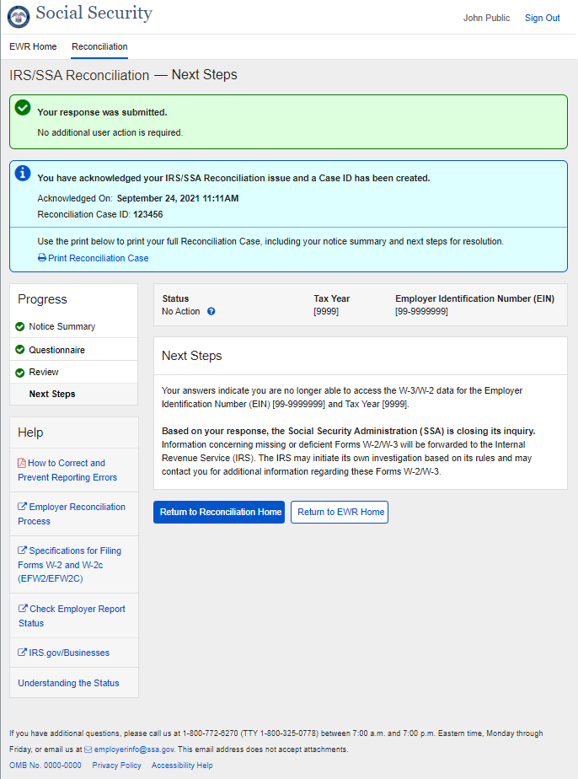
    - NR6_SSA Calls You
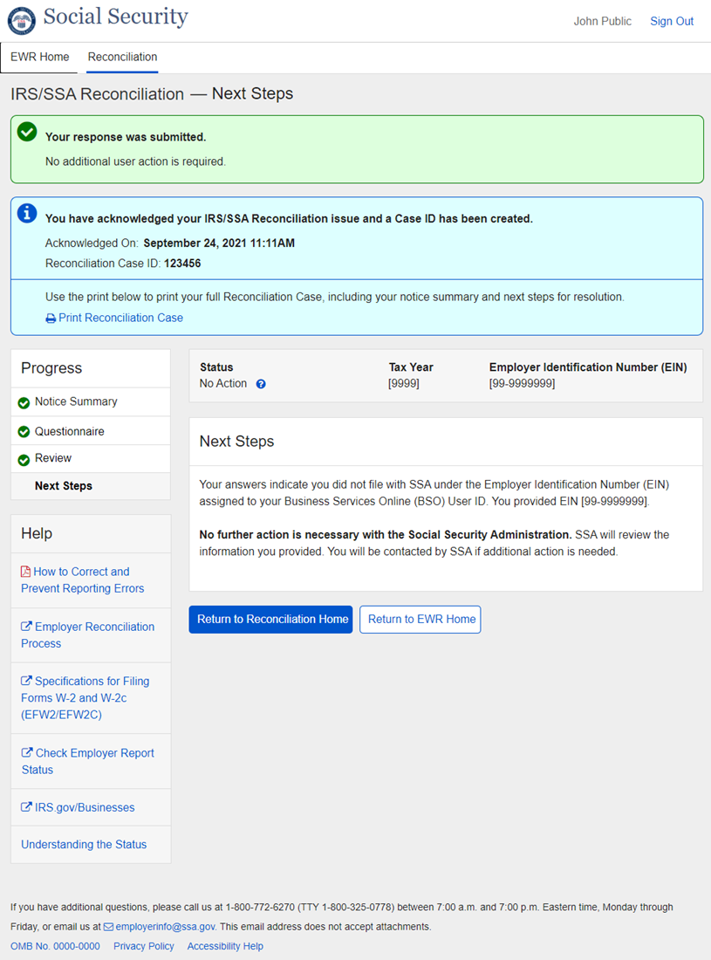
  - Next Steps - Discrepancy between IRS and SSA Path
    - D1_Contact Us
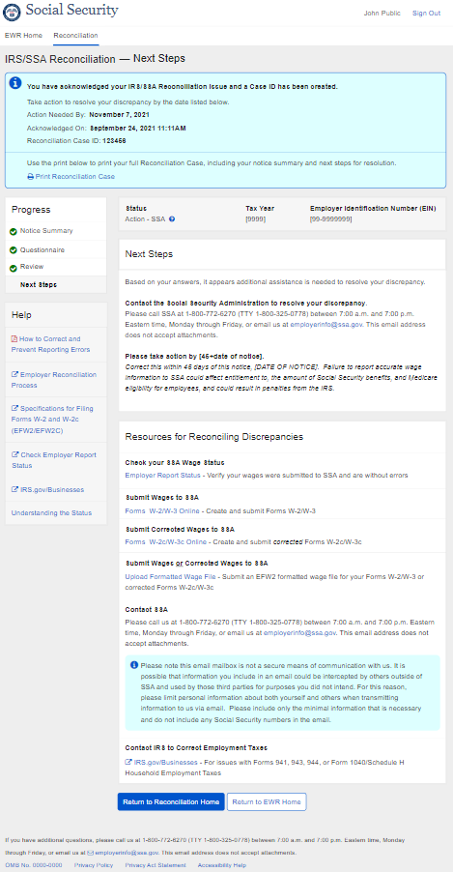
    - D4a_IRS
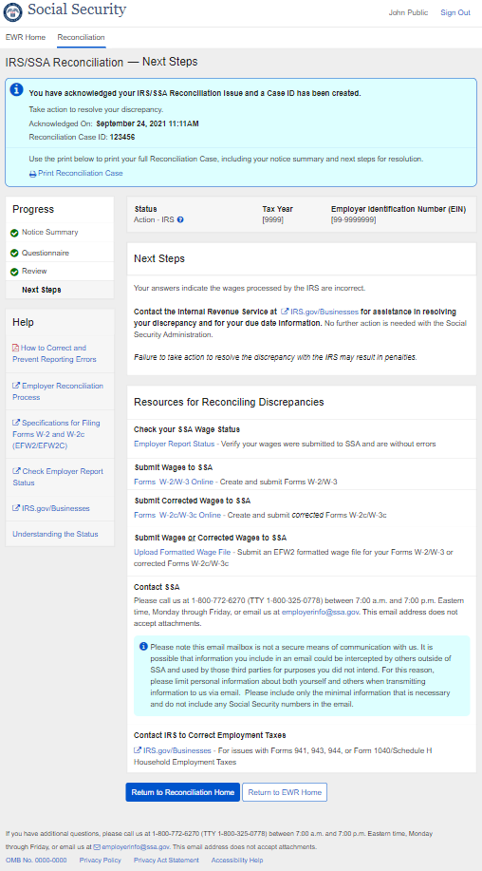
    - D4b1_IRS_Sick Pay equals Discrepancy
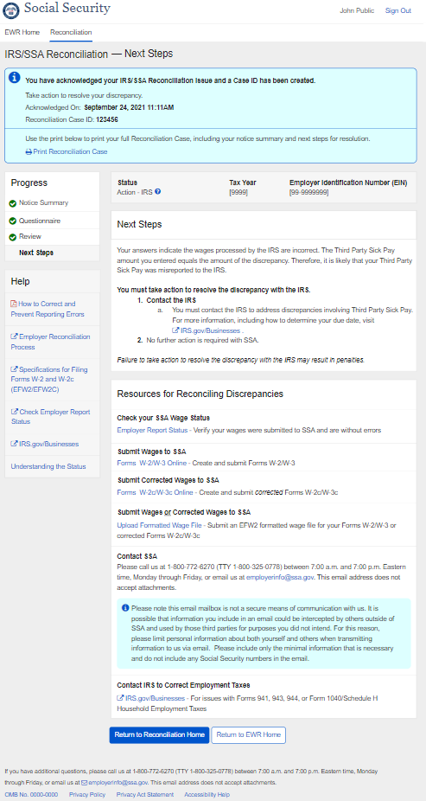
    - D4b2_IRS_Sick Pay not equal Discrepancy
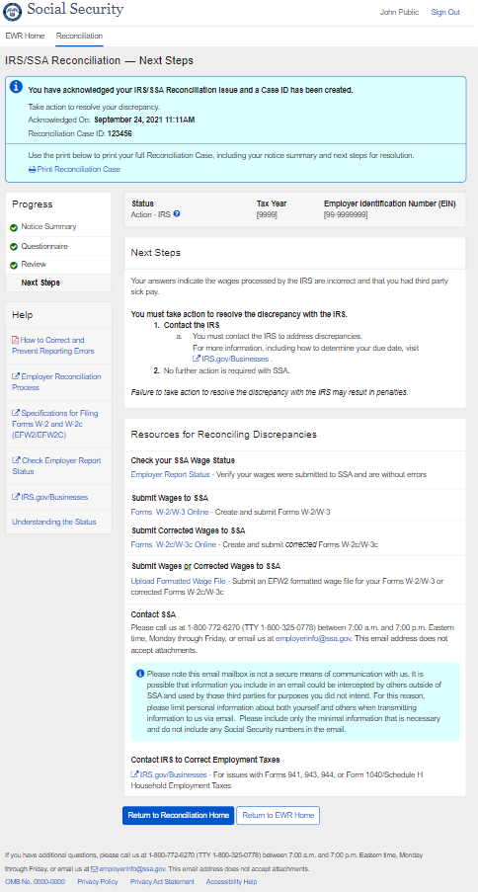

D6_Correction_IRS
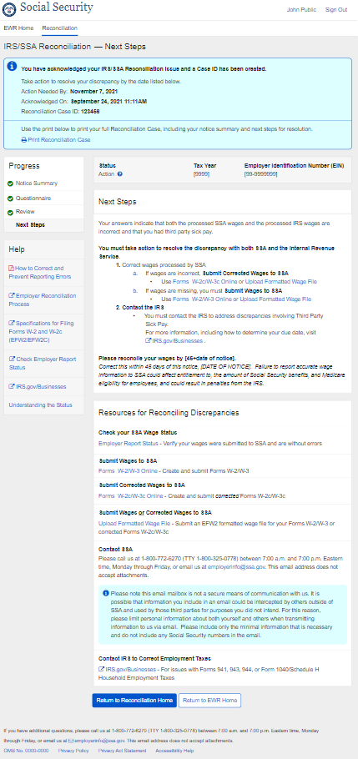
    - D7_Correction
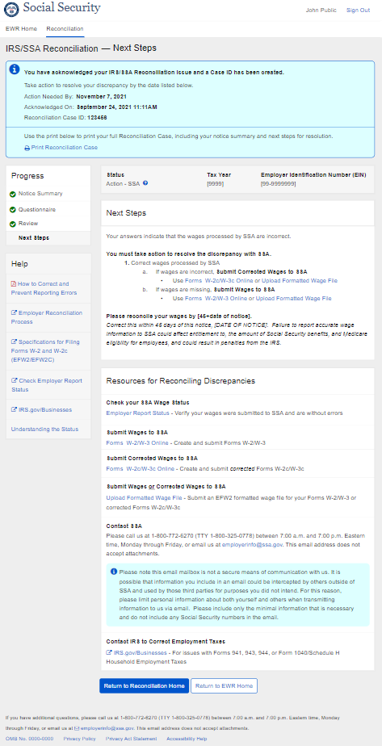
    - D8_All Options
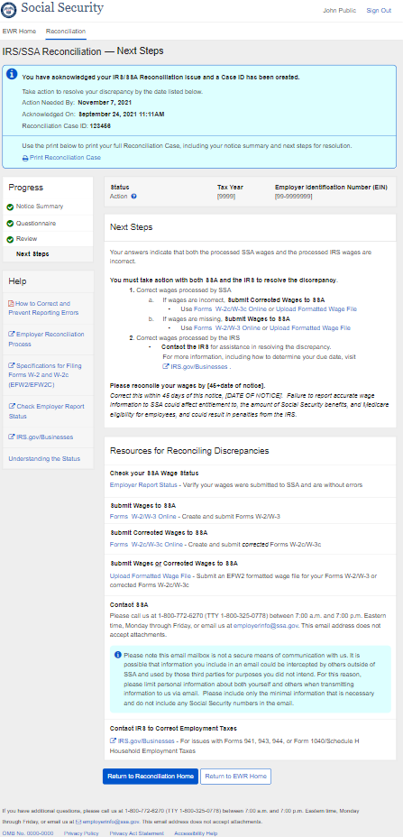
    - D9_No Further Action
  - Next Steps Component - Status Help Tooltip
    - Action-SSA
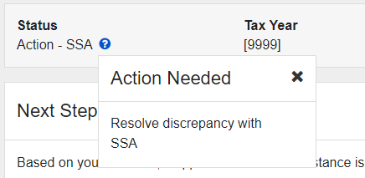

    - Action-IRS
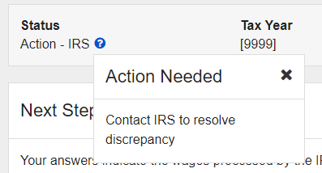

    - Action
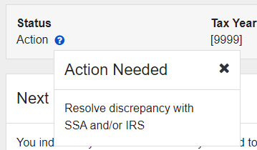

    - No Action
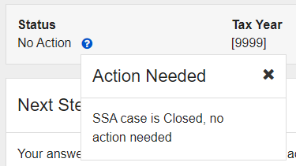
  - Print Reconciliation Case - No Record of Employees’ Earnings
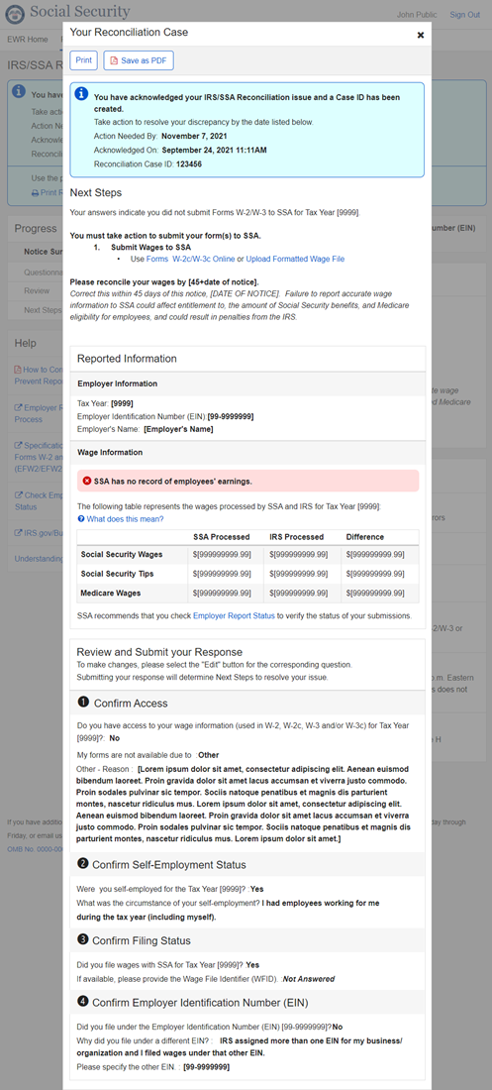
  - Print Reconciliation Case - Discrepancy between IRS and SSA
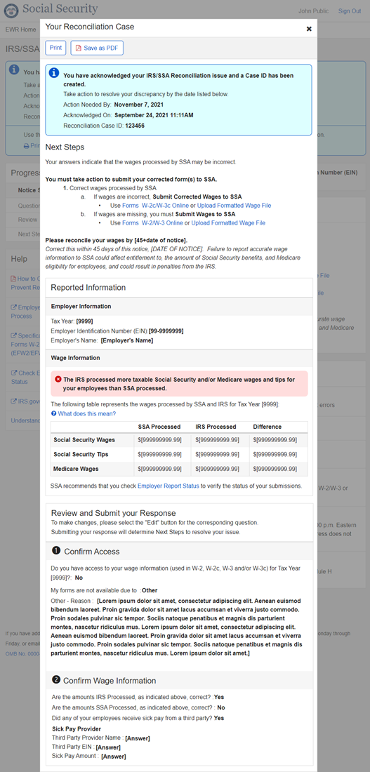
  - Error Messaging
    - Invalid Entry Errors - Text Exceeded Max Length
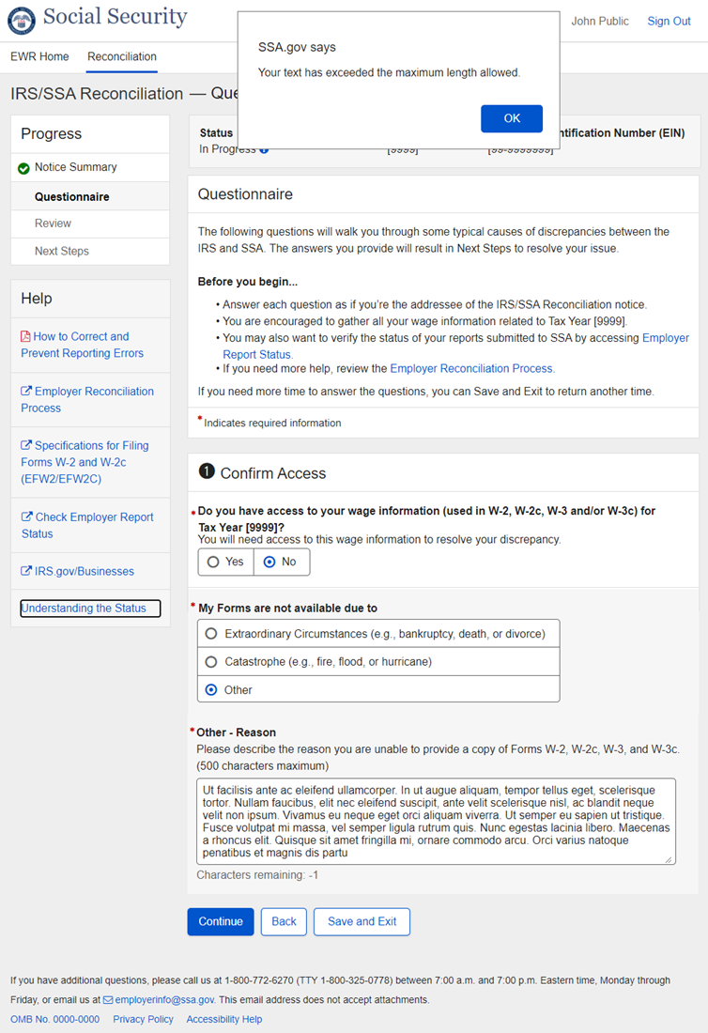
    - Invalid Entry Errors - WFID
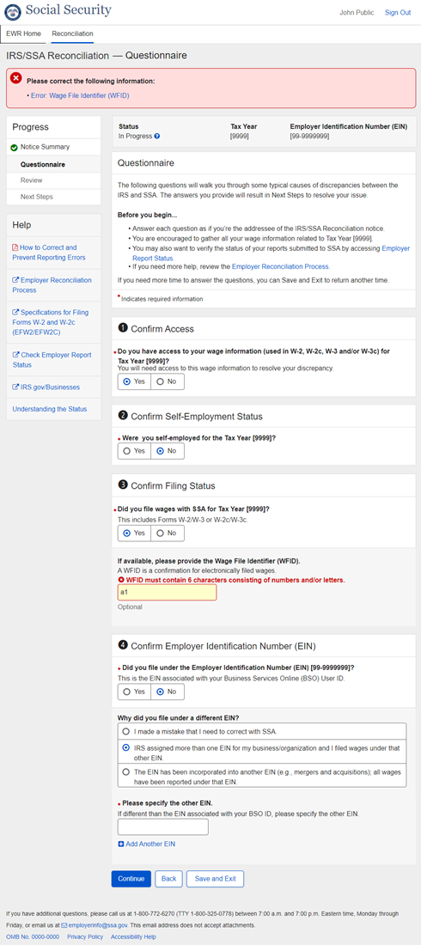
    - Invalid Entry Errors - EIN
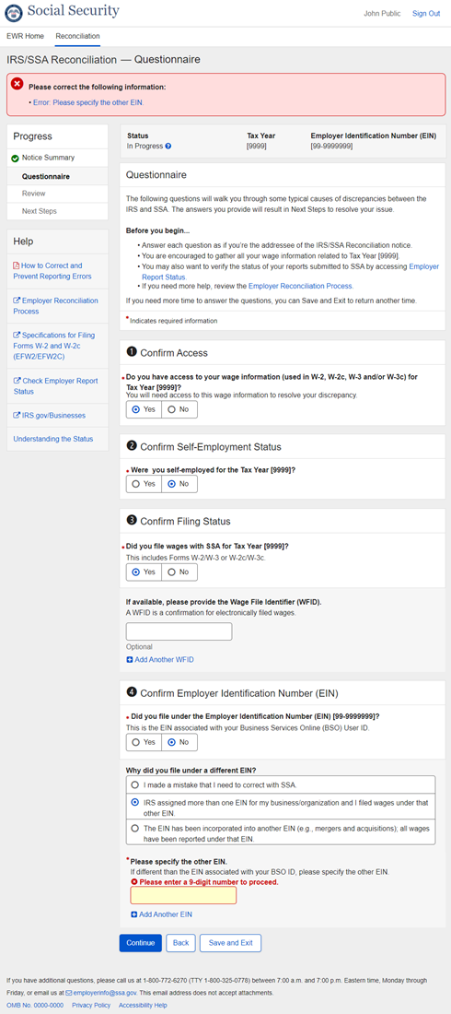
    - Invalid Entry Errors - Sick Pay Provider EIN
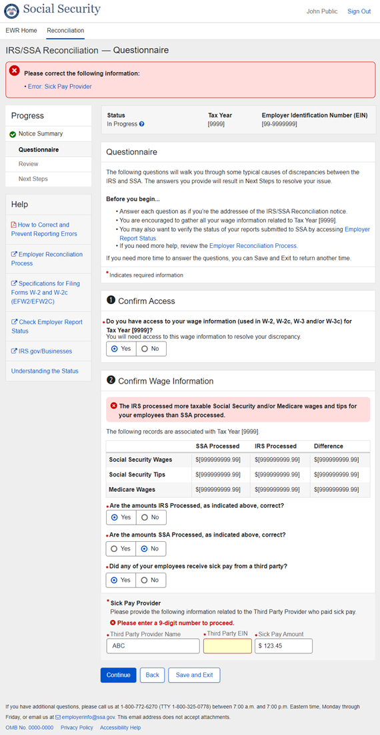
    - Invalid Entry Errors - Sick Pay Provider Amount
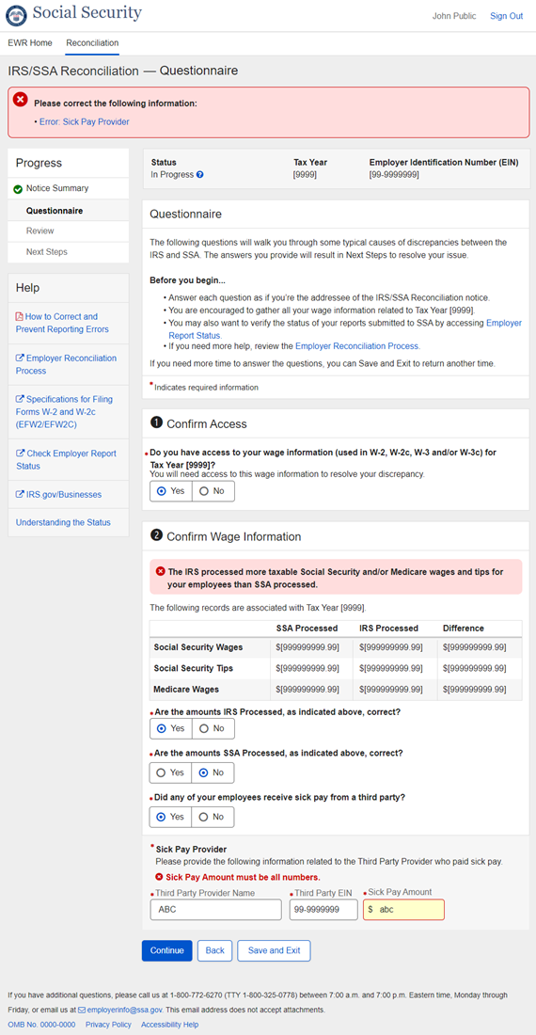
    - Required Field Errors - Other Reason
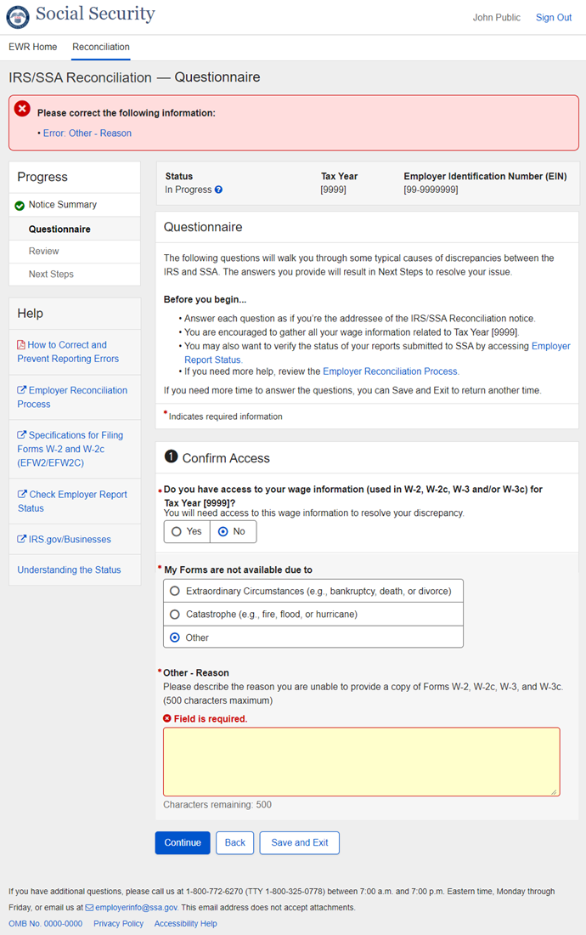
    - Required Field Errors - EIN
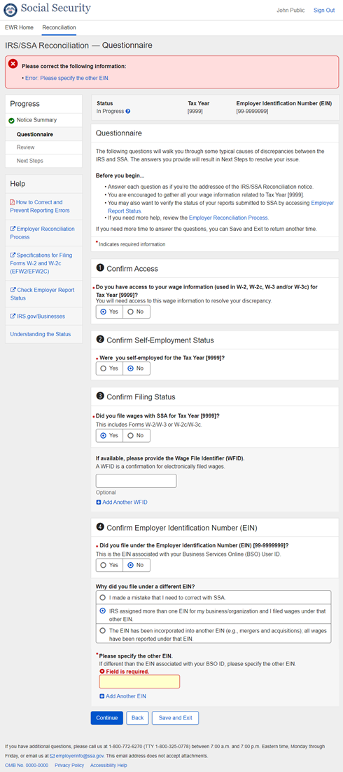
    - Required Field Errors - Sick Pay Provider
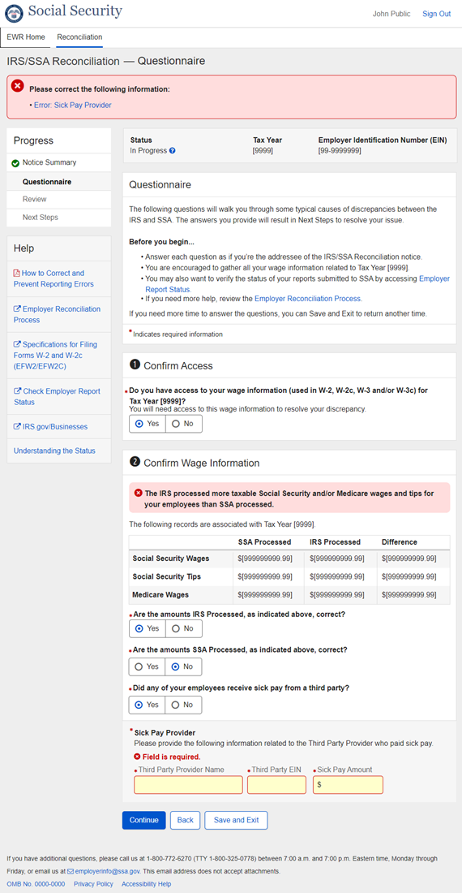
    - System Errors - Invalid URL
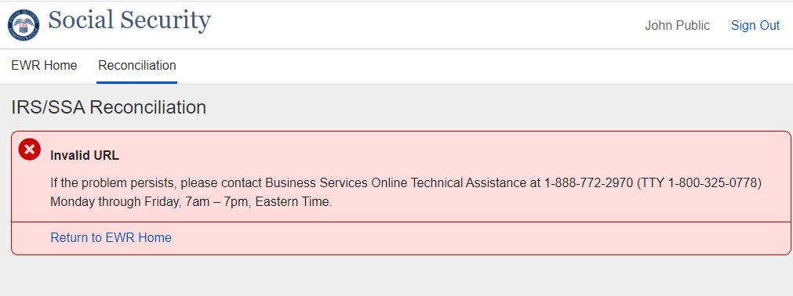

    - System Errors - System Failure
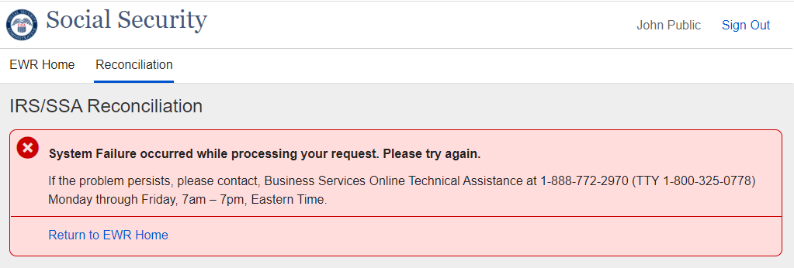

    - System Errors - Application Error
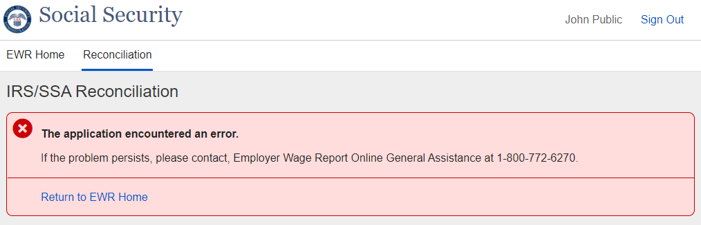

    - System Errors - Refresh Data
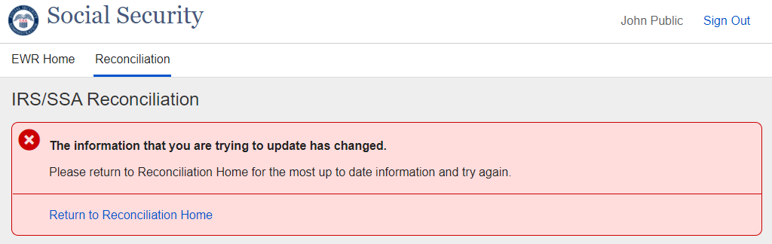
  - Page Footer
    - Page Footer – OMB Link_Paperwork Reduction Act Statement
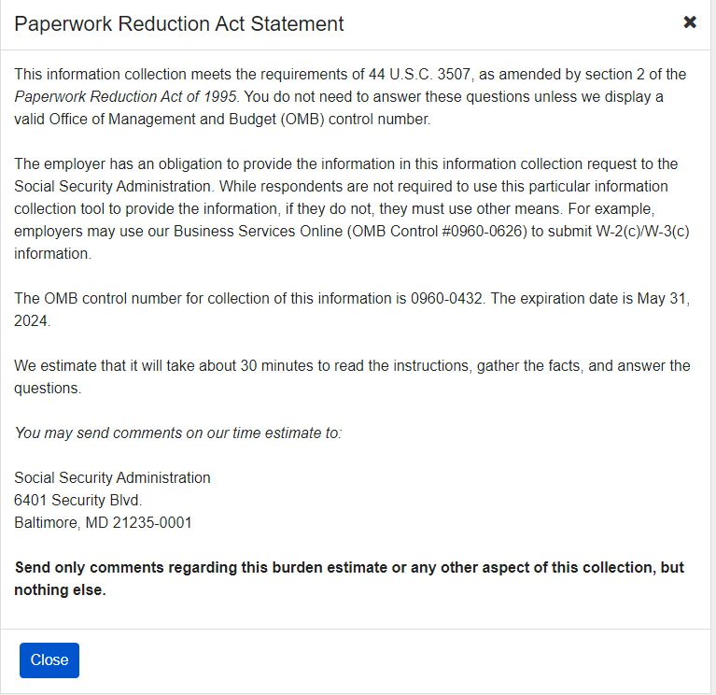

- Appendix A - UXG Contact Information for Analysts, Developers and Others
For information about any of the content included in this design specifications document, contact the User Experience Group (UXG) Project Lead for this project and/or the appropriate project team member (for some projects a UXG designer may have specialized knowledge of one or more parts of the design).
To ensure a timely response to your inquiry in case of absence, please cc the UXG Team Lead.

Name | Project Role | Email | Phone | Specialized Project Knowledge
Sheila Y. Lee | UXG Project Lead | Sheila.Y.Lee@ssa.gov | (410) 965-5695 | All
Emily Ficner | UXG Designer | Emily.Ficner@ssa.gov | (610) 704-8588 | All

