Bipartisan Budget Act (BBA) 826
Office of Management & Budget (OMB) Title II, Title XVI and Concurrent Screen Package

Table of Contents

- Document Version Information 3
- Self-Reporter Screen Progression 4
  - Self-Reporter “Happy Path” Progression 4
    - my Social Security Landing Page 4
      - Title II Self-Reporter Teaser 4
      - Title XVI Self-Reporter Teaser 4
      - Concurrent Self-Reporter Teaser 4
    - Title XVI/Concurrent Monthly Reporting Requirement Acknowledgment 5
    - Choose Employer 5
      - Employer Selection 12
        - Employer Selection: Foreign Address 5
        - Employer Selection “More Details” Modal 6
      - Privacy Act Statement 6
    - Wage Entry 7
      - Empty Wage Table Screen 7
        - Wage Report Frequency of Pay Dropdown 7
      - Wage Entry Screen 8
        - Wage Entry Screen: ‘Gross Pay’ Modal 8
      - Populated Wage Table Screen 8
      - Pay Period Deletion Confirmation Screen 9
    - Title XVI/Concurrent Employer Wage Confirmation Screen 10
      - Title XVI/Concurrent Employer Wage Confirmation Screen ‘Why am I Seeing this?’ Modal 10
    - Overlapping Pay Period Warning 11
      - Overlapping Pay Period More Information Modal 11
    - Wage Report Review 12
      - Title II Wage Report Review Screen 12
      - Title XVI/Concurrent Wage Report Review Screen 12
    - Wage Report Confirmation/Receipt 13
      - Title II Wage Report Confirmation Screen 13
        - Title II Wage Report Confirmation Screen for Self-reporters who are also Representative Payees (Hide/show) 15
        - Title II Wage Report Receipt 15
      - Title XVI Wage Report Confirmation Screen 16
2.1.8.2.1. 16
        - Title XVI/Concurrent Wage Report Receipt 18
      - Concurrent Wage Report Confirmation Screen 19
        - Concurrent Wage Report Confirmation: Self Reporters who are also Representative Payees (hide/show) 20
  - Self-Reporter Variant Screens 21
    - Choose Employer- Single Employer Variant 21
    - Choose Employer Revisited - Multiple Employer Variant 21
      - Choose Employer Revisited- Single Employer on Record 21
      - Choose Employer Revisited – Maximum Number of Employers 22
    - Maximum Number of Employers- Error Screen 23
    - Wage Entry Table Paginated Variant- Maximum Records for Single Employer 24
    - Wage Report Review- Single Employer on Record 25
      - Review Screen- Maximum Employer Limit Information Notice and Form Controls 25
    - Wage Report Receipt Foreign Address 26
  - Self-Reporter Error Screens 27
    - Service Unavailable Error 27
    - Title XVI/Concurrent Monthly Wage Reporting Requirement Acknowledgement Error 27
    - Choose Employer- No Eligible Employer on Record 27
      - Choose Employer- No Eligible Employer on Record More Details Modal 28
    - Empty Wage Entry Table- No Data Entered/Single Employer on Record 28
    - Empty Wage Entry Table- No Data Entered/Multiple Employers on Record 29
    - Empty Wage Entry Table- Data Entered/Multiple Employers on Record 29
    - Wage Entry Modal- Error Summary Example 31
    - Wage Report Submission Error 30
- Representative Payee Screen Progression 31
  - Representative Payee “Happy Path” Progression 31
    - Representative Payee Portal Landing Teasers 31
      - Title II mySSA Representative Payee Portal Landing Teaser 31
      - Title XVI mySSA Representative Payee Portal Landing Teaser 31
      - Concurrent mySSA Representative Payee Portal Landing Teaser 31
    - Choose Worker 32
      - Choose Worker Screen: ‘Need to Report Your Own Wages?’ modal 32
    - Title XVI/Concurrent Monthly Reporting Requirement Acknowledgment Screen 33
    - 1. Title XVI/Concurrent Monthly Reporting Requirement Acknowledgment: ‘Need to Report your own wages?’ RP Modal 33
    - Choose Employer 37
      - Employer Selection “More Details” Modal 34
      - Employer Selection “Need to Report Your Own Wages? Modal 34
    - Wage Entry 35
      - Empty Wage Entry Screen 35
      - Original Representative Payee Entry Screen 32
        - Wage Entry Screen: Gross Pay Modal 35
      - Pay Period Deletion Confirmation Modal 36
    - Wage Report Review 36
      - Title II Wage Report Review Screen 41
      - Title XVI/Concurrent Wage Report Review Screen 42
    - Wage Report Confirmation/Receipt 37
      - Title II Wage Report Confirmation Screen 37
        - Title II Wage Report Receipt 38
      - Title XVI Wage Report Confirmation Screen 39
        - Title XVI/Concurrent Wage Report Receipt 40
      - Concurrent Wage Report Confirmation Screen 41
  - Representative Payee Variant Screens 42
    - Representative Payee Choose Employer (Single Variant) 47
    - Representative Payee Choose Employer (Return Variant) 48
    - my Social Security Landing Page (Authorized as Representative Payee + Receiving Benefits) 42
    - Choose Wage Earner- Single Beneficiary Variant 43
    - Choose Employer- Single Employer Variant 43
    - Choose Employer Revisited- Multiple Employer Variant 44
      - Choose Employer Revisited- Single Employer on Record 44
  - Representative Payee Error Screens 45
    - Choose Wage Earner- Ineligible Wage Earner 45
      - Choose Wage Earner- Ineligible Wage Earner More Details Modal 45
      - Choose Worker- Ineligible Worker, Single Worker on Record ‘Report Own Wages’ Modal 45
      - Choose Worker- Ineligible Worker, Single Worker on Record 46
    - Choose Employer- No Eligible Employer on Record 46
      - Choose Employer- No Eligible Employer on Record More Information Modal 46
      - Choose Employer- No Eligible Employer on Record ‘Report Own Wages’ Modal 47
      - Choose Employer- No Eligible Employer on Record, Single Worker on Record 47
    - Empty Wage Entry Table- No Data Entered/Single Employer on Record 53
    - Empty Wage Entry Table- No Data Entered/Multiple Employers on Record 53
3.3.10 Empty Wage Entry Table- Data Entered/Multiple Employers on Record 48
    - Wage Entry Modal- Error Summary Example 55
    - Wage Report Submission Error 49
- My Wage Reporting Exit Warning Confirmation 63

Document Version Information
Current Version Notes:
This document represents the screen progression for the BBA 826 Wage Reporting application for all eligible Title II, Title XVI and concurrent users. Screens for both self-reporting beneficiary and representative payee scenarios are included.

Each scenario is presented first as a “happy path” displaying a complete screen progression for each user scenario from application entry through report submission and review of receipt, followed by conditional screen variations and error messages within each scenario. This screen package includes all current screens in the myWR path for all releases 1-8.

Self-Reporter Screen Progression

Self-Reporter “Happy Path” Progression

my Social Security Landing Page
- Title II Self-Reporter Teaser
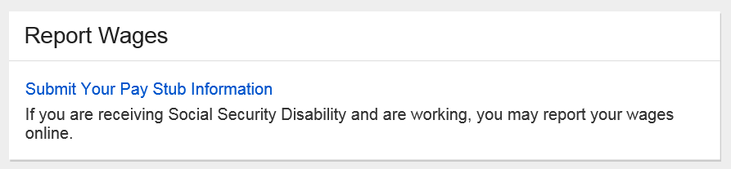

- Title XVI Self-Reporter Teaser
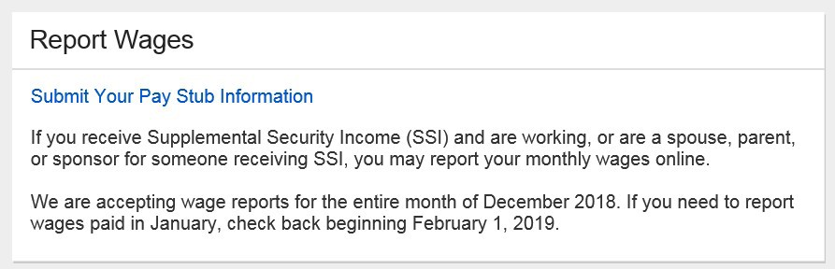

- Concurrent Self-Reporter Teaser
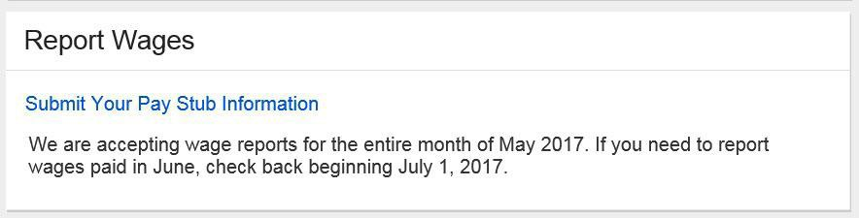

    - Title XVI/Concurrent Monthly Reporting Requirement Acknowledgment
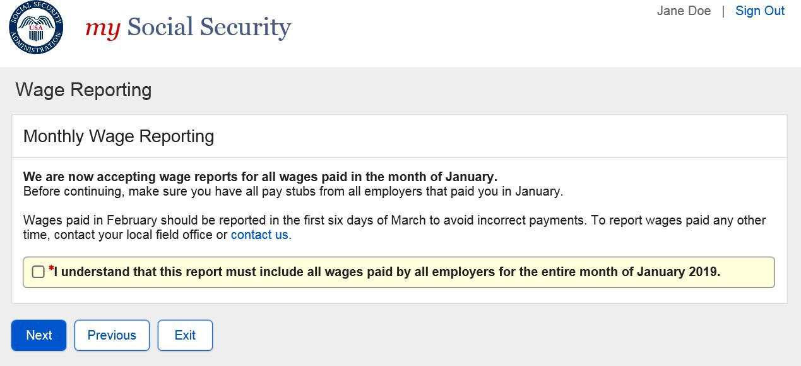

    - Choose Employer
- Employer Selection

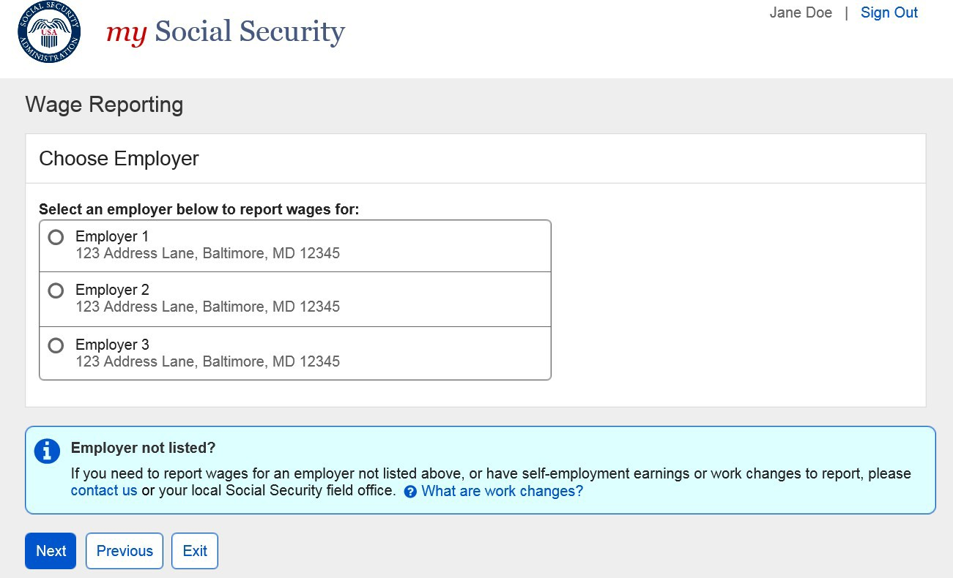

  - Employer Selection: Foreign Address

  - Employer Selection “More Details” Modal
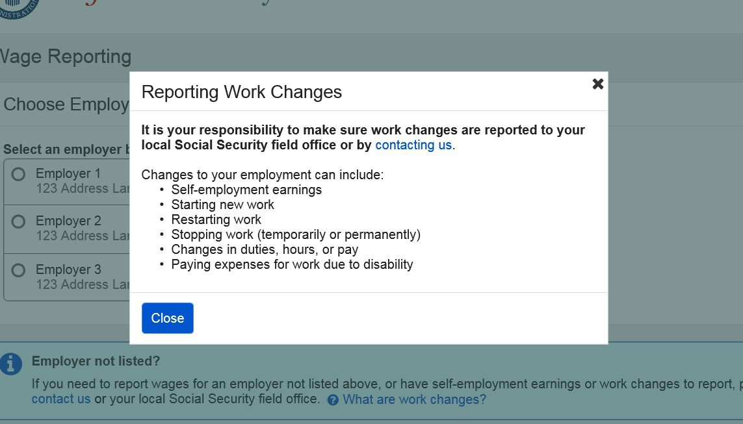

- Privacy Act Statement
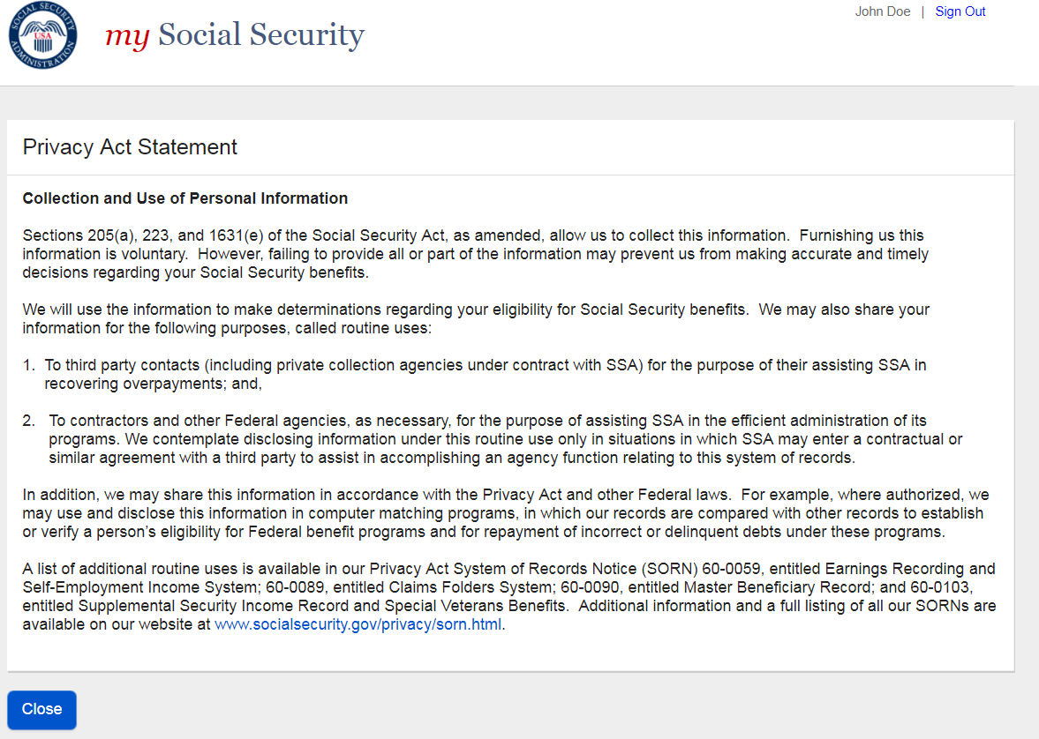

Wage Entry
- Empty Wage Table Screen
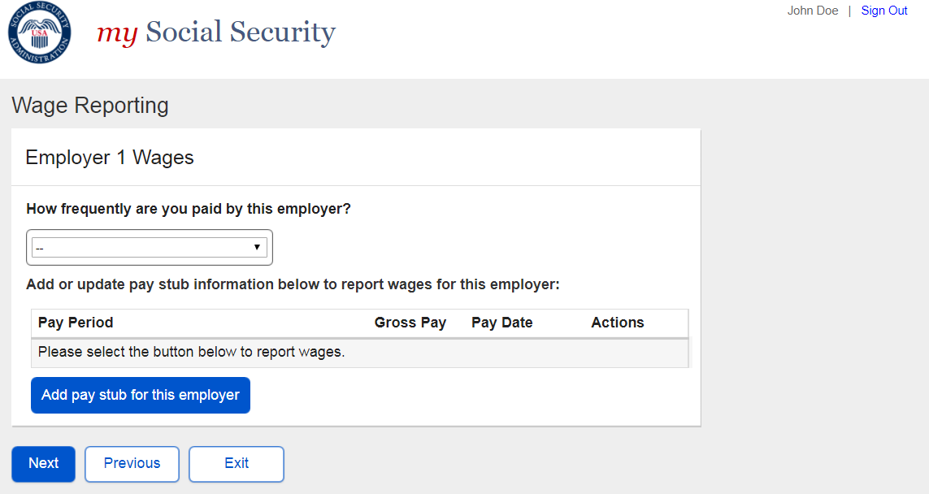

  - Wage Report Frequency of Pay Dropdown
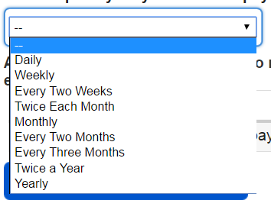

- Wage Entry Screen
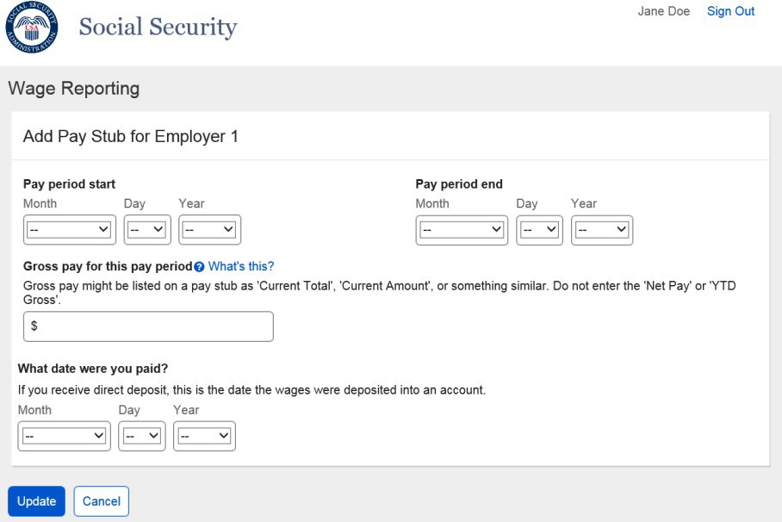
  - Wage Entry Screen: ‘Gross Pay’ Modal
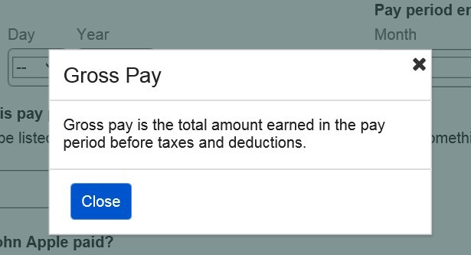

- Populated Wage Table Screen
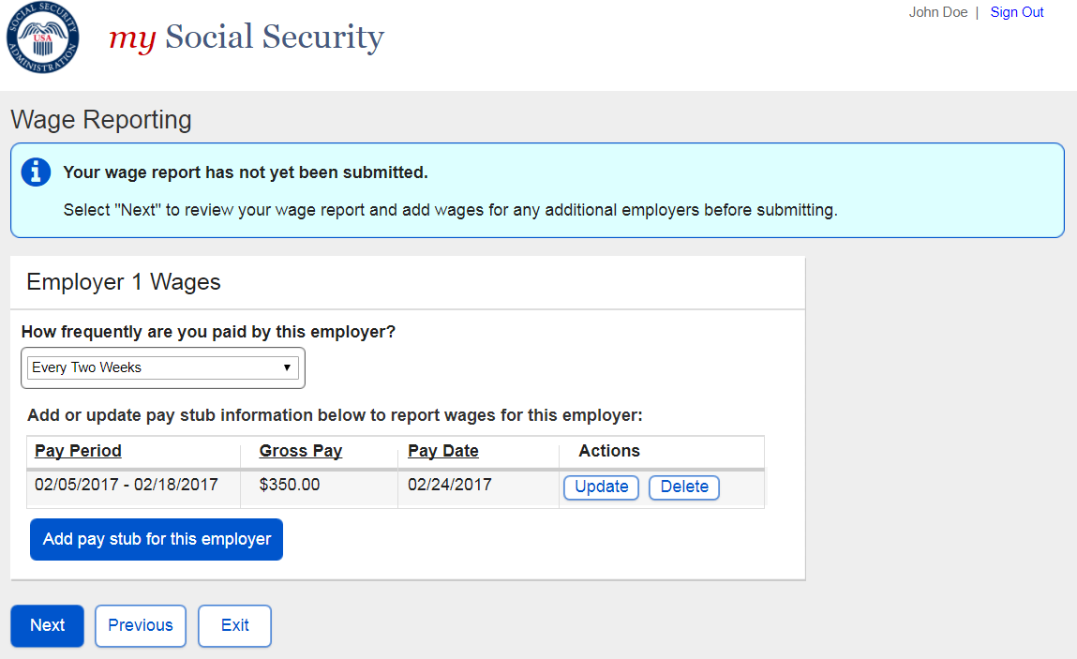

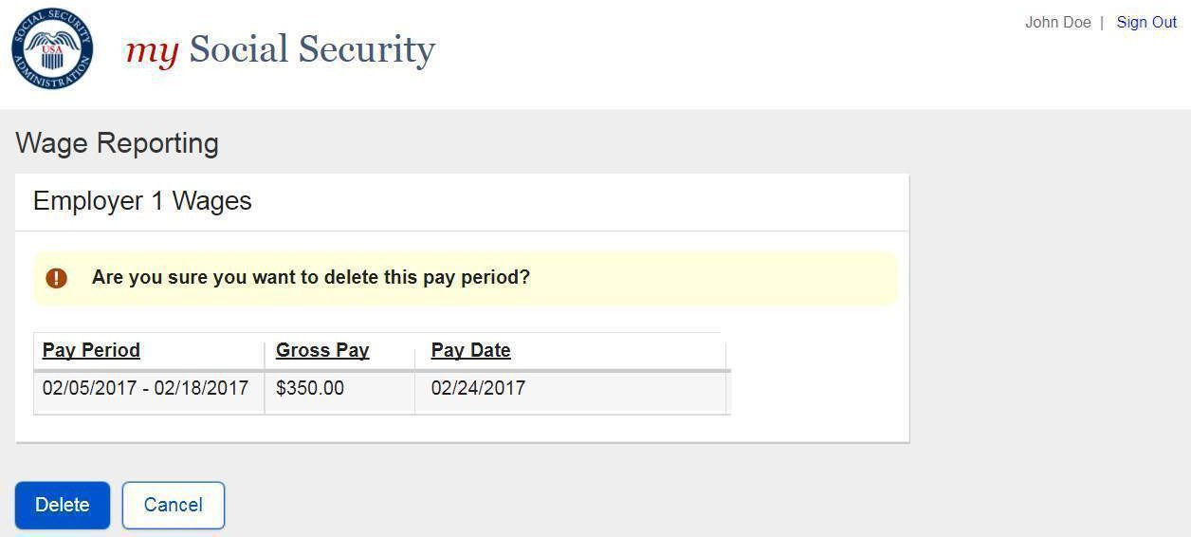
- Pay Period Deletion Confirmation Screen

2.1.3.1. Original Concurrent Wage Report Confirmation for SR users who are also Rep Payees
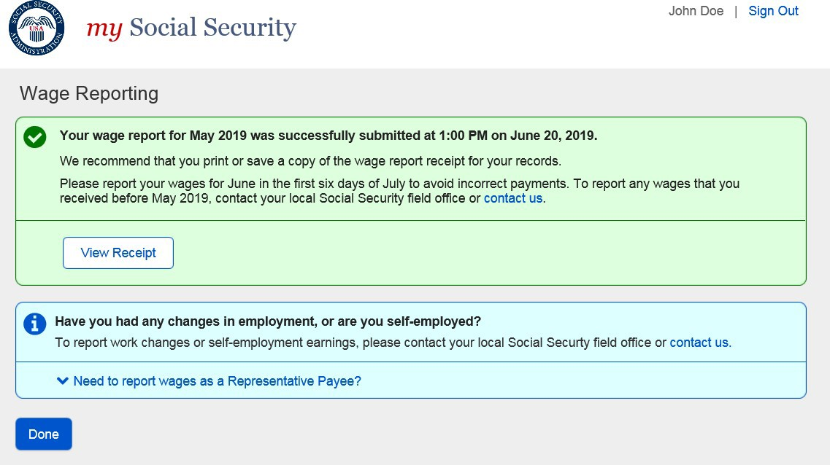

(shown)
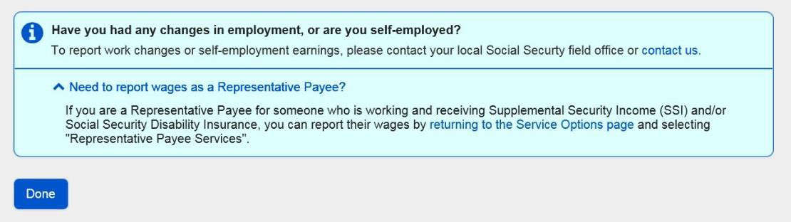

Revised Concurrent Wage Report Confirmation for SR users who are also Rep Payees
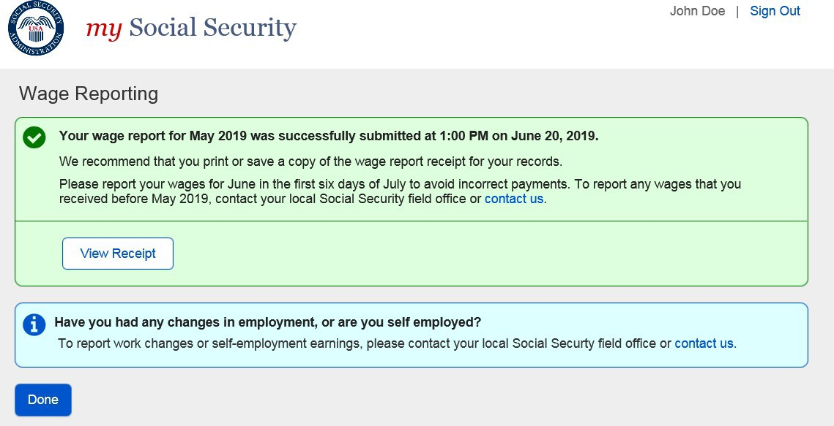

Title XVI/Concurrent Employer Wage Confirmation Screen
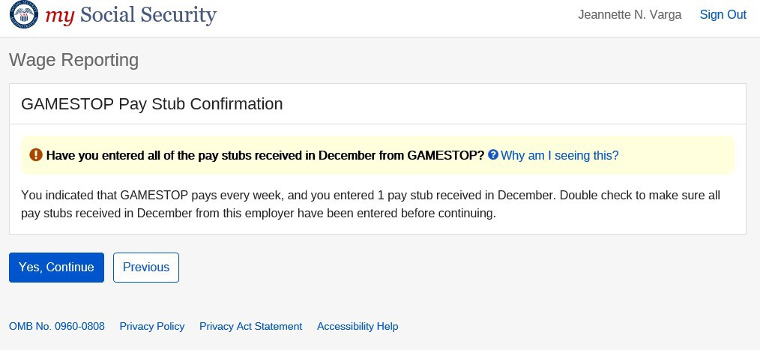

- Title XVI/Concurrent Employer Wage Confirmation Screen ‘Why am I Seeing this?’ Modal
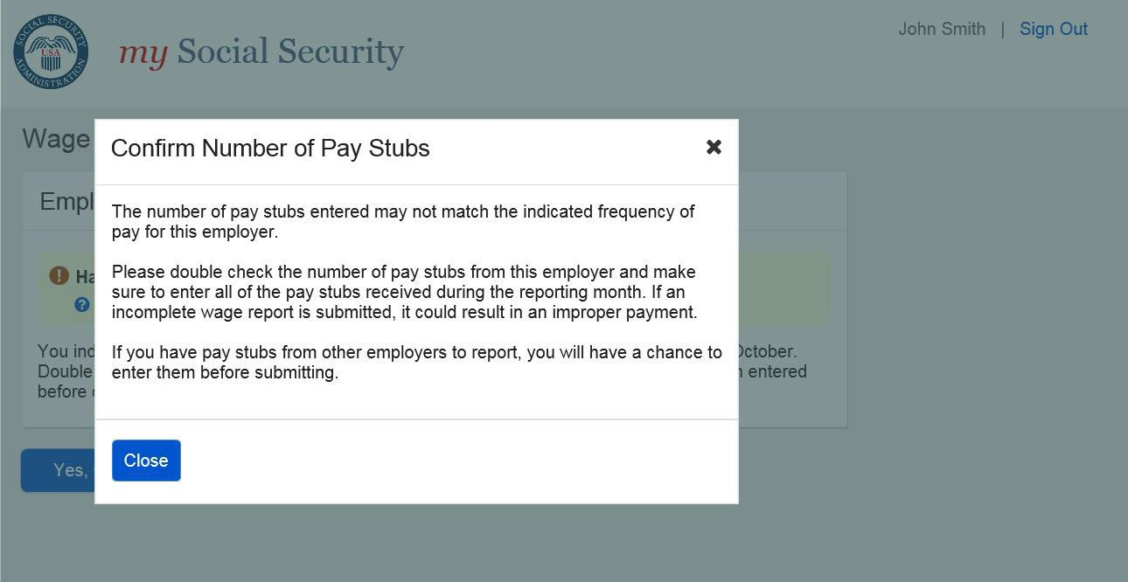

Overlapping Pay Period Warning
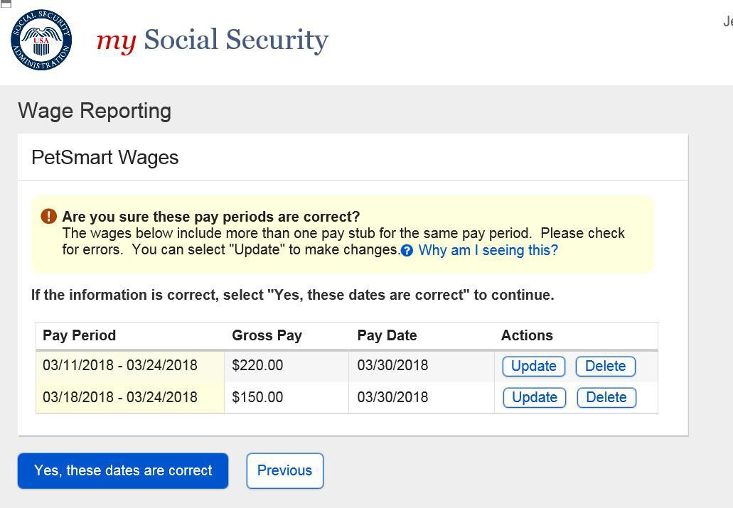

- Overlapping Pay Period More Information Modal
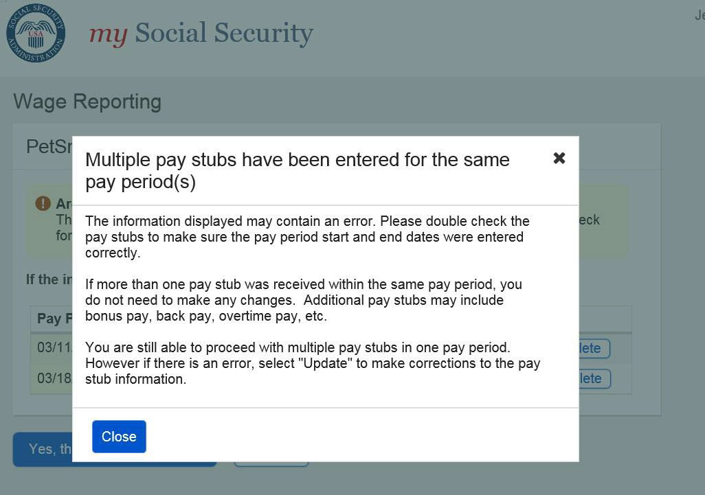

Wage Report Review
- Title II Wage Report Review Screen
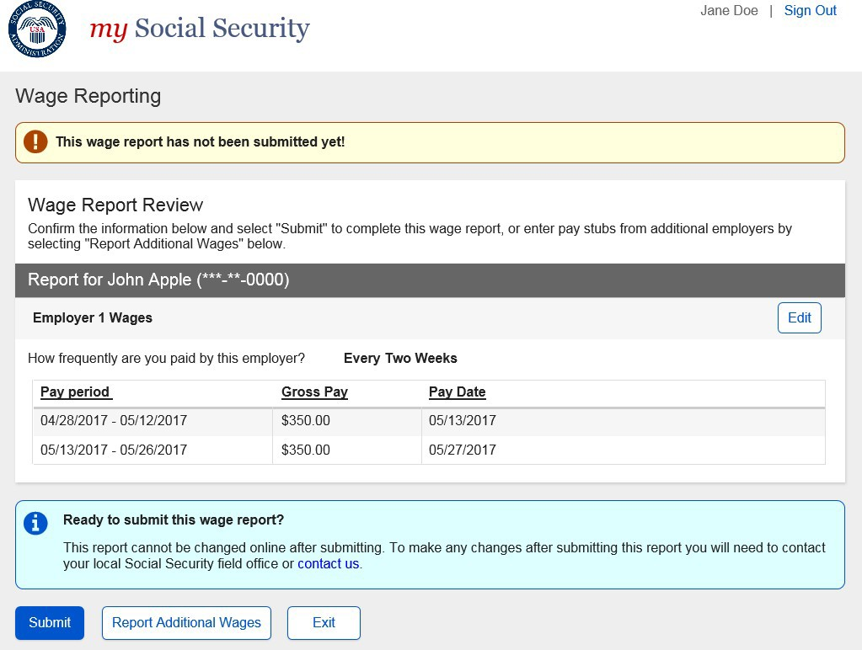

- Title XVI/Concurrent Wage Report Review Screen
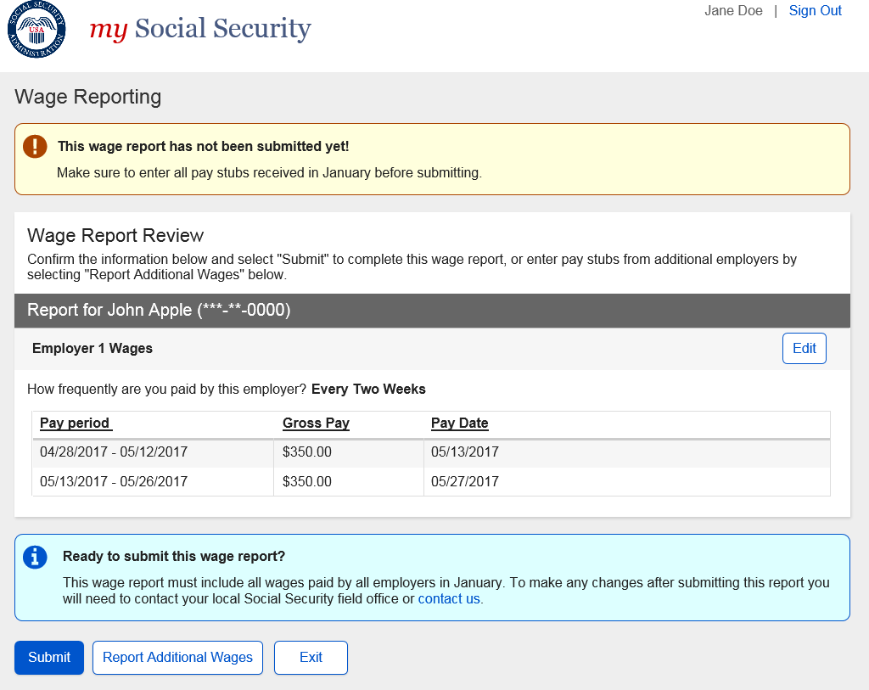

2.1.8.1.1. Original Title II Wage Report Confirmation for SR users who are also Rep Payees
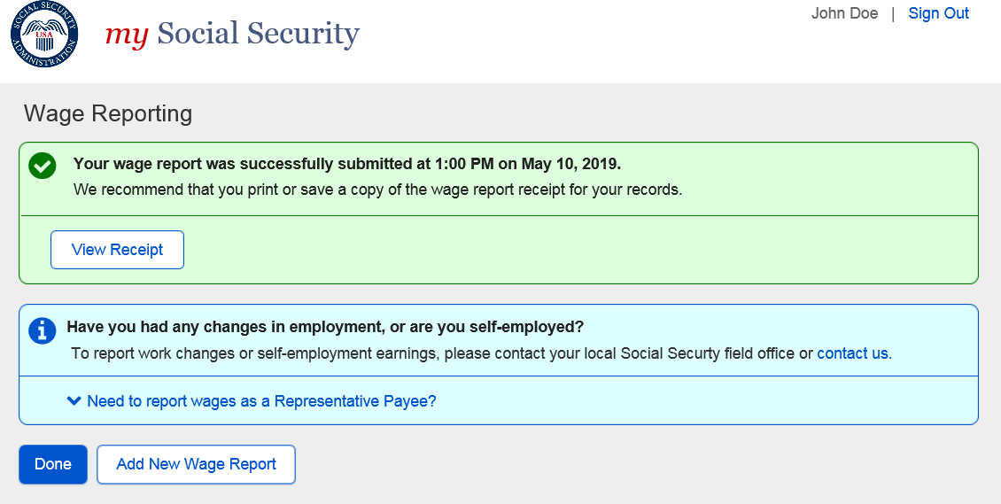
(shown)
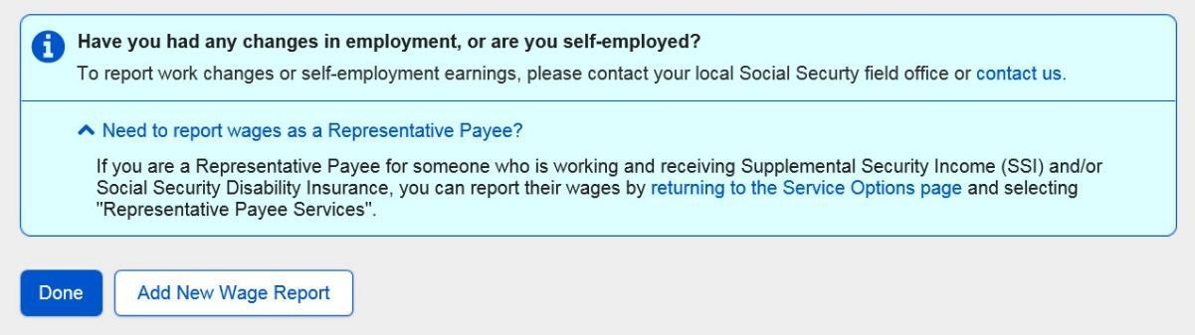

Revised Title II Wage Report Confirmation for SR users who are also Rep Payees

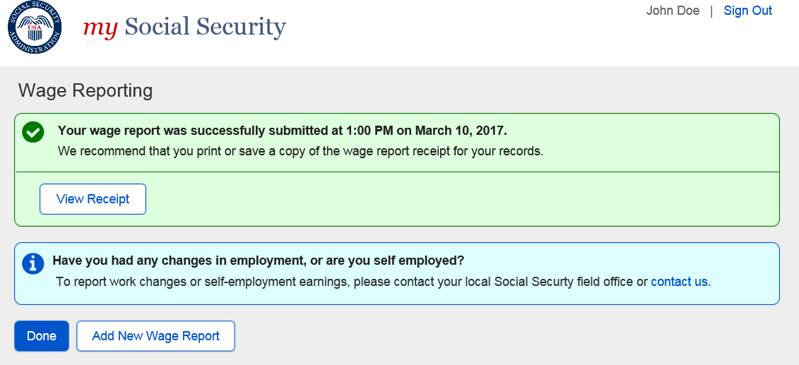

2.1.8.2.1. Original Title XVI Wage Report Confirmation for SR users who are also Rep Payees
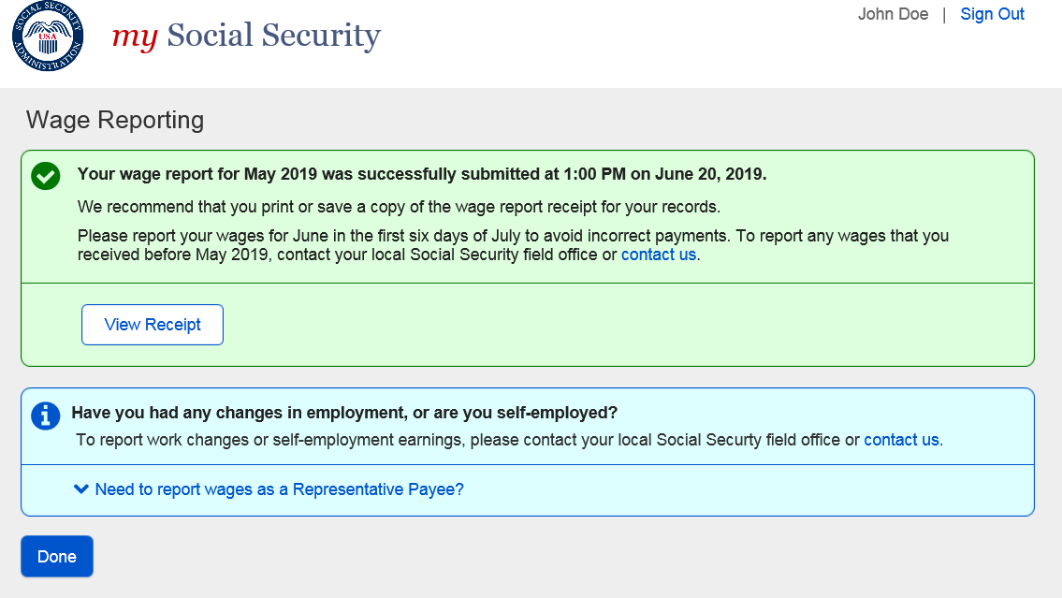
(Shown)

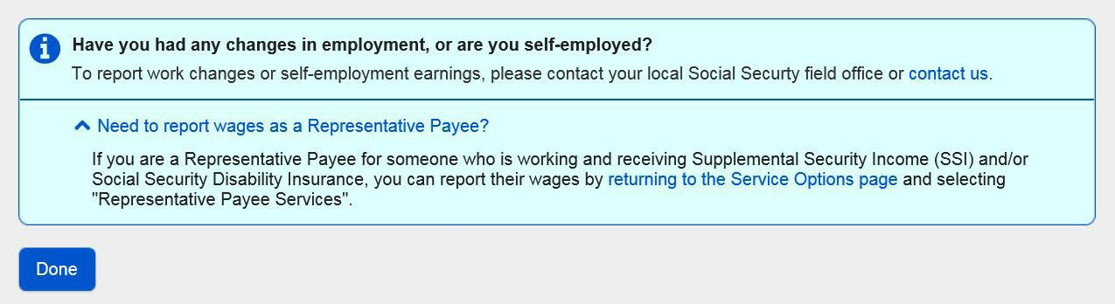

Revised Title XVI Wage Report Confirmation for SR users who are also Rep Payees
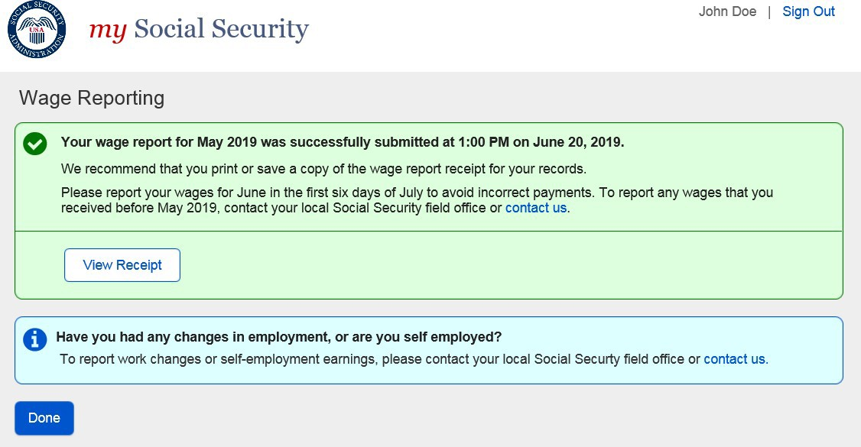

Wage Report Confirmation/Receipt
- Title II Wage Report Confirmation Screen

  - Title II Wage Report Confirmation Screen for Self-reporters who are also Representative Payees (Hide/show)

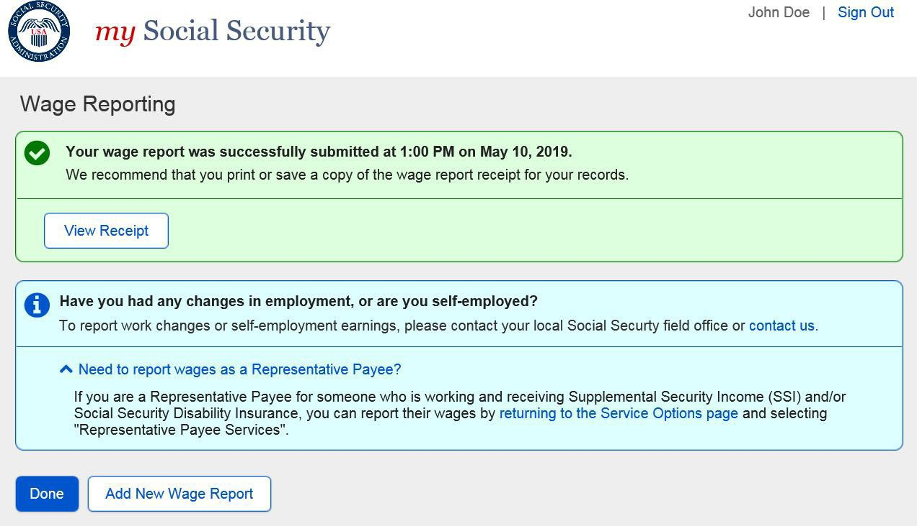

  - Title II Wage Report Receipt
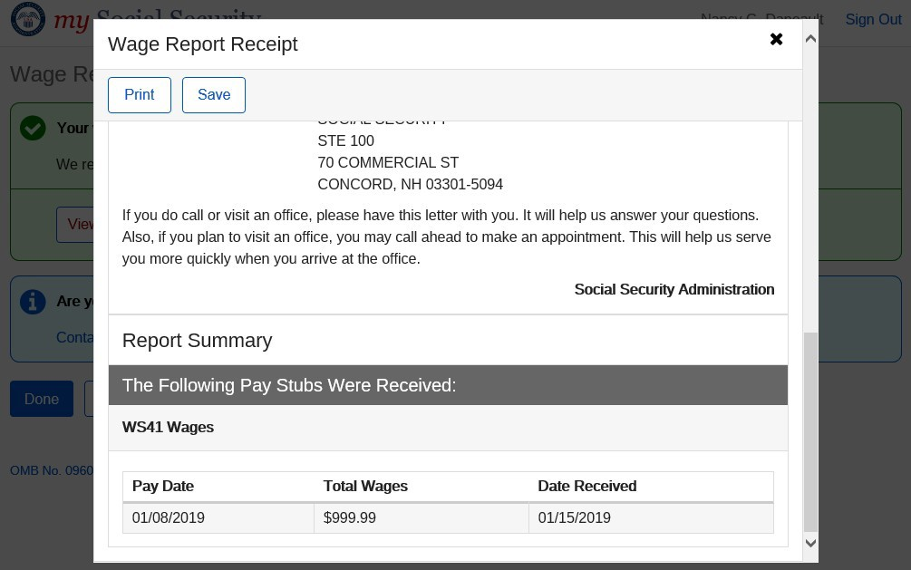
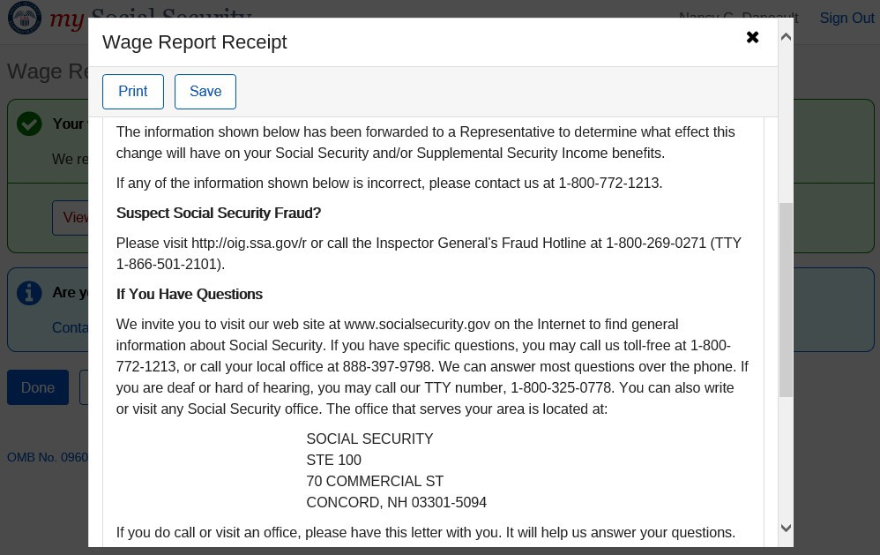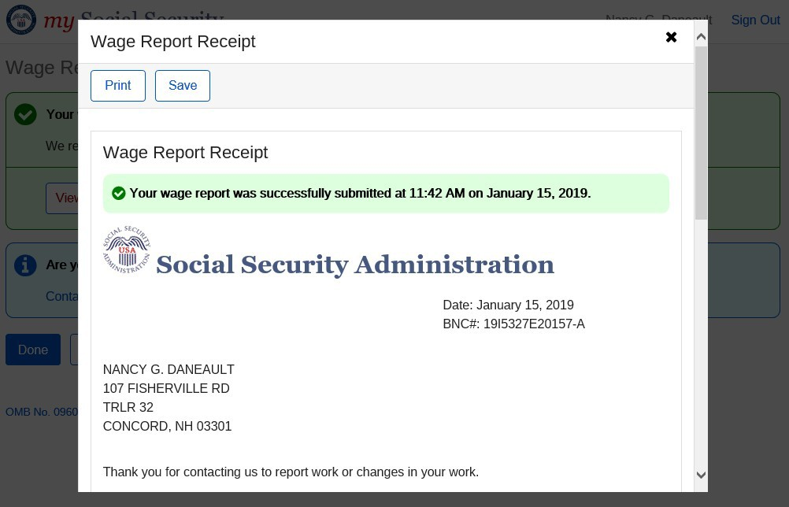

- Title XVI Wage Report Confirmation Screen

  - itle XVI Wage Report Confirmation Screen for Self-reporters who are also Representative Payees (Hide/show)
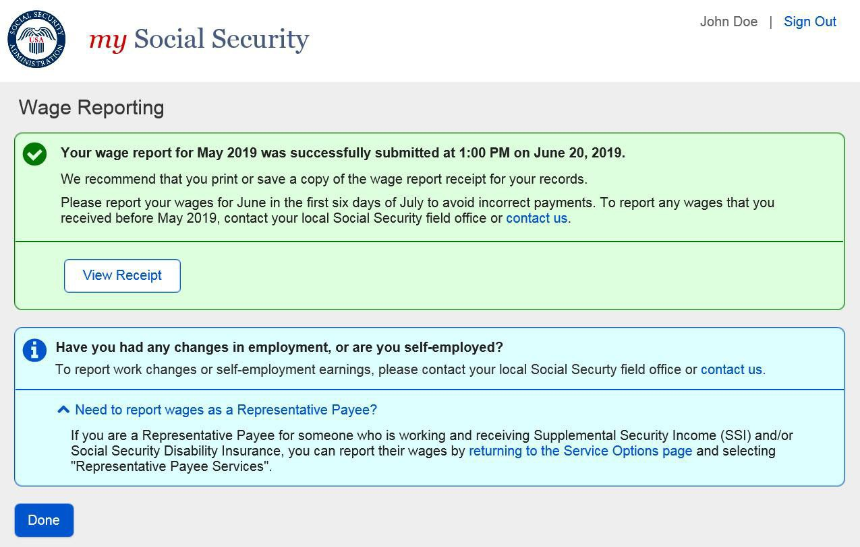

  - Title XVI/Concurrent Wage Report Receipt
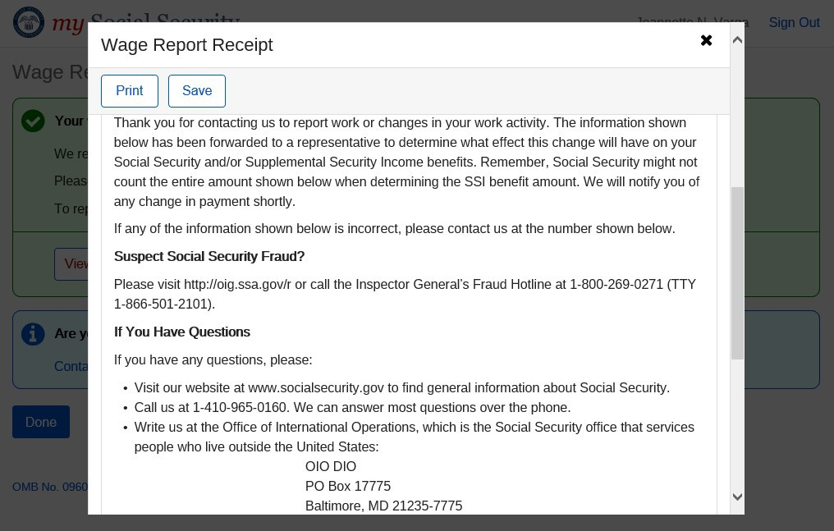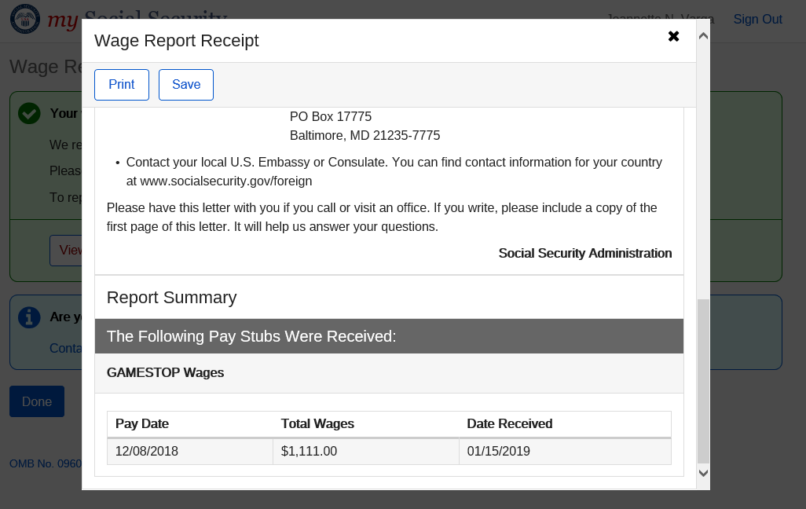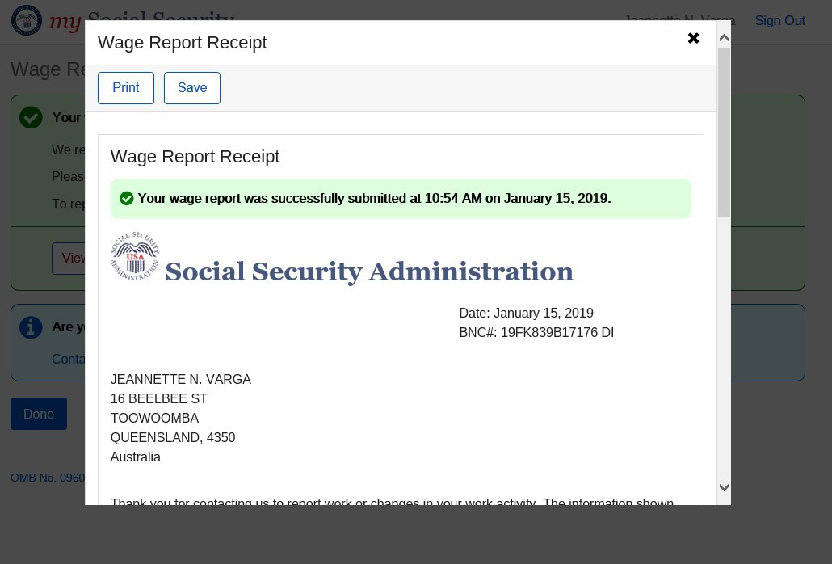

- Concurrent Wage Report Confirmation Screen

  - Concurrent Wage Report Confirmation Screen: For Self Reporters who are also
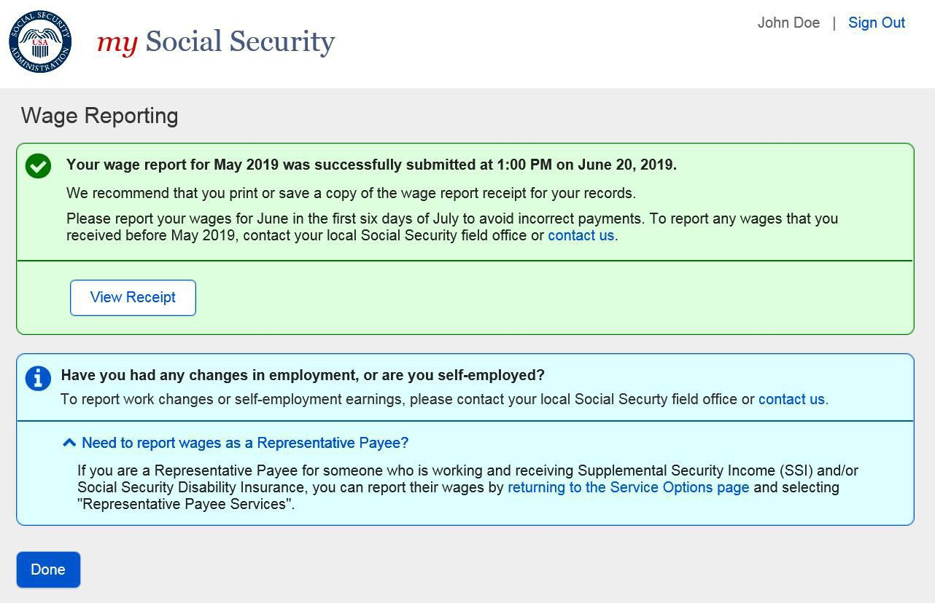
Representative Payees (hide/show)

Self-Reporter Variant Screens

Choose Employer- Single Employer Variant
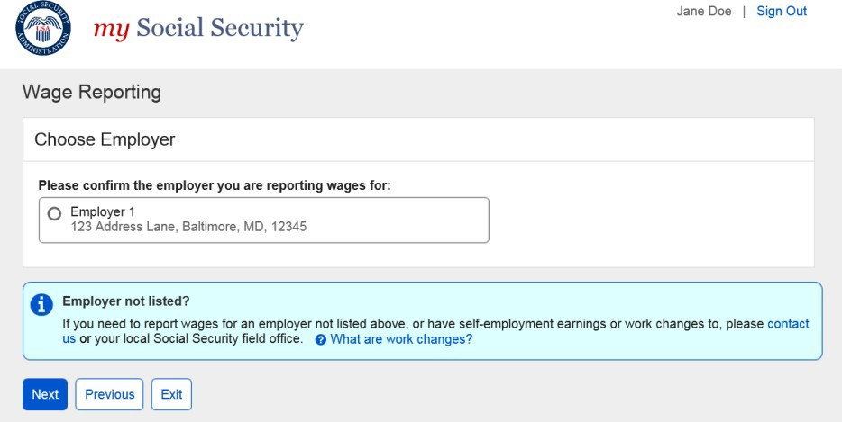

Choose Employer Revisited - Multiple Employer Variant
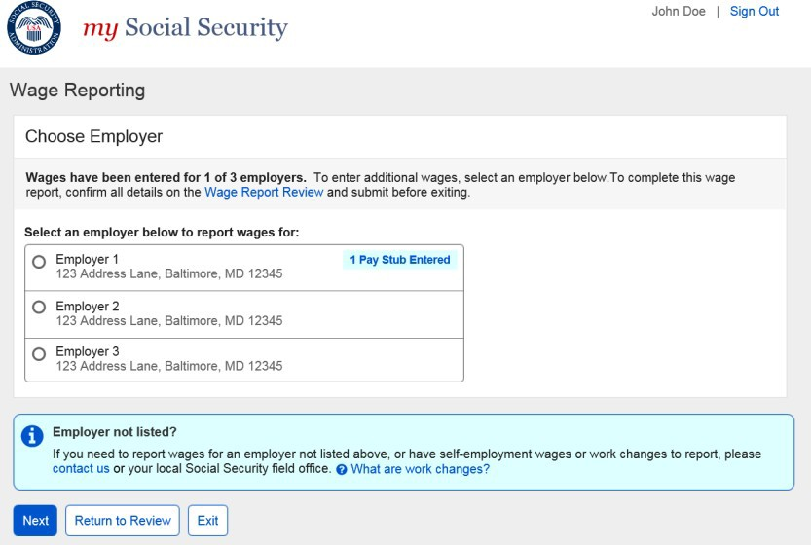
      - Choose Employer Revisited- Single Employer on Record
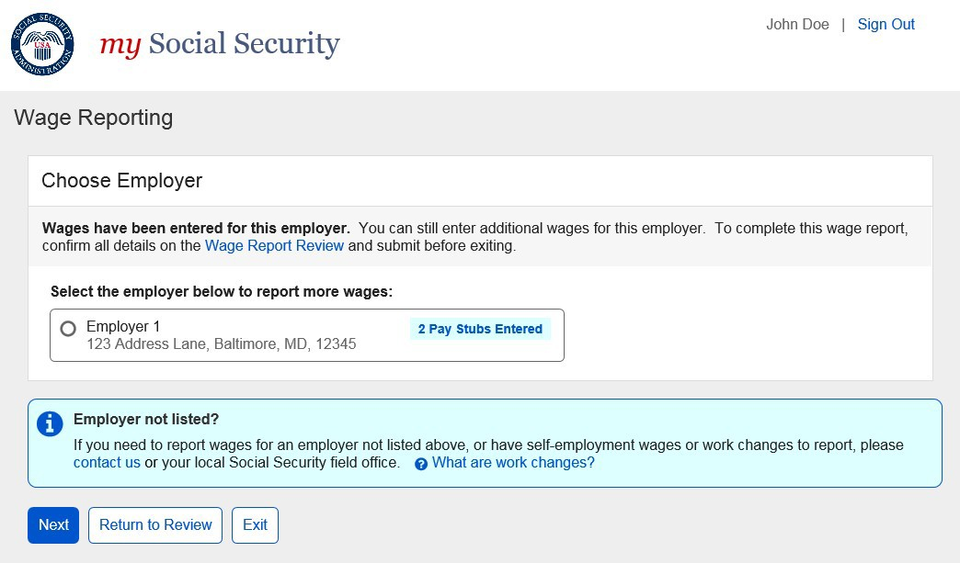

      - Choose Employer Revisited – Maximum Number of Employers
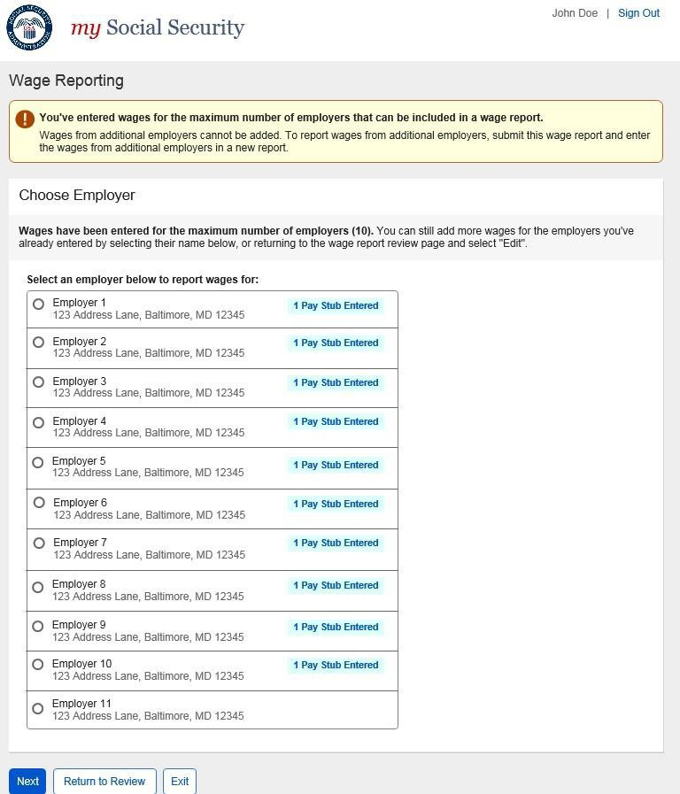

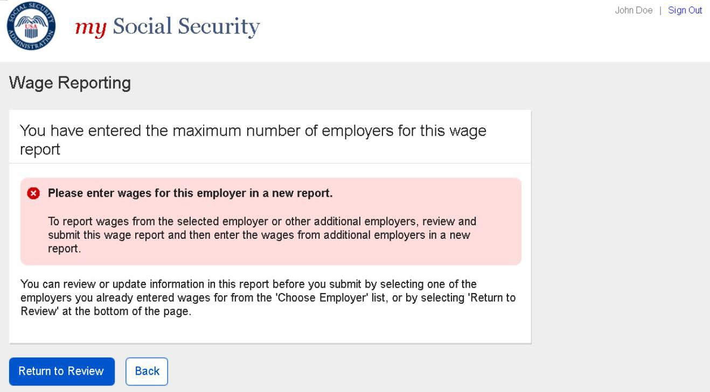
Maximum Number of Employers- Error Screen

Wage Entry Table Paginated Variant- Maximum Records for Single Employer
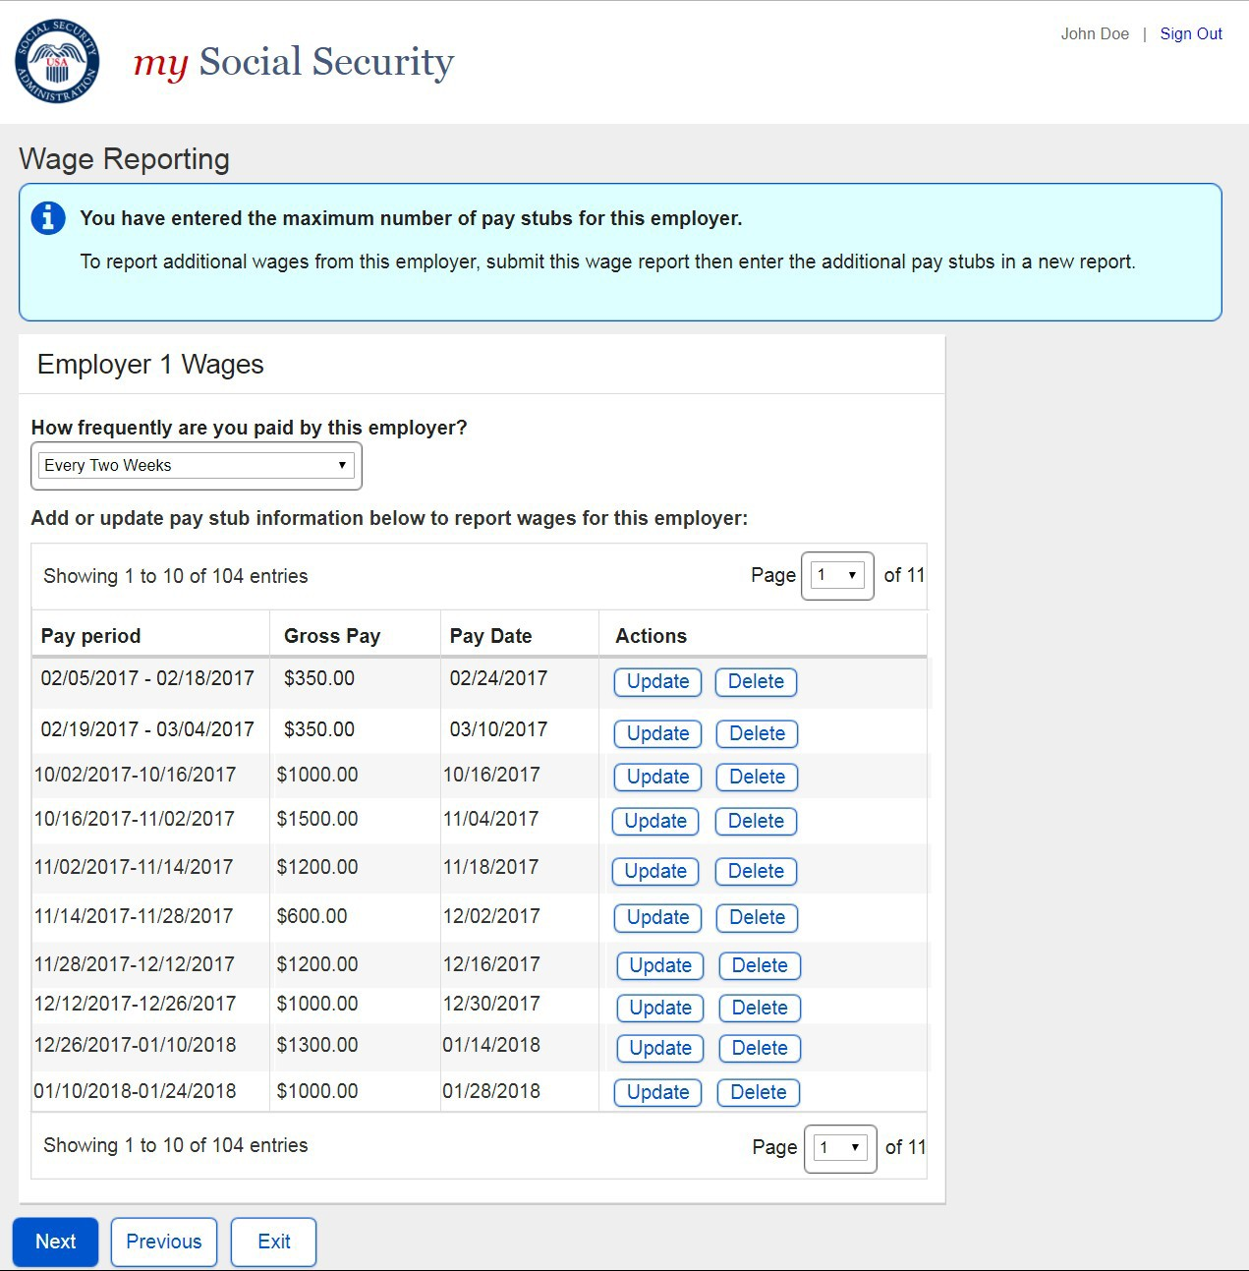

Wage Report Review- Single Employer on Record

      - Review Screen- Maximum Employer Limit Information Notice and Form Controls
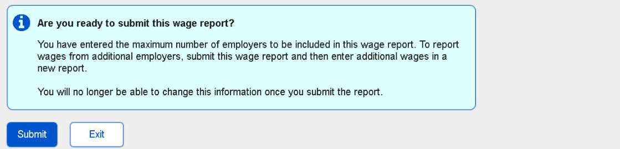

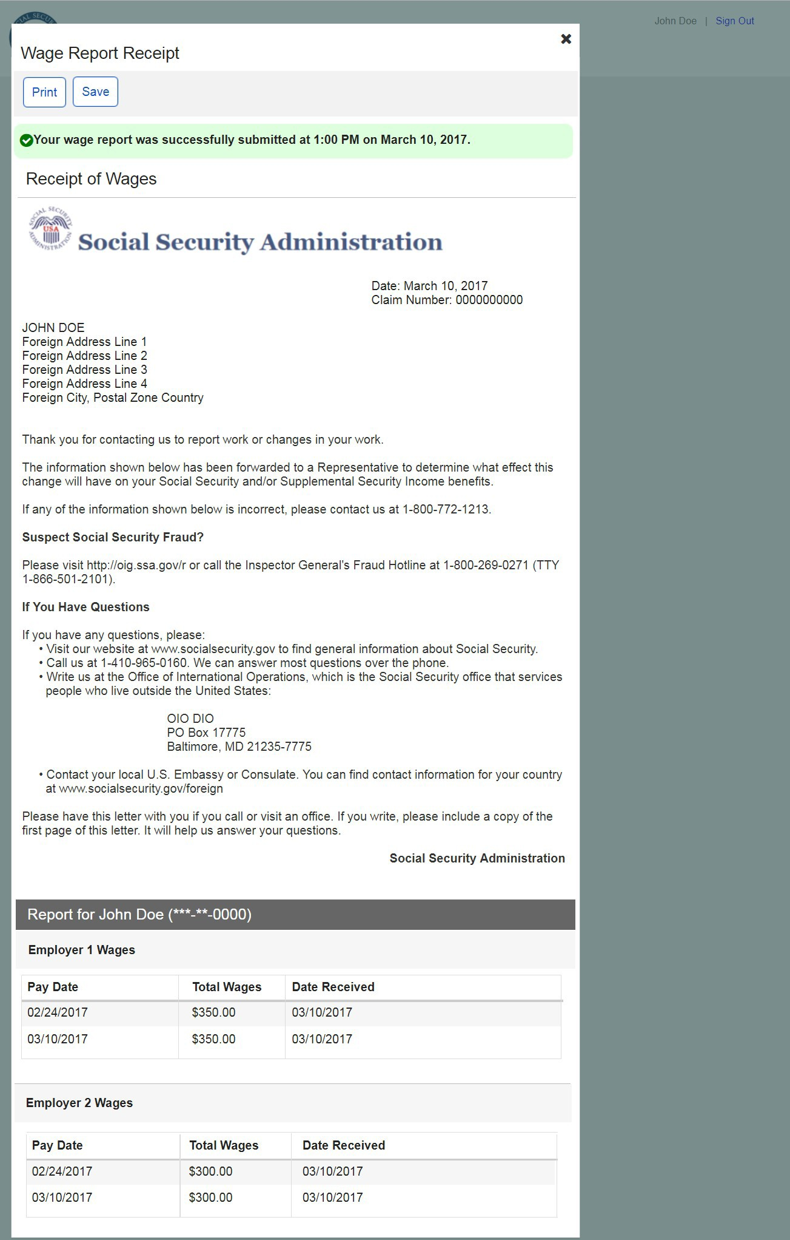
Wage Report Receipt Foreign Address

Self-Reporter Error Screens
    - Service Unavailable Error
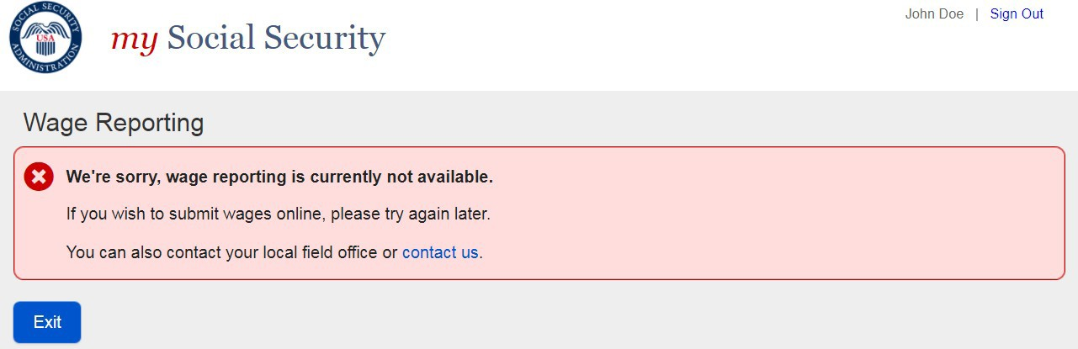
    - Title XVI/Concurrent Monthly Wage Reporting Requirement Acknowledgement Error
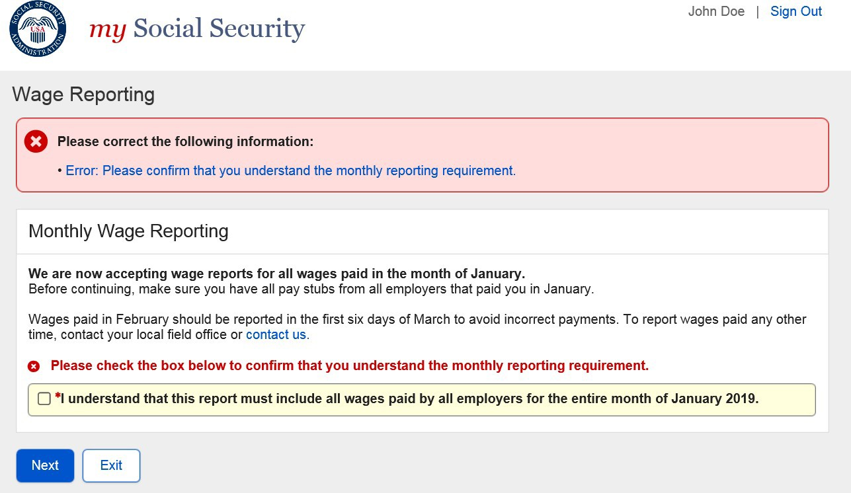
    - Choose Employer- No Eligible Employer on Record
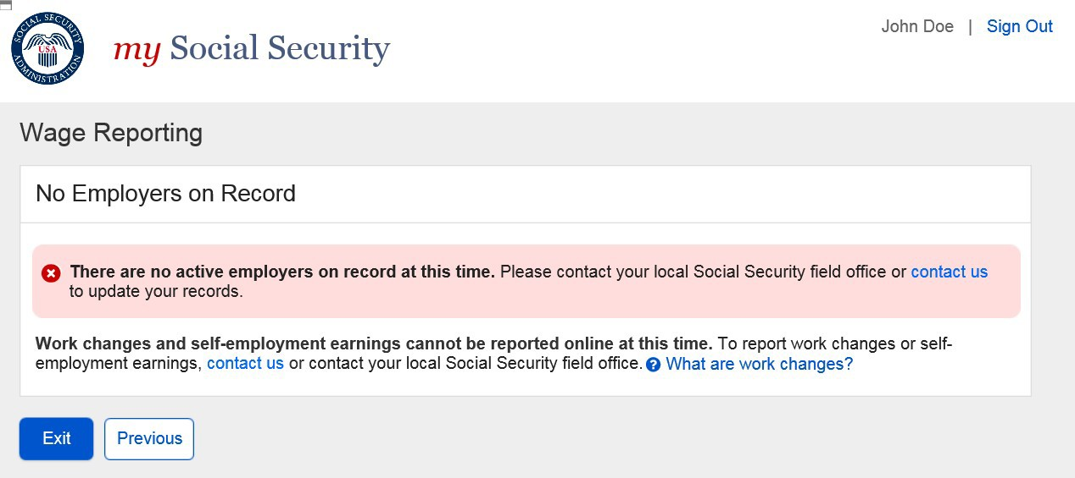

      - Choose Employer- No Eligible Employer on Record More Details Modal
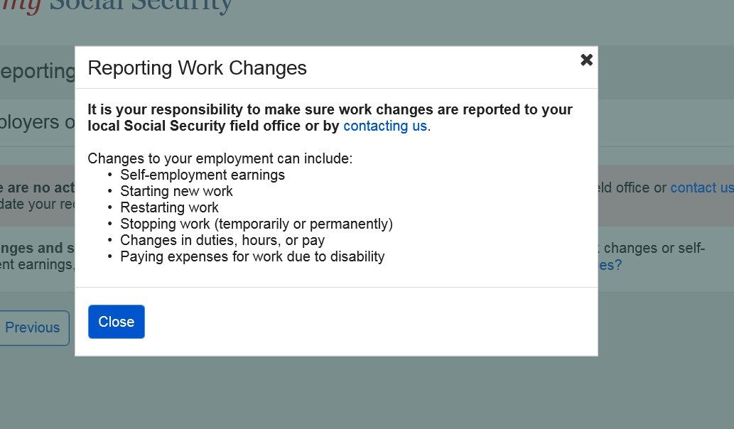

    - Empty Wage Entry Table- No Data Entered/Single Employer on Record
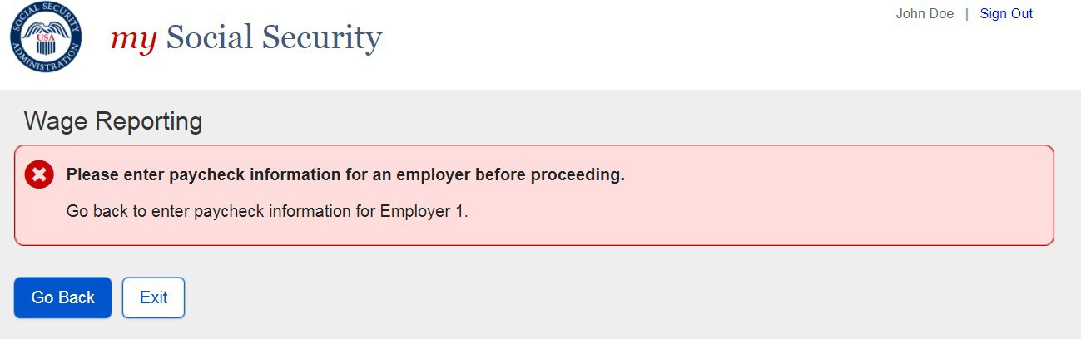

    - Original Empty Wage Entry Table- No Data Entered/Multiple Employers on Record
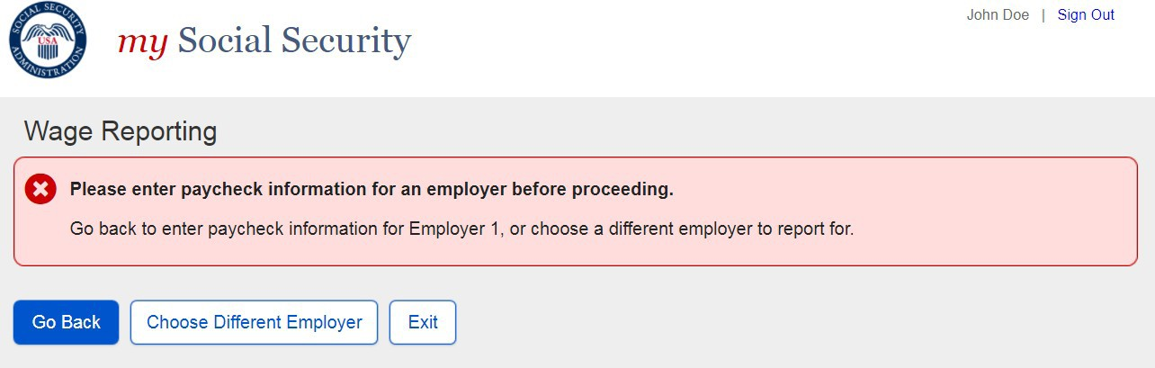

    - Revised Empty Wage Table – No Data Entered/Multiple Employers on Record
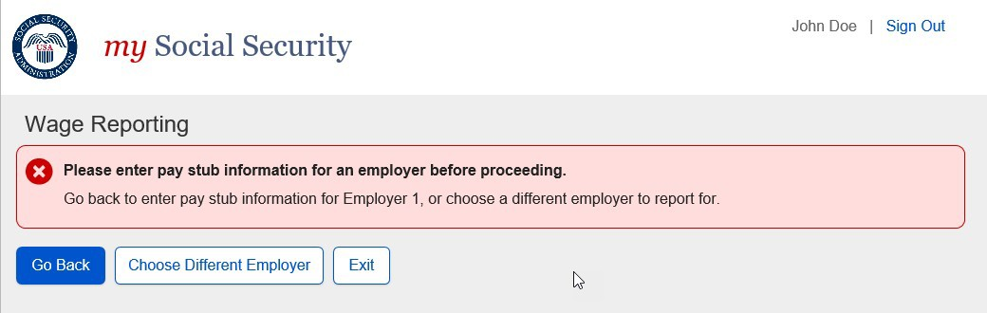

    - Original Empty Wage Table – Data Entered/Multiple Employers on Record
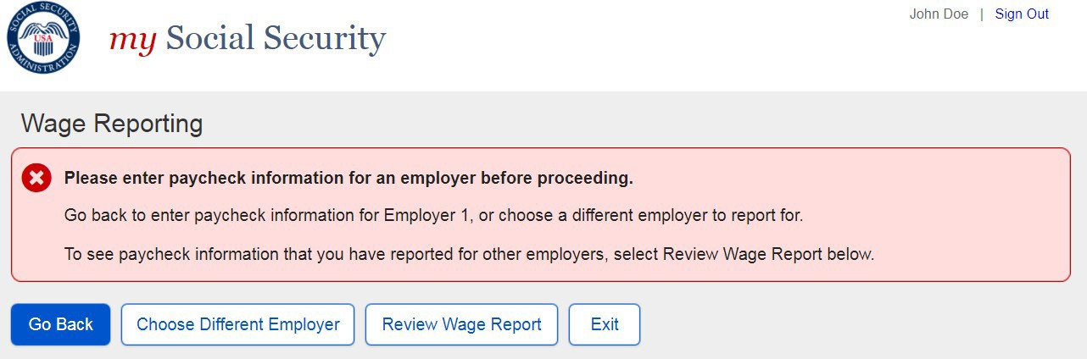

Revised Empty Wage Table – Data Entered/Multiple Employers on Record

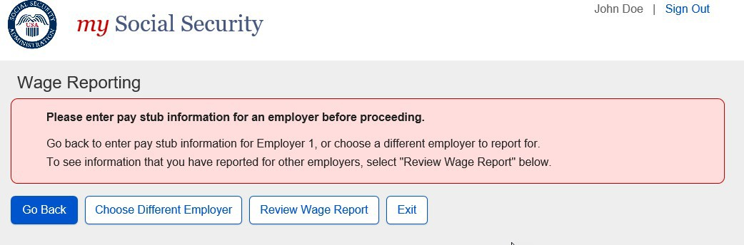

    - Wage Entry Modal- Error Summary Example
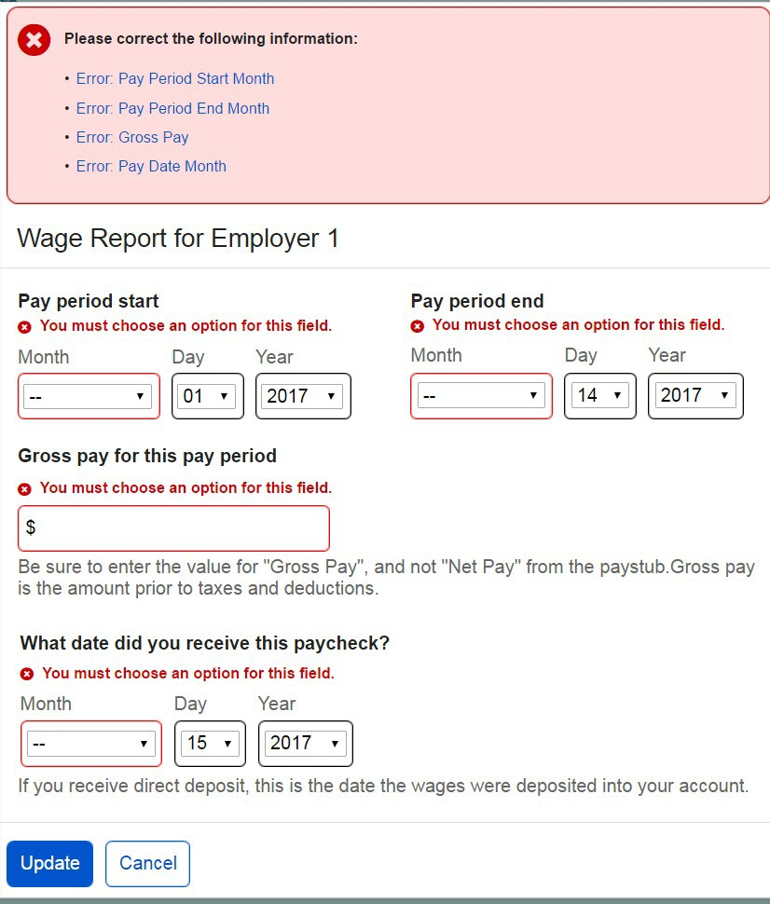
    - Wage Report Submission Error
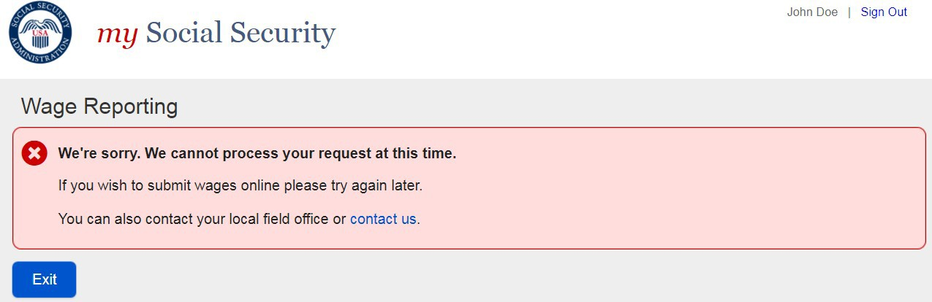

Representative Payee Screen Progression

Representative Payee “Happy Path” Progression

Representative Payee Portal Landing Teasers
- Title II mySSA Representative Payee Portal Landing Teaser
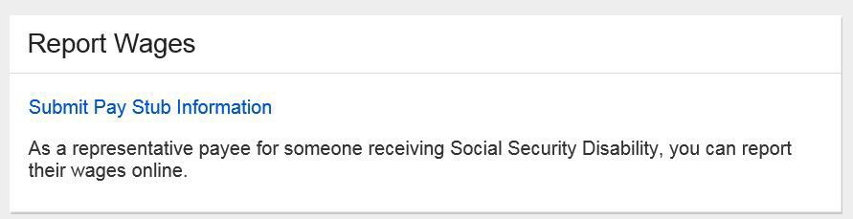

- Title XVI mySSA Representative Payee Portal Landing Teaser
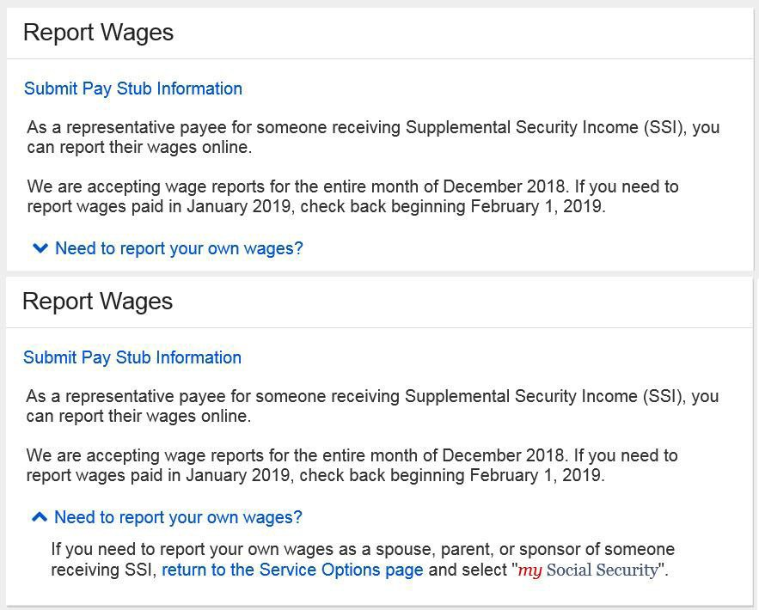

- Concurrent mySSA Representative Payee Portal Landing Teaser
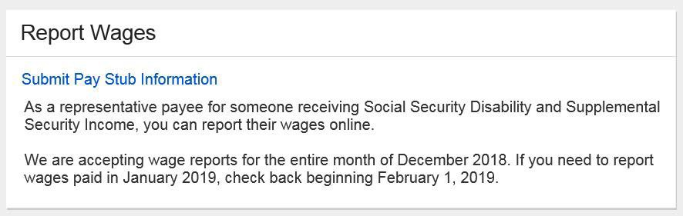

Choose Worker
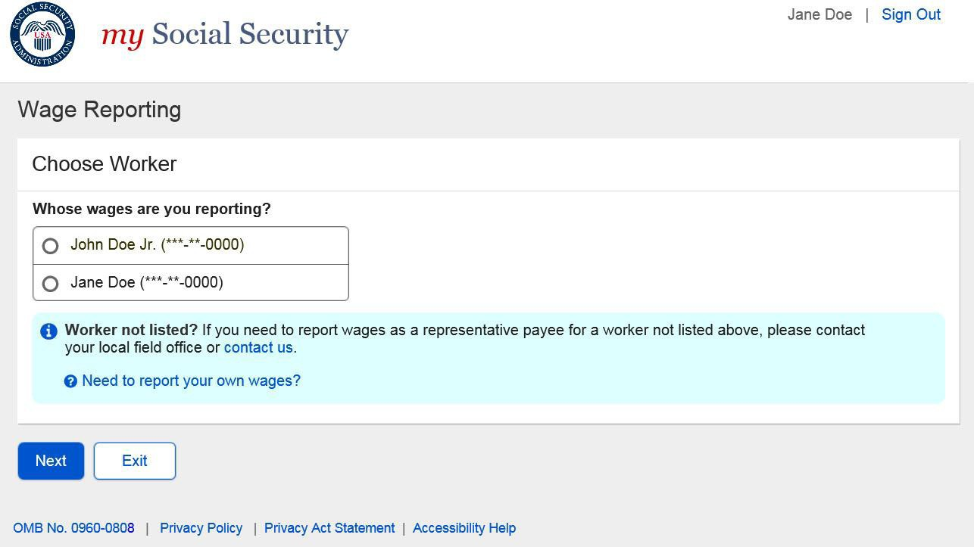
- Choose Worker Screen: ‘Need to Report Your Own Wages?’ modal
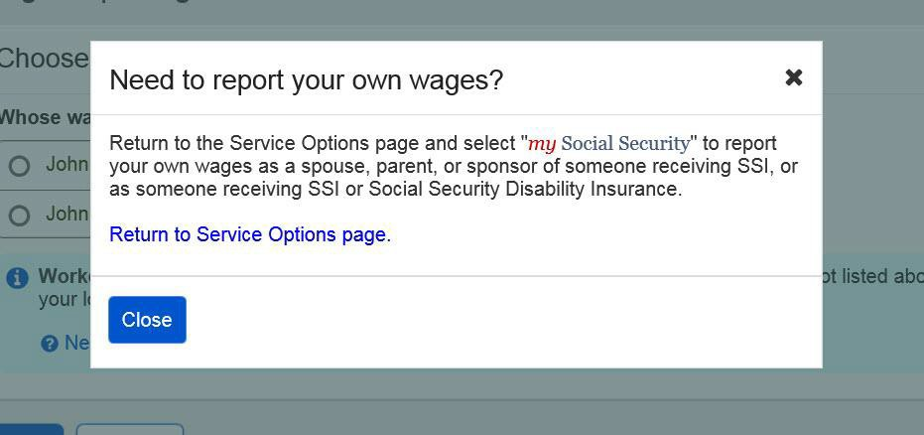

Title XVI/Concurrent Monthly Reporting Requirement Acknowledgment Screen
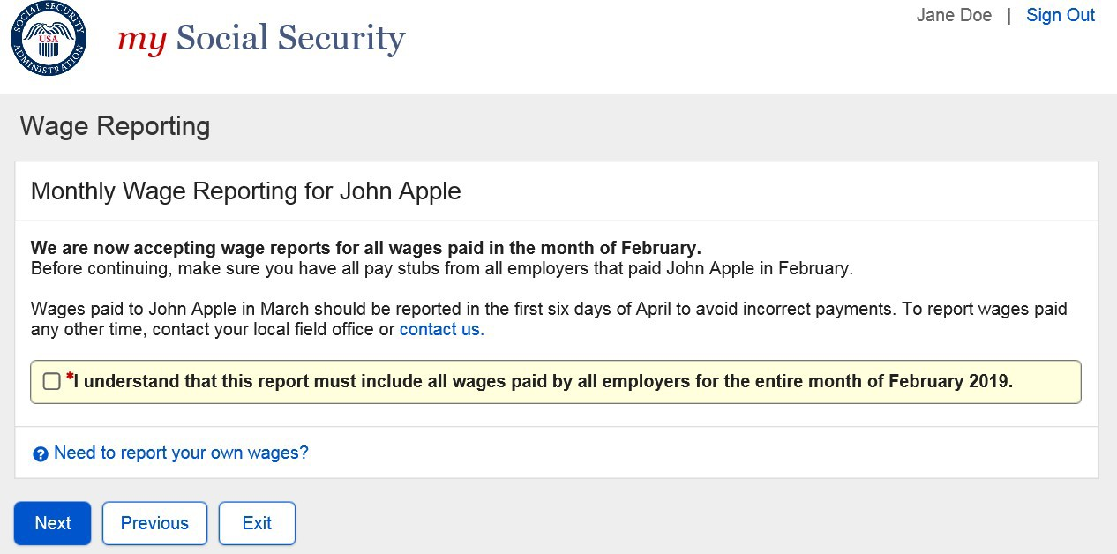

3.1.3.1. Title XVI/Concurrent Monthly Reporting Requirement Acknowledgment Screen: ‘Need to Report your own wages?’ RP Modal
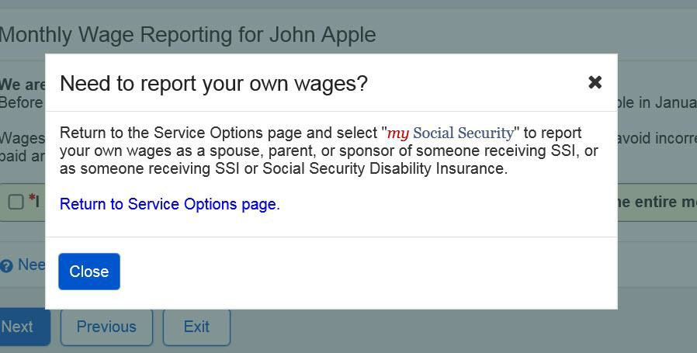

3.1.4. Representative Payee Choose Employer
3.1.4. Original Representative Payee Choose Employer
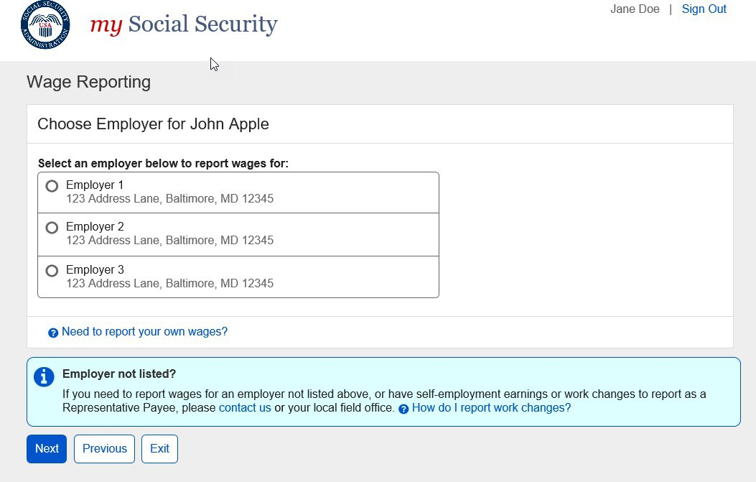

Revised Representative Payee Choose Employer
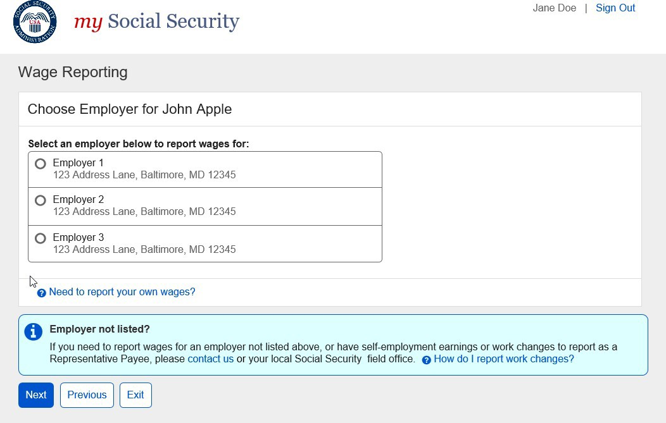

Choose Employer
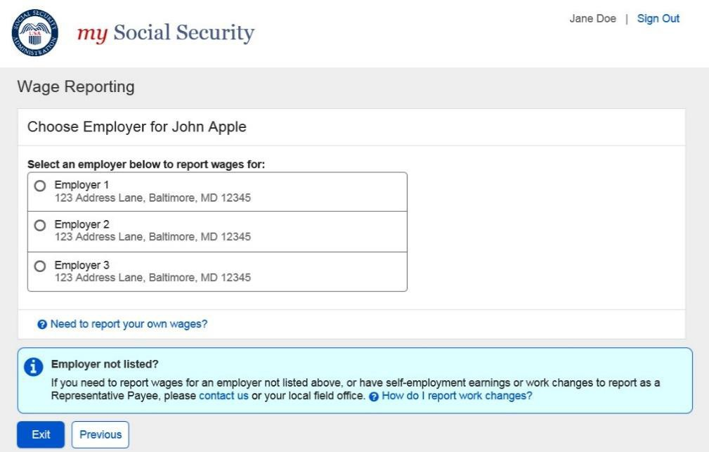

- Employer Selection “More Details” Modal
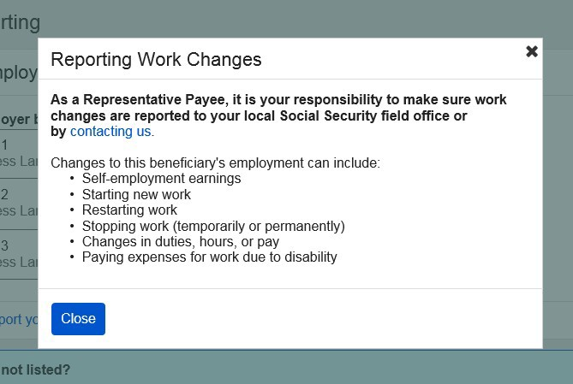
- Employer Selection “Need to Report Your Own Wages? Modal
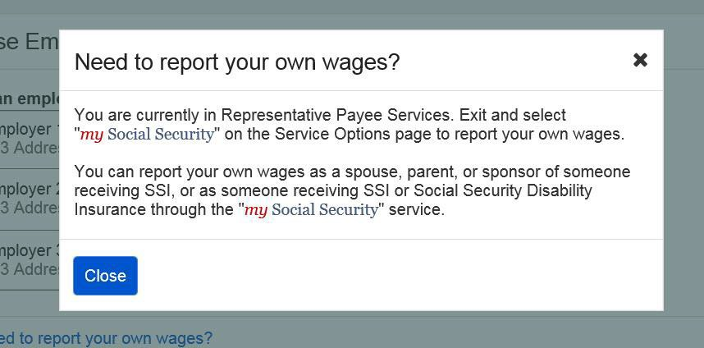

Wage Entry
- Empty Wage Entry Screen
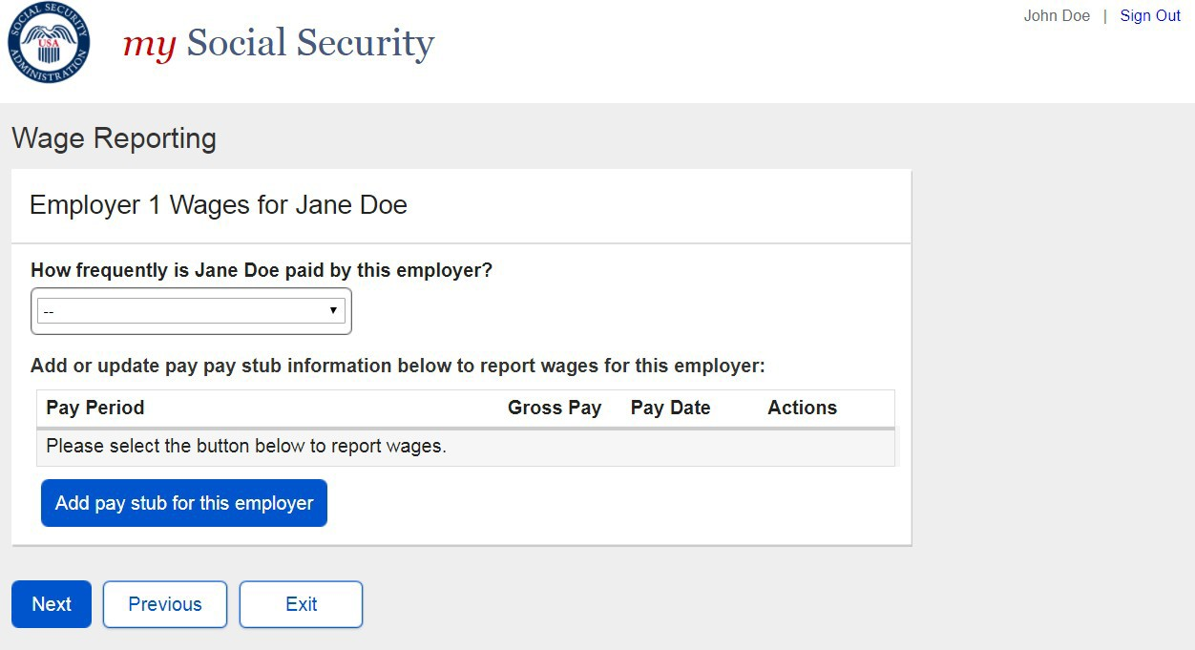
- Wage Entry Screen
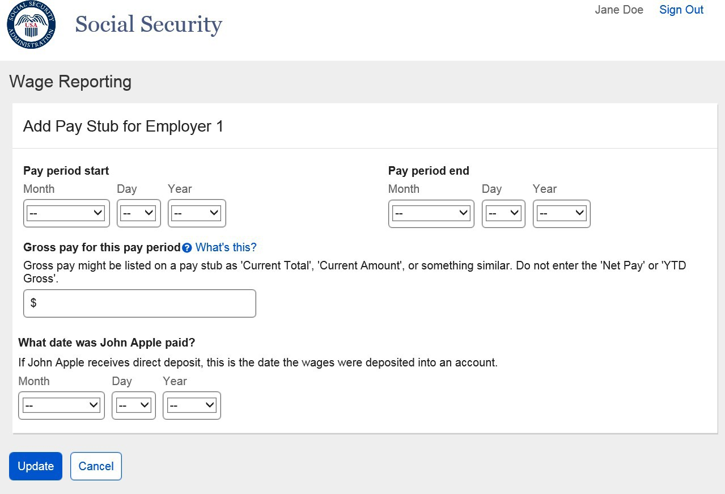

  - Wage Entry Screen: Gross Pay Modal

- Pay Period Deletion Confirmation Modal
    - Wage Report Review
      - Original Title II Representative Payee Review Screen
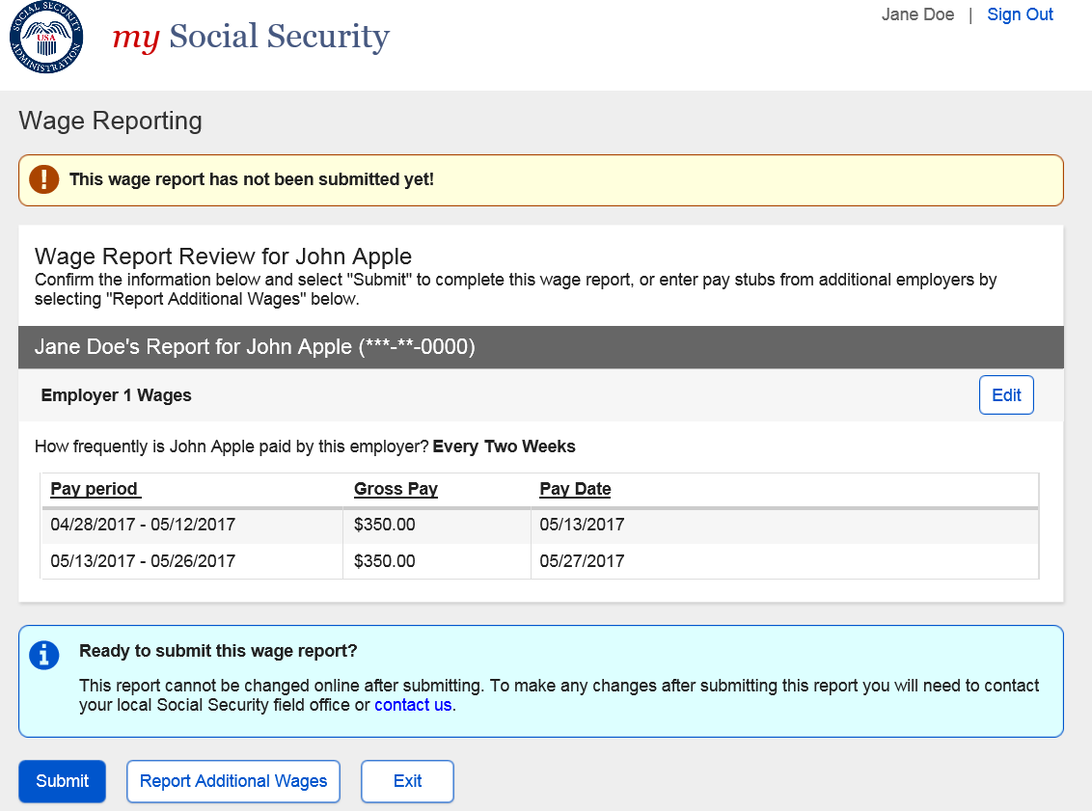

      - Revised Title II Representative Payee Review Screen

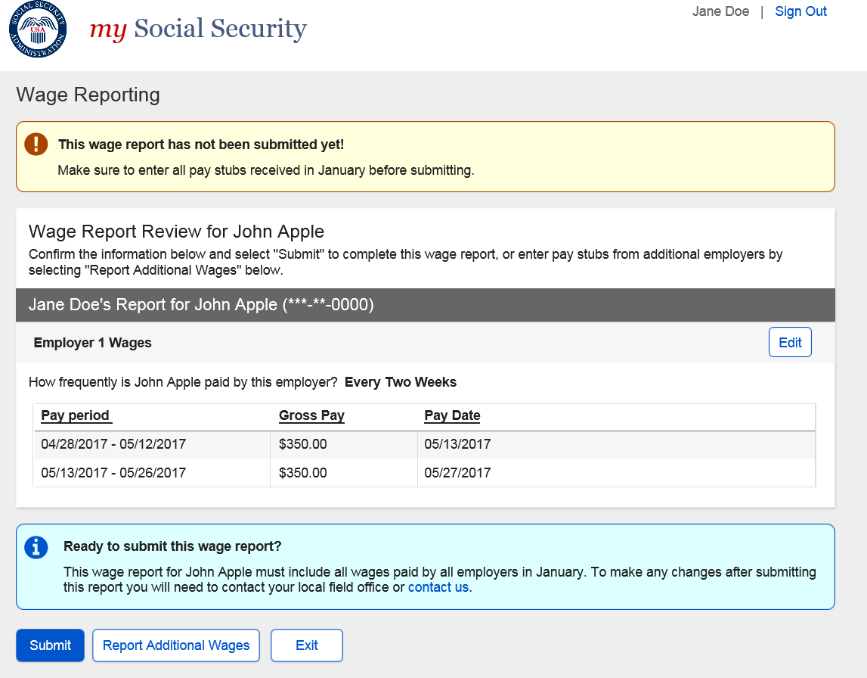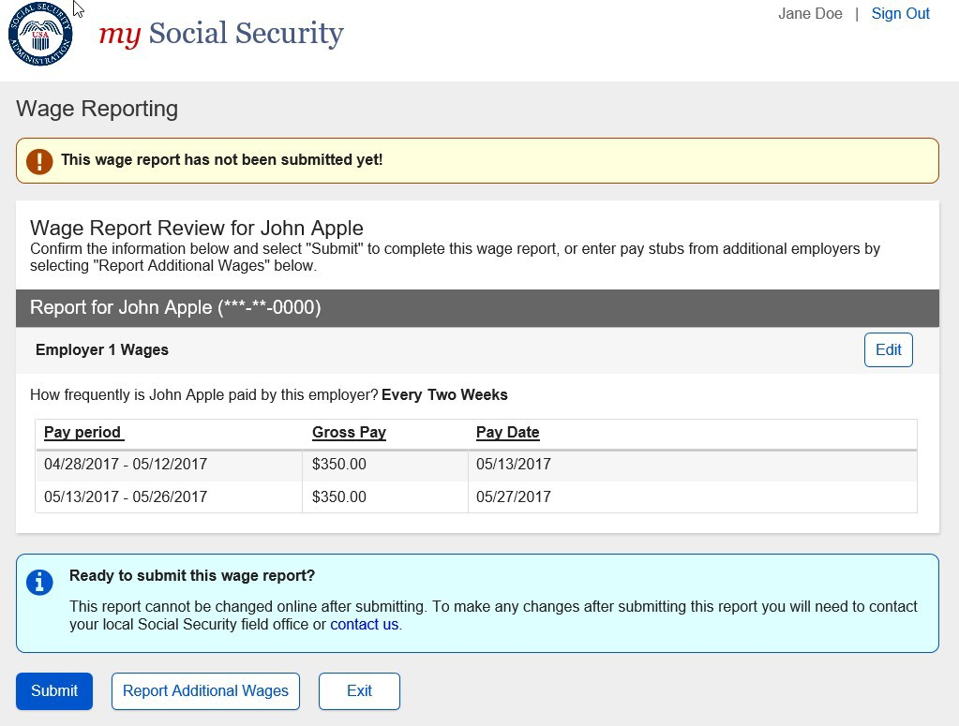
      - Original Title XVI/Concurrent Representative Payee Review Screen

      - Revised Title XVI/Concurrent Representative Payee Review Screen

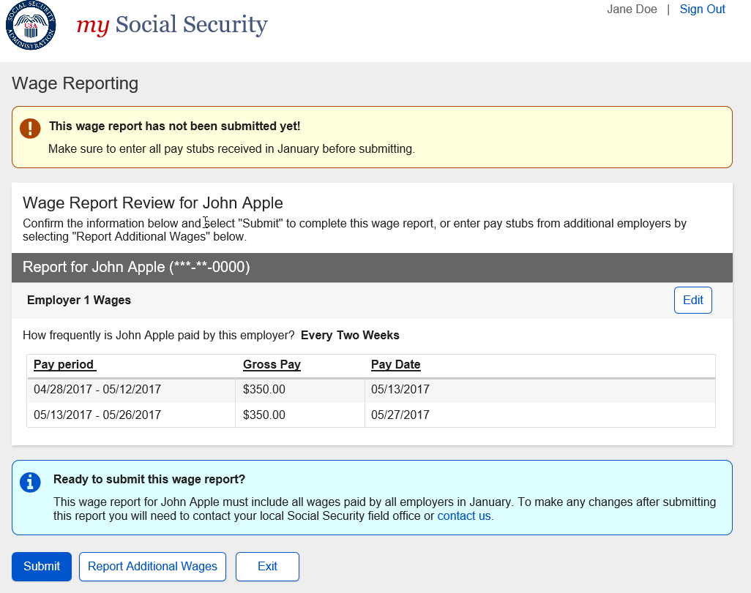

Wage Report Confirmation/Receipt
      - Title II Wage Report Confirmation Screen
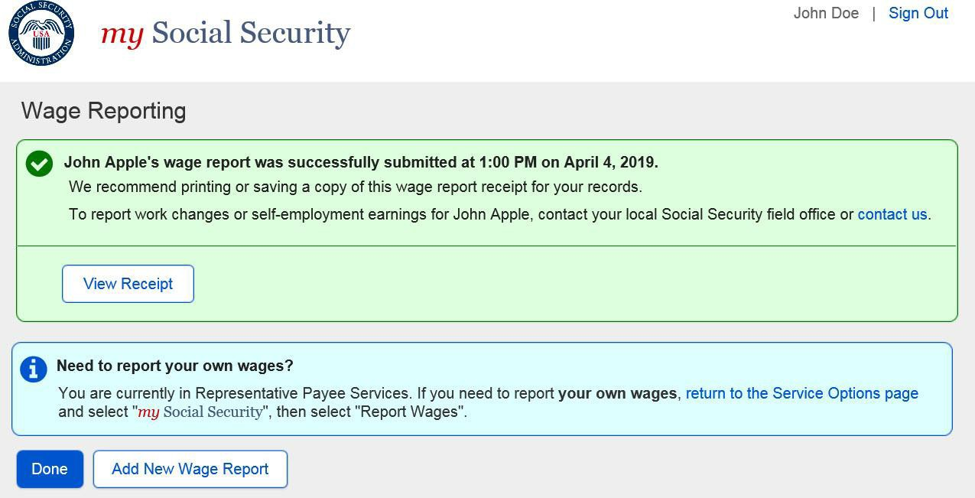

        - Title II Wage Report Receipt
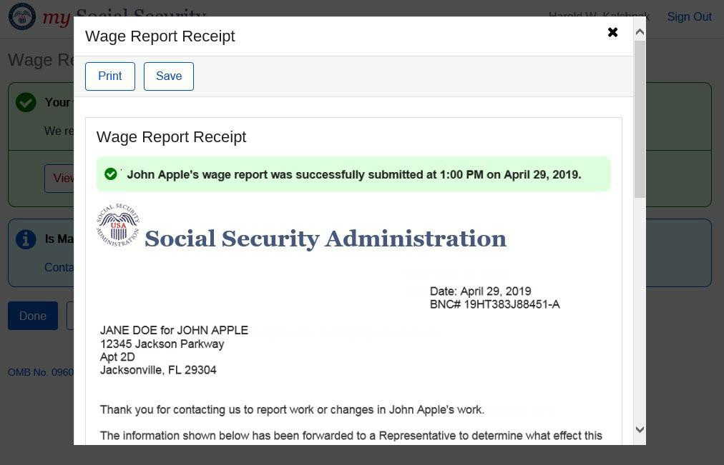

      - Title XVI Wage Report Confirmation Screen
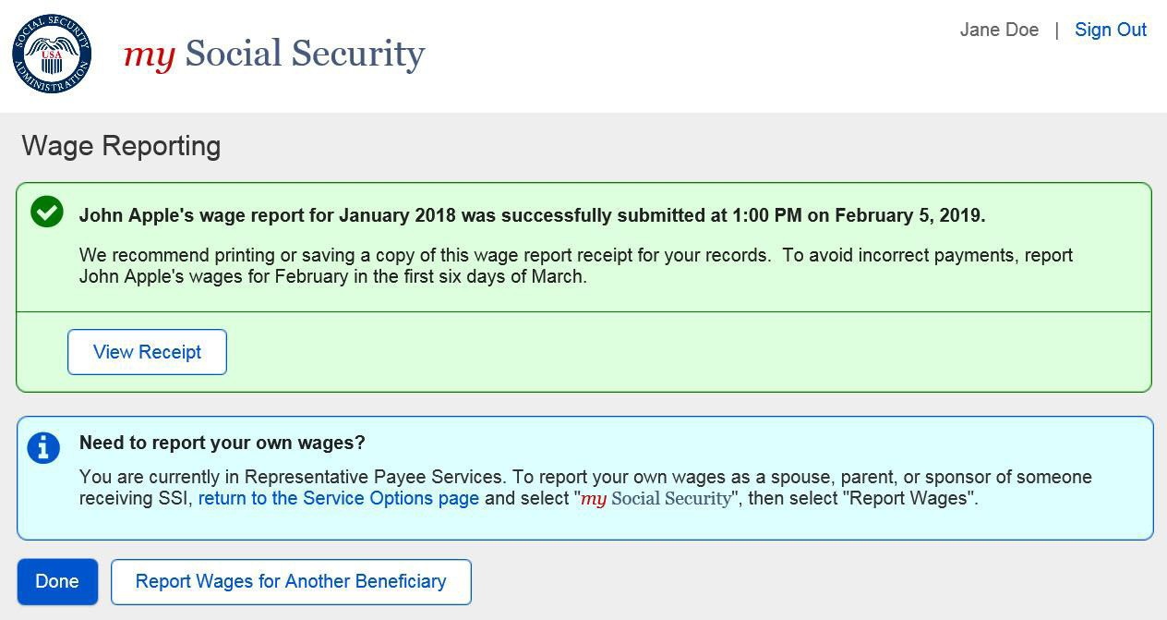

        - Title XVI/Concurrent Wage Report Receipt
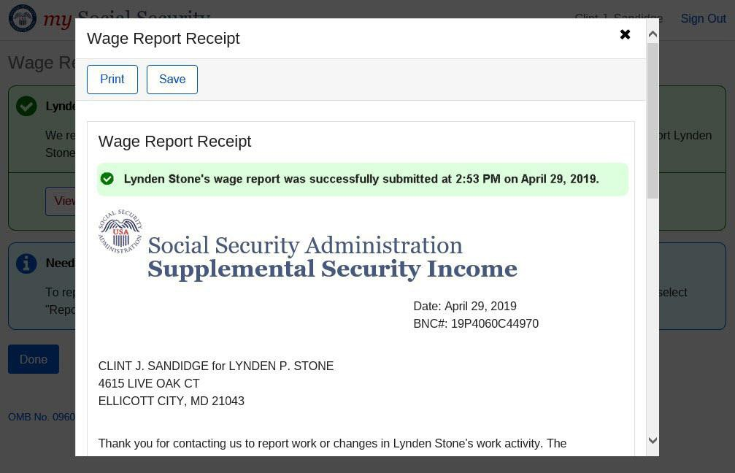

      - Concurrent Wage Report Confirmation Screen
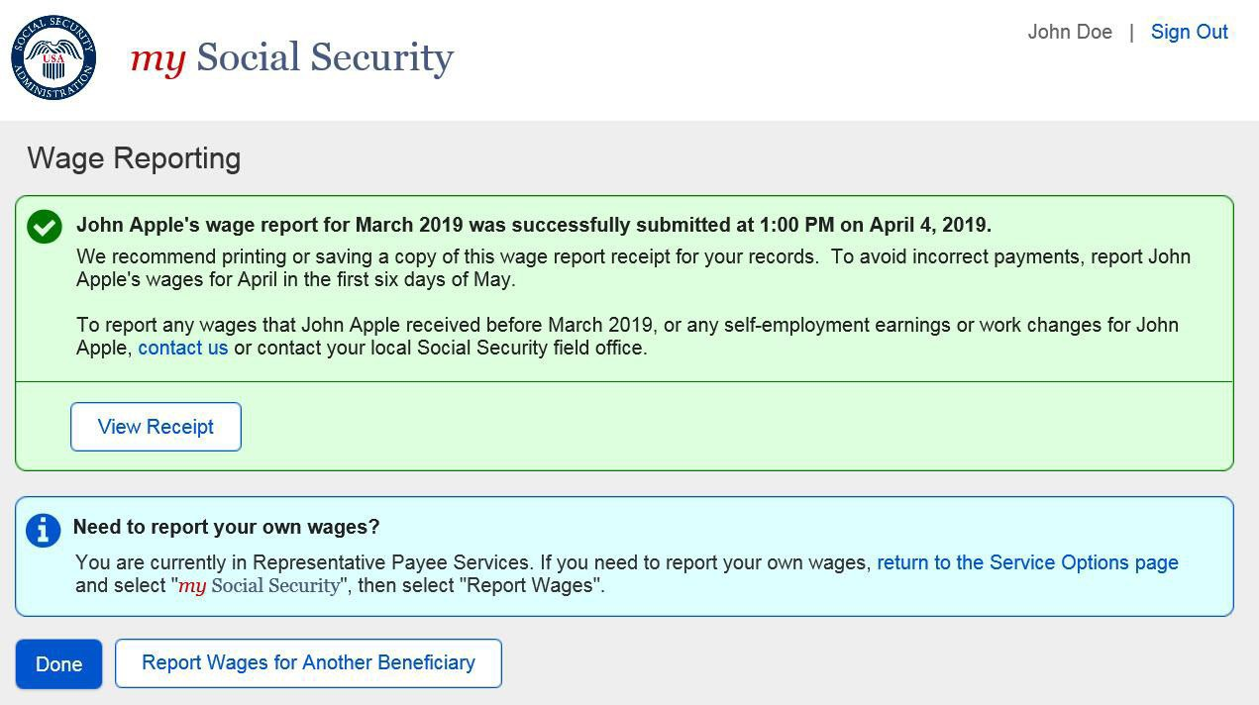

Representative Payee Variant Screens
    - my Social Security Landing Page (Authorized as Representative Payee + Receiving Benefits)
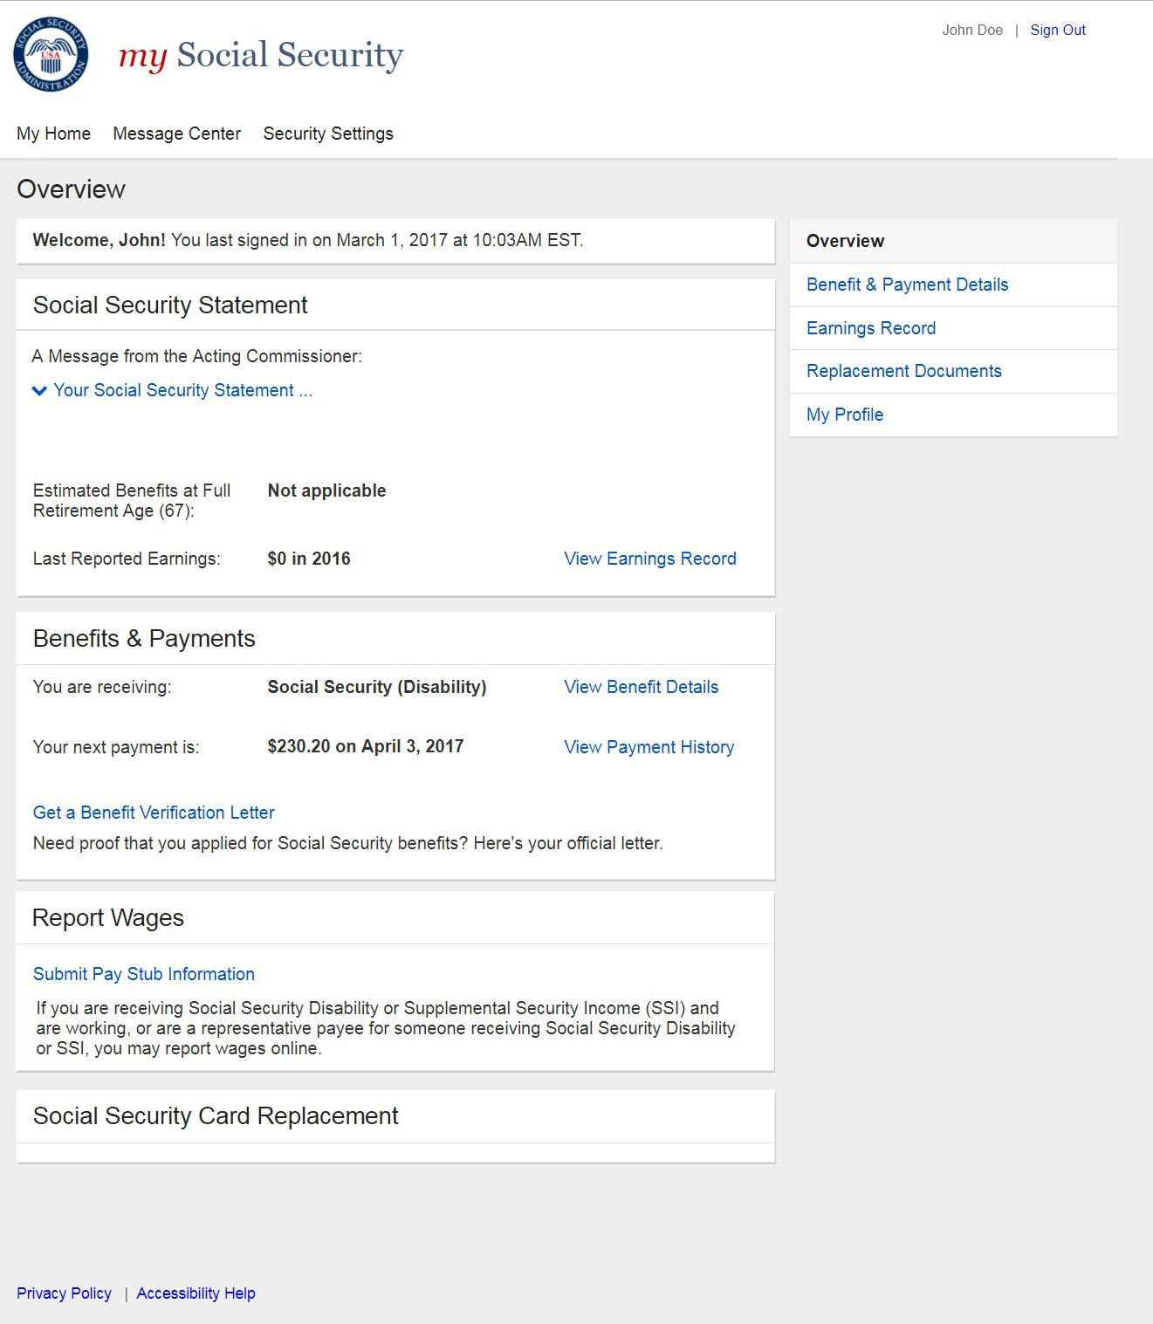

    - Choose Wage Earner- Single Beneficiary Variant
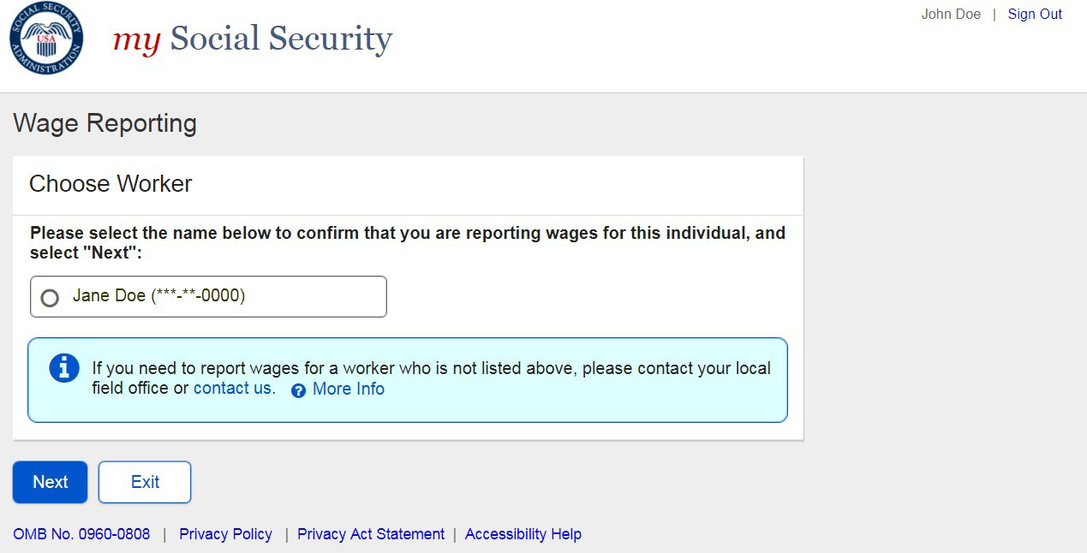

    - Original Choose Employer- Single Employer Variant
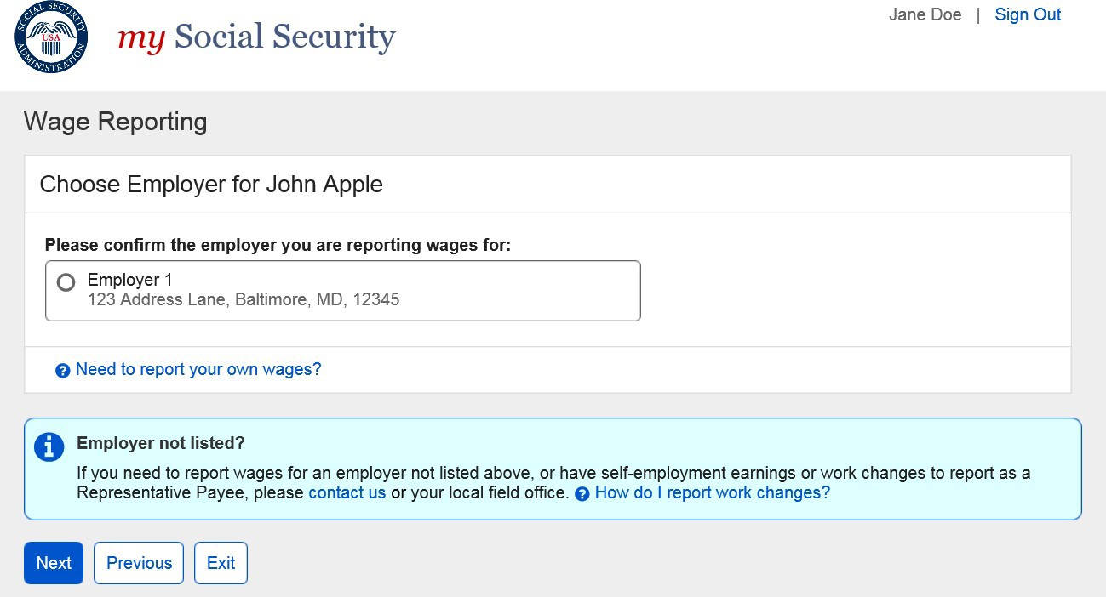

      - Revised Representative Payee Choose Employer (Single Employer Variant)
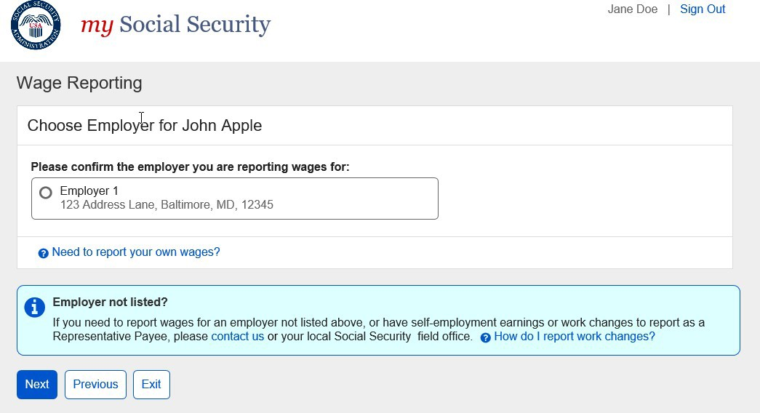

3.2.4.1. Original Representative Payee Choose Employer (Single Employer: Return Variant)

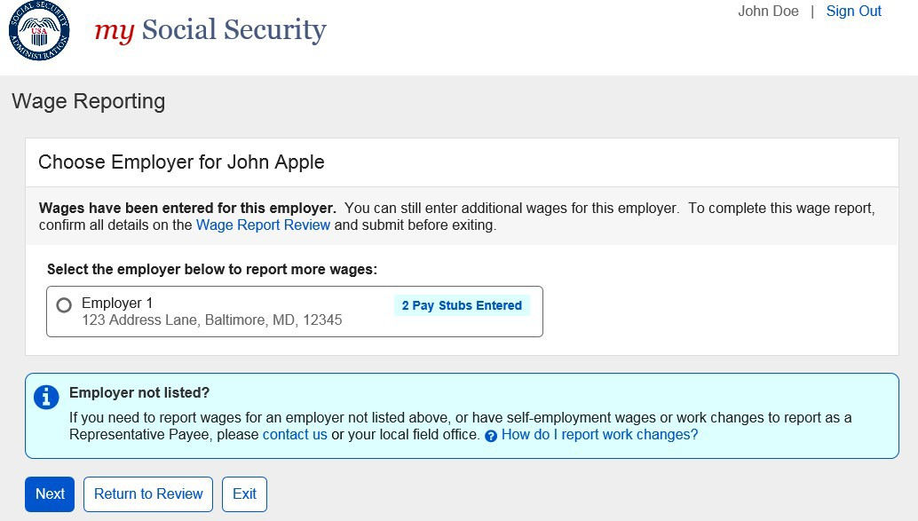

3.2.4.1. Revised Representative Payee Choose Employer (Single Employer: Return Variant)
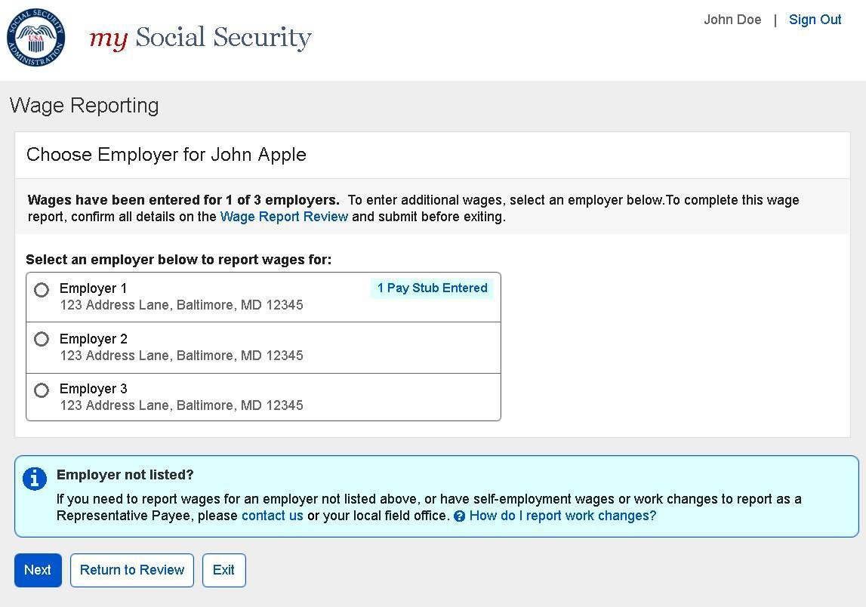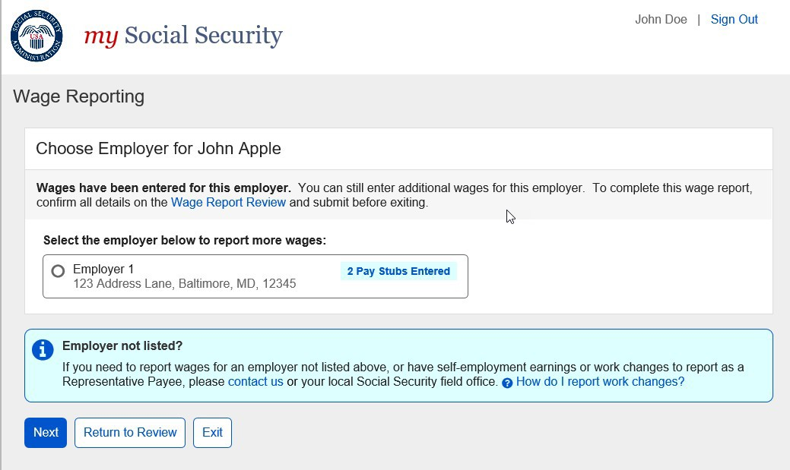

Representative Payee Error Screens

Choose Wage Earner- Ineligible Wage Earner
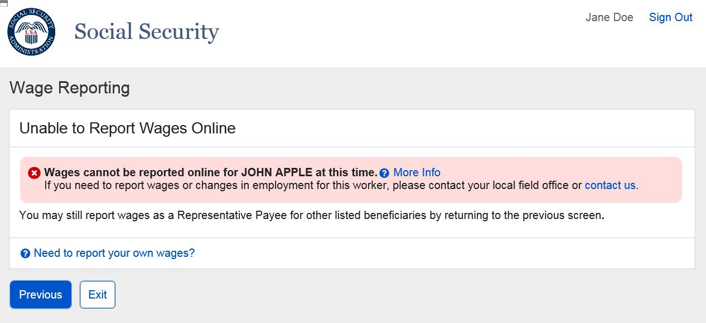
      - Choose Wage Earner- Ineligible Wage Earner More Details Modal
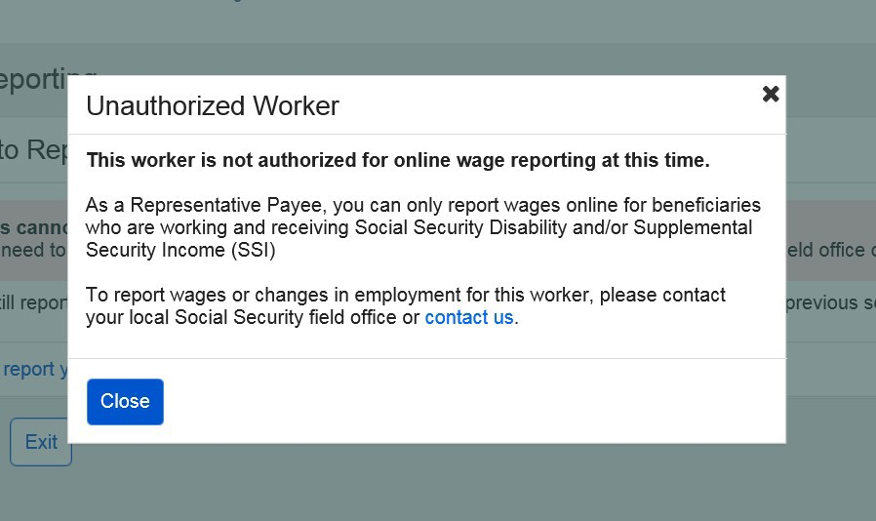
      - Choose Worker- Ineligible Worker, Single Worker on Record ‘Report Own Wages’ Modal
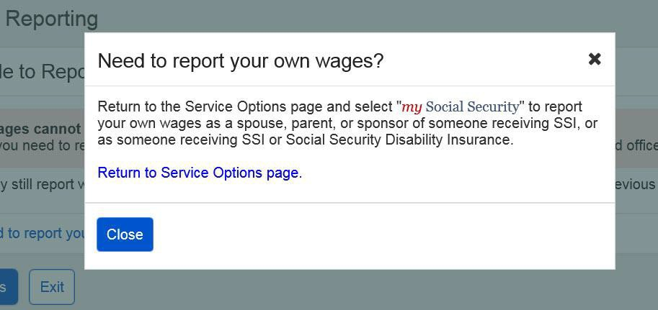

      - Choose Worker- Ineligible Worker, Single Worker on Record
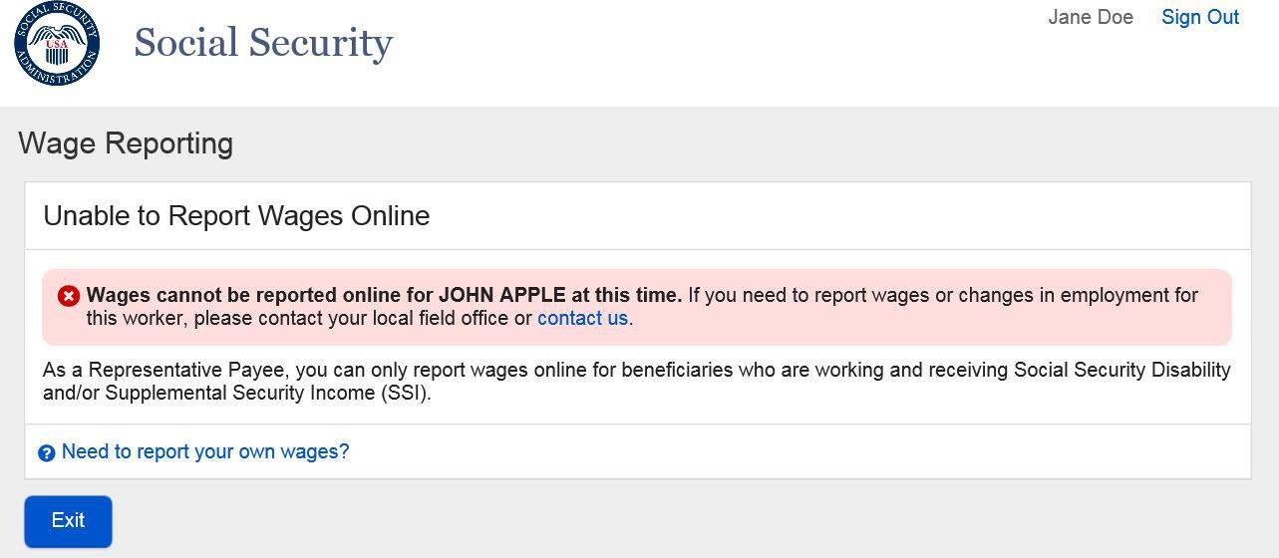

Choose Employer- No Eligible Employer on Record
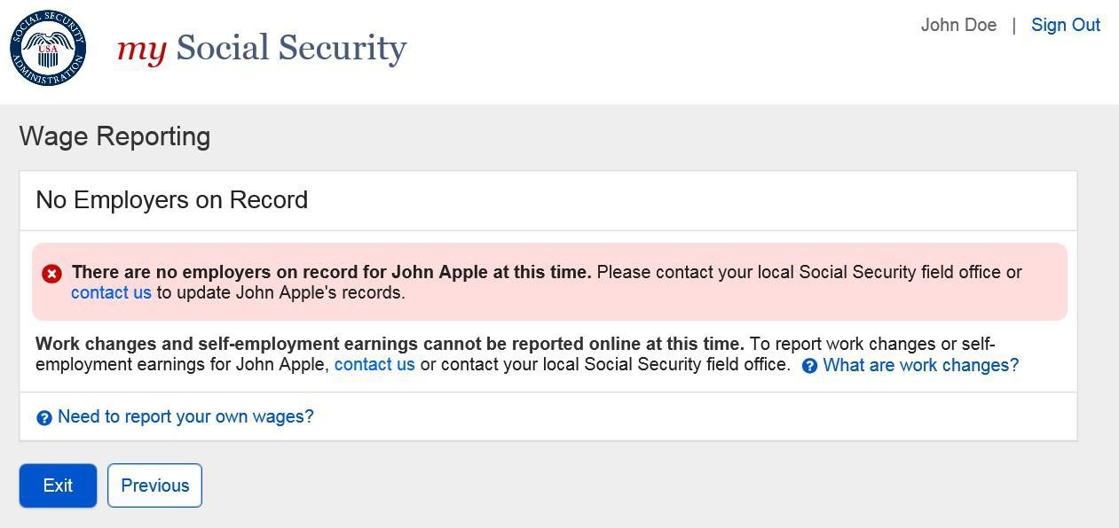
      - Choose Employer- No Eligible Employer on Record More Information Modal
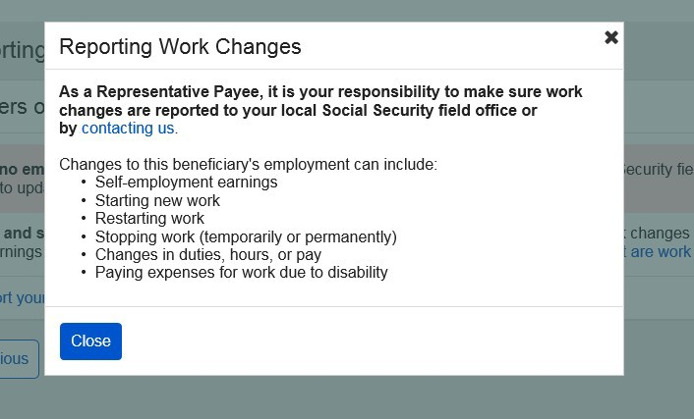

      - Choose Employer- No Eligible Employer on Record ‘Report Own Wages’ Modal
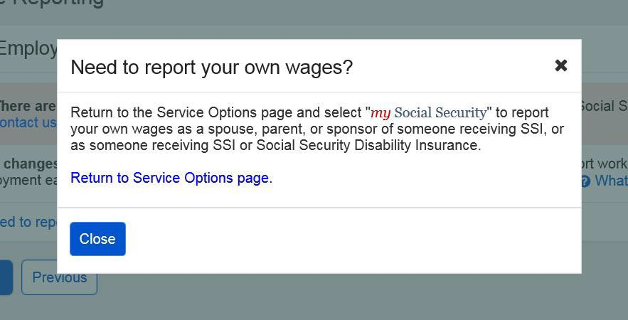

      - Choose Employer- No Eligible Employer on Record, Single Worker on Record
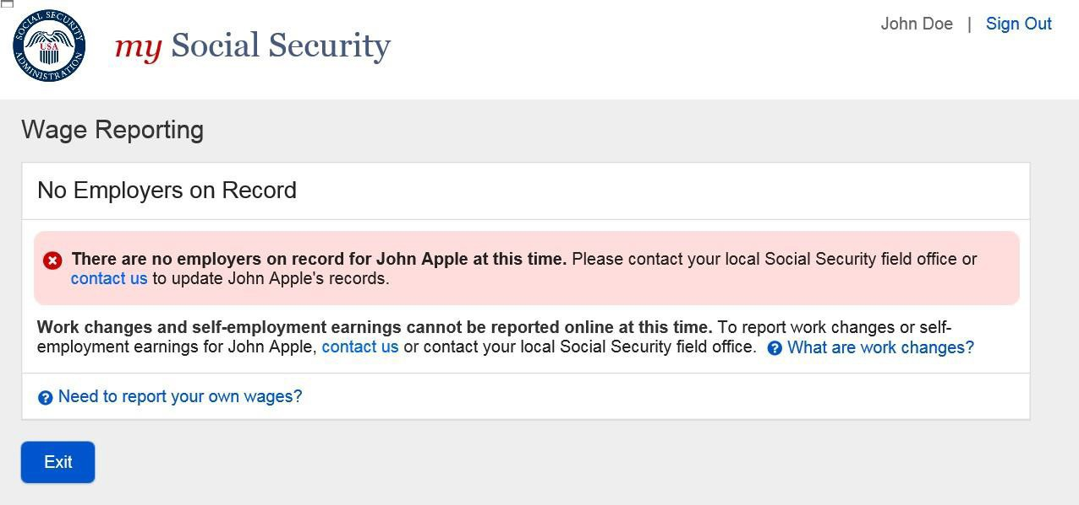
    - Empty Wage Entry Table- No Data Entered/Single Employer on Record
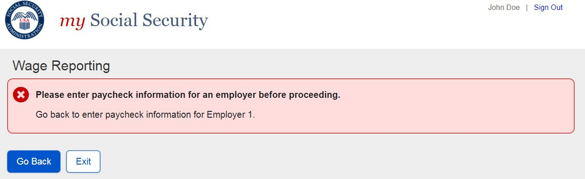

    - Empty Wage Entry Table- No Data Entered/Multiple Employers on Record
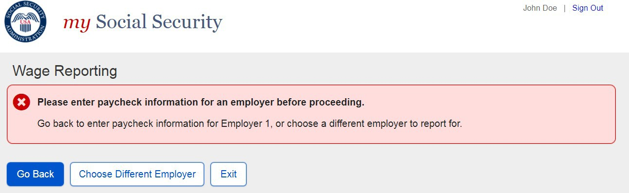

    - Empty Wage Entry Table- Data Entered/Multiple Employers on Record
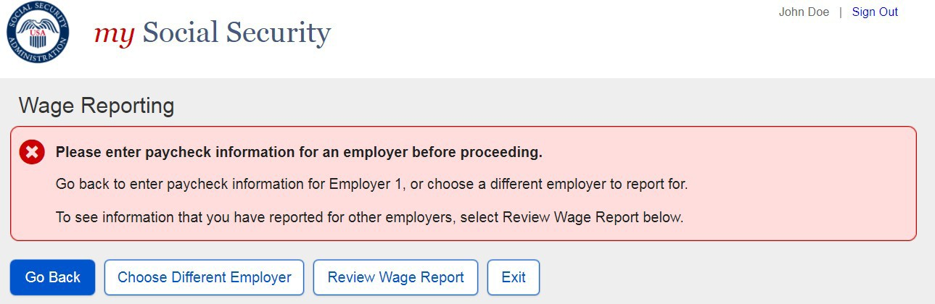

    - Wage Entry Modal- Error Summary Example
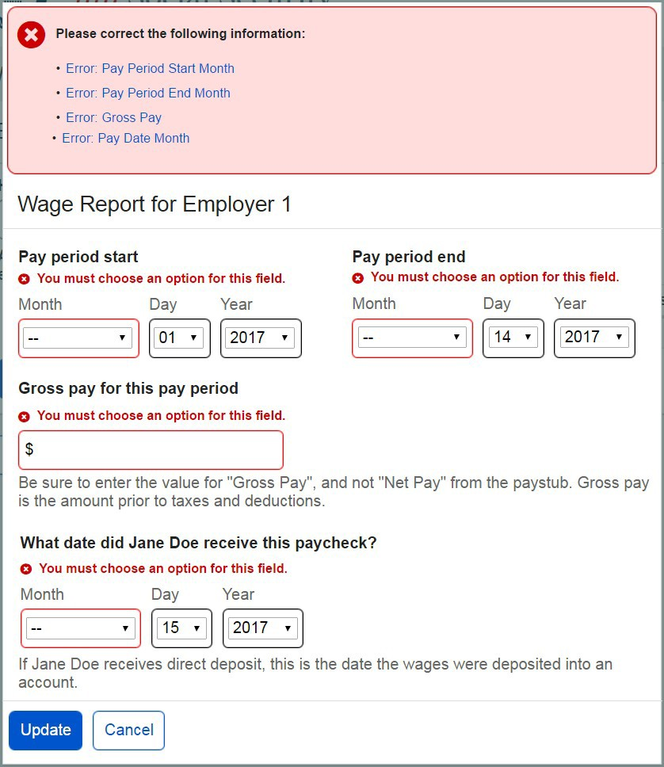

    - Wage Report Submission Error
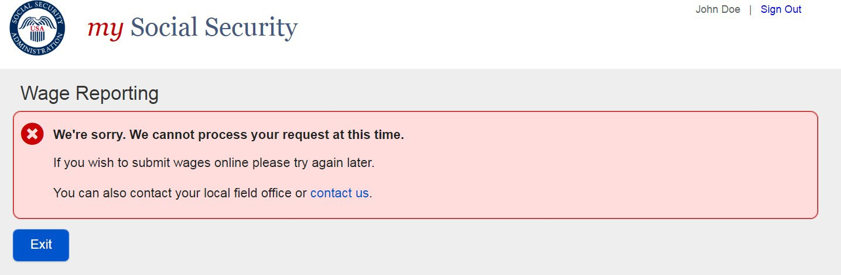

    - Revised Empty Wage Table – No Data Entered/Single Employer on Record

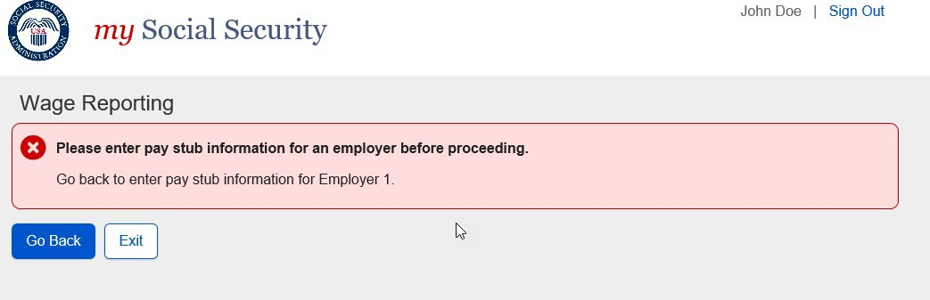

    - Revised Empty Wage Table – No Data Entered/Multiple Employers on Record

    - Original Empty Wage Table – Data Entered/Multiple Employers on Record

3.3.10 Revised Empty Wage Table – Data Entered/Multiple Employers on Record

4.0 myWage Reporting Exit Warning Confirmation
  - Original Exit Warning Confirmation
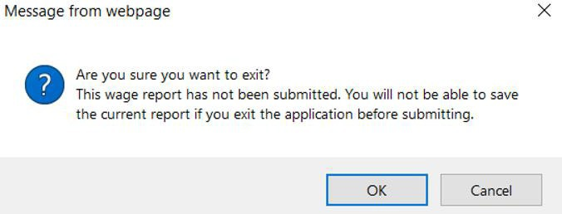

  - Revised Exit Warning Confirmation
