Justification for Non-Substantive Changes to Electronic SSDI and SSI Wage Reporting: myWageReport, SSA Mobile Wage Reporting, and Supplemental Security Income Telephone Wage Reporting
20 CFR 404.1520(b), 404.1571-1576, & 404.1584-1593, 20 CFR 416.701-416.732
OMB No. 0960-0715

Background
The Social Security Administration (SSA) requires Supplemental Security Income (SSI) recipients, deemors, and representative payees to report changes in wages because the receipt of wages could affect eligibility for SSI and payment amount. SSA Mobile Wage Reporting (SSAMWR) is one of several electronic methods available to SSI recipients, deemors, and representative payees that allows users to report the recipient and deemors’ monthly wages on their mobile device.

Pursuant to the Executive Order on Improving the Nation’s Cybersecurity (EO 14028), SSA is improving the ways in which we authenticate users of our public facing electronic services. Currently SSAMWR makes use of Knowledge Based Verification (KBV). The objective of this IT modification release is to implement the Multi-Factor Authentication (MFA) security protocol. SSAMWR will provide various sign-in options for users to securely log in. Furthermore, the updates will increase the public trust when using the SSAMWR application to report their wages.

The IT modification changes outlined below do not affect the SSI Telephone Wage Reporting system or the myWageReport (myWR) Internet application also included under this OMB number. SSA will implement the changes to the SSAMWR application upon OMB approval.

Note: In addition to the change and justification statements, we are including screen shot examples illustrating the changes below. A comprehensive listing of all the various screen iterations affected by a change is available in the included screen package “0960-0715 SSAMWR To-Be Screens.docx.”

Revisions to the Information Collection Screens

Change #1: We are moving the “Instruction Guide” link to the beginning of the process, below the “Get Started” button on the Home screen. The screens below show the revised version:

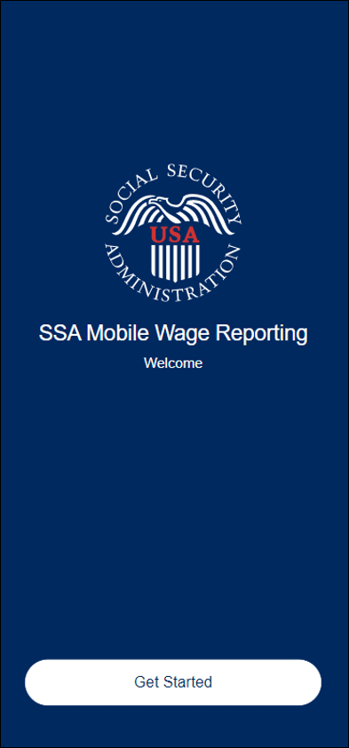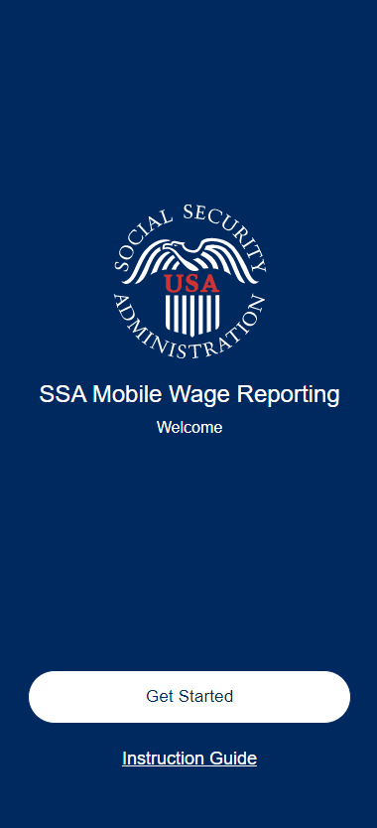

Justification #1: We originally included this link later in the process but since it contains information about the sign-in process and how to report wages using the application, we determined it best to provide the Instruction Guide earlier in the process.

- Change #2: We are adding a new screen named Enhanced Security Options (ESO). Users navigate to this screen by selecting the “Get Started” option on the Home screen. This page will provide users with information related to the importance of security and the various sign-in options users will have available on the next login page, through SSA’s Public Credentialing and Authentication Process (OMB No. 0960-0789), Login.gov, and ID.me, which are not part of the SSAMWR application. We are adding the informative screen below:

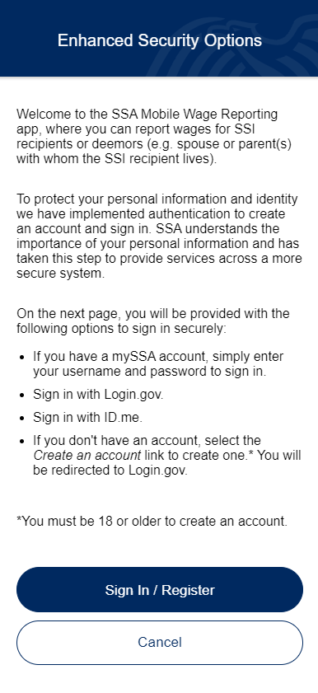

Justification #2: We are adding this ESO page to meet SSA’s security standards, require users to conduct business with SSA in a more secure way, and to inform users on what to expect in the next initial steps of using enhanced security.

- Change #3: We are updating the content of the Privacy Act Statement. The screens below show the revised version:

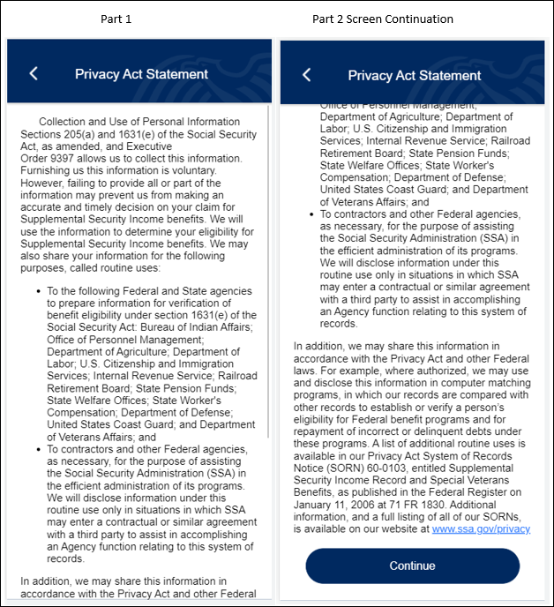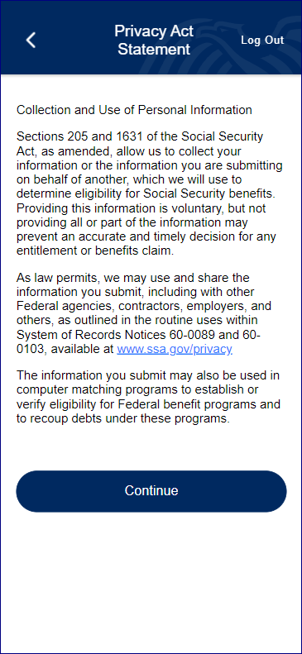

Justification #3: The revised Privacy Act Statement is more streamlined and consistent with our other related applications. Thus, giving the user a more concise and clearer Privacy Act Statement to read.

- Change #4: We are adding a welcome message displaying the user’s first name to the Reporting Month screen. The screens below show the revised version:

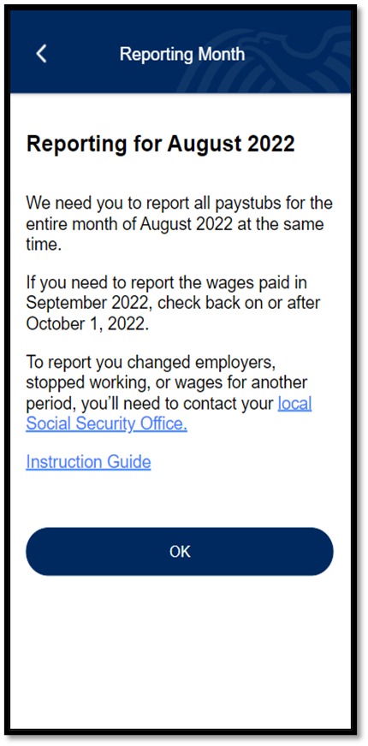
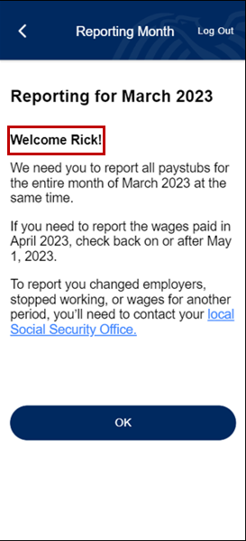

- Justification #4: This message will provide the user of the application a more personalized experience.

- Change #5: We are modifying the Personal Information input screen by updating the title to “Your Wage Information,” and removing the fields for Name, Date of Birth, and Social Security Number. If the user previously selected the option to report wages for Self or for Both (themselves and another person), then the last question (Did you receive any wages...?) will display. If the user previously selected to only report wages for another person, this screen will not be displayed. The screens below show the revised version:

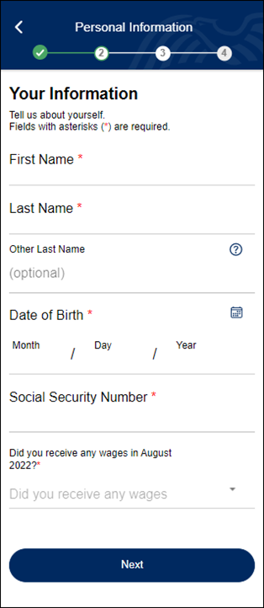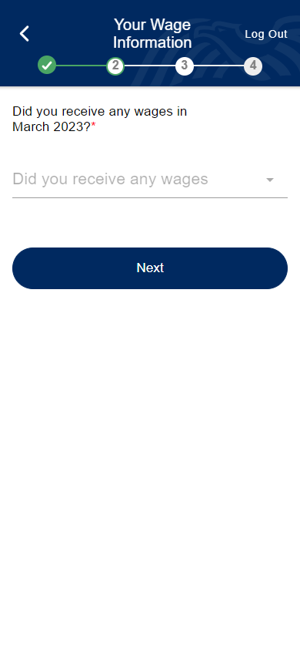

Justification #5: Removing the Personal Identifiable Information (PII) fields on the screen will allow users to navigate through the application efficiently without having to reinput their PII. Additionally, for users only reporting for another person this page will not display. This modification will provide a more user-friendly experience.

- Change #6: For most screens, we are including a “Log Out” option within the header. This will not apply to the Successful Submission screens where the logout option is provided at the bottom of the screen. The screens below show the revised version:

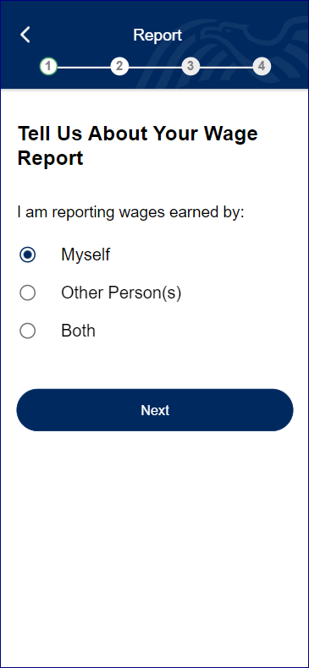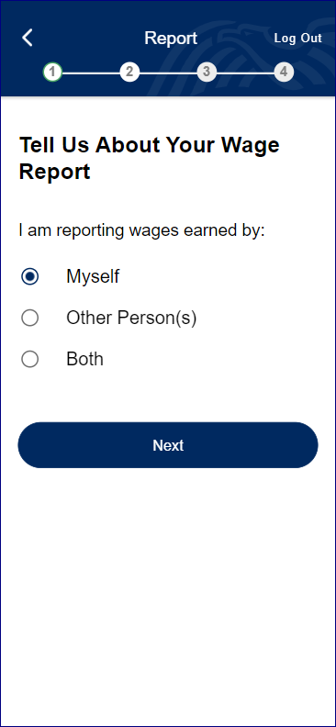

Justification #6: This functionality will permit users to log out of the SSAMWR application conveniently and securely at any point during the wage submission process.

- Change #7: On the Successful Submission screens, we are changing the verbiage of the “Done” button to state “Log Out.” The screens below show the revised version:

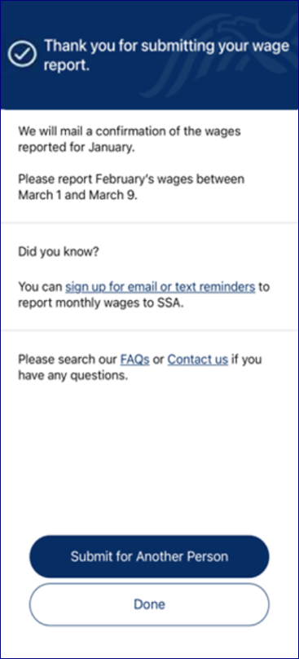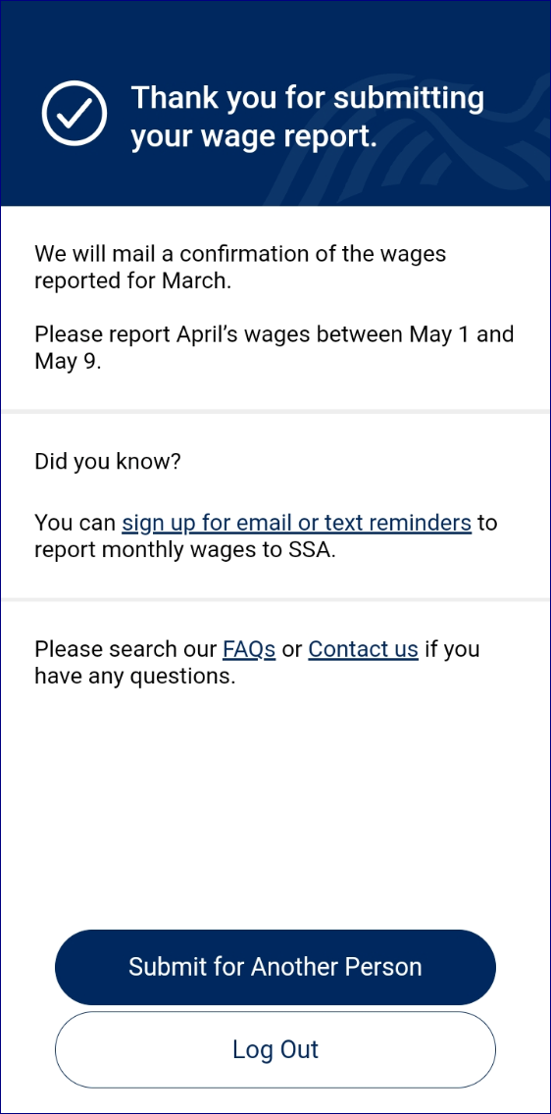

Justification #7: This change more clearly shows the user the effect of selecting the option button and clearly provides the option to log out of the SSAMWR application.

- Change #8: We are adding a pop-up warning message for users who attempt to log out before submitting their wages. The screens below show the revised version:

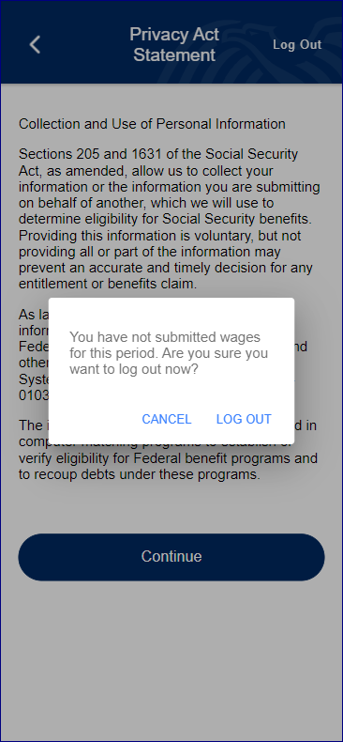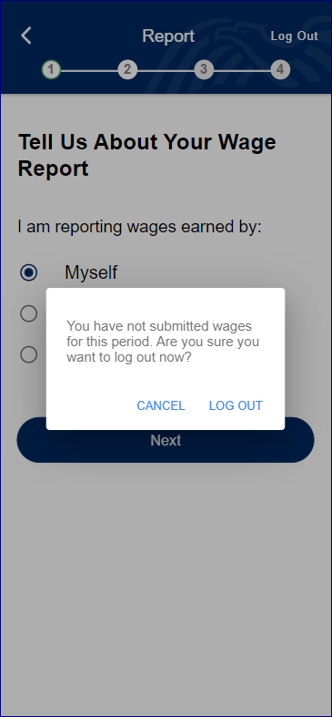

Justification #8: This alert will notify the user that they have not finished submitting wages for the period in question and verify their request to log out. This will prevent any unintentional logouts.

- Change #9: We are changing the verbiage of the “Try Again” button to “Log Out” on this error screen. The screens below show the revised version:

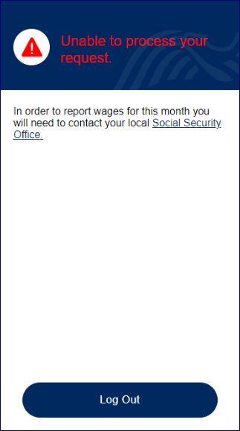

- Justification #9: The updated verbiage will clarify that the button will log the user out of the application and navigate them to the Home Page.

SSA will implement these IT Mod changes to the SSAMWR application upon OMB approval.

Justification for Non-Substantive Changes to the Collection or Resubmission of the Collection within One Year of OMB Approval:
As indicated above, pursuant to Executive Order 14028 on Improving the Nation’s Cybersecurity, SSA is improving the ways in which the authenticate users of our public facing electronic services through these minor IT modifications.

