**Sponsor Assessment (Form S-5)**

**UAC Basic Information and Sponsor Demographic Information Tab**

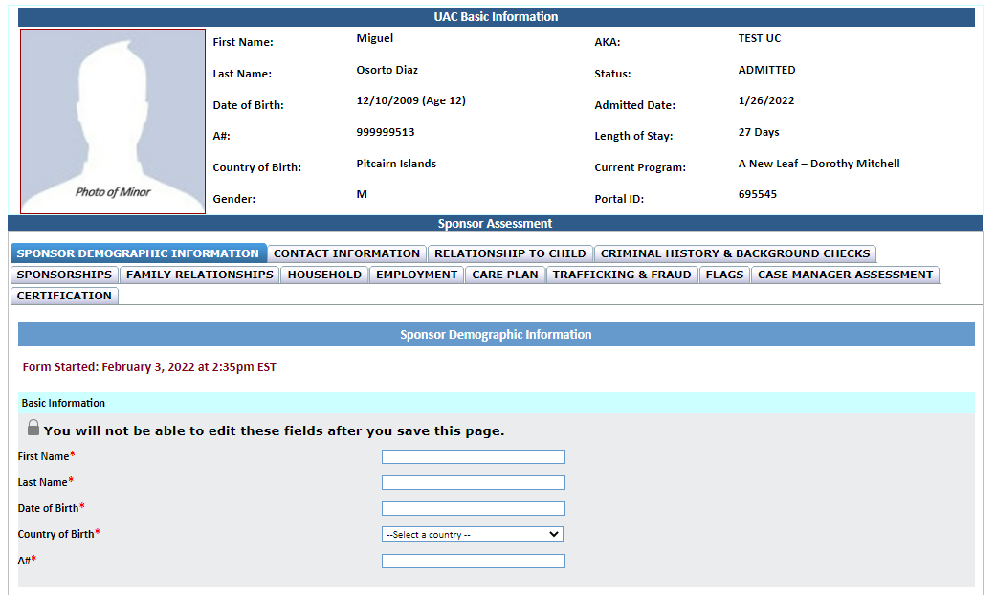

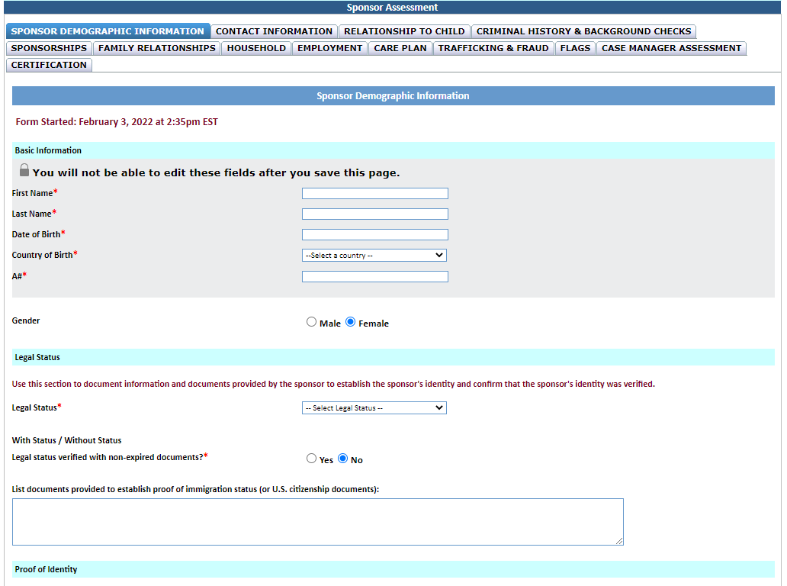



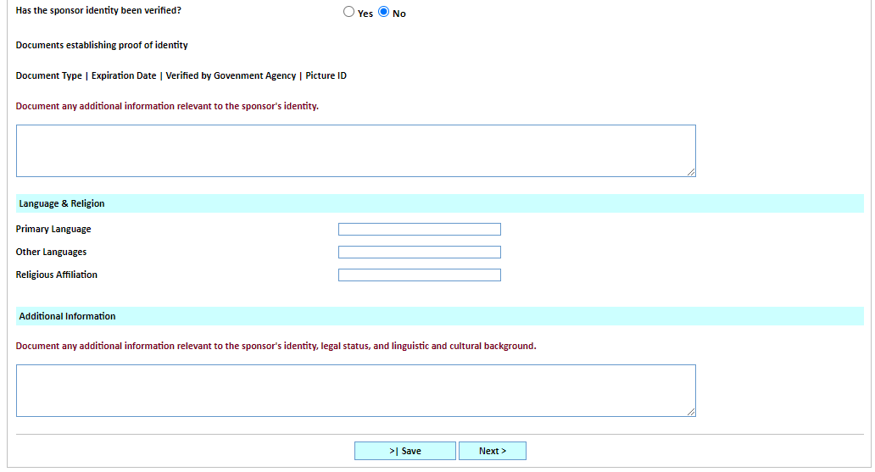

|  |  |  |  |
| --- | --- | --- | --- |
| **Document Type** | **Expiration Date** | **Verified by Government Agency** | **Picture ID** |
|  |  |  |  |
|  |  |  |  |
|  |  |  |  |







**Contact Information Tab**

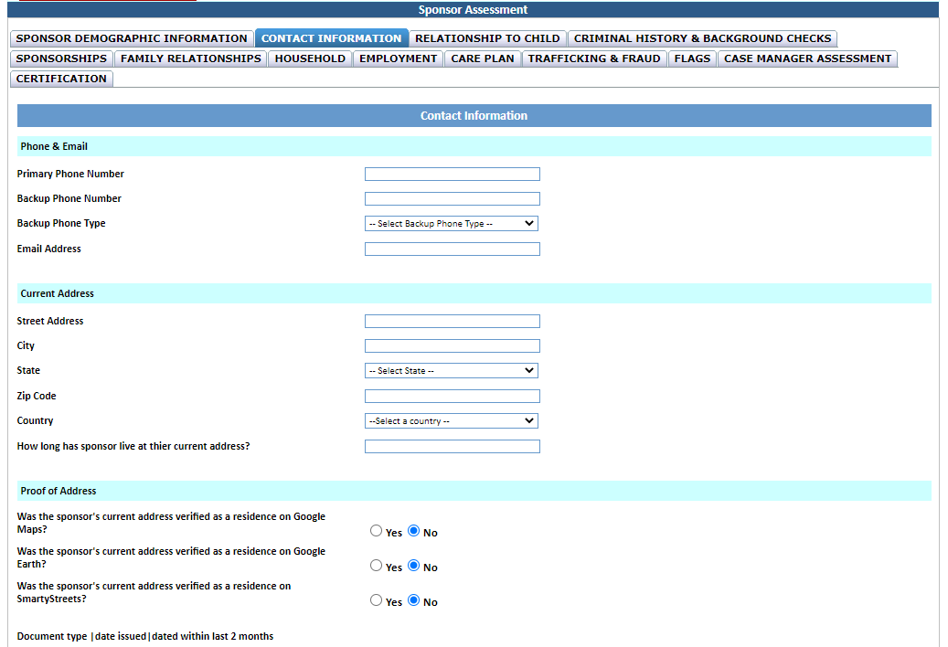





|  |  |  |
| --- | --- | --- |
| **Document Type** | **Date Issued** | **Dated Within Last 2 Months** |
|  |  |  |
|  |  |  |
|  |  |  |



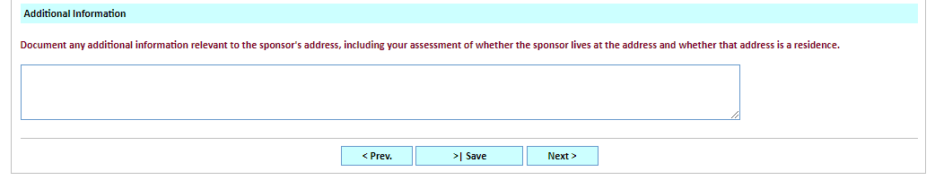

**Relationship to Child Tab**

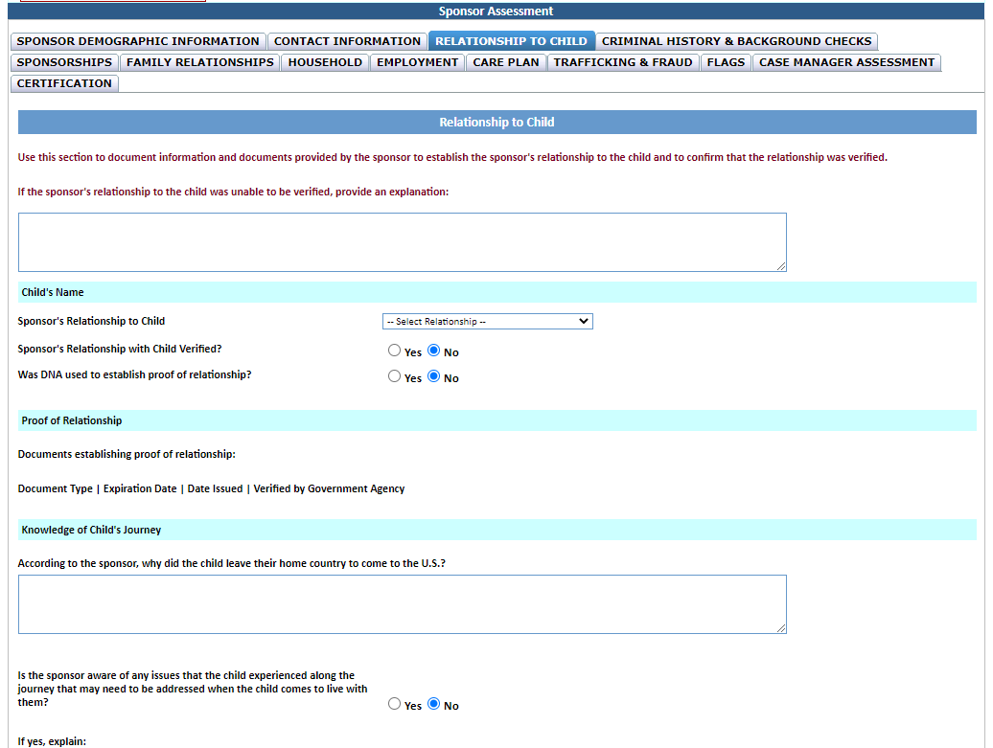

|  |  |  |  |
| --- | --- | --- | --- |
| **Document Type** | **Expiration Date** | **Verified by Government Agency** | **Picture ID** |
|  |  |  |  |
|  |  |  |  |
|  |  |  |  |





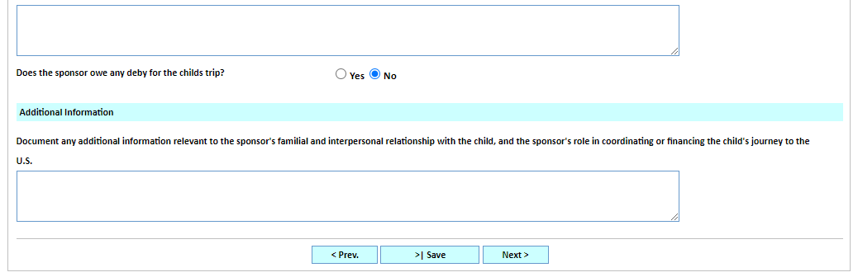

**Criminal History & Background Checks Tab**

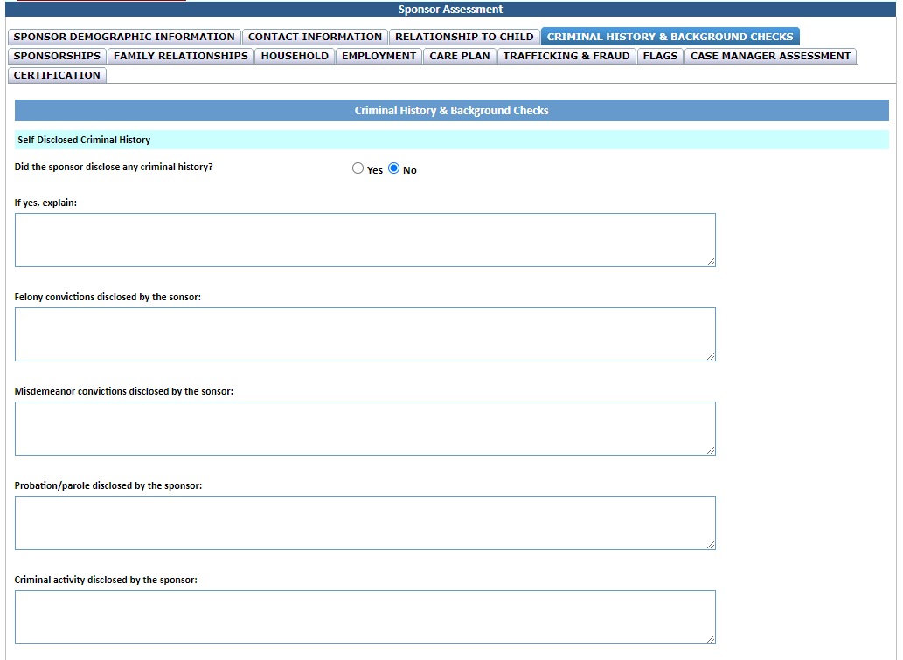



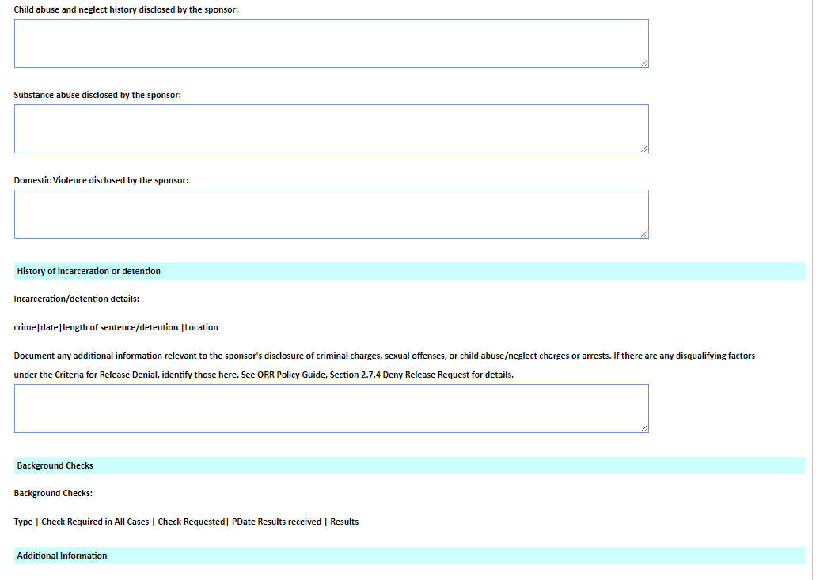



|  |  |  |  |
| --- | --- | --- | --- |
| **Crime** | **Date** | **Length of Sentence/Detention** | **Location** |
|  |  |  |  |
|  |  |  |  |
|  |  |  |  |



|  |  |  |  |  |  |
| --- | --- | --- | --- | --- | --- |
| **Type** | **Check Required in All Cases?** | **Check Requested** | **Date Requested** | **Date Results Received** | **Results** |
|  |  |  |  |  |  |
|  |  |  |  |  |  |
|  |  |  |  |  |  |

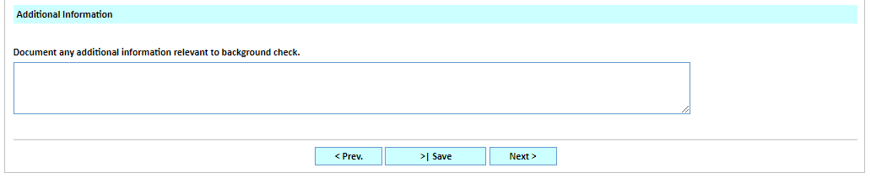

**Sponsorships Tab**

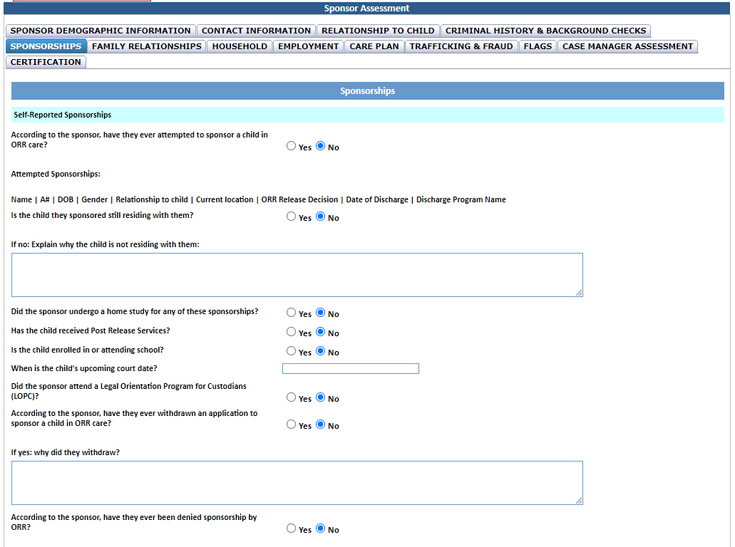

|  |  |  |  |  |  |  |  |  |
| --- | --- | --- | --- | --- | --- | --- | --- | --- |
| **Name** | **A#** | **DOB** | **Gender** | **Relationship to Child** | **Current Location** | **ORR Release Decision** | **Date of Discharge** | **Discharge Program Name** |
|  |  |  |  |  |  |  |  |  |
|  |  |  |  |  |  |  |  |  |
|  |  |  |  |  |  |  |  |  |





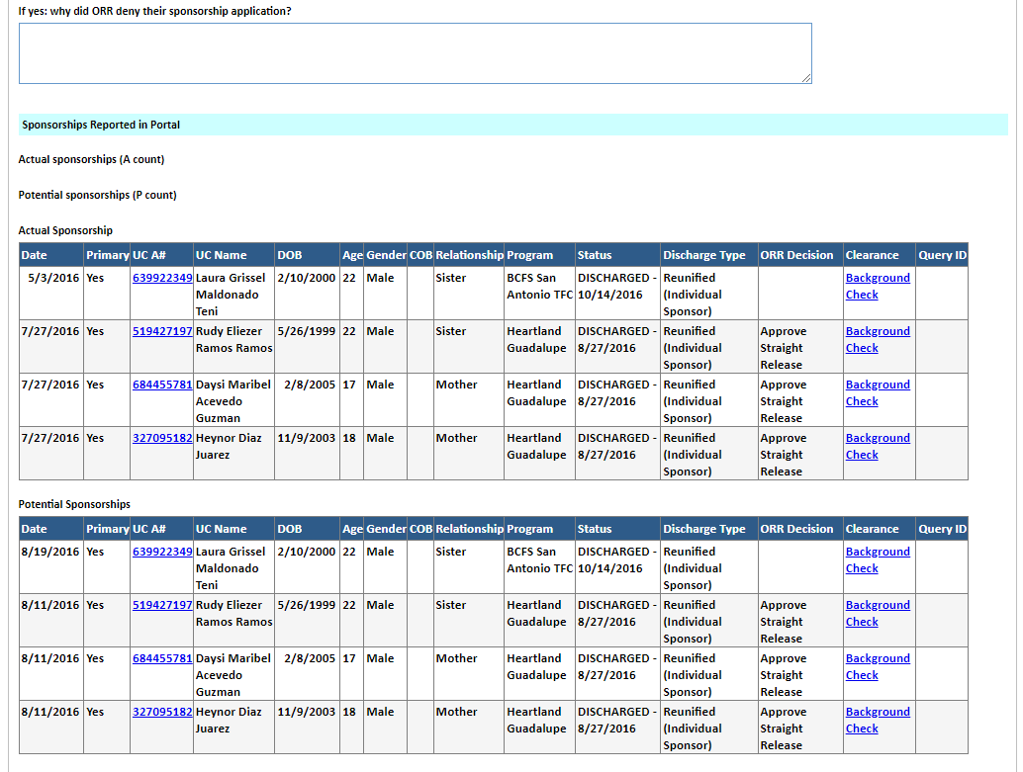



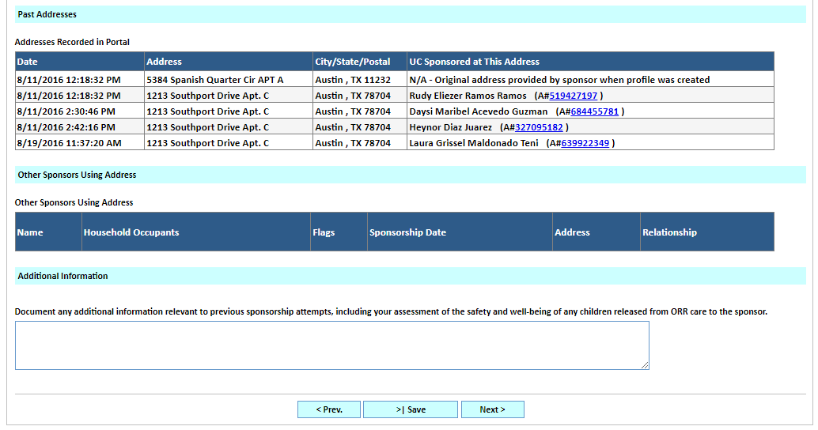



**Family Relationships Tab**

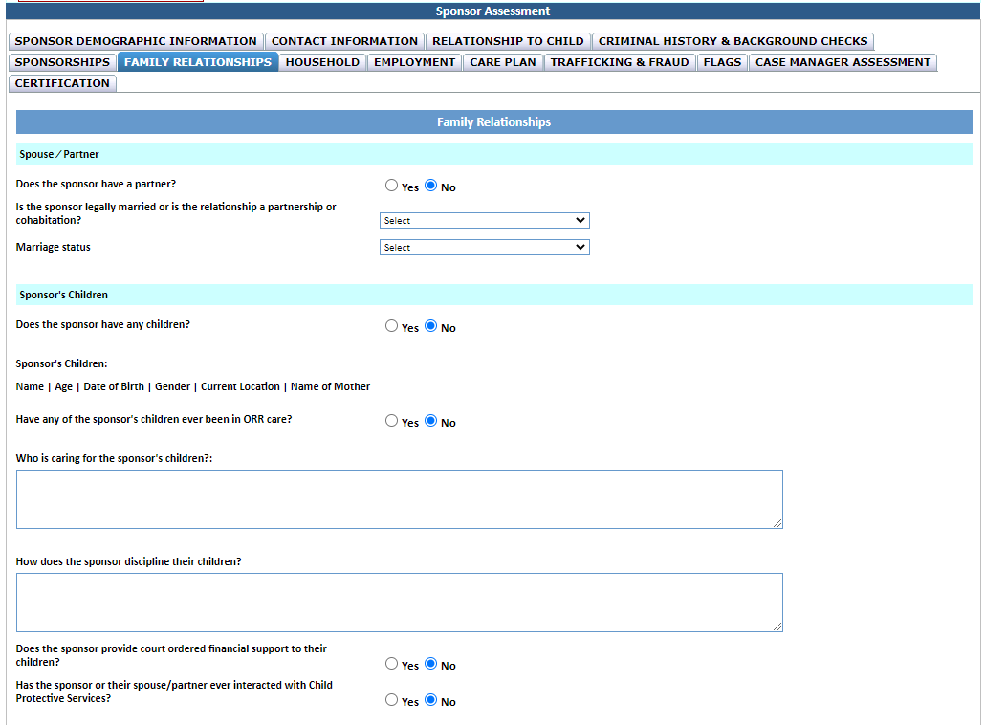



|  |  |  |  |  |  |
| --- | --- | --- | --- | --- | --- |
| **Name** | **Age** | **Date of Birth** | **Gender** | **Current Location** | **Name of Mother** |
|  |  |  |  |  |  |
|  |  |  |  |  |  |
|  |  |  |  |  |  |



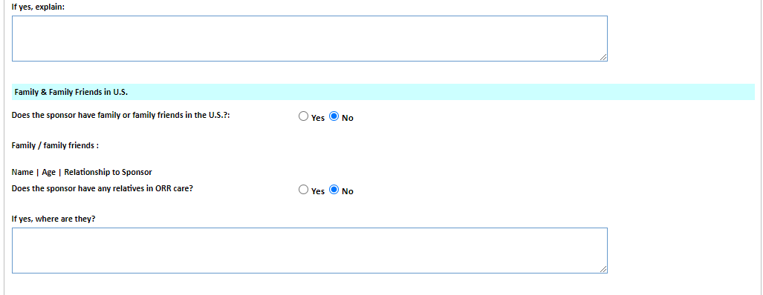



|  |  |  |
| --- | --- | --- |
| **Name** | **Age** | **Relationship to Sponsor** |
|  |  |  |
|  |  |  |
|  |  |  |

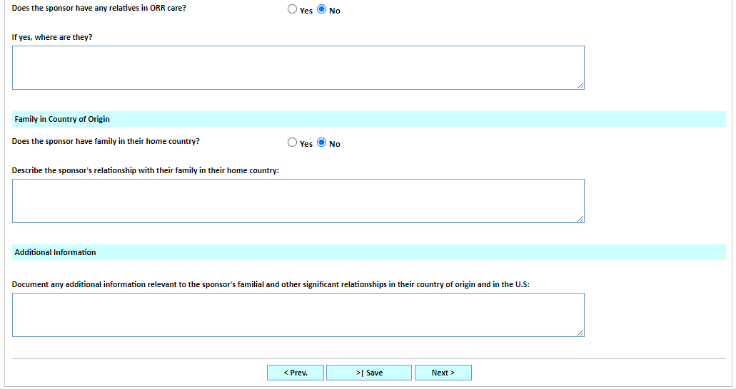

**Household Tab**

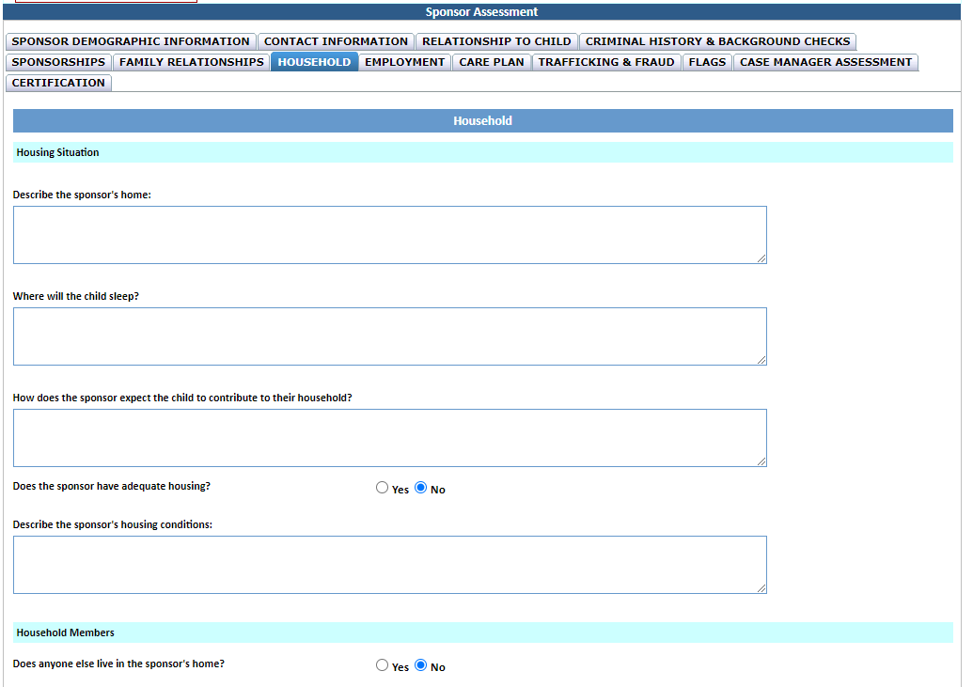

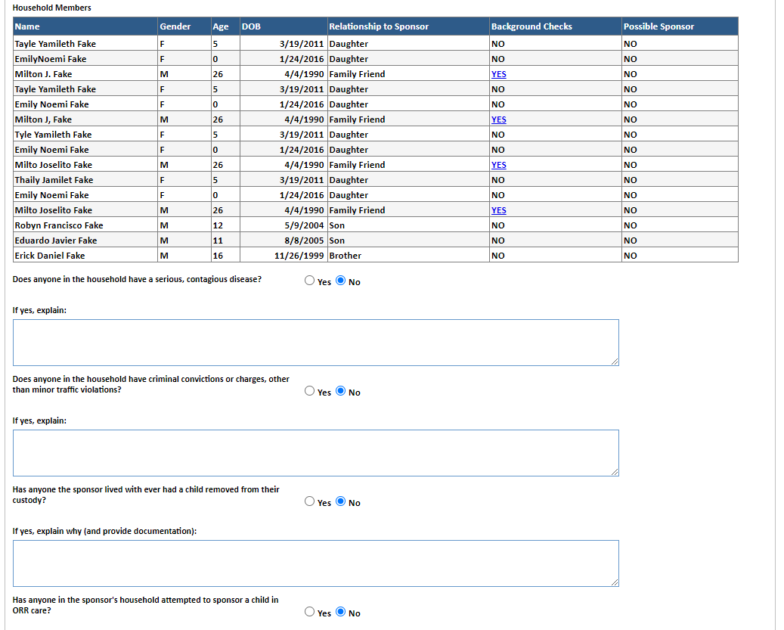



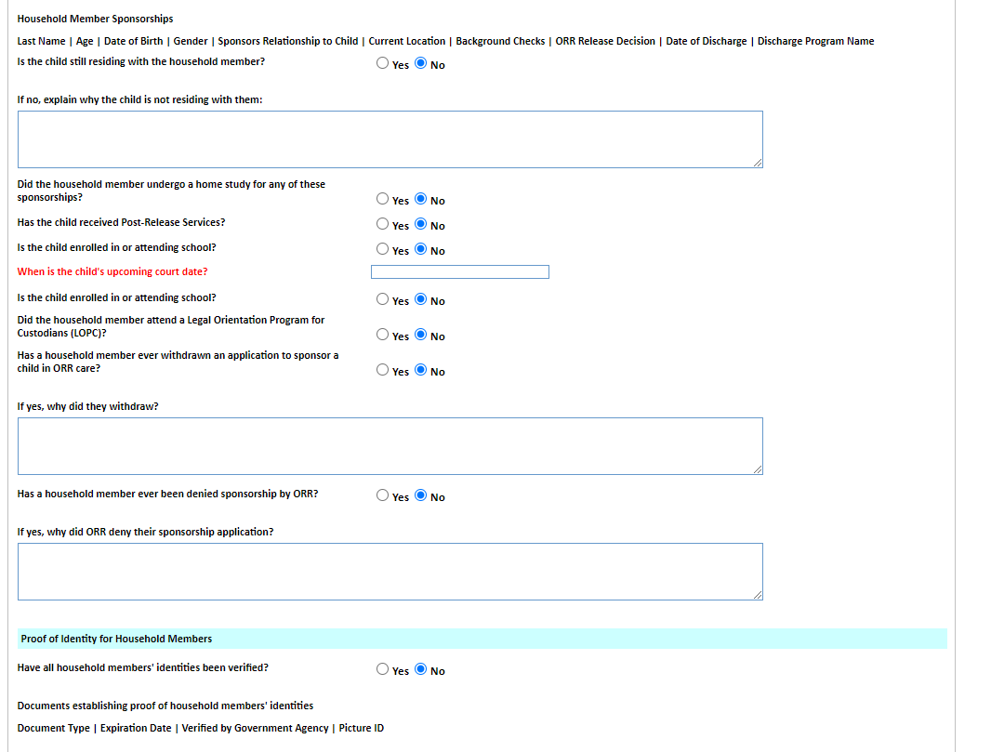

|  |  |  |  |  |  |  |  |  |  |
| --- | --- | --- | --- | --- | --- | --- | --- | --- | --- |
| **Name** | **A#** | **Date of Birth** | **Gender** | **Sponsor’s Relationship to Child** | **Current Location** | **Background Checks** | **ORR Release Decision** | **Date of Discharge** | **Discharge Program Name** |
|  |  |  |  |  |  |  |  |  |  |
|  |  |  |  |  |  |  |  |  |  |
|  |  |  |  |  |  |  |  |  |  |



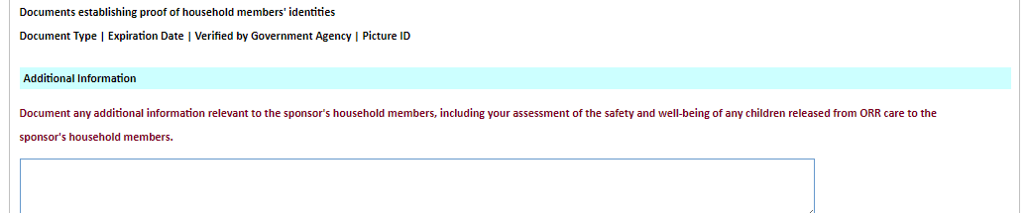

|  |  |  |  |
| --- | --- | --- | --- |
| **Document Type** | **Expiration Date** | **Verified by Government Agency** | **Picture ID** |
|  |  |  |  |
|  |  |  |  |
|  |  |  |  |

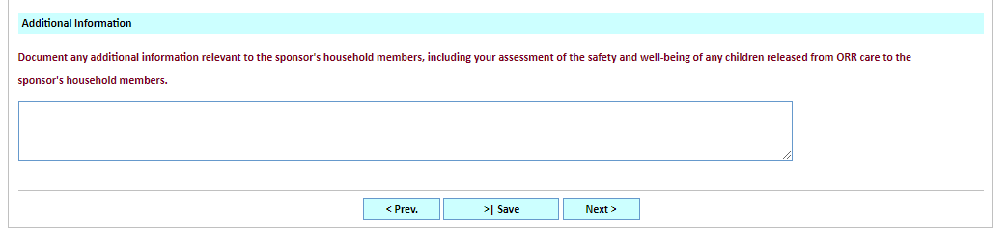

**Employment Tab**

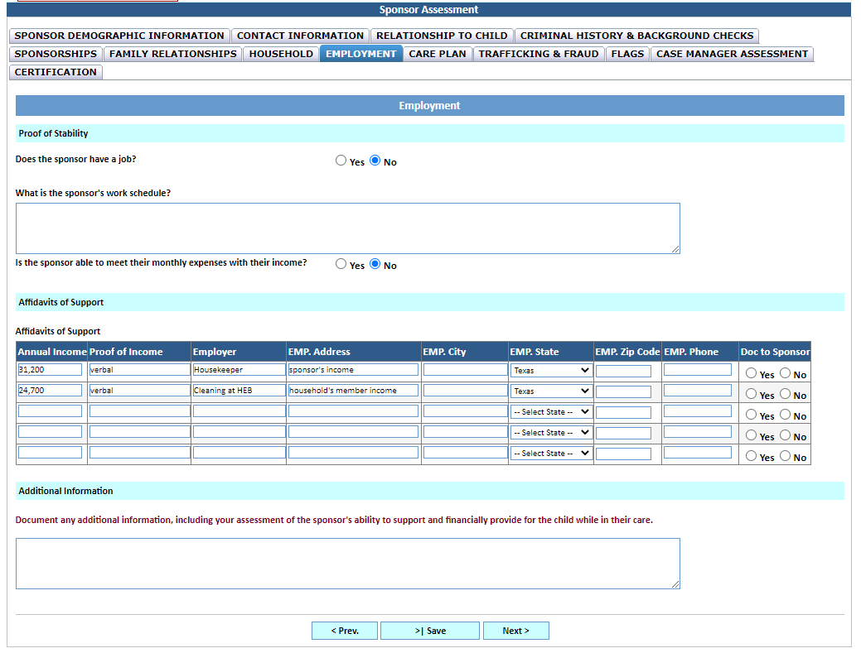



**Care Plan Tab**

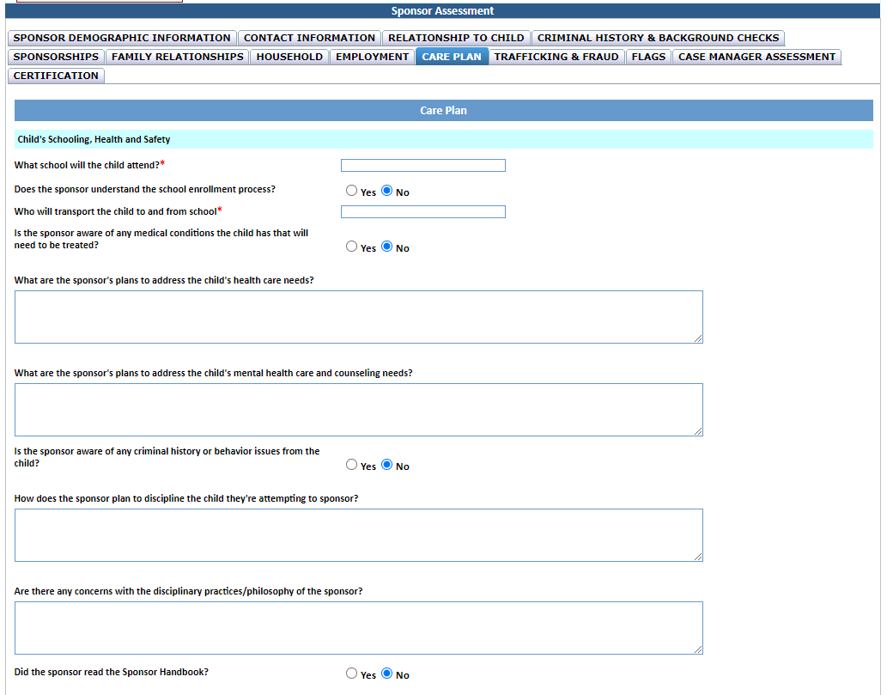



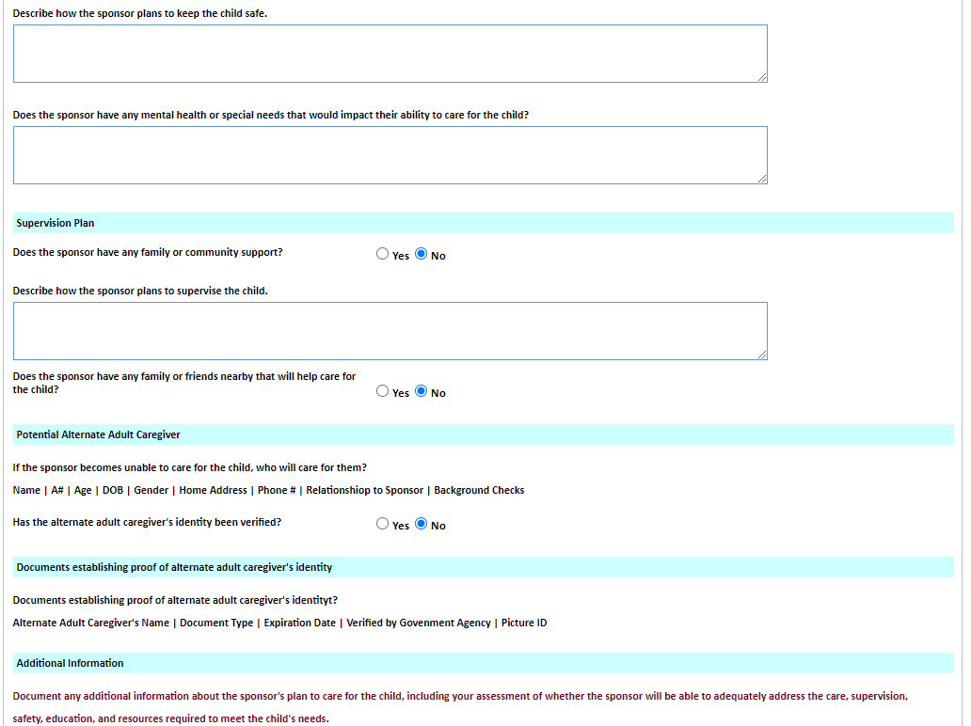



|  |  |  |  |  |  |  |  |
| --- | --- | --- | --- | --- | --- | --- | --- |
| **Name** | **A#** | **Date of Birth** | **Gender** | **Home Address** | **Phone #** | **Relationship to Sponsor** | **Background Checks** |
|  |  |  |  |  |  |  |  |
|  |  |  |  |  |  |  |  |
|  |  |  |  |  |  |  |  |



|  |  |  |  |  |
| --- | --- | --- | --- | --- |
| **Alternate Adult Caregiver’s Name** | **Document Type** | **Expiration Date** | **Verified by Government Agency** | **Picture ID** |
|  |  |  |  |  |
|  |  |  |  |  |
|  |  |  |  |  |

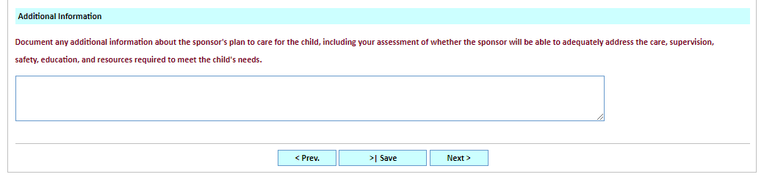

**Trafficking & Fraud Tab**

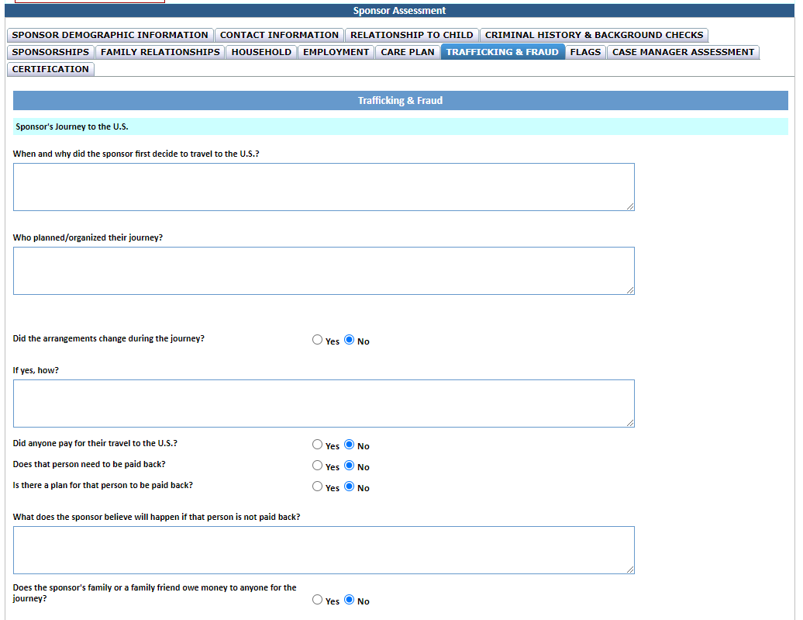



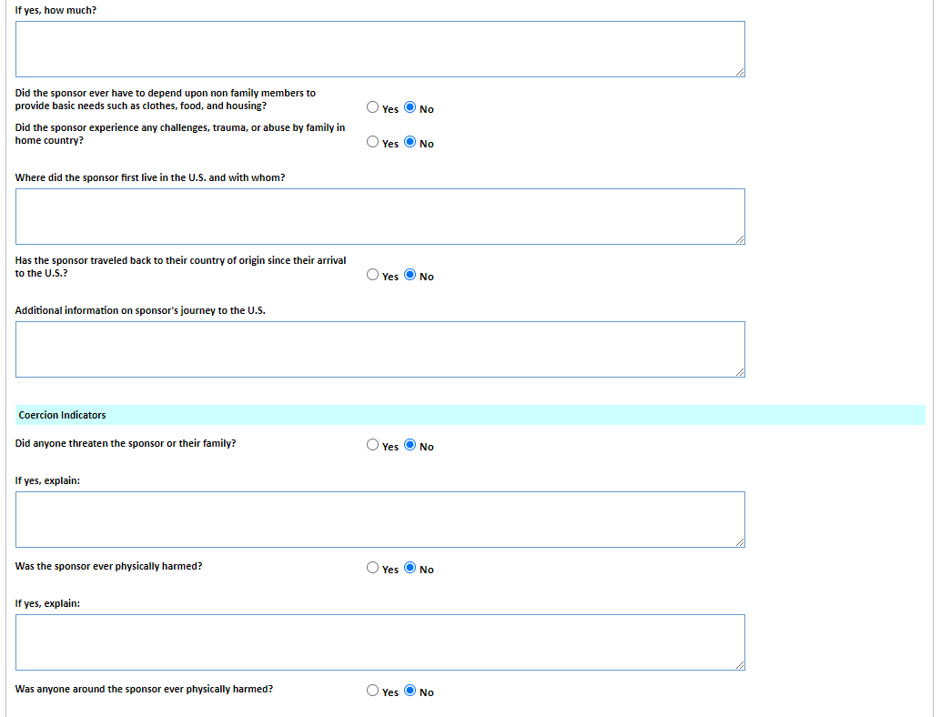



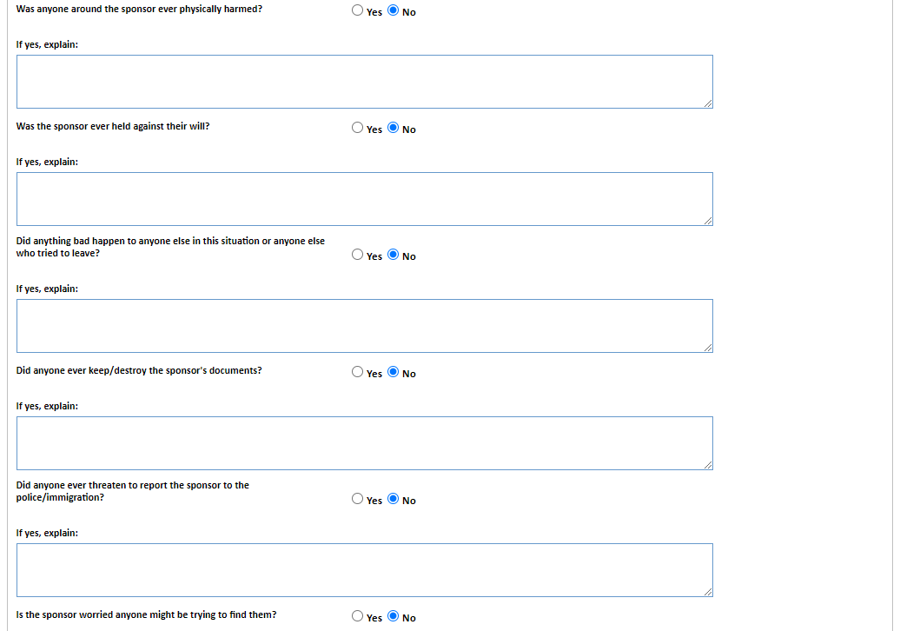



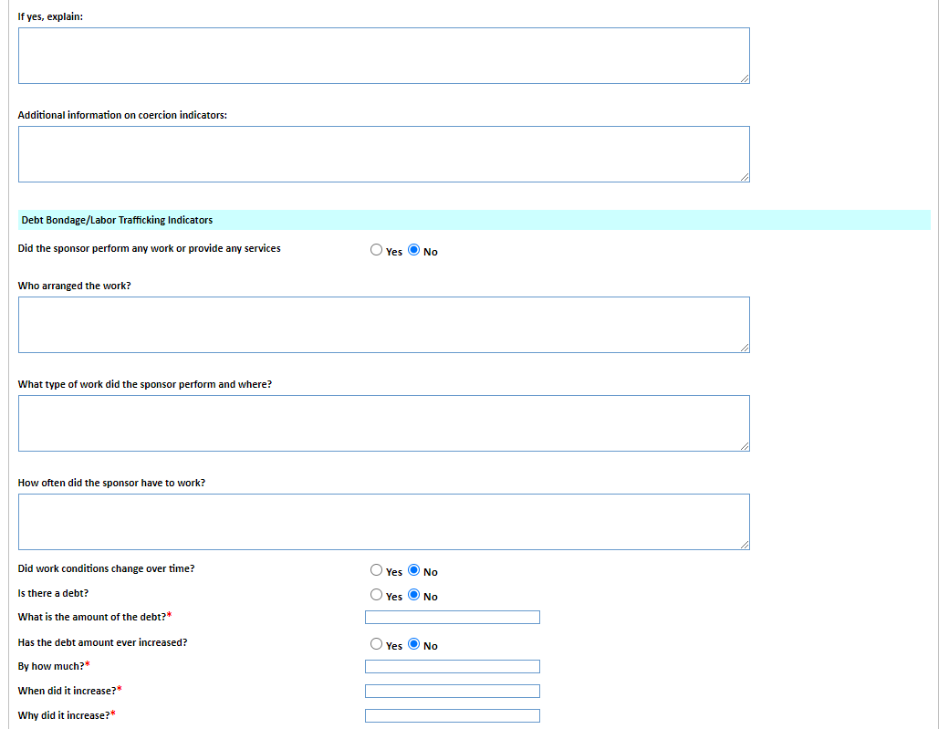



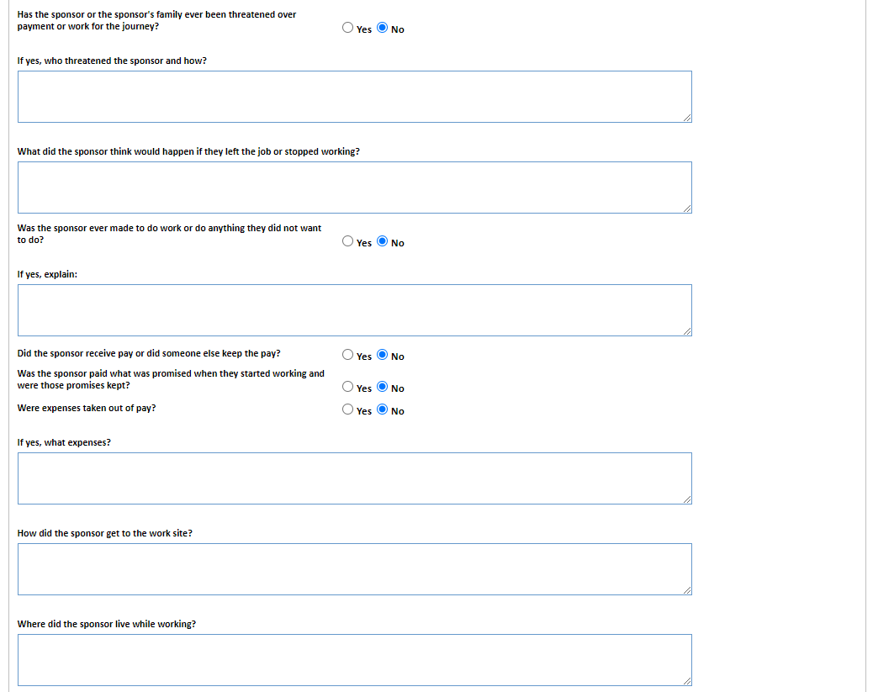



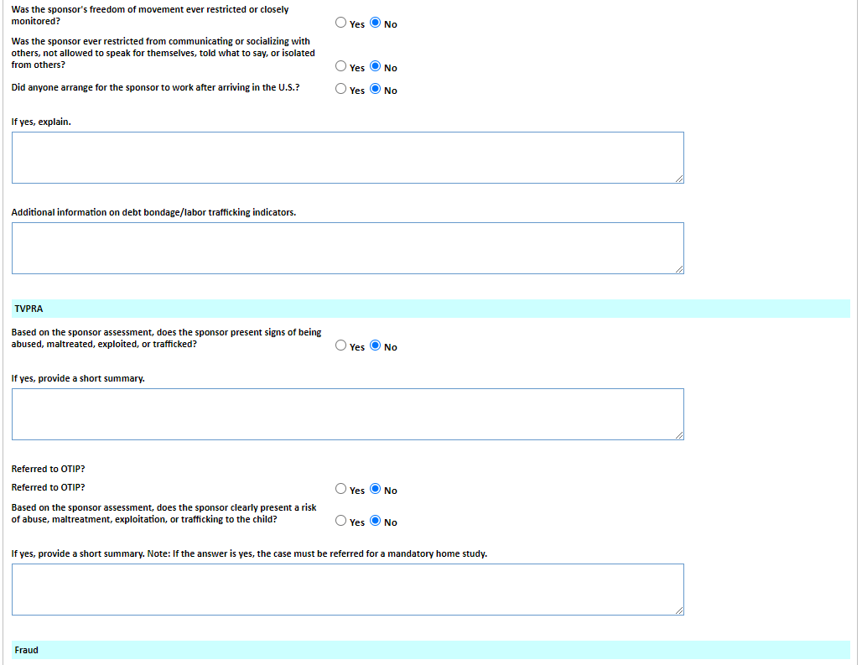



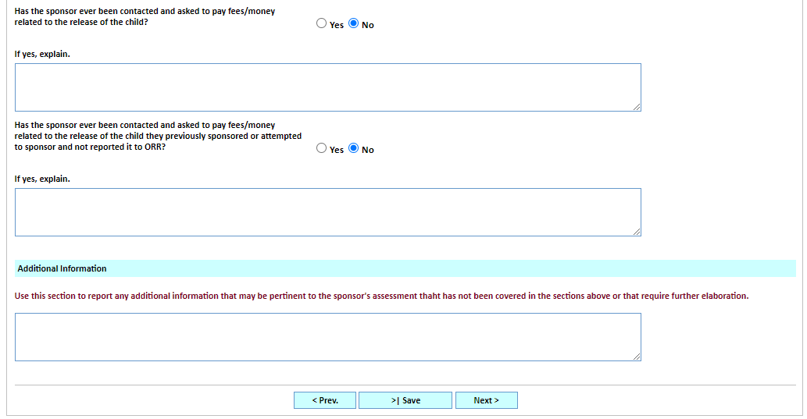



**Flags Tab**

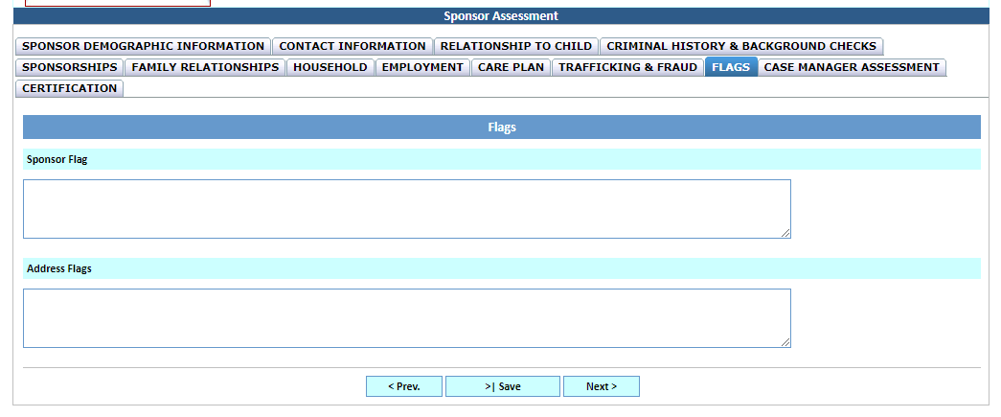

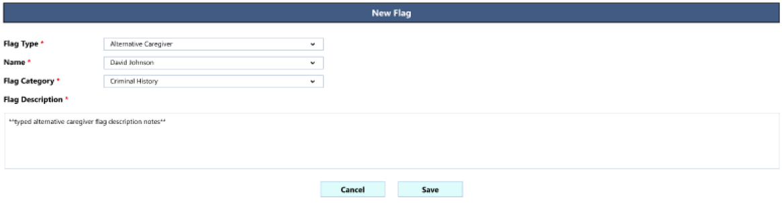

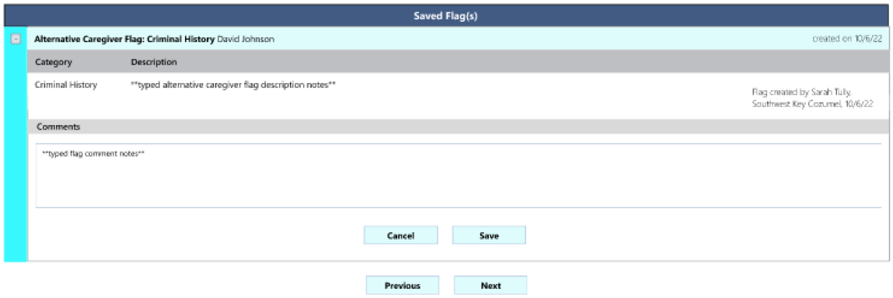

**Case Manager Assessment Tab**

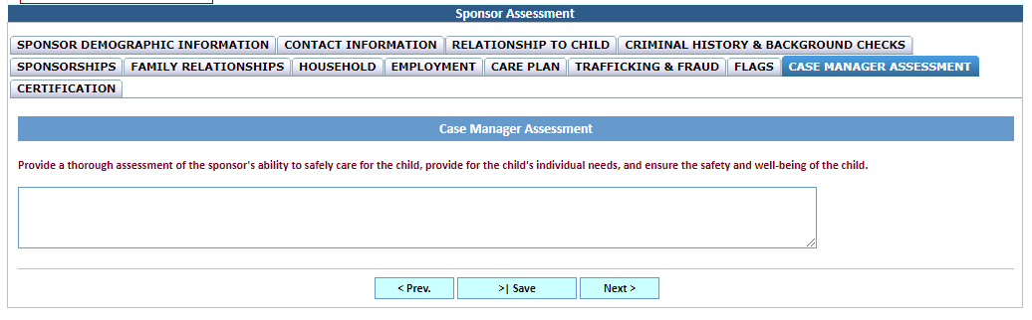

**Certification Tab**

