APPENDIX D. Youth Assent Form for Youth Focus Groups

OMB Number: 0970-0531 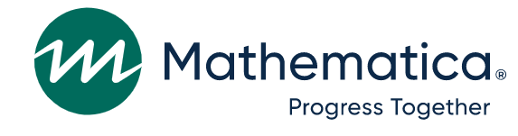Expiration Date: 09/30/2025

STATEMENT OF STUDY ASSENT FOR VOLUNTARY PARTICIPATION
Sponsored by the U.S. Department of Health and Human Services

I understand that I am taking part in a focus group. A focus group is a discussion that Mathematica will lead with youth that participated in programming through [Grantee Organization Name]. If for some reason they cannot do a focus group at my school or program site, I may be asked to do a short interview. The interview questions will be the same as the focus group questions.

The study team from Mathematica wants to learn about my thoughts during a focus group on the Adulthood Preparation Subject topics covered in the programming by [Grantee Organization Name].

During the focus group, I will be able to share my thoughts about the topics and how much I like them or do not like them. I can also share ideas about how the topics could be better. The study team will not ask me about my own behavior.

The study team person described the study to me and answered my questions. The person told me that my parent or guardian has agreed to let me take part in the discussion.

I understand I will get a $40 gift card for participating in this focus group.

Mathematica will keep everything I tell them private. That means no one outside of the study team will see my answers, like teachers, parents, or guardians, unless required by law. If the study team learns that any child participating in the focus group has been hurt or is in danger, or if I tell the study team that I plan to seriously hurt myself or someone else, then, by law, the study team must report it to the appropriate legal authorities.
- I understand the study team has asked all youth in the focus group to keep the information discussed private.
- I also know there is a chance that someone might share what is said with people outside the group.
- I understand the only risk to me during this discussion is that I might not be comfortable answering some questions. If that happens, I do not have to answer the questions. I can also stop taking part in the discussion at any time and will not get in trouble.

I understand that the study team will combine the information I share with information from other youth, and that this information will be part of their report. I understand that the study team will not identify me by name in any reporting.
If I have questions about my rights as a research volunteer or questions about the study, I can call:
- The HML Institutional Review Board, toll-free, at (202) 246-8504, or
- Alicia Meckstroth at Mathematica, at (609) 275-2205.
I understand that it is my choice to take part in the discussion and that I can stop at any time. I understand the study team will audio-record this discussion. I understand the study team will destroy the recording and notes from the session as soon as the study is complete.
Please mark your responses below:
- I agree to take part in the focus group or interview.

_____ Yes _____ No

____________________________ ____________________________ _______________
Name Signature Date

---------------------------------------------------------------------------------------------------------------------

I certify that the staff members assigned to explain the study to participants were trained to do so in terms participants would understand.
Alicia Meckstroth
APS Study Director, Mathematica

