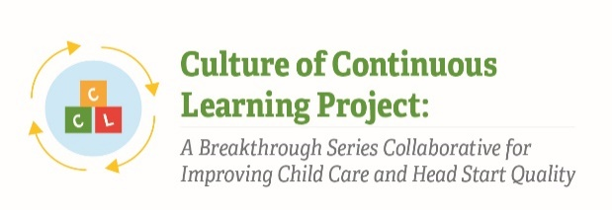

Instrument 6: Learning Session Feedback Form

Culture of Continuous Learning Project: A Breakthrough Series Collaborative for Improving Child Care and Head Start Quality

Respondents | Time of Data Collection
BSC Teams (Administrator, Teachers, Other Staff, Parent) | After each Learning Session

Note: Specific statements and questions in this overall evaluation form are illustrative; different statements and questions may be included depending on the findings discovered during the implementation process. This overall evaluation form was pulled from CCL Phase I instruments and has been adapted to meet the needs of the current project.

Statements and questions will be selected based on relevance at time of data collection such that the time to complete the evaluation form is no more than 15 minutes.

Overall Evaluation
This two-page evaluation is intended to help assess how well this Learning Session was able to meet our goals.
It is anonymous and is for planning purposes only, so please be candid!

 | Strongly Agree | Agree | Neutral | Disagree | Strongly Disagree | Comments
- The [insert session specific title] helped me achieve [insert session learning objectives]. | q | q | q | q | q
- The [insert session specific title] helped me achieve [insert session learning objectives]. | q | q | q | q | q
- Each of the Team Meetings was important to give my team time to process what we learned and translate our learning into action. | q | q | q | q | q
- The [insert session specific title] helped me achieve [insert session learning objectives]. | q | q | q | q | q
- The Affinity Group Session (Day 2 – meetings by role) allowed me to share my strengths and concerns with others in like roles from other teams. | q | q | q | q | q
- Inspiration and Commitment: Overall, I am leaving this Learning Session feeling inspired, empowered, and committed to testing improvements in my practice when I return home. | q | q | q | q | q
- Flow and Structure: This meeting had the right mix of small group and large group discussions to ensure all voices and perspectives were heard. | q | q | q | q | q
- Balanced Focus: We had the right mix of “content” work (focus on social and emotional learning) and ‘process’ work (using the Driver Diagram, the Model for Improvement, PDSAs) to continue moving this work forward. | q | q | q | q | q
- Overall: This Learning Session was a good use of my time, with a solid focus, engaging activities, and concrete results. | q | q | q | q | q
The Paperwork Reduction Act of 1995 (Pub. L. 104-13) Statement: This collection of information is voluntary and will be used to help team members reflect on their experience and provide feedback to the implementation staff and faculty that can be used to improve the BSC. Public reporting burden for this collection of information is estimated to average 15 minutes per response, including the time for reviewing instructions, gathering and maintaining the data needed, and reviewing the collection of information. An agency may not conduct or sponsor, and a person is not required to respond to, a collection of information unless it displays a currently valid OMB control number. The OMB number and expiration date for this collection are OMB #: 0970-XXXX, Exp: XX/XX/XXXX. Send comments regarding this burden estimate or any other aspect of this collection of information, including suggestions for reducing this burden to Kathryn Tout, ktout@childtrends.org or Child Trends, 708 N 1st Suite #333 Minneapolis, MN 55401 Attention: Kathryn Tout

- What (if anything) surprised you about this Learning Session?

- Please use the space below to comment on what you thought was best about the Learning Session.

- Please use the space below to comment on what you thought could most use improvement about this Learning Session.

- Please use the space below to provide any other reflections, comments, or recommendations you have about the Learning Session or the BSC overall.

