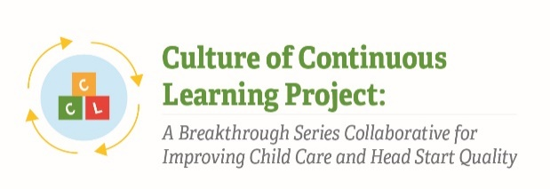

Instrument 7: Action Planning Form

Culture of Continuous Learning Project: A Breakthrough Series Collaborative for Improving Child Care and Head Start Quality

Respondents | Time of Data Collection
BSC Teams (Administrator, Teachers, Other Staff, Parent) | End of each Learning Session

Note: Specific questions in this form are illustrative; different questions may be included depending on the findings discovered during the implementation process. This Action Planning Form was pulled from CCL Phase I instruments and has been adapted to meet the needs of the current project.

Questions will be selected based on relevance at time of data collection such that the time to complete the Action Planning Form is no more than 15 minutes.

Action Planning: Where Should We Begin?

Driver being addressed | How will we do it? |  | How will we measure success? | Who will do it? | When will it get done? | How will we follow up?
What is the secondary driver we are trying to address with this PDSA cycle? | What change will be tested? | What tasks need to be done to prepare for the test? (Gather data, bring in more people, create materials, inform staff or leader, etc.) | What metric, data, or outcome will we be watching to see if this change is making things better? | Who will have primary responsibility? Who else needs to be involved? | What are the short-term timelines | How will we keep track of our progress on this? How will it be shared with the rest of the team?

The Paperwork Reduction Act of 1995 (Pub. L. 104-13) Statement: This collection of information is voluntary and will be used to help teams focus their thinking on next steps for improvement. Public reporting burden for this collection of information is estimated to average 15 minutes per response, including the time for reviewing instructions, gathering and maintaining the data needed, and reviewing the collection of information. An agency may not conduct or sponsor, and a person is not required to respond to, a collection of information unless it displays a currently valid OMB control number. The OMB number and expiration date for this collection are OMB #: 0970-XXXX, Exp: XX/XX/XXXX. Send comments regarding this burden estimate or any other aspect of this collection of information, including suggestions for reducing this burden to Kathryn Tout, ktout@childtrends.org or Child Trends, 708 N 1st Suite #333 Minneapolis, MN 55401 Attention: Kathryn Tout

