
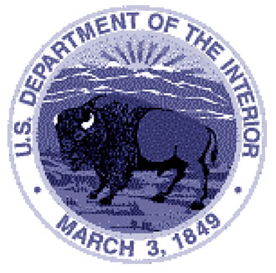

United States Department of the Interior

NATIONAL PARK SERVICE

UNITED STATES PARK POLICE
Headquarters
1100 Ohio Drive, S.W.
Washington, D.C. 20024

IN REPLY REFER TO:

August 9, 2019

Memorandum

To: Members of the Applicant Processing Team

From: Major Richard J. Pope, Commander Training Branch

Subject: The Rehabilitation Act of 1973 and the Force Applicant Process

As members of the Force Applicant Processing Team we are charged with determining the qualifications of applicants in order to recommend for selection the best possible candidate. The screening process is very detailed and has a proven history of success. As in the past, members of the Force Applicant Processing Team continue to recruit, screen and recommend for hire the most qualified candidates following the EEOC’s Guidance provided:

- EEOC, Enforcement Guidance: Pre-employment Disability-Related Questions and Medical Examinations https://www.eeoc.gov/policy/docs/preemp.html
- EEOC, Enforcement Guidance: Disability-Related Inquiries and Medical Examinations of Employees Under the Americans with Disabilities Act https://www.eeoc.gov/policy/docs/guidance-inquiries.html

As a reminder it is your responsibility to review the guidance and apply the principles to our process. This will include careful consideration of responses on the application forms. Specifically, Team members must not request additional medical information from the applicant or from anyone else (such as a former prospective employer). NPS may not remove the applicant from consideration because of a previous denial of employment for medical reasons, if the applicant is able to perform the essential functions of a position with the USPP without posing a direct threat (i.e. significant risk of substantial harm to the individual or others).

