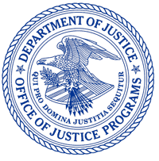
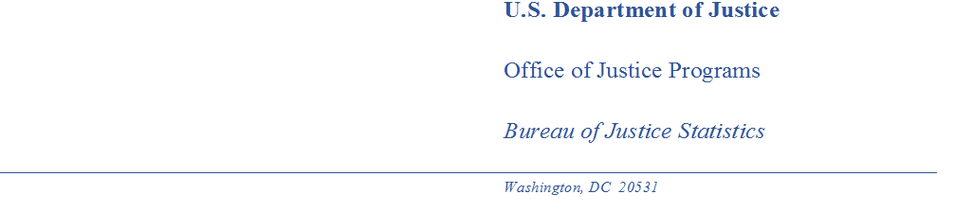

MEMORANDUM

TO: Robert G. Sivinski
Office of Statistical and Science Policy
Office of Management and Budget

THROUGH: Alexis R. Piquero, PhD
Director
Bureau of Justice Statistics

Kevin M. Scott
Principal Deputy Director

Rachel Hansen
Chief, Reentry, Recidivism, and Special Projects Unit

FROM: Michael B. Field
Statistician, Reentry, Recidivism, and Special Projects Unit

DATE: July 11, 2023

SUBJECT: Nonsubstantive change notification for the National Inmate Survey – Jails: OMB Control No. 1121-0376

The Bureau of Justice Statistics (BJS) is notifying OMB of a nonsubstantive change to the National Inmate Survey – Jails (NIS4-J) under OMB Control No: 1121-0376 (expiration date 01/31/2026). The change will add a small food incentive to facility staff and make minor edits to the inmate consent forms.

Under the Prison Rape Elimination Act of 2003 (PREA; P.L. 108-79), the Bureau of Justice Statistics created the National Prison Rape Statistics Program, including the National Inmate Survey (NIS). The NIS-4 is the fourth iteration of the NIS and collects information on sexual victimization self-reported by inmates held in adult correctional facilities, both prisons and jails. Westat was competitively awarded a cooperative agreement to, under BJS’s direction, administer this data collection to jails.

Providing staff incentive

Due to widespread understaffing and general lack of jail staff engagement, resulting in low response rates with inmates within those facilities, BJS and Westat wish to consider offering food to facility staff in the hopes that will encourage them to cooperate with Westat interviewers and more willing to assist fully in escorting sampled inmates to the interview. BJS does not expect this to have any change to the estimated burden for this study.

Westat will coordinate with their facility contacts whether food delivery is allowable at the facility, which day of the visit to provide the food, and the preferred food for delivery (e.g., coffee, donuts, pizza). The delivered food is not intended for inmates for their participation but to motivate facility staff to bring inmates to the interviews in an effective manner.

Edited consent documents

Interviewers have provided feedback to BJS on two pieces of the consent process that seemed to be causing hesitation among inmates: the interviewer’s default position of wearing a medical facemask and the interviewer script using third person language. BJS has edited the inmate consent form and interviewer script to address these concerns (Attachments A and B).

BJS and Westat developed the survey protocol during COVID and, to protect interviewers and inmates, instituted mandatory masking for all interviewers in facilities. As the pandemic has ended, however, interviewers have reported that they are the only persons at some facilities wearing masks and that is causing some discomfort among inmates. The consent form and protocol have been changed to instead have interviewers follow the facility’s guidelines on masking by default and give the inmate an option to request the interviewer wear a mask.

Interviewers have a script they read along with the inmate’s consent form. The original script used third person throughout to refer to the interviewer. Interviewers have reported that some inmates have found this confusing. To address this, we have edited the interviewer script to refer to the interviewer in first person.

Summary

BJS is notifying OMB of the addition of a small food incentive to facility staff and minor edits to the inmate consent forms. We will work to expeditiously respond to any OMB inquiries and/or requests for additional information.

Thank you in advance for your time and consideration.

