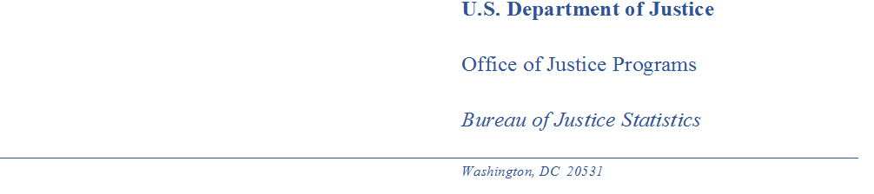

MEMORANDUM

TO: Robert G. Sivinski
Office of Statistical and Science Policy
Office of Management and Budget

THROUGH: Alexis R. Piquero, PhD
Director
Bureau of Justice Statistics

Kevin M. Scott
Principal Deputy Director

Rachel Hansen
Chief, Reentry, Recidivism, and Special Projects Unit

FROM: Michael B. Field
Statistician, Reentry, Recidivism, and Special Projects Unit

DATE: July 11, 2023

SUBJECT: Nonsubstantive change notification for the National Inmate Survey – Prisons: OMB Control No. 1121-0311

The Bureau of Justice Statistics (BJS) is notifying OMB of a nonsubstantive change to the National Inmate Survey – Prisons (NIS4-P) under OMB Control No: 1121-0311 (expiration date 01/31/2026). The change will add a small food incentive to facility staff.

Under the Prison Rape Elimination Act of 2003 (PREA; P.L. 108-79), the Bureau of Justice Statistics created the National Prison Rape Statistics Program, including the National Inmate Survey (NIS). The NIS-4 is the fourth iteration of the NIS and collects information on sexual victimization self-reported by inmates held in adult correctional facilities, both prisons and jails. RTI International was competitively awarded a cooperative agreement to, under BJS’s direction, administer this data collection to prisons.

Providing staff incentive

Due to widespread understaffing and general lack of facility staff engagement, resulting in low response rates with inmates within those facilities, BJS and RTI wish to consider offering food to facility staff in the hopes that will encourage them to cooperate with RTI interviewers and more willing to assist fully in escorting sampled inmates to the interview. BJS does not expect this to have any change to the estimated burden for this study.

RTI will coordinate with their facility contacts whether food delivery is allowable at the facility, which day of the visit to provide the food, and the preferred food for delivery (e.g., coffee, donuts, pizza). The delivered food is not intended for inmates for their participation but to motivate facility staff to bring inmates to the interviews in an effective manner.

Summary

BJS is notifying OMB of the addition of a small food incentive to facility staff. We will work to expeditiously respond to any OMB inquiries and/or requests for additional information.

Thank you in advance for your time and consideration.

