U.S. Department of Treasury
Community Development Financial Institutions Fund

Allocatee (CDE)
Transaction Level Report Data Point Guidance for
AMIS
(July 2023)

Table of Contents

Getting Started 3
Certifying TLRs 15
What’s New in the NMTC Allocatee TLR Guidance? 22
Generating NMTC Reports 25
Understanding the Data Point Boxes 27
CDE Transaction Level Report – Data Point Guidance 31
Notes-Investments 31
TLR Projects Tab 59
TLR Address 106
Loan Source and Disbursements 120

Getting Started
Transaction Level Reports are now in the CDFI Fund’s Awards Management Information System (AMIS). For an overview of the data field changes made, review the “CIIS to AMIS Crosswalk NMTC TLR” guide.

AMIS provides two ways users can create their Transaction Level Report (TLR):
- Manual entry of your Transaction Level Report (TLR) through the AMIS User Interface (UI)
- Upload of multiple TLR records through either a CSV file template or an XML schema

Disclosure

The CDFI Fund may upon request provide information collected and any associated reporting submitted by the Allocatee to an appropriate federal, state, tribal, local, international, or foreign law enforcement agency or other appropriate authority charged with investigating or prosecuting a violation or enforcing or implementing a law, rule, regulation, or order.

Manual Entry
To manually begin your Transaction Level Report (TLR), log into AMIS and click on the TLR Projects tab located in the “More” dropdown.
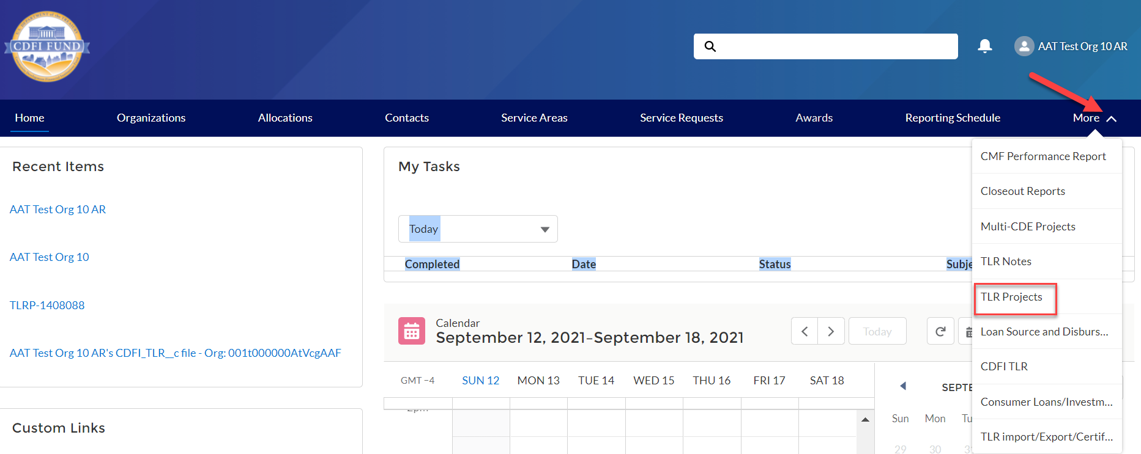
Once on the TLR Projects Tab, click the “New” button.
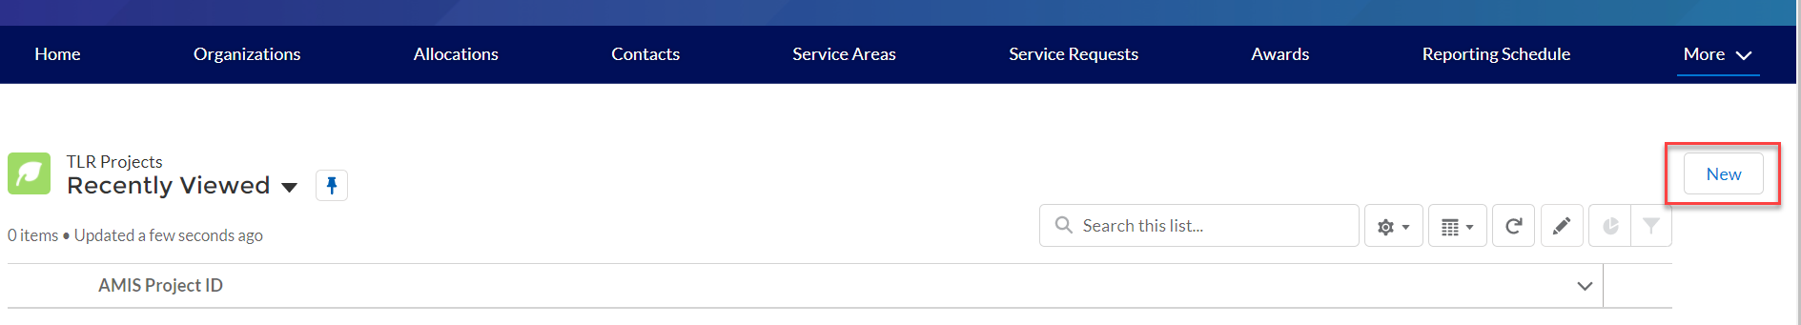
Enter the name of your organization in the “Organization” field and click “Next” to go to the TLR Project detail page to fill out the information based on the Data Points listed in the guide. You can click the search icon to search the list of organizations you are permitted to access.
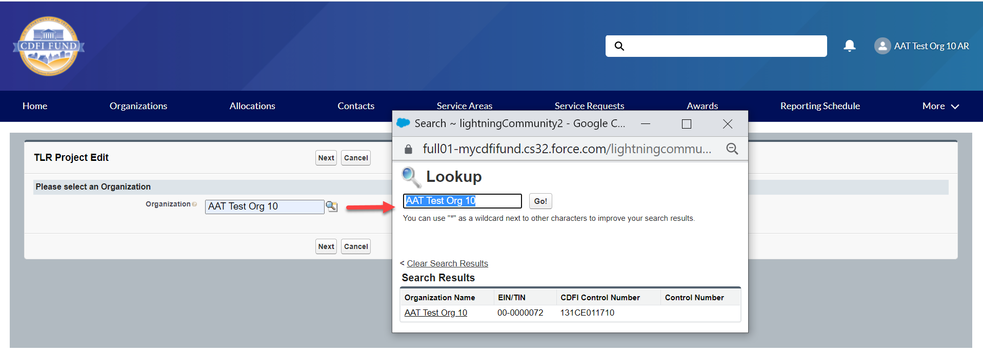
Once you have completed and saved your TLR Project record, click on the TLR Notes Tab located in the “More” dropdown.
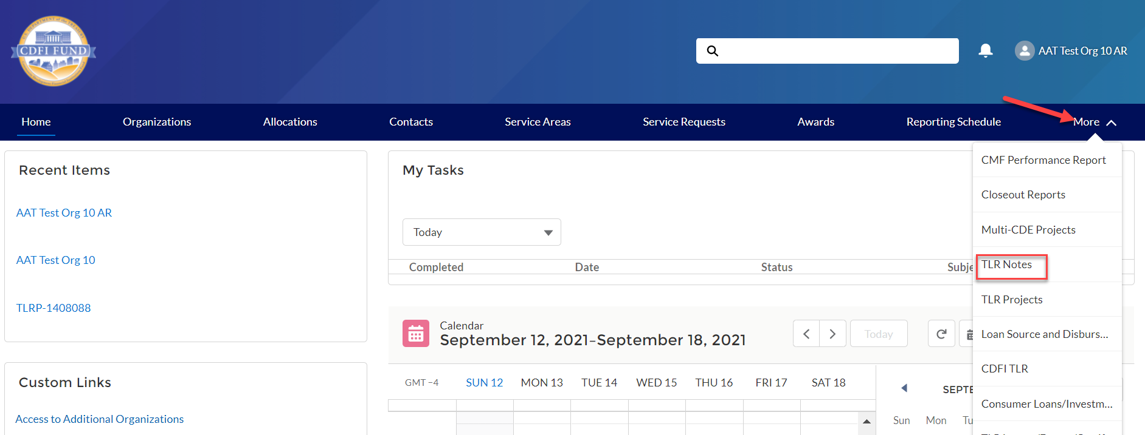
Click the “New” button. Fill out the information based on the Data Points listed in the guide.
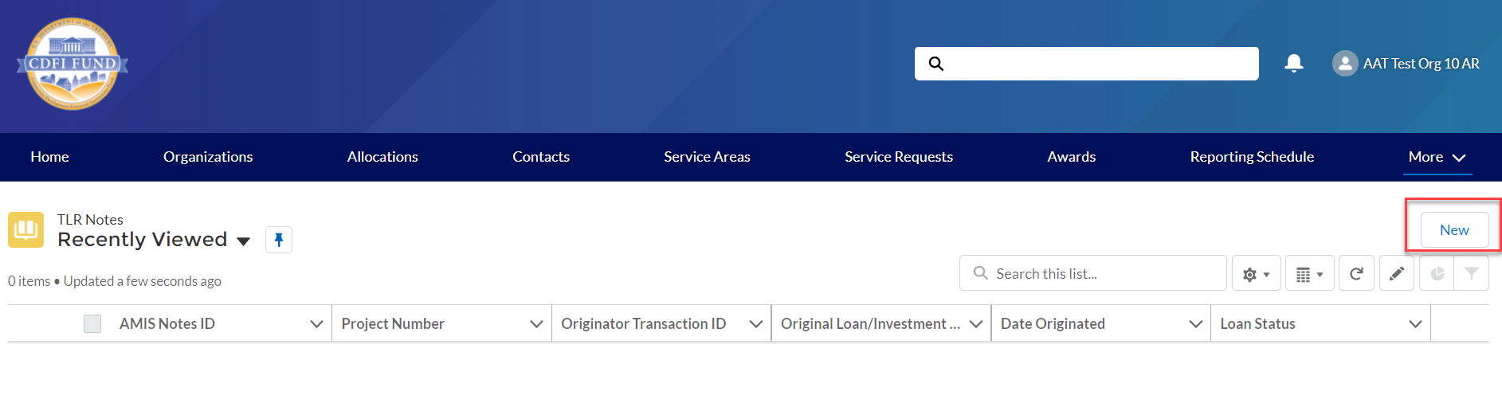
Once you have finished filling out and saving your TLR Note record, scroll down the page to the Loan Source and Disbursements related list (located on the TLR Note record – Related Tab). Click the “New” button. Fill out the information based on the Data Points listed in the guide.
Once you have completed and saved your Loan Source record, click on the TLR Projects Tab again, click on the new record you created and then click on the “New Address” button. Fill out the information based on the Data Points listed in the guide.

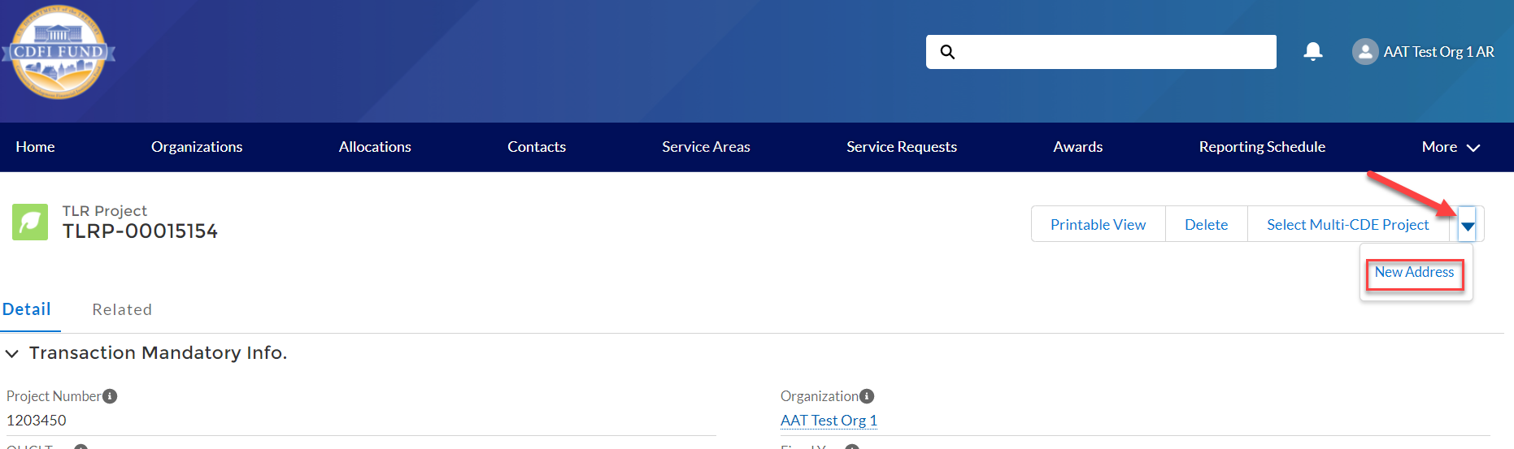
CSV File Upload
To create multiple TLR records at one time, AMIS allows users to upload CSV files to load via a file import graphic interface. Click on the "TLR Import/Export/Certify" tab in the menu bar to get started.
Note: Please use the “General” cell formatting for CSV file uploads.
Note: Since templates change from time to time, it is always best practice to download new templates before beginning a file upload process.
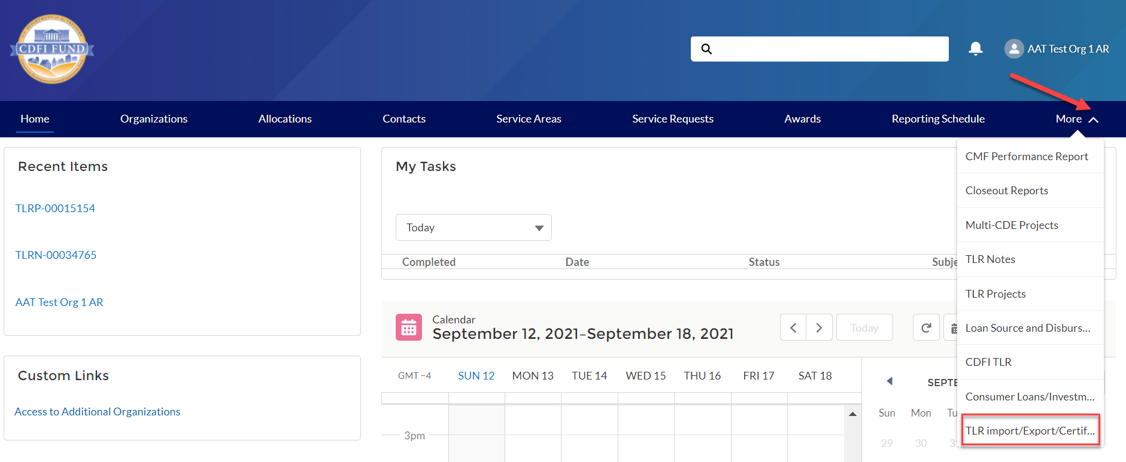
Use the "Organization Name" field to enter the organization’s name to create the TLR records. Click the search icon to see a list of the organizations to which you are associated.

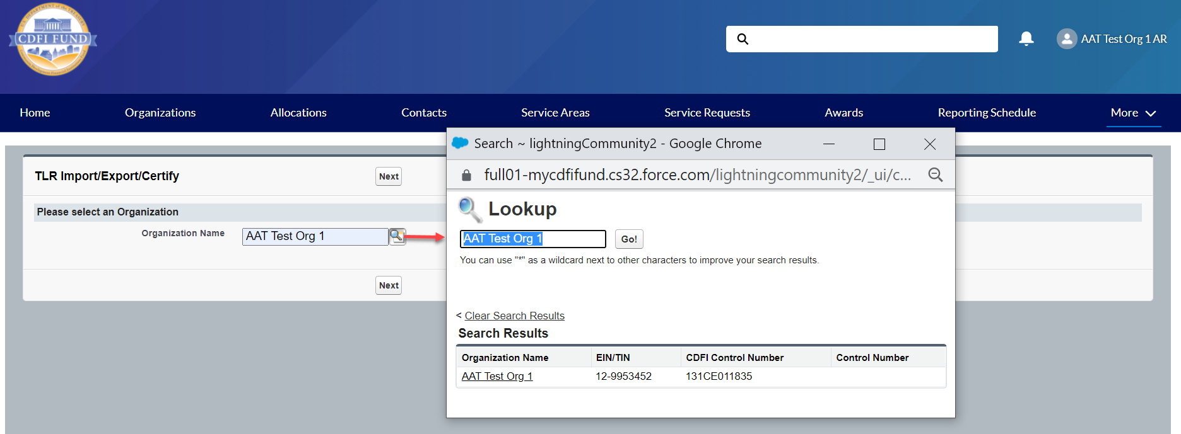

Click the "New_NMTC_TLR_Project.CSV" link to download the template.

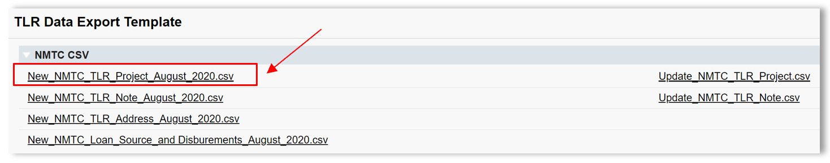
Open the CSV file and take a moment to review what each row represents:
Row 1 = Field label
Row 2 = Field type
Row 3 = Options to choose from when filling out the cells, if applicable.
Row 4 = Help Text
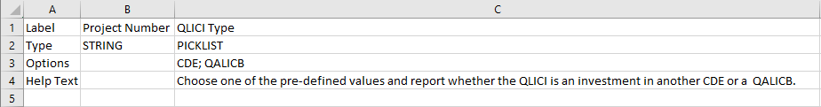
Use row 5 and on in the CSV file to fill out your answers for the labels (fields) in row 1.
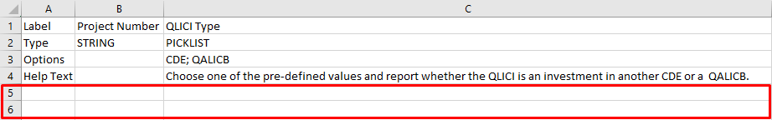
Use the Help Text on the CSV sheet in row 4 as needed to fill out your data.
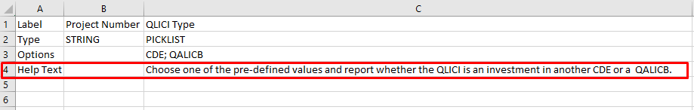
After you save the file, return to the AMIS portal and click the "Import New TLR Project" Link.
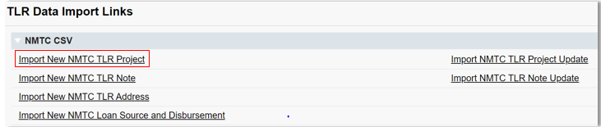
Click on “Add Files” and select the document to be uploaded.

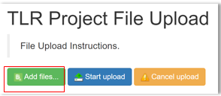
The upload document must be formatted in Microsoft Excel Comma Separated Values File (.csv). If the wrong file is selected in error, click on “Cancel Upload.”

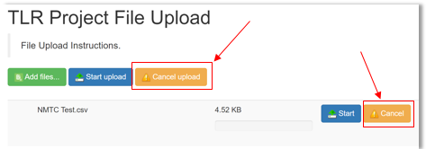
- Once the correctly formatted document is selected, click on “Start Upload”

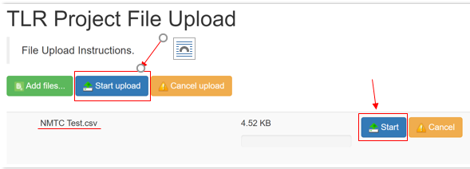
- If the uploaded file is in the wrong format or uses an outdated template, AMIS will automatically generate an error message and provide the user with the correct template. Click on “Download Template,” transfer TLR data on to the new template and resume the upload process.

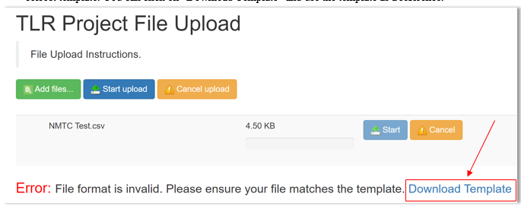
- The correct template can also be found by navigating to Import/Export/Certify tab and clicking on “New_NMTC_TLR_Project_August_2020.csv.”

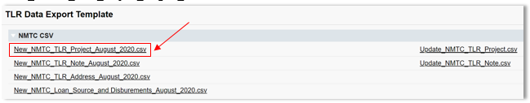

- To cancel an upload mid-progress, click on “Cancel Upload.” This will delete any document already selected. To start a new upload, click on “Add Files,” select the correct upload document and click “Start Upload.”

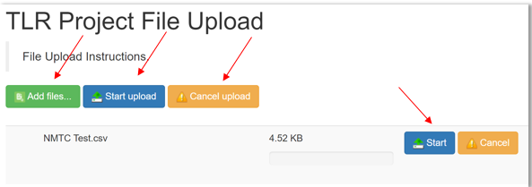
Once the document is uploaded into the AMIS, the user will see a list of errors found in uploaded data. The number of error messages will be displayed along with the Error Message, Error Row and Field name where the error was found.

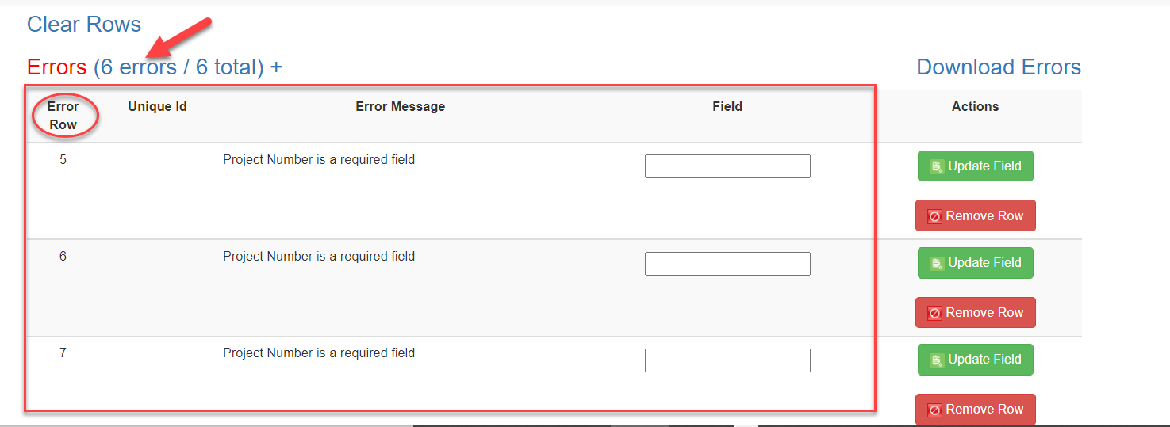
- Users can update incorrect data on the page by entering the correct data and then clicking “Update Field.” If AMIS accepts the new entry, the error will go away. If the newly entered data is still incorrect, AMIS will not save the row and the error will remain on the screen.

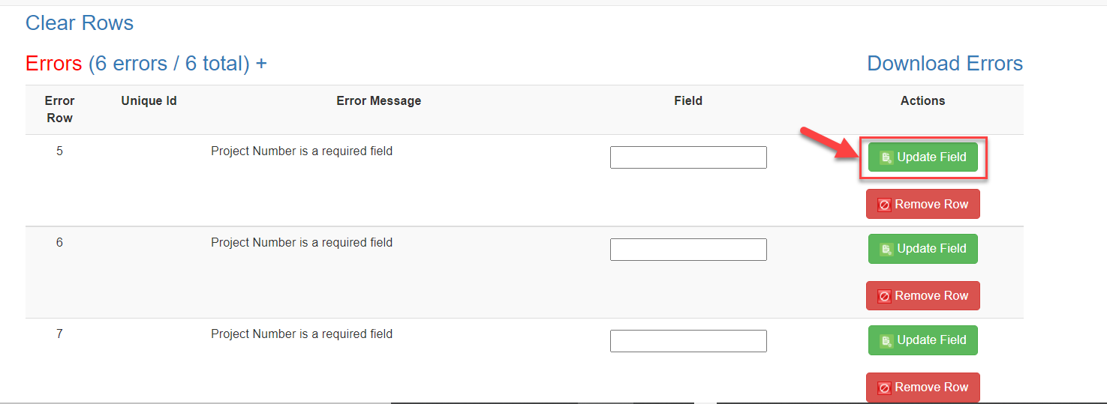
Note: If you receive an error on the Project Number field that indicates that the Project Number already exists, please contact the AMIS Help Desk at AMIS@cdfi.treas.gov for help.

- If the user decides not to upload a specific row, the row may be removed by clicking the red “Remove Row” button. If the user decides not to upload any of the rows, all rows may be removed by clicking “Clear Rows.”

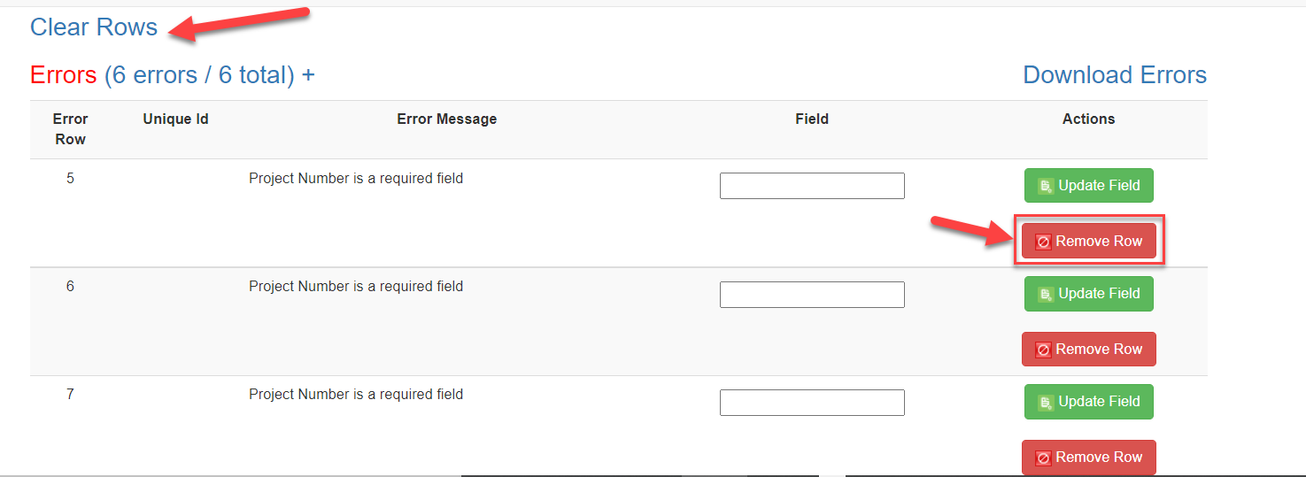

- Alternatively, users can fix errors in their upload data by clicking “Download Errors” and downloading a file containing uploaded data and corresponding error message. The error file can be used to make changes in the original upload file.

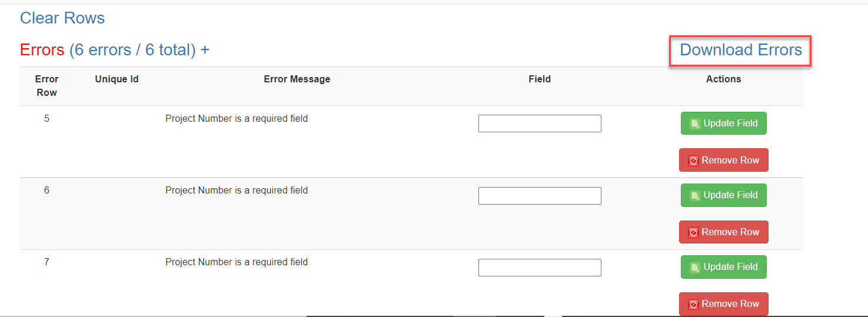

- Once all the incorrect entries have been fixed and the data is uploaded again, users will see a message indicating that no errors were found. To view a file containing all the data that will be successfully uploaded into AMIS, users can click on “Download Submission Preview.”

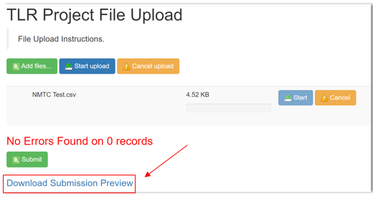

- To submit the finalized data, click “Submit.”

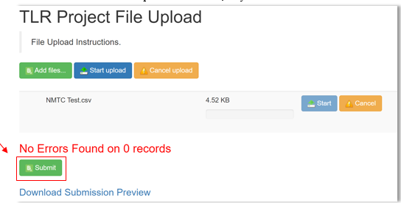

XML File Upload
To create multiple TLR records at one time, AMIS allows users to upload files using an XML schema. To get started click on the "TLR Import/Export/Certify" tab located in the “More” dropdown.
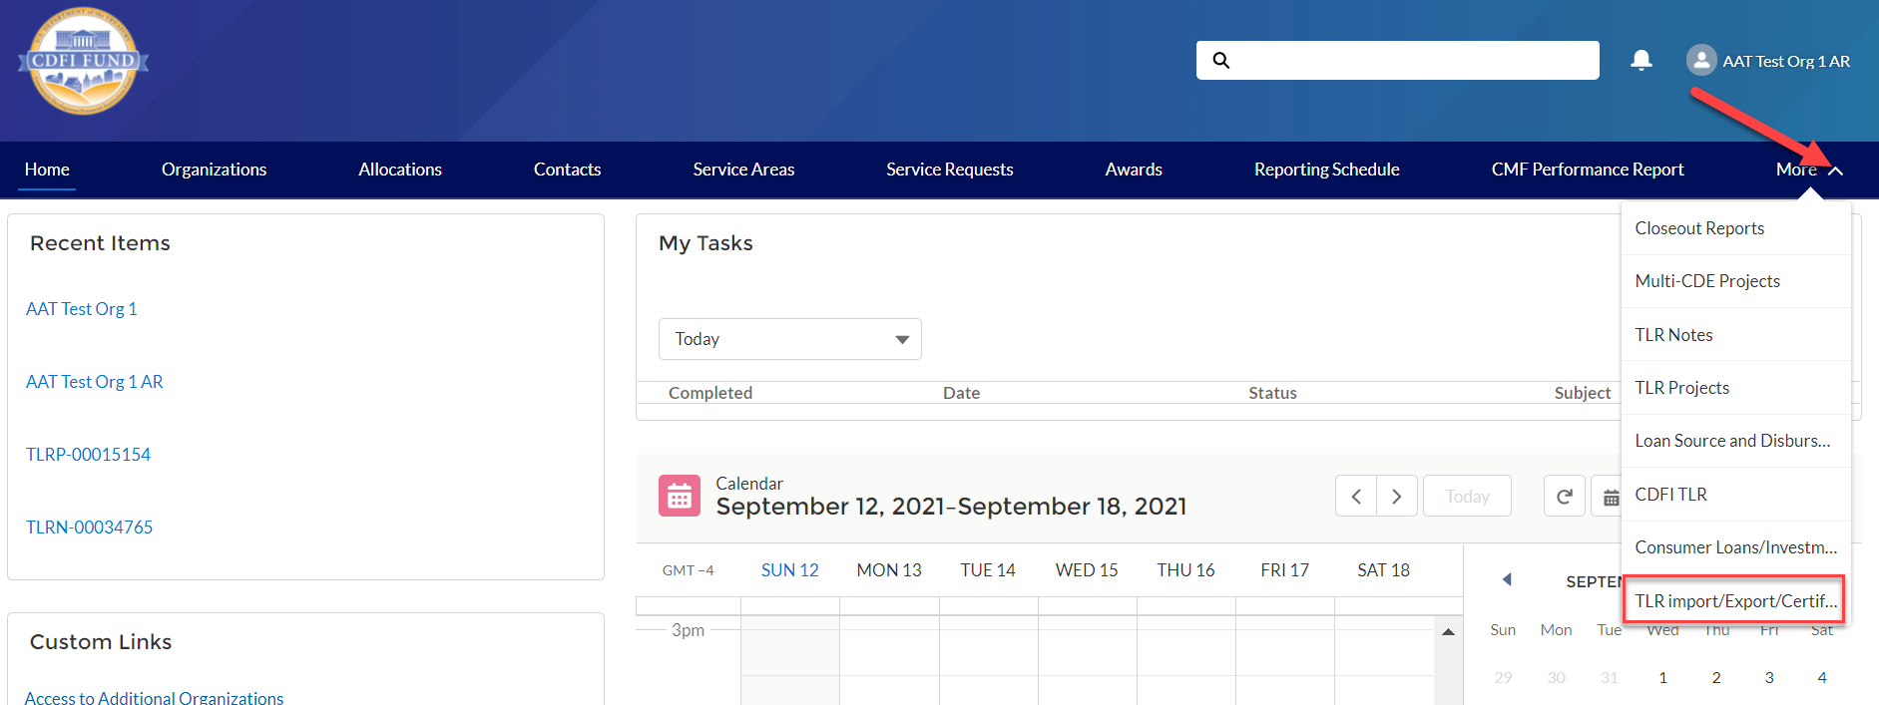
Use the "Organization Name" field to enter the name of the organization for which you are submitting TLR records. You may also select the Organization Name from a list by clicking on the search icon next to the “Organization Name” field and choosing from a list of organizations you are permitted to access.
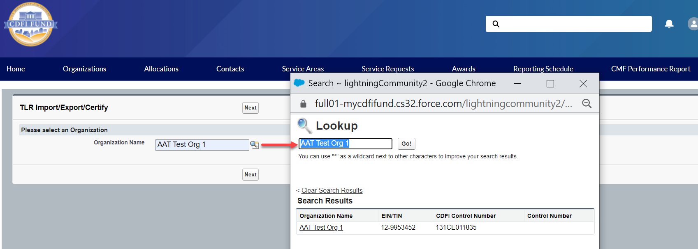
Click the "NMTC_TLR_Xml_Schema.xsd" link to download the XML Schema to use when generating an XML file. XML attribute names contain no spaces, but are otherwise identical to the corresponding data guidance field name.
To submit updates to existing projects, click the “Update_NMTC_TLR_Data.xml” link to download an XML file of current project data already in AMIS. The update template will contain a list of existing TLR Projects that are within the 7-year update window along with their annually updatable fields. Please note that only fields marked as “Annual Update Required” in the Allocatee TLR Data Point Guidance document, are required or allowed to be updated.
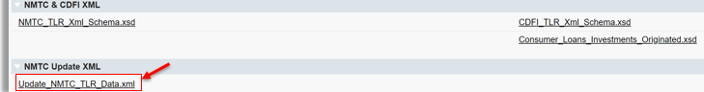
After you fill out and save the file, back on the AMIS portal, click the "Import_XML_NMTC_TLR” link.
Click on “Add Files” and select the document to be uploaded.

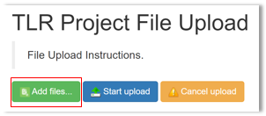
The upload document must be formatted in Extensible Markup Language (.xml). If the wrong file is selected in error, click on “Cancel Upload.”

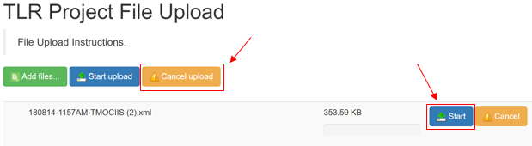
- Once the correctly formatted document is selected, click on “Start Upload”

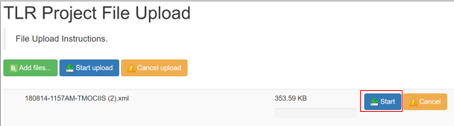

- If the uploaded file is in the wrong format or uses an outdated template, AMIS will automatically generate an error message and provide the user with the correct template. Click on “Download Template,” transfer TLR data on to the new template and resume the upload process.

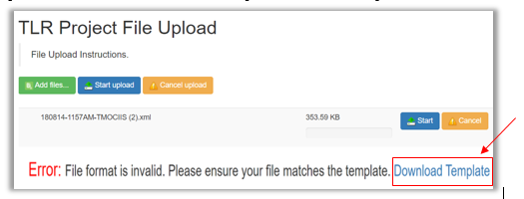
- The correct template can also be found by navigating to Import/Export/Certify tab and clicking on “New_NMTC_TLR_XML_Schema.xsd.”

- Follow the steps 4 through 10 outlined above in the CSV File Upload section.

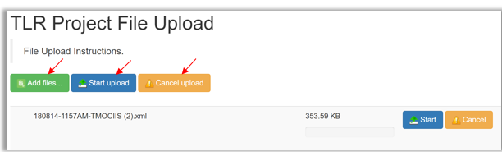

Certifying TLRs
To certify your TLRs, navigate to the “TLR Import/Export/Certify” tab and enter the name of your organization. The earliest Fiscal Year available for certification will be displayed next to the Certification buttons.
Starting August 2020, users have the option to certify data when the data is available -- prior to the reporting due date -- by using the “Interim Certification” button. Once all TLR records for a fiscal year are Interim Certified, users are required to close out the certification window for that fiscal by using the “Final Certification” button.
Interim Certification
To certify records as you go throughout the fiscal year, use the “Interim Certification” button. Users can continue to add records after Interim Certification.
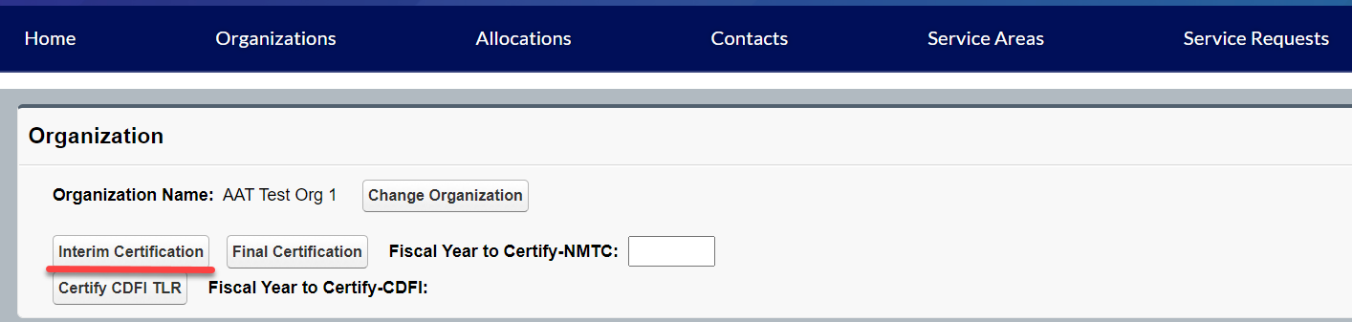
Please Note:
- Each TLR Project must have an active Note to be considered for Interim Certification.
- Each TLR Project must have at least one Address to be considered for Interim Certification
- Each TLR Note must have at least one Loan Source and Disbursement.
If a Project or Note record is missing any of these requirements, AMIS will not certify the records.
Upon clicking the “Interim Certification” button, AMIS pulls all the records that meet the prescribed criteria and runs a final check on the data to ensure that all records meet the data validation rules.
The system counts the following:
- The number of records that have been Interim Certified for that reporting period;
- The number of records that have been submitted but not Interim Certified;
- The number of records that have been submitted but did not pass the validation check (records with errors); and
- The number of records that will be Interim Certified if the user decides to proceed with certification (records without errors).
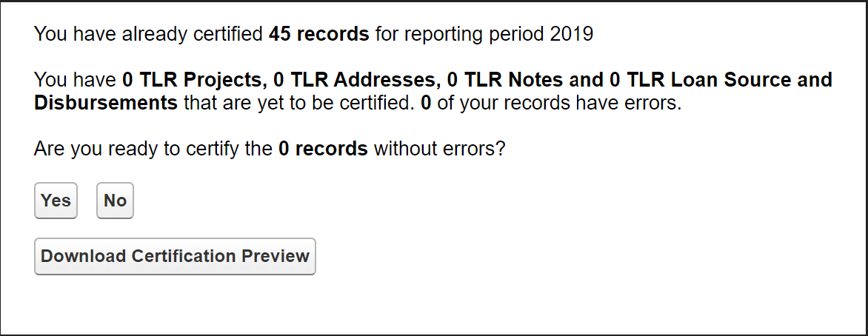
Users have the option of previewing the data compiled by AMIS before certification by clicking “Download Certification Preview.” The first column of the preview file shows the status of a given record. If a record failed a validation, the file shows the data field that caused the record to fail and the validation rule that was not met. To proceed with Interim Certification, click “Yes” when asked if you are ready to submit the records without errors. Users will then be directed to the certification statement page and once they click “Certify NMTC TLR” all submitted TLRs that passed the validation check (all submitted records without errors) will be Interim Certified.
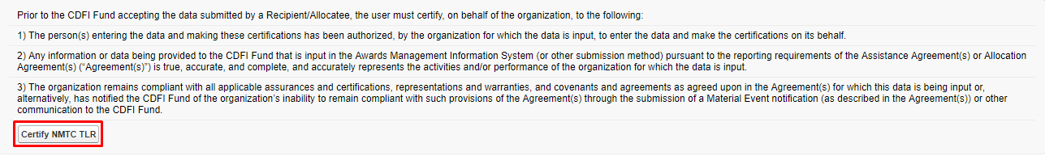
Final Certification
Final Certification for the NMTC TLR is due 180 days after the end of an Organization’s Fiscal Year. Final Certified TLR records will be locked from any editing. The status of the TLR Report as reflected in the AMIS Reporting Schedule (i.e., “Submitted,” “Pending Receipt”, “Submitted-Overdue” etc.) is determined on the date the user runs the “Final Certification” process. The “Final Certification” process closes out the Fiscal Year for any further certification.
Final Certification involves both the reporting of new transactions and changes to the “Annual Update Fields” for “active” transactions that were reported in the prior year.
Note: Once Final Certification has been processed, users can no longer submit/certify records for a given Fiscal Year.

Annual Update Fields
At the beginning of an Organization’s fiscal year, the TLR records that were entered and certified in previous fiscal years will be unlocked so that the user can update “Annual Update” fields (these are the only fields the user will be able to successfully edit). Once users have made the appropriate annual updates to their TLR records, they will be able to proceed with Interim Certification and Final Certification of the TLR. Again, after Final Certification, all the records will be locked from editing until the next fiscal year.
Object | Annual Update Fields
TLR Project | -Actual Jobs Created (Construction)  -Actual Jobs Created (Financed)  -Actual Jobs Created (Tenant)  -Annual Gross Revenue (Reporting Period)
TLR Note | -Amount Charged Off  -Amount Recovered  -Days Delinquent  -Loan Status  -Number of 60 Days or More Delinquent  -Number of Times the Loan Restructured  -Original Loan/Investment Amount  -Principle Balance Outstanding  -Term  -QLICI Level

There are three ways to update existing records.
      - Manually update each record from the User Interface (UI).
      - Use the CSV file upload functionality. See below for directions.
      - Use the XML file upload functionality. See below for directions.

CSV Upload Functionality

            - Go to the TLR Import/Export/Certify Page.
            - Search for the organization you are associated with and download the two update templates called Update_NMTC_TLR_Project.csv and Update_NMTC_TLR_Note.csv.

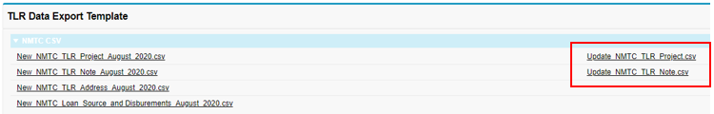

            - Make any necessary modifications to the records on each template.
            - Upload your updates using the import NMTC TLR Project Update and Import NMTC TLR Note Update import data links. The rest of the process follows the regular CSV File Upload process.

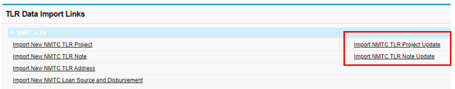

XML Upload Functionality
Updates are also possible through the XML File Upload process on the TLR Import/Export/Certify Page, using the Update NMTC TLR Data.XML template and the Import XML NMTC TLR link

To check whether a TLR Project has successfully been certified (i.e. has undergone Final Certification), navigate to the “TLR Projects” tab located in the “More” dropdown.
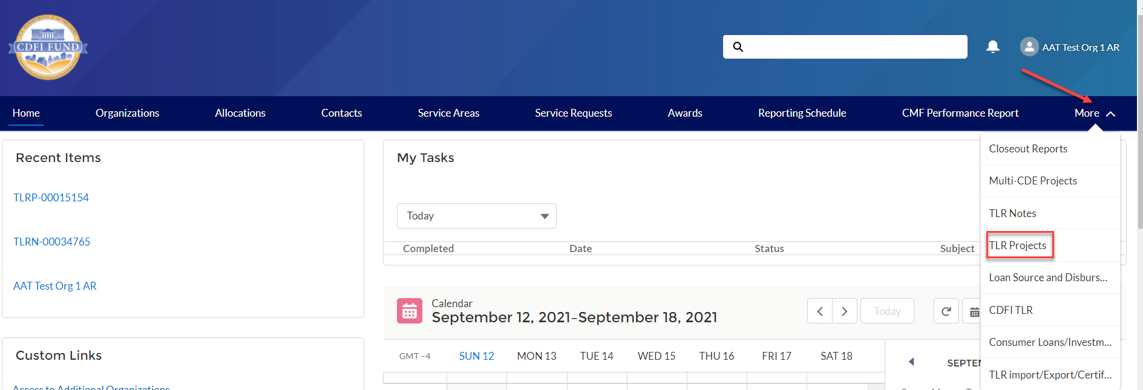
Select “All” from the “View” list.
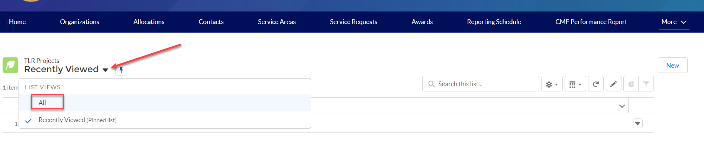

All TLR Project that have successfully passed through Final Certification will have a date displayed under “Last Certified Date.”
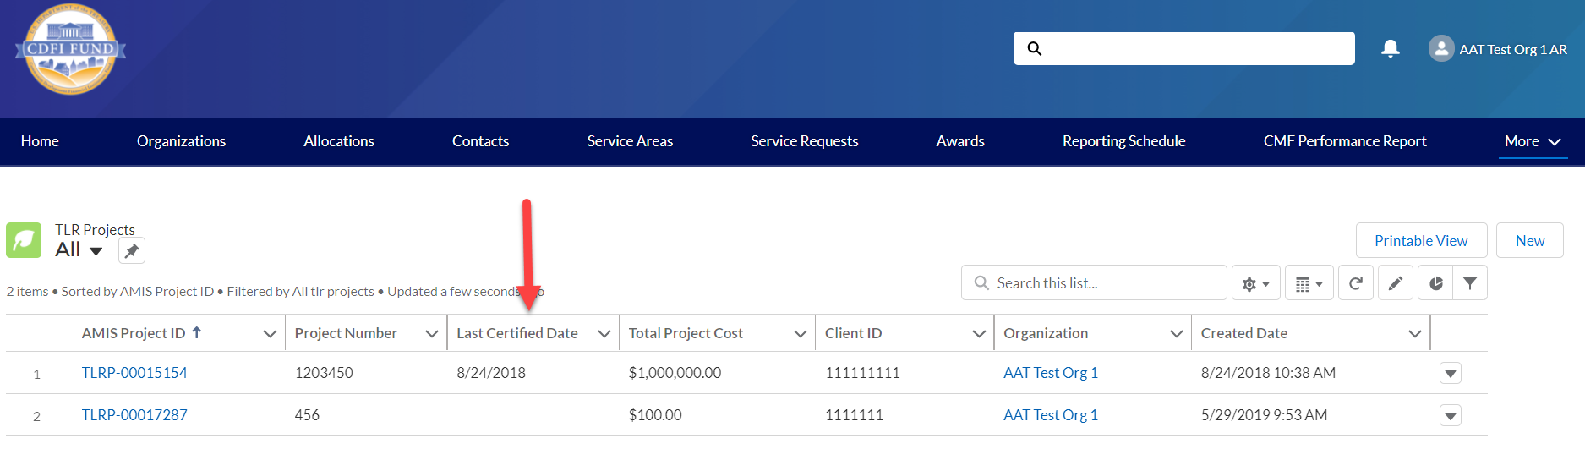
Note: If you happen to have performed Final Certification in error (i.e. you have additional records you need to submit), please contact the AMIS Help Desk at AMIS@cdfi.treas.gov for further assistance.

What’s New in the NMTC Allocatee TLR Guidance?
New Data Points
There are several new data points which have been added to the Project Level report. They are described below based on topic.
Depth of Public Subsidy Data Points
To better measure the depth of public subsidy for NMTC transactions, a new data point is added to the NMTC Allocatee TLR:
- Estimated Annual Net Operating Income
Community Outcomes Data Points
The new additions to the community outcome reporting in the NMTC Allocatee TLR include:
- Projected Full-Time Equivalent (FTE) Permanent Jobs to Be Created and/or Retained at Businesses Financed
- Actual Full-Time Equivalent (FTE) Permanent Jobs Created and/or Retained at Businesses Financed
- Job Quality Measures (Measure of Job Quality)
- Number of Quality Jobs
- Identify Accessible Jobs Measure (Measure of Job Accessibility)
- Number of Accessible Jobs
- Type of Business Loan
- Native American-Owned or Controlled Businesses
- Number of People Served by Commercial Goods or Services
- Number of People Served by Community Goods or Services
- Number of Households Served by Infrastructure Services
- Identify Environmental Restoration and/or Sustainability Outcome Measure
- Quantify Environmental Restoration and/or Sustainability Outcome
Allocation Agreement Compliance Data Points
To enhance the Fund’s ability to assess certain provisions of the Allocation Agreement when QLICIs are originated, the CDFI Fund will collect the following new data points:
- Below Market Interest Rate at Origination
- Blended Interest Rate at Origination
- Comparable Blended Interest Rate at Origination
- What is Interest Rate Comparable at Origination?
- Interest Rate Comparable at Origination – Other

Changes to Existing Data Points
There are several existing data points at the Project Level report which have either been revised or deleted. They are described below based on topic.
General
The revisions to existing data fields:
- Estimated Annual Net Operating Income
Fees and Transaction Costs
Data fields on fees and transaction costs have been revised to ensure that they are mutually exclusive. In addition, all data points will be reported as actual dollar amounts. Three data points related to fees and transaction costs have been deleted due to lack of usage.
Revised fields:
- Total QEI Proceeds Retained by the CDE or CDE Affiliate
- Upfront Fees to the CDE or CDE Affiliate
- Upfront Fees to Investors or Investor Affiliates
- Upfront Fees to Unaffiliated Third Parties
- Upfront Transaction Costs
- Ongoing Fees to the CDE or CDE Affiliate
- Ongoing Fees Paid to Investors or Investor Affiliates
- Ongoing Fees to Unaffiliated Third Parties
- Ongoing Transaction Costs
- Back-end Fees to CDE or CDE Affiliates
- Back-end Fees to Investors or Investor Affiliates
- Back-end Fees to Unaffiliated Third Parties
- Back-end Transaction Costs
Deleted fields:
- Other Sources of Compensation and Profits Charged to Investors
- Other Sources of Compensation and Profits Charged to Borrowers/Investees
- Other Sources of Compensation and Profits Charged to Other Entities
Depth of Public Subsidy Data Points
For “Total Project Cost Public Sources,” the revised guidance shown in italics states that Allocatees must “include federal, state, and local government funds, including funding derived from other tax credits (state and federal) used to directly finance the NMTC project and that were not part of the leverage structure.”
Community Outcomes Data Points
The revisions to existing data fields community outcome reporting in the NMTC Allocatee TLR include:
- Minority-Owned or Controlled Businesses
- Women Owned or Controlled
- Low-Income Owned or Controlled
- Race
- Hispanic Origin
- Projected Full-time Equivalent (FTE) Jobs to Be Created – Construction
- Projected Full-time Equivalent (FTE) Permanent Jobs to Be Created and/or Retained at Tenant Businesses
- Actual Full-time Equivalent (FTE) Jobs Created (Construction)
- Actual Full-time Equivalent (FTE) Permanent Jobs Created and/or Retained at Tenant Businesses
- Square Feet of Real Estate – Industrial/Manufacturing
- Square Feet of Real Estate – Office
- Square Feet of Real Estate – Retail
- Housing Units – Sale
- Housing Units – Rental
- Affordable Housing Units – Sale
- Affordable Housing Units – Rental

Deleted fields:
- Type of Jobs Reported

Allocation Agreement Compliance Data Points
In addition, the CDFI Fund has eliminated the following data points that are no longer relevant in assessing compliance, given that they relate to data points after origination:
- Below Market Interest Rate the end of the reporting period
- Blended Interest Rate the end of the reporting period
- Comparable Blended Interest Rate the end of the reporting period
- Below Market Interest Rates or Flexible Terms Required under Allocation Agreement
- Below Market Interest Rate at the end of the reporting period
- What is Interest Rate Comparable at the end of the reporting period?
- Interest Rate Comparable -- Other
- Interest Rate Financial Note Terms at the end of the reporting period

Notes-Investments
The revisions to existing data fields:
- Projected Residual Value of QLICI that May be Obtained by the QALICB and/or QALICB Affiliate
- Type of Business Loan
New User Features
- There are no new user features at this time.

New Disclosure
The CDFI Fund may upon request provide information collected and any associated reporting submitted by the Allocatee to an appropriate federal, state, tribal, local, international, or foreign law enforcement agency or other appropriate authority charged with investigating or prosecuting a violation or enforcing or implementing a law, rule, regulation, or order.

Generating NMTC Reports

- To generate TLR Reports, log into the CDFI Fund’s Awards Management Information System (AMIS) and click on the “Organizations” tab.

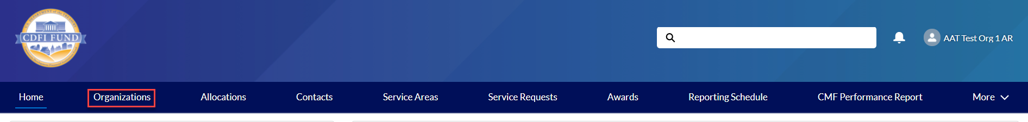
- Find the Organization whose reports you want to view and click on the link.

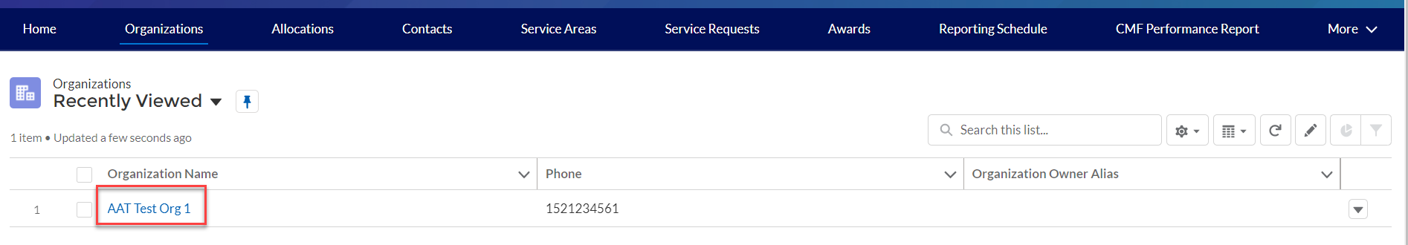

- Once on the Organization page, scroll to the bottom of the details and locate the ‘Custom Links’ section. Links to available reports will be listed in the section.

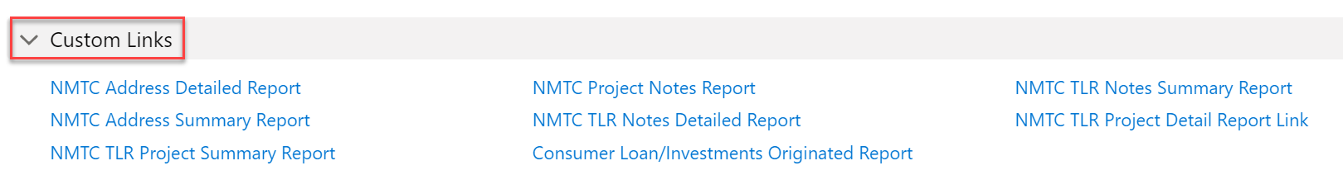

- Left click on the report you would like to generate.

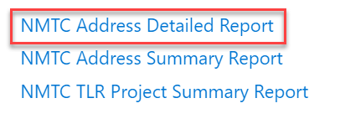

The report generates in a new window with all records that meet the report’s built-in criteria. Customization is not possible at this point.
The report provides a Printable View button and an Export Details button
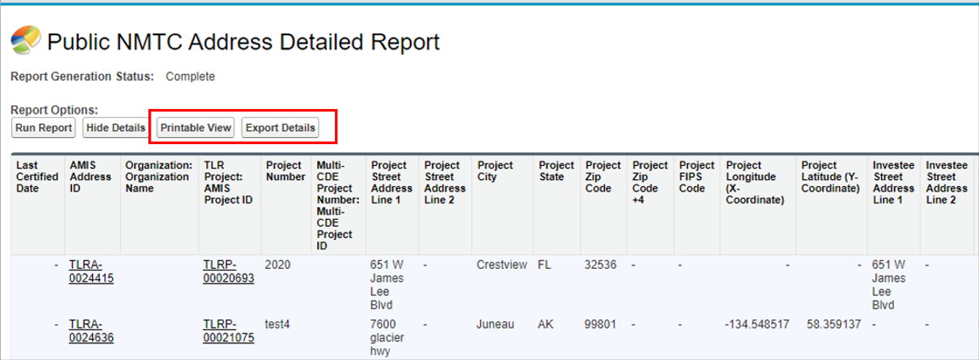
- The Printable View button creates a formatted Excel spreadsheet of the report, suitable for presentation.

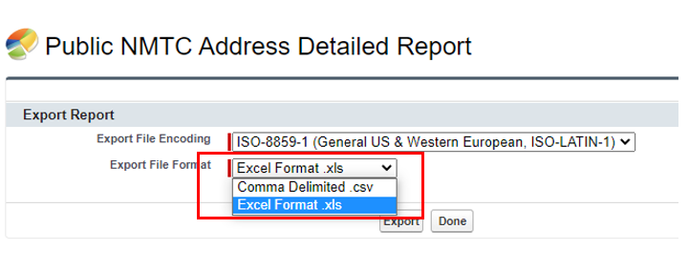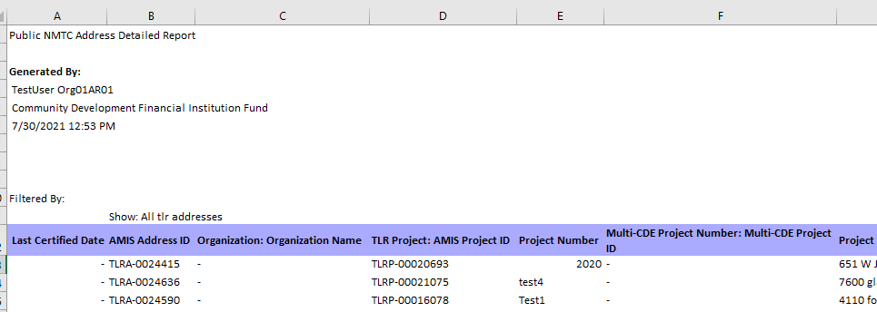

- The Export Details button creates either an unformatted Excel or CSV spreadsheet of the report suitable for analysis, data manipulation (such as filtering) and import into other systems

Understanding the Data Point Boxes

Below is a diagram of how to read and understand the data point boxes listed in the section CDE Transaction Level Report – Data Point Guidance.
Each data point is color-coded according to its related requirements.
Purpose of Color Coding
Mandatory – A response must be provided or the TLR will not be accepted.
Conditionally Required – This field will become enabled and require an answer based on a response in a previous field.
Optional – Not required to provide a response although it is recommended.
AMIS System Generated – User response is not allowed.

Example 1:
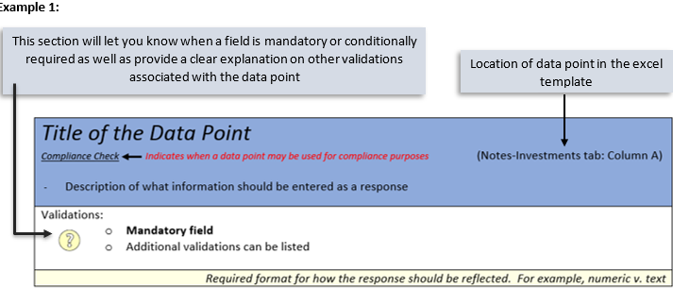

Example 2:
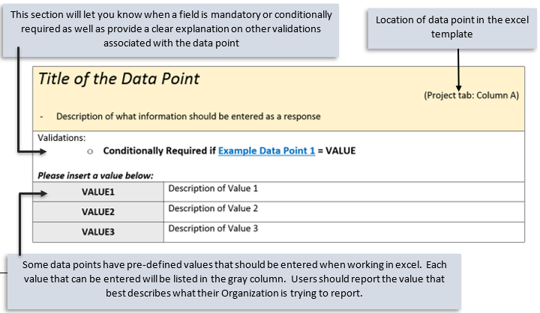
Who to contact for help
If you are experiencing any difficulties with the data entry portion of your report, including document errors, system errors, and basic questions, please contact the AMIS Helpdesk. The most effective means of requesting support is submitting a Service Request. From the AMIS Service Request tab, select the “Create New Service Request” button. Select “Continue” to accept the default record type of “General Inquiry.” Ensure that “NMTC-AMIS technical problem” is selected for the Type drop-down field.

Alternatively, the Allocatee may send an email to AMIS@cdfi.treas.gov. Please type, “NMTC: TLR Assistance Needed” in the subject line of the email. A technical support staff person will generally reply within 24 hours on weekdays. Allocatees may also phone the CDFI Fund IT Help Desk at (202) 653-0422. If a technical support staff person is unavailable to immediately assist, please leave a message and a staff person will return the call within 36 hours on weekdays.

CDE Transaction Level Report – Data Point Guidance

Notes-Investments
Note: For the crosswalk guide on the NMTC TLR field level changes from the previous round refer to the “CIIS to AMIS Crosswalk NMTC TLR”.
Project Number Transaction Mandatory Info (Column B)
TLR Project is used to link a Financial Note(s) to a distinct Project and to track Projects across reporting periods. This field is also used for navigational purposes. This field is automatically generated for the user by the system and is used to link a Financial Note(s) to a distinct Project and to track Projects across reporting periods.
Validations:
- Mandatory Field (Automatically Generated for the user by the system)

Response must be numeric - up to 8 digits

Originator Transaction ID Transaction Mandatory Info (Column C)
Assign a unique Originator Transaction ID to track Financial Note.
Validations:
- Mandatory Field
- Each Originator Transaction ID must be unique to each financial note. Duplicate Originator Transaction ID’s will cause errors in the file.
- Allocatees MUST use the same Originator Transaction ID for each reporting period.
- Originator Transaction ID’s can not contain any special characters such as, but not limited to, commas and exclamation points.
Response must be text - up to 20 characters

Last Certified Date Transaction Mandatory Info
AMIS will populate this field with the date the TLR object was certified.
Validations:
- This field will only populate when the user has certified the TLR object
Format of mm/dd/yyyy
Purpose Transaction Mandatory Info (Column D)
Choose one of the pre-defined values below and identify the primary purpose of the financial note if there are multiple purposes (for example, a loan funding both the purchase of a fixed asset and a facility improvement), select the purpose with the largest percentage of the transaction.
Validations:
- Mandatory Field
Please select one of the following:

BUSINESS | Non-Real Estate Business: Financing to for-profit and nonprofit businesses with more than five employees or in an amount greater than $50,000 for a purpose that is not connected to the development (including construction of new facilities and rehabilitation/enhancement of existing facilities), management, or leasing of real estate.
MICRO | Non- Real Estate Microenterprise: Financing to a for-profit or non-profit enterprise that has five or fewer employees (including the proprietor) with an amount no more than $50,000 for a purpose that is not connected to the development (including construction of new facilities and rehabilitation/enhancement of existing facilities), management, or leasing of real estate.
RECOCOM | Real Estate – Construction/Permanent/Acquisition w/o Rehab – Commercial: Financial Note is for predevelopment financing, construction or permanent financing, or acquisition without rehabilitation of office, retail, manufacturing, or community facility space. Include mixed-use real estate that combines both commercial and residential use.
RECOMULTI | Real Estate – Construction–Housing-Multi Family: Financial Note is for predevelopment financing, or construction of multifamily housing.
RECOSINGLE | Real Estate – Construction–Housing-Single Family: Financial Note is for predevelopment financing, or construction of single-family housing.
RERHCOM | Real Estate–Rehabilitation–Commercial: Financing is to rehabilitate office, retail,  manufacturing, or community facility space. Financial Note may include acquisition costs. Include mixed-use real estate that combines both commercial and residential uses. Exclude acquisitions without rehabilitation.
RERHMULTI | Real Estate – Rehabilitation – Housing – Multi Family: Financing is to rehabilitate or acquire single family housing.
RERHSINGLE | Real Estate – Rehabilitation – Housing – Single-Family: Financing is to rehabilitate or acquire single family housing.
OTHER | Other: Financial note purpose does not match any of the purposes defined above.

Transaction Type Transaction Mandatory Info (Column E)
Report the type of transaction for the financial note by choosing one of the options below.
Validations:
- Mandatory field
Please select one of the following:

TERM | Term Loan
EQTYINV | Equity Investment
LOC | Line of Credit
DEBTEQTY | Debt with Equity
OTHER | Other

Loan Status Transaction Mandatory Info (Column F)
Annual Update Field
Report the status of the loan/investment amount at the reporting period end.
Loans that were “modified” (i.e. increase in principal) must be reported as RESTRUCT and the modified loan also reported as a new transaction.
Validations:
- Mandatory Field
Please select one of the following:

ACTIVE | Active – the financial note was open, on-the-books, and/or had some sort of activity during the reporting year.
ACTIVE END | Active but the financial note has reached the end of its seven-year compliance reporting period.
CLOSED | Closed in good standing – a loan or line of credit that is paid in full (not refinanced) or an equity investment that has been exited.
SOLD | Sold – the financial note is off-the-books but not paid in full.
CHARGEDOFF | Charged off - the financial note is off-the-books but not paid in full.
REFIN | Refinanced - the financial note has been paid in full and the remaining principal amount has been refinanced by another lender.
RESTRUCT | Restructured with a charge off or modified.

Date Originated Financial Note Term (Column G)
Report the date that a legally binding note has been signed by the borrower/investee in favor of the lender/investor.
Validations:
- Mandatory Field
- Date Originated must be prior to the current date.
- See the Date Formatting section for more information.
The response must be in the format of mm/dd/yyyy

Date Formatting
Common Question: I have uploaded my file, but it says that I have not provided a response for this date column/date column is in the incorrect format. I see my date entered, how do I fix it?
The most common fix is to make sure the date column is formatted correctly. When entering an answer into a cell that requires a date, make sure to format the cell as below. This can be done by right clicking on the cell(s). Although it may not fully appear as if it is in the correct format (March 3, 2014 will appear as 3/3/2014 as opposed to 03/3/2014), rest assured, this is correct.

Original Loan/Investment Amount Financial Note Term (Column H)
Annual Update Required
Report the amount of the loan/investment.
Validations:
- Mandatory Field
- Original Loan/Investment Amount cannot be greater than $50,000 if Purpose = MICRO.
- Must be greater than or equal to zero
Response must be in numeric format

Refinancing Financial Note Terms (Column I)
Report whether the loan/investment is a new origination or a refinance of an existing loan/investment with QEI funds.
Validations:
- Mandatory Field
Please select one of the following:

NEWORIGINATION | New Origination
REFINANCEALLOC | Refinance of Allocatee (or Affiliate) Loan/Investment
REFINANCEUNAFF | Refinance of Un-Affiliated Third-Party Loan/Investment

Construction or Permanent Financing Financial Note Terms (Column J)
Report whether the loan/investment is for construction or permanent financing.
Validations:
- Conditionally Required if Purpose = RECOCOM
Please select one of the following:

CONSTRUCTION | Construction
PERMANENT | Permanent
BOTH | Both construction and permanent

Take-out or Acquisition Financing Financial Note Terms (Column K)
Report whether the loan/investment is for take-out or acquisition financing.
Validations:
- Conditionally Required if Construction or Permanent Financing = PERMANENT or BOTH
Please select one of the following:

TAKEOUT | Take-out financing
ACQUISITION | Acquisition without rehabilitation

Acquisition or Rehabilitation Financial Note Terms (Column L)
Report whether the loan/investment includes financing for the acquisition of the property.
Validations:
- Conditionally Required if Purpose = RERHCO
Please select one of the following:

ACQUISITIONREHAB | Acquisition and rehabilitation
REHABILITATION | Rehabilitation only

Rehabilitation Amount Financial Note Terms (Column M)
Report the portion of the Original Loan/Investment Amount that was used for the rehabilitation.
Validations:
- Conditionally Required if Acquisition or Rehabilitation = AQUISITIONTREHAB
- Response must be in dollars greater than zero
- Exclude leveraged dollars.
Response must be in numeric format

Loan Origination Fees Financial Note Terms (Column N)
Report the total loan origination fees, including processing, credit report, and other fees.
Validations:
- Conditionally Required if Transaction Type = Term Loan, Line of Credit, or Debt with Equity
- Value must be > 0 AND less than or equal to Original Loan Investment Amount
- Exclude points
Response must be in dollars up to 2 decimal places

Interest Rate at Origination Financial Note Terms (Column O)
Report the interest rate in effect at the origination of the loan.
Validations:
- Conditionally Required if Transaction Type = Term Loan, Line of Credit, or Debt with Equity.
- Enter the percentage as a whole number (i.e. if the Interest Rate at Origination is 2.0%, enter 2.0
- Value must be => 0 AND <= 100
The response must be in numeric format up to 3 decimal places

Interest Type Financial Note Terms (Column Q)
Choose one of the pre-defined values below and report the type of interest.
Validations:
    - Conditionally Required if Transaction Type = Term Loan, Line of Credit, or Debt with Equity.
Please select one of the following:

FIXED | Fixed
ADJ | Adjustable

Points Financial Note Terms (Column R)
Report the points charged to the borrower at origination.
Validations:
    - Conditionally Required if Transaction Type = Term Loan or Debt with Equity
    - Report the points as a percentage of the original loan amount
    - Include points for the particular financial note reported
Response must be in numeric format up to 3 decimal places

Amortization Type Financial Note Terms (Column S)
Choose one of the pre-defined values below and report how the financial note is amortized.
Validations:
- Conditionally Required if Transaction Type = Term Loan, Line of Credit, or Debt with Equity
Please select one of the following:

FULLAMORT | Fully Amortized – Amortization schedule includes both interest and principal payments throughout the life of the loan.
PARTAMORT | Partially Amortized – The amortization schedule includes some principal payments throughout the life of the loan, with a larger principal payment at maturity.
NONAMORT | Non-Amortizing – Amortization schedule includes interest only payments with a single principal payment at maturity.
OTHER | Other

Length of Amortization Period (in months) Financial Note Terms (Column T)
Report the length of the amortization period.
Validations:
- Conditionally Required if Amortization Type = FULLAMORT or PARTAMORT
- Report the Length of Amortization Period in months
Response must be in numeric format

Period of Interest Only Payments (in months) Financial Note Terms (Column U)
Report the number of interest only payments at the time of origination.
Validations:
- Conditionally Required if Transaction Type = Term Loan
- Report the Period of Interest Only Payments in months
- Period of Interest Only Payments must be less than the amount reported as the Term
Response must be in numeric format

Term (in months) Financial Note Terms (Column V)
Annual Update Required
For each loan and line of credit, report the full term in months. Report the full term, not the remaining term.
Validations:
- Conditionally Required if Transaction Type = Term Loan, Line of Credit, or Debt with Equity
Response must be in numeric format

Guarantee Financial Note Terms (Column W)
If any portion of the loan is guaranteed, choose one of the pre-defined values below and report the source.
Validations:
- Conditionally Required if Transaction Type = Term Loan, Line of Credit, or Debt with Equity
- Exclude performance guarantees
Please select one of the following:

SBA | Small Business Administration (SBA)
USDA | US Department of Agriculture (USDA)
OTHERGOV | Other Federal Government Source
PERSONAL | Personal Guarantee
OTHER | Other
NONE | None

Lien Position Financial Note Terms (Column X)
Choose one of the pre-defined values below and report the CDE’s lien position.
Validations:
- Conditionally Required if Transaction Type = Term Loan, Line of Credit, or Debt with Equity
Please select one of the following:

FIRST | First
SECOND | Second
UNSECURED | Unsecured Debt
OTHER | Other

Collateral Type Financial Note Terms (Column Y)
Choose one of the pre-defined values below and report the type of collateral pledged for the loan/investment.
Validations:
- Conditionally Required if Transaction Type = Term Loan, Line of Credit, or Debt with Equity
Please select one of the following:

RE | Real Estate
REOTHER | Other Real Estate
VEH | Vehicle
EQUIP | Equipment
INVENTORY | Inventory
REC | Receivables
HOMEEQTY | Home Equity
OTHER | Other
NONE | None

Collateral Value at Origination Financial Note Terms (Column Z)
Estimate and report the fair value of the collateral at the time of origination.
Validations:
- Conditionally Required if Transaction Type = Term Loan, Line of Credit, or Debt with Equity
Response must be in numeric format

Equity-Like Features Financial Note Terms (Column AA)
Choose one of the pre-defined values below and report the type of equity-like feature.
Validations:
- Conditionally Required if Transaction Type = Debt with Equity
- If a loan has more than one equity-like feature, choose the one appearing first in the loan agreement
Please select one of the following:

CONVDEBT | Convertible Debt – Loan agreement specifies an option to convert all or part of the loan amount to equity
PERFINT | Performance Based Interest Rate – Loan’s interest rate adjusts based on the borrower’s performance.
ROYALTIES | Royalties – Loan has a royalty participation that gives the investor the right to a percentage of the borrower’s sales or profits.
WARRANTS | Warrants – Loan agreement gives the investor the right to purchase the portfolio company’s stock at a later date at a pre-negotiated price.
OTHER | Other – Loan Agreement specifies an equity-like feature not described above.

Equity Injection Amount Financial Note Terms (Column AB)
Equity injection is an underwriting mechanism used to help borrowers who lack collateral to qualify for a loan. The equity injection measures the amount of the borrower's own assets invested in the business. Report the equity injection amount provided by the investee/borrower (i.e. down payment for a purchase mortgage or the value of machinery the borrower purchased for the financed project).
Validations:
- Optional field
- Include both cash and non-cash injections
Response must be in numeric format

Advanced Purchase Commitment (Column AC)
Report whether the loan/investment is an advance purchase commitment.
Validations:
- Conditionally Required if QLICI Type = QALICB
Response must be YES or NO

Seller Organization (Column AD)
Report the seller organization.
Validations:
- Conditionally Required if Advance Purchase Commitment = YES
Response must be text

Equity Product (Column AE)
Compliance Check
Report whether the financial note is an equity product.
Validations:
- Mandatory field
- Reject if Equity Product = YES & Transaction Type = Term Loan, Line of Credit, Debt with Equity or Other
Response must be YES or NO

Equity-Equivalent Terms & Conditions (Column AF)
Compliance Check
Report whether the financial note has equity-equivalent terms and conditions.
Validations:
- Mandatory field
Response must be YES or NO

Debt with Equity Features (Column AG)
Compliance Check
Report whether the financial note has debt with equity features.
Validations:
- Mandatory field
- Reject if Debt with Equity Features = YES & Transaction Type = Term Loan, Equity, Line of Credit or Other
Response must be YES or NO

Subordinated Debt (Column AH)
Compliance Check
Report whether the financial note is subordinated debt.
Validations:
- Mandatory field
- If Lien Position = FIRST then Subordinated Debt must = NO
Response must be YES or NO

Below Market Interest Rate at Origination (Column AI)
Compliance Check
Report whether the financial note had below market interest rate at origination.
Validations:
- Mandatory field
- Reject if Below Market Interest Rate at Origination = YES AND Interest Rate at Origination >= Comparable Interest Rate at Origination
Response must be YES, NO, or NA

Comparable Interest Rate at Origination (Column AJ)
Report the comparable market interest rate at origination that the Allocatee used to determine that the financial note had a below market interest rate.
Validations:
- Conditionally required if Below Market Interest Rate at Origination = YES
- Comparable Interest Rate at Origination must be greater than Interest Rate at Origination AND <= 100
- Enter the percentage as a whole number (i.e. if the Comparable Interest Rate at Origination is 2.0%, enter 2.0)
Response must be in numeric format up to 3 decimal places

What is Interest Rate Comparable at Origination? (Column #)
Choose one of the pre-defined values below and report the interest rate comparable at origination.
Validations:
- Conditionally Required if Below Market Interest Rate at Origination (Financial Note) = YES
Please select one of the following:

NONNMTC | CDE’s Non-NMTC Transaction
PARENT | CDE’s Parent/Affiliate
BANKS | Banks
OTHER | Other

Interest Rate Comparable at Origination – Other (Column #)
Provide further explanation for what the interest rate is comparable to at origination.
Validations:
- Conditionally Required if What is Interest Rate Comparable At Origination= OTHER
Response must be text

Lower than Standard Origination Fees (Financial Note) (Column AO)
Lower than Standard Origination Fees
Compliance Check
Report whether the financial note has lower than standard origination fees.
Validations:
- Mandatory field
Response must be YES or NO

Standard Origination Fees (Column AP)
Report the comparable market origination fees that the Allocatee used as a benchmark to determine that the financial note has lower than standard origination fees.
Validations:
- Conditionally required if Lower than Standard Origination Fees (Financial Note) = YES
- Standard Origination Fees must be greater than Loan Origination Fees AND less than or equal to Original Loan Amount
Response must be numeric up to 2 decimal places

Longer than Standard Period of Interest Only Payments (Column AQ)
Compliance Check
Report whether the financial note has longer than standard period of interest only payments.
Validations:
- Mandatory field
- If Transaction Type = Term Loan, Line of Credit, or Debt with Equity or Other then Longer than Standard Period of Interest Only Payments must = YES or NO
Response must be YES, NO, or NA

Standard Period of Interest Only Payments (Column AR)
Report the comparable market period of interest only payments. Provide the benchmark period, in months, that the Allocatee used to determine that the financial note has a longer than standard period of interest only payments.
Validations:
- Conditionally Required if Longer than Standard Period of Interest Only Payments = YES
- Report amount in months
- Standard Period of Interest Only Payments must be less than Period of Interest Only Payments
Response must be numeric

Longer than Standard Amortization Period (Column AS)
Compliance Check
Report whether the financial note has a longer than standard amortization period.
Validations:
- Mandatory field
- If Transaction Type = Term Loan, Line of Credit, or Debt with Equity or Other then Longer than Standard Period of Interest Only Payments must = YES or NO
Response must be YES, NO, or NA

Standard Amortization Period (Column AT)
Report the comparable market amortization period. Provide the benchmark period, in months, that the Allocatee used to determine that the financial note has a longer than standard amortization period.
Validations:
- Conditionally Required if Longer than Standard Amortization Period = YES
- Report amount in months
- Standard Amortization Period must be less than Length of Amortization Period
Response must be numeric

What is Standard Amortization Period Comparable? (Column AU)
Standard Amortization Period Comparable?
Choose one of the pre-defined values below and report the standard amortization period comparable.
Validations:
- Conditionally Required if Longer than Standard Amortization Period = YES
Please select one of the following:

NONNMTC | CDE’s Non-NMTC Transaction
PARENT | CDE’s Parent/Affiliate
BANKS | Banks
OTHER | Other

Standard Amortization Period Comparable – Other (Column AV)
Provide further explanation for what the standard amortization period is comparable to.
Validations:
- Conditionally required if What is Standard Amortization Period Comparable? = OTHER
Response must be text

Nontraditional Forms of Collateral (Column AW)
Compliance Check
Report whether the financial note has a nontraditional form of collateral.
Validations:
- Mandatory field
Response must be YES or NO

Traditional Form of Collateral (Column AX)
Choose one of the pre-defined values below and report the comparable market form of collateral that the Allocatee used as a benchmark to determine that the financial note has a nontraditional form of collateral.
Validations:
- Conditionally Required if Nontraditional Forms of Collateral = YES
Please select one of the following:

RE | Real Estate
REOTHER | Other Real Estate
VEH | Vehicle
EQUIP | Equipment
INVENTORY | Inventory
REC | Receivables
HOMEEQTY | Home Equity
OTHER | Other
NONE | None

What is Traditional Forms of Collateral Comparable? (Column AY)
Traditional Collateral Comparable?
Choose one of the pre-defined values below and report the traditional form of collateral comparable.
Validations:
- Conditionally Required if Nontraditional Forms of Collateral = YES
Please select one of the following:

NONNMTC | CDE’s Non-NMTC Transaction
PARENT | CDE’s Parent/Affiliate
BANKS | Banks
OTHER | Other

Traditional Form of Collateral Comparable – Other (Column AZ)
Traditional Collateral Comparable Other
Provide further explanation for what traditional form of collateral is comparable.
Validations:
- Conditionally required if What is Traditional Forms of Collateral Comparable? = OTHER
Response must be text

QLICI Level (Column BA)
Annual Update Required
Compliance Check
Report whether the financial note was funded with original QEI funds (QEI funds invested for the first time), a reinvestment of repaid QLICI(s), or both by choosing an option below.
Validations:
- Mandatory Field
Please select one of the following:
ORIG | Original QEI funds
REINVST | Reinvestment or repaid QLICI’s
ORIGREIN | Both

Principal Balance Outstanding (Column BB)
Annual Update Required
Report the principal balance outstanding at the end of the reporting period.
Validations:
    - Conditionally required if Transaction Type = Term Loan, Line of Credit, or Debt with Equity
Response must be numeric

Dollar Amount Used to Finance Non-Real Estate Activities
NRE Activities Finance Amount (Column BC)
Report, in dollars, the portion of proceeds of the financial notes provided by the CDE that financed non-real estate uses. Non-real estate uses include working capital, inventory, equipment, or any other activity not connected to the development (including construction of new facilities and rehabilitation/enhancement of existing facilities), acquisition, management, or leasing of real estate.
Validations:
- Mandatory field
Response must be numeric up to 2 decimal places

New Originator Transaction ID of Restructured Loan (Column BD)
New Restructured Loan Transaction ID
Report the new Originator Transaction ID for each financial note that was restructured.
Validations:
- Conditionally required if Loan Status = RESTRUCT
- Information provided must match a current or previously submitted Originator Transaction ID (All previously submitted IDs by the Organization regardless of the associated Project)
Response must be text

Days Delinquent (Column BE)
Annual Update Required
Report the number of days that the required loan payment is past due at the reporting period end. If a borrower made a partial payment on the due date but still owes any part of the payment, report that payment as past due.
Validations:
- Conditionally required if Transaction Type = Term Loan, Line of Credit, Debt with Equity or OTHER
Response must be numeric

Number of Times 60 Days or More Delinquent (Column BF)
Number of 60 Days or More Delinquent
Annual Update Required
Report the number of times the loan has been 60 days or more delinquent during the life of the loan.
Validations:
- Conditionally required if Transaction Type = Term Loan, Line of Credit, Debt with Equity or OTHER
- Number of Times 60 Days or More Delinquent must be equal to or greater than the value reported the previous year.
Response must be numeric

Number of Times the Loan was Restructured (Column BG)
Number of Times the Loan Restructured
Annual Update Required
Report the number of times the loan was restructured during the life of the loan.
Validations:
- Conditionally required if Transaction Type = Term Loan, Line of Credit, Debt with Equity or OTHER
- Number of Times the Loan was Restructured must be equal to or greater than the value reported the previous year.
Response must be numeric

Amount Charged Off (Column BH)
Annual Update Required
Report the amount charged off during the life of the loan.
Validations:
- Conditionally required if Transaction Type = Term Loan, Line of Credit, Debt with Equity or OTHER
- Reject if Transaction Type = Equity or if Loan Status = Active
- Amount Charged Off + Amount Recovered must be less than or equal to Original Loan/Investment Amount
Response must be numeric

Amount Recovered (Column BI)
Annual Update Required
Report the amount recovered as of the reporting period end date.
Validations:
    - Conditionally required if Transaction Type = Term Loan, Line of Credit, Debt with Equity or OTHER and Loan Status = ACTIVEEND, CLOSED, SOLD, CHARGED, REFIN, or RESTRUCT.
    - Amount Recovered must be equal to or greater than the value reported the previous year.
Response must be numeric

Actual Rate of Return (Column BJ)
Report the investor’s internal rate of return at the end of the reporting period.
Validations:
- Conditionally required if Transaction Type = Equity Investment
Response must be numeric format up to 3 decimals

Projected Residual Value of QLICI that May be Obtained by the QALICB and/or QALICB Affiliate
Projected Residual Value of QLICI (Column BK)
Report the amount of any equity or debt investment which may be acquired by the QALICB and/or QALICB Affiliate as the result of a put/call option or other arrangement.
Validations:
- Conditionally required if QLICI Type = QALICB and Date Originated is > 12/31/2010
- When Loan Status = CLOSED, please place the final value of the QLICI obtained by the QALICB and/or QALICB Affiliate through a put/call option or other arrangement.
Response must be numeric

Type of Business Loan
Choose one of the pre-defined types below that best describes the type of business loan provided to the QALICB. This is a conditionally required response when the user selects the loan “Purpose” field for either “Business” or “Micro” which then requires the recipient to select one of three broad categories of business loans or investments: Business Working Capital; Business Fixed Capital; and Business Expansion or Business Startup.

Validation:

Conditionally required if Purpose = BUSINESS, MICRO
- Required for TLR Notes originated on or after 10/01/2023

Note that investments in real estate structures cannot be included as “business fixed capital” and instead must be reported in the TLR data point for “Purpose” by selecting the appropriate category. For example “Real Estate – Construction/Permanent/Acquisition w/o Rehab – Commercial,” or “Real Estate–Rehabilitation–Commercial,” etc.

Select one of the measures below:
Business Working Capital | A loan or investment that will be used to cover any ongoing operating expenses of a business such as payroll, inventory, rent or utility expenses.
Business Fixed Assets | A loan or investment that will be used to pay for any tangible property used in the operation of a business, but which is not expected to be consumed or converted into cash in the ordinary course of events. Commonly financed fixed assets include machinery and equipment, furniture and fixtures, and leasehold improvements.
Business Expansion or Startup | A loan to support the expansion or startup of a business or develop a new product line or service which may include a mix of investments in equipment, salaries, materials, etc., to support the business startup or expansion.

TLR Projects Tab
Project Number (Column B)
Assign a unique identifier to each Project.
Validations:
- Mandatory field
- Report the TLR Project Number
- NOTE: If you receive the following error “This identifier already exists. To update, please use a different link” when uploading your TLR file please contact the AMIS Help Desk at AMIS@cdfi.treas.gov for help.
Response must be numeric

QLICI Type (Column C)
Compliance Check
Choose one of the pre-defined values below and report whether the QLICI is an investment in another CDE or a QALICB.
Validations:
- Mandatory field
- Non-Profit businesses (except CDE’s) and Advanced Purchases = QALICB
- Exclude loan purchases (except Advance Purchases), Financial Counseling, and Other Services (FCOS)
Please select one of the following:

CDE | CDE
QALICB | QALICB

Investee Type (Column D)
Choose one of the pre-defined values below and report whether the project is an investment in a business or another CDE.
Validations:
- Mandatory field
- If QLICI Type = CDE then Investee Type must = CDE
- If QLICI Type = QALICB then Investee Type must = BUS
Please select one of the following:

BUS | Business
CDE | CDE

Multi-CDE Project ID (Column E)
Multi-CDE Project Number
Report the Multi-CDE Project Number that was assigned to the Multi-CDE Project. Use the lookup function to identify and report the Multi-CDE Project ID associated with the project.
Validations:
- Conditionally Required if TLR Project is part of Multi-CDE Project
- Additional guidance can be found in the Multi-CDE section of AMIS
- Response must be a valid project number generated by AMIS under the Multi-CDE Project section
- Use the lookup icon to view a list of Multi-CDE Projects associated with the organization that the TLR Project can be linked to.
Response must be text

Project Results from Investment CDE (Column F)
Is this project a result of a secondary loan from an investment made to a CDE?
Report if the project results from funds provided as investments in, or loans to, another CDE.
Validations:
- Mandatory field
- Response must be Yes or No

Associated Project (Column G)

If the project results from an investment in a CDE, enter the AMIS project ID.
This field links the secondary loans or investments resulting from investments in, or loans to, another CDE.
Validations:
Conditionally Required if Project Results from Investment CDE = Yes; and QLICI Type = QALICB

Fiscal Year (Column H)

Choose one of the pre-defined values. The system will auto-populate the current and previous Fiscal Year of the TLR Project available.
Validations:
- Mandatory Field

Last Certified Date
AMIS will populate this field with the date the TLR object was certified.
Validations:
- This field will only populate when the user has certified the TLR object
format of mm/dd/yyyy

Total Project Cost (Column I)
Report the total cost of the project being funded.
Validations:
    - Mandatory Field
    - Include all sources of financing as well as the CDE’s portion of the financing
    - Response cannot be less than:
    - Total Project Cost >=Total Project Cost Public Sources
    - Total Project Cost >=Total Project Cost Private Investment
    - Total Project Cost >=Total Project Cost Other CDE’s + Original Loan/Investment Amount
    - Total Project Cost >=Total Project Cost Public Sources + Total Project Cost Other CDE’s + Original Loan Investment Amount + Total Project Cost Private Investment
Response must be numeric

Total Project Cost Public Sources (Column J)
Report the portion of the Total Project Cost provided by public sources excluding any amount(s) reported in Other Tax Credit Amount and Public Subsidy Used to Fund Leveraged Loan.
Validations:
    - Mandatory Field
    - Required if Date Originated is greater than 12/31/2022
    - Include federal, state, and local government funds, including funding derived from other tax credits (state and federal) used to directly finance the NMTC project and that were not part of the leverage structure.
    - Exclude foundation grants and NMTC funds
    - Response must be in dollar amount

Guidance:
If public sources are being bridged by other types of capital, then those must be included in the dollar amount if the public source is known at the time of closing.
Response must be numeric

Total Project Cost Other CDE’s (Column K)
Report the portion of the total QLICI investments made by other CDE’s into the project from QEI proceeds.
Validations:
    - Conditionally Required if Date Originated > 12/31/2009
    - Response must be in dollar amount
Response must be numeric

Total Project Cost Private Investment (Column L)
Report the portion of the private investment in the project (i.e. CDE’s using non-QEI proceeds, direct bank loans, direct equity, and other investments).
Validations:
    - Conditionally Required if Date Originated > 12/31/2009
    - Exclude all investments utilizing QEI proceeds
    - Response must be in dollar amount
Response must be numeric

Estimated Annual Net Operating Income (Column #)
In the case of a for-profit entity, report the Estimated Annual Net Operating Income, which is the annual revenue less operating costs of the project. In the case of a non-profit entity, report the Change in Net Assets or the Addition to Net Assets.
Validations:
    - Mandatory Field
    - Required for TLR Notes originated on or after 10/01/2023
    - Response must be in dollar amount
    - A value of $0 is allowed.
Response must be numeric

Loan-to-Value Ratio (Column M)
Report the loan-to-value ratio at origination for the total project.
Validations:
    - Conditionally required if one or more financial notes associated with this project has a Transaction Type = Term Loan
    - Enter the percentage as a numeric ratio (i.e. if response is 125%, enter 125)
    - Exclude unsecured loans from calculations
    - Response must be => 0 AND <=500
Response must be numeric up to 3 decimal places OR NA

Projected Debt Service Coverage Ratio (Column N)
Report the projected debt service coverage ratio at origination for the total project.
Validations:
    - Conditionally required if one or more financial notes associated with this project has a Transaction Type = Term Loan
    - Enter the percentage as a numeric ratio (i.e. if response is 125%, enter 1.25)
    - The value entered must be => 0 AND <=5.
Response must be numeric up to 3 decimal places OR NA

Loan Loss Reserve Requirement (Column O)
Report the loan loss reserve requirement for the total project.
    - Validations: Conditionally required if one or more financial notes associated with this project has a Transaction Type = Term Loan
    - Enter the percentage as a whole number (i.e. if response is 25%, enter 25)
    - The Loan Loss Reserve Requirement must be => 0 AND <=100
Response must be numeric up to 3 decimal places OR NA

Investee (Borrower) Guidance
• If the QALICB is a real estate developer, the Investee is the developer.
• If the QALICB is an operating business (non-real estate), the Investee is the business.
• If the QALICB is a single-purpose entity (SPE) created by an operating business to lease back property to that parent business, the Investee is the parent business

Client ID (Column P)
Report a unique identifier to each client (investee/borrower). The Client ID is used to track the investee/borrower across Projects. Please do not use any names, social security numbers or any other personal identifying information in formulating the Client ID.
Validations:
    - Mandatory field
    - Do not use names, social security numbers or any other personal identifying information
Response must be text up to 20 characters

Investee TIN (Column Q)
Report the Tax Identification Number (TIN) of the CDE investee/borrower.
Validations:
    - Conditionally required if QLICI Type = CDE
    - The Investee TIN and Investee CDE must belong to the same organization
Response must be numeric

Investee CDE Certification Number (Column R)
If the Project is an investment in another CDE, report the Certification Number of the CDE investee/borrower.
Validations:
    - Conditionally required if QLICI Type = CDE
    - The Investee CDE Certification Number must be a valid CDE Certification Number.
    - The Investee TIN and Investee CDE must belong to the same organization
Response must be numeric

Date Business Established (Column S)
Report the date formal papers were filed to establish the investee’s/borrower’s business or the date the first sales occurred.
Validations:
    - Optional field
    - Date Business Established must be >= to Date Originated
    - See the Date Formatting section for more information
Response must in the format of mm/dd/yyyy

Entity Structure (Column T)
Choose one of the pre-defined values below and report the investee’s/borrower’s business or government structure.
Validations:
- Conditionally required if Date Originated is after 12/31/2010
Please select one of the following:

NONPROFIT | Non-Profit or Not-for-Profit – Based on the IRS categorization for tax purposes
FORPROFIT | For-Profit – Based on the IRS categorization for tax purposes
TRIBAL | Tribal or Village Government – Entity is a tribal or village government, whether or not it has been federally recognized
OTHER | Other – All other structures that do not fit the descriptions above, such as a government or quasi-government entity (i.e. a water authority)

Minority-Owned or Controlled Businesses (Column U)
Report whether the investee/borrower is at least 51% owned or controlled by one or more individuals that identify themselves as American Indian or Alaskan Native, Asian, Black or African American, Hispanic or Latino, Native Hawaiian or Other Pacific Islander.
Validations:
    - Mandatory field
    - Required for TLR Notes originated on or after 10/01/2023
    - If the business is a for-profit entity, report whether at least 51% of the owners are minorities.
    - If the business is a nonprofit entity, report whether at least 51% of its Board of Directors are minorities.
    - If the QALICB is a single-purpose entity (SPE) created by an operating business to lease back property to that parent business, report minority-controlled status for the parent business.
Response must be YES or NO

Native American-Owned or Controlled Businesses
Report whether the investee/borrower is at least 51% owned or controlled by one or more individuals who are members of Tribal entities recognized by the Bureau of Indian Affairs (BIA) or by individuals having origins in any of the original peoples of Hawaii.
Validations:
    - Mandatory field
    - Required for TLR Notes originated on or after 10/01/2023
    - If the business is a for-profit entity, report whether at least 51% of the owners are Native American.
    - If the business is a nonprofit entity, report whether at least 51% of its Board of Directors are Native American.
    - If the QALICB is a single-purpose entity (SPE) created by an operating business to lease back property to that parent business, report Native American-controlled status for the parent business.
Response must be YES or NO

Women Owned or Controlled (Column V)
Report whether the investee/borrower is at least 51% owned or controlled by one or more women.
Validations:
    - Conditionally required if Investee Type = BUS
    - If the business is a for-profit entity, report whether at least 51% of the owners are women.
    - If the business is a nonprofit entity, report whether at least 51% of its Board of Directors are women.
Response must be YES or NO

Low-Income Owned or Controlled (Column W)
Report whether the investee/borrower is at least 51% owned or controlled by one or more Low-Income Person
Validations:
    - Conditionally required if Investee Type = BUS
    - If the business is a for-profit entity, report whether at least 51% of its equity ownership (or the equivalent in limited liability companies) interest being owned by one or more Low-Income Person.
    - If the business is a nonprofit entity, report whether at least 51% of its Board of Directors (i.e. Governing Board) is comprised of individuals who are Low-Income Persons.
Response must be YES or NO

Race (Column X)
Choose one of the pre-defined values below and report the race of the primary investee(s)/borrower(s)
Validations:
    - Conditionally required if Investee Type = BUS
    - If there is more than one investee/borrower, select the race of the primary investee/borrower
    - If there is more than one primary investee/borrower, select the race of one of them
    - If the investee/borrower is of mixed race, report one of the races
    - If the investee/borrower did not provide their information, report NG
    - If the investee/borrower is a corporation, report NA
Please select one of the following:

AMIND | American Indian
ALASKAN | Alaskan Native
ASIAN | Asian
BLACK | Black or African American
HAWAIIAN | Native Hawaiian
PACIFIC | Other Pacific Islander
WHITE | White
OTHER | Other
NG | Not Given
NA | Not Applicable

Hispanic Origin (Column Y)
Choose one of the pre-defined values below and report whether the primary investee/borrower is Hispanic or Latino.
Validations:
    - Conditionally required if Investee Type = BUS
    - If there is more than one investee/borrower, respond for the primary investee/borrower
    - If the investee/borrower did not provide their information, report NG
    - If the investee/borrower is a corporation, report NA
Please select one of the following:

YES | Yes
NO | No
NG | Not Given
NA | Not Applicable

Business Description – Primary (Column Z)
Choose one of the pre-defined values below and report the primary description of the business of the QALICB.
Validations:
    - Conditionally required if QLICI Type = QALICB (Investee Type = BUS)
    - If QLICI Type = CDE then Business Description – Primary must = OTHER
Please select one of the following:

FOOD | Includes groceries, bakeries, food wholesalers, and farmers’ markets
OFFICE | Financial, professional, scientific, management, business, or other office space
INDUSTRIAL | Industrial, manufacturing, transportation, logistics, or warehousing space
HOUSING | Housing
HEALTH | Health, human, and social service facilities
COMMUNITY | Education and community facilities
ARTS | Facilities or space for the performing arts, cultural, entertainment, or other amenities
RETAIL | Retail
HOTEL | Hotel
MIXED | Includes combinations of office/retail, housing, and community spaces.
OTHER | Other

Business Description – Narrative (Column AA)
Provide an additional description of the type of business that is being financed (e.g. grocery store, Federally Qualified Health Center, charter school, a manufacturing company, etc.) and of the products or services provided by the operating business (e.g. manufacture of farm equipment, early childhood education, primary healthcare, etc.).
Validations:
      - Conditionally required if QLICI Type = QALICB (Investee = BUS)
      - Description cannot exceed 255 characters
The response must be text

NAICS (Column AB)
Report the 6-digit North American Industry Classification (NAICS) Code of the QALICB.
Validations:
    - Conditionally required if QLICI Type = QALICB
Guidance:
    - For investments in leased buildings, the NAICS code for the end user of the leased building must be reported. Avoid using the NAICS codes for Lessors of Real Estate (i.e. 6-digit NAICS codes beginning with 531).
    - To determine the NAICS code for the QALICB financed, go to https://www.census.gov/naics/ and use the keyword search for the latest version of NAICS.
    - Please note that the NAICS code must match the business described in the Business Description field.
Response must be numeric

Annual Gross Revenue from Business Operations at Time of Loan/Investment
Annual Gross Revenue (Loan/Investment) (Column AC)
For business Projects, report the investee’s/borrower’s annual gross business revenue during the most recent 12-month period prior to Project origination for which the information is available. If the QALICB is a single-purpose entity (SPE), report the revenue of the parent business.
Validations:
    - Conditionally required if QLICI Type = QALICB
    - If the QALICB is a single-purpose entity (SPE) created by an operating business to lease back property to that parent business, report the revenue of the parent business
Response must be numeric

Annual Gross Revenue from Business Operations Reported During the Reporting Period (Column AD)
Annual Gross Revenue (Reporting Period)
Annual Update Required
For business Projects, report the investee’s/borrower’s annual gross business revenue during the most recent 12-month period for which the information is available.
If the QALICB is a single-purpose entity (SPE), report revenue for the parent business
Validations:
    - Conditionally required if QLICI Type = QALICB
    - If the QALICB is a single-purpose entity (SPE) created by an operating business to lease back the property to that parent business, report the revenue of the parent business
Response must be numeric

Guidance for Reporting Jobs Projected/Actual Created or Maintained
Currently in AMIS, values must be entered for either the three Projected Jobs fields or the three Actual Job fields in the Project - Outcomes section. The Actual Job fields can be left blank and filled out in the future if the 3 Projected job fields have been completed. Once filled out, the Actual Job fields can only be updated via service request. The type of jobs reported on must all be DIRECT jobs.

Full-Time Equivalent Jobs - One FTE is a 35-hour or more work week.
Part-Time employees - When calculating FTE’s, part-time employees should be combined (i.e. 2 part-time employees that each work 17.5 hours equals one FTE)

Jobs at Time of Loan/Investment (Column AF)
Report the number of full-time equivalent (FTE) jobs in the business at the time the project was originated.
Validations:
    - Conditionally required if Purpose = Business or Micro
    - Reject if Purpose is Real Estate or Other Exclude construction jobs
    - If the QALICB is a single-purpose entity (SPE) created by an operating business to lease back property to that parent business, report jobs for the parent business.
Response must be numeric

Projected Full-time Equivalent (FTE) Jobs to Be Created - Construction (Column AH)
Projected Jobs (Construction)
Report the number of full-time equivalent (FTE) construction jobs projected to be created due to this financing.
Validations:
    - Conditionally required if Purpose = any Real Estate option
    - Exclude induced FTE jobs
    - Include direct jobs only
    - The number of jobs must not change after the transaction’s initial year of being reported
    - Values must be entered for either the three Projected Jobs fields or the three Actual Job fields in the Project - Outcomes section. User may enter a “0” in this field if it does not apply.
Response must be numeric

Projected Full-time Equivalent (FTE) Permanent Jobs to Be Created and/or Retained at Businesses Financed
Projected Permanent Jobs (Financed) (Column AG)
Report the number of permanent full-time equivalent (FTE) jobs projected (at date originated) to be created and/or retained in the business due to this financing.
Validations:
    - Conditionally required if Purpose = BUSINESS or MICRO
    - Exclude construction and induced FTE jobs
    - Include direct jobs only
    - Part-time jobs must be combined into full-time equivalent jobs.
    - Created jobs are jobs that did not exist before NMTC financing.
    - Retained jobs existed before NMTC financing.
    - The number of jobs must not change after the transaction’s initial year of being reported
    - Values must be entered for either the three Projected Jobs fields or the three Actual Job fields in the Project - Outcomes section. User may enter a “0” in this field if it does not apply.
Response must be numeric

Projected Full-time Equivalent (FTE) Permanent Jobs to Be Created and/or Retained at Tenant Businesses
Projected Permanent Jobs (Tenant) (Column AI)
Report the number of permanent full-time equivalent (FTE) jobs projected to be created and/or retained in businesses located at the property financed.
Validations:
    - Optional field
    - Purpose must = any Real Estate option
    - Exclude construction and induced FTE jobs
    - Include direct jobs only
    - The number of jobs must not change after the transaction’s initial year of being reported
    - Values must be entered for either the three Projected Jobs fields or the three Actual Job fields in the Project - Outcomes section. User may enter a “0” in this field if it does not apply.

Guidance:
Include owner-occupied businesses.
Response must be numeric

Actual Full-time Equivalent (FTE) Permanent Jobs Created and/or Retained at Businesses Financed (Column AJ)
Actual Jobs Created (Financed)
Report the cumulative number of permanent full-time equivalent (FTE) jobs created and/or retained in the business due to this financing.
Validations:
    - Conditionally required if Purpose = BUSINESS or MICRO
    - Exclude construction and induced FTE jobs
    - Include direct jobs only
    - Part-time jobs must be combined into full-time equivalent jobs.
    - Created jobs did not exist before NMTC financing.
    - Retained jobs existed before NMTC finacing.
    - Values must be entered for either the three Projected Jobs fields or the three Actual Job fields in the Project - Outcomes section. Note that you will not be able to change the Actual Jobs information once it is entered. This field can be left blank and filled out in the future if all projected job fields are filled out. This field must be reported within 36 months of origination. Please submit a service request if previously entered values need to be updated.
Response must be numeric

Actual Full-time Equivalent (FTE) Jobs Created (Construction) (Column AK)
Report the cumulative number of full-time equivalent (FTE) construction jobs created due to this financing.
Validations:
    - Conditionally required if Purpose = any Real Estate option
    - Exclude induced FTE jobs
    - Include direct jobs only
    - Values must be entered for either the three Projected Jobs fields or the three Actual Job fields in the Project - Outcomes section. Note that you will not be able to change the Actual Jobs information once it is entered. This field can be left blank and filled out in the future if all projected job fields are filled out. Please submit a service request if previously entered values need to be updated.
Response must be numeric

Actual Full-time Equivalent (FTE) Permanent Jobs Created and/or Retained at Tenant Businesses (Column AL)
Actual Jobs Created (Tenant)
Report the cumulative number of permanent full-time equivalent (FTE) jobs created and/or retained in businesses located at the property financed.
Validations:
    - Optional field
    - Purpose must = any Real Estate option
    - Exclude construction and induced FTE jobs
    - Include direct jobs only
    - Values must be entered for either the three Projected Jobs fields or the three Actual Job fields in the Project - Outcomes section. Note that you will not be able to change the Actual Jobs information once it is entered. This field can be left blank and filled out in the future if all projected job fields are filled out. Please submit a service request if previously entered values need to be updated.

Guidance:
Include owner-occupied businesses.
Response must be numeric

Source of Job Estimates (Column AM)
Choose one of the pre-defined values below and report the source of the job estimates reported.
Validations:
- Conditionally required if Purpose = BUSINESS, MICRO, or any Real Estate option
  - Please select one of the following:

NEWFINANCING | New hires that the project business expects to be able to make as a result of the new financing
WAGEDATA | Estimates based on state or local wage data and projected wage and salary expenditures attributable to project financing
ECONOMICIMPACT | Estimates based on economic impact modeling systems such as IMPLAN, RIMSII, or REMI
RULEOFTHUMB | Estimates based on developers “rules of thumb” about jobs created by type of business and square-footage built.
OTHER | Other – Please provide further explanation in Source of Job Estimates – Other
NA | Not Applicable

Response must be text

Source of Job Estimates – Other (Column AN)
Provide further explanation for what the source of job estimates is.
Validations:
  - Conditionally required if Source of Job Estimates = OTHER
Response must be text

Job Quality Measures (Measure of Job Quality)
Select all job quality measures that apply to the projected or actual full-time equivalent (FTE) jobs associated with this project investment.

Validation:
- Conditionally required if Purpose = BUSINESS, MICRO and projected or actual jobs were reported.
- Required for TLR Notes originated on or after 10/01/2023.

Guidance:
No exclusion of data field for Multi-CDE.

Select all that apply:
Livable wage | Classification based on third party method to analyze employee earnings necessary to meet a household’s minimum basic needs and maintain self-sufficiency based on regional data.
Health insurance | A health care plan is offered with employer contributions.
Paid leave | Paid leave is compensation for employee time off for sick leave, vacation and compensatory time.
Career advancement & training | Company offers formal training program to employees or reimburses them for outside training or credentials.
Retirement plan | A retirement plan such as 401(K) or Roth IRA with an employer match.
Profit sharing/stock options | Offers a profit sharing plan or employee stock option plan.
NA | Not Applicable

Number of Quality Jobs
Provide number of full-time equivalent (FTE) quality jobs associated with job quality measures selected above.

Validation:

Conditionally required if Jobs Quality Measures (Measure of Jobs Quality) is not ‘NA’.
- Required for TLR Notes originated on or after 10/01/2023.

Report within 36 months of loan origination

Guidance:
No exclusion of data field for Multi-CDE.
Response must be numeric

Identify Accessible Jobs Measure (Measure of Job Accessibility)
Select all job accessibility measures that apply to the project or actual full-time equivalent (FTE) jobs associated with this project investment.

Validation:
- Conditionally required if Purpose = BUSINESS, MICRO and projected or actual jobs were reported.
- Required for TLR Notes originated on or after 10/01/2023.

Guidance:
No exclusion of data field for Multi-CDE.

Select all that apply.
Number of Low-Income persons | As defined in the NMTC Allocation Application, a Low-Income person is “Any individual having an income, adjusted for family size, of not more than: (1) For metropolitan areas, 80 percent of the area median family income; and (2) For non-metropolitan areas, the greater of (a) 80 percent of the area median family income or (b) 80 percent of the statewide non-metropolitan area median family income.”
Number of Low-Income Community residents | As stated in the NTMC Allocation Application, a Low-Income Community is “Under IRC §45D(e)(1), any population census tract if: (1) The poverty rate for such tract is at least 20 percent, or (2) (a) In the case of a tract not located within a metropolitan area, the median family income for such tract does not exceed 80 percent of statewide median family income, or (b) in the case of a tract located within a metropolitan area, the median family income for such tract does not exceed 80 percent of the greater of statewide median family income or the metropolitan area median family income. With respect to IRC §45D(e)(1)(B), possession-wide median family income shall be used (in lieu of statewide income) in assessing the status of census tracts located within a possession of the United States. Under IRC §45D(e)(2), Targeted Populations will also be treated as Low-Income Communities. See IRS Notice 2006-60. Under IRC §45D(e)(3), in the case of an area that is not tracted for population census tracts, the equivalent county divisions (as defined by the Bureau of the Census for purposes of determining poverty areas) shall be used for purposes of defining poverty rates and median family incomes. See IRC §45D(e) for additional criteria.”
Number of people with employment barriers | Examples include job applicants with lower levels of formal education, longer terms of unemployment, limited language proficiency, displaced workers, formerly incarcerated persons, etc.
NA | Not applicable

Number of Accessible Jobs
Provide number of accessible full-time equivalent (FTE) jobs associated with job accessibility measure(s) selected above.

Validation:

Conditionally required if Accessible Jobs Measures is not ‘NA’.
- Required for TLR Notes originated on or after 10/01/2023.

Report within 36 months of loan origination

Guidance:
No exclusion of data field for Multi-CDE.
Response must be numeric

Square Feet of Real Estate – Industrial/Manufacturing (Column AO)
Square Feet of Real Estate – Industrial/Manufacturing
Report the total number of gross square feet of industrial/manufacturing space that are expected to be constructed, rehabilitated, and/or acquired with funding from the transaction.
Validations:
    - Mandatory Field
Response must be numeric

Square Feet of Real Estate – Office (Column AP)
Report the total number of gross square feet of office space that are expected to be constructed, rehabilitated, and/or acquired with funding from the transaction.
Validations:
    - Conditionally required when Purpose = Real Estate and QLIC Type = QALICB
Response must be numeric

Square Feet of Real Estate – Retail (Column AQ)
Report the total number of gross square feet of retail space that are expected to be constructed, rehabilitated, and/or acquired with funding from the transaction.
Validations:
    - Conditionally required when Purpose = Real Estate and QLIC Type = QALICB
Response must be numeric

Housing Units – Sale (Column AR)
Compliance Check
Report the number of for-sale housing units to be constructed, rehabilitated, and/or acquired with funding from the transaction.
Validations:
    - Conditionally required when Purpose = Real Estate and QLIC Type = QALICB Housing Units – Sale must be greater than or equal to Affordable Housing Units - Sale
Response must be numeric

Housing Units – Rental (Column AS)
Compliance Check
Report the number of rental housing units to be constructed, rehabilitated, and/or acquired with funding from the transaction.
Validations:
    - Conditionally required when Purpose = Real Estate and QLIC Type = QALICB Housing Units – Rental must be greater than or equal to Affordable Housing Units - Rental
Response must be numeric

Affordable Housing Units – Sale (Column AT)
Compliance Check
Of the total Housing Units - Sale to be constructed, rehabilitated, and/or acquired with funding from the transaction, report the number that are projected to be affordable housing units
Validations:
  - Conditionally required when Purpose = Real Estate and QLIC Type = QALICB
Response must be numeric

Affordable Housing Units – Rental (Column AU)
Compliance Check
Of the total Housing Units – Rental to be constructed, rehabilitated, and/or acquired with funding from the transaction, report the number that are projected to be affordable housing units.
Validations:
  - Conditionally required when Purpose = Real Estate and QLIC Type = QALICB
Response must be numeric

Community Facility (Column AV)
Report whether the project financed is a community facility.
Validations:
    - Conditionally required when Purpose = Real Estate and QLIC Type = QALICB
Response must be YES, NO, or Don’t Know

Capacity of Educational Community Facility (Column AW)
Capacity of Educational Community
If the project financed includes an educational facility, report the number of student seats available in the school. If not, report 0.
Validations:
    - Conditionally required if Community Facility = YES
Response must be numeric

Capacity of Childcare Community Facility (Column AX)
If the project financed includes a childcare facility, report the number of childcare slots available. If not, report 0.
Validations:
    - Conditionally required if Community Facility = YES
Response must be numeric

Capacity of Healthcare Community Facility (Column AY)
Capacity of Healthcare Community
If the project financed includes a healthcare facility, report the projected number of visits per year. If not, report 0.
Validations:
    - Conditionally required if Community Facility = YES
Response must be numeric

Capacity of Arts Center Community Facility (Column AZ)
Capacity of Arts Center Community
If the project financed includes an arts center, report the capacity of the arts center (i.e. if the project is a theater, report the seating capacity). If not, report 0.
Validations:
    - Conditionally required if Community Facility = YES
Response must be numeric

Number of People Served by Commercial Goods or Services
Report the number of people (e.g. customers, clients, patients, students, etc.) served by commercial goods or services as a result of NMTC financing per year. Include investments that provide access to retail, grocery stores, farmer’s markets, entertainment, pharmacies, etc.

Validations:
- Conditionally required if QLICI Type = QALICB
- Required for TLR Notes originated on or after 10/01/2023
- Report within 36 months of loan origination
- Zero (0) value is allowed

Guidance:
Follow generally accepted practices for counting people or use the methodology that was described in the NMTC Allocation Application.

Do not exclude Multi-CDEs – for reporting across CDEs, aim to coordinate responses and avoid data issues to best of your ability.
Response must be numeric

Number of People Served by Community Goods or Services
Report the number of people (e.g. clients, patients, students, visitors, attendees, etc.) served by community goods or services as a result of NMTC financing per year. Include investments in community goods or services such as food pantries, healthcare, social services, educational, cultural, etc.

Validations:
- Conditionally required if QLICI Type = QALICB
- Required for TLR Notes originated on or after 10/01/2023
- Report within 36 months of loan origination
- Zero (0) value is allowed

Guidance:
Follow generally accepted practices for counting people or use the methodology that was described in the NMTC Allocation Application.

Do not exclude Multi-CDEs – for reporting across CDEs, aim to coordinate responses and avoid data issues to best of your ability.
Response must be numeric

Number of Households Served by Infrastructure Services

Report the number of households served by infrastructure services as a result of NMTC financing. Include investments in broadband technologies, water and sewer services, and public and private transportation services.

Validations:
- Conditionally required if QLICI Type = QALICB
- Required for TLR Notes originated on or after 10/01/2023
- Report within 36 months of Loan Origination
- Zero (0) value is allowed
Response must be numeric

Identify Environmental Restoration and/or Sustainability Outcome Measure

Choose one of the pre-defined measures below that best quantifies the environmental restoration and/or sustainability outcome achieved as a result of the NMTC investment. Include financing for energy conservation, renewable energy generation, land or water area restoration or conservation, brownfield clean-up, forestry, fisheries, etc.

Validations:
- Conditionally required if QLICI Type = QALICB
- Required for TLR Notes originated on or after 10/01/2023
- Report within 36 months of Loan Origination
- NA is allowed
Select one of the measures
MBTU energy saved / conserved | Estimated energy (MBTUs) conserved as a result of the investment. (Conversions: 1 Kilowatt = 3.412 MBTUs, 1 gallon diesel fuel = 0.139 MBTUs, 1 gallon gasoline = 0.124 MBTUs).
MWh renewable energy produced | Number of megawatts of renewable energy generated as a result of the investment.
Acres | Number of acres or square footage or square miles conserved or restored (e.g. brownfield restoration, forest lands in trust, water area restoration or conservation such as fisheries) as a result of the investment.
Square footage
Square miles
Gallons of water diverted from waste stream | Gallons of water not used or treated as a result of the investment.
NA | Not Applicable

Quantify Environmental Restoration and/or Sustainability Outcome

Report numeric value associated with the environmental restoration and/or sustainability outcome measure selected above.

Validations:
- Conditionally required if Identify Environmental Restoration and/or Sustainability Outcome Measure is not ‘NA’
- Required for TLR Notes originated on or after 10/01/2023
- Report within 36 months of Loan Origination
- Zero (0) value is allowed
Response must be numeric

QALICB Type (Column BA)
Compliance Check
Choose one of the pre-defined values below and report the QALICB type that describes the investee/borrower.
Validations:
    - Conditionally required if QLICI Type = QALICB
Please select one of the following:

RE | Real Estate QALICB
NRE | Non-Real Estate QALICB
SPE | Special Purpose Entity QALICB
QALICB TYPE GUIDANCE
Real Estate QALICB: Financing provided to a Real Estate QALICB refers to entities whose predominant business activity (e.g. more than 50 percent of gross income) is the development (including construction of new facilities and rehabilitation/enhancement of existing facilities), management, or leasing of real estate that will be sold or leased to third partities.

Non-Real Estate QALICB: Transactions with QALICBs whos predominant business activity includes all other types of business activities other than those listed above must be classified as Non-Real Estate QALICBs regardless of: 1) how the business intends to use the proceeds of the transaction; or 2) whether the business intends to use any real estate owned as collateral for a loan.

Special Purpose Entity QALICB: Loans or investments made to a special purpose entity that is controlled by or under common control with an Operating Business, and that was set up specifically to lease the property back to the Operating Business such that the Operating Business is the principal user of the property, must be classified as a Special Purpose Entity QALICB. An Operating Business is considered the principal user of the QALICB’s property if it is the occupant of a majority (i.e., greater than 50%) of the rentable square footage of the QALICB’s property. The QALICB may lease the balance of its property to one or more third parties. The term “Operating Business” is defined in the glossary of the NMTC Allocation Application.

NMTC Eligibility Criteria (Column BB)
Compliance Check
Choose one of the pre-defined values below and report which geographic criteria qualifies this transaction as a NMTC eligible transaction.
Validations:
    - Mandatory field
Please select one of the following:

TARGETAREA | CDFI Fund approved target area or other area (can only be selected if Date Originated is prior to 12/31/2012)
TARGETPOP | Targeted Population
TRACTS | Tracts with low population
HIGHMIGRATION | High migration rural county
2006-2010ACS | American Community Survey 2006-2010 – May apply to QLICIs closed between May 1, 2012 and October 31, 2018.
2011-2015ACS | American Community Survey 2011-2015 – May apply to QLICIs closed between and including October 31, 2017 and October 31, 2018. Exclusively applies to QLICIs closed on or after November 1, 2018.

Related Entity (Column BC)
Compliance Check
Report whether the investee (entity receiving the financing) is a related entity as defined under the applicable allocation agreement.
Validations:
    - Mandatory field
Response must be YES or NO

Guidance for Reporting Fees and Transaction Costs
- Fees and transaction costs paid to investors or third-parties reported by the Allocatee are those fees incurred on behalf of the Allocatee and not for other costs for which the QALICB paid.
- Fees and transaction costs must be reported as the pro-rated amount for multi-CDE transactions.
- For examples of upfront transaction costs, refer to the latest version of the NMTC Allocation Application and its guidance.
- For Back-end Transaction Costs, the amount must be based on the estimate at origination/closing.
- For Fees that are reserved in full from QLICI proceeds but then are paid over time, these must be reported in Ongoing Fee data fields NOT Upfront Fee data fields.

Upfront Fees to Investors or Investor Affiliates (Column BD)
Report the dollar amount of upfront sources of compensation and fees paid to investors or investor Affiliates.
Validations:
    - Mandatory field
    - Required for TLR Notes originated on or after 10/01/2023.
    - Include any and all fees or revenue charged prior to or during the close of the QLICI transaction (i.e. origination fees, placement fees, sub-allocation fees, syndication fees, etc.).
    - This includes any fees or revenue charged before the QEI is made.
    - An upfront fee or revenue is a one-time charge and is not recurring.
    - Exclude transaction costs (e.g. legal, financial modeling/projections, audit, tax preparation, and accounting expenses).
    - Fees must be in dollar amounts.
    - A value of $0 is allowed.

Guidance:
This question is applicable to all CDEs participating in an NMTC project.
For Multi-CDE projects, in which upfront fees to investors or investor affiliates are not directly traceable to a specific CDE, the amount of the fees must be pro-rated to the amount of the QEI.
Response must be numeric

Upfront Fees to the CDE or CDE Affiliate (Column BE)

Report the dollar amount of upfront sources of compensation and fees paid to CDE or CDE Affiliates.
Validations:
    - Mandatory field
    - Required for TLR Notes originated on or after 10/01/2023.
    - Include any and all fees, revenue, or payments charged prior to or during the close of the QLICI transaction, including any cash, loan or payment received by CDE or CDE Affiliates (e.g. placement fees, sub-allocation fees, syndication fees, etc.). This includes any fees, payments, revenue or loans received by the CDE/CDE affiliate before the QEI is made.
    - Do not include any amounts reported in “Total QEI Proceeds Retained by the CDE or CDE Affiliate.”
    - An upfront fee or revenue is a one-time charge and is not recurring.
    - Exclude transaction costs (e.g. legal, financial modeling/projections, audit, tax preparation, and accounting expenses).
    - Fees must be in dollar amounts.
    - A value of $0 is allowed.

Guidance:
If a CDE or a CDE Affiliate charges a fee for services provided that would normally be considered a project cost (e.g., real estate development consulting, financial consulting by a CDE or a CDE Affiliate, etc.), then such a fee must be reported under this data point.

Fees must be reported as an estimate at origination.

Do not double-count fees; base the entered dollar amount on who it was paid to initially.
Response must be numeric

Upfront Fees to Unaffiliated Third Parties (Column BF)
Report the dollar amount of upfront sources of compensation and fees paid to unaffiliated third parties.
Validations:
    - Mandatory field
    - Required for TLR Notes originated on or after 10/01/2023.
  - Include all fees or revenue charged prior to or during the close of the QLICI transaction (e.g. assistance with Allocation Application, identifying/underwriting transactions, managing a portfolio of QLICIs, Allocation Agreement compliance, etc.).
  - This includes any fees or revenue charged before the QEI is made.
  - Exclude transaction costs (e.g. legal, financial modeling/projections, audit, tax preparation, and accounting expenses).
  - An upfront fee or revenue is a one-time charge and is not recurring.
    - Fees must be in dollar amounts.
    - A value of $0 is allowed.

Guidance:
Fees must be reported as an estimate at origination.

Do not double-count fees; base the entered dollar amount on who it was paid to initially.
Response must be numeric

Ongoing Fees Paid to Investors or Investor Affiliates (Column BG)
Report the dollar amount of ongoing sources of compensation and fees paid to investor or investor Affiliates.
Validations:
    - Mandatory field
    - Required for TLR Notes originated on or after 10/01/2023.
    - Include any and all revenue collected throughout the allocation compliance period (i.e. asset management fees, compliance fees, interest rate spread, loan servicing, etc.)
    - Exclude transaction costs (e.g. legal, audit, tax preparation, and accounting expenses).
    - Exclude any ordinary interest or dividend payments passed through to investors.
    - An ongoing fee is charged after the QLICI is closed and during the seven year compliance period.
    - Applicants must report the total, in aggregate, that will be charged over the seven year compliance period.
    - Fees must be in dollar amounts.
    - A value of $0 is allowed.
Response must be numeric

Ongoing Fees to the CDE or CDE Affiliate (Column BH)
Report the dollar amount of ongoing sources of compensation and fees paid to the CDE or CDE Affiliate.
Validations:
    - Mandatory field
    - Required for TLR Notes originated on or after 10/01/2023.
    - Include any and all fees or revenue collected throughout the allocation compliance period (e.g. asset management fees, compliance fees, interest rate spread, loan servicing fees, Allocation Agreement compliance, etc.).
    - Exclude transaction costs (e.g. legal, audit, tax preparation, and accounting expenses).
    - Exclude any ordinary interest or dividend payments passed through to investors. An ongoing fee or revenue is charged after the QLICI transaction is closed and during the seven year compliance period.
    - Applicants must report the total, in aggregate, that will be charged over the seven year compliance period.
    - Fees must be in dollar amounts.
    - A value of $0 is allowed.
Response must be numeric

Ongoing Fees to Unaffiliated Third Parties (Column BI)
Report the dollar amount of ongoing sources of compensation and fees paid to unaffiliated third parties.
Validations:
    - Mandatory field
    - Required for TLR Notes originated on or after 10/01/2023.
    - Include any and all revenue collected throughout the allocation compliance period (e.g. asset management fees, compliance fees, loan servicing, Allocation Agreement compliance, etc.).
    - Exclude transaction costs (e.g. legal, audit, tax preparation, and accounting expenses).
    - An ongoing fee or revenue is charged after the QLICI transaction is closed and during the seven year compliance period.
    - Applicants must report the total, in aggregate, that will be charged over the seven year compliance period.
    - Fees must be in dollar amounts.
    - A value of $0 is allowed.
Response must be numeric

Total QEI Proceeds Retained by the CDE or CDE Affiliate (Column BJ)
Report the total dollar amount of the QEI proceeds retained by the CDE prior to the QLICI being made.
Validations:
    - Mandatory field
    - Required for TLR Notes originated on or after 10/01/2023.
    - QEI proceeds retained by the CDE plus Amount of the QLICI must equal the total QEI.
    - Do not include any amounts included in “Upfront Fees to the CDE or CDE Affiliate.”
    - Fees must be in dollar amounts.
    - A value of $0 is allowed.

Guidance:
Amounts withheld for Loan Loss Reserves of future QLICIs must NOT be included in this dollar amount. Loan Loss Reserves are collected in another data field.
Response must be numeric

Back-end Fees to Investors or Investor Affiliates (Column BK)
Report the amount of back-end sources of compensation and fees paid to investors or investor Affiliates.
Validations:
    - Mandatory field
    - Required for TLR Notes originated on or after 10/01/2023.
    - Include any and all revenue collected at the end of or after the seven year compliance period (e.g. success, residuals, exit fees, carried interest, etc.).
    - Exclude transaction costs (e.g. legal, audit, tax preparation, and accounting expenses associated with exiting an NMTC transaction).
    - A back-end fee or revenue is a one-time charge and not recurring.
    - Fees must be in dollar amounts.
    - A value of $0 is allowed.
Response must be numeric

Back-end to CDE or CDE Affiliates (Column BL)
Report the dollar amount of back-end sources of compensation and fees paid to CDE or CDE Affiliates.
Validations:
    - Mandatory field
    - Required for TLR Notes originated on or after 10/01/2023.
    - Include any and all fees, revenue, or repayments collected at the end of or after the seven-year compliance period retained by the CDE or CDE Affiliates (e.g. success, residuals, loan repayments, reserves, donations, exit fees, carried interest, Allocation Agreement reporting and compliance, etc.). Exclude third-party transaction costs paid to parties not affiliated to CDE (e.g. legal, audit, tax preparation, and accounting expenses associated with exiting an NMTC transaction).
    - Exclude transaction costs (e.g. legal, audit, tax preparation, and accounting expenses associated with exiting an NMTC transaction).
    - A backend fee or revenue is a one-time charge and not recurring.
    - Fees must be in dollar amounts.
    - A value of $0 is allowed.
Response must be numeric

Back-end Fees to Unaffiliated Third Parties (Column BM)

Report the dollar amount of back-end sources of compensation and fees paid to unaffiliated third parties.
Validations:
    - Mandatory field
    - Required for TLR Notes originated on or after 10/01/2023.
    - Include any and all revenue collected at the end of or after the seven year compliance period (e.g. success, residuals, exit fees, Allocation Agreement compliance, etc.), except for transaction costs.
    - Exclude transaction costs (e.g. legal, financial modeling/projections, audit, tax preparation, and accounting expenses associated with exiting an NMTC transaction).
    - A backend fee or revenue is a one-time charge and not recurring.
    - Fees must be in dollar amounts.
    - A value of $0 is allowed.
Response must be numeric

Upfront Transaction Costs (Column BN)
Report the dollar amount of upfront transaction costs..
Validations:
  - Mandatory field
  - Required for TLR Notes originated on or after 10/01/2023.
  - Include any and all transaction costs collected prior to or during the close of the QLICI transaction paid to parties not affiliated to CDE (e.g. legal, financial modeling/projections, placement fees, syndication fees, audit, tax preparation, and accounting expenses associated with closing an NMTC transaction). If the fees are paid to an affiliate of the CDE, it must be reported under the Upfront Fees to the CDE or CDE Affiliate.
  - Fees must be in dollar amount.
  - A value of $0 is allowed.
Response must be numeric

Ongoing Transaction Costs (Column BO)
Report the dollar amount of ongoing transaction costs.
Validations:
  - Mandatory field
  - Required for TLR Notes originated on or after 10/01/2023.
  - Include any and all transaction costs collected after the QLICI transaction is closed and during the seven year compliance period (e.g. legal, audit, tax preparation, and accounting expenses).
  - Applicants must report the total, in aggregate, that will be charged over the seven year compliance period.
  - Fees must be in dollar amounts.
  - A value of $0 is allowed.
Guidance:
Fees and expenses paid from QLICI interest must NOT be reported in this data field.
Response must be numeric

Back-end Transaction Costs (Column BP)
Report the dollar amount of back-end transaction costs.
Validations:
  - Mandatory field
  - Required for TLR Notes originated on or after 10/01/2023.
  - Include any and all transaction costs collected at the end of or after the seven year compliance period (e.g. legal, audit, tax preparation, and accounting expenses associated with exiting an NMTC transaction).
  - Fees must be in dollar amounts.
  - A value of $0 is allowed.

Guidance:
Back-end transaction costs must be reported as an estimate at origination.
Response must be numeric

Below Market Interest Rate at Origination (Column #)
Compliance Check
Report whether the project had a below market interest rate at origination.
Validations:
    - Mandatory field
Response must be YES or NO or NA

Blended Interest Rate at Origination (Column #)
Compliance Check
Report the blended interest rate in effect at origination.
Validations:
    - Conditionally required if Below Market Interest Rate at Origination = YES
    - When calculating the blended interest rate, users may treat equity investments as 0% interest loans
    - Response must be > 0 AND <100
    - Enter the percentage as a whole number (i.e. if the Blended Interest Rate is 2%, enter 2.0)
Response must be numeric up to 3 decimal places

Comparable Blended Interest Rate at Origination (Column #)
Report the comparable market rate at origination that the Allocatee used as a benchmark to determine that the project has a below market interest rate.
Validations:
    - Conditionally required if Below Market Interest Rate at Origination = YES
    - Enter the percentage as a whole number (i.e. if the Blended Interest Rate is 2%, enter 2.0)
    - Comparable Blended Interest Rate at Origination must be greater than Blended Interest Rate at Origination AND <=100
Response must be numeric up to 3 decimal places

Lower than Standard Origination Fees (Column BT)
Compliance Check
Report whether the project has lower than standard origination fees.
Validations:
    - Mandatory field
Response must be YES or NO

Standard Origination Fees (Project) (Column BU)
Report the comparable market origination fees that the Allocatee used as benchmark to determine that the project has lower than standard origination fees.
Validations:
    - Conditionally required if Lower than Standard Origination Fees = YES
    - Value must be > 0 and <= Total Original Loan Amount (at Project level)
Response must be in dollars up to 3 decimal places

Higher than Standard Loan to Value Ratio (Column BV)
Compliance Check
Report whether the project has a higher than standard loan to value ratio.
Validations:
    - Mandatory field
Response must be YES or NO

Standard Loan to Value Ratio (Column BW)
Report the comparable market loan to value ratio that the Allocatee used as benchmark to determine that the project has higher than standard loan to value ratio.
Validations:
    - Conditionally required if Higher than Standard Loan to Value Ratio = YES
    - Enter the percentage as a whole number (i.e. if 2%, enter 2.0)
    - Value must be > 0 AND less than the Loan-to-Value Ratio
Response must be numeric up to 3 decimal places

More Flexible Borrower Credit Standards (Column BX)
Compliance Check
Report whether the project has more flexible borrower credit standards.
Validations:
    - Mandatory field
Response must be YES or NO

Lower than Standard Debt Service Coverage Ratio (Column BY)
Lower than Standard Debt Service Ratio
Compliance Check
Report whether the project has a lower than standard debt service coverage ratio.
Validations:
    - Mandatory field
Response must be YES or NO

Standard Debt Service Coverage Ratio (Column BZ)
Report the comparable market debt service coverage ratio that the Allocatee used as benchmark to determine that the project has a lower than standard debt service coverage ratio.
Validations:
    - Conditionally required if Lower than Standard Debt Service Coverage Ratio = YES
    - Must be expressed as a ratio (e.g. if response is 150%, enter 1.5)
    - Value must be greater than the Projected Debt Service Coverage Ratio AND <= 5
Response must be numeric up to 3 decimal places

Lower than Standard Loan Loss Reserve Requirement
Lower than Standard Loan Loss Req (Column CA)
Compliance Check
Report whether the project has a lower than standard loan loss reserve requirement.
Validations:
    - Mandatory field
Response must be YES or NO

Standard Loan Loss Reserve Requirement (Column CB)
Report the comparable standard loan loss reserve requirement that the Allocatee used as benchmark to determine that the project has a lower than standard debt service coverage ratio.
Validations:
    - Conditionally required if Lower than Standard Loan Loss Reserve Requirement = YES
    - Enter the percentage as a whole number (i.e. if 25%, enter 25.0)
    - Value must be greater than the Loan-Loss-Reserve Requirement AND <= 100
Response must be numeric up to 3 decimal places

Poverty Rates Greater than 25% but less than or equal to 30%
Poverty Rates Greater > 25% and < 30% (Column CC)
Compliance Check
Poverty Rates Greater than 25% but less than or equal to 30%.
Validations:
    - Mandatory field
Response must be YES, NO or NA

Poverty Rates Greater than 30% (Column CD)
Compliance Check
Poverty Rates Greater than 30%
Validations:
    - Mandatory field
Response must be YES, NO or NA

Median Income Less than or Equal to 60% of Area Median Income
Median Income Rates ≤ 60% of Area Median Income (Column CE)
Compliance Check
If located within a Non-Metropolitan area, median family income does not exceed 60% of statewide median family income or if located within a Metropolitan Area, median family income does not exceed 60% of the statewide median family income or the metropolitan area median family income.
Validations:
    - Mandatory field
Response must be YES, NO or NA

Median Income Greater than 60% of Area Median Income but less than 70%
Median Income 60-70% Area Median Income (Column CF)
Compliance Check
If located within a non-metropolitan area, median family income is greater than 60% but less than 70% of statewide median family income or if located within a metropolitan area, median family income greater than 60% but less than or equal to 70% of the statewide median family income or the metropolitan area median family income.
Validations:
    - Mandatory field
Response must be YES, NO or NA

Unemployment rates equal to or greater than 1.25 but less than 1.5 times the national average
Unemployment rates 1.25 – 1.5 Nation AVG (Column CG)
Compliance Check
Unemployment rates equal to or greater than 1.25 but less than 1.5 times the national average.
Validations:
    - Mandatory field
Response must be YES, NO or NA

Unemployment rates at least 1.5 times the national average
Unemployment rates equal 1.5X national average (Column CH)
Compliance Check
Unemployment rates at least 1.5 times the national average.
Validations:
    - Mandatory field
Response must be YES, NO or NA

Designated for Redevelopment (Column CI)
Compliance Check
Designated for redevelopment by a governmental agency.
Validations:
    - Mandatory field
Response must be YES, NO or NA

Designated EZ, EC, or RC (Column CJ)
Compliance Check
Federally designated Empowerment Zone, Enterprise Communities, or Renewal Communities.
Validations:
    - Mandatory field
Response must be YES, NO or NA

SBA Designated HUB Zone (Column CK)
Compliance Check
U.S. Small Business Administration (SBA) designated HUB Zones, to the extent that the QLICI’s will support businesses that obtain HUB Zone certification from the SBA.
Validations:
    - Mandatory field
    - Round 1 and Round 2 Allocatees – For a project to qualify as an eligible AHD under this criterion, the project must only be located in an SBA designated HUB Zone.
    - Round 3, Allocatees and all Allocatees thereafter – For a project to qualify as an eligible AHD under this criteria, the project must be located in an SBA designated HUB Zone and the QLICIs support businesses that obtain HUB Zone certification from the SBA.
Response must be YES, NO or NA

Designated Native American or Alaska Native Area, Hawaiian Homeland, or Redevelopment Area by Tribe or Other Authority
Designated Native American (Column CL)
Compliance Check
Federally designated as Native American or Alaskan areas, Hawaiian Homelands, or redevelopment areas by the appropriate tribal or other authority.
Validations:
    - Mandatory field
Response must be YES, NO or NA

Brownfield Redevelopment Area (Column CM)
Compliance Check
Federally designated Brownfields redevelopment areas.
Validations:
    - Mandatory field
Response must be YES, NO or NA

Encompassed by HOPE VI Redevelopment Plan (Column CN)
Compliance Check
Validations:
    - Mandatory field
Response must be YES, NO or NA

Located in a Hot Zone (Column CO)
Compliance Check
Located in a Hot Zone. This is defined as geographic areas designated by the Fund as having greater levels of economic distress.
Validations:
    - Mandatory field
    - Must be NO or NA if Date Originated is after 12/31/12
Response must be YES, NO or NA

Appalachian Regional Commission or Delta Regional Authority
Appalachian Commission/Delta Authority (Column CP)
Compliance Check
Areas designated as distressed by the Appalachian Regional Commission or Delta Regional Authority.
Validations:
    - Mandatory field
Response must be YES, NO or NA

Colonias (Column CQ)
Compliance Check
Areas as designated by the U.S. Department of Housing and Urban Development.
Validations:
    - Mandatory field
Response must be YES, NO or NA

Medically Underserved Area (Column CR)
Compliance Check
Federally designated medically underserved areas, to the extent that QLICI activities will support health related services.
Validations:
    - Mandatory field
Response must be YES, NO or NA

TIF District or Enterprise Zone Program (Column CS)
Compliance Check
Federally designated Opportunity Zones, Promise Zones, Impacted Coal Counties, base realignment and closure areas, State Enterprise Zone programs, or other similar state/local programs targeted towards particularly economically distressed communities.
Validations:
    - Mandatory field
    - TIF District or Enterprise Zone Program ≠ Designated for Redevelopment
Response must be YES, NO or NA

High Migration Rural County (Column CT)
Compliance Check
Validations:
    - Mandatory field
Response must be YES, NO or NA

Non-Metropolitan Census Tract (Column CU)
Compliance Check
Validations:
    - Mandatory field
Response must be YES, NO or NA

FEMA (Column CV)
Compliance Check
Counties for which the Federal Emergency Management Agency (FEMA) has (a) issued a “major disaster declaration” since July 15, 2005; and (b) made a determination that such County is eligible for both “individual and public assistance;” provided that, for areas not located within the GO Zone, the initial project investment was made within 24 months (or as specified by the Allocation Agreement) of the disaster declaration.
Validations:
    - Mandatory field
Response must be YES, NO or NA

TAA Program (Column CW)
Compliance Check
Businesses certified by the Department of Commerce as eligible for assistance under the Trade Adjustment Assistance for Firms (TAA) Program.
Validations:
    - Mandatory field
Response must be YES, NO or NA

Food Desert (Column CX)
Compliance Check
A Low-Income census tract where a substantial number or share of residents has low access to a supermarket or large grocery store. Census tracts qualify as food deserts if they meet low-income and low-access thresholds established by the USDA and can be found using the Food Access Research Atlas at http://www.ers.usda.gov/data-products/food-access-research-atlas.aspx. Note: This option may only be selected to the extent QLICI activities will increase access to healthy food.
Validations:
    - Mandatory field
Response must be YES, NO or NA

Targeted Populations (Column CY)
Compliance Check
As permitted by IRS and related CDFI Fund guidance materials, projects serving Targeted Populations to the extent that: (a) such projects are 60 percent owned by Low-Income Persons (LIPs); or (b) at least 60 percent of employees are LIPs; or (c) at least 60 percent of customers are LIPs.
Validations:
    - Mandatory field
Response must be YES, NO or NA

Other Areas of Higher Distress (Column CZ)
Compliance Check
Report any responses applicable to the transaction in the same text as appears in the Allocation Agreement. In addition to the Standard List outlined above, some Allocations may have additional targeted areas approved in their Allocation Agreement.
Validations:
    - Mandatory field
Response must be YES, NO or NA

TLR Address
The CDFI Fund requires that Organizations confirm that all addresses are geocodable with a new Esri verification process. If users enter an incorrect address, the new ESRI address verification process will send an error message informing users of the address accuracy score and a possible alternative to the entered address. Users will be required to correct and re-enter the address or an alternative location indicator. (Please see image below.)
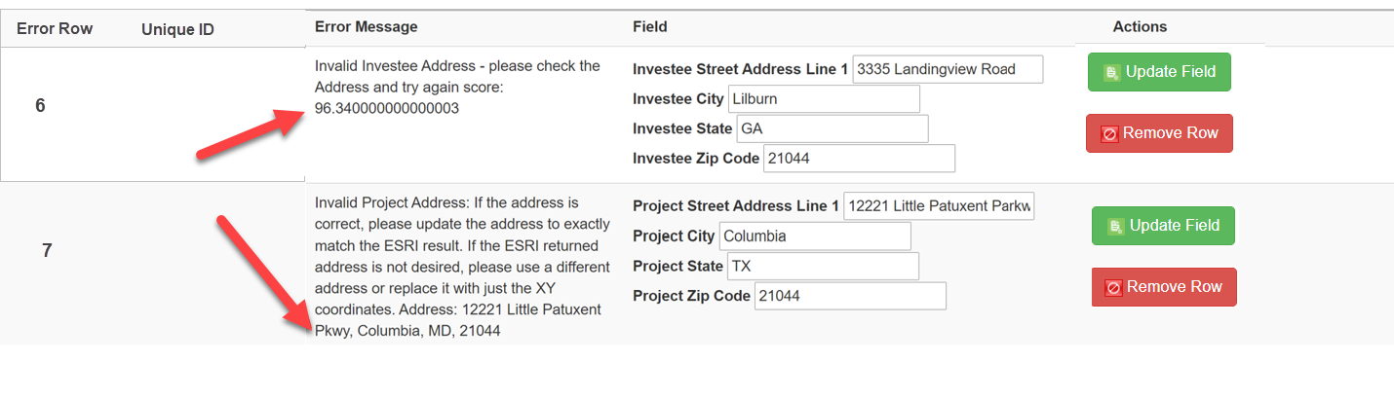
X,Y Coordinates – specify an exact geographic location using longitude and latitude. X,Y Coordinates must not be rounded, and AMIS requires that both the coordinates be reported to five (5) decimal points. The latitude and longitude can be found using a variety of tools such as a GPS, an address locator, or a map-based tool.
Example:
X Coordinate (Longitude, typically displayed as negative for continental US locations): -77.04201
Y Coordinate (Latitude, typically displayed as positive for continental US locations): 38.90397
How to find a FIPS code and census tract data:

The CDFI Fund offers the following guidance for obtaining a Federal Information Processing Standard (FIPS) code and/or maps for addresses that cannot be validated in CIMS:

- Log in and open the CDFI Information Mapping System (CIMS) https://www.cdfifund.gov/mapping-system.
- On the CIMS landing page that opens, under the Accessing the Mapping Software section, click on the button that says ‘Public.’
- On the next page that opens, choose the button labeled ‘NMTC.’
- By default, a map displays with a search box asking for an address—highlighted yellow in the screenshot below.

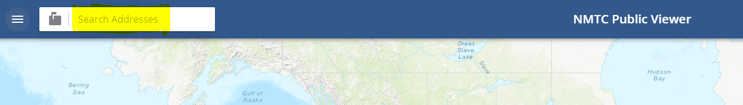

- Click on the mailbox icon to the left of the search box. This will display a list of search options.
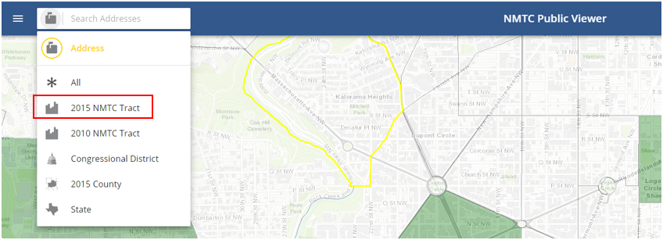

- Select the ‘2015 NMTC Tract’ option and enter the 11 digit FIPS code you are looking for.
- Press “Enter” on your keyboard.
- Select the FIPS code that displays under the search box.
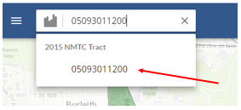

- CIMS will display a map and characteristics of the selected FIPS. Note that you may need to open the left-hand navigation (three-line icon to the left of the search box) and click on the “Details” tab to see the FIPS’ characteristics.
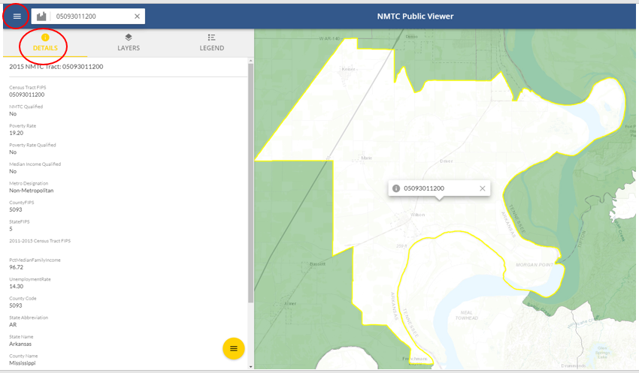

If you don’t know the FIPS Code, you can use the Address, County, or State search options to find the FIPS code for a specific area on a map.

A street address will return the most exact location
- Select the Address search option.
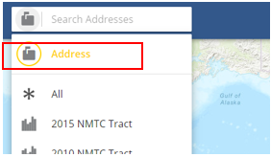

- Enter the full address in one line, for example “1801 L St NW, Washington, DC, 20036.”
- Press “Enter” on your keyboard.
- Select the Address from the dropdown.
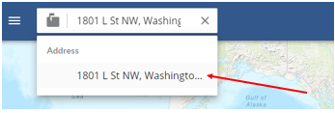

- CIMS will display a map of the specific street location.
- Click on the Layers tab in the left-hand navigation and select the ‘2015 NMTC Tract’ option.
- Right click on the map and you will see the FIPS code.
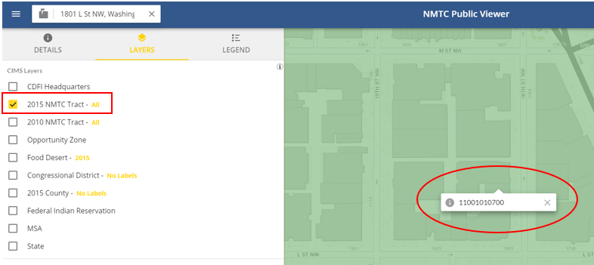

- Click on the Details tab and the characteristics for the FIPS code will display.
- Zoom out a bit and you can see the whole FIPS code area.
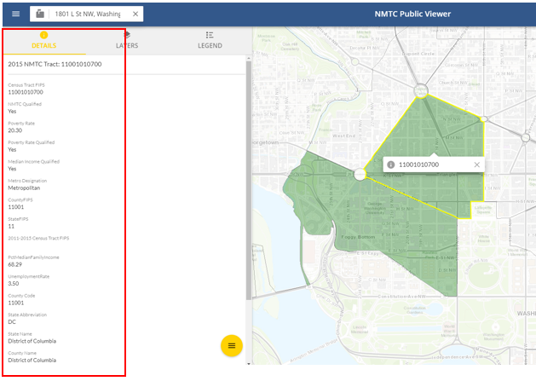

Finally, a county or state can also help you find a FIPS code if you do not have a specific address

- Select either the county or state search options.
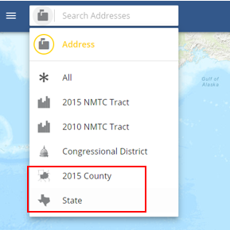

- Enter the name of the county or state.
- Press “Enter” on your keyboard.
- Select the name from the dropdown.
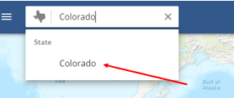

- CIMS will display a map of the county or state.
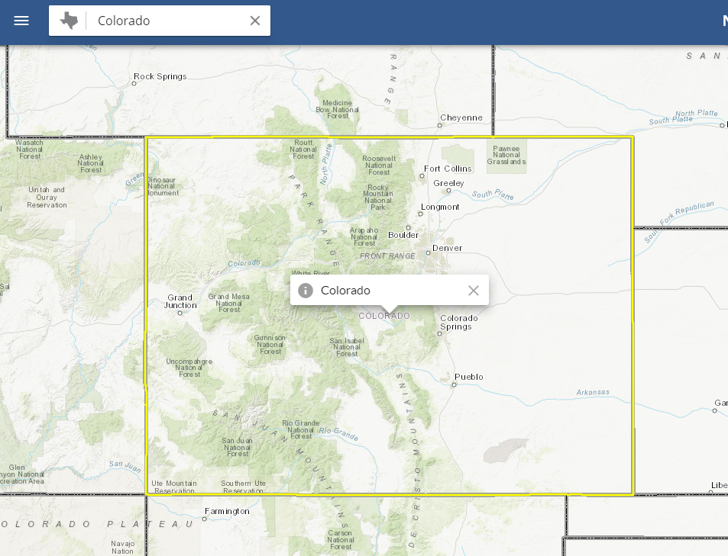
- After the map is displayed, use the left navigator and “Layers” tab to identify the characteristics of different tracts.
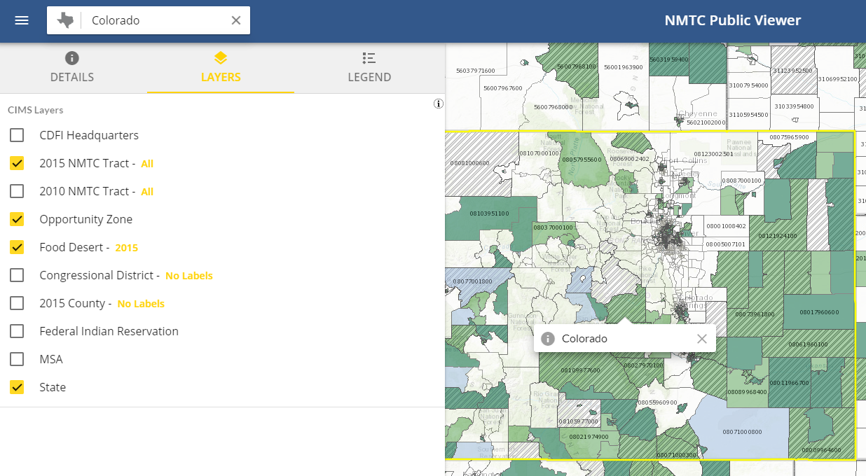

- Zoom into the map to establish the project’s location, using the street grid or other map features as a guide.
- Click on the map to identify the census tract. The FIPS Code will be displayed in the pop-up box. The census tract characteristics will display under the “Details” tab in the left-hand navigation.
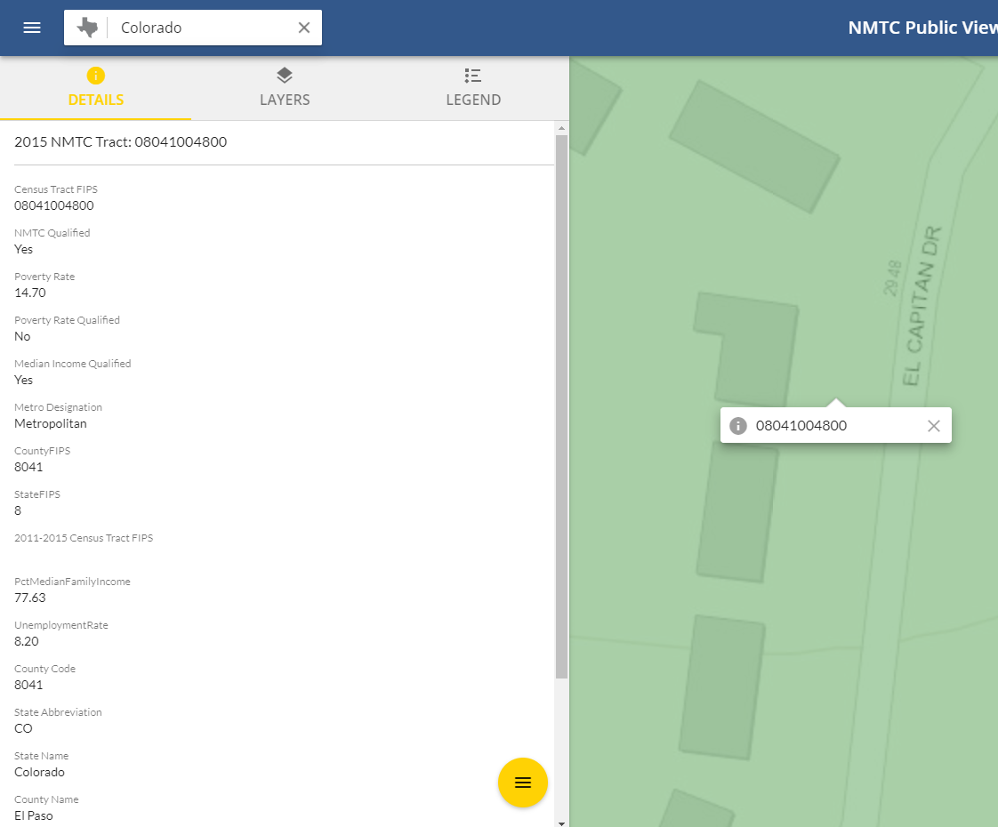

For more information on mapping, consult the following guidance:
https://amis.cdfifund.gov/s/CDFIFundAMIS-TrainingManual-AE101.pdf

Project Number (Column B)
Compliance Check
Report the project number for each address that was previously input in Project Number column on the Notes-Investment tab: Column A.
Validations:
    - Mandatory Field (System will automatically populate the number of the associated TLR Project)
    - Project Number must match a Project Number reported on the Notes-Investment tab.
Response must be numeric - up to 8 digits

Multi-CDE Project Number (Column C)
Report the Multi-CDE Project Number that was assigned to the project. Use the lookup function to identify and report the Multi-CDE Project ID associated with the project.
Validations:
    - Conditionally Required if the TLR Project that the TLR Address is being entered for is part of a Multi-CDE Project.
    - Additional guidance can be found in the Multi-CDE section of AMIS.
    - Response must be a valid project number generated by AMIS under the Multi-CDE Project section.
    - Use the lookup icon to view a list of Multi-CDE Projects associated with the organization that the TLR Project can be linked to.

Investee Street Address Line 1 (Column D)
Compliance Check
Report the address for the investee/borrower.
Validations:
  - Field is Mandatory unless one of the following two conditions are met:
- Investee Longitude and Latitude are populated; OR
- The Investee State is a US territory—Puerto Rico (PR), America Samoa (AS), Guam (GU), the Commonwealth of the Northern Mariana Islands (MP) or the United States Virgin Island (VI), in which case the Investee Address Line 1 MUST NOT be entered.
    - No Post Office Boxes or Rural Routes
Response must be text

Investee Street Address Line 2 (Column E)
Report the second line of the investee’s street address, if necessary.
Validations:
    - Optional Field
    - No Post Office Boxes or Rural Routes
Response must be text

Investee City (Column F)
Compliance Check
Report the investee’s city.
Validations:
  - Field is Mandatory unless one of the following two conditions are met:
- Investee Longitude and Latitude are populated; OR
- The Investee State is a US territory—Puerto Rico (PR), America Samoa (AS), Guam (GU), the Commonwealth of the Northern Mariana Islands (MP) or the United States Virgin Island (VI), in which case the Investee City MUST NOT be entered.

Response must be text

Investee State (Column G)
Compliance Check
Report the two-letter state abbreviation. If the location is one of the following US Territories, include the two-letter abbreviations for that territory—Puerto Rico (PR), America Samoa (AS), Guam (GU), the Commonwealth of the Northern Mariana Islands (MP) or the United States Virgin Island (VI).
Validations:
    - Mandatory Field
Response must be text

Investee Zip Code (Column H)
Compliance Check
Report the five-digit zip code.
Validations:
  - Field is Mandatory unless one of the following two conditions are met:
- Investee Longitude and Latitude are populated; OR
- The Investee State is a US territory—Puerto Rico (PR), America Samoa (AS), Guam (GU), the Commonwealth of the Northern Mariana Islands (MP) or the United States Virgin Island (VI), in which case the Investee Zip Code MUST NOT be entered.

Response must be numeric

Investee Zip Code +4 (Column I)
Compliance Check
Report the four-digit zip code extension
Validations:
    - Optional Field
Response must be numeric

FIPS Code – refers to the 11-digit Federal Information Processing Standards codes. The FIPS Code is a combination of the State, County, and Tract Code. To find a FIPS Code visit: Find FIPS code

The results of the geocode system display as:
When entered into AMIS, FIPS Codes must appear as: 11001010700
As of June 25, 2014, AMIS has updated with the most recent census data. Please use the most current census information when obtaining and reporting FIPS Codes.

Investee FIPS Code (Column J)
Report the investee’s 11-digit FIPS Code.
Validations:
    - Optional Field
Response must be numeric

Investee Longitude (Column K)
Report the Investee Longitude.
Validations:
    - Conditionally required if primary address fields are not entered OR if location is within the five U.S. territories (i.e. Puerto Rico (PR), American Samoa (AS), Guam (GU), U.S. Virgin Islands (VI), or Northern Mariana Islands (MP).
Response must be numeric
Investee Latitude (Column L)
Report the Investee Latitude.
Validations:
    - Conditionally required if primary address fields are not entered OR if location is within the five U.S. territories (i.e. Puerto Rico (PR), American Samoa (AS), Guam (GU), U.S. Virgin Islands (VI), or Northern Mariana Islands (MP).
Response must be numeric

Project Street Address Line 1 (Column M)
Compliance Check
Report the location of the business or other real estate for which the loan or investment is being used.
Validations:
  - Field is Mandatory unless one of the following two conditions are met:
- Project Longitude and Latitude are populated; OR
- The Project State is a US territory—Puerto Rico (PR), America Samoa (AS), Guam (GU), the Commonwealth of the Northern Mariana Islands (MP) or the United States Virgin Island (VI), in which case the Project Street Address Line 1 MUST NOT be entered.
    - No Post Office Boxes or Rural Routes
Response must be text

Project Street Address Line 2 (Column N)
Report the second line of the project’s street address, if necessary.
Validations:
    - Optional Field
    - No Post Office Boxes or Rural Routes
Response must be text

Project City (Column O)
Compliance Check
Report the project’s city.
Validations:
  - Field is Mandatory unless one of the following two conditions are met:
- Project Longitude and Latitude are populated; OR
- The Project State is a US territory—Puerto Rico (PR), America Samoa (AS), Guam (GU), the Commonwealth of the Northern Mariana Islands (MP) or the United States Virgin Island (VI), in which case the Project City MUST NOT be entered.

Response must be text

Project State (Column P)
Compliance Check
Report the two-letter state abbreviation. If the location is one of the following US Territories, include the two-letter abbreviations for that territory—Puerto Rico (PR), America Samoa (AS), Guam (GU), the Commonwealth of the Northern Mariana Islands (MP) or the United States Virgin Island (VI).
Validations:
    - Mandatory Field
Response must be text

Project Zip Code (Column Q)
Compliance Check
Report the five-digit zip code.
Validations:
  - Field is Mandatory unless one of the following two conditions are met:
- Project Longitude and Latitude are populated; OR
- The Project State is a US territory—Puerto Rico (PR), America Samoa (AS), Guam (GU), the Commonwealth of the Northern Mariana Islands (MP) or the United States Virgin Island (VI), in which case the Project Zip Code MUST NOT be entered.

Response must be numeric

Project Zip Code +4 (Column R)
Compliance Check
Report the four-digit zip code extension
Validations:
    - Optional Field
Response must be numeric

Project FIPS Code (Column S)
Report the project’s 11-digit FIPS Code.
Validations:
    - Optional Field.
Response must be numeric

Project Longitude (Column T)
Report the Project Longitude.
Validations:
    - Conditionally required if primary address fields are not entered OR if location is within the five U.S. territories (i.e. Puerto Rico (PR), American Samoa (AS), Guam (GU), U.S. Virgin Islands (VI), or Northern Mariana Islands (MP).
Response must be numeric

Project Latitude (Column U)
Report the Project Latitude.
Validations:
    - Conditionally required if primary address fields are not entered OR if location is within the five U.S. territories (i.e. Puerto Rico (PR), American Samoa (AS), Guam (GU), U.S. Virgin Islands (VI), or Northern Mariana Islands (MP).
Response must be numeric

Loan Source and Disbursements

The Loan Source section in AMIS collects data previously reported in the QEI Distribution Report in CIIS. This includes data related to the source of QLICI funds (i.e. QEIs/RQIs used and amount used from each QEI/RQI) and disbursement information (i.e. amount of disbursement(s) and date of disbursement(s)).
Loan Source information is required.
AMIS now allows the users to report Loan Source and Disbursements information via CSV and XML upload.
Various warnings and validations rules are built in to the Loan Source user interface in AMIS to ensure that loan source and disbursement data is entered accurately. In the case that a Loan Source is entered with inconsistent values, the user will not be able to save the data.

TLR NOTE ID
The system will auto-populate this field with the TLR Note ID of the TLR Note if one was previously selected. If this field is not prepopulated, the user will be required to look-up the TLR Note.
Validations:
    - Mandatory Field
    - Will auto-populate with the TLR Note number. If this field is not prepopulated, the user will be required to look-up the TLR Note.
    - Once Loan Source data is saved, this field allows the users to easily navigate back to the associated TLR Note via the “TLR Note” field hyperlink.
Alphanumeric

Originator Transaction ID Transaction Mandatory Info (Column B)
Assign a unique Originator Transaction ID to track Financial Note.
Validations:
- Mandatory Field
- Each Originator Transaction ID must be unique to each financial note. Duplicate Originator Transaction ID’s will cause errors in the file.
- Allocatees MUST use the same Originator Transaction ID for each reporting period.
- Originator Transaction ID’s can not contain any special characters such as, but not limited to, commas and exclamation points.
Response must be text - up to 20 characters

Revolving Loan (Column C)
Report if the Disbursement is made to a revolving loan or loan fund.
Validations:
    - Optional field
    - Checkbox for the user to mark when a loan is revolving.
Checkbox

Record Type of New Record (Column D)
Choose one of the pre-defined values below and indicate whether the Loan Source record type being reported is a QEI, RQI, or Other.
Validations:
    - Mandatory Field
Please select one of the following:

- QEI | QEI
- RQI | RQI
- Other | Other

Picklist Selection

Disbursement Date (Column E)
Report the Disbursement date.
Validations:
    - Mandatory Field
Format of mm/dd/yyyy

QEI Name (Column F)
Report the QEI that the Loan Source is associated with.
Validations:
    - Conditionally required: If “QEI” was selected as the disbursement type
    - QEI Identifier must be in the following format: QEI12345678 (“QEI” followed by eight numbers).
Lookup Field to QEIs

AMIS Number (Column G)
Report the Allocation if record type is RQI.
Validations:
    - Conditionally required based on the record type
Lookup Field to AMIS Number on the Allocation object

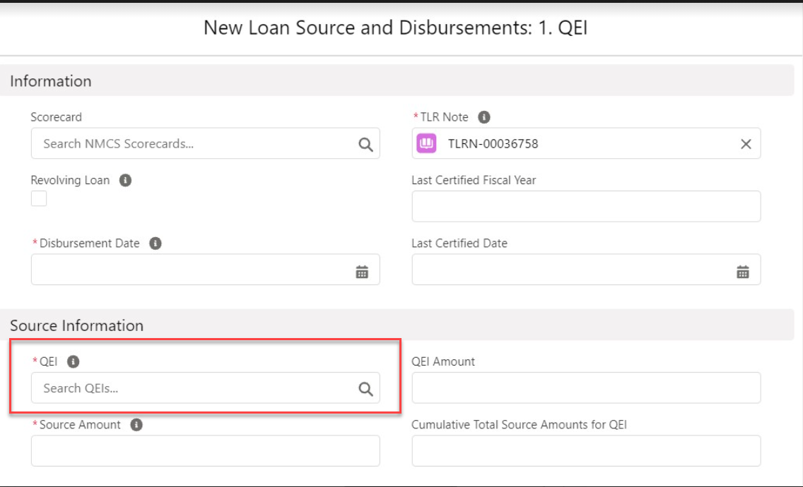
Note: Click on the search icon to search for the QEI the Loan Source record is associated with.

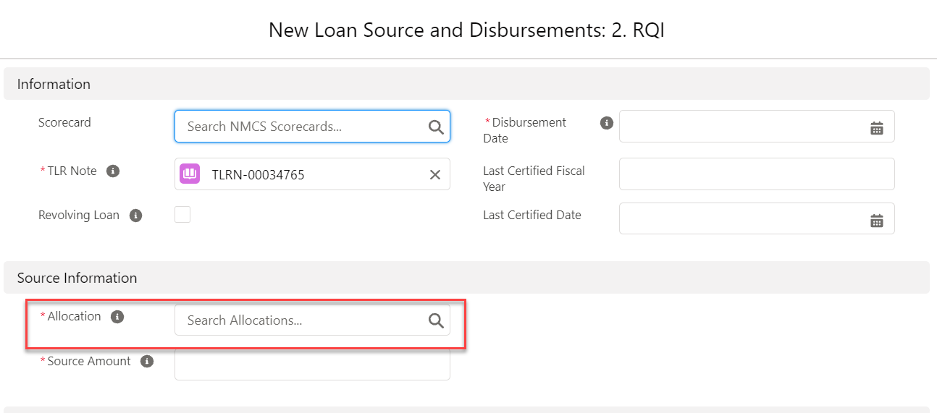
Note: Click on the search icon to search for the Allocation the Loan Source record is associated with.
Source Amount (Column H)
For each Loan Source, report the amount disbursed. The Source Amount represents the portion of the QEI or RQI used to fund the associated disbursement.
Validations:
    - Mandatory Field
    - Reported QEIs must be a valid QEI for the Allocatee in the Allocation and QEI Tracking module in AMIS.
    - Reported Allocations containing the RQI must be a valid Allocation for the Allocatee Allocation and QEI Tracking module in AMIS.
    - The sum of Source Amounts cannot exceed the Original Loan/Investment Amount.
    - The Sum of Source Amounts for QEI Loan Source must not exceed the Total QEI Amount on the QEI Record.
    - The Sum of Source Amounts for RQI Loan Source must not exceed the Total RQI Amount on the RQI Record.
Response Must Be Numeric

