OMB Control Number: 1670-0037
OMB Expiration Date: 12/31/2021

Paperwork Reduction Act
The public reporting burden to complete this information collection is estimated at 1 minutes per response, including the time for reviewing instructions, searching existing data sources, gathering and maintaining the data needed, and the completing and reviewing the collected information. The collection of information is voluntary. An agency may not conduct or sponsor, and a person is not required to respond to a collection of information unless it displays a currently valid OMB control number and expiration date. Send comments regarding this burden estimate or any other aspect of this collection of information, including suggestions for reducing this burden to DHS/CISA/CSD, 245 Murray Lane, SW, Mail Stop 0640, Arlington, VA 20598-0640 ATTN: PRA [OMB Control No. 1670-0037].

Mail Lists (NCAS) Subscription Form
CISA GovDelivery Subscriber Forms
In late 2021, CISA migrated three different GovDelivery Accounts (representing US-CERT, HSIN-CI, and CISA topics on the main DHS HQ GovDelivery Accounts) into one new combined GovDelivery account. Prior to this, individual accounts were managed separately by their respective entities, to include the previous approvals for forms.
With this migration we moved to a single sign up form for GovDelivery. At the request of the OCC, we only gather the email address of the person subscribing and no other PII, other than the topics they subscribe for in GovDelivery.
While individual topics can create custom links to subscribe to their individual topic, all such links use the same exact form with the same text and options and this is not alterable by users.
The following screen shots show all information requested of subscribers to CISA’s GovDelivery and all entry points for signing up. The individual US-CERT/ICS pages that existed in previous iterations no longer exist and there is a single unified CISA presence.
HQ OPA GovDelivery References: https://dhsconnect.dhs.gov/org/offices/opa/web/Pages/services/GovDelivery.aspx

Primary GovDelivery Sign-Up Portal: https://public.govdelivery.com/accounts/USDHSCISA/subscriber/new
This page has been reviewed by the CISA Privacy Office multiple times.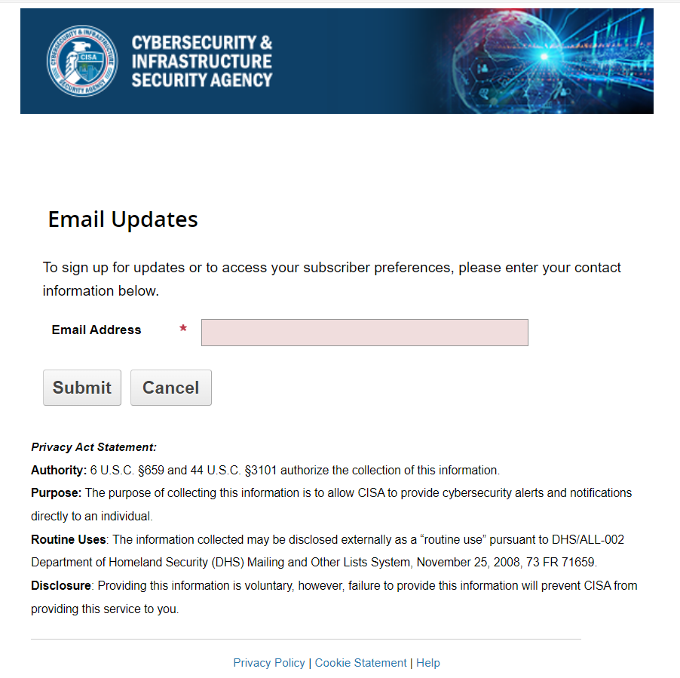

Subscription Preferences Page (Subscriptions Tab):
The following tabs can be accessed once a user creates an account on GovDelivery and logs in via the above page.
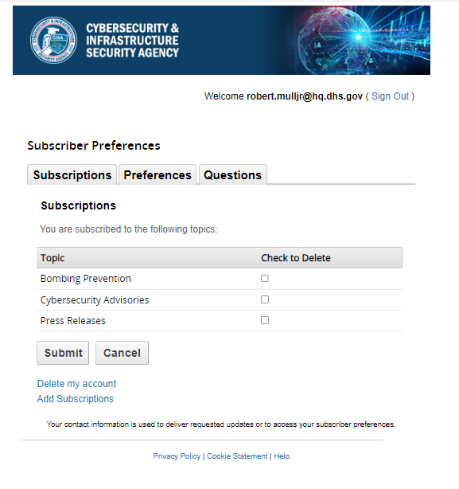

Subscription Preferences Page (Preferences Tab):

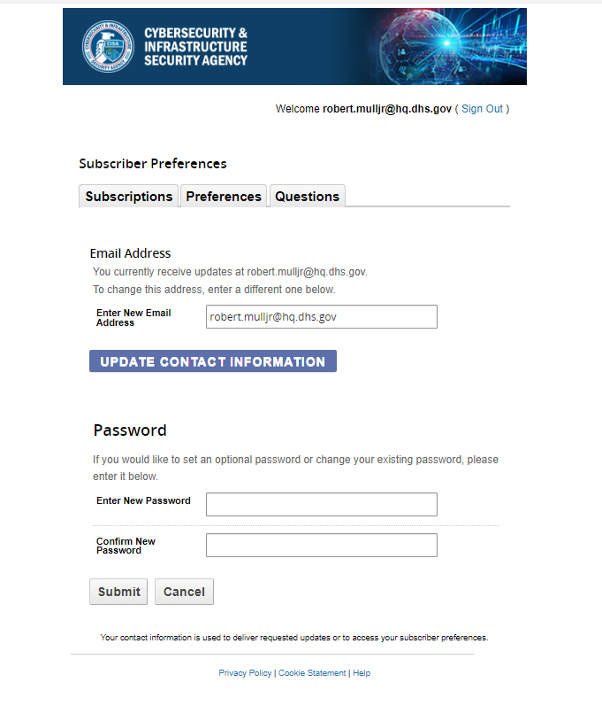

Subscription Preferences Page (Questions Tab):
Questions are a feature of GovDelivery that CISA does use, so this tab is not populated.
