OMB Control Number: 1670-0037
OMB Expiration Date: 12/31/2021
Paperwork Reduction Act
The public reporting burden to complete this information collection is estimated at 1 minute per response, including the time for reviewing instructions, searching existing data sources, gathering and maintaining the data needed, and the completing and reviewing the collected information. The collection of information is voluntary. An agency may not conduct or sponsor, and a person is not required to respond to a collection of information unless it displays a currently valid OMB control number and expiration date. Send comments regarding this burden estimate or any other aspect of this collection of information, including suggestions for reducing this burden to DHS/CISA/CSD, 245 Murray Lane, SW, Mail Stop 0640, Arlington, VA 20598-0640 ATTN: PRA [OMB Control No. 1670-0037].

CSET Download Form
https://cisa.gov/downloading-and-installing-cset
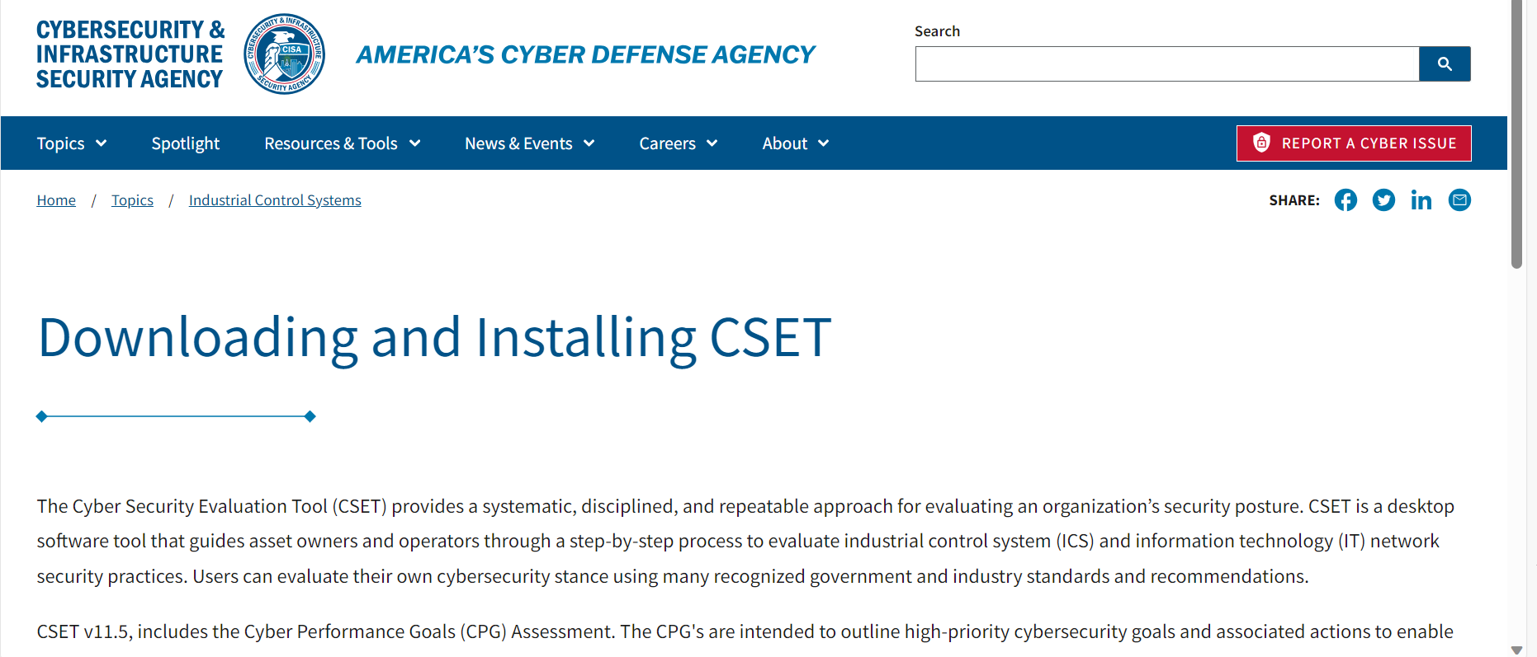
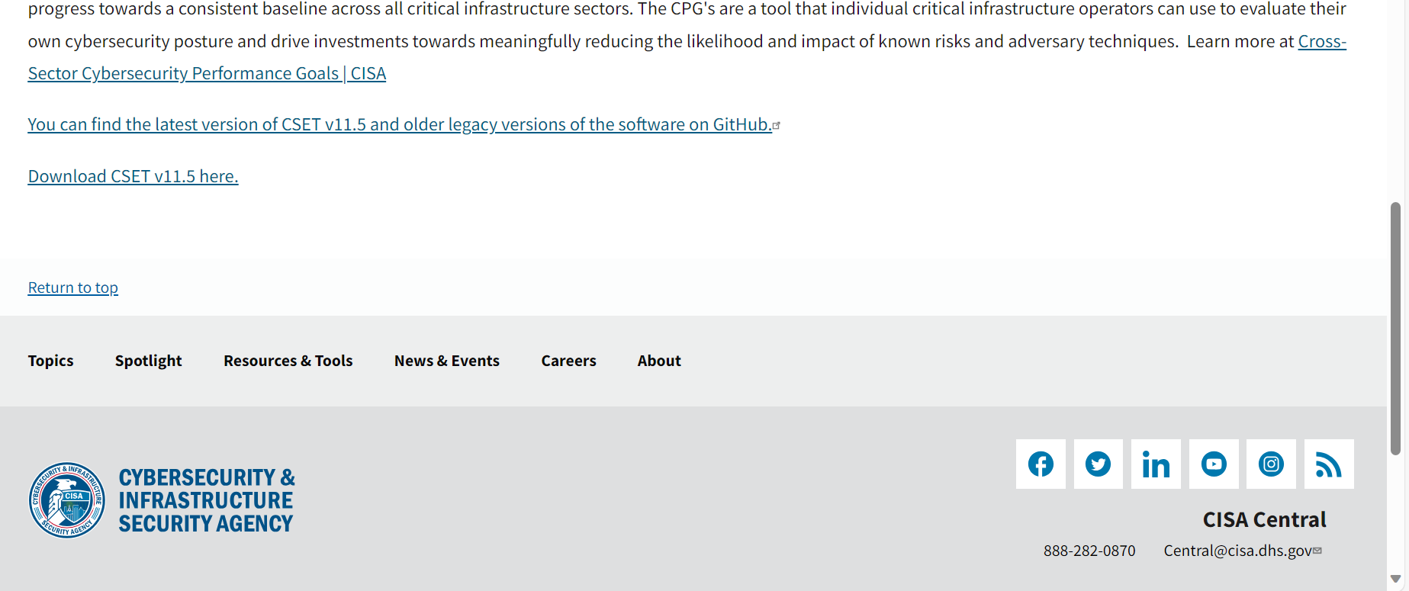

https://cset-download.inl.gov
