High School and Beyond 2022 (HS&B:22)
First Follow-up Field Test Recruitment and Data Collection

OMB# 1850-0944 v.10

Appendix A – Communication Materials

Submitted by
National Center for Education Statistics
U.S. Department of Education

July 2023
revised September 2023

Table of Contents

Appendix A.1 Endorsement Request Letter (previously approved) 2
Appendix A.2 State Notification Letter (new) 3
Appendix A.3a F1FT District Delay Letter (previously approved) 4
Appendix A.3b F1FT District Recruitment Letter (new) 5
Appendix A.4a F1FT School Delay Notification Letter (previously approved) 7
Appendix A.4b. F1FT School Recruitment Letter- field test participant (new) 8
Appendix A.4c F1FT School Recruitment Letter- field test non-participant (new) 9
Appendix A.5a School Coordinator Role Overview (modified) 10
Appendix A.5b School Coordinator Letter Accompanying Permission Materials (previously approved) 13
Appendix A.5c School Coordinator Role Overview Virtual School (modified) 14
Appendix A.6 School Thank You Letter (previously approved) 16
Appendix A.7a Parent Notification Letter (modified) 17
Appendix A.7b Parent Notification Letter – Spanish (modified) 18
Appendix A.7c Parent Permission Letter – Implicit (modified) 19
Appendix A.7d Parent Permission Letter - Implicit – Spanish (modified) 20
Appendix A.7e Parent Permission Letter – Explicit (modified) 21
Appendix A.7f Parent Permission Letter – Explicit – Spanish (modified) 23
Appendix A.7g Student Assent Form (modified) 25
Appendix A.7h Student Script (modified) 26
Appendix A.8 Study Information Sheet (modified) 27
Appendix A.9a Frequently Asked Questions (modified) 28
Appendix A.9b Frequently Asked Questions Virtual Schools (modified) 30
Appendix A.10 Brochure Text (previously approved) 32
Appendix A.11 Study Video (previously approved) 33
Appendix A.12 Recruitment Website Text (modified) 35
Appendix A.13a Out-of-School Data Collection – Parent Letter (modified) 47
Appendix A.13b Out-of-School Data Collection – Parent Letter Reminder (previously approved) 48
Appendix A.13c Out-of-School Data Collection – Parent Email Initial (modified) 49
Appendix A.13d Out-of-School Data Collection – Parent Email Reminder (previously approved) 50
Appendix A.13e Out-of-school Data Collection – Student Letter (modified) 51
Appendix A.13f Out-of-school Data Collection – Student Letter Reminder (modified) 52
Appendix A.13g Out-of-School Data Collection – Student Email Initial (modified) 53
Appendix A.13h Out-of-School Data Collection – Student Email Reminder (modified) 54
Appendix A13.i Out-of-School Data Collection – Student Postcard (previously approved) 55
Appendix A.14a Summary of Mathematics Questions (Modified) 56
Appendix A.14b Summary of Student Survey (modified) 57
Appendix A.14c Summary of Parent Survey (modified) 59
Appendix A.14d Summary of Mathematics Teacher Survey (modified) 60
Appendix A.14e Summary of School Counselor Survey (modified) 61
Appendix A.14f Summary of School Administrator Survey (modified) 62
Appendix A.15 Student Rostering Materials (modified) 63
Appendix A.16a Parent Data Collection Letter (modified) 79
Appendix A.16b Parent Data Collection Letter Reminder (modified) 80
Appendix A.16c Parent Data Collection Reminder Postcard (modified) 81
Appendix A.16d Parent Data Collection Abbreviated Survey Postcard (previously approved) 82
Appendix A.16e Parent Data Collection Email (previously approved) 83
Appendix A.16f Parent Data Collection Email Reminder (previously approved) 84
Appendix A.16g Parent Data Collection Email Reminder (previously approved) 85
Appendix A.16h Parent Data Collection Email Reminder (new) 86
Appendix A.16i Parent Data Collection Reinterview Email – Web (previously approved) 87
Appendix A.16j Parent Data Collection Reinterview Email – CATI (previously approved) 88
Appendix A.17a Staff Data Collection Letters – Math Teacher Letter (modified) 89
Appendix A.17b Staff Data Collection Letters – Math Teacher Reminder (modified) 90
Appendix A.17c Staff Data Collection Letters – Math Teacher Email (modified) 91
Appendix A.17d Staff Data Collection Letters – Math Teacher Email Reminder (modified) 92
Appendix A.17e Staff Data Collection Letters – School Counselor (modified) 93
Appendix A.17f Staff Data Collection Letters Reminder – School Counselor (modified) 94
Appendix A.17g Staff Data Collection Email– School Counselor (modified) 95
Appendix A.17h Staff Data Collection Email Reminder – School Counselor (modified) 96
Appendix A.17i Staff Data Collection Letters – School Administrator (modified) 97
Appendix A.17j Staff Data Collection Letters Reminder– School Administrator (modified) 98
Appendix A.17k Staff Data Collection Email – School Administrator (modified) 99
Appendix A.17l Staff Data Collection Email Reminder– School Administrator (modified) 100
Appendix A.17m Staff Data Collection Email Reminder– School Coordinator (new) 101
Appendix A.17n School Staff Participation Certificate (previously approved) 102
Appendix A.17o School Staff Post Card Reminder (new) 103
Appendix A.18 Parent/Student Incentive Receipt Form (previously approved) 104
Appendix A.19a Lead Postcards (previously approved) 105
Appendix A.19b Informational Materials (modified) 108
Appendix A.20 Digital Digests (modified) 111

Appendix A.1 Endorsement Request Letter (previously approved)
<Title First Name Last Name> <Date>
<National Education Organization Official’s Title>
<National Education Organization>
<Address>
<City, State Zip>

Dear <Name>:
We are writing to request support from your organization for the U.S. Department of Education’s High School & Beyond Longitudinal Study of 2022 (HS&B:22). Educational success is crucial to individual and societal outcomes. Understanding what factors propel some students to successful completion of high school and entry into work or college while leaving others behind is a critical function of this National Center for Education Statistics’ (NCES) research study.
HS&B:22 will give policymakers and educators information they need to improve the high-school experience and outcomes for ALL students. It will offer the opportunity to explore students transitions into and out of high-school and create a big picture view of K-12 education and trends as it follows the elementary and middle grades longitudinal studies.
We are hoping you will partner with us by learning more about HS&B:22 and encouraging participation of schools that are selected to represent the U.S. Educational experience in this study. Your support and a letter of endorsement can show how important this study is and increase participation and success of the study. Without school participation, the validity of national estimates is at risk.
  - If the 1.3 million dropouts from the Class of 2010 had graduated, the nation would have seen $337 billion more in earnings over the course of the students’ lifetimes.2
Next steps: Support HS&B:22 by lending your logo and name, providing a letter of endorsement, and sharing information about the study with your members and partners.
You may contact Lisa Kessler at RTI International with questions at (919) 485-2708 or HSB22@rti.org. You may also contact HS&B:22 Project Officer Elise Christopher at NCES at (202) 245-7098. We are confident that you will see the value and importance of this research and will want to partner with us to advance the quality of education for high school students.
Sincerely,
<NCES Commissioner>

NCES is authorized to conduct the High School and Beyond Longitudinal Study of 2022 (HS&B:22) by the Education Sciences Reform Act of 2002 (ESRA 2002, 20 U.S.C. §9543) and to collect students’ education records from education agencies or institutions for the purposes of evaluating federally supported education programs under the Family Educational Rights and Privacy Act (FERPA, 34 CFR §§ 99.31(a)(3)(iii) and 99.35). The data are being collected for NCES by RTI International, a U.S.-based nonprofit research organization. All of the information students, parents, and staff provide may be used only for statistical purposes and may not be disclosed, or used, in identifiable form for any other purpose except as required by law (20 U.S.C. §9573 and 6 U.S.C. §151). The collected information will be combined across respondents to produce statistical reports.
  - Allensworth, E., & Easton, J.Q. (2007). What matters for staying on-track and graduating in Chicago public high schools: A close look at course grades, failures, and attendance in the freshman year. University of Chicago Consortium on School Research.
  - 2 Campaign for CHSE High School Equity. "Plan for Success: Communities of Color Define Policy Priorities for High School Reform." Campaign for CHSE High School Equity. Accessed February 18, 2015.5.

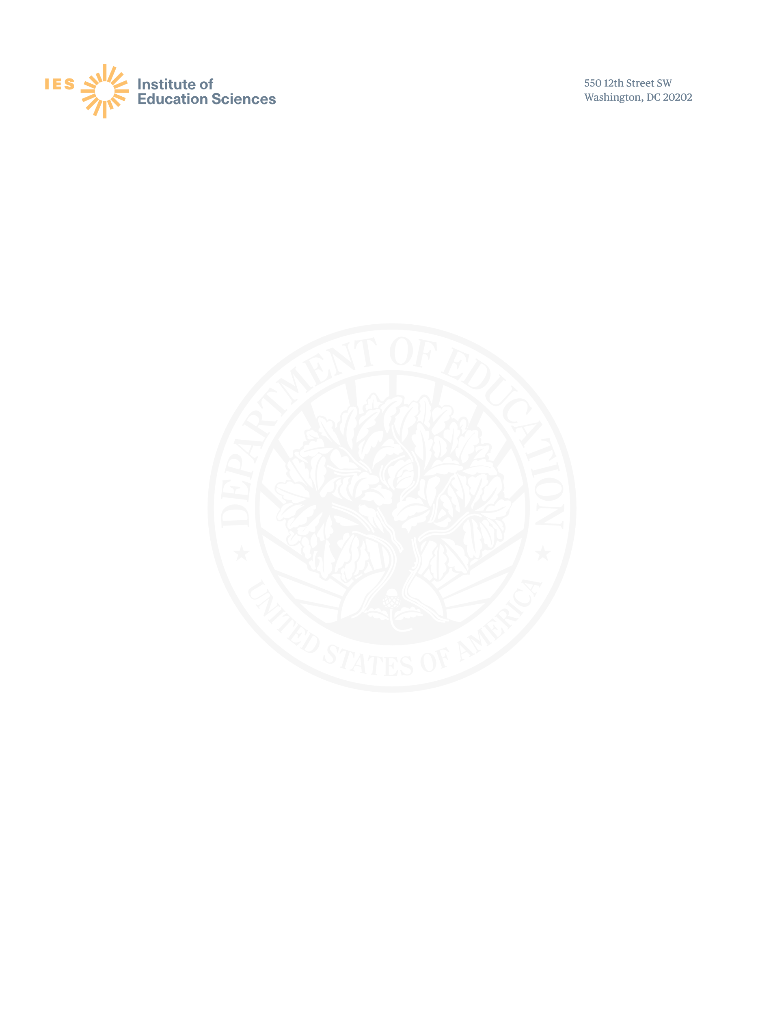
Appendix A.2 State Notification Letter (new)

Dear [Name]:

In 2019, districts and schools in [State] and throughout the United States were invited to participate in the High School and Beyond Longitudinal Study of 2022 (HS&B:22) field test, conducted by the U.S. Department of Education’s National Center for Education Statistics (NCES). We are writing to inform you that the follow-up field test for grade 12 will occur during the 2023-2024 school year, with data collection scheduled for spring 2024, with the same cohort of schools that were sampled in 2019.

HS&B:22 is the only longitudinal and nationally representative study to look at high school students, building upon decades of previous research dating back to the 1970s. Providing national-level information to better understand what factors lead students to successful completion of high school and entry into the workforce or postsecondary education, as well as those factors that are barriers to success, is a critical function of high school longitudinal studies such as HS&B:22. Data collected from HS&B:22, as well as previous longitudinal studies, offer an extraordinary opportunity to study trends in students’ high school experiences and education outcomes. Additionally, HS&B:22 data can be used to examine changes over time and shed light on the effects of various policies, demographic shifts, and school practices on student achievement, growth, and education attainment.

Selected districts and schools will soon receive their study invitations, and cooperation of all sampled schools is imperative to accurately represent the diverse landscape of the high school experience across the United States. We invite you to contact the study helpdesk at 855-500-1439 or email hsb22@rti.org with questions, or to navigate to https://surveys.nces.ed.go/hsb22 to learn more. You may also contact NCES Project Officer Elise Christopher, PhD at Elise.Christopher@ed.gov.
Thank you for your continued support and partnership of this critical national research advancing the quality of education for our country’s high school students. We look forward to working with your schools during the 2023-24 school year.
Sincerely,
<NCES Commissioner>

HS&B:22 is a voluntary study conducted by the National Center for Education Statistics (NCES) of the U.S. Department of Education and is being administered by RTI International.

NCES is authorized to conduct the High School and Beyond Longitudinal Study of 2022 (HS&B:22) by the Education Sciences Reform Act of 2002 (ESRA 2002, 20 U.S.C. §9543). The data are being collected for NCES by RTI International, a U.S.-based nonprofit research organization. All of the information you provide may be used only for statistical purposes and may not be disclosed, or used, in identifiable form for any other purpose except as required by law (20 U.S.C. §9573 and 6 U.S.C. §151

.

Appendix A.3a F1FT District Delay Letter (previously approved)
** This was already sent to school districts to inform of the study delay due to the COVID-19 pandemic**

Dear District Leader:

During the 2019-2020 school year, one or more of the schools in your district graciously participated in the field test of High School and Beyond Longitudinal Study of 2020 (HS&B:20). I am writing to thank you for your district’s continued support and to inform you that we have made a change in our plans for the first follow-up data collection activities.

- The follow-up student data collection for the 9th grade cohort will no longer take place due to the coronavirus pandemic. We will select a new group of 12th grade students at your school(s) during the 2023-2024 school year to participate spring of 2024.

- We will still contact study schools during the 2022-2023 school year to learn where study students are located but will not be conducting any HS&B:22 sessions at the schools. If your district provided the initial roster, we will reach out to you first for this activity.

- The study is now known as HS&B:22 due to the delay in field test and full-scale data collection activities.

Your district’s continued support in this endeavor is important to advance the quality of education for our country’s high school students. We look forward to working with your school(s) to make HS&B:22 a success!

Sincerely,

<NCES COMMISSIONER>

HS&B:22 is a voluntary study conducted by the National Center for Education Statistics (NCES) of the U.S. Department of Education and is being administered by RTI International. For additional study details please visit the HS&B:22 study website https://surveys.nces.ed.gov/hsb22. Should you have any questions, please call the HS&B:22 toll-free information number, 855-500-1439, or send an e-mail to HSB22@rti.org.

NCES is authorized to conduct the High School and Beyond Longitudinal Study of 2022 (HS&B:22) by the Education Sciences Reform Act of 2002 (ESRA 2002, 20 U.S.C. §9543). The data are being collected for NCES by RTI International, a U.S.-based nonprofit research organization. All of the information you provide may be used only for statistical purposes and may not be disclosed, or used, in identifiable form for any other purpose except as required by law (20 U.S.C. §9573 and 6 U.S.C. §151).

Appendix A.3b F1FT District Recruitment Letter (new)

Dear District Leader:
In 2019, one or more of your schools <were invited to participate> <participated> in the High School and Beyond Longitudinal Study of 2022 (HS&B:22) field test, conducted by the U.S Department of Education’s National Center for Education Statistics (NCES). We are writing to inform you that the follow-up field test for 12th grade will occur during the 2023-2024 school year with data collection scheduled for spring 2024. Please see the attached list of sampled school(s) in your district.
NCES fulfills a Congressional mandate to collect and report statistics on the condition of American education. Please encourage your sampled school(s) to review HS&B:22 materials and provide a timely response to participate. We will select about 40 12th grade students at each sampled school to participate in a 90-minute session that includes a student survey and math items.
HS&B:22 gives back to schools and offers:
- A menu of incentive options for schools, staff, and students.
- School staff are invited to attend a no-cost professional development session on STEM or project-based learning.
- Flexible scheduling and schools select their HS&B:22 session date.

The 12th grade data collection will further explore students’ completion of high school and entry into the workforce or postsecondary education, collecting data that can be used to examine student achievement, determine what leads students to positive outcomes, and better understand factors that may be barriers to success. This information is essential to helping us ensure our students complete high school and graduate prepared for success in college, career, and life.
We look forward to working with your school(s) during this important longitudinal study field test! We will reach out to you in the next few days to answer your questions, and then we will contact your district’s sampled school(s).
Sincerely,
<NCES COMMISSIONER>

HS&B:22 is a voluntary study conducted by the National Center for Education Statistics (NCES) of the U.S. Department of Education and is being administered by RTI International. For additional study details please visit the HS&B:22 study website https://surveys.nces.ed.gov/hsb22. Should you have any questions, please call the HS&B:22 toll-free information number, 855-500-1439, or send an e-mail to HSB22@rti.org.

NCES is authorized to conduct the High School and Beyond Longitudinal Study of 2022 (HS&B:22) by the Education Sciences Reform Act of 2002 (ESRA 2002, 20 U.S.C. §9543). The data are being collected for NCES by RTI International, a U.S.-based nonprofit research organization. All of the information you provide may be used only for statistical purposes and may not be disclosed, or used, in identifiable form for any other purpose except as required by law (20 U.S.C. §9573 and 6 U.S.C. §151).

List of Sampled Schools:

Appendix A.4a F1FT School Delay Notification Letter (previously approved)

Dear Principal:

During the 2019-2020 school year, your school graciously participated in the field test of the High School and Beyond Longitudinal Study of 2020 (HS&B:20). I am writing to thank you for your school’s continued support and to inform you that we have made changes to our plans for the first follow-up data collection activities.

- The follow-up student data collection for the 9th grade cohort will no longer take place due to the coronavirus pandemic. We will select a new group of 12th grade students at your school(s) during the 2023-2024 school year to participate in spring of 2024.

- We will still contact you during the 2022-2023 school year to learn where study students are located but will not be conducting any HS&B:22 sessions in your school. We will conduct the first and only planned follow-up for this study in the spring of 2024.

- The study is now known as HS&B:22 due to the delay in the field test and full-scale data collection activities.

Thank you for your continued support of this important endeavor aimed at advancing the quality of education for all of our country’s high school students. We look forward to working with your school to make HS&B:22 a success!

Sincerely,
<NCES COMMISSIONER>

HS&B:22 is conducted by the National Center for Education Statistics (NCES) of the U.S. Department of Education and is being administered by RTI International. For additional study details please visit the HS&B:22 study website https://surveys.nces.ed.gov/hsb22. Should you have any questions, please call the HS&B:22 toll-free information number, 855-500-1439, or send an e-mail to HSB22@rti.org.

NCES is authorized to conduct the High School and Beyond Longitudinal Study of 2022 (HS&B:22) by the Education Sciences Reform Act of 2002 (ESRA 2002, 20 U.S.C. §9543). The data are being collected for NCES by RTI International, a U.S.-based nonprofit research organization. All of the information you provide may be used only for statistical purposes and may not be disclosed, or used, in identifiable form for any other purpose except as required by law (20 U.S.C. §9573 and 6 U.S.C. §151).

Appendix A.4b. F1FT School Recruitment Letter- field test participant (new)

Dear Principal,
We appreciate your school’s continued support of the High School and Beyond Longitudinal Study of 2022 (HS&B:22) field test. Your school participated in the 2019 data collection and 2023 enrollment status update (ESU) activities. The follow-up field test for 12th grade will occur during the 2023-2024 school year with data collection scheduled for spring 2024, when we will select approximately 40 twelfth-grade students to participate in a 90-minute session that includes a student survey and math items.
HS&B:22 explores student transitions into high school; equity in education; family factors and other influences on students’ mindset; and the various pathways leading to college and the workforce. We are confident that you will continue to see the significance of this research to advance the quality of education for our country’s high school students. Your support in the conclusion of this field test is essential to helping ensure our students complete high school and graduate prepared for success in college, career, and life.

New and Improved Data Collection Procedures!
Your school can choose from:
- A menu of incentive options for schools, staff, and students.
- Flexible scheduling: you select the HS&B:22 session date.
- A new mode of data collection using your school’s computers to participate.
- If preferred, we can provide Chromebooks to your school for the session.
- Online synchronous sessions available for virtual schools.

Next Steps: A member from the HS&B:22 study team will reach out to you in the next few days to answer your questions and obtain the name of your School Coordinator (SC), who will serve as your study liaison. If you prefer to contact us first, please call us at 855-500-1439 or email HSB22@rti.org

Sincerely,
<NCES Commissioner>

HS&B:22 is a voluntary study conducted by the National Center for Education Statistics (NCES) of the U.S. Department of Education and is being administered by RTI International. For additional study details please visit the HS&B:22 study website https://surveys.nces.ed.gov/hsb22. Should you have any questions, please call the HS&B:22 toll-free information number, 855-500-1439, or send an e-mail to HSB22@rti.org.

NCES is authorized to conduct the High School and Beyond Longitudinal Study of 2022 (HS&B:22) by the Education Sciences Reform Act of 2002 (ESRA 2002, 20 U.S.C. §9543). The data are being collected for NCES by RTI International, a U.S.-based nonprofit research organization. All of the information you provide may be used only for statistical purposes and may not be disclosed, or used, in identifiable form for any other purpose except as required by law (20 U.S.C. §9573 and 6 U.S.C. §151).

Appendix A.4c F1FT School Recruitment Letter- field test non-participant (new)

Dear Principal,
In 2019 your school was invited to participate in the High School and Beyond Longitudinal Study of 2022 (HS&B:22) field test, conducted by the U.S Department of Education’s National Center for Education Statistics (NCES). We are writing to inform you that the follow-up field test for 12th grade will occur during the 2023-2024 school year with data collection scheduled for spring 2024. Your school is invited to participate in this important activity, and we appreciate your support. We would select approximately 40 twelfth-grade students to participate in a 90-minute session that includes a student survey and math items.
HS&B:22 explores student transitions into high school; equity in education; family factors and other influences on students’ mindset; and the various pathways leading to college and the workforce. We are confident that you will continue to see the significance of this research to advance the quality of education for our country’s high school students. Your support in the conclusion of this field test is essential to helping ensure our students complete high school and graduate prepared for success in college, career, and life.

New and Improved Data Collection Procedures!
Your school can choose from:
- A menu of incentive options for schools, staff, and students.
- Flexible scheduling: you select the HS&B:22 session date.
- A new mode of data collection using your school’s computers to participate.
- If preferred, we can provide Chromebooks to your school for the session.
- Online synchronous sessions available for virtual schools.

Next Steps: A member from the HS&B:22 study team will reach out to you in the next few days to answer any questions and obtain the name of your School Coordinator (SC) who will serve as your study liaison. If you prefer to contact us first, please call us at 855-500-1439 or email HSB22@rti.org

Sincerely,
<NCES Commissioner>
HS&B:22 is a voluntary study conducted by the National Center for Education Statistics (NCES) of the U.S. Department of Education and is being administered by RTI International. For additional study details please visit the HS&B:22 study website https://surveys.nces.ed.gov/hsb22. Should you have any questions, please call the HS&B:22 toll-free information number, 855-500-1439, or send an e-mail to HSB22@rti.org.

NCES is authorized to conduct the High School and Beyond Longitudinal Study of 2022 (HS&B:22) by the Education Sciences Reform Act of 2002 (ESRA 2002, 20 U.S.C. §9543). The data are being collected for NCES by RTI International, a U.S.-based nonprofit research organization. All of the information you provide may be used only for statistical purposes and may not be disclosed, or used, in identifiable form for any other purpose except as required by law (20 U.S.C. §9573 and 6 U.S.C. §151).

Appendix A.5a School Coordinator Role Overview (modified)

Welcome, colleague, to the exciting role of School Coordinator (SC) for the High School and Beyond Longitudinal Study of 2022 (HS&B:22), conducted by the National Center for Education Statistics (NCES). By helping with HS&B:22, you are contributing to the success of a study that will help educators, parents, and researchers learn how to best support student socioemotional and academic growth and learning during these extremely important years. We need your help, and we thank you in advance.

Study Activities
Student Session- Approximately 40 students in grade 12 will be invited to participate in a survey about their life in high school: class selections, grades, and social topics. They will also complete a math component.
HS&B:22 will be conducted at your school using your school computers, or we can ship Chromebooks upon request.
Student participants will receive an incentive selected by the school and a service certificate from the U.S. Department of Education.

Counselor and Administrator Survey- The principal and one counselor will complete surveys about school characteristics, staffing, the student population, and the academic environment. The surveys are completed online, and login credentials will be sent to each participant. If allowed, counselors and administrators may receive <incentive> and a U.S. Department of Education certificate of service for their participation.

Teacher Survey- One teacher of selected students in grade 12 will complete an online survey about their professional background. Teachers will also respond to questions about students participating in HS&B:22. If allowed, teachers will receive <incentive> for their time.

Parent Survey- The parent survey will ask about students’ education experiences, parents’ involvement in and expectations for their children’s academic attainment, and family characteristics. Parents can participate online or via telephone interview.

Permission Forms: Determine which type of form to use for your school. RTI will mail forms to you several weeks before the session. Please send these forms home with the students selected for the study when they arrive.

Roster- Provide a roster of your entire 12th grade enrollment so that we can select the students. If your school is small, we may select all 12th grade students to participate.
- Upload the 12th grade student roster to the secure HS&B:22 website.
- Receive a list of selected students and submit parent and teacher information for each student.
Logistics-
- Select date, time, and location for the student session.
- Distribute the permission forms and reminders if needed. You may be asked to call parents for outstanding forms.
- Work with your Session Facilitator (SF) to identify any students who may need accommodations.
- Notify teachers, parents, and students and explain activities coming up.
Session Day- Session facilitators will arrive about 1.5 hours before the session to set up. Please be available before the session to locate and bring any students that did not arrive on time. If you are unable to be there, designate another staff member to fill in for you that day.

Token of Appreciation-If allowed: As a token of our appreciation for your time and effort, you will be mailed a $100 check once the student session is complete. The person who completes the upload of the 12th grade roster will receive $50. Your school will receive $200 or cash equivalent in school supplies. Students will receive a 2-hour certificate of community service from the U.S. Department of Education plus a token of appreciation selected by your school. Staff will also receive <incentive> and service certificate.

THANK YOU for doing your part to improve the excellence of high school education for this generation and beyond!

School Coordinator Checklist

Task | Activity | Timeline | Completed
1 | Upload 12th grade roster to https://surveys.nces.ed.gov/hsb22. You may also provide teacher and parent info or provide it after student sampling | Within 2 weeks of receiving upload instructions
2 | If you did not provide teacher and parent info, log back into https://surveys.nces.ed.gov/hsb22 and provide teacher and parent information for sampled students | Within 1 week of receiving student sample list
3 | Select day and time for student session | During logistics call
4 | Reserve the media center or empty classroom for the student session | During logistics call
5 | Determine parental consent type (notified, implicit, explicit) | During logistics call
6 | Communicate with parents, teachers, and students about upcoming activities | 4-6 weeks prior to student session
7 | Send home parental permission forms | As soon as they arrive from RTI
8 | Remind parents to sign and return forms as needed | Weekly after forms are sent home
9 | Communicate to your HS&B:22 SF when permission forms are returned and be willing to call parents to encourage participation | Weekly after forms are sent home
10 | Determine if any students need accommodations | 1-2 weeks prior to student session
11 | Meet in person with your SF for a pre-session visit | 1 week prior to student session
12 | Receive Chromebook Shipment **Only if your school has requested study Chromebooks** | 1-2 days prior to student session
13 | Meet the SF at school | 1.5 hours before the session begins
14 | Assist as needed to set up and locate any students who did not arrive for the session | During the session day
15 | Return all permission forms to the SF and allow them to use the school fax machine | During the session day
16 | If needed, schedule a make-up session for students unable to attend | After the session day

Appendix A.5b School Coordinator Letter Accompanying Permission Materials (previously approved)

Dear <SC name>:
Thank you for your school’s participation in the High School and Beyond Longitudinal Study of 2022 (HS&B:22) and for all you have done to prepare for the data collection thus far. We look forward to coming to your school on <session date> to conduct the student session(s).
In this mailing, we have provided the student tracking form (STF) which lists the 12th grade students selected to participate at your school and parental permission materials for each selected student. In anticipation of the in-school session, we ask that you:
- distribute the parental <notification letters/permission forms> to the students listed on the STF<s>; and
- work with RTI’s session facilitator (SF) to finalize the logistics of the session(s), determine the eligibility of the students listed on the STF<s> to participate in the study, and discuss any accommodations that may be needed for students.
<IF INCENTIVE ALLOWED: As a token of our appreciation for your time and effort with HS&B:22, a check for $100 will be mailed to you after all student sessions have been completed at the school. Your school will also receive <incentive>.>
RTI’s session facilitator (SF) will contact you in the next few days to confirm the session logistics and to assist you in completing the activities listed above. Should you have questions in the meantime, you may contact us at 1-855-500-1439 or HSB22@rti.org.
Thank you again for serving as the school coordinator and for your help to make HS&B:22 successful at your school.
Sincerely,
Dan Pratt
Project Director, HS&B:22

Appendix A.5c School Coordinator Role Overview Virtual School (modified)

Welcome, colleague, to the exciting role of School Coordinator (SC) for the High School and Beyond Longitudinal Study of 2022 (HS&B:22) conducted by the National Center for Education Statistics (NCES). By helping with HS&B:22, you are contributing to the success of a study that will help educators, parents, and researchers learn how to best support student socioemotional and academic growth and learning during these extremely important years. We need your help, and we thank you in advance.

Study Activities
Student Session- Approximately 40 students in grade 12 will be invited to participate in an online survey about their life in high school: class selections, grades, and social topics. Students will participate virtually using a home computer. If feasible, we will host a virtual synchronous session and your sampled students can participate at the same time with study staff available to assist.
Student participants will receive <incentive> and a service certificate from the U.S. Department of Education.
Counselor and Administrator Surveys- The principal and one counselor will complete surveys about school characteristics, staffing, the student population, and the academic environment. The surveys are completed online, and login credentials will be sent to each participant. If allowed, counselors and administrators may receive <incentive> and a U.S. Department of Education certificate of service for their participation.

Teacher Survey- Teachers of sampled students in grade 12 will complete an online survey about their professional background. Teachers will also respond to questions about students participating in HS&B:22. If allowed, teachers will receive <incentive> for their time.

Parent Survey- The parent survey will ask about students’ education experiences, parents’ involvement in and expectations for their children’s academic attainment, and family characteristics. Parents can participate online or via telephone interview.

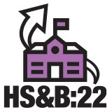

Virtual Synchronous Session: To maximize participation, we encourage you to select an HS&B:22 session date so your sampled students can participate online at the same time. We will send you a ZOOM link ahead of the session and assist students so they can log in and participate. The staff who assists with the session will receive $100.

Roster- Provide a roster of your entire 12th grade enrollment so that we can select the students to participate. If your school is small, we may select all 12th grade students to participate.
- Upload the 12th grade student roster to the secure HS&B:22 website.
- Receive the list of selected students and submit parent and teacher information for each student.
Login Credentials: An envelope containing the student and parent login information will be sent home to each family with a selected student. If the envelope is lost or misplaced, the family may email HSB22Survey@rti.org or call 855-500-1439 to request the login credentials.

Token of Appreciation- If allowed: As a token of our appreciation for your time and effort with HS&B:22, the person who completes the upload of the 12th grade roster will receive $50 plus a 2-hour service certificate from the U.S. Department of Education. Your school will receive $200 or cash equivalent in school supplies. Students will receive a 2-hour certificate of community service from the U.S. Department of Education plus a token of appreciation selected by your school. Staff will also receive <incentive> and service certificate.

THANK YOU for doing your part to improve the excellence of high school education for this generation and beyond!

Appendix A.6 School Thank You Letter (previously approved)

<DATE>

<School name>
<Address 1>
<Address 2}
<City, state, zip>

We are writing to thank you for your school’s participation in the High School and Beyond Longitudinal Study of 2022 (HS&B:22) field test this spring. The contributions of schools like yours provide invaluable feedback on the current high school experience, and we are grateful for your partnership. We would like to extend a special thank you to <School Coordinator name> <IF LP DIFFERENT FROM SC: and <List provider name>> for working with us to coordinate the student session(s) and ensure the study’s success at your school. <if applicable: We have enclosed <incentive> as a token of our appreciation for the school’s participation.>

If you have any questions, please call us at (855) 500-1439 or email us at HSB22@rti.org.

Thank you for helping to make HS&B:22 a success!

Sincerely,

Dan Pratt
Project Director, HS&B:22

Appendix A.7a Parent Notification Letter (modified)
HS&B:22 is conducted by the National Center for Education Statistics in the U.S. Department of Education. This important study provides you and your child the opportunity to share your experiences and opinions to help improve education for all students in the future.

WHO: Approximately 40 twelfth-grade students from your child’s school. Your child will represent other twelfth graders like them.
WHAT: Students will complete a survey and answer some math questions on a computer. Participation is voluntary.
WHEN: In the spring, at a convenient time chosen by your child’s school, students will spend up to 90 minutes participating.







IMPORTANT: This is not a test, and it is not graded. We follow very strict laws to protect personal information and any data collected. All information collected is securely maintained. All reports will use aggregate information for all students who participate; no names will be published in the data files or reports.
NCES is authorized to conduct the High School and Beyond Longitudinal Study of 2022 (HS&B:22) by the Education Sciences Reform Act of 2002 (ESRA 2002, 20 U.S.C. §9543) and to collect students’ education records from education agencies or institutions for the purposes of evaluating federally supported education programs under the Family Educational Rights and Privacy Act (FERPA, 34 CFR §§ 99.31(a)(3)(iii) and 99.35). The data are being collected for NCES by RTI International, a U.S.-based nonprofit research organization. All of the information students, parents, and staff provide may be used only for statistical purposes and may not be disclosed, or used, in identifiable form for any other purpose except as required by law (20 U.S.C. §9573 and 6 U.S.C. §151). The collected information will be combined across respondents to produce statistical reports.

Your child’s school is participating in the High School and Beyond Longitudinal Study of 2022 (HS&B:22)!
Your child will receive a certificate for 2 hours of community service from the U.S. Department of Education and a small gift as a “thank you” for participating. Schools and staff may also receive an incentive for participating.

WHERE: The school will choose the best location for the session, typically a classroom or media center.
WHY: The study will help us learn more about students’ academic and social growth during high school and ways we can support them. Together, this information helps us learn how to give all high schoolers the experience and skills they need to thrive in high school, and beyond.
To learn more: Watch a short video to see what participation will look like by visiting the study website at https://surveys.nces.ed.gov/hsb22/.
If you have questions, please call us at (855) 500-1439 or send an email to HSB22Survey@rti.org.
Thank you for taking the time to learn about this important study and how you can help.

Appendix A.7b Parent Notification Letter – Spanish (modified)

HS&B:22 que está llevando a cabo el Centro Nacional para Estadísticas de Educación del Departamento de Educación de los Estados Unidos. HS&B:22 les brinda a usted y a su estudiante la oportunidad única de compartir sus experiencias y opiniones para ayudar a mejorar la educación de su estudiante y la de otros estudiantes en el
¿QUIÉNES?: Aproximadamente
40 estudiantes de 12 ° grado de la escuela de su hijo/a. Su hijo/a representará a otros estudiantes de 12 ° grado como él/ella.
¿QUÉ?: Los estudiantes completarán una encuesta y responderán algunas preguntas de matemáticas en una computadora. La participación es voluntaria.
¿CUÁNDO?: En la primavera, en un horario conveniente elegido por la escuela de su hijo/a, los estudiantes pasarán hasta 90 minutos participando.

INFORMACIÓN IMPORTANTE: Esto no es un examen y tampoco se califica. Seguimos leyes muy estrictas para proteger la información personal de los participantes y cualquier información que se obtenga. Toda la información se mantendrá de manera segura y el nombre de su estudiante nunca se guardará junto con sus respuestas. Todos los reportes usarán información agregada de todos los estudiantes que participen.
NCES está autorizado a hacer el estudio HS&B:22 por el Acta de la Reforma de Educación de 2002 (ESRA 2002, 20 U.S.C. §9543) y a obtener expedientes escolares de los estudiantes, de agencias o instituciones educativas con el propósito de evaluar programas educativos que cuentan con apoyo a nivel federal bajo la Ley de Derechos Educativos y Privacidad Familiar (FERPA, 34 CFR §§ 99.31(a)(3)(iii) y 99.35). La recolección de datos la está llevando a cabo en nombre de NCES la firma RTI International, una organización sin fines de lucro que realiza estudios y está basada en los Estados Unidos. Toda la información que los estudiantes, los padres, y el personal proporcione podrán usarse solamente para propósitos estadísticos y no podrán divulgarse ni usarse de manera que permita identificar a los participantes para ningún otro propósito a menos que lo exija alguna ley (20 U.S.C. §9573 y 6 U.S.C. §151). La información que se obtenga se combinará con la de otros participantes para producir reportes estadísticos.

La escuela de su estudiante está participando en el estudio Durante y Después de High School 2022 (HS&B:22)!
Su estudiante recibirá un certificado de parte del Departamento de Educación de los Estados Unidos que lo/la acredita por 2 horas de servicio comunitario, así como también un pequeño regalo como muestra de agradecimiento por su participación. Las escuelas y el personal también pueden recibir un incentivo por participar.

¿DÓNDE?: La escuela elegirá el lugar más adecuado para llevar a cabo la sesión. Generalmente, ese hace en un salón de clases o la biblioteca.
¿POR QUÉ?: El estudio nos ayudará a conocer más sobre el crecimiento académico y social de los estudiantes durante high school, así como sobre las diferentes maneras en que podemos darles apoyo. Esta información, de manera conjunta, nos ayuda a conocer la forma en que debemos darles a todos los estudiantes de high school la experiencia y las habilidades necesarias para florecer en high school y en el futuro.
Para conocer más sobre el estudio: Por favor, mire un video breve en el que se muestra cómo sería la participación de su estudiante visite la página de Internet https://surveys.nces.ed.gov/hsb22/. Si usted tiene alguna pregunta, por favor llámenos al (855) 500-1439 o envíenos un correo electrónico a la dirección HSB22Survey@rti.org.
Gracias por dedicar tiempo a conocer sobre este estudio tan importante y la manera en que usted puede contribuir.

Appendix A.7c Parent Permission Letter – Implicit (modified)

HS&B:22 is conducted by the National Center for Education Statistics in the U.S. Department of Education. This important study provides you and your child the opportunity to share your experiences and opinions to help improve education for all students in the future.

WHO: Approximately 40 twelfth-grade students from your child’s school. Your child will represent other twelfth graders like them.
WHAT: Students will complete a survey and answer some math questions on a computer. Participation is voluntary.
WHEN: In the spring, at a convenient time chosen by your child’s school, students will spend up to 90 minutes participating.



IMPORTANT: This is not a test, and it is not graded. We follow very strict laws to protect personal information and any data collected. All information collected is securely maintained. All reports will use aggregate information for all students who participate; no names will be published in the data files or reports.
NCES is authorized to conduct the High School and Beyond Longitudinal Study of 2022 (HS&B:22) by the Education Sciences Reform Act of 2002 (ESRA 2002, 20 U.S.C. §9543) and to collect students’ education records from education agencies or institutions for the purposes of evaluating federally supported education programs under the Family Educational Rights and Privacy Act (FERPA, 34 CFR §§ 99.31(a)(3)(iii) and 99.35). The data are being collected for NCES by RTI International, a U.S.-based nonprofit research organization. All of the information students, parents, and staff provide may be used only for statistical purposes and may not be disclosed, or used, in identifiable form for any other purpose except as required by law (20 U.S.C. §9573 and 6 U.S.C. §151). The collected information will be combined across respondents to produce statistical reports.

Your child’s school is participating in the High School and Beyond Longitudinal Study of 2022 (HS&B:22)!
Your child will receive a certificate for 2 hours of community service from the U.S. Department of Education and a small gift as a “thank you” for participating. Schools and staff may also receive an incentive for participating.

WHERE: The school will choose the best location for the session, typically a classroom or media center.
WHY: The study will help us learn more about students’ academic and social growth during high school and ways we can support them. Together, this information helps us learn how to give all high schoolers the experience and skills they need to thrive in high school, and beyond.
To learn more: Watch a short video to see what participation will look like by visiting the study website at https://surveys.nces.ed.gov/hsb22/.
If you have questions, please call us at (855) 500-1439 or send an email to HSB22Survey@rti.org.
Thank you for taking the time to learn about this important study and how you can help.
You only need to return the attached form if you do not want your student to participate.

Appendix A.7d Parent Permission Letter - Implicit – Spanish (modified)

HS&B:22 que está llevando a cabo el Centro Nacional para Estadísticas de Educación del Departamento de Educación de los Estados Unidos. HS&B:22 les brinda a usted y a su estudiante la oportunidad única de compartir sus experiencias y opiniones para ayudar a mejorar la educación de su estudiante y la de otros estudiantes en el futuro.

¿QUIÉNES?: Aproximadamente 40 estudiantes de 12 ° grado de la escuela de su hijo/a. Su hijo/a representará a otros estudiantes de 12 ° grado como él/ella.

¿QUÉ?: Los estudiantes completarán una encuesta y responderán algunas preguntas de matemáticas en una computadora. La participación es voluntaria.
¿CUÁNDO?: En la primavera, en un horario conveniente elegido por la escuela de su hijo/a, los estudiantes pasarán hasta 90 minutos participando.

INFORMACIÓN IMPORTANTE: Esto no es un examen y tampoco se califica. Seguimos leyes muy estrictas para proteger la información personal de los participantes y cualquier información que se obtenga. Toda la información se mantendrá de manera segura y el nombre de su estudiante nunca se guardará junto con sus respuestas. Todos los reportes usarán información agregada de todos los estudiantes que participen.
NCES está autorizado a hacer el estudio HS&B:22 por el Acta de la Reforma de Educación de 2002 (ESRA 2002, 20 U.S.C. §9543) y a obtener expedientes escolares de los estudiantes, de agencias o instituciones educativas con el propósito de evaluar programas educativos que cuentan con apoyo a nivel federal bajo la Ley de Derechos Educativos y Privacidad Familiar (FERPA, 34 CFR §§ 99.31(a)(3)(iii) y 99.35). La recolección de datos la está llevando a cabo en nombre de NCES la firma RTI International, una organización sin fines de lucro que realiza estudios y está basada en los Estados Unidos. Toda la información que los estudiantes, los padres, y el personal proporcione podrán usarse solamente para propósitos estadísticos y no podrán divulgarse ni usarse de manera que permita identificar a los participantes para ningún otro propósito a menos que lo exija alguna ley (20 U.S.C. §9573 y 6 U.S.C. §151). La información que se obtenga se combinará con la de otros participantes para producir reportes estadísticos.

La escuela de su estudiante está participando en el estudio Durante y Después de High School 2022 (HS&B:22)!

Su estudiante recibirá un certificado de parte del Departamento de Educación de los Estados Unidos que lo/la acredita por 2 horas de servicio comunitario, así como también un pequeño regalo como muestra de agradecimiento por su participación. Las escuelas y el personal también pueden recibir un incentivo por participar.

¿DÓNDE?: La escuela elegirá el lugar más adecuado para llevar a cabo la sesión. Generalmente, ese hace en un salón de clases o la biblioteca.
¿POR QUÉ?: El estudio nos ayudará a conocer más sobre el crecimiento académico y social de los estudiantes durante high school, así como sobre las diferentes maneras en que podemos darles apoyo. Esta información, de manera conjunta, nos ayuda a conocer la forma en que debemos darles a todos los estudiantes de high school la experiencia y las habilidades necesarias para florecer en high school y en el futuro.
Para conocer más sobre el estudio: Por favor, mire un video breve en el que se muestra cómo sería la participación de su estudiante visite la página de Internet https://surveys.nces.ed.gov/hsb22/. Si usted tiene alguna pregunta, por favor llámenos al (855) 500-1439 o envíenos un correo electrónico a la dirección HSB22Survey@rti.org.
Gracias por dedicar tiempo a conocer sobre este estudio tan importante y la manera en que usted puede contribuir.
Si usted no desea que su estudiante participe, lo único que tiene que hacer es devolver el formulario incluido.

Appendix A.7e Parent Permission Letter – Explicit (modified)
HS&B:22 is conducted by the National Center for Education Statistics in the U.S. Department of Education. This important study gives you and your child the opportunity to share your experiences and opinions to help improve education for all students in the future.

WHO: Approximately 40 twelfth-grade students from your child’s school. Your child will represent other twelfth graders like them.
WHAT: Students will complete a survey and answer some math questions on a computer. Participation is voluntary.
WHEN: In the spring, at a convenient time chosen by your child’s school, students will spend up to 90 minutes participating.

IMPORTANT: This is not a test, and it is not graded. We follow very strict laws to protect personal information and any data collected. All information collected is securely maintained. All reports will use aggregate information for all students who participate; no names will be published in the data files or reports.
NCES is authorized to conduct the High School and Beyond Longitudinal Study of 2022 (HS&B:22) by the Education Sciences Reform Act of 2002 (ESRA 2002, 20 U.S.C. §9543) and to collect students’ education records from education agencies or institutions for the purposes of evaluating federally supported education programs under the Family Educational Rights and Privacy Act (FERPA, 34 CFR §§ 99.31(a)(3)(iii) and 99.35). The data are being collected for NCES by RTI International, a U.S.-based nonprofit research organization. All of the information students, parents, and staff provide may be used only for statistical purposes and may not be disclosed, or used, in identifiable form for any other purpose except as required by law (20 U.S.C. §9573 and 6 U.S.C. §151). The collected information will be combined across respondents to produce statistical reports.

Your child’s school is participating in the High School and Beyond Longitudinal Study of 2022 (HS&B:22)!
Your child will receive a certificate for 2 hours of community service from the U.S. Department of Education and a small gift as a “thank you” for participating. Schools and staff may also receive an incentive for participating.

WHERE: The school will choose the best location for the session, typically a classroom or media center.
WHY: The study will help us learn more about students’ academic and social growth during high school and ways we can support them. Together, this information helps us learn how to give all high schoolers the experience and skills they need to thrive in high school, and beyond.
To learn more: Watch a short video to see what participation will look like by visiting the study website at https://surveys.nces.ed.gov/hsb22/.
If you have questions, please call us at (855) 500-1439 or send an email to HSB22Survey@rti.org.
Thank you for taking the time to learn about this important study and how you can help.


ACTION NEEDED!

Please sign and return the attached form <OR submit an online signature> for your student to participate <by visiting the study website>.

Parent/Guardian Explicit Permission Form – HS&B:22

Your student has been asked to participate in a study on student learning called High School and Beyond 2022 (HS&B:22). Student data will be collected in one session during the school day. The student session will be led by a team of researchers from RTI International, on behalf of the National Center for Education Statistics (NCES).

PLEASE CHECK ONE:

Yes, I give permission for my child to participate in HS&B:22.

No, I do not give permission for my child to participate in HS&B:22.

PLEASE SIGN YOUR NAME BELOW:

_____________________________________________________ Date of signature: _____/_______/_______
(Signature of parent or guardian)

PLEASE PRINT:
Student name: _____________________________________________
School name: ______________________________________________
Parent name: ______________________________________________
Parent telephone: _________________________________________
Parent email: ______________________________________________
Parent home address: ___________________________________________________________________________________________________ Street address City State Zip

FOR OFFICE USE ONLY:
Student ID: ________________________________________________

Appendix A.7f Parent Permission Letter – Explicit – Spanish (modified)

HS&B:22 que está llevando a cabo el Centro Nacional para Estadísticas de Educación del Departamento de Educación de los Estados Unidos. HS&B:22 les brinda a usted y a su estudiante la oportunidad única de compartir sus experiencias y opiniones para ayudar a mejorar la educación de su estudiante y la de otros estudiantes en el futuro.

¿QUIÉNES?: Aproximadamente 40 estudiantes de 12 ° grado de la escuela de su hijo/a. Su hijo/a representará a otros estudiantes de 12 ° grado como él/ella.
¿QUÉ?: Los estudiantes completarán una encuesta y responderán algunas preguntas de matemáticas en una computadora. La participación es voluntaria.
¿CUÁNDO?: En la primavera, en un horario conveniente elegido por la escuela de su hijo/a, los estudiantes pasarán hasta 90 minutos participando.

INFORMACIÓN IMPORTANTE: Esto no es un examen y tampoco se califica. Seguimos leyes muy estrictas para proteger la información personal de los participantes y cualquier información que se obtenga. Toda la información se mantendrá de manera segura y el nombre de su estudiante nunca se guardará junto con sus respuestas. Todos los reportes usarán información agregada de todos los estudiantes que participen.
NCES está autorizado a hacer el estudio HS&B:22 por el Acta de la Reforma de Educación de 2002 (ESRA 2002, 20 U.S.C. §9543) y a obtener expedientes escolares de los estudiantes, de agencias o instituciones educativas con el propósito de evaluar programas educativos que cuentan con apoyo a nivel federal bajo la Ley de Derechos Educativos y Privacidad Familiar (FERPA, 34 CFR §§ 99.31(a)(3)(iii) y 99.35). La recolección de datos la está llevando a cabo en nombre de NCES la firma RTI International, una organización sin fines de lucro que realiza estudios y está basada en los Estados Unidos. Toda la información que los estudiantes, los padres, y el personal proporcione podrán usarse solamente para propósitos estadísticos y no podrán divulgarse ni usarse de manera que permita identificar a los participantes para ningún otro propósito a menos que lo exija alguna ley (20 U.S.C. §9573 y 6 U.S.C. §151). La información que se obtenga se combinará con la de otros participantes para producir reportes estadísticos.

La escuela de su estudiante está participando en el estudio Durante y Después de High School 2022 (HS&B:22)!

Su estudiante recibirá un certificado de parte del Departamento de Educación de los Estados Unidos que lo/la acredita por 2 horas de servicio comunitario, así como también un pequeño regalo como muestra de agradecimiento por su participación. Las escuelas y el personal también pueden recibir un incentivo por participar.

¿DÓNDE?: La escuela elegirá el lugar más adecuado para llevar a cabo la sesión. Generalmente, ese hace en un salón de clases o la biblioteca.
¿POR QUÉ?: El estudio nos ayudará a conocer más sobre el crecimiento académico y social de los estudiantes durante high school, así como sobre las diferentes maneras en que podemos darles apoyo. Esta información, de manera conjunta, nos ayuda a conocer la forma en que debemos darles a todos los estudiantes de high school la experiencia y las habilidades necesarias para florecer en high school y en el futuro.
Para conocer más sobre el estudio: Por favor, mire un video breve en el que se muestra cómo sería la participación de su estudiante visite la página de Internet https://surveys.nces.ed.gov/hsb22/. Si usted tiene alguna pregunta, por favor llámenos al (855) 500-1439 o envíenos un correo electrónico a la dirección HSB22Survey@rti.org.
Gracias por dedicar tiempo a conocer sobre este estudio tan importante y la manera en que usted puede contribuir.
¡ACCION NECESARIA!
Por favor firme y devuelva el formulario incluido. <O, visite la página del estudio en Internet para enviar su firma electrónica.>

Formulario de permiso explícito de los padres/tutores – HS&B:22

Se le ha pedido a su estudiante que participe en un estudio sobre el aprendizaje estudiantil llamado Durante y Después de High School 2022 (High School and Beyond 2022 o HS&B:22, por sus siglas en inglés). Los datos de los estudiantes se obtendrán en una sesión durante el día escolar. La sesión para los estudiantes será dirigida por un equipo de investigadores de la organización RTI International, en nombre del Centro Nacional para Estadísticas Educativas (NCES, por siglas en inglés).

POR FAVOR MARQUE UNO:

Sí, doy permiso para que mi hijo participe en HS&B:22.

No, no doy permiso para que mi estudiante participe en HS&B:22.

POR FAVOR FIRME SU NOMBRE ABAJO:

____________________________________________Fecha de la firma: _____/_____/______
(Firma del padre o tutor)

POR FAVOR IMPRIMIR:
Nombre del estudiante: _____________________________________________
Nombre de la escuela: ______________________________________________
Nombre del padre: ______________________________________________
Teléfono de los padres: _________________________________________
Correo electrónico de los padres: ______________________________________________
Domicilio de los padres:
___________________________________________________________________________________________________ Calle Ciudad Estado Código postal

SÓLO PARA USO DE OFICINA:
Identificación del Estudiante:________________________________________________

Appendix A.7g Student Assent Form (modified)
High School and Beyond Longitudinal Study of 2022 (HS&B:22)
Student Assent Form (used only when required by the school)
You are being asked to participate in a national study called the High School and Beyond Longitudinal Study of 2022 (HS&B:22). This study is conducted by the National Center for Education Statistics (NCES) within the U.S. Department of Education.
Your participation in HS&B:22 is voluntary. The information you provide will be combined with the information received from thousands of other students, parents, and school staff. No names of schools or individuals will be published in study reports. Each student who participates will receive a certificate of community service [if allowed by district: and a token of appreciation valued at $<FILL>.
Please check only one option below to indicate your decision to participate in the study.

Yes, I will participate in HS&B:22.

No, I will not participate in HS&B:22.

PRINT your name here:

SIGN your name here:

Date: _______/_______/____________

FOR OFFICE USE ONLY:
Student ID: ________________________________________________
School name: ________________________________________________

Appendix A.7h Student Script (modified)
INSTRUCTION TO SF: READ THE FOLLOWING SCRIPT VERBATIM TO THE STUDENTS PRIOR TO STARTING THE STUDENT SESSION.

Welcome, my name is [SF1 name] and this is [SF2 name]. You are here today because you were selected to represent high school students in an important study called the High School and Beyond Longitudinal Study of 2022, or HS&B:22 for short. We are very excited that you are able to join us today. For the next 90 minutes or so, you will be using a computer to answer questions about yourself and math questions. Please do the best that you can. If you do not know an answer or do not want to answer a question, you may skip it. This is not a test and you will not be graded on how you answer the questions. <if using study Chromebooks: You can touch the screen or use the touchpad to answer the questions.> You can also have the questions read aloud to you if you like by clicking on the “read aloud” button.

Your participation in HS&B:22 is voluntary, and all the information you provide will be combined with all of the other information we collect. No names of schools or individuals will be included in any study reports.

When you are all done you will see a screen that says “Congratulations.” When you see that screen, please raise your hand, and I will come over and log you out and collect your student login card. You may keep the earbuds and the pencil. And you will receive a certificate of community service [if allowed: and a token of appreciation valued at $<FILL>]. Please meet me here [point out where student should go] to check out. Next, [please sit quietly until the end of the session/please go back to your class after you get a hall pass]. Any questions?

[If hardcopy student assent is required, distribute student assent forms and say: Please check “Yes, I will participate in HS&B:22” if you would like to participate, or “No, I will not participate in HS&B:22” if you decide you do not want to participate. If you check “no” please raise your hand.]

Okay, let’s get started. Go ahead and enter the username and password on the card at your desk. Then click “start” on the screen and follow the instructions.

Appendix A.8 Study Information Sheet (modified)
HS&B:22 Study Information Sheet
HS&B:22 data collection takes place between January and June 2024

Appendix A.9a Frequently Asked Questions (modified)
FREQUENTLY ASKED QUESTIONS- Follow-up Field Test

What is HS&B:22 and why is it important? | The High School and Beyond Longitudinal Study of 2022 (HS&B:22) follow-up field test is conducted by the National Center of Education Statistics (NCES) within the U.S. Department of Education. Studies like this occur once a decade. HS&B:22 will take place during the 2023-2024 school year (spring 2024).  Selected students, their families, and school staff all have an important role in helping us learn more about the high school experience, students’ academic and social growth, and ways we can support students in gaining the knowledge and skills they need to thrive in high school and beyond.
Why did my school get selected? | Study schools were randomly selected by geographic region, locale, and type: public and private, including charter, magnet, and virtual schools.  Your school represents schools like yours across the country and cannot be replaced!
Why should my school participate? | High school is rapidly changing. What worked in schools 10 years ago may not be relevant today. Educators at all levels rely on scientific data from studies such as HS&B:22 to make decisions about policies, funding, programs, and practices.  HS&B:22 needs the participation of all selected schools to capture an accurate picture of high school students and their environment. If you have been selected, your participation is crucial.
How will this study benefit my school? | Schools will receive $200 or cash equivalent in school supplies as a thank you. All schools ultimately benefit from research findings that will inform policies and practices in order to advance education at the high school level for generations to come.
How is privacy and confidentiality protected? | As a federal study, HS&B:22 complies with all laws and regulations, and we have a rigorous set of standards and procedures to safeguard the privacy of participants and the confidentiality of data.  Results are never reported for individual respondents. No schools, staff, students, or families will ever be identified.
How many students and how are they selected? | We will request a list of all 12th grade students and randomly select about 40 per school. All students will have a chance to be selected regardless of race, gender, disability, or ELL status. Accommodations will be made for those students with special needs.
What is involved for students? | Students will complete a survey and answer some math questions. The student session will take 90 minutes or less, on a date selected by the school.  If allowed, students will receive a $10 gift card and 2 hours of community service credit from the U.S. Department of Education.
Who conducts the student session? | RTI International, a not-for-profit research organization in North Carolina, is conducting HS&B:22 for NCES. RTI staff will facilitate the student session at your school. Your school may choose to use your school’s computers, or we can provide Chromebooks for the student session.
What is involved for school staff? | A school administrator, one counselor, and one teacher of each selected student (average 2-4 teachers per school) will be asked to complete a questionnaire. School staff input is voluntary but also critical!  Staff can complete the online survey at their convenience, at once or in increments. They will be offered <incentive> for their time.
Are parents involved in HS&B:22? | Parents provide information on the home environment and family involvement in their student’s education. The parent/guardian of selected students will be invited to complete a web-based (or telephone or paper) questionnaire at a convenient time. Their input is extremely important and an essential part of this study!
What should my school do now? | Please select a staff member to serve as a School Coordinator (SC)—a primary contact to help with scheduling, providing the list of students, and distributing parent permission forms.  If permitted, the SC receives $50 for providing the student roster and an additional $100 at the end of data collection.
Is HS&B:22 mandatory? | All participation is voluntary, and participants can skip any question they do not wish to answer. There will be no penalties for not participating.
How will the information HS&B:22 collects be used? | HS&B:22 data will allow us to examine student, school, and family factors that impact successful outcomes. The study will capture unique experiences in high school and can provide insight to:  - Student transitions into high school and preparations for postsecondary education and/or work plans;  - Academic achievement, reducing achievement gaps, and equal access to educational opportunities;  - Career and technical education opportunities available to students; and  - Use of technology for innovations such as online learning and effects on student outcomes.  Many education policies, programs, and practices currently in use are based on research that used NCES’s longitudinal data.
I am ready to get started, how do I contact the HS&B:22 team? | Phone: 855-500-1439  Email: HSB22@rti.org  Website: https://surveys.nces.ed.gov/hsb22

Appendix A.9b Frequently Asked Questions Virtual Schools (modified)

FREQUENTLY ASKED QUESTIONS VIRTUAL SCHOOLS- Follow-up Field Test

What is HS&B:22 and why is it important? | The High School and Beyond Longitudinal Study of 2022 (HS&B:22) follow-up field test is conducted by the National Center for Education Statistics (NCES) within the U.S. Department of Education. Studies like this occur once a decade. HS&B:22 will take place during the 2023-2024 school year (spring 2024).  Selected students, their families, and school staff all have an important role in helping us learn more about the high school experience, students’ academic and social growth, and ways we can support students in gaining the knowledge and skills they need to thrive in high school and beyond.
Why did my school get selected? | Study schools were randomly selected by geographic region, locale, and type: public and private, including charter, magnet, and virtual schools.  Your school represents schools like yours across the country and cannot be replaced!
Why should my school participate? | High school is rapidly changing. What worked in schools 10 years ago may not be relevant today. Educators at all levels rely on scientific data from studies such as HS&B:22 to make decisions about policies, funding, programs, and practices.  HS&B:22 needs the participation of all selected schools to capture an accurate picture of high school students and their environment. If you have been selected, your participation is crucial.
How will this study benefit my school? | Schools will receive $200 or cash equivalent in school supplies as a thank you. All schools ultimately benefit from research findings that will inform policies and practices that will advance education at the high school level for generations.
How is privacy and confidentiality protected? | As a federal study, HS&B:22 complies with all laws and regulations, and we have a rigorous set of standards and procedures to safeguard the privacy of participants and the confidentiality of data.  Responses are always kept private. Results are never reported for individual respondents. No schools, staff, students, or families will ever be identified.
How many students and how are they selected? | We will request a list of all 12th grade students and randomly select about 40 per school. All students will have a chance to be selected regardless of race, gender, disability, or ELL status. Accommodations will be made for those students with special needs.
What is involved for students? | Students will complete a survey and answer some math questions. The student session will take 90 minutes or less and students will participate virtually.  If allowed, students will receive a $10 gift card and 2 hours of community service credit from the U.S. Department of Education.
Who conducts the study? | RTI International, a not-for-profit research organization in North Carolina, is conducting HS&B:22 for NCES. Your school may schedule a virtual synchronous session and RTI staff will conduct the session online with your sampled students all at once.

What is involved for school staff? | A school administrator, one counselor, and the math teacher of each selected student (average 2-4 teachers per school) will be asked to complete a questionnaire. School staff input is voluntary but also critical!  Staff can complete the online survey at their convenience, at once or in increments. They will be offered <incentive> for their time.
Are parents involved in HS&B:22? | Parents provide information on the home environment and family involvement in their student’s education. The parent/guardian of selected students will be invited to complete a web-based (or telephone or paper) questionnaire at a convenient time. Their input is extremely important and an essential part of this study!
What should my school do now? | Please select a staff member to serve as a School Coordinator (SC)—a primary contact to help with providing the list of 12th grade students and can send reminders as needed to encourage participation.  If permitted, the SC receives $50 for their assistance. If your school schedules a virtual synchronous session, the SC will receive $100 for assisting with the session.
Is HS&B:22 mandatory? | All participation is voluntary, and participants can skip any question they do not wish to answer. There will be no penalties for not participating.
How will the information HS&B:22 collects be used? | HS&B:22 data will allow us to examine student, school, and family factors that impact successful outcomes. The study will capture unique experiences in high school and can provide insight to:  - Student transitions into high school and preparations for postsecondary education and/or work plans;  - Academic achievement, reducing achievement gaps, and equal access to educational opportunities;  - Career and technical education opportunities available to students; and  - Use of technology for innovations such as online learning and effects on student outcomes.  Many education policies, programs, and practices currently in use are based on research that used NCES’s longitudinal data.
I am ready to get started, how do I contact the HS&B:22 team? | Phone: 855-500-1439  Email: HSB22@rti.org  Website: https://surveys.nces.ed.gov/hsb22

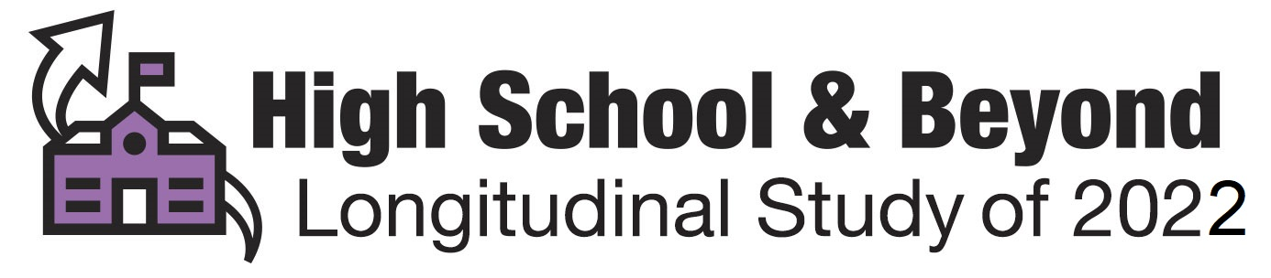

Appendix A.10 Brochure Text (previously approved)
High School and Beyond Longitudinal Study of 2022 (HS&B:22) Study Brochure

What is HS&B:22?
The High School and Beyond Longitudinal Study of 2022 (HS&B:22) is a research study that will build on decades of research (since 1972) to understand what makes students successful as they enter high school and progress to postsecondary education, the military, or early careers.

Why participate in HS&B:22?
You have been given an opportunity to share your experiences and opinions. While your name will never be used in any reports, your input will be used to improve education now and in the future. We want to hear from you!

What does participation involve?
Students will respond to a survey and answer math questions. . Questionnaires will be completed by school administrators about the school and its environment; math teachers on their background, teaching approaches, and student engagement in class; counselors on counseling practices at the school; and parents about the home environment and their experiences with their child’s school.

Who is conducting the study?
HS&B:22 is conducted by the National Center for Education Statistics (NCES) part of the U.S. Department of Education. NCES collects, analyzes, and reports statistics on the condition of education in the United States. Our mission is to provide scientific evidence on which to ground education practice and policy and to share this information in formats that are useful and accessible to educators, parents, policymakers, researchers, and the public. NCES has contracted RTI International, an independent, not-for-profit research institute, to collect the data for HS&B:22.

Did you know?
- How a student does in 9th grade has more influence on graduating from high school than all other factors, including race/ethnicity, gender, socioeconomic status, and prior academic achievement, combined.
https://tinyurl.com/y773hksf
- Attendance contributes more than any other factor to course failure and low grades.
https://tinyurl.com/ybn22dew
- Nearly half of students who begin college do not graduate within six years.
https://tinyurl.com/y74xz2zu
- If the 1.3 million dropouts from the Class of 2010 had graduated, the nation would have seen $337 billion more in earnings over the course of the students’ lifetimes.
https://tinyurl.com/jgesdzp

Contact Us
Schools & school staff: (855) 500-1439 or HSB22@rti.org
Parents: (855) 500-1439 or HSB22survey@rti.org
https://surveys.nces.ed.gov/hsb22

Appendix A.11 Study Video (previously approved)


NCES High School and Beyond Study Video Script

Voiceover: Imagine being part of something bigger than yourself.



You can. But we all have to work together to make our voices heard.
(images of students populate screen)

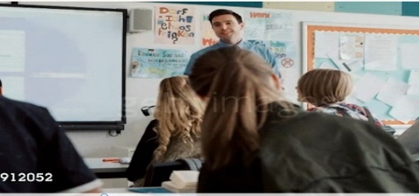
The National Center for Education Statistics wants to hear from everyone involved with the high school experience. (Scan of classroom)

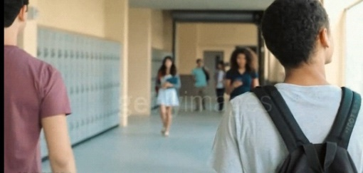

We need schools to participate in our High School and Beyond Study.
(Shot of students walking through hallway)

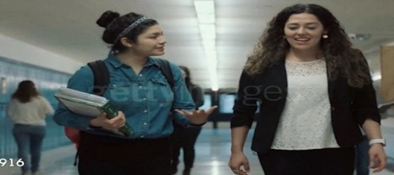
We’re gathering data from students, along with their parents, teachers, counselors, and principals, too.
(Multiple shots of students walking, talking with school staff,
Administrators in a school setting)



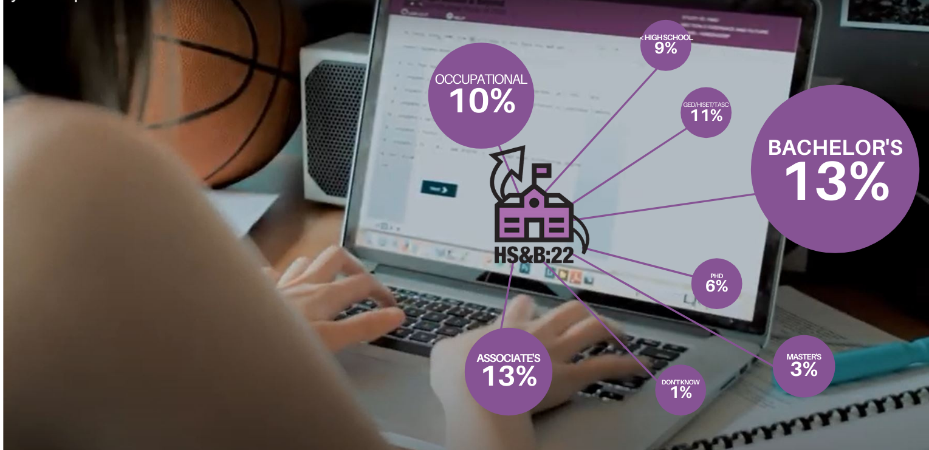
We want to know what people think about high school.
What works? What doesn’t? (Image of student participating
in HS&B on Chromebook)

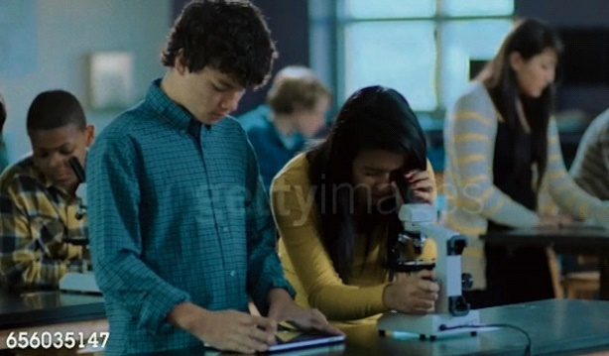
How can we improve education today, and in the future?
(Image of science class)

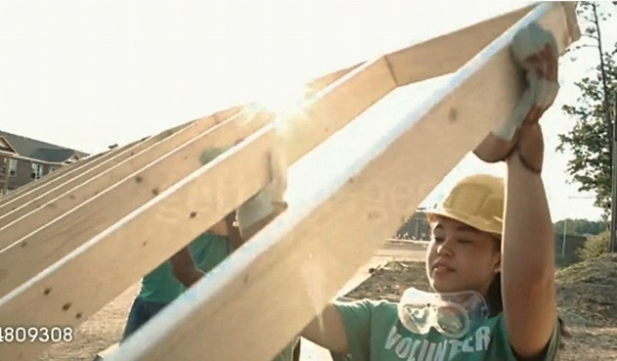

We all have an integral part to play. (image of volunteering
community service, Habitat for Humanity)



Now is the time to make your voice heard.
(video of Malala speaking)

ON-SCREEN TEXT: We’re listening
ON-SCREEN TEXT: When you are contacted, please participate in the High School and Beyond study https://surveys.nces.ed.gov/hsb22
ON-SCREEN LOGOS: U.S. Department of Education, HS&B:22

Appendix A.12 Recruitment Website Text (modified)
The recruitment website is used to provide information to school staff and parents about the study. The website also serves as a portal to securely upload student list information and complete the parent and school staff questionnaires.

HS&B:22 Website Content

Landing Page
- Sign-In
- Welcome to HS&B:22! High School and Beyond Longitudinal Study of 2022 (HS&B:22) is a national study of 9th and 12th graders as they progress through high school and beyond. This site is for school staff, parents, and students who are participating in HS&B:22. Click here to login.
- 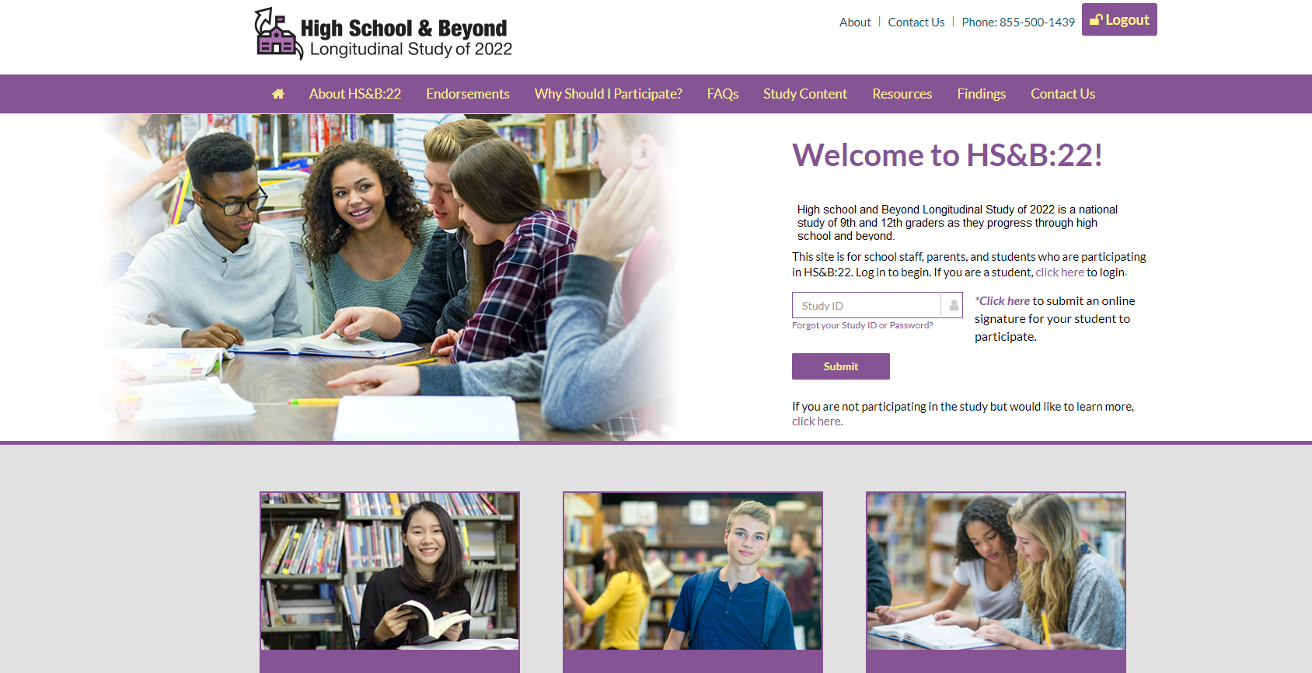

NCES is authorized to conduct the High School and Beyond Longitudinal Study of 2022 (HS&B:22) by the Education Sciences Reform Act of 2002 (ESRA 2002, 20 U.S.C. §9543). The data are being collected for NCES by RTI International, a U.S.-based nonprofit research organization. All of the information you provide may be used only for statistical purposes and may not be disclosed, or used, in identifiable form for any other purpose except as required by law (20 U.S.C. §9573 and 6 U.S.C. §151).
According to the Paperwork Reduction Act of 1995, no persons are required to respond to a collection of information unless it displays a valid OMB control number. The valid OMB control number for this voluntary information collection is 850-0944. Approval expires xx/xx/20xx. The time required to complete this information collection is estimated to average approximately 40 minutes per response for school administrators, 25 minutes per response for parents, 25 minutes per response for school counselors, 25 minutes per response for teachers, and 30 minutes per response for student surveys, including the time to review instructions, gather the data needed, and complete and review the information collection. If you have any comments concerning the accuracy of the time estimate, suggestions for improving this survey, or any comments or concerns regarding the status of your individual submission of this survey, please write directly to: High School and Beyond Longitudinal Study of 2022 (HS&B:22), National Center for Education Statistics, Potomac Center Plaza, 550 12th St, SW, Room 3505, Washington, DC 20202.
Contact info: website, phone, email

About HS&B:22
- High School and Beyond Longitudinal Study of 2022(HS&B:22) is a national longitudinal study conducted by the National Center for Education Statistics (NCES) within the U.S. Department of Education. Study participants include 9th & 12th -grade students and their families, teachers, school administrators, and guidance counselors. HS&B:22 will help educators, parents, researchers, and policymakers better understand the factors that contribute to student success. Information collected through the study also can be used to improve high school educational experiences for this generation and beyond.
- NCES Info: The National Center for Education Statistics (NCES) collects, analyzes, and report statistics on the condition of education in the United States. Our mission is to provide scientific evidence on which to ground education practice and policy and to share this information in formats that are useful and accessible to educators, parents, policymakers, researchers, and the public.
  - Longitudinal Series info: timeline with links to information about each study
- RTI Info: RTI is an independent, nonprofit institute that provides research, development, and technical services to government and commercial clients worldwide. Our mission is to improve the human condition by turning knowledge into practice.

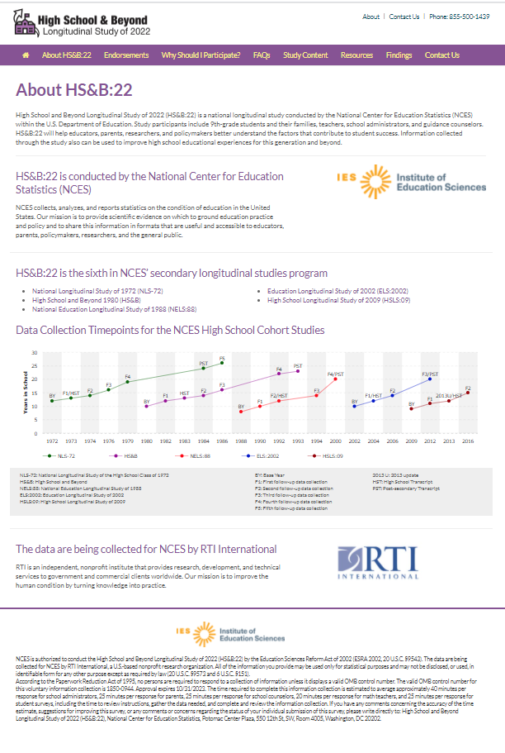
Endorsements

The following organizations have endorsed HS&B:22:

Council of Chief State School Officers
National School Boards Association
National Parent Teacher Association
National Indian Education Association
National Education Association
National Charter Schools Institute
National Catholic Educational Association
The Institute for Excellence in Education
Council of Islamic Schools in North America
Council for American Private Education
National Association of Independent Schools
Association for Career and Technical Education

Why Should I Participate?

- You have been given an opportunity to share your experiences and opinions. While your name will never be used in any reports, your input will be used to improve education for our children and those in the future. We want to hear from you!
- What can you contribute by participating in HS&B:22?
  - Districts can learn about HS&B:22 and how the collected data can be used to improve policies that support student success. They can support participation among peers and educators.
  - Counselors can share information about supports they offer to students in their schools.
  - Teachers can share information about their unique learning environments, background, and individual students' classroom experiences.
  - Principals can provide valuable information about their school’s unique structure and environment.
  - Parents can encourage their children to participate and to tell researchers about their transition to high school, their social and academic experiences, and how their school environment and culture impact their growth.
  - Students can join with peers across the U.S. to participate in student sessions where they will have the opportunity to share information about their high school experiences.

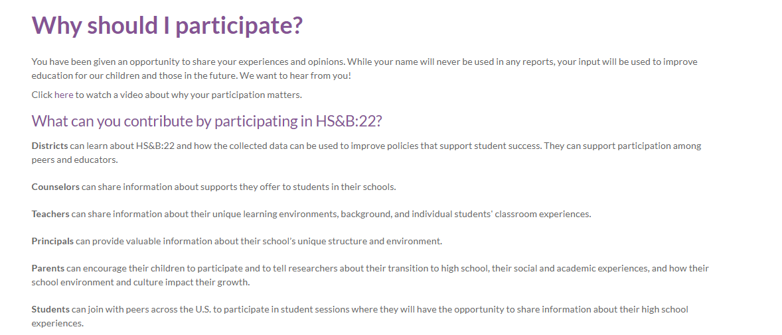

- How will my school benefit?
  - This is a unique opportunity for schools and educators to contribute in a way that will impact student outcomes for generations to come. Schools that participate in the High School and Beyond Longitudinal Study of 2022 will join national research that will be used to improve the high school experience for all students. Schools will also receive $200 for participating. HS&B:22 will give $150 to the school coordinator. Students will receive a token of appreciation if allowed by the school.
- Why is this study important?
  - Providing national-level information in order to better understand what factors lead students to successful completion of high school and entry into work or postsecondary education, as well as those factors that are barriers to success, is a critical function of high school longitudinal studies such as HS&B:22. Research has long shown that increases in education attainment are associated with a wide range of important civic and life outcomes, including stronger employment prospects and earning potential, lower incarceration rates, higher voting rates, and better health and life expectancy (Cutler & Lleras-Muney, 2006; Julian & Kominski, 2011; Milligan, Moretti, & Oreopoulos, 2004; Oreopoulos & Petronijevic, 2013; Sum, Khatiwada, & McLaughlin, 2009).
  - Data from HS&B:22 can also contribute to improved educational experiences by documenting opportunity and achievement gaps and how well schools address inequity. Finally, HS&B:22 and its predecessor studies offer an extraordinary opportunity to study trends in students’ high school experiences and education outcomes. By maintaining linkages with NCES’s previous high school longitudinal studies, HS&B:22 data can be used to examine changes over time and shed light on the effects of various policies, demographic shifts, and school practices on student achievement, growth, and education attainment.
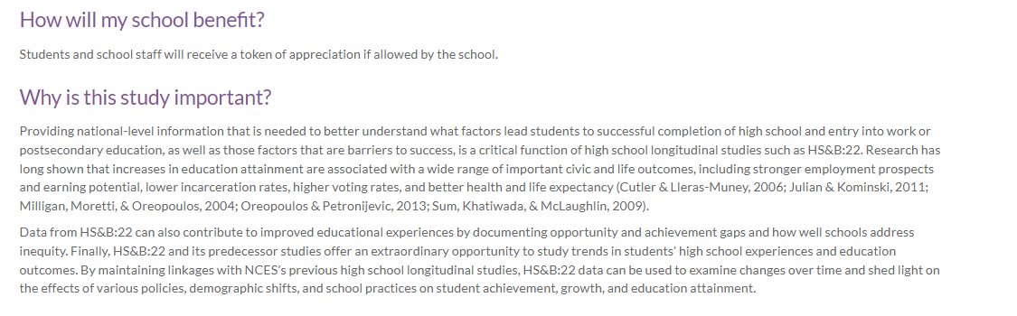

Study Content

HS&B:22 field test will survey 12th grade students and their parents and school staff. Additionally, students will complete a math assessment. Please click on the boxes below to learn more.

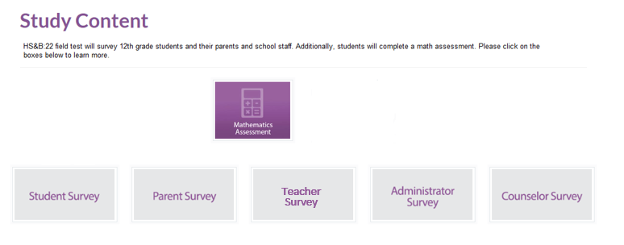
Student | Parent | Administrator | Counselor | Teacher
Background Information | Background Information | School Characteristics | Counseling Program Characteristics | Teacher Characteristics
Native language | Home Language(s) | School Calendar | Counseling Staff Activities | Class-level Characteristics
High School Completion | Academic Experiences | Student Characteristics | Transitions | Coursework
Art Courses | School Discipline | School Performance | Coursework | Student-level Characteristics
Career and Technical Education | Systematic Racism | Technology | Graduation Requirements | Programs and Services
School Climate and Belonging | Family Structure | Personnel | Programs and Services | School Climate
Student’s Peers | Parental Academic Expectations | School Budget |  | Teacher Attitudes and Expectations
Student Dropout and Attendance Information | Student’s Future Plans | Funding Sources
Out-of-school Activities | Guidance | School Improvement Plan
Technology Usage | College Choice
Student Attitudes and Beliefs | Financial Aid
Family and Homelife | Economic Insecurity
Current Employment | Student Wellness
Guidance and Workforce Preparation | Parent Wellness
Plans for First Year After High School | Negative life experiences since 2020
College Application and Choice | Locating Information
College Costs and Financial Aid
Educational and Occupational Aspirations
Health and Wellness
Negative life experiences since 2020
Locating Information

Resources
Links to Resources
- HS&B:22 School Brochure
- HS&B:22 District/Diocese Letter
- HS&B:22 School Letter
- HS&B:22 Student Video
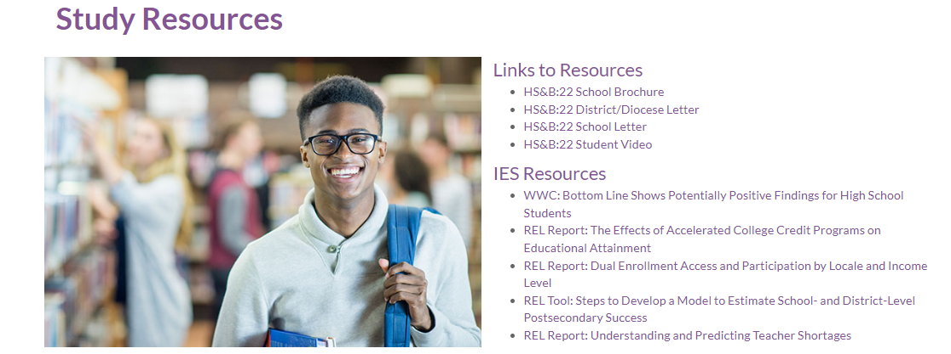
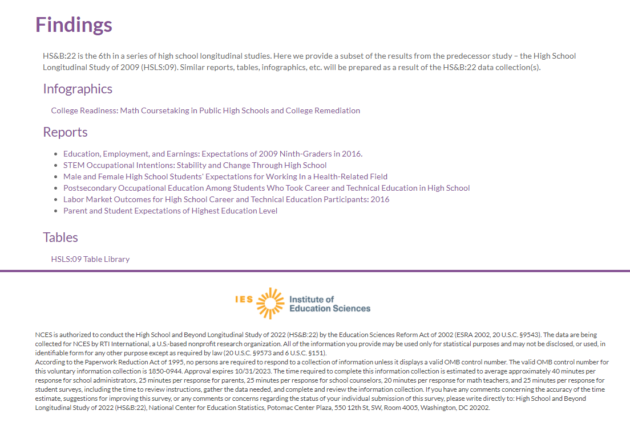

HS&B:22 Student Roster Instructions
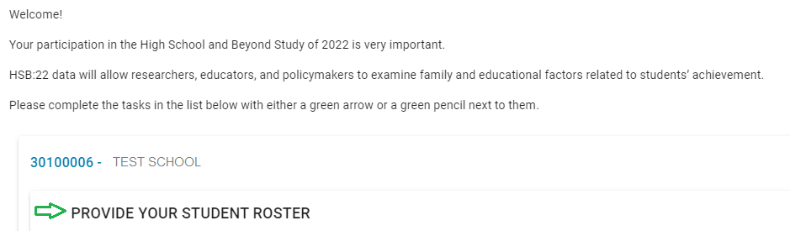

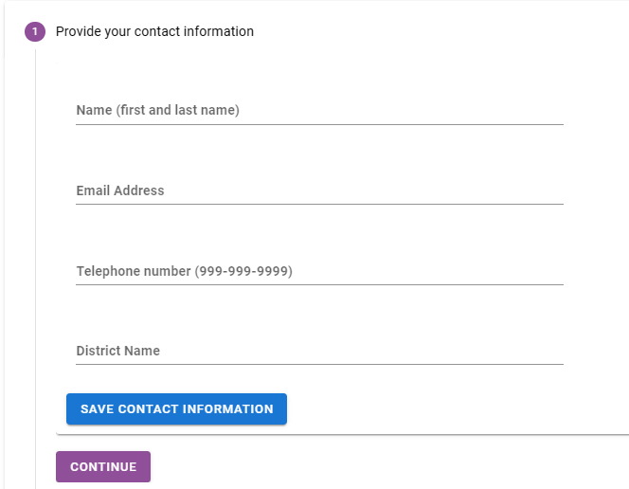

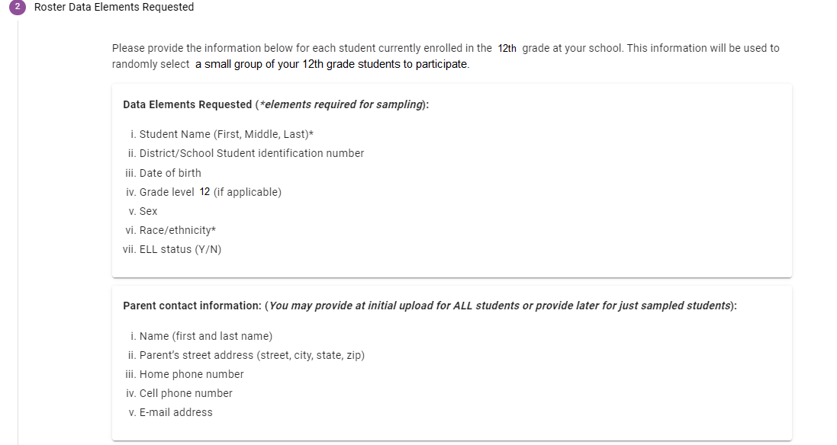
Teacher contact information: (12th grade math teacher, or ELA if student does not take math)
- 12th grade student’s teacher (last, first)
- 12th grade student’s teacher’s email address
- 12th grade student’s math or language arts course name
- 12th grade student’s math or language arts course period/section
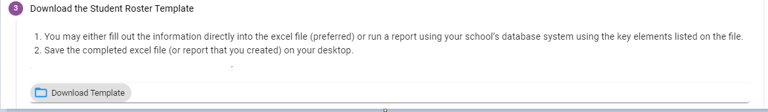

Student Roster Template:
Student Data Elements | Parent Data Elements | Teacher Data Elements- student’s math teacher information ** If student does not take math in the 12th grade, please add ELA teacher**
Student First Name Last Name in separate columns | Parent/guardian First Name Last Name in separate columns | Student’s Teacher First Name Last Name in separate columns
District or School Student ID number | Parent/guardian street address, city, state, zip | Student’s Teacher Email
Date of Birth (mm, dd, yyyy) | Home phone | Student’s Math or ELA Course Name
Grade Level (12) | Cell phone | Student’s Math or ELA Course Period/Section
Sex (male or female) | Email address
Race (U.S. Census bureau classifications select all that apply to each student: White, Black or African American, American Indian or Alaska Native, Asian, Native Hawaiian or other Pacific Islander)
Is the student Hispanic? (yes/no)
Is student enrolled as an English Language Learner? (yes/no)
Does the student have an IEP/504 plan? (yes/no)

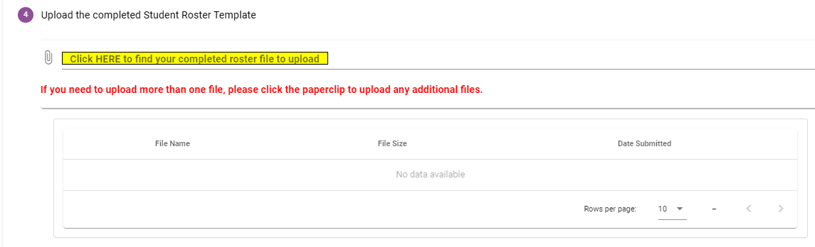

Appendix A.13a Out-of-School Data Collection – Parent Letter (modified)
<PARENT NAME> <DATE>
<ADDR1>
<ADDR2>
<CITY STATE ZIP>
Dear <Parent or Guardian Name>:
<If child only: Your child can share their high school experiences and opinions and help improve education for them and other students in the future.> <If parent already participated, add: You have already provided valuable information for this study and we thank you for your participation.> <If parent and child needed: You and your child can share your high school experiences and opinions and help improve education for your child and other students in the future.>. <If we’ve already reached out to the parent and are adding the child to the out-of-school data collection: You were recently contacted to share your experiences and opinions about the high school experience, and we would also like to ask [child name] to share their experience.>
The U.S. Department of Education’s National Center for Education Statistics (NCES) is conducting the High School and Beyond Longitudinal Study of 2022 (HS&B:22) study. We want to hear from you <If parent and child needed: both> about what works for you with the high school experience and what doesn’t work. We are listening!
Students will be asked to spend about <FILL> minutes taking a survey and answering math questions on the computer. In return, we will send them a certificate for 2 hours of community service from the U.S. Department of Education and <incentive>.
Participation is easy! Please give your child the enclosed envelope so they can participate. The envelope contains the information that needs to be entered into the computer to log in and complete the session.
<If parent has not already participated: You will also be asked to complete a survey and will receive a separate letter about your participation. Your participation is very important, but we know there are many demands on your time. We will periodically send reminders for you to complete the HS&B:22 survey via e-mail, mail, text, and phone.
If the 1.3 million dropouts from the Class of 2010 had graduated, the nation would have seen $337 billion more in earnings over the course of the students’ lifetimes.
https://www.dosomething.org/us/facts/11-facts-about-education-america
The enclosed brochure provides more information about the study. If you have questions, please call (855) 500-1439 or email us at HSB22Survey@rti.org. You can also get more information by watching a short video on our website https://surveys.nces.ed.gov/hsb22.

We thank you in advance for your cooperation in this important research.
Sincerely,

<NCES Commissioner>

IMPORTANT: This is not a test, and it is not graded. We follow very strict laws to protect personal information and any data collected. All information collected is securely maintained. All reports will use aggregate information for all students who participate; no names will be published in the data files or reports.
NCES is authorized to conduct the High School and Beyond Longitudinal Study of 2022 (HS&B:22) by the Education Sciences Reform Act of 2002 (ESRA 2002, 20 U.S.C. §9543) and to collect students’ education records from education agencies or institutions for the purposes of evaluating federally supported education programs under the Family Educational Rights and Privacy Act (FERPA, 34 CFR §§ 99.31(a)(3)(iii) and 99.35). The data are being collected for NCES by RTI International, a U.S.-based nonprofit research organization. All of the information students, parents, and staff provide may be used only for statistical purposes and may not be disclosed, or used, in identifiable form for any other purpose except as required by law (20 U.S.C. §9573 and 6 U.S.C. §151). The collected information will be combined across respondents to produce statistical reports.

Appendix A.13b Out-of-School Data Collection – Parent Letter Reminder (previously approved)
<PARENT NAME> <DATE>
<ADDR1>
<ADDR2>
<CITY STATE ZIP>
Dear <Parent or Guardian Name>:
We recently sent you information about The U.S. Department of Education’s National Center for Education Statistics (NCES) High School and Beyond Longitudinal Study of 2022 (HS&B:22) study. If your child has already submitted responses, we thank you both.
If your child has not participated yet, please give them a reminder. <CHILD_NAME> is asked to spend about <time> minutes taking a survey and answering math questions on the computer. In return, we will send them <incentive> and a certificate for 2 hours of community service from the U.S. Department of Education.
Please give your child the enclosed envelope so they can participate. The envelope contains the information that needs to be entered into the computer to log in and complete the session.
You will also be asked to complete a survey and will receive a separate letter about your participation.
If you have questions, please call (855) 500-1439 or email us at HSB22Survey@rti.org. You can also get more information by watching a short video on our website https://surveys.nces.ed.gov/hsb22.

We thank you in advance for your cooperation in this important research.
Sincerely,

<NCES Commissioner>

IMPORTANT: This is not a test, and it is not graded. We follow very strict laws to protect personal information and any data collected. All information collected is securely maintained. All reports will use aggregate information for all students who participate; no names will be published in the data files or reports.
NCES is authorized to conduct the High School and Beyond Longitudinal Study of 2022 (HS&B:22) by the Education Sciences Reform Act of 2002 (ESRA 2002, 20 U.S.C. §9543) and to collect students’ education records from education agencies or institutions for the purposes of evaluating federally supported education programs under the Family Educational Rights and Privacy Act (FERPA, 34 CFR §§ 99.31(a)(3)(iii) and 99.35). The data are being collected for NCES by RTI International, a U.S.-based nonprofit research organization. All of the information students, parents, and staff provide may be used only for statistical purposes and may not be disclosed, or used, in identifiable form for any other purpose except as required by law (20 U.S.C. §9573 and 6 U.S.C. §151). The collected information will be combined across respondents to produce statistical reports.

Appendix A.13c Out-of-School Data Collection – Parent Email Initial (modified)

Dear <Parent or Guardian Name>:
<CHILD’S NAME> was selected to take part in the High School and Beyond Longitudinal Study of 2022 (HS&B:22). Your child has an opportunity to help improve education for themselves and other students in the future.
We are asking <CHILD_NAME> to spend about <time> minutes taking a survey and answering math questions on the computer.
Once we have received <CHILD’S_NAME> response, we will send them a certificate for 2 hours of community service from the U.S. Department of Education and <incentive>.
Please give your child the login information below that needs to be entered into the computer to log in and complete the session.

Web Address: https://surveys.nces.ed.gov/hsb22
Student Study ID: <XXXXXXXX>
Student Password: <XXXXXXXX><PW_ind>

You will also be asked to complete a survey and will receive a separate email about your participation.

If you have questions, please call (855) 500-1439 or email us at HSB22Survey@rti.org. You can also get more information by watching a short video on our website https://surveys.nces.ed.gov/hsb22.
We thank you in advance for your cooperation in this important research.
Sincerely,

<NCES Commissioner>

Appendix A.13d Out-of-School Data Collection – Parent Email Reminder (previously approved)

Dear <Parent or Guardian Name>:
We noticed that we have not received <CHILD’S_NAME> response to the HS&B:22 study, and we wanted to make sure your child had the opportunity to receive <incentive> and 2 hours of community service from the U.S. Department of Education. All <CHILD_NAME> has to do is spend about <time> minutes on the computer completing a survey and answering math questions.

Participation is easy! Please give your child the login information below that needs to be entered into the computer to log in and complete the session.
Web Address: https://surveys.nces.ed.gov/hsb22
Student Study ID: <XXXXXXXX>
Student Password: <XXXXXXXX><PW_ind>

You will also be asked to complete a survey and will receive a separate email about your participation.

If you have questions, please call or email us at HSB22Survey@rti.org. You can also get more information by watching a short video on our website https://surveys.nces.ed.gov/hsb22.
We thank you in advance for your cooperation in this important research.
Sincerely,

<NCES Commissioner>

Appendix A.13e Out-of-school Data Collection – Student Letter (modified)
<DATE>

<STUDENT NAME> Web Address: https://surveys.nces.ed.gov/hsb22
<ADDR1> Student Study ID: <XXXXXXXX>
<CITY STATE ZIP> Student Password: <XXXXXXXX><PW_ind>

Dear <Student Name>:
YOU can make a difference!
Congratulations! You have been selected to share your high school experiences and opinions. Your input will help to improve education for students now and in the future.
The High School and Beyond Longitudinal Study of 2022 (HS&B:22) is conducted by the National Center for Education Statistics (NCES) in the U.S. Department of Education.
This is your chance to provide information that could lead to important changes in education.
Your participation is voluntary, but we can’t do this without you. The study will take about <time> minutes and will include a short survey and answer math questions. Your answers will never be shared with your parents, teachers, or school staff.
We will send you a certificate for two hours of volunteer service from the U.S. Department of Education and <incentive> after you have completed the session. To participate, please use the web link and the unique student study ID and Password provided above.
RTI International will collect the data for HS&B:22 on behalf of NCES. We hope that you will take part in this important research. Participation is easy and we really value your responses! The enclosed brochure provides more information about the study. If you have questions, please call (855) 500-1439 or email us at HSB22Survey@rti.org.
‘Believe you can and you’re halfway there’
-Theodore Roosevelt-
We thank you in advance for your cooperation in this important research.
Sincerely,

<NCES Commissioner>

IMPORTANT: This is not a test, and it is not graded. We follow very strict laws to protect personal information and any data collected. All information collected is securely maintained. All reports will use aggregate information for all students who participate; no names will be published in the data files or reports.
NCES is authorized to conduct the High School and Beyond Longitudinal Study of 2022 (HS&B:22) by the Education Sciences Reform Act of 2002 (ESRA 2002, 20 U.S.C. §9543) and to collect students’ education records from education agencies or institutions for the purposes of evaluating federally supported education programs under the Family Educational Rights and Privacy Act (FERPA, 34 CFR §§ 99.31(a)(3)(iii) and 99.35). The data are being collected for NCES by RTI International, a U.S.-based nonprofit research organization. All of the information students, parents, and staff provide may be used only for statistical purposes and may not be disclosed, or used, in identifiable form for any other purpose except as required by law (20 U.S.C. §9573 and 6 U.S.C. §151). The collected information will be combined across respondents to produce statistical reports.

Appendix A.13f Out-of-school Data Collection – Student Letter Reminder (modified)
<DATE>

<STUDENT NAME> Web Address: https://surveys.nces.ed.gov/hsb22
<ADDR1> Student Study ID: <XXXXXXXX>
<CITY STATE ZIP> Student Password: <XXXXXXXX><PW_ind>

Dear <Student Name>:
We recently sent you information about your selection in an exciting new study, the High School and Beyond Longitudinal Study 2022, or HS&B:22, and we didn’t want you to miss out on an opportunity to earn two hours of volunteer service from the U.S. Department of Education and <incentive>. All you have to do is spend about <time> minutes answering a short survey and some math questions. We would really appreciate it if you would share your high school experiences and opinions to help improve education for you and other students now and in the future.
HS&B:22 is conducted by the National Center for Education Statistics (NCES) in the U.S. Department of Education, and RTI International is collecting the data for HS&B:22.
It is your decision to participate or not, but we hope that you will decide to join fellow students taking part in this important research. We will never share your responses with your parents, teachers, or school staff. Participation is easy! Just use the web link and the unique student study ID and Password provided above.
If you have any questions, please call (855) 500-1439 or email us at HSB22Survey@rti.org. You can also get more information by watching a short video on our website https://surveys.nces.ed.gov/hsb22.

Thank you so much for your cooperation in this important research.
Sincerely,

<NCES Commissioner>

IMPORTANT: This is not a test, and it is not graded. We follow very strict laws to protect personal information and any data collected. All information collected is securely maintained. All reports will use aggregate information for all students who participate; no names will be published in the data files or reports.
NCES is authorized to conduct the High School and Beyond Longitudinal Study of 2022 (HS&B:22) by the Education Sciences Reform Act of 2002 (ESRA 2002, 20 U.S.C. §9543) and to collect students’ education records from education agencies or institutions for the purposes of evaluating federally supported education programs under the Family Educational Rights and Privacy Act (FERPA, 34 CFR §§ 99.31(a)(3)(iii) and 99.35). The data are being collected for NCES by RTI International, a U.S.-based nonprofit research organization. All of the information students, parents, and staff provide may be used only for statistical purposes and may not be disclosed, or used, in identifiable form for any other purpose except as required by law (20 U.S.C. §9573 and 6 U.S.C. §151). The collected information will be combined across respondents to produce statistical reports.

Appendix A.13g Out-of-School Data Collection – Student Email Initial (modified)
Dear <Student Name>:
Congratulations! You have been selected to participate in the High School and Beyond Longitudinal Study of 2022 (HS&B:22). This is your chance to not only improve education for yourself and other students, but you will also earn <incentive> and 2 hours of volunteer service from the U.S. Department of Education.
All we are asking you to do is to take about <time> minutes to complete a short survey and answer some math questions.
Here’s the information you need to participate:
Web Address: https://surveys.nces.ed.gov/hsb22
Student Study ID: <XXXXXXXX>
Student Password: <XXXXXXXX><PW_ind>

If you have questions, please call (855) 500-1439 or email us at HSB22Survey@rti.org. You can also get more information on our website by watching a short video on our website https://surveys.nces.ed.gov/hsb22.
We thank you in advance for your cooperation in this important research.
Sincerely,

<NCES Commissioner>

Appendix A.13h Out-of-School Data Collection – Student Email Reminder (modified)

Dear <Student Name>:
We wanted to remind you that it’s not too late to earn <incentive> and 2 hours of volunteer service from the U.S. Department of Education! All you have to do is spend about <time> minutes completing a short survey and answer some math questions. Students nationwide are participating in the High School and Beyond Longitudinal Study of 2022 (HS&B:22), and we need your input too!
This is your chance to provide information that could lead to important changes in education.
Your participation is voluntary, but we can’t do this without you. Your answers will never be shared with your parents, teachers, or school staff. To participate, please use the web link and the unique student study ID and Password provided below.

Web Address: https://surveys.nces.ed.gov/hsb22
Student Study ID: <XXXXXXXX>
Student Password: <XXXXXXXX><PW_ind>

If you have questions, please call (855) 500-1439 or email us at HSB22Survey@rti.org. You can also get more information on our website by watching this short video at https://surveys.nces.ed.gov/hsb22.
We thank you in advance for your cooperation in this important research.
Sincerely,

<NCES Commissioner>

Appendix A13.i Out-of-School Data Collection – Student Postcard (previously approved)

We’re sorry we missed you at the HS&B:22 student session at your school! We would still like for you to participate at home. Please complete the <time>-minute session on your computer. You can log in at:

Web Address: surveys.nces.ed.gov/hsb22
Student Study ID: <XXXXXXXX>
Student Password: <XXXXXXXX><PW_ind>

When you have finished, we will send you a certificate for 2 hours of community service and <incentive>.

Appendix A.14a Summary of Mathematics Questions (Modified)

Approximate length  Goal for Field Test | 40 minutes
Mode of administration | In school computerized administration using Chromebooks, tablet-like computers with touchscreen capability and an attached keyboard, that will be brought into the school by the study: OR  In school computerized administration using school-provided equipment (with or without touchscreen capability), school network, and Internet access to the study website  Out of school computerized administration using students’ personal computers with or without touchscreen capability
Key constructs | Number Systems and Arithmetic  - Number sense  - applying basic operations with fractions and integers to word problems  - representing and understanding rational numbers in multiple forms  - understanding the relative size of irrational numbers  - understanding basic concepts of ratio, rate, and proportional relationships  - using rational numbers to solve problems and understand slope and functions  Algebra and Functions  - understanding the use of expressions beginning with letter representations of a single number  - solving and representing linear equations and inequalities  - understanding functions  - comparing functions represented in different ways  - distinguishing between linear and nonlinear functions  - comparing and creating representations of different functions  Geometry and Measurement  - analyzing geometric figures in one, two, or three dimensions  - measuring physical attributes  - systems of measurement  understanding transformations  Data, Probability, and Statistics  - understanding how to represent and interpret data  - calculating and interpreting descriptive statistics  - demonstrating a general conceptual understanding of data distribution shapes and properties  - using basic probability rules and counting techniques

Appendix A.14b Summary of Student Survey (modified)

 | Student Survey
Approximate length  Goal for Field Test | 30 minutes (90 min session including math, and a student survey)
Mode of administration | In school computerized administration using Chromebooks, tablet-like computers with touchscreen capability and an attached keyboard, that will be brought into the school by the study; OR  In school computerized administration using school-provided equipment (with or without touchscreen capability), school network, and Internet access to the study website  Out of school computerized administration using students’ personal computers with or without touchscreen capability.
Key constructs | Student Background  - Demographics (i.e., sex, race/ethnicity, date of birth)  - Language characteristics (e.g., first language, how often speaks English at home, how often speaks non-English language at home and with friends, preferred language, English fluency)  - Participation in ELL program  High School Completion  - Type of high school credential most likely to receive  - Timeline for graduation  - Description of current or most recent high school program  Arts courses  - Reasons for taking arts course(s) or not  - Beliefs about arts course(s)  - Growth mindset about learning art  - Likelihood of future arts involvement  Career and Technical Education  - Reasons for or for not taking CTE courses in high school  - Enrollment in a career cluster, career pathway, or program of study  - Plans to pursue a career in CTE field studied in high school  - Perceived preparedness for chosen career pathway  School Climate, Belonging, and Peers  - Racial/ethnic inclusion  - Student’s perception of equity in school’s disciplinary practices  - Feeling the need to code switch  - Pervasiveness of hearing negative remarks (e.g., homophobic, racist, sexist, about certain religions, about people with disabilities)  - Peers’ plans (e.g., high school, postsec, workforce)  Dropout and Absenteeism  - Ever stopped out of school  - Reasons for leaving school and school and parent’s actions  - Frequency of missing or skipping school or class and main reasons for excessive absences  Out-of-school Activities  - Out of school activities participated in  - Hours of reading outside of school non-schoolwork  - Hours of homework per week  - Frequency of and difficulty with internet usage for homework  Attitudes and Beliefs  - Imposter syndrome  - Attitudes and beliefs about civic responsibility  Family and Home life  - Student has caregiver role  Current Employment  - Student employment status (e.g., ever or currently employed, type of work, hours worked each week/weekend)  - School assisted with employment  - Student performs volunteer work  - Student contributes money to family  Guidance and Workforce Preparation  - Academic guidance received (e.g., academic courses, going to college, financial aid)  - Frequency of talking to parents about post high school plans  - Occupational guidance received (e.g., job selection, finding a job)  - Perceived quality of information received from high school counselor  - Activities done by parent and student to prepare for life after high school, including college and career  - Student’s greatest influences on college and career planning  Plans for First Year After High School  - Plans for continuing education (e.g., timeline, type of degree or certificate program, full-time or part-time status, housing, reasons for or for not continuing)  - Plans to work (e.g., job title, whether formal apprenticeship, full-time or part-time employment)  - People talked to about college entrance requirements and/or job selection  - Plan to join the Armed Forces (e.g., branch and component)  - Plans for gap year  College Application and Choice  - School’s applied to or plans to apply to (e.g., number of schools, name of first and second school most likely to attend, name of reach school, name of first choice college)  - Importance of college characteristics in school choice  - Field of study student is considering  College Costs and Financial Aid  - College affordability and financial literacy  - Student has ever applied for financial aid and reasons for or not applying for aid  - Reasons student thinks they would or would not qualify for financial aid  - Maximum amount student is willing to borrow per year for school  - Student’s ability to attend school if they do not have a job  Educational and Occupational Aspirations  - Educational attainment and occupation/career expectations (e.g., highest level of education will attain, job student believes they will have at age 30, level of education needed for expected job, reasons student became interested in expected job).  - Importance of career characteristics.  Health and Wellness  - Lingering negative impacts of Covid-19  - Negative life experiences since start of 9th grade (not Covid specific)  Locating Information for Future Follow-Up

Appendix A.14c Summary of Parent Survey (modified)

 | Parent Survey
Approximate length | Up to 25 minutes for parents that elect to complete the full survey; 5 minutes for parents that complete only the brief micro survey.
Mode of administration | Web-based administration accessible by individualized link, with a telephone-based interview option available.
Key constructs | School Experiences  - School assigned or chosen  - Grades student repeated or skipped  - Ever participated in gifted and talented program  - Student’s activities outside of school, tutoring and summer school  - School discipline and systematic racism  - Suspension, expulsion, and dropout experiences  - Availability of digital devices and internet at home  Family  - Family composition (e.g., number/types of parents or guardians and marital status, number of people in household, and number of siblings)  - Student’s amount of time spent living with parent/guardian  - Siblings’ educational experience (e.g., number in high school, graduated from high school, and continued education after high school)  - Student contributing money to family  Background Information  - Student’s demographics (i.e., sex, race/ethnicity, date of birth)  - Parent/guardian demographics (i.e., race/ethnicity, birth year)  - Language characteristics (e.g., language(s) spoken at home, parent’s language as a barrier to school involvement)  - Student’s participation in ELL program  Guidance and Future Plans  - Educational guidance received (e.g., influence on course selection, participation by nonresident parent, parents’/guardians’ educational and occupational advice, talk with counselor/teacher about college admission, financial aid, and finding a job for child)  - Priorities after high school and educational expectations (e.g., desired and expected, timeline)  - College choice (e.g., school that child will most likely, parent’s first choice)  - Family’s plans for financing postsecondary education, savings, and economic insecurity  - Student’s plans to work (e.g., right after high school, expectations or plans at age 30)  Home Life and Wellness  - Student’s wellness (e.g., mental health treatment, depression and/or anxiety medication)  - Parent’s wellness (e.g., physical and mental health)  - Student’s role as caregiver to family member  - Housing insecurity/homelessness  - Financial insecurity  - Hardships since student started 9th grade (not COVID specific)
Locating Information for Future Follow-up

Appendix A.14d Summary of Mathematics Teacher Survey (modified)

 | Teacher Survey
Approximate length | 25 minutes for Math teacher, 10 minutes for English Language Arts Teacher
Mode of administration | Web-based administration accessible by individualized link.

Key constructs | Teacher background and classroom characteristics  Classroom Characteristics  - Math course subject  - Class size (number of students)  - Class rigor  - Classroom behavior  - Achievement level of class  Classroom Mathematics Instruction  - Taught course before or first time  - Source of course curriculum used (e.g., local, state, national)  - Mathematics teaching objectives  - Sources of teaching materials (e.g., textbook, open educational resources)  - Type of classroom (i.e., Distance learning, in person, hybrid)  Teacher Experience and Background  - Type of teacher (i.e., Math, English Language Arts)  - Highest degree and major field(s) of study  - Type of certification  - Total years of teaching subject (i.e., Math, English Language Arts)  - Total years of teaching any subject  - Employment status in school (e.g., full-time, part-time, long-term substitute)  - Number of class periods or sections currently teaching  - Number of lesson plan preparations  - Demographic information (i.e., sex, race/ethnicity, year born)  School Climate and Teaching Practices  - School climate  - Teaching climate  - Growth mindset  Teacher provided information on individual students  Mathematical Thinking  - Appropriate level for student  - Demonstrated mathematics abilities  Observations/Impressions  - Positive behavior  - Attendance/tardiness  - Preparedness  - Future expectations for college attendance  Student Characteristics  - Taught student since beginning of school year  - IEP/ISP status

Appendix A.14e Summary of School Counselor Survey (modified)

 | School Counselor Survey
Approximate length | 25 minutes
Mode of administration | Web-based administration accessible by individualized link.
Key constructs | School and Counseling Program Characteristics  - Counseling program priorities  - Trauma-informed practices  - Counseling services offered to students  School Courses and Academic Programs  - Course placement practices  - Course offerings (e.g., Advanced Placement, International Baccalaureate, dual enrollment, CTE) and participation in select programs  - Instructional modalities (e.g., distance learning, online, blended learning, work-based) , why being offered, and student participation in select modalities  Counseling and Support Services  - Academic assistance  - Credit recovery program  School Graduation Requirements and Transitions after High School  - Assistance with graduation, postsecondary, and workforce preparation  - School’s network with employers  - Belongingness programs or resources for students

Appendix A.14f Summary of School Administrator Survey (modified)
 | School Administrator Survey
Approximate length  Goal for Main Study | 40 minutes
Mode of administration | Web-based administration accessible by individualized link.
Key constructs | School Characteristics  - School characteristics (e.g., public/private, grades served, special type/focus)  - School calendar, start time  Student Characteristics  - Percent of students receiving free or reduced-priced lunch  - Graduation rate  Teaching Staff  - Number of teachers by full-time and part-time status  - Number of non-teaching staff by full-time and part-time status  - School Resource Officer employer  School Programs and Coursework  - Technology available for student use  - Internet connection type  School Climate  - School’s total annual budget and specific areas (e.g., pupil support, extracurricular activities)  - Importance of private funding sources  - Equitable practices  - School improvement plan

Appendix A.15 Student Rostering Materials (modified)
Request for Student Roster Information from Schools
Go to:
https://surveys.nces.ed.gov/hsb22
Study ID: <STUDY ID FILL>
Password: <PASSWORD FILL>

Dear <List Provider>:

We are looking forward to working with your students on the High School and Beyond Longitudinal Study of 2022 field test (HS&B:22). Your school’s participation is important to the success of the study, and we appreciate it! To select the student sample, we are asking you to provide information about each student enrolled in your school in grade 12. Approximately 40 12th grade students will be selected. If your school is small, we may invite all 12th grade students. If permitted by your district and school, you will receive <incentive> for your assistance.

We understand that not all students are enrolled in math during spring semester of 2024. For 12th grade students with no spring math class, please provide the fall math class teacher and course. If student has not taken any math course in the 2023-23 school year, then we request the English Language Arts (ELA) course and teacher.

Please provide the roster information listed below via the study website once your school’s enrollment is stable for the 2023-2024 school year. Your unique credentials to access the study website are listed in the top right corner of this letter. Electronic submission of participant’s information will be monitored for viruses, malware, and other threats by Federal employees and contractors in accordance with the Cybersecurity Enhancement Act of 2015. All student, staff, and parent information will be removed and replaced with a study ID. Students’ names are not on any study materials that leave the schools.

Student Data Elements | Parent Data Elements | Teacher Data Elements- 12th grade Math (ELA if no math in grade 12)
Student Name | Parent name | Student’s Teacher Name
District / School Student ID number | Parent street address, city, state, zip | Student’s Teacher Email
Date of Birth | Home phone | Student’s Math or ELA Course Name
Grade Level (12) | Cell phone | Student’s Math or ELA Course Period/Section
Sex | Email address
Race
Hispanic indicator (yes/no)
ELL status (yes/no)
IEP/504 status (yes/no) sampled students only

This information request conforms to the requirements of the Family Educational Rights and Privacy Act of 1974 (FERPA) (20 U.S.C. §1232g; 34 CFR Part 99). For the purposes of this collection of data, FERPA permits education agencies and institutions to disclose personally identifiable information from students’ education records, without consent, to authorized representatives of the Secretary of Education in connection with an evaluation of federally supported education programs (34 CFR §§ 99.31(a)(3)(iii) and 99.35). Student data are subject to strict protections that are adhered to by NCES and its contractor organizations. Roster information will be securely destroyed when no longer needed for the purposes specified in 34 CFR §99.35.

NCES is authorized to conduct the High School and Beyond 2022 (HS&B:22) by the Education Sciences Reform Act of 2002 (ESRA 2002, 20 U.S.C. §9543). The data are being collected for NCES by RTI International, a U.S.-based nonprofit research organization. All of the information you provide may be used only for statistical purposes and may not be disclosed, or used, in identifiable form for any other purpose except as required by law (20 U.S.C. §9573 and 6 U.S.C. §151).

Sincerely,

Dan Pratt, Project Director

HS&B:22 Student Roster Instructions
Student Roster Instructions
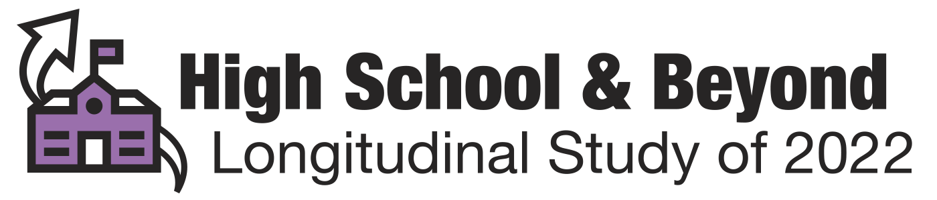

First time logging into the HS&B:22 Study Portal

- Go to: https://surveys.nces.ed.gov/hsb22

- Input your Study ID in the box. You will need your Study ID every time you log into the portal. Your Study ID was provided to you via email. If you do not know your study ID, please email us at HSB22@rti.org.
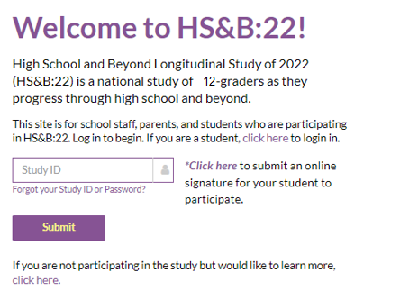

- You will receive a 2-factor authentication code via email from ed.gov. Input this code into the study portal. If you do not receive a code, please email us at HSB22@rti.org.
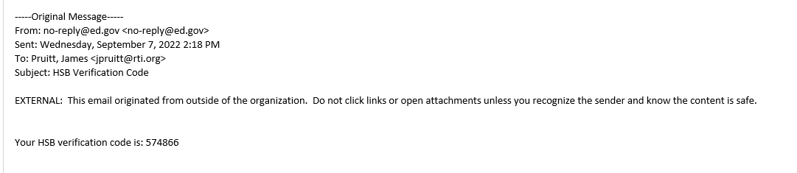
If someone else tries to log into the portal using your study ID, they will not receive the code. 2-factor authentication is a mandatory security step that is required for all data stored on federal servers.
Please email us your name, school name, and email address if you believe the code is being sent to another staff member at your school. We will set up a portal account for you and the code will be sent to your email address.

- Create your password. Keep record of your password in a safe place. Please note the password convention rules.
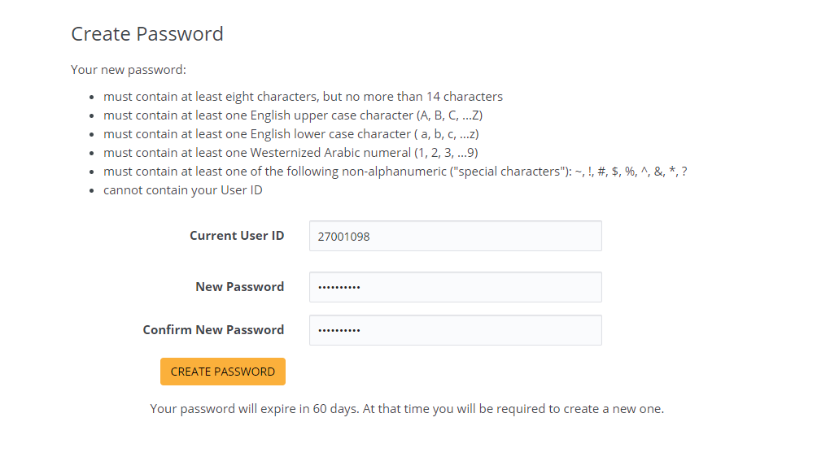

- You will be prompted to log in again using your Study ID, Password, then 2-factor authentication code from your email. Every time you log into the portal, you will repeat this step.

Congratulations! You are in the HS&B:22 study portal

How to Reset your Password
- If you forgot your password, please use the password reset function in the study portal
- Click ‘Forgot your Study ID or Password’

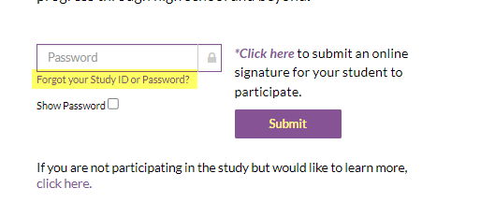
- Input your Study ID in the box and click ‘reset your password’

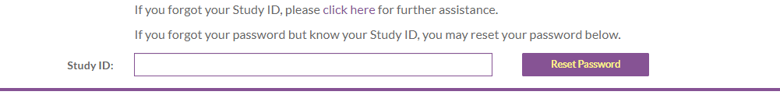

Providing your Roster
- Click on the green arrow
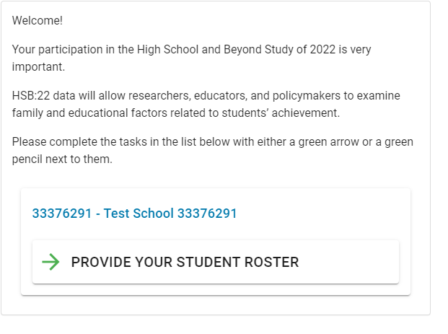
- Provide your contact information. Click ‘Save Contact information’ then ‘Continue’
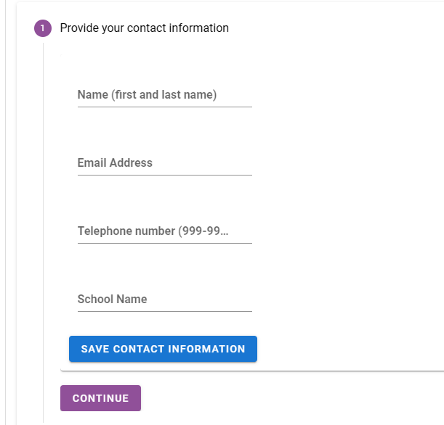
- Read ‘Roster Data Elements Requested’ and click CONTINUE.

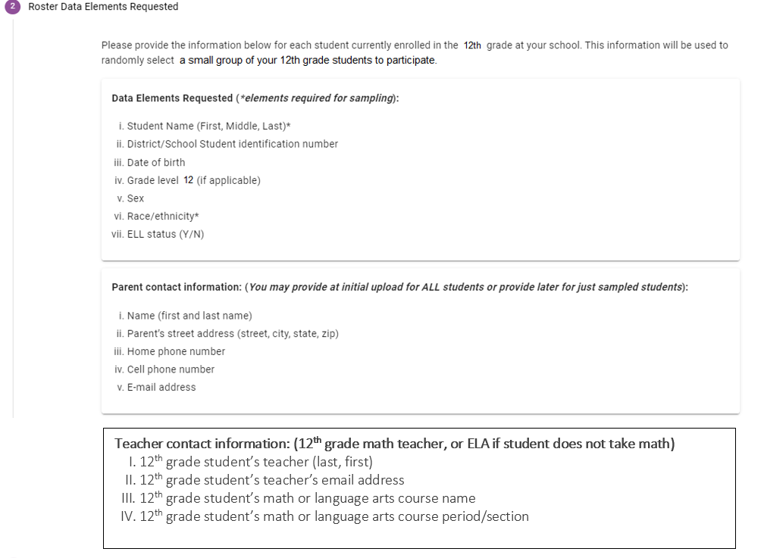
- Click the blue folder- ‘Download Template’.
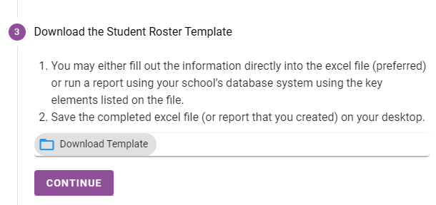

- An excel file will open. Download this template to your computer.
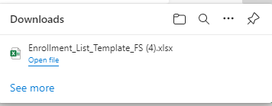

- Please fill out the requested information on the file or use the data elements listed on the file to run a report using your school’s database system.

- You can either provide all information at once or only student information. We recommend you provide all at once if possible.

- Log back into the study portal using your Study ID, Password, and 2-factor Authentication Code

- Click on #4- Upload the completed Student Roster Template. (You do not need to repeat steps 1-3)
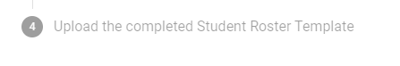
- Click the yellow bar to locate the completed file on your computer.
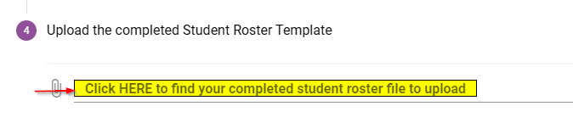
- Confirm Upload – Click Yes.
This step is important! If you accidentally click ‘no’ the file will not be sent to us.
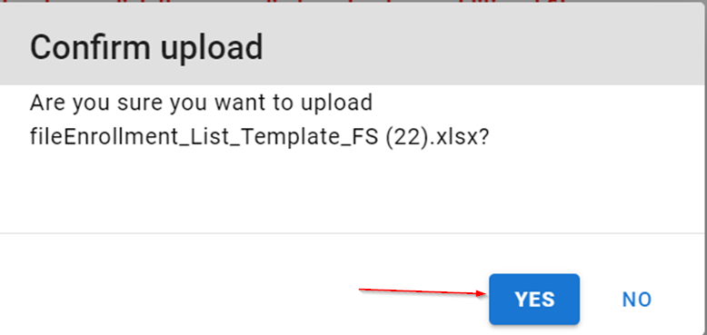
- To confirm that a file was uploaded, you should see the file you uploaded listed in the table on your screen.
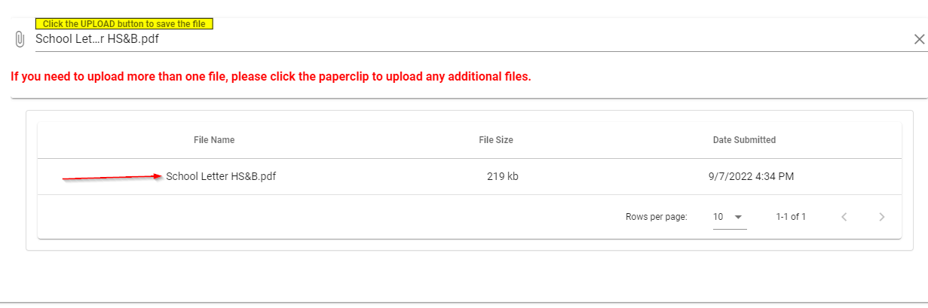

Troubleshooting
- You did not receive the 2-factor authentication code.
If you are trying to log into the portal with another staff member’s study ID, the 2-factor authentication code email may still be sent to their email address. Please email us at HSB22@rti.org with your school’s name, your name, and your email so we can create a portal account for you.
There are some cases where the email containing the 2-factor authentication code is redirected to spam or junk boxes. Be sure to check these locations for ed.gov emails.
Some districts and schools have firewalls that block these emails from arriving, no matter what troubleshooting steps we take. In this rare case, please contact us for alternate solutions.

- You uploaded the file, but we did not receive it.
Please review page 8 of this guide. If you did not click ‘YES’ after you uploaded the file, we will not receive it. You should see the file name appear in the table on your screen if the file was sent to us.

- Your study ID is not valid.
Please type your ID and password directly into the boxes, as opposed to copy/paste. Sometimes copy/paste adds extra characters that are not visible to users but disrupt the log in process.
Your Study ID is not your email address. Your Study ID begins with a ‘3’ and is an eight-digit number and was provided to you via email with the login instructions.
If you cannot locate your study ID, please reach out to us at HSB22@rti.org and we can re-send it to you.

- Something else is not working.
If you receive any other error messages or encounter any other issues, if possible, take a screen shot of your screen with the error message. Send to us at HSB22@rti.org.
Please call us for troubleshooting assistance at 855-500-1439. Our help desk is available Monday- Thursday from 8:00 AM ET – 7:00 PM ET and on Fridays from 8:00 AM ET – 5:00 PM ET.
You can also reach out directly your study liaison at their direct # and email so they can assist.

Viewing Your Sampled Students
- Go to: https://surveys.nces.ed.gov/hsb22

Input your Study ID in the box.
- Enter your password
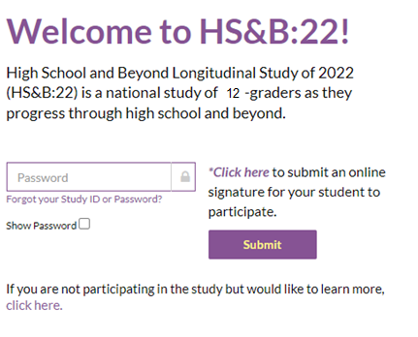

- You will receive a 2-factor authentication code to your email from ed.gov. Input this code into the study portal.

- Click green arrow ‘REVIEW LIST OF SAMPLED STUDENTS’

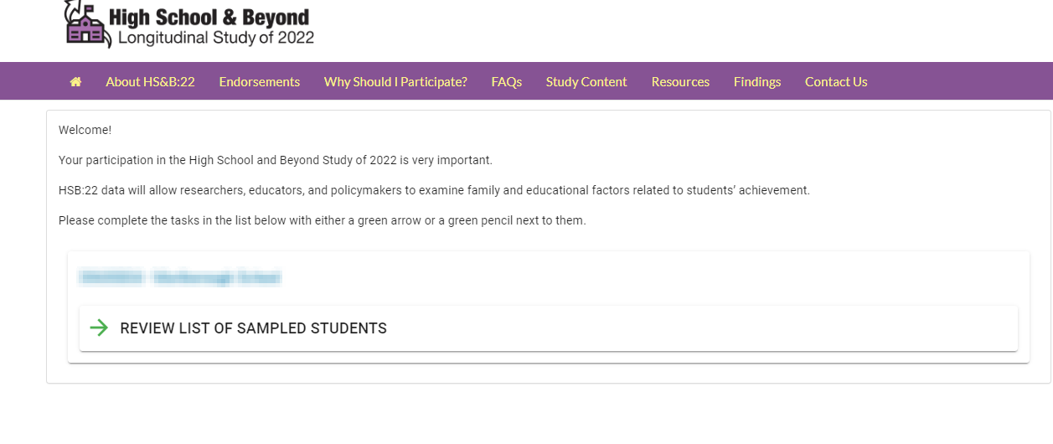
- You can view the sampled students on your screen.
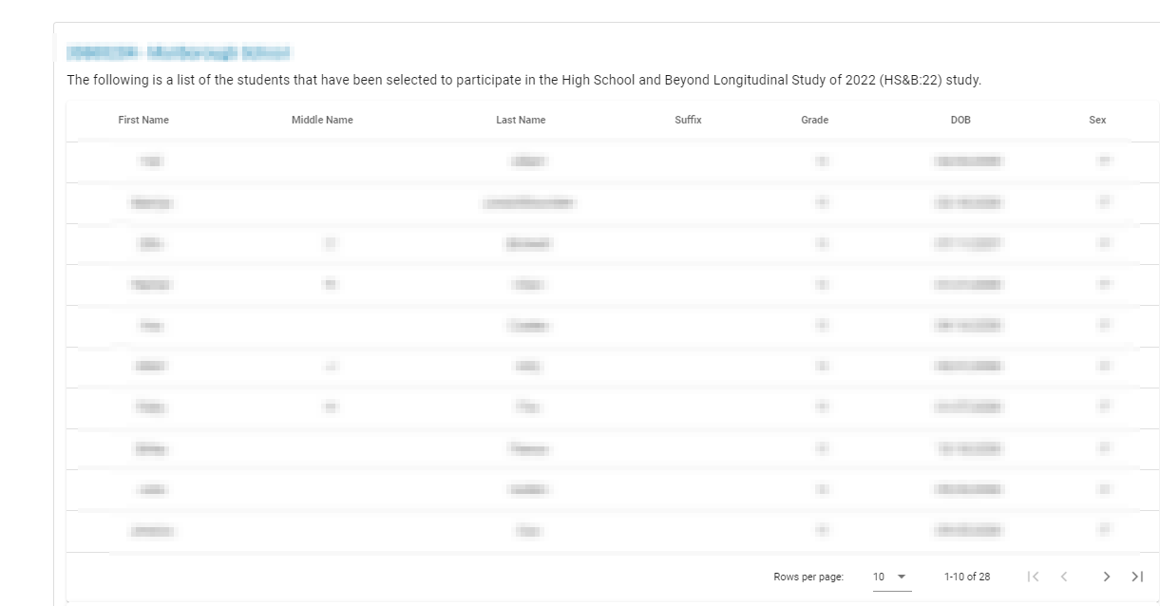

- You can download the file by clicking the blue ‘DOWNLOAD STUDENT SAMPLE TEMPLATE’
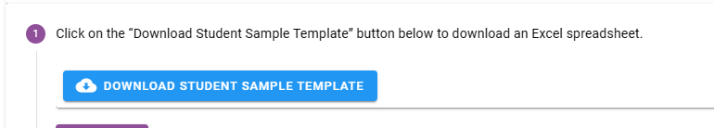

The file is prefilled with information you have already provided.
If you have already provided parent and teacher information, congratulations! You are finished!

Adding Parent and/or Teachers

If you did not provide parent/teacher lists on your initial file, you will be asked to log back into the study portal to do so. Please follow the same login procedure outlined at the beginning of this document by inputting your Study ID, Password, and 2-factor authentication code.

- Click green arrow ‘REVIEW LIST OF SAMPLED STUDENTS’

- Download your school’s list of selected students by clicking the blue ‘DOWNLOAD STUDENT SAMPLE TEMPLATE’

- An excel file will open. Download this template to your computer.

- Save the file to your computer.
- The file will be prefilled with information you have already provided. Please fill in the missing information for parent and/or teacher lists.

- Save the file again to your computer.

- If you have logged out of the study portal, please log back in. Remember, you will receive a code for 2-factor authentication code via email from ed.gov!

- Once you are in the portal again, click on ‘Review List of Sampled Students’

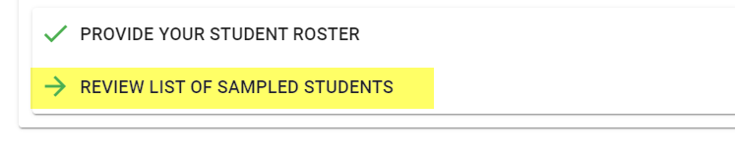
- Click on the grey #5 that reads ‘Upload File’. (You can skip steps 1-4; you’ve already completed these)
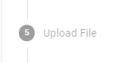

- Click on the yellow bar to locate the file on your computer.
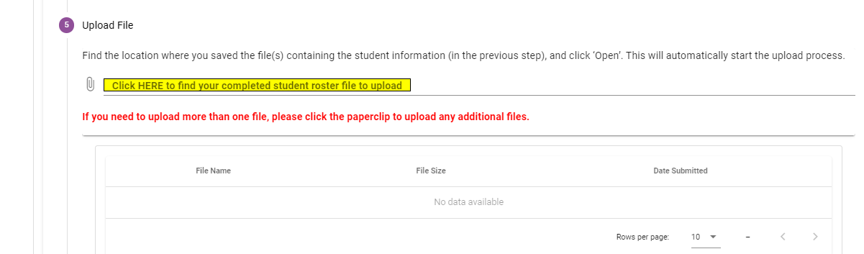

- Locate the file on your computer.

- Confirm upload- click yes.

- To confirm that a file was uploaded, you should see the file you uploaded listed in the table on your screen.

- These steps can be repeated if you need to provide additional information later.

Appendix A.16a Parent Data Collection Letter (modified)
Dear Parent or Guardian,

We are thrilled that your child’s school is participating in the High School and Beyond Longitudinal Study of 2022 (HS&B:22). Here at the National Center for Education Statistics (NCES) in the U.S. Department of Education, we are reaching out to schools, students, parents, school counselors, teachers, and school administrators to understand the high school experience. The information that is provided will contribute to improving education for students now and in the future. You may have already received a letter inviting your child to participate in HS&B:22, or that letter will be coming to you in the next few weeks.

In the meantime, we would greatly appreciate it if the person most knowledgeable about <student_firstname>’s school and home life would complete a [X]-minute survey for the study. As a token of our appreciation, you will receive <incentive> for completing the survey. <If group 1: You can complete the survey online or over the phone by calling (855) 500-1439.> <If group 2: You can complete the survey online, over the phone by calling (855) 500-1439, or by completing and returning the enclosed paper survey.>

You will receive $<X> for only <X> minutes of your time!
To complete the parent survey online, please log into:
surveys.nces.ed.gov/hsb22
Study ID: <xxxxxxxx>
Password: <xxxxxxxx><pw_indicator>

<If group 1: If you cannot complete the full survey, we will still send you $<X> for completing the first section.> Your participation will directly benefit your child’s school. Teachers will earn incentives and continuing education credits during this research, and we need everyone to do their part. Please complete your survey today!

To learn more, watch a short video at the study website at https://surveys.nces.ed.gov/hsb22/. If you have questions, please call us at (855) 500-1439 or send email to HSB22Survey@rti.org. Thank you for supporting education by participating in this important study!

Sincerely,

<NCES Commissioner>

Enclosures: Study Information Sheet,<Paper Survey and Reply Envelope,> Brochure and Flyer

The study is conducted by the National Center for Education Statistics (NCES), part of the U.S. Department of Education. All of the information collected is protected, as required by law. NCES is authorized to conduct HS&B:22 by the Education Sciences Reform Act of 2002 (ESRA 2002, 20 U.S.C. §9543) and to collect students’ education records from education agencies or institutions for the purposes of evaluating federally supported education programs under the Family Educational Rights and Privacy Act (FERPA, 34 CFR §§ 99.31(a)(3)(iii) and 99.35). The data are being collected for NCES by RTI International, a U.S.-based nonprofit research organization. All of the information you and your child provide may be used only for statistical purposes and may not be disclosed, or used, in identifiable form for any other purpose except as required by law (20 U.S.C. §9573 and 6 U.S.C. §151). The collected information will be combined across respondents to produce statistical reports. Completing the survey is voluntary for you and your child and there are no penalties for not participating. You may also skip any question you do not want to answer if you choose to participate.

Appendix A.16b Parent Data Collection Letter Reminder (modified)

Dear <Parent or Guardian>,

We recently sent you information about the High School and Beyond Longitudinal study of 2022 (HS&B:22). It is not too late to participate in this exciting study that students, parents, school counselors, teachers, and school administrators are participating in nationwide. Your contributions will help improve education for students now and in the future.

Participating is easy and should only take about <time> minutes. Your participation will directly benefit your child’s school. As a token of our appreciation, you will receive <incentive> when you finish the survey. You may have already received a letter inviting your child to participate in HS&B:22, or that letter will be coming to you in the next few weeks.
<If group 1: You can complete the survey online or over the phone by calling (855) 500-1439.> <If group 2: You can complete the survey online, over the phone by calling (855) 500-1439, or by completing and returning the enclosed paper survey.>

To complete the parent survey online, please log into:
American students are outperforming one group: their grandparents. In fact, Millennials are on track to be the most educated generation in history compared with older generations when they were the same age.
http://www.pewresearch.org/fact-tank/2015/08/10/5-facts-about-americas-students/

surveys.nces.ed.gov/hsb22
Study ID: <xxxxxxxx>
Password: <xxxxxxxx><pw_indicator>

<If group 1: If you cannot complete the full survey, we will still send you $<X> for completing the first section.>

To learn more about HS&B:22, watch a short video at the study website at https://surveys.nces.ed.gov/hsb22/. If you have questions, please call us at (855) 500-1439 or send an email to HSB22Survey@rti.org. Thank you for supporting education by participating in this important study.

Sincerely,

<NCES Commissioner>

Enclosures: Study Information Sheet, <Paper Survey and Reply Envelope,> Brochure and Flyer

The study is conducted by the National Center for Education Statistics (NCES), part of the U.S. Department of Education. All of the information collected is protected, as required by law. NCES is authorized to conduct HS&B:22 by the Education Sciences Reform Act of 2002 (ESRA 2002, 20 U.S.C. §9543) and to collect students’ education records from education agencies or institutions for the purposes of evaluating federally supported education programs under the Family Educational Rights and Privacy Act (FERPA, 34 CFR §§ 99.31(a)(3)(iii) and 99.35). The data are being collected for NCES by RTI International, a U.S.-based nonprofit research organization. All of the information you and your child provide may be used only for statistical purposes and may not be disclosed, or used, in identifiable form for any other purpose except as required by law (20 U.S.C. §9573 and 6 U.S.C. §151). The collected information will be combined across respondents to produce statistical reports. Completing the survey is voluntary for you and your child and there are no penalties for not participating. You may also skip any question you do not want to answer if you choose to participate.

Appendix A.16c Parent Data Collection Reminder Postcard (modified)

<FirstName>,

The High School and Beyond Longitudinal Study of 2022 (HS&B:22) is happening now! Nationwide, schools, students, parents, school counselors, teachers, and school administrators are participating in this study!

The information you provide will help improve education for students now and in the future.

It only takes <time> minutes, and we’ll send you <incentive>. <If group 1: If you cannot complete the full survey, we will still send you $<X> for completing the first section.>

To complete online, go to https://surveys.nces.ed.gov/hsb22
Study ID: <xxxxxxxx>
Password: <xxxxxxxx><pw_indicator>

Please participate today by completing online, <or> calling us at (855) 500-1439 <If group 2: or returning the paper survey we previously sent you>.

If you have questions, call the HS&B:22 Help Desk at (855) 500-1439 or send an email to HSB22Survey@rti.org.

Thank you for supporting education by participating in this important study.

The High School and Beyond Longitudinal Study of 2022 (HS&B:22) is being conducted by the National Center for Education Statistics (NCES) with the U.S. Department of Education. RTI International is carrying out the HS&B:22 data collection on behalf of NCES.

Appendix A.16d Parent Data Collection Final Reminder Postcard (modified)

Why participate in HS&B:22?

We need YOUR input so the study can represent the experiences of all high school students across the U.S.

<FNAME>, your participation will now take only <time> minutes, and we will send you $<incentive> to thank you for your time.

Complete online: https://surveys.nces.ed.gov/hsb22

Study ID: <xxxxxxxx>
Password: <xxxxxxxx><pw_indicator>

Please participate today by completing online, <or> calling us at (855) 500-1439 <If group 2: or returning the paper survey we previously sent you>!

The High School and Beyond Longitudinal Study of 2022 (HS&B:22) is being conducted by the National Center for Education Statistics (NCES) with the U.S. Department of Education. RTI International is carrying out the HS&B:22 data collection on behalf of NCES.

Appendix A.16e Parent Data Collection Email (modified)

Dear <Parent or Guardian>,

We are thrilled that your child’s school is participating in the High School and Beyond Longitudinal Study of 2022 (HS&B:22).You may have already received a letter inviting your child to participate in HS&B:22, or that letter will be coming to you in the next few weeks. We are hoping that the person most knowledgeable about <student_firstname>’s school and home life would complete a <time>-minute survey for the study.

As a token of our appreciation, you will receive <incentive> for completing the survey. <If group 1: You can complete the survey online or over the phone by calling (855) 500-1439.> <If group 2: You can complete the survey online, over the phone by calling (855) 500-1439, or by completing and returning the paper survey we recently sent you.>

.
To complete the parent survey online, please use the login information below:

Study website: https://surveys.nces.ed.gov/hsb22
Study ID: <xxxxxxxx>
Password: <xxxxxxxx><pw_indicator>

<If group 1: If you cannot complete the full survey, we will still send you $<X> for completing the first section.>

NCES has been conducting studies like this since 1970. This is your opportunity to contribute information that may lead to change. Your participation will directly benefit your child’s school. Teachers will earn incentives and continuing education credits during this research, and we need everyone to do their part. Please log in today and complete your survey!

For more information please watch this brief video about the study at https://surveys.nces.ed.gov/hsb22. You may also call the study hotline at (855) 500-1439 or send email to HSB22Survey@rti.org. Thank you for supporting education by participating in this important study.

Sincerely,

<NCES Commissioner>

Appendix A.16f Parent Data Collection Email Reminder (modified)

Dear Parent or Guardian,

Did you know that it’s not too late to participate in the High School and Beyond Longitudinal Study of 2022 (HS&B:22)? This is a study that schools, students, parents, school counselors, math teachers, and school administrators are participating in around the nation. The information you provide will help improve education for students now and in the future.

Please complete the <time>-minute survey for the study. As a token of our appreciation, you will receive <incentive> when you finish the survey. <If group 1: You can complete the survey online or over the phone by calling (855) 500-1439.> <If group 2: You can complete the survey online, over the phone by calling (855) 500-1439, or by completing and returning the paper survey we recently sent you.>

To complete the parent survey online, please use the login information below:

Study website: surveys.nces.ed.gov/hsb22
Study ID: <xxxxxxxx>
Password: <xxxxxxxx><pw_indicator>

<If group 1: If you cannot complete the full survey, we will still send you $<X> for completing the first section.>
NCES has been conducting studies like this since 1970. This is your opportunity to contribute information that may lead to change.

For more information, please watch this brief video about the study at https://surveys.nces.ed.gov/hsb22. You may also call the study hotline at (855) 500-1439 or send email to HSB22Survey@rti.org. Thank you for supporting education by participating in this important study.

Sincerely,

<NCES Commissioner>

Appendix A.16g Parent Data Collection Email Reminder (modified)

Dear <<fname>>,

My name is Elise Christopher and I am the Project Officer for the High School and Beyond Longitudinal Study of 2022 (HS&B:22), from the National Center for Education Statistics (NCES). I hope that you will take a bit of time out of your busy schedule to complete the HS&B:22 survey today. This survey is part of a nationwide study of students’ education and life experiences as they move through high school and transition into postsecondary education and/or the workforce. Your views and those of your child are important to this study. Decisions about what high school courses to take, whether to pursue further education after high school, and which future career paths to follow are important for policymakers and researchers to understand.

On average, the survey takes only about <time> minutes and you will receive <<inc_amount>> as a token of appreciation for filling it out. <If group 1: You can complete the survey online or over the phone by calling (855) 500-1439.> <If group 2: You can complete the survey online, over the phone by calling (855) 500-1439, or by completing and returning the paper survey we recently sent you.>

To complete the survey online, go to our secure website:
https://surveys.nces.ed.gov/hsb22
Study ID: <xxxxxxxx>
Password: <xxxxxxxx><pw_indicator>

<If group 1: If you cannot complete the full survey, we will still send you $<X> for completing the first section.>

If you have questions, please call us at 855-500-1439. You may also contact HSB22Survey@rti.org. Our data collection contractor, RTI International, is available to assist you with any questions you may have.

Thank you for helping to make HS&B:22 a success.

Elise Christopher, PhD
HS&B:22 Project Officer
National Center for Education Statistics (NCES)
U.S. Department of Education
Elise.Christopher@ed.gov

Appendix A.16h Parent Data Collection Email Reminder (new)
Dear Parent or Guardian,

We need your help. Your child’s school is participating in the High School and Beyond Longitudinal Study of 2022 (HS&B:22). The National Center for Education Statistics in the U.S. Department of Education wants to hear from you to learn more about your child’s high school experiences and plans for after graduation.

We only ask for <time> minutes of your time and you will receive <incentive> as a token of our appreciation.<If group 1: You can complete the survey online or over the phone by calling (855) 500-1439.> <If group 2: You can complete the survey online, or over the phone by calling (855) 500-1439, or by completing and returning the enclosed paper survey.>

To complete the parent survey online, please log into:
You will receive <$X> for only <X> minutes of your time!
surveys.nces.ed.gov/hsb22
Study ID: <xxxxxxxx>
Password: <xxxxxxxx><pw_indicator>

<If group 1: If you cannot complete the full survey, we will still send you $<X> for completing the first section.>

Information that you provide will contribute to improving education for students now and in the future. Please complete the survey today. If you have questions, please call us at (855) 500-1439 or send email to HSB22Survey@rti.org.
Sincerely,

<NCES Commissioner>

Appendix A.16i Parent Paper Survey Instructions (new)
This instructions document will be mailed with the paper micro survey form. The final document may have minor revisions to the instructions portions based on the final design of the paper form. All informed consent text will be included verbatim. The survey items that will appear on the paper survey form are included in Appendix B.

Welcome to the High School and Beyond Longitudinal Study of 2022 (HS&B:22). Your participation is essential to the success of this study.

On average, the parent survey takes about 5 minutes to complete, and we will send you $<X> as a token of our appreciation. You can complete the survey online using the login instructions included on the attached letter, over the phone by calling (855) 500-1439, or by completing the enclosed paper survey and returning it in the envelope provided.
You may decline to answer any question or stop the survey at any time. Completing the survey is voluntary and there are no penalties for not participating. The risk of participation in this study is minimal, given the strict confidentiality and security procedures in place as required by law.
Responses gathered for this study will only be reported as a group; no names will be linked to any study participant’s answers. Additionally, your responses and your 12th grader’s responses will not be reported individually to their school.
If you have questions about the study, you may contact the study's Help Desk toll-free number at 855-500-1439, or you can email HSB22Survey@rti.org. Please include your study ID when calling or emailing so we can assist you more easily. If you have questions about your or your 12th grader’s rights as a study participant, you may contact RTI’s Office of Research Protection at 919-316-3358 in Durham, NC (or toll-free at 866-214-2043) or email OREP@rti.org.
The National Center for Education Statistics (NCES) is authorized to conduct HS&B:22 by the Education Sciences Reform Act of 2002 (ESRA 2002, 20 U.S.C. 9543) and to collect students’ education records from education agencies or institutions for the purposes of evaluating federally supported education programs under the Family Educational Rights and Privacy Act (FERPA, 34 CFR 99.31(a)(3)(iii) and 99.35). The data are being collected for NCES by RTI International, a U.S.-based nonprofit research organization. All of the information you provide may be used only for statistical purposes and may not be disclosed, or used, in identifiable form for any other purpose except as required by law (20 U.S.C. 9573 and 6 U.S.C. 151).

Appendix A.17a Staff Data Collection Letters – Math Teacher Letter (modified)

<DATE>
Your login information:
Website: <insert URL>
Study ID: <ID>
Password: <Password>
<TEACHER NAME>
<SCHOOL NAME>
<ADDR1>
<ADDR2>
<CITY STATE ZIP>
Dear <TEACHER NAME>,
<SCHOOL NAME> is participating in the High School and Beyond Longitudinal Study of 2022 (HS&B:22) field test follow-up, conducted by the National Center for Education Statistics (NCES), part of the U.S. Department of Education’s Institute of Education Sciences. You are receiving this invitation to participate because one or more of your 12th grade students has been selected. <Incentive Fill: As a token of our appreciation, you will receive $30 for answering questions about your background and selected student.> You will also receive a Certificate of Service from the U.S. Department of Education for your survey.
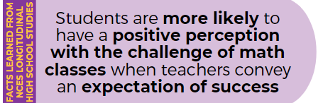
HS&B:22 focuses on factors that lead to positive outcomes for high school students. This is data that educators, policymakers, and researchers need to inform practices, knowledge funding, and to support student success. This is your opportunity to provide information about your experiences and opinions as a teacher, providing essential information about academic policies and curriculum in the classroom. The survey will include several general questions about your background and experiences at school and in the classroom and a teacher student report for one student. The survey will take about <25 minutes or (ELA) 15 minutes>. Your participation is voluntary and very important to the success of this study.
To access the online questionnaire, use the web address and unique study ID and password provided at the top of this letter.
Should you have any questions, please call (855) 500-1439 or email HSB22StaffSurvey@rti.org. You can also learn more about the study in the enclosed materials, or by watching a short video on our website https://surveys.nces.ed.gov/hsb22.
Source: Kelly, S., & Zhang, Y. (2016). Teacher Support and Engagement in Math and Science: Evidence from the High School Longitudinal Study. The High School Journal 99(2), 141-165.

We thank you in advance for your cooperation in making this important research study a success.
Sincerely,
<NCES Commissioner>

NCES is authorized to conduct the High School and Beyond Longitudinal Study of 2022 (HS&B:22) by the Education Sciences Reform Act of 2002 (ESRA 2002, 20 U.S.C. §9543) and to collect students’ education records from education agencies or institutions for the purposes of evaluating federally supported education programs under the Family Educational Rights and Privacy Act (FERPA, 34 CFR §§ 99.31(a)(3)(iii) and 99.35). The data are being collected for NCES by RTI International, a U.S.-based nonprofit research organization. All of the information students, parents, and staff provide may be used only for statistical purposes and may not be disclosed, or used, in identifiable form for any other purpose except as required by law (20 U.S.C. §9573 and 6 U.S.C. §151). The collected information will be combined across respondents to produce statistical reports.

Appendix A.17b Staff Data Collection Letters – Math Teacher Reminder (modified)

<DATE>
<TEACHER NAME>
Your login information:

Website: <insert URL>
Study ID: <ID>
Password: <Password>
<SCHOOL NAME>
<ADDR1>
<ADDR2>
<CITY STATE ZIP>
Dear <TEACHER NAME>,
We are following up on survey information recently sent to you about the field test follow-up of the U.S. Department of Education’s High School and Beyond Longitudinal Study of 2022 (HS&B:22), in which <SCHOOL NAME> is participating. You are invited to complete a survey because one or more of your students are in the study. <Incentive fill: As a reminder, you will receive $30 for answering questions about your background and selected students. You will also receive a Certificate of Service from the U.S. Department of Education for your survey.> <As a reminder, you will receive a Certificate of Service from the U.S. Department of Education for your survey.>
This is your opportunity to provide information about your experiences and opinions as a teacher, providing essential information about academic policies and curriculum in the classroom. The survey will include general questions about your background and experiences at school and in the classroom. The survey will take about 25 minutes <if ELA fill 15 minutes> . Your participation is voluntary and very important to the success of this study.
To access the online questionnaire, use the web address and unique study ID and password provided at the top of this letter.
Should you have any questions, please call (855) 500-1439 or email HSB22StaffSurvey@rti.org. You can also learn more about the study in the enclosed materials.
Source: Kelly, S., & Zhang, Y. (2016). Teacher Support and Engagement in Math and Science: Evidence from the High School Longitudinal Study. The High School Journal 99(2), 141-165.

We thank you in advance for your cooperation in making this important research study a success.
Sincerely,

<NCES Commissioner>

NCES is authorized to conduct the High School and Beyond Longitudinal Study of 2022 (HS&B:22) by the Education Sciences Reform Act of 2002 (ESRA 2002, 20 U.S.C. §9543) and to collect students’ education records from education agencies or institutions for the purposes of evaluating federally supported education programs under the Family Educational Rights and Privacy Act (FERPA, 34 CFR §§ 99.31(a)(3)(iii) and 99.35). The data are being collected for NCES by RTI International, a U.S.-based nonprofit research organization. All of the information students, parents, and staff provide may be used only for statistical purposes and may not be disclosed, or used, in identifiable form for any other purpose except as required by law (20 U.S.C. §9573 and 6 U.S.C. §151). The collected information will be combined across respondents to produce statistical reports.

Appendix A.17c Staff Data Collection Letters – Math Teacher Email (modified)
SUBJECT LINE: Share your voice! Inform education practices nationwide
(Insert email header)
Dear <TEACHER NAME>,
Your school is participating in the High School and Beyond Longitudinal Study of 2022 (HS&B:22) field test follow-up, which is conducted by the National Center for Education Statistics (NCES), part of the U.S. Department of Education’s Institute of Education Sciences.
This is an opportunity for your voice and the voices of your students to be heard by providing information about your experiences and opinions as a teacher. The survey will take about 25 minutes <if ELA fill 15 minutes>. Your participation is voluntary but very important to the success of this study.
As a token of our appreciation, you will receive a Certificate of Service from the U.S. Department of Education for your time. <You <your school> will also receive $30 or cash equivalent in school supplies for answering the questions about your background and a student teacher report for one student. To access the online questionnaire, please use the web address and unique study ID and password provided below.

Website: surveys.nces.ed.gov/hsb22
Study ID: <ID>
Password: <Password>

Should you have any questions, please call the HS&B:22 information number, (855) 500-1439, or send an email to HSB22StaffSurvey@rti.org. You can also learn more about the study and education research focused on high school students by visiting the HS&B:22 website at https://surveys.nces.ed.gov/hsb22, or by watching a short video (https://youtu.be/trUll4bCvY0).
We thank you in advance for your cooperation in making this important research study a success.
Sincerely,

<NCES Commissioner>

HS&B:22 is conducted by the National Center for Education Statistics (NCES) in the U.S. Department of Education’s Institute for Education Sciences. NCES is authorized to conduct the High School and Beyond Longitudinal Study of 2022 (HS&B:22) by the Education Sciences Reform Act of 2002 (ESRA 2002, 20 U.S.C. §9543) and to collect students’ education records from education agencies or institutions for the purposes of evaluating federally supported education programs under the Family Educational Rights and Privacy Act (FERPA, 34 CFR §§ 99.31(a)(3)(iii) and 99.35). The data are being collected for NCES by RTI International, a U.S.-based nonprofit research organization. All of the information students, parents, and staff provide may be used only for statistical purposes and may not be disclosed, or used, in identifiable form for any other purpose except as required by law (20 U.S.C. §9573 and 6 U.S.C. §151). The collected information will be combined across respondents to produce statistical reports.

Study Conducted by: |  | Data Collected by: | 

Appendix A.17d Staff Data Collection Letters – Math Teacher Email Reminder (modified)
SUBJECT LINE: Teachers make a difference every day and HS&B:22 wants to hear from you!
(Insert email header)
Dear <TEACHER NAME>,
It is not too late to participate in the High School and Beyond Longitudinal Study of 2022 (HS&B:22) field test follow-up. This is an opportunity to support your school and students and for your voice to be heard by providing information about your experiences and opinions as a teacher. The survey will include general questions about your background and experiences teaching and a student teacher report for one student. The survey will take about 25 minutes <if ELA fill 15 minutes>. Your participation is voluntary and very important to the success of this study.
As a token of our appreciation, you will receive a Certificate of Service from the U.S. Department of Education for your time. <You will also receive $30 for answering the questions about your background and one selected student.> To access the online questionnaire, please use the web address and unique study ID and password provided below.
Website: surveys.nces.ed.gov/hsb22
Study ID: <ID>
Password: <Password>
Should you have any questions, please call (855) 500-1439 or email HSB22StaffSurvey@rti.org. You can also get more information by watching a short video on our website https://surveys.nces.ed.gov/hsb22.
We thank you in advance for your cooperation in making this important research study a success.
Sincerely,

<NCES Commissioner>

HS&B:22 is conducted by the National Center for Education Statistics (NCES) in the U.S. Department of Education’s Institute for Education Sciences. NCES is authorized to conduct the High School and Beyond Longitudinal Study of 2022 (HS&B:22) by the Education Sciences Reform Act of 2002 (ESRA 2002, 20 U.S.C. §9543) and to collect students’ education records from education agencies or institutions for the purposes of evaluating federally supported education programs under the Family Educational Rights and Privacy Act (FERPA, 34 CFR §§ 99.31(a)(3)(iii) and 99.35). The data are being collected for NCES by RTI International, a U.S.-based nonprofit research organization. All of the information students, parents, and staff provide may be used only for statistical purposes and may not be disclosed, or used, in identifiable form for any other purpose except as required by law (20 U.S.C. §9573 and 6 U.S.C. §151). The collected information will be combined across respondents to produce statistical reports.

Appendix A.17e Staff Data Collection Letters – School Counselor (modified)

<DATE>
Your login information:

Website: <insert URL>
Study ID: <ID>
Password: <Password>
Website: <insert URL>
Study ID: <ID>
Password: <Password>
<COUNSELOR NAME>
<SCHOOL NAME>
<ADDR1>
<ADDR2>
<CITY STATE ZIP>
Dear <COUNSELOR NAME>,
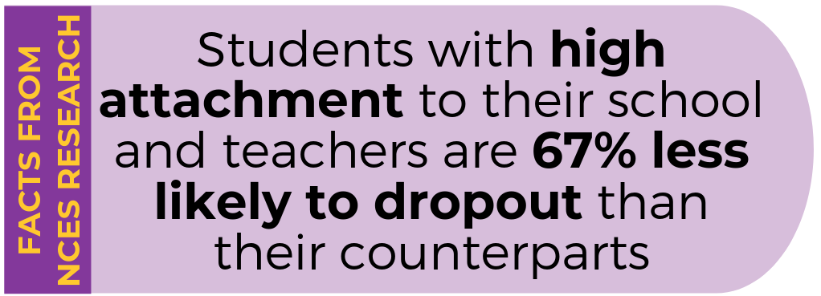
<SCHOOL NAME> is participating in the High School and Beyond Longitudinal Study of 2022 (HS&B:22) field test follow-up, conducted by the National Center for Education Statistics (NCES), part of the U.S. Department of Education’s Institute of Education Sciences. To gain a wholistic view of the high school education experience, we are asking you to complete an online school counselor questionnaire on behalf of your school. Your participation will provide essential information about student services, activities and programs in the school, and other school related experiences that impact student learning.
This is an opportunity for your voice to be heard by providing information about your experiences and opinions as a counselor. Your participation is voluntary and very important to the success of this study, and you will receive a Certificate of Service from the U.S. Department of Education <and [incentive]> for your time.
Source: Kotok, S., Ikoma, S., & Bodovski, K. (2016). School climate and dropping out of school in the era of accountability. American Journal of Education, 122(4), 569–599. https://doi.org/10.1086/687275
To access the questionnaire online, please use the web address and unique study ID and Password provided at the top of this letter. It should take no longer than [fill] minutes to complete. We recommend gathering the following information in advance of completing the survey:
- School and counseling program characteristics
- School courses and academic programs
- Counseling and support services offered
Should you have any questions, please call (855) 500-1439 or email to HSB22StaffSurvey@rti.org. You can also learn more about the study and education research focused on students in the enclosed materials, or by watching a short video on our website https://surveys.nces.ed.gov/hsb22.
We thank you in advance for your cooperation in making this important research study a success.
Sincerely,

<NCES Commissioner>

NCES is authorized to conduct the High School and Beyond Longitudinal Study of 2022 (HS&B:22) by the Education Sciences Reform Act of 2002 (ESRA 2002, 20 U.S.C. §9543) and to collect students’ education records from education agencies or institutions for the purposes of evaluating federally supported education programs under the Family Educational Rights and Privacy Act (FERPA, 34 CFR §§ 99.31(a)(3)(iii) and 99.35). The data are being collected for NCES by RTI International, a U.S.-based nonprofit research organization. All of the information students, parents, and staff provide may be used only for statistical purposes and may not be disclosed, or used, in identifiable form for any other purpose except as required by law (20 U.S.C. §9573 and 6 U.S.C. §151). The collected information will be combined across respondents to produce statistical reports.

Appendix A.17f Staff Data Collection Letters Reminder – School Counselor (modified)

<DATE>
Your login information:

Website: <insert URL>
Study ID: <ID>
Password: <Password>
Website: <insert URL>
Study ID: <ID>
Password: <Password>
<COUNSELOR NAME>
<SCHOOL NAME>
<ADDR1>
<ADDR2>
<CITY STATE ZIP>
Dear <COUNSELOR NAME>,
We are following up on information recently sent to you about the U.S. Department of Education’s High School and Beyond Longitudinal Study of 2022 (HS&B:22) field test follow-up, in which <SCHOOL NAME> is participating. To gain a wholistic view of the high school education experience, we are asking you to complete an online school counselor questionnaire to provide essential information about student services, activities and programs in the school, and other school related experiences that impact student learning.
This is an opportunity to support not only your students, but students nationwide by providing information about your experiences and opinions as a counselor. Your participation is voluntary and very important to the success of this study. You will receive a Certificate of Service from the U.S. Department of Education <and [incentive]> for your time.
To access the questionnaire online, please use the web address and unique study ID and Password provided at the top of this letter. It should take no longer than [fill] minutes to complete.
We recommend gathering the following information in advance of completing the survey:
- School and counseling program characteristics
- School courses and academic programs
- Counseling and support services offered
Should you have any questions, please call (855) 500-1439 or email to HSB22StaffSurvey@rti.org. You can also learn more about the study and education research focused on students in the enclosed materials, or by watching a short video on our website https://surveys.nces.ed.gov/hsb22.
We thank you in advance for your cooperation in making this important research study a success.
Sincerely,

<NCES Commissioner>

NCES is authorized to conduct the High School and Beyond Longitudinal Study of 2022 (HS&B:22) by the Education Sciences Reform Act of 2002 (ESRA 2002, 20 U.S.C. §9543) and to collect students’ education records from education agencies or institutions for the purposes of evaluating federally supported education programs under the Family Educational Rights and Privacy Act (FERPA, 34 CFR §§ 99.31(a)(3)(iii) and 99.35). The data are being collected for NCES by RTI International, a U.S.-based nonprofit research organization. All of the information students, parents, and staff provide may be used only for statistical purposes and may not be disclosed, or used, in identifiable form for any other purpose except as required by law (20 U.S.C. §9573 and 6 U.S.C. §151). The collected information will be combined across respondents to produce statistical reports.

Appendix A.17g Staff Data Collection Email– School Counselor (modified)
SUBJECT LINE: Share your voice! Inform education practices and student supports nationwide
(Insert email header)
Dear <COUNSELOR NAME>,
Your school is participating in the High School and Beyond Longitudinal Study of 2022 (HS&B:22) field test follow-up, which is conducted by the National Center for Education Statistics (NCES), part of the U.S. Department of Education’s Institute of Education Sciences.
This is an opportunity for you to provide information about your experiences and opinions as a school counselor. Your participation is voluntary but very important to the success of this study. Please complete the [fill]-minute questionnaire to provide essential information about student services, programs, activities, and curriculum in the school and other school-related experiences that impact student learning. You will receive a Certificate of Service <and [incentive]> from the U.S. Department of Education for your time.
Please log in using the web address and unique study ID and password provided below. We recommend gathering the following information in advance of completing the survey:
- School and counseling program characteristics
- School courses and academic programs
- Counseling and support services offered

Website: surveys.nces.ed.gov/hsb22
Study ID: <ID>
Password: <Password>
If you have any questions, please call the HS&B:22 information number, (855) 500-1439, or send an email to HSB22StaffSurvey@rti.org. You can also learn more about the study and education research focused on students in high school by visiting the HS&B:22 website at https://surveys.nces.ed.gov/hsb22 or by watching a short video at https://youtu.be/trUll4bCvY0.
Thank you for making this important research study a success.
Sincerely,

[ NCES Commissioner]

HS&B:22 is conducted by the National Center for Education Statistics (NCES) in the U.S. Department of Education’s Institute for Education Sciences. NCES is authorized to conduct the High School and Beyond Longitudinal Study of 2022 (HS&B:22) by the Education Sciences Reform Act of 2002 (ESRA 2002, 20 U.S.C. §9543) and to collect students’ education records from education agencies or institutions for the purposes of evaluating federally supported education programs under the Family Educational Rights and Privacy Act (FERPA, 34 CFR §§ 99.31(a)(3)(iii) and 99.35). The data are being collected for NCES by RTI International, a U.S.-based nonprofit research organization. All of the information students, parents, and staff provide may be used only for statistical purposes and may not be disclosed, or used, in identifiable form for any other purpose except as required by law (20 U.S.C. §9573 and 6 U.S.C. §151). The collected information will be combined across respondents to produce statistical reports.

Appendix A.17h Staff Data Collection Email Reminder – School Counselor (modified)
SUBJECT LINE: HS&B:22: Don’t forget to complete your survey!
(Insert email header)
Dear [Counselor Name]
This email is to follow up on an invitation you should have received from the U.S. Department of Education about your school’s participation in the High School and Beyond Longitudinal Study of 2022 (HS&B:22) field test follow-up. This is an opportunity for you to share your experiences and opinions as a school counselor. This information will be combined with data from counselors across the nation to inform high school policy and practice. You will receive a Certificate of Service from the U.S. Department of Education <and [incentive]> for your time. Participation is voluntary and very important to the success of this study.
Please use the web address and unique study ID and password provided below to complete an online questionnaire. The survey should take no longer than [fill] minutes to complete. We recommend gathering the following information in advance of completing the survey:
- School and counseling program characteristics
- School courses and academic programs
- Counseling and support services offered

Website: surveys.nces.ed.gov/hsb22
Study ID: <ID>
Password: <Password>
Should you have any questions, please call the HS&B:22 information number, (855) 500-1439, or send an email to HSB22StaffSurvey@rti.org. You can also learn more about the study and education research focused on students in high school by visiting the HS&B:22 website at HS&B:22 - Home (ed.gov), or by watching a short video at https://youtu.be/EolkmqoHoWk.
We thank you in advance for your cooperation in making this important research study a success.
Sincerely,

HS&B:22 Staff Data Collection Team
HSB22StaffSurvey@rti.org

HS&B:22 is conducted by the National Center for Education Statistics (NCES) in the U.S. Department of Education’s Institute for Education Sciences. NCES is authorized to conduct the High School and Beyond Longitudinal Study of 2022 (HS&B:22) by the Education Sciences Reform Act of 2002 (ESRA 2002, 20 U.S.C. §9543) and to collect students’ education records from education agencies or institutions for the purposes of evaluating federally supported education programs under the Family Educational Rights and Privacy Act (FERPA, 34 CFR §§ 99.31(a)(3)(iii) and 99.35). The data are being collected for NCES by RTI International, a U.S.-based nonprofit research organization. All of the information students, parents, and staff provide may be used only for statistical purposes and may not be disclosed, or used, in identifiable form for any other purpose except as required by law (20 U.S.C. §9573 and 6 U.S.C. §151). The collected information will be combined across respondents to produce statistical reports.

Appendix A.17i Staff Data Collection Letters – School Administrator (modified)

<DATE>
Your login information:

Website: <insert URL>
Study ID: <ID>
Password: <Password>
Website: <insert URL>
Study ID: <ID>
Password: <Password>
<ADMIN NAME>
<SCHOOL NAME>
<ADDR1>
<ADDR2>
<CITY STATE ZIP>
Dear <ADMIN NAME>,
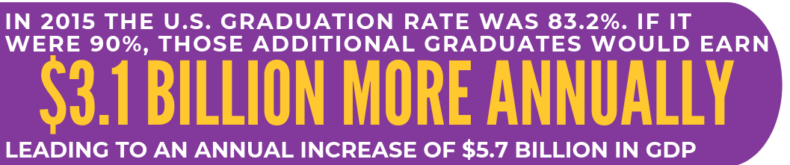
Thank you for your school’s participation in the High School and Beyond Longitudinal Study of 2022 (HS&B:22) field test follow-up. To provide a wholistic view of the high school education experience, we are asking you to participate in an online administrator questionnaire about academic policies and programs, activities and curriculum in the school, and other school related experiences that impact student learning. This is an opportunity for you to provide information about your experiences and opinions as a school administrator. Your participation is voluntary and very important to the success of this study.
Source: http://impact.all4ed.org/
You will receive a Certificate of Service from the U.S. Department of Education <and [incentive]> for your time. To access the questionnaire online, please use the web address and unique study ID and Password provided at the top of this letter. The survey should take no longer than [fill] minutes to complete. We recommend gathering the following information in advance of completing the survey:
- School graduation rate
- Percent of students receiving free or reduced lunch
- Number of teachers
- Number of non-teaching staff
- School’s total annual budget
- School improvement plan
Learn more about the study and education research focused on students in high school in the enclosed information or by watching a short video on our website https://surveys.nces.ed.gov/hsb22. Should you have any questions, please call (855) 500-1439 or email to HSB22StaffSurvey@rti.org
We thank you in advance for your cooperation in making this important research study a success.
Sincerely,
<NCES Commissioner>

HS&B:22 is conducted by the National Center for Education Statistics (NCES) in the U.S. Department of Education’s Institute for Education Science. NCES is authorized to conduct the High School and Beyond Longitudinal Study of 2022 (HS&B:22) by the Education Sciences Reform Act of 2002 (ESRA 2002, 20 U.S.C. §9543) and to collect students’ education records from education agencies or institutions for the purposes of evaluating federally supported education programs under the Family Educational Rights and Privacy Act (FERPA, 34 CFR §§ 99.31(a)(3)(iii) and 99.35). The data are being collected for NCES by RTI International, a U.S.-based nonprofit research organization. All of the information students, parents, and staff provide may be used only for statistical purposes and may not be disclosed, or used, in identifiable form for any other purpose except as required by law (20 U.S.C. §9573 and 6 U.S.C. §151). The collected information will be combined across respondents to produce statistical reports

Appendix A.17j Staff Data Collection Letters Reminder– School Administrator (modified)

<DATE>
Your login information:
Website: <insert URL>
Study ID: <ID>
Password: <Password>
<ADMIN NAME>
<SCHOOL NAME>
<ADDR1>
<ADDR2>
<CITY STATE ZIP>
Dear <ADMIN NAME>,
Thank you for <SCHOOL>’s participation in the High School and Beyond Longitudinal Study of 2022 (HS&B:22) field test follow-up. Please take time to participate by completing the online administrator questionnaire and provide essential information about academic policies and programs, activities and curriculum in the school, and other school related experiences that impact student learning. Your participation is voluntary and very important to the success of this study.
You will receive a Certificate of Service from the U.S. Department of Education <and [incentive]> for your time. To access the questionnaire online, please use the web address and unique study ID and Password provided at the top of this letter. The survey should take no longer than [fill] minutes to complete.
We recommend gathering the following information in advance of completing the survey:
- School graduation rate
- Percent of students receiving free or reduced lunch
- Number of teachers
- Number of non-teaching staff
- School’s total annual budget
- School improvement plan

Should you have any questions, please call (855) 500-1439 or email to HSB22StaffSurvey@rti.org. Learn more about the study and education research focused on students in high school in the enclosed information or by watching a short video on our website https://surveys.nces.ed.gov/hsb22.
We thank you in advance for your cooperation in making this important research study a success.
Sincerely,

<NCES Commissioner>

HS&B:22 is conducted by the National Center for Education Statistics (NCES) in the U.S. Department of Education’s Institute for Education Science. NCES is authorized to conduct the High School and Beyond Longitudinal Study of 2022 (HS&B:22) by the Education Sciences Reform Act of 2002 (ESRA 2002, 20 U.S.C. §9543) and to collect students’ education records from education agencies or institutions for the purposes of evaluating federally supported education programs under the Family Educational Rights and Privacy Act (FERPA, 34 CFR §§ 99.31(a)(3)(iii) and 99.35). The data are being collected for NCES by RTI International, a U.S.-based nonprofit research organization. All of the information students, parents, and staff provide may be used only for statistical purposes and may not be disclosed, or used, in identifiable form for any other purpose except as required by law (20 U.S.C. §9573 and 6 U.S.C. §151). The collected information will be combined across respondents to produce statistical reports.

Appendix A.17k Staff Data Collection Email – School Administrator (modified)
SUBJECT LINE: Share your voice! Inform education practices and student supports nationwide
(Insert HSB:22 Email header)
Dear <ADMIN NAME>,
We are grateful for your school’s participation in the High School and Beyond Longitudinal Study of 2022 (HS&B:22) field test follow-up. Please complete your online administrator questionnaire to provide essential information about academic policies, programs, activities, and curriculum in the school. Your participation is voluntary and very important to the success of this study. You will receive a Certificate of Service from the U.S. Department of Education <and [incentive]> for your time.
To access the questionnaire online, please use the web address and unique study ID and password provided below.
Website: surveys.nces.ed.gov/hsb22
Study ID: <ID>
Password: <Password>
The survey should take no longer than [fill] minutes and does not have to be completed at one sitting. We recommend gathering the following information in advance of completing the survey:
- School graduation rate
- Percent of students receiving free or reduced lunch
- Number of teachers
- Number of non-teaching staff
- School’s total annual budget
- School improvement plan
Please reach out to us at (855) 500-1439, or HSB22StaffSurvey@rti.org if you have any questions. Learn more about the study by watching a short video on our website https://surveys.nces.ed.gov/hsb22.
We thank you in advance for your cooperation in making this important research study a success.

Sincerely,

<NCES Commissioner>

HS&B:22 is conducted by the National Center for Education Statistics (NCES) in the U.S. Department of Education’s Institute for Education Sciences. NCES is authorized to conduct the High School and Beyond Longitudinal Study of 2022 (HS&B:22) by the Education Sciences Reform Act of 2002 (ESRA 2002, 20 U.S.C. §9543) and to collect students’ education records from education agencies or institutions for the purposes of evaluating federally supported education programs under the Family Educational Rights and Privacy Act (FERPA, 34 CFR §§ 99.31(a)(3)(iii) and 99.35). The data are being collected for NCES by RTI International, a U.S.-based nonprofit research organization. All of the information students, parents, and staff provide may be used only for statistical purposes and may not be disclosed, or used, in identifiable form for any other purpose except as required by law (20 U.S.C. §9573 and 6 U.S.C. §151). The collected information will be combined across respondents to produce statistical reports.

Appendix A.17l Staff Data Collection Email Reminder– School Administrator (modified)
SUBJECT LINE: Don’t forget to complete your survey for HS&B:22(insert study email header)

Dear <ADMIN NAME>,
As you know, the High School and Beyond Longitudinal Study of 2022 (HS&B:22) field test follow-up is being conducted in your school. We are ready for you to complete your [fill]-minute administrator questionnaire to provide essential information about academic policies and programs, activities and curriculum in your school, and other school related experiences that impact student learning. You will receive a Certificate of Service <and [incentive]> from the U.S. Department of Education for your time.
Please log in using the web address and unique study ID and password provided below. We recommend gathering the following information in advance of completing the survey:
- School graduation rate
- Percent of students receiving free or reduced lunch
- Number of teachers
- Number of non-teaching staff
- School’s total annual budget
- School improvement plan

Website: surveys.nces.ed.gov/hsb22
Study ID: <ID>
Password: <Password>

Please reach out to us at (855) 500-1439, or HSB22StaffSurvey@rti.org if you have any questions. Learn more about the study and education research focused on students in high school by visiting the HS&B:22 website at HS&B:22 - Home (ed.gov), or by watching a short video at https://youtu.be/trUll4bCvY0.
Thank you for making this important research study a success.

Sincerely,

HS&B:22 Staff Data Collection Team
HSB22StaffSurvey@rti.org

HS&B:22 is conducted by the National Center for Education Statistics (NCES) in the U.S. Department of Education’s Institute for Education Sciences. NCES is authorized to conduct the High School and Beyond Longitudinal Study of 2022 (HS&B:22) by the Education Sciences Reform Act of 2002 (ESRA 2002, 20 U.S.C. §9543) and to collect students’ education records from education agencies or institutions for the purposes of evaluating federally supported education programs under the Family Educational Rights and Privacy Act (FERPA, 34 CFR §§ 99.31(a)(3)(iii) and 99.35). The data are being collected for NCES by RTI International, a U.S.-based nonprofit research organization. All of the information students, parents, and staff provide may be used only for statistical purposes and may not be disclosed, or used, in identifiable form for any other purpose except as required by law (20 U.S.C. §9573 and 6 U.S.C. §151). The collected information will be combined across respondents to produce statistical reports.

Appendix A.17m Staff Data Collection Email Reminder– School Coordinator (new)

Subject line: HS&B:22 Progress at your school

Dear School Coordinator,

Thank you for working with us on the High School and Beyond Longitudinal Study of 2022 (HS&B:22) field test follow-up. Several teachers, a counselor, and a school administrator have been invited to complete online questionnaires; below is a summary of their progress.

- The Administrator survey to be completed by <fill with admin Qx contact or admin Qx designee> is <pull from monitor report> <fill with : Complete, in progress, not started>.
- The School Counselor survey to be completed by <Fill with Counselor Qx contact> is <pull from monitor report> <fill with: Complete, in progress, not started>. Or < A school counselor still needs to be identified, please email the name and email of a 12th grade counselor to us at HSB22StaffSurvey@rti.org>>
- The teacher survey to be completed by <teacher name> is <fill with : Complete, in progress, not started>. [NEXT]
[Fill teacher bullet for each teacher at the school]

As the School Coordinator, we kindly request that you reach out to any staff who have a survey in progress or not started and ask them to complete it at their earliest convenience. <if allowed: You can remind them that they will receive a monetary incentive as a thank you for participating at the end of data collection.>

Thank you for your continued partnership in making HS&B:22 a success. Please contact us if you have any questions.

HS&B:22 Staff Data Collection Team
HSB22StaffSurvey@rti.org

HS&B:22 is conducted by the National Center for Education Statistics (NCES) in the U.S. Department of Education’s Institute for Education Sciences. NCES is authorized to conduct the High School and Beyond Longitudinal Study of 2022 (HS&B:22) by the Education Sciences Reform Act of 2002 (ESRA 2002, 20 U.S.C. §9543) and to collect students’ education records from education agencies or institutions for the purposes of evaluating federally supported education programs under the Family Educational Rights and Privacy Act (FERPA, 34 CFR §§ 99.31(a)(3)(iii) and 99.35). The data are being collected for NCES by RTI International, a U.S.-based nonprofit research organization. All of the information students, parents, and staff provide may be used only for statistical purposes and may not be disclosed, or used, in identifiable form for any other purpose except as required by law (20 U.S.C. §9573 and 6 U.S.C. §151). The collected information will be combined across respondents to produce statistical reports.

Appendix A.17n School Staff Participation Certificate (previously approved)

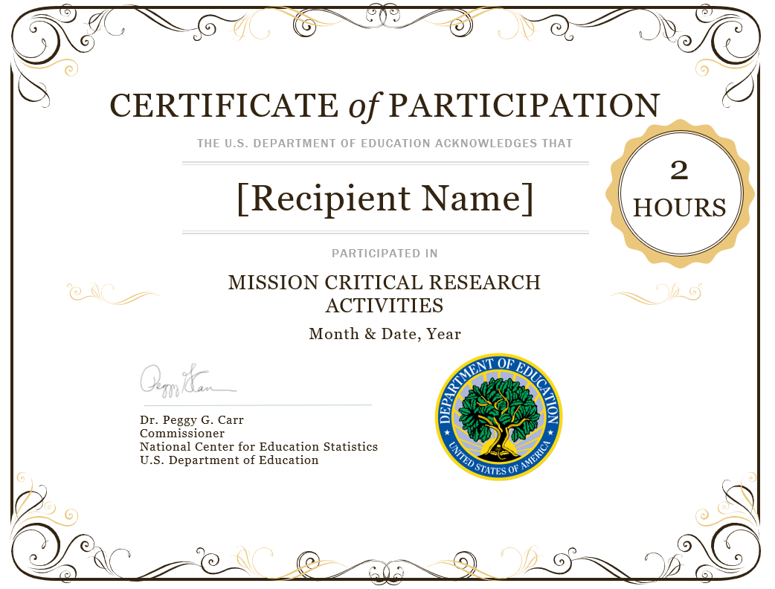

Appendix A.17o School Staff Post Card Reminder (new)
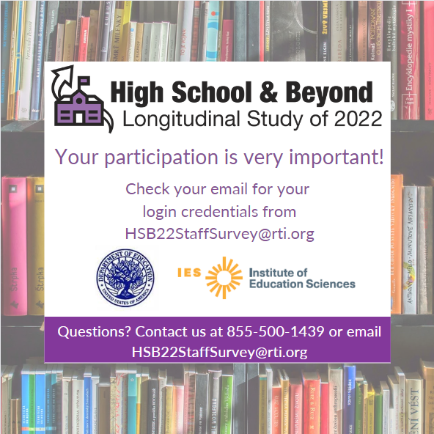

Appendix A.18 Parent/Student Incentive Receipt Form (previously approved)

Interview Incentive Receipt
National Center for Education Statistics (NCES)
and
RTI International
Thank you for participating in the High School and Beyond Study (HS&B:22)
In appreciation of your participation in this important study, you are eligible to receive $______.
Since maintaining the confidentiality of your information is important to us, your name will not be entered on this form. However, the interviewer must sign and date this form to certify you received (or declined) the incentive.

___________________________________ _________ __ __ __ __ __ __ __ __
Interviewer Date Study ID
□ Accepted Incentive □ Declined Incentive

Appendix A.19a Lead Postcards (previously approved)

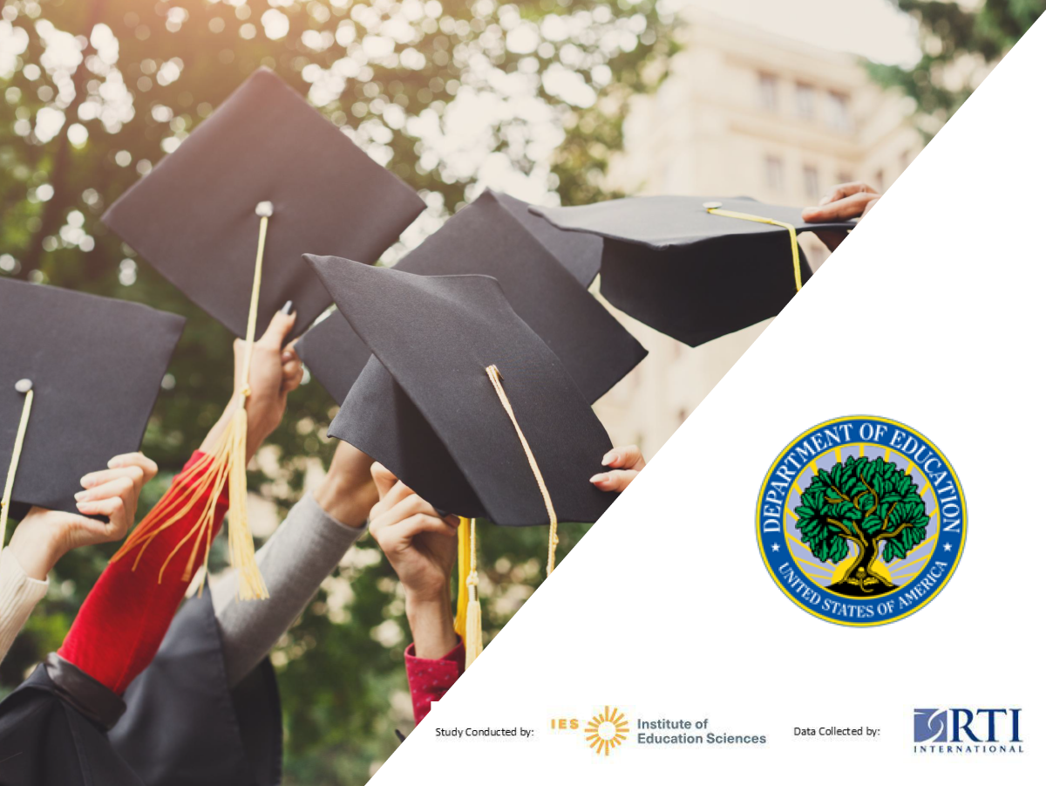

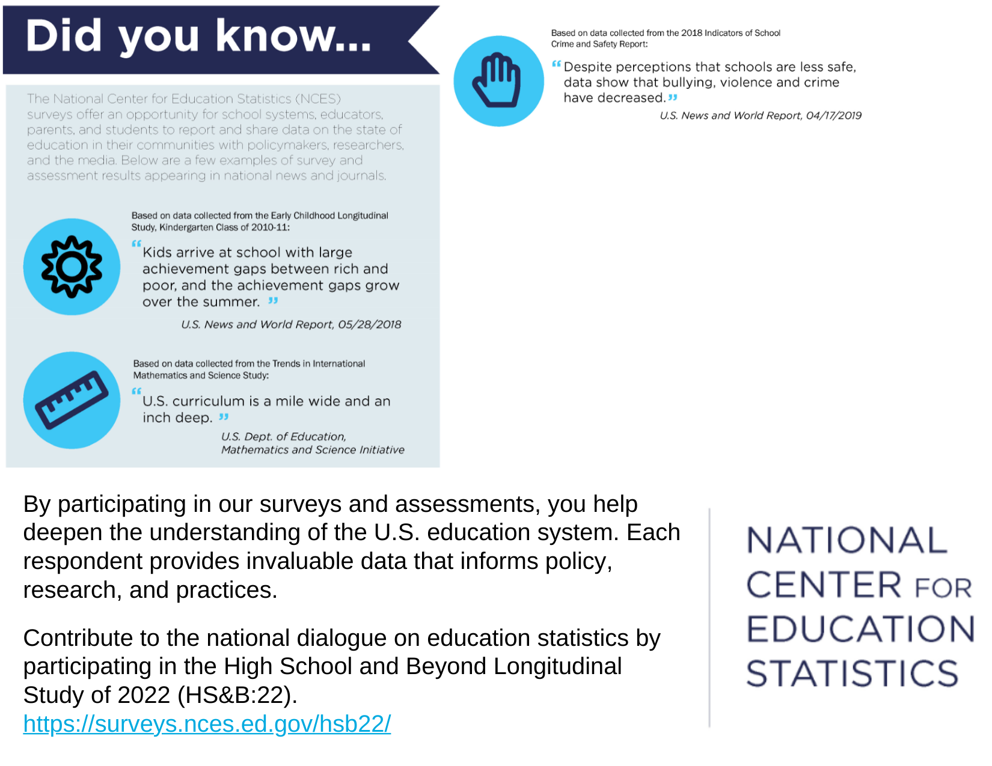
<<ADDRESS>>
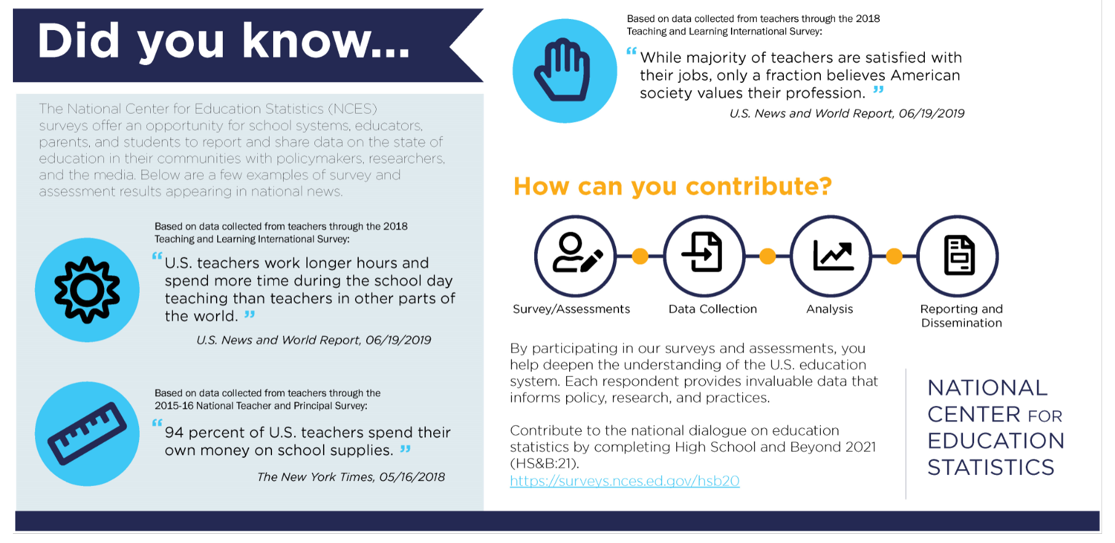
By participating in our surveys and assessments, you help deepen the understanding of the U.S. education system. Each respondent provides invaluable data that informs policy, research, and practices.

Contribute to the national dialogue on education statistics by completing High School and Beyond 2022 (HS&B:22).
https://surveys.nces.ed.gov/hsb22/

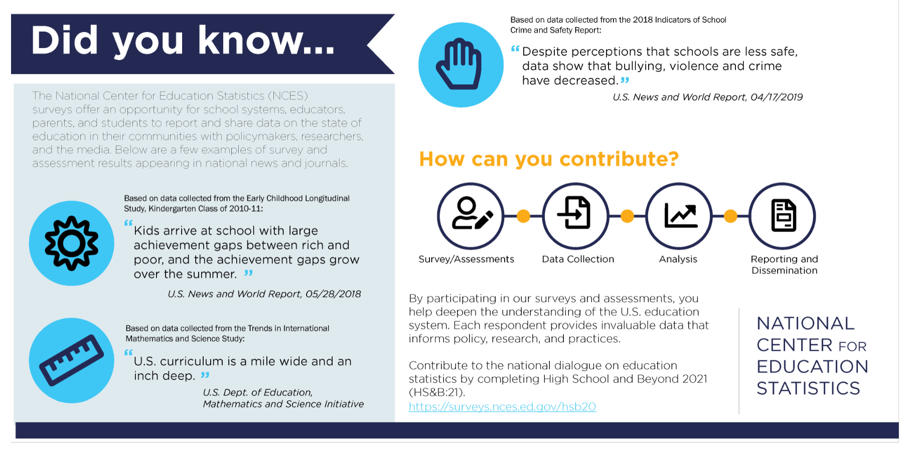
By participating in our surveys and assessments, you help deepen the understanding of the U.S. education system. Each respondent provides invaluable data that informs policy, research, and practices.

Contribute to the national dialogue on education statistics by completing High School and Beyond 2022 (HS&B:22).
https://surveys.nces.ed.gov/hsb22/

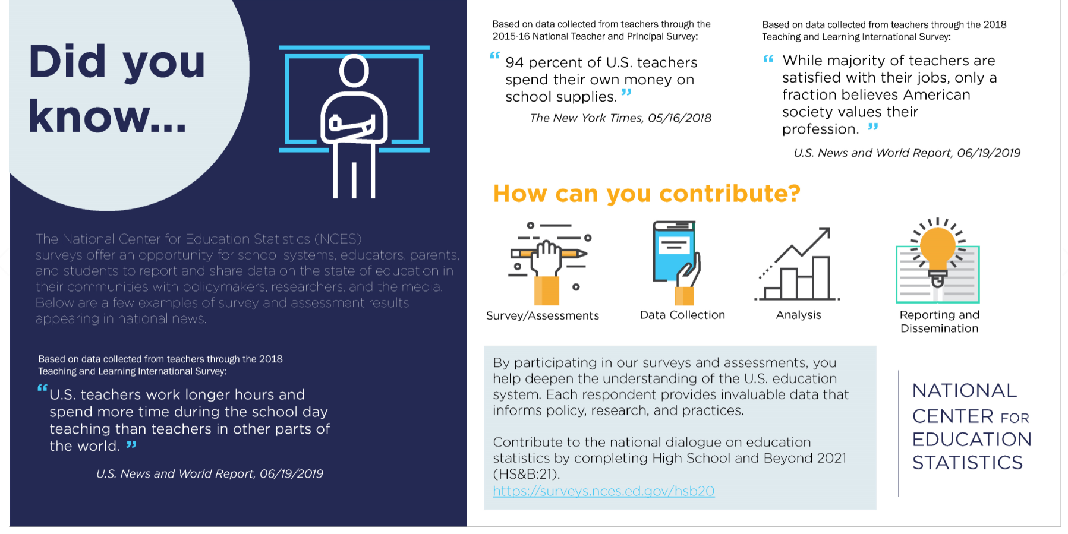
By participating in our surveys and assessments, you help deepen the understanding of the U.S. education system. Each respondent provides invaluable data that informs policy, research, and practices.

Contribute to the national dialogue on education statistics by completing High School and Beyond 2022 (HS&B:22).
https://surveys.nces.ed.gov/hsb22/

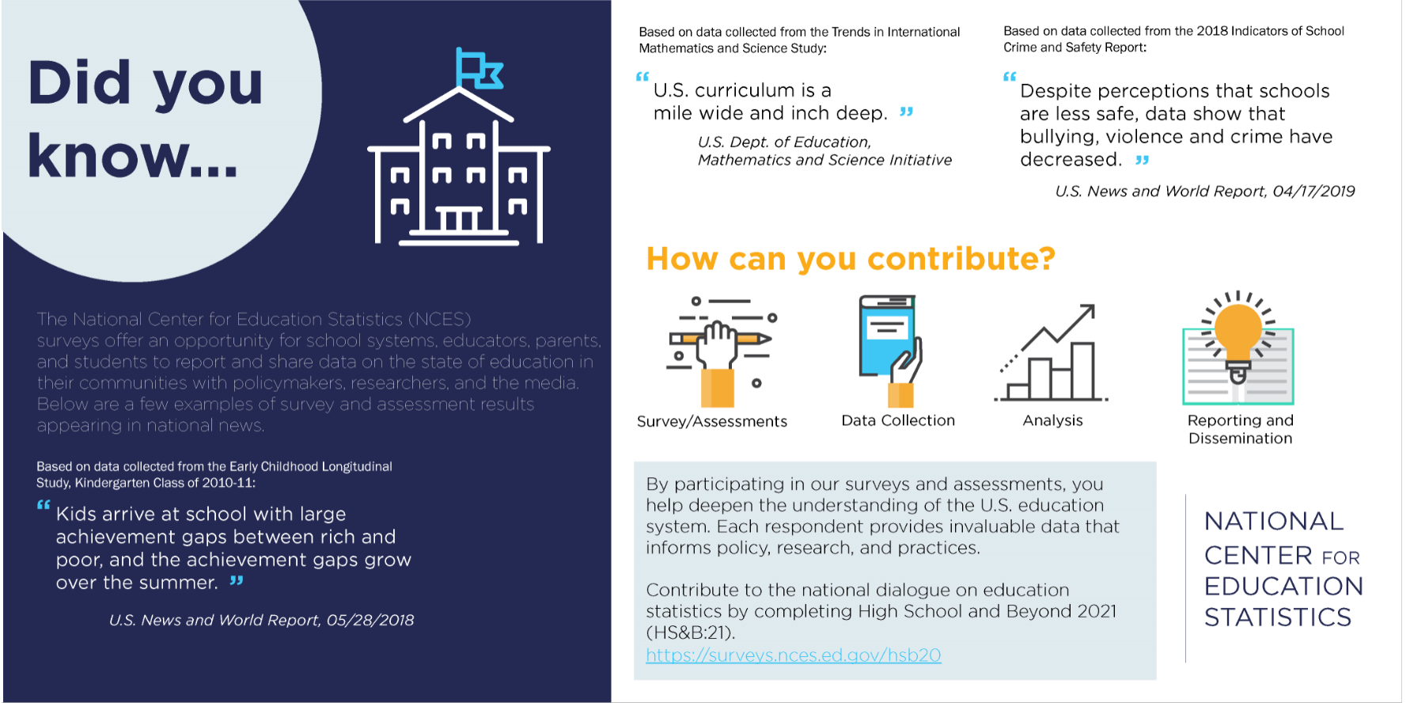
By participating in our surveys and assessments, you help deepen the understanding of the U.S. education system. Each respondent provides invaluable data that informs policy, research, and practices.

Contribute to the national dialogue on education statistics by completing High School and Beyond 2022 (HS&B:22).
https://surveys.nces.ed.gov/hsb22/

Appendix A.19b Informational Materials (modified)

Study Snapshot Page 1

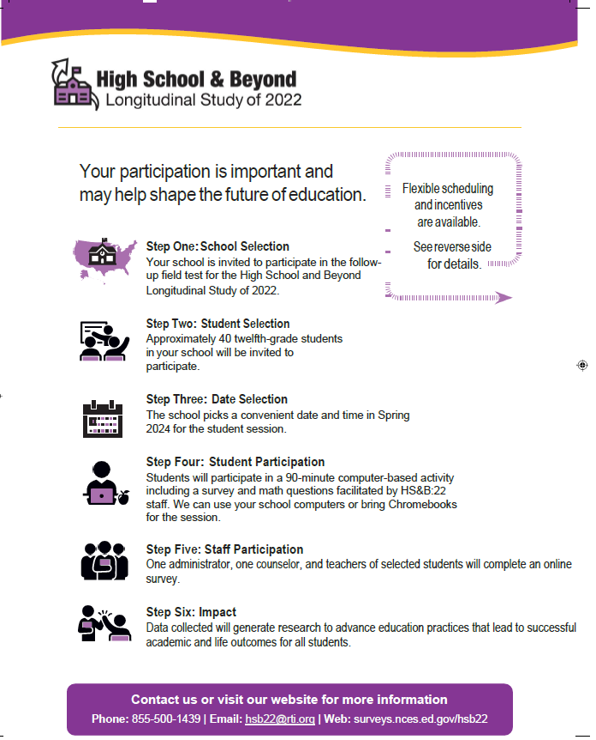
Study Snapshot Page 2

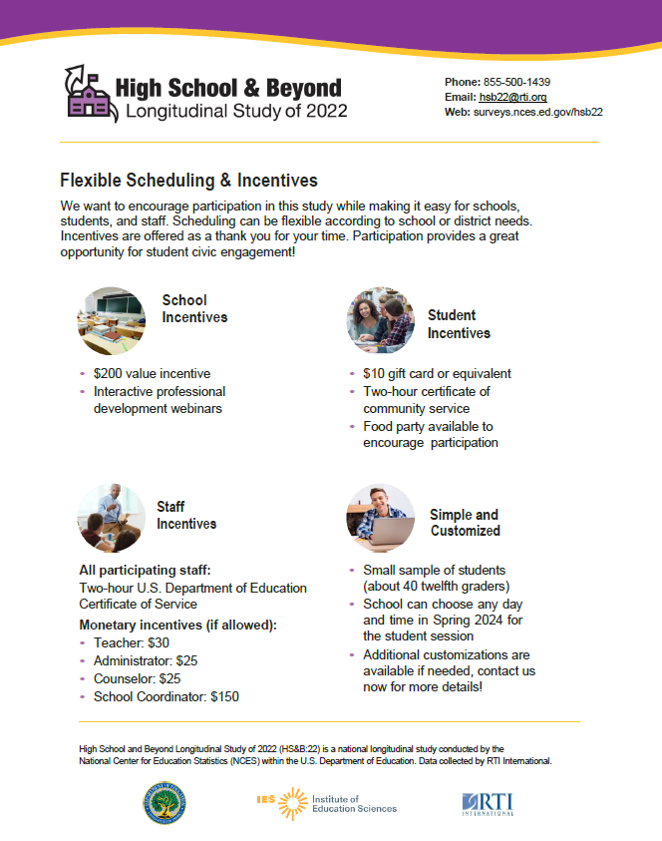

How is HS&B:22 Different
From State, Local & Other Research?

- HS&B:22 is a unique opportunity for all involved in the education experience—students, educators, and parents—to contribute meaningful information that will impact student outcomes for generations to come.
- This is not just another test or survey. Rather, HS&B:22 will capture a wholistic view of student learning, growth, and social and interpersonal development during the critical high school years.
- While NAEP and state assessments measure student performance and progress, NCES longitudinal studies are the only studies that collect data on school and family experiences that allow us to examine associations between contextual factors and student outcomes.
- HS&B:22 is not high stakes – the study does not affect student grades or school accountability ratings.
- HS&B:22 was designed with input from educators and recognizes that a “one size fits all” approach does not work. Within an overarching framework, we partner with districts and schools to customize a data collection plan that complies with district policies and minimizes disruption to the school day.
- Many educational programs and practices currently in use are based on research that used NCES’s longitudinal data. School participation today is essential for producing research-based practices for tomorrow.
- Findings generated from HS&B:22 will not only advance teaching and learning, but will also inform federal, state, and local policy, programming, and funding decisions.
- With limited resources available, it is imperative that districts and schools join together in research that will benefit all of our nation’s youth.
- What we learn from HS&B:22 will be invaluable to better understanding student achievement and what factors lead students to successfully complete high school and enter postsecondary education or the workforce.

Appendix A.20 Digital Digests (modified)

Digital Digest Issue 1
Study Update
The HS&B:22 study team is planning for data collection to occur during winter/spring of the 2023-2024 school year. Please make sure to connect with the study team as they begin reaching out to you. Your partnership is highly valued.
Key study information:
- Approximately 40 twelfth grade students per school will be invited to participate.
- The student session is 90 minutes with math and survey questions.
- You may use your school’s computers, or we will provide Chromebooks. If your school is virtual, your students will participate online.
- It’s critical that we have participation from all types of schools! Public, private, Catholic, charter, and virtual schools have all been invited.
- There are no grades given or individual student reports. Students are proud to contribute to this exciting body of knowledge!

Here are some additional resources you may find helpful:
- Perkins Innovation and Modernization Grant Program (US Department of Education- OCTAE)

a. Includes a citation to this REL report which used the predecessor study’s data (HSLS:09)

Incentives
Incentives are available for schools, students, and teachers if permitted. Your school may choose between either a check or a gift card for school supplies.
We are very excited to offer additional professional development incentives to our schools. Participating schools may send staff to a no-cost interactive webinar and can choose from 2 timely topics: STEM or project-based learning.

Digital Digest Issue 2
Study Update
Did you know that participation in the HS&B:22 follow-up field test will help make sure that questions are equitable and will help inform the full-scale study?
Key study information:
- HS&B:22 is conducted by the U.S. Department of Education’s National Center for Education Statistics division.
- We are excited to finally have an opportunity to work with your school(s)!
- The study is flexible and built with understanding that schools are busy with many commitments.
- You have options and we can customize a student session that fits with your school’s schedule.
- Trained session facilitators will administer the session at your school, or if your school is virtual your students can participate online.

Here are some additional resources you may find helpful:
Learn about the bipartisan bill that eliminates barriers and expenses for students with disabilities seeking to access support services in college: Respond, Innovate, Support and Empower (RISE) Act.
  - Press release from Rep. Marc Molinaro’s office
  - Media article and video

School Coordinators
During this time, schools are designating their ‘School Coordinators’. This staff member will serve as the study liaison for your school and will be compensated (if permitted) for their time.
Please consider who at your school can distribute parental consent forms and assist as needed for a successful student session.

Digital Digest Issue 3
Study Update
The HS&B:22 team is thankful for your partnership and collaboration. Currently, the project continues to obtain the staff name and contact information of each school’s designated school coordinator (SC).
Key Study Information
- Selected twelfth grade students will participate in a computerized session that is 90 minutes or less. Many students finish early.
- The study brings Chromebooks and an internet hotspot to conduct your student session, OR you may opt to use your school’s computers.
- If your school is virtual, we recommend scheduling a virtual synchronous session so all students can log in and participate at the same time. Study staff can assist your students to log in and complete their sessions!

Here are some additional resources you may find helpful:
RTI International published a whitepaper about managing change in education:
https://www.rti.org/sites/default/files/related-content-files/managing_change_in_education_0.pdf
NCES has an online DATALAB with over 5000 published analysis tables by topic, publication, and source:
https://nces.ed.gov/datalab/index.aspx

Logistics
We will reach out to SCs personally to introduce ourselves and complete a logistics call. During this call we will discuss parent permission, incentives, and potential best days to schedule the 90-minute student session. Please inform your SC to expect a call from the HS&B:22 study team!

Digital Digest Issue 4
Study Update
Do you have your calendar set yet for the 2023-2024 school year? We are now scheduling HS&B:22 student session dates for our participating schools. Please connect with us to discuss the best day(s) that will work for your school.
Key Study Information
- The 90-minute student session is flexible and can be scheduled at a time that works best for your school.
- HS&B:22 staff will administer the student session.
- Although not required, school leaders are welcome and encouraged to stop by at the beginning of the student session. We find that a word of encouragement from your school sets the tone for a successful HS&B:22 day!

Here are some additional resources you may find helpful:
https://nces.ed.gov/collegenavigator/

NCES Blog- You’ve been Asked to Participate in a Study

Certificates of Service
We are pleased to announce that all HS&B:22 school participants (teachers/students) will receive a certificate of service from the U.S. Department of Education.
Students will receive 2 hours of service which can be used as volunteer hours needed for their high school diplomas.

Digital Digest Issue 5
Study Update
The HS&B:22 study team would like to highlight the importance of the 12th grade roster request coming in the fall. This is the most critical task for your school, and the person most familiar with your school’s data system is best suited to provide this file to us.
All files will be uploaded via the study website. To provide maximum flexibility, your school can choose to either use the study-provided excel template or run a report using your school’s data system containing the requested roster elements.

Here are some additional resources you may find helpful:
Arts credits earned in High School and Postsecondary Enrollment

Money Matters: Exploring Young Adults’ Financial Literacy and Financial Discussions with their Parents

Data Confidentiality
We understand that this file will contain sensitive data. All electronic data files will be monitored for viruses, malware, and other threats by Federal employees and contractors in accordance with the Cybersecurity Enhancement Act of 2015. All student, staff, and parent information will be removed and replaced with study ID. Students’ names are NOT on any study materials that leave the schools.
Digital Digest Issue 6
Study Update
Data collection is underway at this time and will continue through the end of the school year. All student, staff, and parent surveys must be complete before that date.
Key Study Information
- Let us know how we can help! If you are still working on your 12th grade list or have a question about your student session, please give us a call at 855-500-1439.
- Students can skip any question they do not want to answer. There are no grades given; this is not a test.
- Students will receive their incentives and certificates after the student session.
- Schools/staff will receive their incentives after data collection ends.
- Checks and school supply gift cards will go out starting in May.

Maximize Participation
With your support, your students and colleagues will be excited to have their voices heard in this important study. They were selected to represent ALL students and staff in the country to learn what works best for high schooler

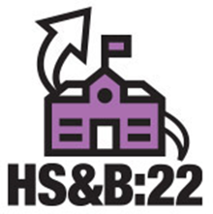

Here are some additional resources you may find helpful:

How High-Quality, Small-Group Tutoring Can Accelerate Learning

Ask An Expert: Implications of a Four-Day School Week in a Rural Community

