**United States Department of Agriculture**

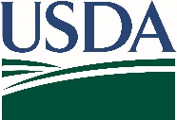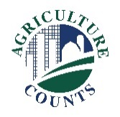

National Agricultural Statistics Service

Minnesota Field Office

In Cooperation with the Minnesota Department of Agriculture

January 30, 2023

**What do I do next?**

Complete your survey:

**Online** at [agcounts.usda.gov](http://www.agcounts.usda.gov). **Online reporting is fast, convenient, and secure.**All you need is your unique survey code on the enclosed form to begin.

**By mail, fax or email**. Complete the questionnaire and mail it back in the prepaid return envelope provided, fax it to 855-271-9802, or email to nassrfoumr@usda.gov.

**Why am I getting this letter?**

Enclosed is your Monthly Report of Dairy Products. **You now have the ability to report your data on-line.** Simply go to [agcounts.usda.gov](https://www.agcounts.usda.gov/static/cawi/layouts/cawi/breeze/index.html) and enter the 12-digit Survey Code found on the label of your survey. This Survey Code will remain the same throughout 2023. Reporting on-line is optional. If you prefer, you may continue to report by mail, fax, or email.

**How will the data be used?**

We greatly appreciate your continued response to our Dairy Products survey. NASS milk and dairy statistics are used by the dairy industry in planning, pricing, and projecting supplies of milk and milk products.

The information you provide will be used for statistical purposes only. In accordance with federal law, your responses will be kept confidential and will not be disclosed in identifiable form. We will publish the survey findings in the *Dairy Products* report, released during the first week of every month.

Thank you for participating and for your support of our programs and U.S. agriculture. If you have any questions, please feel free to contact Audra Hubbell at 608-621-6543. For more information on this survey, visit: nass.usda.gov/Surveys/Guide_to_NASS_Surveys/.

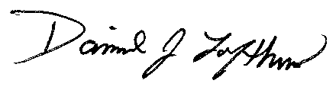Sincerely,

Dan Lofthus

State Statistician, Minnesota Field Office

Enclosure