Non-substantive Change Request
0535-0213 – Agricultural Surveys Program
Agricultural Survey (List) US Master Version - June 2022

As part of NASS’ effort to investigate the use of electronic mail (email) to request survey response, NASS is requesting to add the following two qualitative questions at the conclusion of the June Agricultural (List) Survey. Only those operations that complete the survey via Computer Assisted Survey Interviewing (CASI) will have these questions. They will not be on the printed June Agricultural Survey.
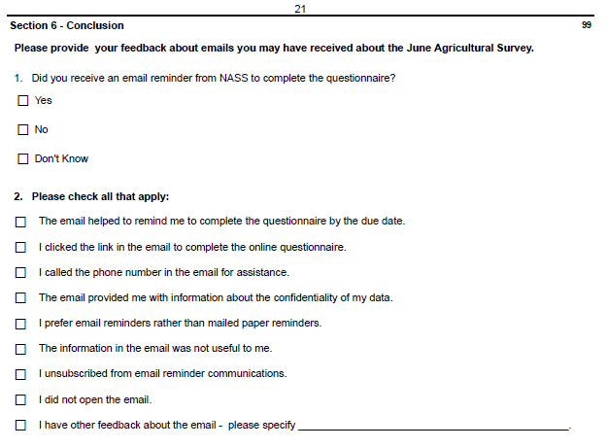
Summarized data will not be published, but used to investigate the use of electronic mail (email) for future surveys. These changes will not impact the current sample size or respondent burden. The revised questionnaire has been loaded to ROCIS.

