**Non-substantive Change Request**

**0535-0213 – Agricultural Surveys Program**

**June Area Survey – June 1, 2023**

This non-substantive change request affects Section O (Technology) of the 2023 June Area Survey.

Item 3 will be changed from

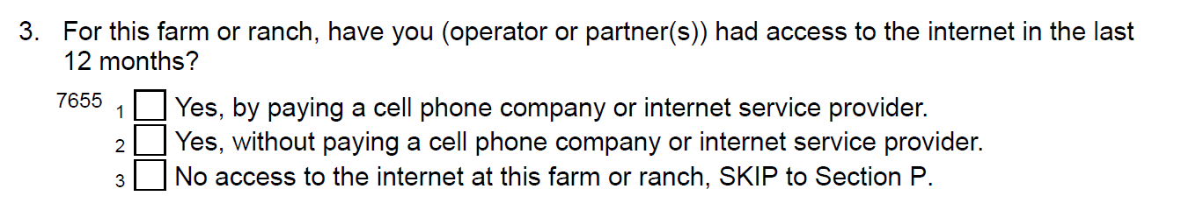

To

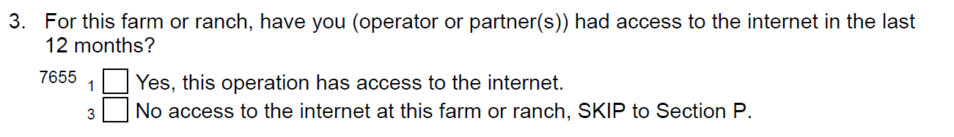

Section O is asked in every odd year and data are used to produce the Farm Computer Usage and Ownership report at <https://usda.library.cornell.edu/concern/publications/h128nd689>. The report presents data on farm computer usage, including computer access, ownership or leasing, farm business use, and internet access.

Removing the pay/no pay question will result in the removal of the right two columns from the publication *Farm Computer Usage and Ownership*:

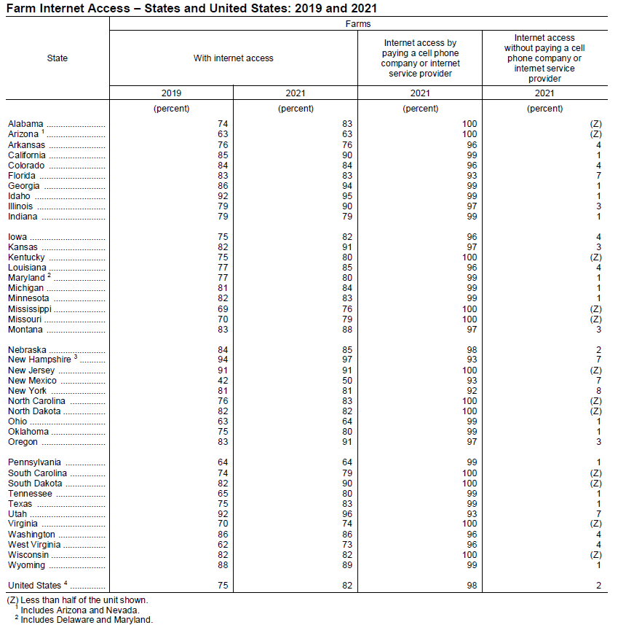

These changes will not impact the current sample size or respondent burden.

The revised master questionnaire is loaded to ROCIS.