Non-substantive Change Request
0535-0213 – Agricultural Surveys Program
SHEEP AND GOAT REPORT - JANUARY 1, 2024
This non-substantive change request affects Section 1 (Total Sheep and Lambs) of the 2024 Sheep and Goat Report. The potential change was requested by the Sheep Industry.

From:
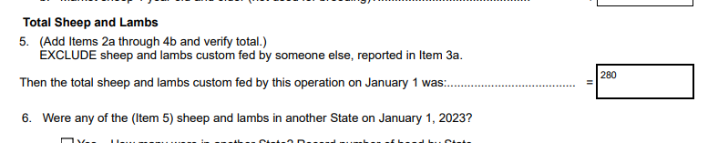
To:
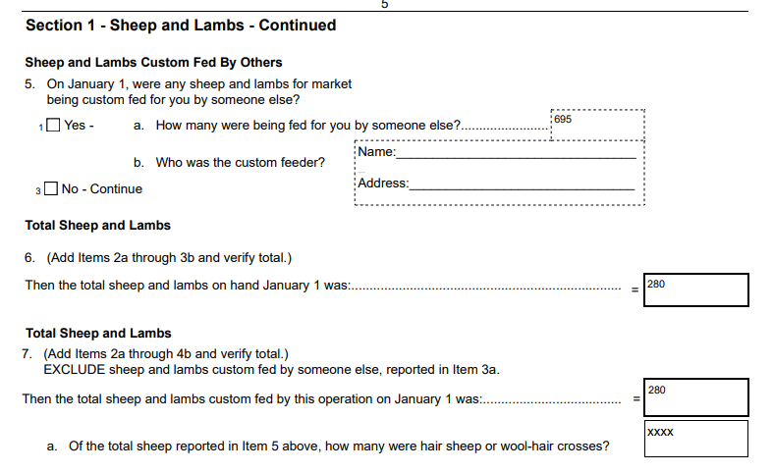

These changes will not impact the current sample size or respondent burden.
The revised master questionnaire is loaded to ROCIS.

