Appendix B: Screener

[FORCE RESPONSE TO ALL SCREENER QUESTIONS]

Thank you for your interest! To get started, we first need to ask you a few questions to see if you are eligible to participate in the study.

[WILLING] Are you willing to answer a few questions to see if you are eligible to participate in the study?

- Yes
- No

[IF WILLING = 1, CONTINUE]
[IF WILLING = 2, TERMINATE]

[AGE] What is your age? [SOURCE: NY-ATS]

_____ years [OPEN TEXT NUMERIC, WHOLE NUMBERS ONLY. RANGE: 0-110]

[TERMINATE IF AGE < 21]

[GENDID] What is your gender identity? [SOURCE: UPDATED OMB GUIDANCE]

- Woman
- Man
- Non-binary or gender non-conforming
- Transgender woman/girl
- Transgender man/boy
- Another gender identity
- Prefer not to say

[HISPANIC] Are you [IF GENDID = 2 OR 5, “Hispanic or Latino”; IF GENDID = 1 OR 4, “Hispanic or Latina”; IF GENDID = 3 OR 6 OR 7, “Hispanic, Latino, or Latina”]? [SOURCE: UPDATED OMB GUIDANCE]

- Yes, [IF GENDID = 2 OR 5, “Hispanic or Latino”; IF GENDID = 1 OR 4, “Hispanic or Latina”; IF GENDID = 3 OR 6 OR 7, “Hispanic, Latino, or Latina”]
- No, not [IF GENDID = 2 OR 5, “Hispanic or Latino”; IF GENDID = 1 OR 4, “Hispanic or Latina”; IF GENDID = 3 OR 6 OR 7, “Hispanic, Latino, or Latina”]

[RACE] What is your race? Select all that apply. [SOURCE: UPDATED OMB GUIDANCE]

- American Indian or Alaska Native
- Asian
- Black or African American
- Native Hawaiian or Other Pacific Islander
- White

[EDUC] What is the highest grade or level of school you have completed? [SOURCE: PATH]

- Less than high school
- Some high school, no diploma
- High school graduate—diploma
- Some college but no degree
- Associate degree—occupational/vocational
- Associate degree—academic program
- Bachelor’s degree (ex: BA, AB, BS)
- Master’s degree (ex: MA, MS, MEng, MEd, MSW)
- Professional school degree (ex: MD, DDS, DVM, JD)
- Doctorate degree (ex: PhD, EdD)
- Prefer not to say

The next questions are about vaping products, such as e-cigarettes, vape pens, personal vaporizers and mods, e-cigars, e-pipes, e-hookahs, and hookah pens.

Characteristics of vaping products include:

- They are battery-powered and produce vapor or aerosol instead of smoke.
- Some vaping products can be bought as one-time, disposable products. Others can be bought as reusable kits with cartridges or a tank system.
- They typically use a nicotine liquid called "e-liquid" although the amount of nicotine can vary and some may not contain any nicotine at all. [TEXT SOURCE: ADAPTED FROM PATH.]

Some common brands include Juul, Vuse, NJOY, Bidi Stick, Suorin, SMOK, and Puff Bar.

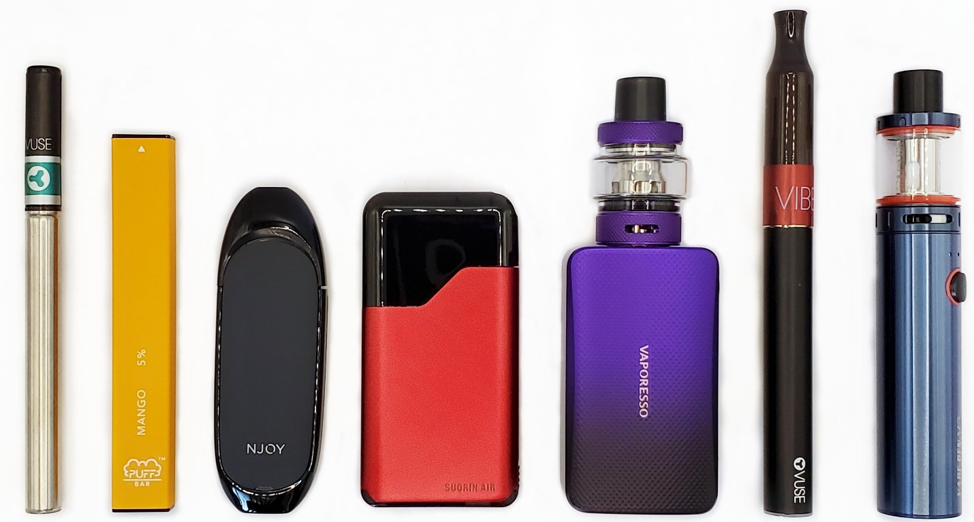

When answering these questions about vaping, please do NOT include products with marijuana, THC, or CBD.

[EVER_VAPE] Have you ever vaped? [SOURCE: ADAPTED FROM PATH]

- Yes
- No

[TERMINATE IF EVER_VAPE = 2]

[CURR_VAPE] On how many of the past 30 days did you vape? [SOURCE: ADAPTED FROM PATH]

____ days [OPEN TEXT NUMERIC, WHOLE NUMBERS ONLY. RANGE = 0-30]

[TERMINATE IF CURR_VAPE = 0]

[EVER_VAPEFREQ] How many times have you vaped in your entire life? [SOURCE: ADAPTED FROM PATH]

- 1 time, even just a few puffs
- 2 to 10 times
- 11 to 20 times
- 21 to 50 times
- 51 to 99 times
- 100 or more times
- Don’t know

Please think about the vaping device you use most often. If possible, please have this device in front of you as you answer these questions.

[SCRN_REUSE] Is the device …? [SOURCE: ADAPTED FROM SAFETY REPORTING PORTAL]

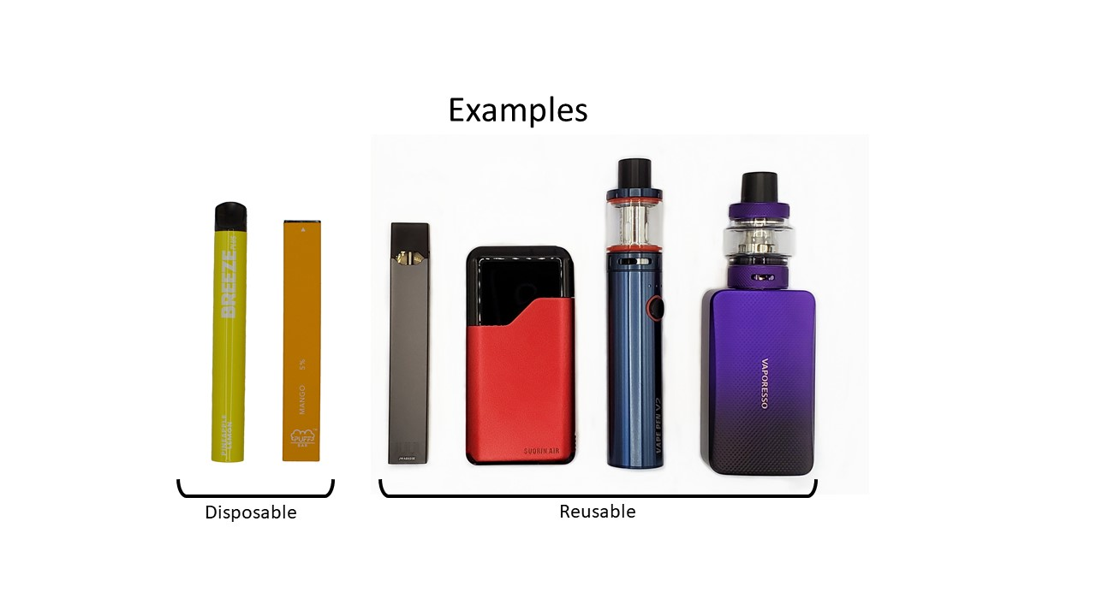

- Disposable (throw the device away when it runs out of battery or the e-liquid is finished)
- Reusable

[ASK IF SCRN_REUSE = 2]
[SCRN_CUSTOM] Did you build, modify, or customize the device? [SOURCE: SAFETY REPORTING PORTAL]

- Yes
- No

[ASK IF SCRN_REUSE = 2]
[SCRN_ELIQCONT] How does your device hold e-liquid? [SOURCE: ADAPTED FROM SAFETY REPORTING PORTAL]

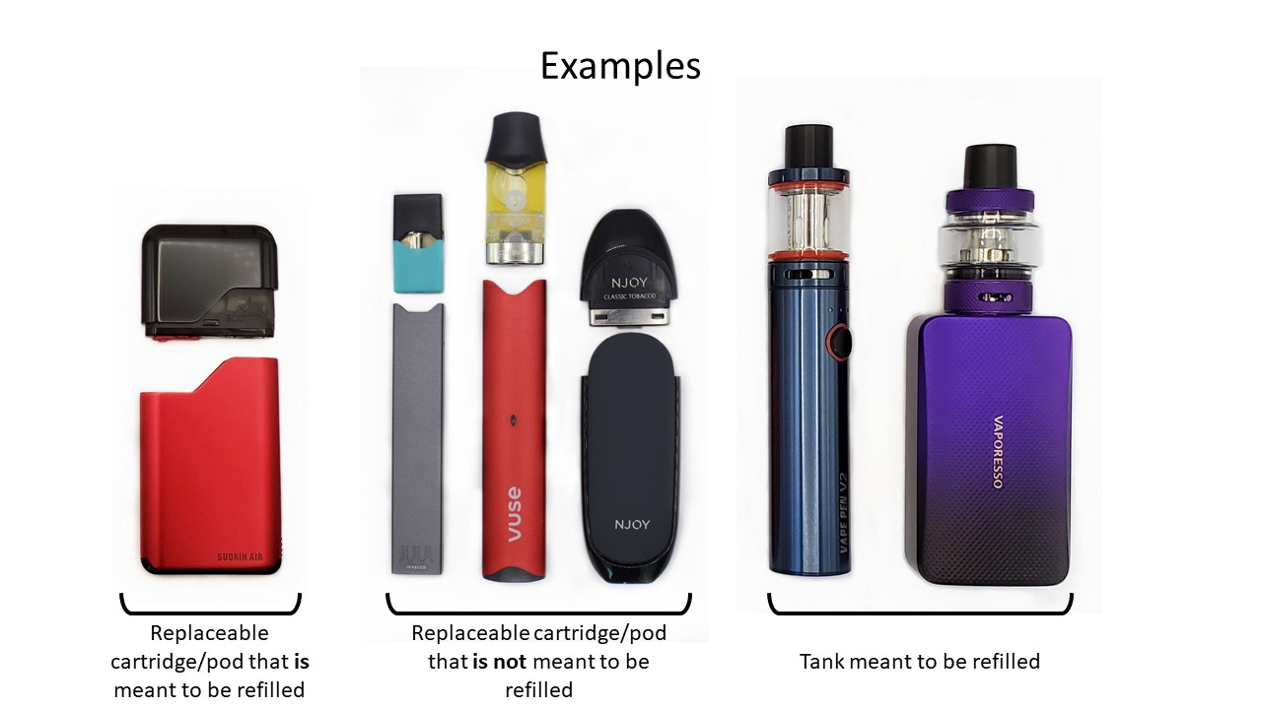

- A replaceable cartridge or pod that is meant to be refilled with e-liquid
- A replaceable cartridge or pod that is not meant to be refilled with e-liquid
- A tank meant to be refilled with e-liquid
- Don’t know

[ASK IF SCRN_REUSE = 2]
[SCRN_BATTREP] Is the battery replaceable? [SOURCE: ADAPTED FROM SAFETY REPORTING PORTAL] 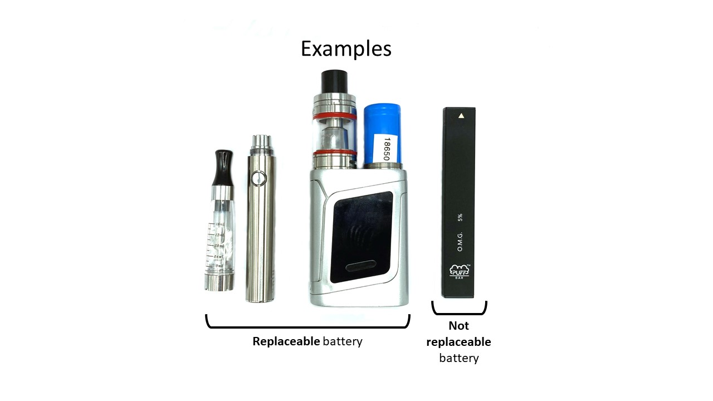

- Yes
- No
- Don’t know

[ASK IF SCRN_BATTREP = 1]
[SCRN_BATTCHG] Is the battery rechargeable? [SOURCE: ADAPTED FROM SAFETY REPORTING PORTAL] 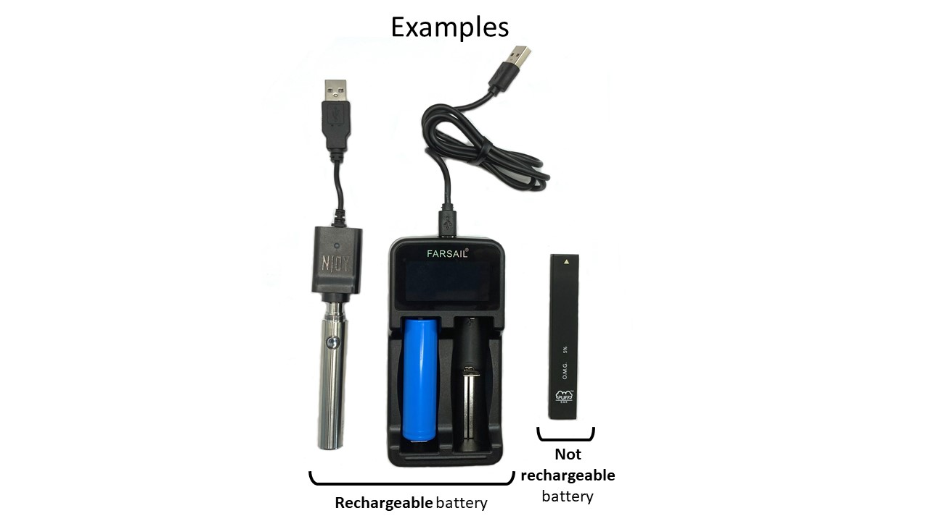

- Yes
- No
- Don’t know

[ASK IF SCRN_REUSE = 2]
[SCRN_SET] Does your vaping device have settings that change the power (wattage) or heat (temperature)? [SOURCE: NEW MEASURE] 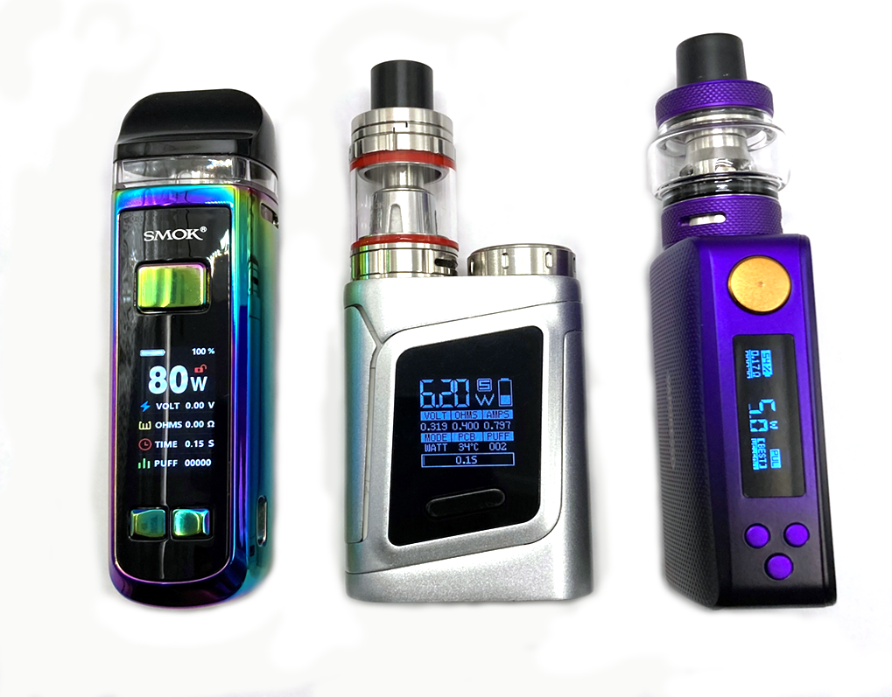

- Yes
- No
- Don’t know

[IF TERMINATED, DISPLAY NEW SCREEN]
You do not qualify for the longer survey. Thank you for your time.
Paperwork Reduction Act Statement: The public reporting burden for this information collection has been estimated to average 2 minutes per response to complete the screener (the time estimated to read, review, respond). Send comments regarding this burden estimate or any other aspects of this information collection, including suggestions for reducing burden, to PRAStaff@fda.hhs.gov.

[IF ELIGIBLE, DISPLAY NEW SCREEN]
You have qualified for this survey. Please click the "Continue" button below to continue.
Paperwork Reduction Act Statement: The public reporting burden for this information collection has been estimated to average 2 minutes per response to complete the screener (the time estimated to read, review, respond). Send comments regarding this burden estimate or any other aspects of this information collection, including suggestions for reducing burden, to PRAStaff@fda.hhs.gov.
[WHEN CONTINUE IS CLICKED, GO TO [CONSENT]]

Appendix C: Consent

Introduction and Purpose
You have been invited to take part in a research study. The purpose of the study is to gather information on individuals’ experiences using vaping products. RTI International, a non-profit research organization in North Carolina, is conducting this study. The study is sponsored by the Center for Tobacco Products at the U.S. Food and Drug Administration (FDA).

The mission of the FDA is to promote and protect public health. In conducting this study, FDA does not intend to sell tobacco, nor promote, condone, normalize, or encourage its use. The questionnaires, surveys, and messages in this study are not intended to promote, directly or indirectly, other behaviors that may be a gateway to subsequent risky behaviors, such as illegal drug use, binge drinking, and smoking.

Procedures
You are one of about 6,000 people being asked to participate in this study. If you agree to participate, you will be asked to answer a series of questions about your experiences using vaping products. The study should take approximately 15-20 minutes to complete.

Benefits
There is no direct benefit to you for participating. By participating in this study, you may help the FDA better understand the knowledge, attitudes, and behaviors related to vaping products and help the FDA better communicate on this topic, improving the health and wellbeing of current and future generations.

Risks
There are minimal psychological, social, or legal risks to participating in this study. There are some questions that may make you uncomfortable, such as questions about your tobacco use. If you do not wish to answer those questions, you can skip them. There is also a potential risk of loss of confidentiality. Every effort will be made to protect your information, but this cannot be guaranteed.

Confidentiality
The privacy and confidentiality of your information is of the highest importance, and we are committed to maintaining a secure environment in which you can participate. All information you share in this study will be kept confidential to the extent provided by law. The study team will not disclose your name or personal information (email address, phone number) to anyone, including FDA, and your personal information will not be linked to any of your responses. The information you share with us will be combined with the information from other participants into a summary report, and details of individual responses will not be linked to a specific participant. The information that participants provide will be stored on password protected computers at RTI and FDA that only authorized project staff can access. RTI will retain these files for up to five years from the completion of the study and then delete them. You will not be contacted again about this research study in the future. In the unlikely event of a data breach, you may be contacted after the study ends.

This research is covered by a Certificate of Confidentiality from FDA to help us protect your privacy. This means that the researchers cannot disclose your name or other information that could identify you in any civil, criminal, administrative, legislative, or other proceedings (like a court trial), without your consent. Information collected for this research that could identify you also cannot be used as evidence in a legal proceeding without your consent.

In addition, with the Certificate of Confidentiality, researchers involved in this study generally may not provide your name, or any other information that could identify you, to anyone who is not connected with the research. However, in the following situations, the Certificate does not prevent the researchers involved in this study from disclosing study information that could identify you:
- if you consent to someone receiving your information from this study, including situations where the information is necessary for your medical treatment;
- when your study information is used for other scientific research, as allowed by federal regulations protecting research subjects;
- when information is needed by FDA, which is funding this study, in order to audit or evaluate federally funded studies;
- when a law otherwise requires disclosure (such as requirements to make certain reports to FDA, reporting threats of harm to self/others, or reports of child abuse), except this does not apply to disclosure in a legal proceeding.

The Certificate does not prevent you from voluntarily providing information about yourself or your involvement in this research study to others.

The Certificate of Confidentiality will not be used to prevent disclosure for any purpose you have consented to in this informed consent document.

Token of Appreciation
You will receive points in your Dynata account as a token of appreciation for completing this study. Points will be deposited into your account within 30 days after you complete the study and can be redeemed at your convenience. If you do not complete the study, or if Dynata rejects your data because of their standard policies about speeding, you will not receive the token of appreciation.

Right to Refuse or Withdraw
Your participation in this study is completely voluntary, and you can refuse to answer any question or withdraw from the study for any reason at any time without penalty.

Persons to Contact
If you have questions about the study, you can call the RTI project director, Erik Crankshaw, at 919-316-3809.

If you have any questions about your rights as a study participant or have questions, concerns, or complaints regarding the research study, you can call RTI’s Office of Research Protection toll-free at 1-866-214-2043.

You can print or take a screenshot of this form if you would like a copy for your records.

[NEW SCREEN]
[CONSENT] If you have read the previous screens and agree to participate, please click the Yes button. If not, click the No button.

- Yes, I agree to participate in this study.
- No, I do not agree to participate in this study.

[IF CONSENT = 2, DISPLAY NEW SCREEN]
You do not qualify for the longer survey. Thank you for your time.
Paperwork Reduction Act Statement: The public reporting burden for this information collection has been estimated to average 2 minutes per response to complete the screener (the time estimated to read, review, respond). Send comments regarding this burden estimate or any other aspects of this information collection, including suggestions for reducing burden, to PRAStaff@fda.hhs.gov.
[IF ELIGIBLE AND CONSENT = 1, DISPLAY NEW SCREEN]
You have qualified for the longer survey. You are encouraged to find a private area to complete the survey.
To help you answer the survey questions, it may be helpful to have your vaping device or packaging in front of you. If the device is not available to you, it may be helpful to look at an image of your device online.
Please click the "Continue" button below to continue.
Paperwork Reduction Act Statement: The public reporting burden for this information collection has been estimated to average 2 minutes per response to complete the screener (the time estimated to read, review, respond). Send comments regarding this burden estimate or any other aspects of this information collection, including suggestions for reducing burden, to PRAStaff@fda.hhs.gov.
[WHEN CONTINUE IS CLICKED, GO TO SURVEY]

Appendix D: Survey

[PROGRAMMING INSTRUCTIONS: ALL QUESTIONS FROM THIS POINT ON WILL ALLOW SKIPS. IF A PARTICIPANT SKIPS A QUESTION, THE FOLLOWING POP-UP REMINDER WILL SHOW: “There is an unanswered question on this page. Would you like to continue?” RESPONSE OPTIONS: “Continue without answering” or “Answer this question”.]

SECTION 1: DEVICE CHARACTERISTICS AND PURCHASING BEHAVIORS

[PROGRAMMER: GENERATE PIPE VARIABLES ACCORDING TO THE LOGIC IN THE TABLE BELOW]

Pipe Variable Name | Criteria | Piped Text
PIPE_REUSE | SCRN_REUSE = 1 | disposable
 | SCRN_REUSE = 2 | reusable
PIPE_ELIQCONT | SCRN_ELIQCONT = 1 | replaceable cartridge or pod that is meant be refilled with e-liquid
 | SCRN_ELIQCONT = 2 | replaceable cartridge or pod that is not meant be refilled with e-liquid
 | SCRN_ELIQCONT = 3 | tank meant to be refilled with e-liquid
PIPE_BATTREP | SCRN_BATTREP = 1 | can be replaced
 | SCRN_BATTREP = 2 | cannot be replaced
PIPE_BATTCHG | SCRN_BATTCHG = 1 | can be recharged
 | SCRN_BATTCHG = 2 | cannot be recharged
PIPE_SETT | SCRN_SETWATT = 1 OR SCRN_SETTEMP = 1 | Has
 | SCRN_SETNO = 1 | Does not have

Earlier you said that the vaping device you used most often:

[PIPE TEXT ACCORDING TO RESPONSES IN SCREENER]

- Is [PIPE_REUSE]
- [IF SCRN_REUSE = 2] Has a [PIPE_ELIQCONT]
- [IF SCRN_REUSE = 2 AND SCRN_BATTREP = 1, 2] Has a battery that [PIPE_BATTREP]
- [IF SCRN_REUSE = 2 AND SCRN_BATTCHG = 1, 2] Has a battery that [PIPE_BATTCHG]
- [IF SCRN_REUSE = 2 AND (SCRN_SETWATT = 1 OR SCRN_SETTEMP = 1 OR SCRN_SETNO = 1)] [PIPE_SETT] settings that can be changed

Please think about this device when answering the next questions. If possible, please have this device and/or the packaging in front of you as you answer these questions. If the device or packaging is not available, it may be helpful to look at an image of your device online.

[BRAND] What brand is this device? [SOURCE: NEW MEASURE]

- Juul
- Vuse
- NJOY
- Bidi Stick
- Suorin
- SMOK
- Puff Bar
- Other, please specify: ___________________

[MODEL] What is the model name or number of your device? [SOURCE: NEW MEASURE] 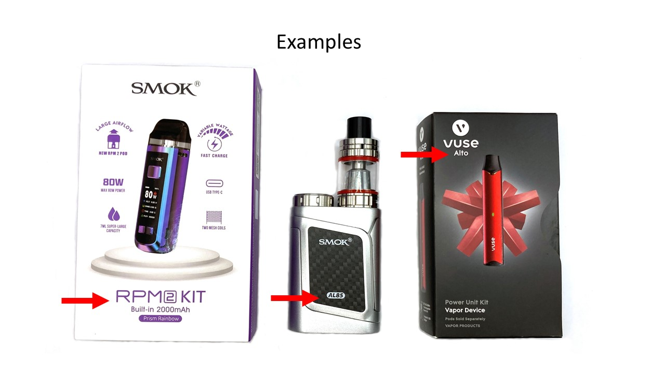

___________________ [OPEN TEXT]
99. Don’t know

[UL] Some products (such as batteries) have a “UL” symbol on them. Does the device, battery, or packaging have a “UL” symbol on it? [SOURCE: NEW MEASURE]

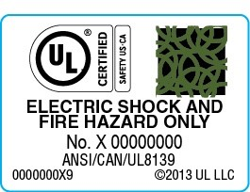

- Yes
- No
- Don’t know

[ASK IF SCRN_REUSE = 2 AND (SCRN_CUSTOM = 1 OR SCRN_SET = 1)]
[OHM] What coil resistance level (ohms) do you usually vape at? [SOURCE: NEW MEASURE]

- Sub-ohm (less than 1 ohm)
- 1 ohm or more
- Don’t know

[ASK IF SCRN_BATTREP = 1]
[BATTSOURCE] Please think about the batteries you typically use for your vaping device. Were these batteries…? [SOURCE: NEW MEASURE]

- Supplied by the device manufacturer (included in the original package or purchased from the same company)
- Recommended by the device manufacturer (e.g., manufacturer recommended 18650 battery size) but purchased elsewhere
- Not supplied or recommended by the device manufacturer
- Don’t know

[ASK IF SCRN_REUSE = 2]
[CHGSOURCE] Please think about the charger you typically use for your vaping device. Was the charger…? [SOURCE: NEW MEASURE]

- Supplied by the device manufacturer (included in the original package or purchased from the same company)
- Recommended by the device manufacturer, but purchased elsewhere
- Not supplied or recommended by the device manufacturer
- Don’t know

[ATTN_1] The following question is designed to ensure that people are at a high attention level throughout the survey. Please select “Some days” as your answer to this question. [SOURCE: RTI SOCIAL MEDIA RECRUITMENT TEAM ATTENTION CHECK]

- Every day
- Some days
- Rarely
- Not at all

[ASK IF SCRN_CUSTOM = 1]
[HOWMOD] Earlier in the survey, you said that you built, modified, or customized your vaping device. Please tell us more about how you built, modified, or customized the device.

_______ [OPEN TEXT]

SECTION 2: USE BEHAVIORS

As a reminder, it may be helpful to have your vaping device or supplies with you while you answer these questions or look online for an image of your device or supplies.
[ASK IF SCRN_ELIQCONT = 1, 3]
[ELIQ_SIZE] What size e-liquid bottles do you typically use? [SOURCE: ADAPTED FROM YAMAGUCHI ET AL., 2021]

- 30 ml or less
- 45 ml
- 60 ml
- 75ml
- 100 ml
- 120 ml
- 180 ml
- 200 ml
- Greater than 200 ml
- I do not have a typical size
- Don’t know

[ASK IF SCRN_ELIQCONT = 1, 3]
[ELIQ_GO] About how long does it usually take you to go through one e-liquid bottle? [SOURCE: ADAPTED FROM YAMAGUCHI ET AL., 2022]
________ [SELECT: day/week/month/year] [OPEN TEXT NUMERIC, WHOLE NUMBERS ONLY]
[ASK IF SCRN_ELIQCONT = 2]
[POD_GO] About how long does it usually take you to go through one pre-filled vape pod? [SOURCE: ADAPTED FROM YAMAGUCHI ET AL., 2022]
________ [SELECT: day/week/month/year] [OPEN TEXT NUMERIC, WHOLE NUMBERS ONLY]

[ASK IF SCRN_REUSE = 1]
[DISP_GO] About how long does it usually take you to go through one disposable vape device? [SOURCE: ADAPTED FROM YAMAGUCHI ET AL., 2022]
________ [SELECT: day/week/month/year] [OPEN TEXT NUMERIC, WHOLE NUMBERS ONLY]

[ASK IF SCRN_REUSE = 2]
[FREQ_MAINT] How often, if at all, do you do each of the following? If never, please select “I never do this.” [SOURCE: NEW MEASURES]

________ times per [SELECT: day/week/month/year] [OPEN TEXT NUMERIC, WHOLE NUMBERS ONLY]
1. I never do this

[FREQ_MAINT_BATTCHG] Change the battery in your vaping device
[FREQ_MAINT_BATTCHECK] Check your device’s battery for signs of problems or damage
[FREQ_MAINT_CHECK] Check your device for a sticky substance (carbon build-up or “gunk”)
[FREQ_MAINT_COILCLN] Clean your device’s coils

[ASK IF SCRN_REUSE = 2]
For the next questions, please think about all the vaping devices you use.

[FRQ] How often, if at all, do you do each of the following? [SOURCE: NEW MEASURES]

[USE SCROLLING LIST; RANDOMIZE ORDER OF ITEMS]

- Never
- Rarely
- Sometimes
- Often
- Very often
- Not relevant to any vapes I use

[FRQ_CHG] Charge batteries or device for more than 5 hours or overnight
[FRQ_LOOSE] Carry loose batteries in your pocket or bag
[FRQ_PLAST] Carry batteries in a plastic container
[FRQ_OTH] Use a charger that was not supplied or recommended by the device manufacturer
[FRQ_HOT] Leave the device or batteries in a very hot place, like a hot car
[FRQ_COLD] Leave the device or batteries in a very cold place, like a cold car
[FRQ_DROP] Drop the device or the batteries onto a hard surface
[FRQ_MIX] Mix old and new batteries or different types of batteries in the device

SECTION 3: EVIDENCE OF RISK

Now, please think about all of the vaping devices you’ve used.

[EVID] Have you ever seen or experienced any of the following in your vaping device(s)? (Select all that apply) [SOURCE: NEW MEASURE]

[RANDOMIZE 1-8; KEEP 9 AT END]

- [EVID_HOT] Device, battery, or charger is hot to the touch
- [EVID_MELT] Melted components
- [EVID_COIL] Burned coils
- [EVID_FLAME] Flame
- [EVID_CRACK] Cracking or breaking of the device (not the pod/cartridge/tank)
- [EVID_BURN] Visible signs of having burned
- [EVID_ON] Failure to turn on (even with a charged battery)
- [EVID_TASTE] Burnt or abnormal taste when in use
- [EVID_NONE] None of the above [EXCLUSIVE]

SECTION 4: PERCEPTIONS OF O/F/Es

[AWARE] Have you ever heard that the batteries in vaping devices can… (Select all that apply) [SOURCE: NEW MEASURE]

[USE SCROLLING LIST]

- Yes
- No

[AWARE_OVER] Overheat. Overheating is defined as the battery or device getting very hot to the touch.
[AWARE_FIRE] Catch fire. Catching fire is defined as having flames or smoke coming from the battery or device.
[AWARE_EXPL] Explode. Explosion is defined as a battery or device shattering or bursting apart.

For the next questions, please think about all of the vaping devices you currently use.

[LK_OVER] In the future, how likely do you think it is that the batteries for your vaping device(s) will overheat? [SOURCE: NEW MEASURE]

- Not at all likely
- A little likely
- Somewhat likely
- Very likely
- Extremely likely

[LKHARM_OVER] If the batteries for your vaping device(s) overheated, how likely do you think it is that you would be injured? [SOURCE: NEW MEASURE]

- Not at all likely
- A little likely
- Somewhat likely
- Very likely
- Extremely likely

[LK_FIRE] In the future, how likely do you think it is that the batteries for your vaping device(s) will catch fire? [SOURCE: NEW MEASURE]

- Not at all likely
- A little likely
- Somewhat likely
- Very likely
- Extremely likely

[LKHARM_FIRE] If the batteries for your vaping device(s) caught fire, how likely do you think it is that you would be injured? [SOURCE: NEW MEASURE]

- Not at all likely
- A little likely
- Somewhat likely
- Very likely
- Extremely likely

[LK_EXPL] In the future, how likely do you think it is that the batteries for your vaping device(s) will explode? [SOURCE: NEW MEASURE]

- Not at all likely
- A little likely
- Somewhat likely
- Very likely
- Extremely likely

[LKHARM_EXPL] If the batteries for your vaping device(s) exploded, how likely do you think it is that you would be injured? [SOURCE: NEW MEASURE]

- Not at all likely
- A little likely
- Somewhat likely
- Very likely
- Extremely likely

Some behaviors might increase the chances that your vaping device(s) or batteries will overheat, catch fire, or explode.

[RISK] Which of the following do you think might increase the chance that a vaping device or its battery will overheat, catch fire, or explode? (Select all) [RANDOMIZE ORDER OF RESPONSE OPTIONS 1-10; HOLD 11 AT END] [SOURCE: NEW MEASURES]

- [RISK_CHG] Charging the batteries or device for more than 5 hours or overnight
- [RISK_LOOSE] Carrying loose batteries in your pocket or bag
- [RISK_PLAST] Carrying batteries in a plastic container
- [RISK_CHGOTH] Use a charger that was not supplied or recommended by the device manufacturer
- [RISK_HOT] Leaving the device or batteries in a very hot place, like a hot car
- [RISK_COLD] Leaving the device or batteries in a very cold place, like a cold car
- [RISK_DROP] Dropping the device or the batteries onto a hard surface
- [RISK_REPL] Replacing the batteries if they get wet
- [RISK_MIX] Mixing old and new batteries or different types of batteries in the device
- [RISK_PLANE] If traveling on an airplane, putting vapes in your carry-on baggage
- [RISK_NONE] None of the above [EXCLUSIVE]

[ATTN_2] The following question is designed to ensure that people are at a high attention level throughout the survey. Please select ‘Agree’ as your answer to this item. [SOURCE: RTI SOCIAL MEDIA RECRUITMENT TEAM ATTENTION CHECK]

- Strongly disagree
- Disagree
- Agree
- Strongly agree

SECTION 5: O/F/E INCIDENCE

Please think about all of your experiences vaping.

[OFE] Have you ever experienced the following:

[SCROLLING LIST]

- Yes
- No

[OFE_OH] Vaping device or battery overheating. Overheating is defined as the battery or device getting very hot to the touch.
[OFE_FIRE] Vaping device or battery catching fire. Catching fire is defined as having flames or smoke coming from the battery or device.
[OFE_EXPL] Vaping device or battery exploding. Explosion is defined as a battery or device shattering or bursting apart.

[ASK IF OFE_OH = 1]
[OFE_OHDAMD] Have you ever experienced a vaping device or battery overheating so much that it damaged the battery, melted the plastic components, or burned the wiring or wicks of the vaping device?

- Yes
- No

[ASK IF OFE_OH = 1]
[OFE_OHDAMP] Have you ever experienced a vaping device or battery overheating so much that it damaged property (for example, car interior, floors, furniture, clothing, or cell phones)?

- Yes
- No

[ASK IF OFE_OH = 1]
[OFE_OHBRN] Have you ever experienced a vaping device or battery overheating so much that it burned your skin, tongue, or lips?

- Yes
- No

[ASK IF OFE_OH = 1 AND OFE_OHDAMD = 2 AND OFE_OHDAMP = 2 AND OFE_OHBRN = 2]
[OFE_OH_NUM] How many times have you experienced a vaping device or battery overheating?

_______ [OPEN TEXT NUMERIC, WHOLE NUMBERS ONLY, ALLOWABLE RANGE 1-100]

[ASK IF OFE_OHDAMD = 1]
[OFE_OHDAMD_NUM] How many times have you experienced a vaping device or battery overheating so much that it caused visible damage to the device or battery (for example, damaged battery, melted plastic components, or burnt wirings or wicks)?

_______ [OPEN TEXT NUMERIC, WHOLE NUMBERS ONLY, ALLOWABLE RANGE 1-100]

[ASK IF OFE_OHDAMP = 1]
[OFE_OHDAMP_NUM] How many times have you experienced a vaping device or battery overheating so much that it damaged property (for example, car interior, floors, furniture, clothing, or cell phones)?

_______ [OPEN TEXT NUMERIC, WHOLE NUMBERS ONLY, ALLOWABLE RANGE 1-100]

[ASK IF OFE_OHBRN = 1]
[OFE_OHBRN_NUM] How many times have you experienced a vaping device or battery overheating so much that it burned your skin, tongue, or lips?

_______ [OPEN TEXT NUMERIC, WHOLE NUMBERS ONLY, ALLOWABLE RANGE 1-100]

[ASK IF OFE_FIRE = 1]
[OFE_FIRE_NUM] How many times have you experienced a vaping device or battery catching fire?

_______ [OPEN TEXT NUMERIC, WHOLE NUMBERS ONLY, ALLOWABLE RANGE 1-100]

[ASK IF OFE_EXPL = 1]
[OFE_EXPL_NUM] How many times have you experienced a vaping device or battery exploding?

_______ [OPEN TEXT NUMERIC, WHOLE NUMBERS ONLY, ALLOWABLE RANGE 1-100]

[PROGRAMMER: GENERATE 7-LEVEL CATEGORICAL VARIABLE OFE_GRP WITH THE CATEGORIES DESCRIBED IN THE FOLLOWING TABLE]

# | Description | Criteria
1 | No O/F/E | OFE_OH = 2 AND OFE_FIRE = 2 AND OFE_EXPL = 2
2 | Non-serious overheating | OFE_OH = 1 AND OFE_OHDAMD = 2 AND OFE_OHDAMP = 2 AND OFE_OHBRN = 2 AND OFE_FIRE = 2 AND OFE_EXPL = 2
3 | Overheating that caused visible damage to the device/battery | OFE_OH = 1 AND OFE_OHDAMD = 1 AND OFE_OHDAMP = 2 AND OFE_OHBRN = 2 AND OFE_FIRE = 2 AND OFE_EXPL = 2
4 | Overheating that caused other property damage | OFE_OH = 1 AND (OFE_OHDAMD = 1 OR 2) AND OFE_OHDAMP = 1 AND OFE_OHBRN = 2 AND OFE_FIRE = 2 AND OFE_EXPL = 2
5 | Overheating that caused burns | OFE_OH = 1 AND (OFE_OHDAMD = 1 OR 2) AND (OFE_OHDAMP = 1 OR 2) AND OFE_OHBRN = 1 AND OFE_FIRE = 2 AND OFE_EXPL = 2
6 | Fire | OFE_FIRE = 1 AND OFE_EXPL = 2
7 | Explosion | OFE_EXPL = 1
. | Indeterminate | (OFE_OH = MISSING) OR ((OFE_OH = 1 AND (OFE_OHDAMD = MISSING OR OFE_OHDAMP = MISSING OR OFE_OHBRN = MISSING)) OR (OFE_FIRE = MISSING) OR (OFE_EXPL = MISSING)

[PROGRAMMER: GENERATE PIPING VARIABLES PIPE_TIME AND PIPE_OFE ACCORDING TO THE CRITERIA IN THE TABLE BELOW]
Criteria | PIPE_TIME | PIPE_OFE1 | PIPE_OFE2
OFE_GRP = 2 AND OFE_OH_NUM = 1 | time | overheated | overheated
OFE_GRP = 2 AND (OFE_OH_NUM > 1 OR MISSING) | most serious incident | overheated | overheated
OFE_GRP = 3 AND OFE_OHDAMD_NUM = 1 | time | overheated so much that it caused visible damage to the device components or battery | got damaged from overheating
OFE_GRP = 3 AND (OFE_OHDAMD_NUM > 1 OR MISSING) | most serious incident | overheated so much that it caused visible damage to the device components or battery | got damaged from overheating
OFE_GRP = 4 AND OFE_OHDAMP_NUM = 1 | time | overheated so much that it damaged property | damaged property from overheating
OFE_GRP = 4 AND (OFE_OHDAMP_NUM > 1 OR MISSING) | most serious incident | overheated so much that it damaged property | damaged property from overheating
OFE_GRP = 5 AND OFE_OHBRN_NUM = 1 | time | overheated so much that it burned you | burned you
OFE_GRP = 5 AND (OFE_OHBRN_NUM > 1 OR MISSING) | most serious incident | overheated so much that it burned you | burned you
OFE_GRP = 6 AND OFE_FIRE_NUM = 1 | time | caught fire | caught fire
OFE_GRP = 6 AND (OFE_FIRE_NUM > 1 OR MISSING) | most serious incident | caught fire | caught fire
OFE_GRP = 7 AND OFE_EXPL_NUM = 1 | time | exploded | exploded
OFE_GRP = 7 AND (OFE_EXPL_NUM > 1 OR MISSING) | most serious incident | exploded | exploded

[IF OFE_GRP = 1 (NO O/F/E) OR . (INDETERMINATE), GO TO SECTION 9 (OTHER TOBACCO PRODUCT USE)]
[ASK IF OFE_GRP = 2-7]
For the next several questions, please think about the [PIPE_TIME] when a vaping device or battery has [PIPE_OFE1].

[WHEN] Approximately when did this incident occur?

- Within the past 3 months
- More than 3 months ago but within the past year
- More than one year ago

[FORCE RESPONSE]
[PART] What [PIPE_OFE2]? [SOURCE: NEW MEASURE]

- The vaping device
- The battery or batteries on their own (not inside a vaping device)

[PROGRAMMER: GENERATE PIPING VARIABLE PIPE_PART ACCORDING TO THE CRITERIA IN THE TABLE BELOW]

Criteria | Piped Text
PART = 1 | device
PART = 2 | battery

SECTION 6: CONTEXTUAL DETAILS OF NON-SERIOUS O/F/E

[ADMINISTER SECTION 6 IF OFE_GRP =2]

6.1: DEVICE

[ADMINISTER SECTION 6.1 IF PART = 1]

For the next several questions, please think about the vaping device that [PIPE_OFE2].

[ASK IF PART = 1]
[OFE_STAT_NS] When the device [PIPE_OFE2], was the device…?

- On
- Off
- In standby mode
- Don’t know

[ASK IF PART = 1]
[OFE_CHG_NS] When the device [PIPE_OFE2], was the device charging?

- Yes
- No
- Don’t know

[ASK IF PART = 1 AND OFE_STAT_NS = 1]
[OFE_STATON_NS] When the device [PIPE_OFE2], which of the following was happening? [SINGLE SELECT]

- I was vaping (puffing or inhaling)
- I was holding the device in my hands but not vaping
- I was changing or replacing a battery
- The device was in a pocket
- The device was being stored in a purse, bag, or luggage
- The device was being stored in a car
- The device was sitting on a surface
- Other, please specify: _____
- Don’t know

[ASK IF PART = 1 AND OFE_STAT_NS = 2]
[OFE_STATOFF_NS] When the device [PIPE_OFE2], which of the following was happening?

- I was holding the device in my hands but not vaping
- I was changing or replacing a battery
- The device was in a pocket
- The device was being stored in a purse, bag, or luggage
- The device was being stored in a car
- The device was sitting on a surface
- Other, please specify: _____________
- Don’t know

[ASK IF PART = 1 AND OFE_CHG_NS = 1]
[OFE_CHGTYPE_NS] What kind of charger were you using?

- The charger that came with the device or is meant for use with the device
- Another charger (for example, a phone charger)
- Don’t know

For the next questions, it may be helpful to have your vaping device with you or look online for an image of your device.

[ASK IF PART = 1]
[OFE_D_REUSE_NS] Is the device that [PIPE_OFE2]…? [SOURCE: ADAPTED FROM SAFETY REPORTING PORTAL]

- Disposable (throw the device away when the e-liquid is finished)
- Reusable

[ASK IF PART = 1 AND OFE_D_REUSE_NS = 2]
[OFE_D_CUSTOM_NS] Did you build, modify, or customize the device? [SOURCE: SAFETY REPORTING PORTAL]

- Yes
- No

[ASK IF PART = 1 AND OFE_D_REUSE_NS = 2]
[OFE_D_ELIQCONT_NS] How does the device hold e-liquid? [SOURCE: ADAPTED FROM SAFETY REPORTING PORTAL]

- A replaceable cartridge or pod that is meant be refilled with e-liquid
- A replaceable cartridge or pod that is not meant be refilled with e-liquid
- A tank meant to be refilled with e-liquid
- Don’t know

[ASK IF PART = 1 AND OFE_D_REUSE_NS = 2]
[OFE_D_BATTREP_NS] Is the battery replaceable? [SOURCE: ADAPTED FROM SAFETY REPORTING PORTAL]

- Yes
- No
- Don’t know

[ASK IF PART = 1 AND OFE_D_BATTREP_NS = 1]
[OFE_D_BATTCHG_NS] Is the battery rechargeable? [SOURCE: ADAPTED FROM SAFETY REPORTING PORTAL]

- Yes
- No
- Don’t know

[ASK IF PART = 1]
[OFE_D_BRAND_NS] What brand is the device that [PIPE_OFE2]? [SOURCE: NEW MEASURE]

- Juul
- Vuse
- NJOY
- Bidi Stick
- Suorin
- SMOK
- Puff Bar
- Other, please specify: ___________________

[ASK IF PART = 1]
[OFE_D_MODEL_NS] What is the model name or number of the device that [PIPE_OFE2]? [SOURCE: NEW MEASURE]

___________________ [OPEN TEXT]
-99. Don’t know

[ASK IF PART = 1 AND OFE_D_BATTREP_NS = 1]
[OFE_D_BATTSOURCE_NS] Please think about the battery for the device that [PIPE_OFE2]. Was this battery…? [SOURCE: NEW MEASURE]

- Supplied by the device manufacturer (included in the original package or purchased from the same company)
- Recommended by the device manufacturer (e.g., manufacturer recommended 18650 battery size) but purchased elsewhere
- Not supplied or recommended by the device manufacturer
- Don’t know

6.2: BATTERY

[ADMINISTER SECTION 6.2 IF PART = 2]

For the next several questions, please think about the battery that [PIPE_OFE2].

[ASK IF PART = 2]
[OFE_BATTSTAT_NS] When the battery [PIPE_OFE2], which of the following was happening?

- The battery was being charged
- I was holding the battery in my hands
- I was putting the battery in the device or taking it out of the device
- The battery was in a pocket
- The battery was being stored in a purse, bag, or luggage
- The battery was being stored in a car
- The battery was sitting on a surface
- Other, please specify: _________________
- Don’t know

For the next questions, it may be helpful to have your battery with you or look online for an image of your battery.

[ASK IF PART = 2]
[OFE_B_BATTREP_NS] Is the battery replaceable? [SOURCE: ADAPTED FROM SAFETY REPORTING PORTAL]

- Yes
- No
- Don’t know

[ASK IF PART = 2 AND OFE_B_BATTREP_NS = 1]
[OFE_B_BATTCHG_NS] Is the battery rechargeable? [SOURCE: ADAPTED FROM SAFETY REPORTING PORTAL]

- Yes
- No
- Don’t know

[ASK IF PART = 2]
[OFE_B_BATTSOURCE_NS] Please think about the battery that [PIPE_OFE2]. Was this battery… ? [SOURCE: NEW MEASURE]

- Supplied by the device manufacturer (included in the original package or purchased from the same company)
- Recommended by the device manufacturer (e.g., manufacturer recommended 18650 battery size) but purchased elsewhere
- Not supplied or recommended by the device manufacturer
- Don’t know

6.3: SEQUELAE

Please think about what happened as a result of the [PIPE_PART] when it [PIPE_OFE2].

[OFE_HPROB_NS] Were you or anyone else injured because of the [PIPE_PART] when it [PIPE_OFE2]? [SOURCE: NEW MEASURE]

- Yes
- No
- Don’t know

[ASK IF OFE_HPROB_NS = 1]
[OFE_HPROB_OE_NS] Please describe these injuries. [SOURCE: NEW MEASURE]

____ [OPEN TEXT]

[ASK IF OFE_HPROB_NS = 1]
[OFE_MEDICAL_NS] Did you or the other person seek medical care because of these injuries? [SOURCE: NEW MEASURE]
- Yes
- No
- Don’t know

Thank you for telling us about your experience. Now we have some additional questions about other topics.

SECTION 7: CONTEXTUAL DETAILS OF SERIOUS O/F/E

[ADMINISTER SECTION 7 IF OFE_GRP = 3-7]

7.1: DEVICE

[ADMINISTER SECTION 7.1 IF OFE_GRP = 3-7 AND PART = 1]

For the next several questions, please think about the vaping device that [PIPE_OFE2].

[ASK IF PART = 1]
[OFE_STAT] When the device [PIPE_OFE2], was the device…?

- On
- Off
- In standby mode
- Don’t know

[ASK IF PART = 1]
[OFE_CHG] When the device [PIPE_OFE2], was the device charging?

- Yes
- No
- Don’t know

[ASK IF PART = 1 AND OFE_STAT = 1]
[OFE_STATON] When the device [PIPE_OFE2], which of the following was happening? [SINGLE SELECT]

- I was vaping (puffing or inhaling)
- I was holding the device in my hands but not vaping
- I was changing or replacing a battery
- The device was in a pocket
- The device was being stored in a purse, bag, or luggage
- The device was being stored in a car
- The device was sitting on a surface
- Other, please specify: _____
- Don’t know

[ASK IF PART = 1 AND OFE_STAT = 2]
[OFE_STATOFF] When the device [PIPE_OFE2], which of the following was happening?

- I was holding the device in my hands but not vaping
- I was changing or replacing a battery
- The device was in a pocket
- The device was being stored in a purse, bag, or luggage
- The device was being stored in a car
- The device was sitting on a surface
- Other, please specify: _____________
- Don’t know

[ASK IF PART = 1 AND OFE_CHG = 1]
[OFE_CHGTYPE] What kind of charger were you using?

- The charger that came with the device or is meant for use with the device
- Another charger (for example, a phone charger)
- Don’t know

[ASK IF PART = 1 AND OFE_CHG = 1]
[OFE_D_CHGTIME] When the device [PIPE_OFE2], how long had it been charging? [SOURCE: NEW MEASURE]

- Less than 1 minute
- Between 1 minute and 5 hours
- More than 5 hours
- Don’t know

[ASK IF PART = 1 AND OFE_STATON = 1]
[OFE_DEVHOT] Did the device feel hot to the touch? [SOURCE: NEW MEASURE]
- Yes
- No
- Don’t know

[ASK IF PART = 1 AND OFE_STATON = 1]
[OFE_USETIME] Earlier you said you were vaping (puffing or inhaling) when the device [PIPE_OFE2]. About how long had you been vaping (puffing or inhaling) when the incident happened? [SOURCE: NEW MEASURE]

- Less than 1 minute
- 1 to 5 minutes
- 6 to 10 minutes
- 11 to 30 minutes
- More than 30 minutes
- Don’t know

[ASK IF PART = 1 AND (OFE_STATON = 4 OR OFE_STATOFF = 3)]
[OFE_D_POCKET] What was in your pocket when the device [PIPE_OFE2]? (Select all that apply) [SOURCE: NEW MEASURE]

[OFE_D_POCKET_LOOSE] Loose batteries
[OFE_D_POCKET_KEY] Keys, coins, or other metal objects
[OFE_D_POCKET_NM] Non-metal objects
[OFE_D_POCKET_PHONE] Cell phone
[OFE_D_POCKET_IDK] I don’t know [EXCLUSIVE]
[OFE_D_POCKET_OTH] Other, please specify: _________________

[ASK IF PART = 1]
[OFE_D_ TEMP] When the device [PIPE_OFE2], was it…? [SOURCE: NEW MEASURE]

- In a very hot location (for example, a hot car or in the sun)
- In a very cold location (for example, a cold car or outside in cold weather)
- None of the above

[ASK IF PART = 1]
[OFE_D_LOC] When the device [PIPE_OFE2], where were you? [SOURCE: ADAPTED FROM SAFETY REPORTING PORTAL]

- Car, bus, subway, or train
- Airplane
- In the place where I live
- Public indoor location (office, store, school)
- Public outdoor location (park, sidewalk)
- I don’t know [EXCLUSIVE]
- Other, please specify: _________________

[ASK IF PART = 1 AND OFE_D_LOC =2]
[OFE_D_PLANESTR] Where were you storing the device while you were on the plane? [SOURCE: NEW MEASURE]

- Checked baggage
- Carry-on baggage
- In a pocket
- Other

[ASK IF PART = 1]
[OFE_D] Which of the following did you notice during or immediately after the device [PIPE_OFE2]? Select all that apply [SOURCE: NEW MEASURE]

[OFE_DHOT] Device, mouthpiece, or battery was hot to the touch
[OFE_DMELT] Melted components
[OFE_DCOIL] Burned coils
[OFE_DFLAME] Flame
[OFE_CRACK] Cracking or breaking of the device (not the pod/cartridge/tank)
[OFE_DBURN] Visible signs of having burned
[OFE_DON] Failure to turn on (even with a charged battery)
[OFE_DTASTE] Burnt or abnormal taste when in use
[OFE_DNONE] None of the above [EXCLUSIVE]

[ASK IF PART = 1]

For the next questions, it may be helpful to have your vaping device with you or look online for an image of your device.

Thinking about the vaping device that [PIPE_OFE2]...

[OFE_D_REUSE] Is the device …? [SOURCE: ADAPTED FROM SAFETY REPORTING PORTAL]

- Disposable (throw the device away when the e-liquid is finished)
- Reusable

[ASK IF PART = 1 AND OFE_D_REUSE = 2]
[OFE_D_CUSTOM] Did you build, modify, or customize the device? [SOURCE: SAFETY REPORTING PORTAL]

- Yes
- No

[ASK IF PART = 1 AND OFE_D_CUSTOM = 1]
[OFE_D_CUSTOMOE] Please tell us more about how you built, modified, or customized the device that [PIPE_OFE2]. [NEW ITEM]

____ [OPEN TEXT]

[ASK IF PART = 1 AND OFE_D_REUSE = 2]
[OFE_D_ELIQCONT] How does the device hold e-liquid? [SOURCE: ADAPTED FROM SAFETY REPORTING PORTAL]

- A replaceable cartridge or pod that is meant be refilled with e-liquid
- A replaceable cartridge or pod that is not meant be refilled with e-liquid
- A tank meant to be refilled with e-liquid
- Don’t know

[ASK IF PART = 1 AND OFE_D_REUSE = 2]
[OFE_D_BATTREP] Is the battery replaceable? [SOURCE: ADAPTED FROM SAFETY REPORTING PORTAL]

- Yes
- No
- Don’t know

[ASK IF PART = 1 AND OFE_D_BATTREP = 1]
[OFE_D_BATTCHG] Is the battery rechargeable? [SOURCE: ADAPTED FROM SAFETY REPORTING PORTAL]

- Yes
- No
- Don’t know

[ASK IF PART = 1 AND OFE_D_REUSE = 2]
[OFE_D_COIL] Is the coil (or coils) in the device replaceable?

- Yes
- No
- Don’t know

[ASK IF PART = 1 AND OFE_D_REUSE = 2]

Thinking about the device that [PIPE_OFE2]…

[OFE_D_SET] Does your vaping device have settings that change the power (wattage) or heat (temperature)? [SOURCE: NEW MEASURE]

- Yes
- No
- Don’t know

[ASK IF PART = 1 AND OFE_D_REUSE = 2 AND (OFE_D_CUSTOM = 1 OR OFE_D_SET = 1)]
[OFE_D_OHM] What coil resistance level (ohms) were you vaping at when the device [PIPE_OFE2]? [SOURCE: NEW MEASURE]

- Sub-ohm (less than 1 ohm)
- 1 ohm or more
- Don’t know

[ASK IF PART = 1]
[OFE_D_BRAND] What brand is the device that [PIPE_OFE2]? [SOURCE: NEW MEASURE]

- Juul
- Vuse
- NJOY
- Bidi Stick
- Suorin
- SMOK
- Puff Bar
- Other, please specify: ___________________

[ASK IF PART = 1]
[OFE_D_MODEL] What is the model name or number of the device that [PIPE_OFE2]? [SOURCE: NEW MEASURE]

___________________ [OPEN TEXT]
-99. Don’t know

[ASK IF PART = 1]
[OFE_D_UL] Some products (such as batteries) have a “UL” symbol on them. Does the device, battery, or packaging have a “UL” symbol on it? [SOURCE: NEW MEASURE]
- Yes
- No
- Don’t know

[ASK IF PART = 1 AND OFE_D_BATTREP = 1]
[OFE_D_BATTSOURCE] Please think about the battery for the device that [PIPE_OFE2]. Was this battery…? [SOURCE: NEW MEASURE]

- Supplied by the device manufacturer (included in the original package or purchased from the same company)
- Recommended by the device manufacturer (e.g., manufacturer recommended 18650 battery size) but purchased elsewhere
- Not supplied or recommended by the device manufacturer
- Don’t know

[ASK IF PART = 1 AND OFE_D_REUSE = 2]
[OFE_D_CHRGRSOURCE] Please think about the charger for the device that [PIPE_OFE2]. Was this charger…? [SOURCE: NEW MEASURE]

- Supplied by the device manufacturer (included in the original package or purchased from the same company)
- Recommended by the device manufacturer, but purchased elsewhere
- Not supplied or recommended by the device manufacturer
- Don’t know

7.2: BATTERY

[ADMINISTER SECTION 7.2 IF OFE_GRP = 3-7 AND PART = 2]

For the next several questions, please think about the battery that [PIPE_OFE2].[ASK IF PART = 2]
[OFE_BATTSTAT] When the battery [PIPE_OFE2], which of the following was happening?

- The battery was being charged
- I was holding the battery in my hands
- I was putting the battery in the device or taking it out of the device
- The battery was in a pocket
- The battery was being stored in a purse, bag, or luggage
- The battery was being stored in a car
- The battery was sitting on a surface
- Don’t know
- Other, please specify: _________________

[ASK IF PART = 2 AND OFE_BATTSTAT = 1]
[OFE_B_CHGTIME] When the battery [PIPE_OFE2], how long had it been charging? [SOURCE: NEW MEASURE]

- Less than 1 minute
- Between 1 minute and 5 hours
- More than 5 hours
- Don’t know

[ASK IF PART = 2 AND OFE_BATTSTAT = 4]
[OFE_B_POCKET] What was in your pocket when the battery [PIPE_OFE2]? (Select all that apply) [SOURCE: NEW MEASURE]

[OFE_B_POCKET_LOOSE] Other loose batteries
[OFE_B_POCKET_DEV] Device with battery installed
[OFE_B_POCKET_KEY] Keys, coins, or other metal objects
[OFE_B_POCKET_NM] Non-metal objects
[OFE_B_POCKET_PHONE] Cell phone
[OFE_B_POCKET_IDK] I don’t know [EXCLUSIVE]
[OFE_B_POCKET_OTH] Other, please specify: _________________
[OFE_B_POCKET_NONE] None of the above [EXCLUSIVE]

[ASK IF PART = 2]
[OFE_B_TEMP] When the battery [PIPE_OFE2], was it…? [SOURCE: NEW MEASURE]

- In a very hot location (for example, a hot car or in the sun)
- In a very cold location (for example, a cold car or outside in cold weather)
- None of the above

[ASK IF PART = 2]
[OFE_B_LOC] When the battery [PIPE_OFE2], where were you? [SOURCE: ADAPTED FROM SAFETY REPORTING PORTAL]

- Car, bus, subway, or train
- Airplane
- In the place where I live
- Public indoor location (office, store, school)
- Public outdoor location (park, sidewalk)
- I don’t know [EXCLUSIVE]
- Other, please specify: _________________

[ASK IF PART = 2 AND OFE_B_LOC = 2]
[OFE_B_PLANESTR] Where were you storing the battery while you were on the plane? [SOURCE: NEW MEASURE]

- Checked baggage
- Carry-on baggage
- In a pocket
- Other

[ASK IF PART = 2]
[OFE_B] Which of the following did you notice when the battery [PIPE_OFE2]? Select all that apply [SOURCE: NEW MEASURE]

[OFE_BHOT] Battery was hot to the touch
[OFE_BMELT] Battery was melted or melting
[OFE_BLEAK] Battery was leaking fluid
[OFE_BFLAME] Flame
[OFE_BBURN] Visible signs of having burned
[OFE_BNONE] None of the above [EXCLUSIVE]

[ASK IF PART = 2]
For the next questions, it may be helpful to have your battery with you or look online for an image of your battery.

Thinking about the battery that [PIPE_OFE2]...

[OFE_B_BATTREP] Is the battery replaceable? [SOURCE: ADAPTED FROM SAFETY REPORTING PORTAL]

- Yes
- No
- Don’t know

[ASK IF PART = 2]
[OFE_B_BATTCHG] Is the battery rechargeable? [SOURCE: ADAPTED FROM SAFETY REPORTING PORTAL]

- Yes
- No
- Don’t know

[ASK IF PART = 2]
[OFE_B_UL] Some products (such as batteries) have a “UL” symbol on them. Does the battery have a “UL” symbol on it? [SOURCE: NEW MEASURE]

- Yes
- No
- Don’t know

[ASK IF PART = 2]
[OFE_B_BATTSOURCE] Please think about the battery that [PIPE_OFE2]. Was this battery…? [SOURCE: NEW MEASURE]

- Supplied by the device manufacturer (included in the original package or purchased from the same company)
- Recommended by the device manufacturer (e.g., manufacturer recommended 18650 battery size) but purchased elsewhere
- Not supplied or recommended by the device manufacturer
- Don’t know

SECTION 8: CONSEQUENCES OF O/F/E
[ADMINISTER SECTION 8 IF OFE_GRP = 3-7]

Please think about what happened as a result of the [PIPE_PART] that [PIPE_OFE2].

[OFE_HPROB] Were you or anyone else injured because of the [PIPE_PART] that [PIPE_OFE2]? [SOURCE: NEW MEASURE]

- Yes
- No
- Don’t know

[ASK IF OFE_HPROB = 1]
[OFE_HPROB_OE] Please describe these injuries. [SOURCE: NEW MEASURE]

____ [OPEN TEXT]

[ASK IF OFE_HPROB = 1]
[OFE_MEDICAL] Did you or the other person seek medical care because of these injuries? [SOURCE: NEW MEASURE]

- Yes
- No
- Don’t know

[OFE_PROP] Did you experience any serious property damage because of the [PIPE_PART] that [PIPE_OFE_2]? [SOURCE: NEW MEASURE]

- Yes
- No
- Don’t know

[OFE_BEHAV] How, if at all, did you change your vaping behavior because of the [PIPE_PART] that [PIPE_OFE_2]? For example, did you try to stop vaping, switch to a different type of vape, or make no change at all? [SOURCE: NEW MEASURE]

____ [OPEN TEXT]

[OFE_REPORT] To whom, if anyone, did you report this incident? (Select all that apply) [SOURCE: ADAPTED FROM SAFETY REPORTING PORTAL]

- [OFE_REPORT_FDA] U.S. Food & Drug Administration (FDA)
- [OFE_REPORT_OPH] Another public health agency (e.g., local or state health department)
- [OFE_REPORT_MAN] The manufacturer
- [OFE_REPORT_STR] Store or website where I got the [PIPE_PART]
- [OFE_REPORT_OTH] Other, please specify: ______
- [OFE_REPORT_NO] I did not report the incident [EXCLUSIVE]

[OFE_OE] Is there anything else you would like to tell us about the time when your [PIPE_PART] [PIPE_OFE2]? For example: [SOURCE: NEW MEASURE]

- What do you think caused the problem?
- What product and parts were involved?
- What happened before the incident?
- What happened during the incident?

____ [OPEN TEXT]

Thank you for telling us about your experience. Now we have some additional questions about other topics.

SECTION 9: OTHER TOBACCO PRODUCT USE

[EVER_TOB] Which of the following products have you ever used, even just one time? (Select all that apply)

- [EVER_CIG] Cigarettes
- [EVER_LCC] Cigars, cigarillos, or little cigars
- [EVER_HOOK] Tobacco in a hookah or waterpipe
- [EVER_PIPE] Pipes filled with tobacco
- [EVER_SLT] Chewing tobacco, snuff, snus, or dip
- [EVER_HTP] Heated tobacco products (for example, IQOS)
- [EVER_POUCH] Nicotine pouches (for example, Zyn or Velo)
- [EVER_NRT] Nicotine replacement therapy, such as patches or gum (for example, NicoDerm)
- [EVER_NONE] None of the above [EXCLUSIVE; SKIP TO ECONSTAB]

[ASK IF EVER_CIG = 1 OR EVER_LCC = 1 OR EVER_HOOK = 1 OR EVER_PIPE = 1 OR EVER_SLT = 1 OR EVER_HTP = 1 OR EVER_POUCH = 1]
[CURR_TOB] Which of the following products have you used in the past 30 days? (Select all that apply)
[PROGRAMMER NOTE: POPULATE WITH ONLY RESPONSE OPTIONS SELECTED IN EVER_TOB]

- [CURR_CIG] Cigarettes
- [CURR_LCC] Cigars, cigarillos, or little cigars
- [CURR_HOOK] Tobacco in a hookah or waterpipe
- [CURR_PIPE] Pipes filled with tobacco
- [CURR_SLT] Chewing tobacco, snuff, snus, or dip
- [CURR_HTP] Heated tobacco products (for example, IQOS)
- [CURR_POUCH] Nicotine pouches (for example, Zyn or Velo)
- [CURR_NRT] Nicotine replacement therapy, such as patches or gum (for example, NicoDerm)
- [CURR_NONE] None of the above [EXCLUSIVE]

SECTION 10: ADDITIONAL DEMOGRAPHICS AND PSYCHOSOCIAL PREDICTORS

[ECONSTAB] Which one of these comes closest to your own feelings about your household’s current income? [SOURCE: ADAPTED FROM HINTS 5 CYCLE 3-4]

- Living comfortably
- Getting by
- Finding it difficult
- Finding it very difficult
- Prefer not to answer

[DIGLIT] When you search the internet for information about vaping or related topics, how easy or difficult is it for you to… [SOURCE: DADACZYNSKI ET AL., 2021]
- Very difficult
- Difficult
- Easy
- Very easy
- I don’t search the internet for this kind of information

[DIGLIT1] find the exact information you are looking for?
[DIGLIT2] make a choice from all the information you find?
[DIGLIT3] use the proper words or search query to find the information you are looking for?

[INFOSEEK] Have you ever looked for any of the following information about vapes from any source? Select all [SOURCE: ADAPTED FROM HINTS-FDA CYCLE 2]

- [INFOSEEK1] Health effects or addictiveness of vaping
- [INFOSEEK2] Battery problems, such as explosions
- [INFOSEEK3] Using vapes to quit or reduce smoking
- [INFOSEEK4] List of what’s in in vaping products
- [INFOSEEK5] Cost or coupons
- [INFOSEEK6] Instructions or tutorials
- [INFOSEEK7] Where to buy
- [INFOSEEK8] How to get free samples
- [INFOSEEK9] Product or flavor reviews or recommendations
- [INFOSEEK10] Something else
- [INFOSEEK11] None of the above [EXCLUSIVE]

[AWR] Have you ever heard from any of these sources about vapes exploding or catching fire? (Select all that apply) [SOURCE: NEW MEASURE]
- [AWR_NEWS] A news website or TV/radio program, such as local news, CNN, or Fox News
- [AWR_SOCMED] Social media, like Twitter, Facebook, Reddit, YouTube, TikTok or Instagram
- [AWR_MANU] A vape manufacturer’s website
- [AWR_WEB] Another vaping-related website, like a review site
- [AWR_POD] A podcast
- [AWR_CONV] Conversations with friends, family, or acquaintances
- [AWR_OTHER] Another source
- [AWR_NO] None of the above [EXCLUSIVE]

Thank you for participating in this study.

This research was sponsored by the U.S. Food and Drug Administration, also known as the FDA. FDA would like to thank you for sharing your opinions, as they will be very useful in helping to understand people’s reactions to and thoughts about tobacco product information. If you are a tobacco user, or have a friend or family member who is a tobacco user, and you would like information on how to quit, please visit https://smokefree.gov/. If you would like more information about battery safety, please visit https://www.fda.gov/tobacco-products/products-ingredients-components/tips-help-avoid-vape-battery-explosions.

Paperwork Reduction Act Statement: The public reporting burden for this information collection has been estimated to average 16 minutes per response to complete the survey (the time estimated to read, review, respond). Send comments regarding this burden estimate or any other aspects of this information collection, including suggestions for reducing burden, to PRAStaff@fda.hhs.gov.

