ATTACHMENT C: youth and young adult SURVEY SCREENER
TITLE OF INFORMATION COLLECTION: HISPANIC/LATINO YOUTH AND YOUNG ADULT TOBACCO USE ONLINE SURVEY STUDY
FDA Project Lead: Emily Sanders, MPH
Food and Drug Administration (FDA)
Center for Tobacco Products (CTP)
Principal Investigator: Everly Macario, Sc.D., M.S., Ed.M.
Telephone: 224.244.3965
Address: IQ Solutions, Inc., 11300 Rockville Pike # 901, Rockville, MD 20852
SCREENER

[FOR ALL POTENTIAL PARTICIPANTS: CONSENT/ASSENT TO SCREENING]

Are you willing to take part in this survey to see if you are eligible for this study?
- No [TERMINATE SCREENING; GO TO TERMINATION TEXT.]
- Yes
-99 REFUSED [TERMINATE SCREENING; GO TO TERMINATION TEXT.]

Screening
I’m going to ask you a few general questions about yourself to determine whether you are eligible for this survey. This survey is being sponsored by the U.S. Food and Drug Administration (FDA). You may stop taking this survey at any time if there are any questions you do not wish to answer.
Block 1
[S1] How old are you?
_________ [MUST BE 13-24 FOR ELIGIBILITY]
[S2] Which of these best describes your racial and/or ethnic background?
(SELECT ALL THAT APPLY)
- American Indian or Alaska Native ​ Skip to S[6] if #4 not also selected
- Asian ​ Skip to S[6] if #4 not also selected
- Black or African American ​ Skip to S[6] if #4 not also selected
- Hispanic or Latino [MUST SELECT FOR ELIGIBILITY]
- Native Hawaiian or Other Pacific Islander Skip to S[6] if #4 not also selected
- White Skip to S[6] if #4 not also selected

[S3] Which of the following best describes your background?
(SELECT ALL THAT APPLY) ​
- Mexican, Mexican American, Chicano/a ​
- Puerto Rican
- Salvadoran
- Dominican
- Cuban
- Other Hispanic or Latino origin or ancestry (Specify:________________) ​

[S4] Do you consider yourself to be any of the following? (Select for all that apply)
 | Yes | No
Mixed or mixed race, that is, belonging to more than one racial group, such as mestizo, mulatto or some other mixed race.
Afro-Latino, Afro-Hispanic and/or Afro-Caribbean. That is, a person of Latin(a/o/x) or Hispanic with black African ancestry.
Indigenous or Native American, such as (Maya, Nahua, Taino, Quiche, Aymara, Quechua) or some other indigenous or Native American origin.

[S5] What language(s) do you usually speak with your family?
- Only Spanish ​
- Spanish more than English ​
- Spanish and English equally ​
- English more than Spanish ​
- Only English

​[S6] What is your gender identity?
(SELECT ALL THAT APPLY)
- Woman/girl
- Man/boy
- Non-binary or gender non-conforming
- Transgender woman/girl
- Transgender man/boy
- Another gender identity
- Prefer not to say

[S7] Which of the following best represents how you think of yourself?
(SELECT ALL THAT APPLY)
- Straight or heterosexual ​
- Bisexual ​
- Gay or lesbian ​
- Pansexual ​
- Queer ​
- Asexual ​
- I am not sure yet
- Something else ___________
- Prefer not to say

[S8] What state do you live in?

[PROGRAMMER note: INCLUDE DROP DOWN LIST OF 50 STATES & WASHINGTON D.C. INCLUDE AN OPTION for ‘I don’t live in the United States’. SHOULD APPEAR FIRST IN DROP DOWN. INCLUDE AN OPTION FOR 99. Prefer not to answer. SHOULD APPEAR LAST IN DROP DOWN.]

[S9a] Were you born in the United States or U.S. Territories (for example, Puerto Rico)?
- Yes
- No
- Prefer not to answer

[S9b] Where were your parents/primary guardians born?
- Both born outside the U.S.
- Both born in the U.S. (including American territories [for example, Puerto Rico])
- One born in the U.S., one born outside the U.S.
- One born in the U.S., unsure of other
- One born outside the U.S., unsure of other
- Don’t know
The next questions are about vapes. You may also know them as e-cigarettes.
Vapes/e-cigarettes are battery-powered and produce vapor or aerosol instead of smoke. They contain nicotine liquid, sometimes called "e-liquid" or "e-juice," although the amount of nicotine can vary, and some may not contain any nicotine at all.
Some can be bought as one-time, disposable products, while others can be bought as re-usable kits that are rechargeable. Some common brands include JUUL, Vuse, NJOY, blu, Puff Bar, and Suorin.
Please do NOT include vaping marijuana/THC/CBD with these products when answering the questions in this section.
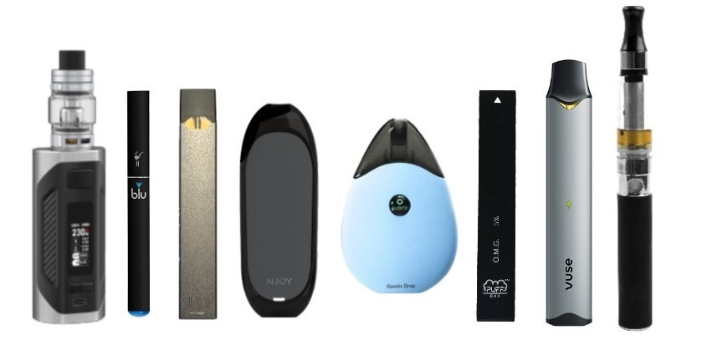
[S10] Have you ever tried vaping, even one time?
- Yes à Move to S11
- No à Skip to S12

[S11] During the past 30 days, on how many days did you vape? Please do NOT include vaping marijuana/THC/CBD when answering this question.
- __________ [0-30 Days] àIF >0, Skip to S14.

[S12] Please do NOT include vaping marijuana/THC/CBD when answering these questions.
Thinking about the future…

 | Definitely Yes | Probably Yes | Probably Not | Definitely Not
Do you think that you will vape soon? | ₁ | ₂ | ₃ | ₄
Do you think you will vape at any time in the next year? | ₁ | ₂ | ₃ | ₄
If one of your best friends were to offer you a vape, would you use it? | ₁ | ₂ | ₃ | ₄

[S13] Are you curious about vaping nicotine? [Only display if S10 = 2]
- Definitely yes
- Probably yes
- Probably not
- Definitely not [Used for branch]

[S14] Have you ever tried smoking a cigarette, even one or two puffs?
- Yes à S15
- No à Block 2, if under 18; à Block 3 if 18+

[S15] During the past 30 days, on how many days did you smoke cigarettes?
__________ [0-30 Days]

Block 2 [Under 18]
[S16A]: How much money does your family have?​
  - Not enough to get by ​
  - Just enough to get by ​
  - Only have to worry about money for fun or extras ​
  - Never have to worry about money

Block 3 [18+]

[S16 B – IF AGE 18-24]: Considering your own income and the income from any other people who help you, how much money do you have? ​
- Not enough to get by ​
- Just enough to get by ​
- Only have to worry about money for fun or extras ​
- Never have to worry about money

Block 4

[S17- AGE CONFIRMATION] What is your date of birth?

Please use the following format (MM/DD/YYYY)
____/______/_______
[S18- US RESIDENCE CONFIRMATION] What is your CURRENT Zip Code? __________
Block 5 END SURVEY [Customize]

[THANK_YOU] [IF FAIL CHECKPOINT CRITERIA]
Thank you for taking the time to take our eligibility screener. Unfortunately, based on your responses, you do not qualify to participate in our survey.

OMB No: 0910-0810 Expiration Date: 12/31/2024
Paperwork Reduction Act Statement: An agency may not conduct or sponsor, and a person is not required to respond to, a collection of information unless it displays a currently valid OMB control number. The public reporting burden for this collection of information has been estimated to average 3 minutes per response including the time for reviewing instructions and completing and reviewing the collection of information. Send comments regarding this burden estimate or any other aspects of this collection of information, including suggestions for reducing burden to PRAStaff@fda.hhs.gov.

OR

Block 6 CONTINUE
You are invited to complete our web survey. The survey will take about 15 minutes. Please click the “Next” button to continue and take the survey now.
- Next

OMB No: 0910-0810 Expiration Date: 12/31/2024
Paperwork Reduction Act Statement: An agency may not conduct or sponsor, and a person is not required to respond to, a collection of information unless it displays a currently valid OMB control number. The public reporting burden for this collection of information has been estimated to average 3 minutes per response including the time for reviewing instructions and completing and reviewing the collection of information. Send comments regarding this burden estimate or any other aspects of this collection of information, including suggestions for reducing burden to PRAStaff@fda.hhs.gov.

