ATTACHMENT D: SURVEY INSTRUMENT
TITLE OF INFORMATION COLLECTION: HISPANIC/LATINO YOUTH AND YOUNG ADULT TOBACCO USE ONLINE SURVEY STUDY
FDA Project Lead: Emily Sanders, MPH
Food and Drug Administration (FDA)
Center for Tobacco Products (CTP)
Principal Investigator: Everly Macario, Sc.D., M.S., Ed.M.
Telephone: 224.244.3965
Address: IQ Solutions, Inc., 11300 Rockville Pike # 901, Rockville, MD 20852

[Each item or series of items on the Questionnaire will be presented on a separate page separated by a “NEXT” button as indicated in programming instructions. There will also be a “BACK” button presented on each page in case participants accidentally skip a question.]

[Section A: Tobacco and other substance use]
[A1.] The following questions are about vaping. Please do NOT include vaping marijuana/THC/CBD/Delta 8 when answering these questions.
RANDOMIZE LIST (1-18)
(SELECT UP TO 3) What are the main reasons that you are curious about vapes?
- To help me feel relaxed/calm
- To deal with stress
- To get a nicotine buzz
- To boost my mood
- A way to spend time with friends
- My friends use them
- My family uses them (e.g. siblings, cousins)
- To try to quit cigarettes
- To use in places where you can’t smoke cigarettes
- They are cheap
- They come in interesting flavors
- They are easy to get
- They are easy to use
- They are tobacco-free
- They are less harmful than cigarettes.
- They are less addictive than cigarettes
- They do not have a bad smell
- People I admire use them, like influencers and celebrities
- They are easy to hide
- Some other reason [_______]
ASK: Respondents who have not tried but are curious about vaping (S10=2 AND S13=1-3)

[A2.] The following questions are about vaping. Please do NOT include vaping marijuana/THC/CBD/Delta 8 when answering these questions.
RANDOMIZE LIST (1-18)
(SELECT UP TO THREE) What are the main reasons you use or have tried vapes?
- To help me feel relaxed/calm
- To deal with stress
- To get a nicotine buzz
- To boost my mood
- A way to spend time with friends
- My friends use them
- My family uses them (e.g. siblings, cousins)
- To try to quit cigarettes
- To use in places where you can’t smoke cigarettes
- They are cheap
- They come in interesting flavors
- They are easy to get
- They are easy to use
- They are tobacco-free
- They are less harmful than cigarettes.
- They are less addictive than cigarettes
- They do not have a bad smell
- People I admire use them, like influencers and celebrities
- They are easy to hide
- Some other reason [_______]
ASK: Respondents who have ever used vapes (S10=1)

[A3.] When you vaped in the past 30 days, did you vape…? (SELECT ALL THAT APPLY)
- Nicotine
- THC, including marijuana flower and concentrates, such as hash oil and shatter
- Delta-8
- CBD
- Zero nicotine e-liquid
- Something else (Please specify__________)
- Don’t know
ASK: Respondents who have used vapes in the past 30 days (S11>0)

[A4.] When you vape, do you usually vape nicotine?
- Yes
- No
- Don’t Know

ASK: Respondents who have used vapes in the past 30 days (S11>0)

[A5.] When you vape nicotine, what percentage nicotine do you usually use?
- Less than 5% nicotine
- 5% nicotine
- More than 5% nicotine
- Don’t know the % nicotine

ASK: Respondents who have vaped nicotine in the past 30 days (A4=1)

[A6.] In the next 3 months, do you think you will…
  - Vape as much as you do now
  - Increase how much you vape
  - Decrease how much you vape
  - Stop vaping altogether
ASK: Respondents who have vaped nicotine in the past 30 days (A4=1)

[A7.] When you vape, what flavors do you prefer? (SELECT ALL THAT APPLY)
RANDOMIZE 1-5.
- Tobacco-flavored
- Menthol
- Mint
- Fruit
- Candy, desserts, or other sweets
- Some other flavor
Please specify____________ [OPEN TEXT]
- Don’t know

ASK: Respondents who have vaped nicotine in the past 30 days (A4=1)
[A8.] During the past 30 days, what vape brands did you use most often? (SELECT ALL THAT APPLY)
RANDOMIZE 1-10.
- JUUL
- Puff Bar
- Vuse
- Hyde
- Smok
- Esco Bar
- Mr. Fog
- Kangvape
- Vaporesso
- NJOY
- blu
- Leap
- GLAS
- Logic
- Posh
- Suorin
- Elf Bar
- Ignite
- HQD
- BIDI
- Fume
- Esco
- Breeze
- Hyppe
- Something else.
Please specify _________ [OPEN TEXT]
- Don’t know

ASK: Respondents who have vaped nicotine in the past 30 days (A4=1)

[A9.] For the following question, please think about the vape device you use most often to vape nicotine. What kind is it?
- A disposable device that you throw away when it’s empty (like blu or Puff Bar)
- A device that uses prefilled cartridges or pods that you replace when they are empty (like a JUUL)
- A device with a tank that is either pre-filled or you refill with liquids (like Suorin Drop or Smok Novo)
- Some other type of device (please specify) ___________ [OPEN TEXT]
- Don’t know [EXCLUSIVE]

ASK: Respondents who have vaped nicotine in the past 30 days (A4=1)

[A10.] The following questions are about cigarettes.
About how many cigarettes have you smoked in your entire life? Your best guess is fine.
- 1. 1 or more puffs but never a whole cigarette
2 1 cigarette
3 2 to 5 cigarettes
4 6 to 15 cigarettes (about 1/2 a pack total)
5 16 to 25 cigarettes (about 1 pack total)
6 26 to 99 cigarettes (more than 1 pack, but less than 5 packs)
7 100 or more cigarettes (5 or more packs)
8 Don’t know/not sure

ASK: Respondents who have ever smoked cigarettes (S14=1)

[A11.] When you smoked cigarettes in the past 30 days, did you smoke menthol or non-menthol?
- Menthol
- Non-Menthol
- Both
- Don’t know

ASK: Respondents who have smoked cigarettes in the past 30 days (S15>0)

[A12.] Thinking about the future…
 | Definitely Yes | Probably Yes | Probably Not | Definitely Not
Do you think that you will try/smoke a cigarette soon? | ☐1 | ☐2 | ☐3 | ☐4
Do you think you will smoke a cigarette at any time in the next year? | ☐1 | ☐2 | ☐3 | ☐4
If one of your best friends were to offer you a cigarette, would you smoke it? | ☐1 | ☐2 | ☐3 | ☐4

ASK: Respondents who have not smoked cigarettes in past 30 days (S15=0 or Skipped)

[A13.] Are you curious about smoking cigarettes?
- Definitely yes
- Probably yes
- Probably not
- Definitely not
ASK: Respondents who have never smoked cigarettes (S14=2)

RETURN TO ASKING ALL RESPONDENTS.

INTRO TEXT: The following questions are about different products you may or may not have tried.
[A14.] The next questions are about smoking tobacco in a hookah, which is a type of water pipe. It is sometimes also called a "narghile" pipe. People smoke shisha or hookah tobacco in a hookah.
Please do NOT include vaping marijuana/THC/CBD/Delta 8 when answering these questions.
Have you ever tried smoking hookah?
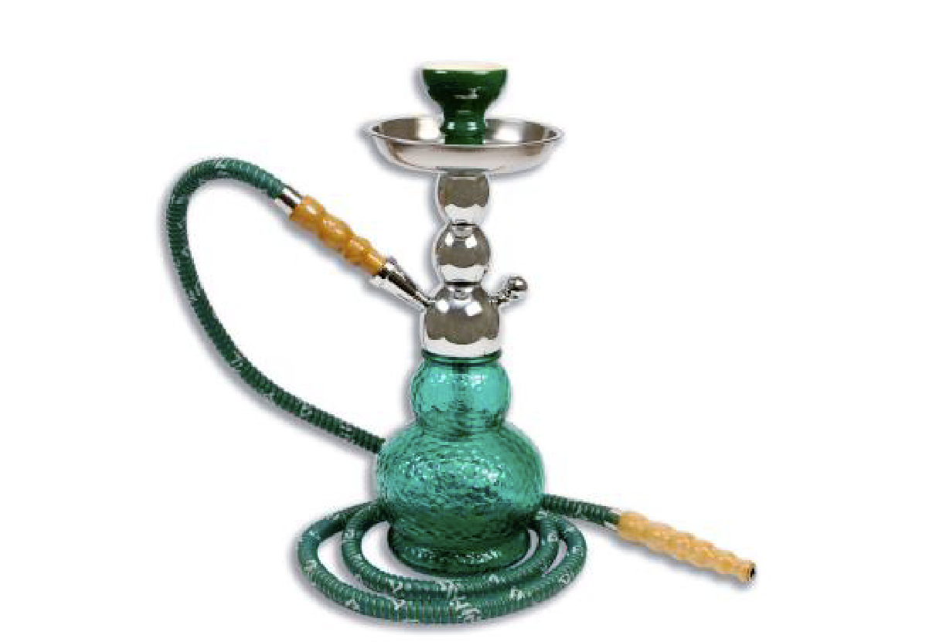
1 Yes
2 No
98 Don’t know

ASK: ALL respondents

[A15.] During the past 30 days, on how many days did you smoke hookah? (Your best guess is fine).
- Have not smoked hookah in the past 30 days
- 1 or 2 days
- 3-5 days
- 6-9 days
- 10-19 days
- 20-29 days
- All 30 days

ASK: Respondents who have ever smoked hookah (A14=1)
[A16.] Thinking about the future…
 | Definitely Yes | Probably Yes | Probably Not | Definitely Not
Do you think that you will smoke hookah soon? | ☐1 | ☐2 | ☐3 | ☐4
Do you think you will smoke hookah at any time in the next year? | ☐1 | ☐2 | ☐3 | ☐4
If one of your best friends were to offer you hookah, would you smoke it? | ☐1 | ☐2 | ☐3 | ☐4

ASK: Respondents who have not smoked hookah in past 30 days (A15=1 or SKIPPED) OR have never smoked hookah (A14 = No or DK)

[A17.] Are you curious about smoking hookah?
- Definitely yes
- Probably yes
- Probably not
- Definitely not
ASK: Respondents who have never smoked hookah (A14=2) or SKIPPED
[A18.] The next questions are about cigarillos. Some of these products may have a wooden or plastic tip while others are untipped. Some common brands of cigarillos are Black & Mild, Backwoods, Swisher Sweets, White Owl, Dutch Masters, and Game.

[SHOW IMAGES OF CIGARILLOS]
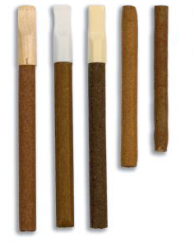

ASK: ALL RESPONDENTS
[A19.] Have you ever smoked plastic-tipped or wood-tipped cigarillos, even one or two puffs?
The brand pictured—Black & Mild—is just an example, but there are others.

Please do NOT include marijuana or blunt use when answering this question.
[show picture of tipped cigarillos]
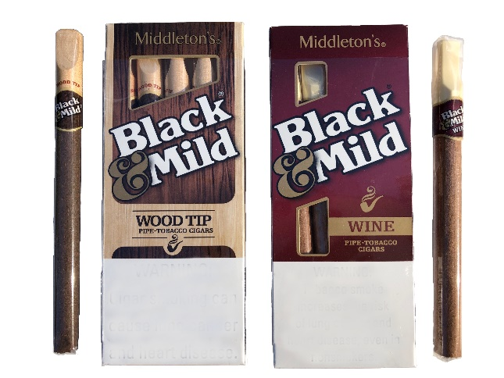
1. Yes
2. No
98. Don’t know

ASK: ALL respondents

[A20]. During the past 30 days, on how many days did you smoke plastic-tipped or wood- tipped cigarillos, even one or two puffs? (Your best guess is fine).

The brand pictured—Black & Mild—is just an example, but there are others.
Please do NOT include marijuana or blunt use when answering this question. [INSERT PICTURE OF TIPPED CIGARILLOS]
- Have not smoked tipped cigarillos in the past 30 days
- 1 or 2 days
- 3-5 days
- 6-9 days
- 10-19 days
- 20-29 days
- All 30 days

ASK: Respondents who ever smoked tipped cigarillos (A19=1)

[A21.] Please do NOT include marijuana or blunt use when answering this question.
Have you ever smoked untipped cigarillos, even one or two puffs?
The brands pictured – Backwoods, Swisher Sweets and Game —are just examples, but there are others, such as White Owl and Dutch Masters.
[show picture of untipped cigarillos]
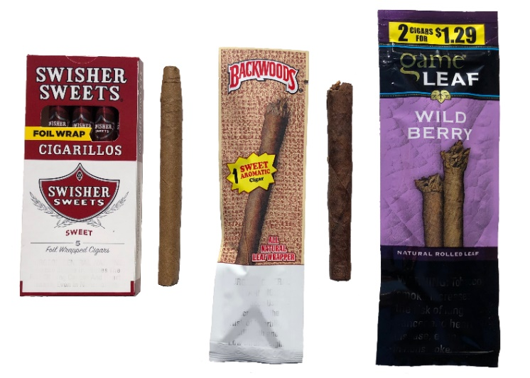
1. Yes
2. No
98. Don’t know

ASK: ALL respondents
[A22]. Please do NOT include marijuana or blunt use when answering this question.

During the past 30 days, on how many days did you smoke untipped cigarillos, even one or two puffs? (Your best guess is fine).

The brands pictured—Swisher Sweets, Game, and Backwoods—are just examples, but there are others, like White Owl and Dutch Masters.

[INSERT PICTURES OF UNTIPPED CIGARILLOS]
- Have not smoked untipped cigarillos in the past 30 days
- 1 or 2 days
- 3-5 days
- 6-9 days
- 10-19 days
- 20-29 days
- All 30 days

ASK: Respondents who ever smoked tipped cigarillos (A21=1)

[A23.] Please do NOT include marijuana or blunt use when answering the following questions.
Thinking about the future…
 |  | Definitely Yes | Probably Yes | Probably Not | Definitely Not
a. | Do you think that you will smoke a cigarillo soon? | ₁ | ₂ | ₃ | ₄
b. | Do you think you will smoke a cigarillo at any time in the next year? | ₁ | ₂ | ₃ | ₄
c. | If one of your best friends were to offer you a cigarillo, would you smoke it? | ₁ | ₂ | ₃ | ₄

ASK: All respondents who have not smoked cigarillos in past 30 days (A20=1 AND A22=1 or SKIPPED) OR have never smoked cigarillos A19 AND A21 = No or DK

[A24.] Are you curious about smoking cigarillos?
- Definitely yes
- Probably yes
- Probably not
- Definitely not
ASK: All respondents who have never smoked cigarillos (A19=2 AND A21=2) or DK/SKIPPED

[A25.] Sometimes people take the tobacco out of a cigarillo (examples of brands include Backwoods, Swisher Sweets or Black and Mild) and replace it with marijuana, or they may put marijuana into a cigar/tobacco leaf wrap. This is sometimes called a “blunt.”
Have you ever smoked a blunt, even one or two puffs?
- Yes
- No
- Don’t know

ASK: All respondents

[A26.] During the past 30 days, on how many days did you smoke a blunt, even one or two puffs? (Your best guess is fine).
- Have not smoked a blunt in the past 30 days
- 1 or 2 days
- 3-5 days
- 6-9 days
- 10-19 days
- 20-39 days
- All 30 days

ASK: Respondents who ever smoked blunts (A25=1)
[A27.] Thinking about the future…
 |  | Definitely Yes | Probably Yes | Probably Not | Definitely Not
a. | Do you think that you will smoke a blunt soon? | ₁ | ₂ | ₃ | ₄
b. | Do you think you will smoke a blunt at any time in the next year? | ₁ | ₂ | ₃ | ₄
c. | If one of your best friends were to offer you a blunt, would you use it? | ₁ | ₂ | ₃ | ₄

ASK: Respondents who have not smoked blunts in the last 30 days (A26=1) or SKIPPED OR never smoked blunts (A25 = No or DK)

[A28.] Are you curious about smoking blunts?
- Definitely yes
- Probably yes
- Probably not
- Definitely not
ASK: Respondents who have never smoked blunts (A25=2) or DK/SKIPPED

[A29.] You indicated you have smoked blunts in the last 30 days. Other than smoking blunts, how else have you used marijuana in the past 30 days? (SELECT ALL THAT APPLY)
- I have not used marijuana other than blunts in the past 30 days [EXCLUSIVE]
- Smoked marijuana (like a joint, pipe, bong or waterpipe)
- Vaped marijuana (like hash oil, marijuana concentrates, or dried marijuana leaves, buds, or flowers)
- Used marijuana another way (please specify:___________________)

ASK: Respondents who have smoked blunts in past 30 days (A25>0)
[A30.] You indicated you have not smoked blunts in the last 30 days. How, if at all, have you used marijuana in the past 30 days? (SELECT ALL THAT APPLY)
- I have not used marijuana in the past 30 days [EXCLUSIVE]
- Smoked marijuana (like a joint, pipe, bong or waterpipe)
- Vaped marijuana (like hash oil, marijuana concentrates, or dried marijuana leaves, buds, or flowers)
- Used marijuana another way (please specify:___________________)

ASK: Respondents who have never smoked blunts (or DK/SKIPPED) OR A26 = 1
[A31.] Other than you, has anyone who currently lives with you used any of the following during the past 30 days? (SELECT ALL THAT APPLY)
- Cigarettes
- Cigarillos such as Backwoods, Black and Milds, Swisher Sweets, or Dutch Masters.
- Hookah
- Vapes, vaping products or electronic cigarettes
- Blunts
- THC (marijuana/weed) as a liquid in an electronic cigarette or vape pen
- Any other form of tobacco or marijuana
- No, no one who lives with me has used any form of tobacco or marijuana during the past 30 days
- Don’t know

PROGRAMMER: DO NOT ALLOW A RESPONSE OF 8 IN COMBINATION WITH OTHER RESPONSES.
ASK: ALL Respondents

[Section B: KABs, Risk Perceptions and Social Norms]

INTRO TEXT: The next questions are about what you think or believe. There are no right or wrong answers.
[B1.] Which of the following best describes how you think of yourself?
- Vaper
- Social vaper
- Occasional vaper
- Ex-vaper
- Someone who tried vaping
- Nonvaper

[Source: Adapted from Villanti et al.]

ASK: Respondents who have ever vaped (S10=1)

[B2.] How sure are you that you could easily stop vaping if you started vaping?
- Not at all sure
- Slightly sure
- Somewhat sure
- Mostly sure
- Completely sure

ASK: Respondents who have never vaped (S10=2)
[B3.]
 |  | Not at all harmful | Slightly harmful | Somewhat harmful | Very harmful | Extremely harmful | Don’t know
a. | How harmful do you think nicotine, on its own, is to health? | 1 | 2 | 3 | 4 | 5 | 6
b. | How harmful do you think tobacco, on its own, is to health? | 1 | 2 | 3 | 4 | 5 | 6

ASK: All Respondents

[B4. – Health Perceptions] How much do you agree or disagree with the following statements?
PROGRAMMER: RANDOMIZE ALL ROWS
 | Strongly Disagree | Disagree | Neutral | Agree | Strongly Agree
If you vape, you will become addicted | ☐1 | ☐2 | ☐3 | ☐4 | ☐5
Once you start vaping you will be unable to stop | ☐1 | ☐2 | ☐3 | ☐4 | ☐5
Vaping is healthier than smoking cigarettes | ☐1 | ☐2 | ☐3 | ☐4 | ☐5
Vaping exposes your lungs to metal particles | ☐1 | ☐2 | ☐3 | ☐4 | ☐5
Vaping exposes you to harmful chemicals | ☐1 | ☐2 | ☐3 | ☐4 | ☐5
Vaping changes your brain | ☐1 | ☐2 | ☐3 | ☐4 | ☐5
Vaping relieves stress | ☐1 | ☐2 | ☐3 | ☐4 | ☐5
Vaping helps you concentrate | ☐1 | ☐2 | ☐3 | ☐4 | ☐5
Vaping damages your DNA | ☐1 | ☐2 | ☐3 | ☐4 | ☐5
Vaping makes anxious feelings worse such as feeling nervous, restless, or tense from nicotine | ☐1 | ☐2 | ☐3 | ☐4 | ☐5
Vaping affects your ability to play sports or exercise | ☐1 | ☐2 | ☐3 | ☐4 | ☐5
Vaping is more harmful to teenagers than adults. | ☐1 | ☐2 | ☐3 | ☐4 | ☐5

ASK: ALL respondents

[B5. – Social Perceptions] How much do you agree or disagree with the following statements?
PROGRAMMER: RANDOMIZE ALL ROWS
 | Strongly Disagree | Disagree | Neither Agree Nor Disagree | Agree | Strongly Agree
Vaping has a harmful impact on the Hispanic/Latin(a/o/x) community | ☐1 | ☐2 | ☐3 | ☐4 | ☐5
Most people I know vape. | ☐1 | ☐2 | ☐3 | ☐4 | ☐5
If I vape I will disappoint my parents or other family members important to me | ☐1 | ☐2 | ☐3 | ☐4 | ☐5
Most Hispanic/Latino/a/x people I know vape. | ☐1 | ☐2 | ☐3 | ☐4 | ☐5
Vaping will help me fit in with my friends. | ☐1 | ☐2 | ☐3 | ☐4 | ☐5
People who vape are going through a hard time. | ☐1 | ☐2 | ☐3 | ☐4 | ☐5
I will have a harder time getting a job if I vape. | ☐1 | ☐2 | ☐3 | ☐4 | ☐5
People who vape are trendy or cool. | ☐1 | ☐2 | ☐3 | ☐4 | ☐5
My family would disapprove if I used vapes. | ☐1 | ☐2 | ☐3 | ☐4 | ☐5
My friends would disapprove if I used vapes. | ☐1 | ☐2 | ☐3 | ☐4 | ☐5

ASK: All respondents

[B6.] How much do you think people harm themselves when they…
PROGRAMMER: RANDOMIZE ALL ROWS
 | No harm | A little harm | Some harm | A lot of harm | Not familiar with this product
Smoke cigarettes? | ☐1 | ☐2 | ☐3 | ☐4 | ☐5
Vape nicotine? | ☐1 | ☐2 | ☐3 | ☐4 | ☐5
Smoke blunts? | ☐1 | ☐2 | ☐3 | ☐4 | ☐5
Smoke hookah? | ☐1 | ☐2 | ☐3 | ☐4 | ☐5
Vape THC (marijuana/weed)? | ☐1 | ☐2 | ☐3 | ☐4 | ☐5

ASK: All respondents.

[B7.] Which of the following best describes vaping inside your current home?
- Vaping is allowed anywhere in your home
- Vaping is never allowed anywhere in your home
- Something in between
- Don’t know

ASK: All respondents.
[B8.] How many of your 4 closest friends vape?
- 0
- 1
- 2
- 3
- 4

ASK: All respondents

[B9.] Out of every 10 people your age, how many do you think use vapes? (Select One)
0 1 2 3 4 5 6 7 8 9 10

ASK: All respondents

[Section C: Psychographics]

INTRO TEXT: The following questions are about different experiences or feelings you may have had in your life.
[C1.] How much do you agree or disagree with each of the following statements:
RANDOMIZE
 | Strongly Disagree | Disagree | Neither Disagree or Agree | Agree | Strongly Agree
I find it easy to harmonize my Hispanic/Latino/a/x and U.S. cultures. | ☐1 | ☐2 | ☐3 | ☐4 | ☐5
I feel that my Hispanic/Latino/a/x and U.S. cultures are incompatible. | ☐1 | ☐2 | ☐3 | ☐4 | ☐5
I feel a part of Hispanic/Latino/a/x and U.S. cultures at the same time. | ☐1 | ☐2 | ☐3 | ☐4 | ☐5
I do not blend my Hispanic/Latino/a/x and U.S. cultures. | ☐1 | ☐2 | ☐3 | ☐4 | ☐5

[Source: Bicultural Identity Integration Scale–Version 2]
ASK: All respondents.

[C2.] Thinking about your Hispanic, Latin(a/o), Latinx ethnicity, how much do you agree or disagree with each statement:
RANDOMIZE
 | Strongly Disagree | Disagree | Neither Disagree or Agree | Agree | Strongly Agree
I have spent time trying to find out more about my Hispanic, Latin(a/o), Latinx ethnicity, such as its history, traditions, and customs. | ☐1 | ☐2 | ☐3 | ☐4 | ☐5
I am active in organizations or social groups that include mostly Hispanic, Latin(a/o), Latinx members. | ☐1 | ☐2 | ☐3 | ☐4 | ☐5
I have a clear sense of my Hispanic, Latin(a/o), Latinx background and what it means for me. | ☐1 | ☐2 | ☐3 | ☐4 | ☐5
I think a lot about how my life will be affected by being Hispanic, Latin(a/o), Latinx. | ☐1 | ☐2 | ☐3 | ☐4 | ☐5
I am happy that I am Hispanic, Latin(a/o), Latinx. | ☐1 | ☐2 | ☐3 | ☐4 | ☐5
I have a strong sense of belonging to the Hispanic, Latin(a/o), Latinx community. | ☐1 | ☐2 | ☐3 | ☐4 | ☐5
I understand pretty well what being Hispanic, Latin(a/o), Latinx means to me. | ☐1 | ☐2 | ☐3 | ☐4 | ☐5
To learn more about my ethnic background, I have often talked to other people about my Hispanic, Latin(a/o), Latinx ethnicity. | ☐1 | ☐2 | ☐3 | ☐4 | ☐5
I have a lot of pride in my Hispanic, Latin(a/o), Latinx ethnic group and its accomplishments. | ☐1 | ☐2 | ☐3 | ☐4 | ☐5
I participate in Hispanic, Latin(a/o), Latinx cultural practices such as special food, music, or customs. | ☐1 | ☐2 | ☐3 | ☐4 | ☐5
I feel a strong attachment towards my own Hispanic, Latin(a/o), Latinx ethnicity. | ☐1 | ☐2 | ☐3 | ☐4 | ☐5
I feel good about my Hispanic, Latin(a/o), Latinx background. | ☐1 | ☐2 | ☐3 | ☐4 | ☐5

[Adapted from: https://www.phenxtoolkit.org/protocols/view/710801 Scoring: The affirmation/belonging subscale includes items 3, 5, 6, 7, 9, 11, and 12. The exploration subscale includes items 1, 2, 4, 8, and 10. (Item 3 loads on both subscales.) Scores range from 1-4.]
ASK: All respondents.

[C3.] In your day-to-day life, how often do any of the following things happen to you because you are Hispanic/Latino/a/x?

 | Almost every day | At least once a week | A few times a month | A few times a year | Less than once a year | Never
- Because you are Hispanic/Latino/a/x you are treated with less courtesy or respect than other people are.
- Because you are Hispanic/Latino/a/x you receive poorer service than other people at restaurants or stores.
- Because you are Hispanic/Latino/a/x people act as if they think you are not smart.
- Because you are Hispanic/Latino/a/x people act as if they are afraid of you.
- Because you are Hispanic/Latino/a/x you are threatened or harassed.

[Adapted From: Every Day Discrimination Scale -Short Version - https://scholar.harvard.edu/davidrwilliams/node/32397]
ASK: All respondents.

[C4.] How much do you agree or disagree with the following statements:
 | Strongly Disagree | Disagree | Neither Disagree or Agree | Agree | Strongly Agree
The neighborhood/area where I live is mostly Hispanic/Latino/a/x | ☐1 | ☐2 | ☐3 | ☐4 | ☐5
I feel close to people at my school (youth only) | ☐1 | ☐2 | ☐3 | ☐4 | ☐5
I am happy to be at my school (youth only) | ☐1 | ☐2 | ☐3 | ☐4 | ☐5
I feel like I am a part of my school (youth only) | ☐1 | ☐2 | ☐3 | ☐4 | ☐5
I feel part of a community of people who share my Hispanic, Latin(a/o), Latinx identity. | ☐1 | ☐2 | ☐3 | ☐4 | ☐5
I feel connected to other people who share my Hispanic, Latin(a/o), Latinx identity. | ☐1 | ☐2 | ☐3 | ☐4 | ☐5
When interacting with members of the community who share my Hispanic, Latin(a/o), Latinx identity, I feel like I belong. | ☐1 | ☐2 | ☐3 | ☐4 | ☐5
I’m not like other people who share my Hispanic, Latin(a/o), Latinx identity. (Reversal) | ☐1 | ☐2 | ☐3 | ☐4 | ☐5
I feel isolated and separate from other people who share my Hispanic, Latin(a/o), Latinx identity. (Reversal) | ☐1 | ☐2 | ☐3 | ☐4 | ☐5

[Citation: Testa, R. J., Habarth, J., Peta, J., Balsam, K., & Bockting, W. (2015). Development of the Gender Minority Stress and Resilience Measure. Psychology of Sexual Orientation and Gender Diversity, 2(1), 65].
ASK: All respondents.

[C5]. The next few statements are related to feelings about your family. How much do you agree or disagree with each of the following:
 | Strongly Disagree | Disagree | Neither Disagree or Agree | Agree | Strongly Agree
My family is always there for me in times of need. | ☐1 | ☐2 | ☐3 | ☐4 | ☐5
I am proud of my family. | ☐1 | ☐2 | ☐3 | ☐4 | ☐5
I cherish the time I spend with my family. | ☐1 | ☐2 | ☐3 | ☐4 | ☐5
I know my family has my best interests in mind. | ☐1 | ☐2 | ☐3 | ☐4 | ☐5
My family members and I share similar values and beliefs. | ☐1 | ☐2 | ☐3 | ☐4 | ☐5

[Scale from: https://www.researchgate.net/publication/236650376_Factorial_invariance_of_the_Pan-Hispanic_Familism_Scale (pg. 415 of the article—this study validated with adults) Note: Translated questions are in this paper as well]

ASK: All respondents.

[C6.] The next few questions will ask about your mental or emotional health and you have the right to skip these questions. Additionally, if you experience any distress while taking this survey, you may contact the (1) Substance Abuse and Mental Health Services Administration (SAMHSA) Disaster Distress Helpline (1-800-985-5990) or the (2) Suicide Prevention Lifeline (1-800-273-8255), which both offer free 24/7 support services.
Over the past 2 weeks, how often have you been bothered by the following problems ...
 | Not at all | Several days | More than half the days | Nearly every day
Feeling nervous, anxious, or on edge? | ☐1 | ☐2 | ☐3 | ☐4
Not being able to stop or control worrying? | ☐1 | ☐2 | ☐3 | ☐4
Feeling down, depressed, or hopeless? | ☐1 | ☐2 | ☐3 | ☐4
Having little interest or pleasure in doing things? | ☐1 | ☐2 | ☐3 | ☐4
[Source: GAD-2 and PHQ2]
ASK: All respondents.

[C7.] How strongly do you agree or disagree with the following statements about your likes/preferences:
 | Strongly Disagree | Disagree | Neither Disagree or Agree | Agree | Strongly Agree
I like to explore strange new places. | ☐1 | ☐2 | ☐3 | ☐4 | ☐5
I like to do frightening things. | ☐1 | ☐2 | ☐3 | ☐4 | ☐5
I like new and exciting experiences, even if I have to break the rules. | ☐1 | ☐2 | ☐3 | ☐4 | ☐5
I prefer friends who are exciting and unpredictable. | ☐1 | ☐2 | ☐3 | ☐4 | ☐5

[Source: Brief Sensation Seeking Scale (BSSS-4) (Stephenson, Hoyle, Palmgreen, & Slater, 2003)]
ASK: All respondents.

[C8.] How much do you agree or disagree with the following statement: Religion is a big part of my daily life?
- Strongly Disagree
- Disagree
- Neutral
- Agree
- Strongly Agree

ASK: All respondents.
[C9.] How much do you agree or disagree with each of the following statements:
 | Strongly Disagree | Disagree | Neither Disagree or Agree | Agree | Strongly Agree
I have learned that what is going to happen will happen. | ☐1 | ☐2 | ☐3 | ☐4 | ☐5
If something bad is going to happen to me, it will happen no matter what I do. | ☐1 | ☐2 | ☐3 | ☐4 | ☐5
If bad things happen, it is because they were meant to happen. | ☐1 | ☐2 | ☐3 | ☐4 | ☐5
There is no sense in planning a lot; if something good is going to happen, it will. | ☐1 | ☐2 | ☐3 | ☐4 | ☐5
Life is very unpredictable, and there is nothing one can do to change the future. | ☐1 | ☐2 | ☐3 | ☐4 | ☐5
People die when it is their time to die and there is not much that can be done about it | ☐1 | ☐2 | ☐3 | ☐4 | ☐5

[Source: Esparza et al 2014. Simultaneous Development of a Multidimensional Fatalism Measure in English and Spanish. https://link.springer.com/content/pdf/10.1007/s12144-014-9272-z.pdf]
ASK: All respondents.
[C10.] How much do you agree or disagree with the following statements about your parents or guardians:
 | Strongly Disagree | Disagree | Neither Disagree or Agree | Agree | Strongly Agree
My parents/guardians want me to live by or follow the mainstream U.S. way of life | ☐1 | ☐2 | ☐3 | ☐4 | ☐5
My parents/guardians want me to live by or follow the Hispanic way of life | ☐1 | ☐2 | ☐3 | ☐4 | ☐5
Source: Perceived Parental Cultural Expectations scale adapts from Unger et al (2009). Parent–Child Acculturation Patterns and Substance Use among Hispanic Adolescents: A Longitudinal Analysis.
ASK: All respondents.

[Section D: Demographics and Closing]
INTRO TEXT: You’re almost done! Just a few more questions about yourself.

[D1.] What is the highest level of education you have completed?

1. Some high school or less
2. GED
3. High school diploma
4. Some college but no degree
5. Currently enrolled in college or university
6. Trade/technical/vocational school
7. Associate degree
8. Bachelor’s degree
9. Master’s degree or higher

ASK: All respondents age 19-24

[D2.] Which of the following best describes your current status? (Please select only one response, your main status now.)
- Employed with a salary or hourly pay
- Self-employed
- Not currently working (Out of work)
- Not currently working (In school/student)
- Not currently working (Unable to work)

ASK: All respondents age 19-24

[D3.] Do you live…?
- In an urban or city area
- In a suburban area next to a city
- In a small town or rural area
- Don’t Know/Not Sure
ASK: All respondents
[D4.] Who do you currently live with?
- Family (including significant other/partner)
- Roommates
- Alone

ASK: All respondents

Thank you for taking time to complete this survey. You may close this window now.
OMB No: 0910-0810 Expiration Date: 12/31/2024
Paperwork Reduction Act Statement: An agency may not conduct or sponsor, and a person is not required to respond to, a collection of information unless it displays a currently valid OMB control number. The public reporting burden for this collection of information has been estimated to average 15 minutes per response including the time for reviewing instructions and completing and reviewing the collection of information. Send comments regarding this burden estimate or any other aspects of this collection of information, including suggestions for reducing burden to PRAStaff@fda.hhs.gov.

ASK: All respondents

