Copy Testing of Tobacco Prevention and Cessation Advertisements Research Study
Screener
PROGRAMMER notes:

respondents will be recruited through Two sources:
- panel THROUGH A PARENT (PANEL_PAR)
- social media (sm)

ADMINISTER SCREENER TO ALL.

FOR RECRUITMENT VIA PANEL_PAR, SCREENER WILL BE HOSTED BY PANEL PROVIDER. FOR RECRUITMENT VIA SM, SCREENER WILL BE HOSTED BY RTI.

QUESTIONS IN SCREENER CANNOT BE SKIPPED

SCREENER

[DISPLAY INTRO_SM IF SOURCE = SM]

[INTRO_SM]
Welcome to the Media and Health Survey!

The U.S. Food and Drug Administration is developing education programs that aim to improve the health of youth and young adults.

- Paperwork Reduction Act Statement: According to the Paperwork Reduction Act of 1995, an agency may not conduct or sponsor, and a person is not required to respond to a collection of information unless it displays a valid OMB control number. The valid OMB control number for this information collection is 0910-0810. The time required to complete this information collection is estimated to average 5 minutes per response, including the time for reviewing instructions, searching existing data sources, gathering and maintaining the data needed, and completing and reviewing the collection of information. Send comments regarding this burden estimate or any other aspects of this collection of information, including suggestions for reducing burden to PRASTAFF@fda.hhs.gov.
- You are being asked to answer a few questions to see if you are eligible for a study of youth in the United States.
- You may only complete this questionnaire one time.
- It will only take about 5 minutes to see if you are eligible.
- If we determine you are eligible, you will have the opportunity to continue and complete an additional online survey for a $10 electronic gift card.
- You may only take that survey one time and you will only receive one $10 electronic gift card if you complete it. If we find that you have completed the survey more than once, you may not receive a gift card. Once we complete this check, we will send you a $10 electronic gift card to the email address you provide. The gift card will be sent within 1-2 weeks.
- Your answers to the questions will be kept private to the fullest extent allowable by law and your participation is voluntary. Please read our privacy policy before continuing.

Thank you for your interest in this survey. [IF SOURCE = PANEL_PAR: We have asked your parent to give you privacy to answer the survey questions.] Please be sure you are in a private and comfortable place before you begin answering the questions below.

Are you willing to answer a few questions to see if you are qualified to participate in the study?
- Yes
- No [TERMINATE]

[IF TERMINATE, DISPLAY: Thank you for your consideration.]

To get started, we first need to ask you a few questions to see if you are eligible to take the survey.

[AGE] How old are you (in years)?

_________________years old [NUMERIC FIELD, WHOLE NUMBERS ONLY, MIN=3, MAX = 110]

[(IF SOURCE = PANEL_PAR AND AGE <13 OR >17) OR (IF SOURCE = SOCIAL MEDIA AND AGE <15 OR >17), TERMINATE AND DISPLAY: We’re sorry, but you are not eligible to participate in this study. Thank you for your interest.]

[VAPE_INTRO] The next questions are about vaping products or vapes. You may also know them as e-cigarettes. Some common brands are JUUL, Vuse, Puff Bar, NJOY, and blu.

Please do NOT include vapes with marijuana, THC, CBD, or Delta-8 when answering these questions. [SOURCE OF VAPE_INTRO TEXT: FDA MMS WAVE 7]

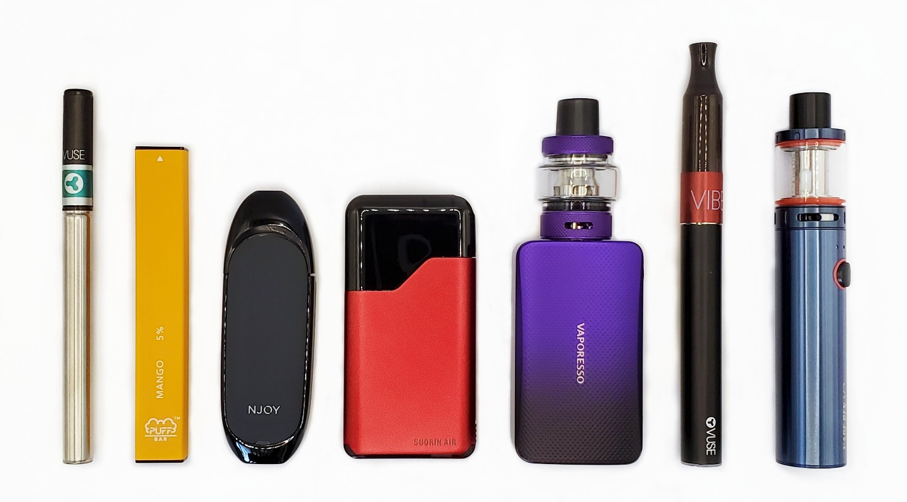

[EVER_VAPE] Have you ever vaped, even one time? [SOURCE: FDA EXPECTT SURVEY]

1. Yes
2. No

[ASK if ever_vape = 1]
[curr_VAPE] During the past 30 days, on how many days did you vape? [Adapted from path wave 6]

___________days [NUMERIC, WHOLE NUMBERS ONLY. RANGE = 0-30]

[ask IF EVER_VAPE = 2 OR (ever_vape = 1 and CURR_VAPE = 0)]
[Yr_VAPE] Do you think you will vape in the next year? [adapted from STRONG ET AL., 2015]

- Definitely yes
- Probably yes
- Probably not
- Definitely not

[ask if EVER_VAPE = 2 OR (ever_vape = 1 and curr_vape = 0)]
[Soon_VAPE] Do you think that you will vape soon? [adapted from STRONG ET AL., 2015]

- Definitely yes
- Probably yes
- Probably not
- Definitely not

[ask IF EVER_VAPE = 2 OR (ever_vape = 1 and CURR_VAPE = 0)]
[Friend_VAPE] If one of your best friends were to offer you a vaping product, would you use it? [adapted from STRONG ET AL., 2015]

- Definitely yes
- Probably yes
- Probably not
- Definitely not

[ever_smk] This next question is about cigarette smoking. Have you ever tried cigarette smoking, even one or two puffs? [from path wave 6]

- Yes
- No

[ASK if ever_smk = 1]
[SMK_100] Have you smoked at least 100 cigarettes in your entire life?

- Yes [TERMINATE]
- No

[ASK if ever_smk = 1 ]
[curr_smk] During the past 30 days, on how many days did you smoke cigarettes?

___________days [NUMERIC, WHOLE NUMBERS ONLY. RANGE = 0-30]

[ask IF EVER_SMK = 2 OR CURR_SMK = 0]
[Yr_SMK] Do you think you will smoke cigarettes in the next year? [adapted from STRONG ET AL., 2015]

- Definitely yes
- Probably yes
- Probably not
- Definitely not

[ask if EVER_SMK = 2 OR curr_SMK = 0]
[Soon_SMK] Do you think that you will smoke cigarettes soon? [adapted from STRONG ET AL., 2015]

- Definitely yes
- Probably yes
- Probably not
- Definitely not

[ask IF EVER_SMK = 2 OR CURR_SMK = 0]
[Friend_SMK] If one of your best friends were to offer you a cigarette, would you smoke it? [adapted from STRONG ET AL., 2015]

- Definitely yes
- Probably yes
- Probably not
- Definitely not

[HISPANIC] Are you Hispanic or Latino?
- Yes
- No

[RACE] What is your race? (Select all that apply):
- American Indian or Alaska Native
- Asian
- Black or African American
- Native Hawaiian or Other Pacific Islander
- White

[ASK IF HISPANIC = 1]
[HISPANIC_orgn] Which of the following best describes you? (Select all that apply)

- Mexican/Mexican American/Chicano/a
- Puerto Rican
- Cuban
- Salvadoran
- Dominican
- Other Hispanic, Latin(a/o), Latinx origin or ancestry
- Prefer not to answer [EXCLUSIVE]

[gender] Are you (select all that apply):
- Female
- Male
- Transgender, non-binary, or another gender identity

[STATE] Please indicate your state of residence.

[INSERT LIST WITH 50 US STATES + DC + OPTION “I DO NOT LIVE IN THE U.S. (99)]

[DOB] What is your date of birth? Please use the following format (MM/DD/YYYY)
_ _ / _ _ / _ _ _ _

[PROGRAMMER: CONSTRUCT VARIABLE FOR PARTICIPANT AGE (AGE2) BASED ON RESPONSE TO DOB]

[SEX_OR] Which of the following best represents how you think of yourself (select all that apply?
- Straight or heterosexual
- Bisexual
- Gay or lesbian
- Pansexual
- Queer
- Asexual
- I am not sure yet
- Something else
- Prefer not to answer

[DISTRACTOR1] About how often do you visit social media sites, such as Instagram, TikTok, Snapchat, Facebook, or Twitter?

- Every hour or more
- More than once a day
- About once a day
- 3-5 days a week
- 1-2 days a week
- Every few weeks or less
- I do not have a social media account
[COMP] Have you ever received money or gift cards from a company for sharing your opinions in a discussion group, interview, or survey about tobacco?
- Yes, within the past 3 months
- Yes, more than 3 months ago
- No
- I’m not sure

[TEST_SND] Next, we’d like to make sure you can view and hear videos that we’ll show later in the survey. Please make sure your volume is turned on. On the next screen, you will be asked to identify the sound of an animal.

[INSERT TEST AUDIO; RANDOMIZE AUDIO SELECTED]

Please identify the animal you just heard.

- Dog
- Cat
- Elephant
- Frog
- Ape
- Horse
- Bird.
- I could not hear the animal

[TEST_VID] On the next screen you will be shown the image of an animal and asked to identify which animal you see.
[INSERT TEST VIDEO; RANDOMIZE VIDEO SELECTED]

What animal can you see in the video above?

- Dog
- Cat
- Elephant
- Frog
- Ape
- Horse
- Bird.
- I could not see the animal

[ask if source = sm]
[EMAIL] Please enter your email address: _____________________ [OPEN TEXT, VALIDATE E-MAIL FORMAT]

The email address you provide is used only for the purposes of this survey and will not be sold or shared.

[ask if source = sm]
[EMAIL_VER] Please verify your email address: _____________________ [OPEN TEXT, VALIDATE E-MAIL FORMAT]

[IF EMAIL ≠ EMAIL_VER, DISPLAY WARNING: “The e-mail addresses you entered do not match. Please try again.”]

ELIGIBILITY AND QUOTAS

CATEGORIZE RESPONDENTS ACCORDING TO THE CRITERIA IN TABLE 1. GENERATE VARIABLE FOR TOBACCO USE GROUP (TOBGRP).

TOTAL SAMPLE = 600 N, WITH QUOTAS OF N = 300 IN GROUPS 1-3 AND N = 300 IN GROUPS 4-6.

TABLE 1. TOBACCO USE GROUPS
# | TOBACCO USE GROUP | CRITERIA | QUOTA
1 | Susceptible Non-Triers (VAPES) | EVER_VAPE = 2 AND [(YR_VAPE = 1, 2, OR 3) OR (SOON_VAPE = 1, 2, OR 3) OR FRIEND_VAPE = 1, 2, OR 3)] | N=150 IN GROUP 1
2 | Susceptible Lifetime USERS (VAPES) | EVER_VAPE = 1 AND CURR_VAPE = 0 AND [(YR_VAPE = 1, 2 OR 3) OR (SOON_VAPE = 1, 2, OR 3) OR (FRIEND_VAPE = 1, 2, OR 3)] | N=150 IN GROUPS 2-3 (ALLOW NATURAL FALLOUT ACROSS GROUPS 2-3)
3 | Current USERS (VAPES) | CURR_VAPE > 0
4 | Susceptible Non-Triers (CIGARETTES) | EVER_SMK = 2 AND [(YR_SMK = 1, 2, OR 3) OR (SOON_SMK = 1, 2, OR 3) OR FRIEND_SMK = 1, 2, OR 3)] | N=150 IN GROUP 4
5 | Susceptible Lifetime USERS (CIGARETTES) | EVER_SMK = 1 AND CURR_SMK = 0 AND [(YR_SMK = 1, 2 OR 3) OR (SOON_SMK = 1, 2, OR 3) OR (FRIEND_SMK = 1, 2, OR 3)] | N=150 IN GROUPS 5-6 (ALLOW NATURAL FALLOUT ACROSS GROUPS 5-6)
6 | Current USERS (CIGARETTES) | CURR_SMK > 0

IF PARTICIPANT QUALIFIES FOR BOTH A VAPE AND CIGARETTE USER GROUP, ASSIGN PARTICIPANT TO THE CIGARETTE GROUP.

TERMINATE IF:

- RESPONDENT DOES NOT MEET CRITERIA FOR ANY GROUP LISTED IN TABLE 1
- (SOURCE = PANEL_PAR AND AGE ≠ 13-17) OR (SOURCE = SM AND AGE ≠ 15-17)
- SMK_100 = 1
- COMP = 1
- TEST_SND ≠ RANDOMLY SELECTED AUDIO
- TEST_VID ≠ RANDOMLY SELECTED VIDEO
- AGE ≠ AGE2

[IF TERMINATE, DISPLAY: We’re sorry, but you are not eligible to participate in this study. Thank you again for your interest.]

[IF ELIGIBLE, DISPLAY SURVEY_INTRO]
[SURVEY_INTRO] Congratulations! You are eligible and are invited to complete our 20-minute web survey [IF SOURCE = SM: for a $10 gift card]. Please click the forward arrow button at the bottom of the page to continue and take the survey now. [IF SOURCE = SM: After you complete the survey, we will send you a $10 gift card to the email address you provided. The gift card will be sent within 1-2 weeks after we have verified that you have only completed the survey one time.]

