1A Ads (Pre-Production Vapes)
1A_1 _PRE (Scary Enough)
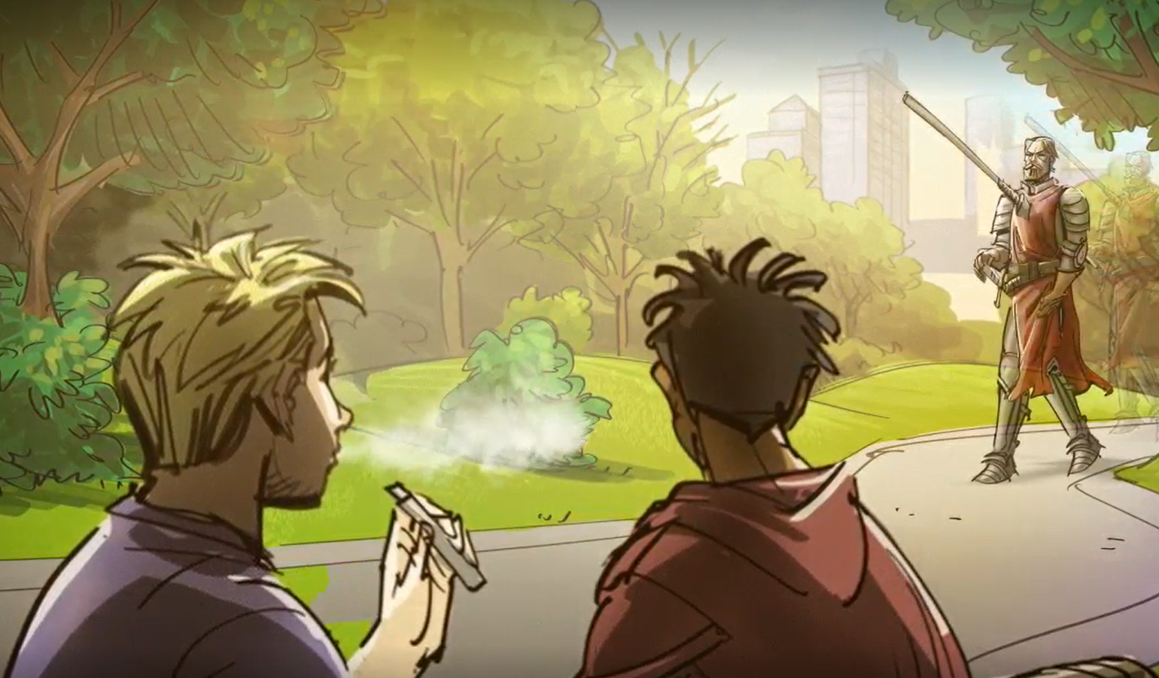
V/O: This commercial begins with a medieval knight walking up to teens walking up to teens who are hanging out in a park.
“Hey mister, you got a spear in your chest!”
“Indeed, I do! Begotten in the siege of Truffleberry as the light faded from mine enemy’s eyes.”
“Cool story, bro.”
“But ye, young lads! Great King of Scots! Ye have put metal into ye own lungs by ye own hand!”
We see the knight gesture toward the teens and the vapes they are holding.
“Nickel, chromium and lead! Metal particles that not even the great wizard could remove.”
If you vape, you could be inhaling toxic metal particles into your lungs.

1A_2 _PRE (Awkward Silence)
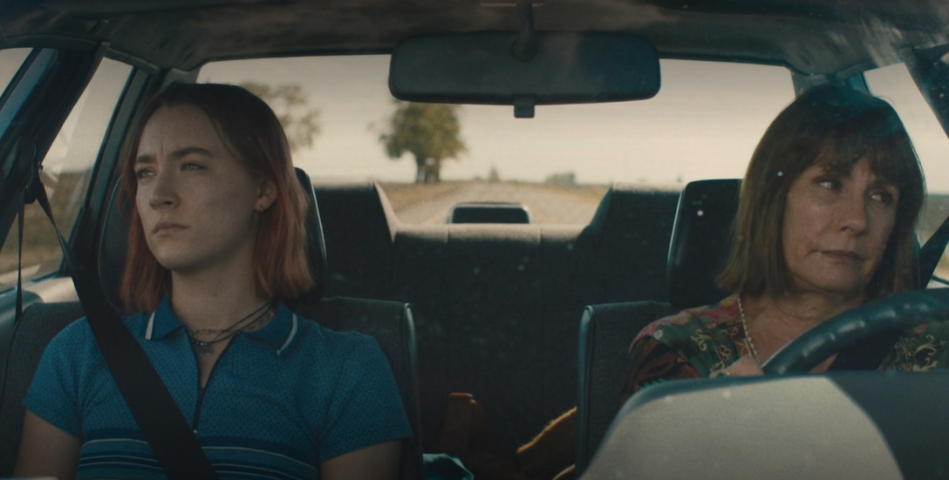
V/O: We see a mom and daughter in a car in total silence. Tension is thick in the air, nobody is talking. Words on the screen say: That awkward silence after you have just been caught vaping. Disappointment is written all over the mom’s face. The teen can’t meet her eyes. Words on the screen say: Most vapes contain high levels of nicotine and disappointment. The Real Cost.

1A_3 _PRE (Possessed)
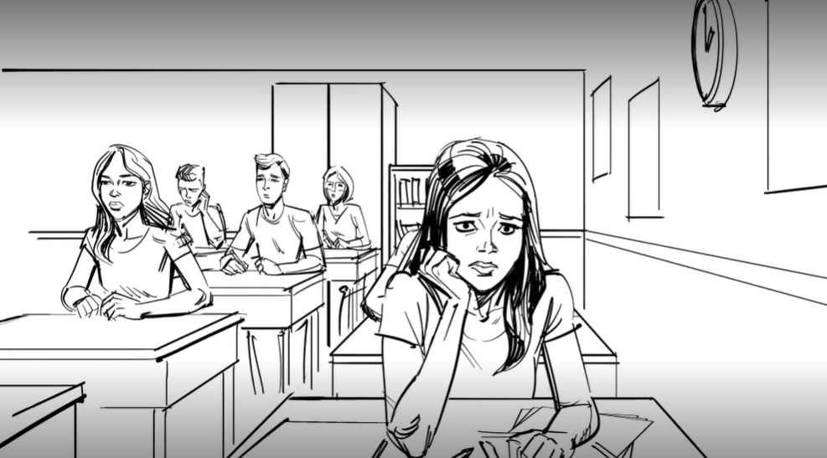
V/O: This commercial begins with a student in a high school class. She looks at the clock then back at the teacher. Suddenly, she’s yanked from her seat as if she’s being pulled sideways by an unseen force. Her classmates are stunned. She slowly bends over backwards. Once her hands reach the floor behind her, she spider walks down the aisle. Her classmates are horrified. She leaves the classroom and continues to spider walk into the girls restroom. She stands up straight. She takes a vape out of her pocket. A voice says: Whether you vape or smoke cigarettes, nicotine cravings can take control of you.

1A_4_PRE (Epidemic)
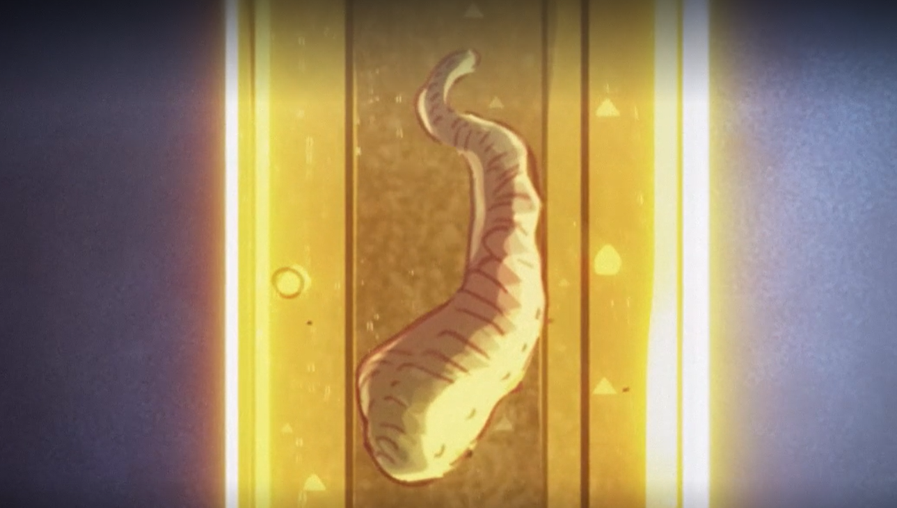
V/O: This commercial starts with an organism floating in a vile of liquid. There’s a disease spreading and just 10 seconds from exposure, it can reach your brain. Once there, it can make changes. If you vape, you may be infected by nicotine, which can lead to a disease called addiction. See how to stay safe on TheRealCost.gov.

1A_5_PRE (No Vape in Team - Cheer)

V/O: This commercial opens on a cheerleading team about to perform at a competition. The cheerleaders are on stage, focused and locked-in. They launch into a round of smaller group stunts. The cheerleaders are completely in sync as they perform, lifting their teammates high in the air. The routine goes off like clockwork. Then the whole team comes together to form a human pyramid. Everyone is perfectly in place for the big lift, except for a single cheerleader, out of breath, doesn’t quite make it to her spot in time. As the cheerleader struggles to catch her breath, her grip slips and so does she, bringing her team down with her. We hear a voice say:
“When one of us can’t get it done, we all cant get it done.”
We cut to the locker room, where the cheerleader who couldn’t catch her breath sneaks a hit from her vape.
“Many vapes can contain toxic chemicals that can irreversibly damage your lungs, making you the weak link.”

1A_6_PRE (No Vape in Team - Reps)
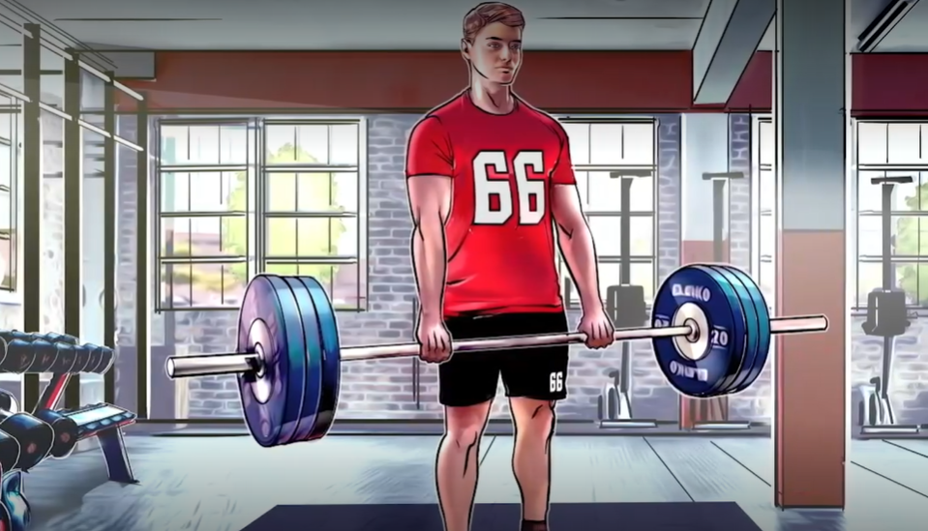
V/O: This commercial follows four members of the same high school football team and shows how their actions of the field impact their entire team. We see one of the players lifting weights. We hear a voice say:
“Every pound you lift, makes us all stronger. Every step you climb makes us all faster. Every minute you study, we all get smarter. Every rep you take is a rep we all take. And every rip you take is a rip the team takes.”
When you vape, you can inhale toxic chemicals that irreversibly damage your lungs.
“If you lose a step, we all lose a step.”

1A_7_PRE (AIP Toilet)
V/O: This commercial begins with an anxious girl frantically taking something out of her purse. She accidentally drops it, and it falls into the toilet.
Announcer: What drug is so addictive, you would do anything to get it?
V/O: We see that it’s a vape. She debates whether to hit it.
Announcer: The most popular vapes contain seriously addictive levels of nicotine. Whether you are addicted to vapes or something else, addiction isn’t pretty.
1A_8_PRE (Macroscopic Metals)
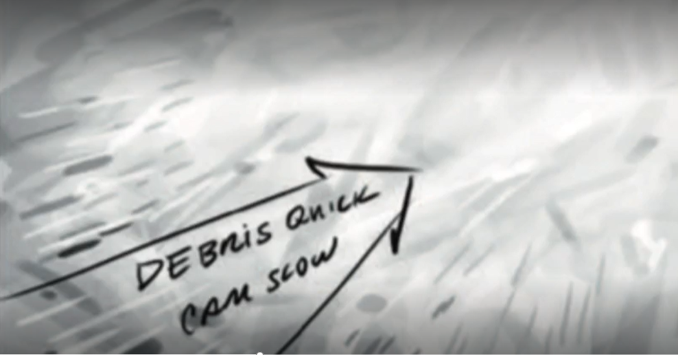
V/O: We start by seeing a dark abyss. Then a cloud up close as metallic shards begin to break through the surface. The sharp objects form a chaotic storm and move through a tube-like structure crashing into the walls. The camera slows as we float upwards towards a light and suddenly we are in a smoky calm as we see the end of a vape pen. The smoke clears, and now we see the face of a teenager as he removes a vape from his mouth. A voice says:
“There’s a lot more to vapes than vapor. If you vape, you could be inhaling metals like nickel, chromium and lead that can damage your lungs.”
1B Ads (Post-Production Vapes)

1B_1 _POST (Scary Enough)
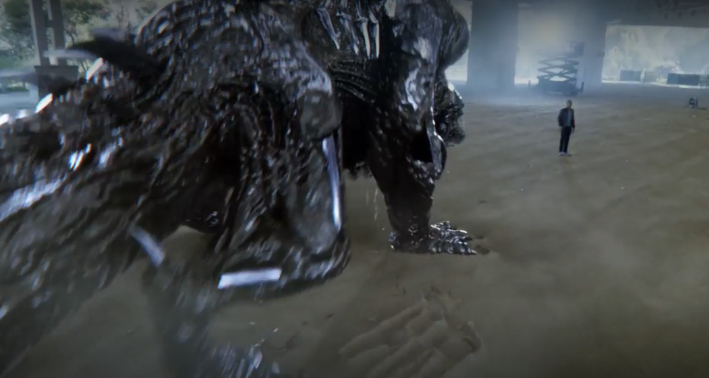
V/O: If you vape, you could be inhaling toxic metals into your lungs. To show how scary that is, we made a metal monster with special effects that show metal particles being inhaled and music, music that will make your heart racing. But nothing is as scary as the facts – vaping can deliver toxic metals like nickel and lead into your lungs. That’s metal – in your lungs.

1B_2 _POST (Awkward Silence)
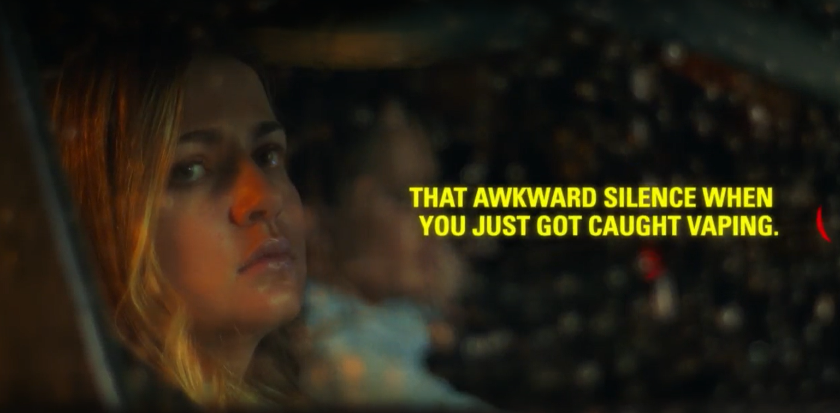
No V/O – Text on screen: That awkward silence when you just got caught vaping. Most vapes contain high levels of nicotine. And disappointment.
1B_3 _POST (Possessed)
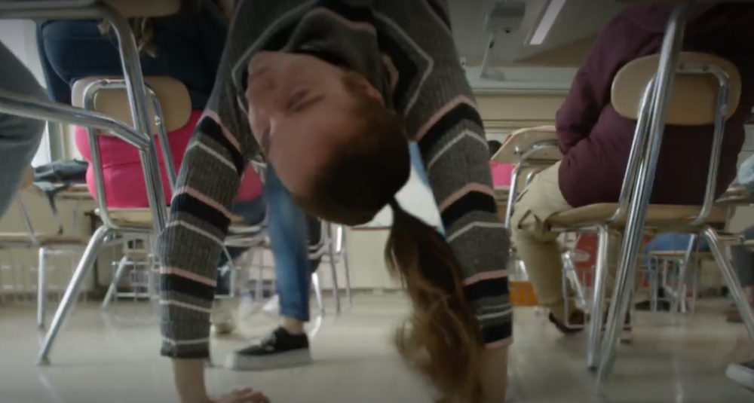
V/O: If you vape, nicotine cravings can take control of you. Are you possessed by nicotine?

1B_4 _POST (Epidemic)
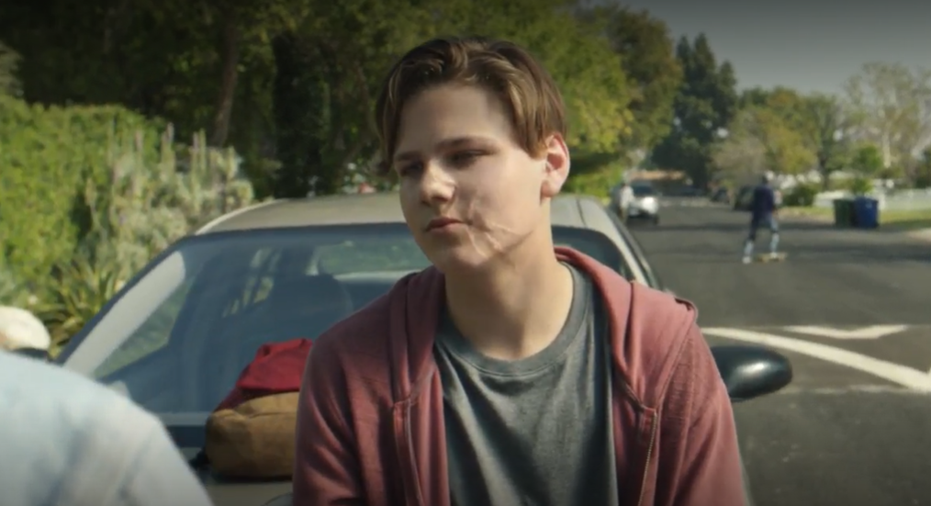
V/O: There is an epidemic spreading. Scientists say it can change your brain. It can release dangerous chemicals like formaldehyde into your bloodstream. It can expose your lungs to acrolein which can cause irreversible damage. It’s not a parasite, not a virus, not an infection. It’s vaping.

1B_5 _POST (No Vape in Team - Track)
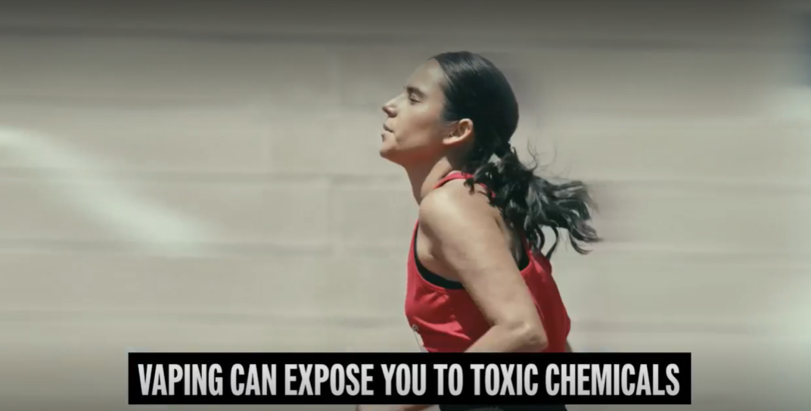
Text on screen: Vaping can expose you to toxic chemicals that can damage your lungs and the team.
“If I fall behind, we all fall behind.”
Text on screen: There’s no vape in team.

1B_6 _POST (No Vape in Team - Football)
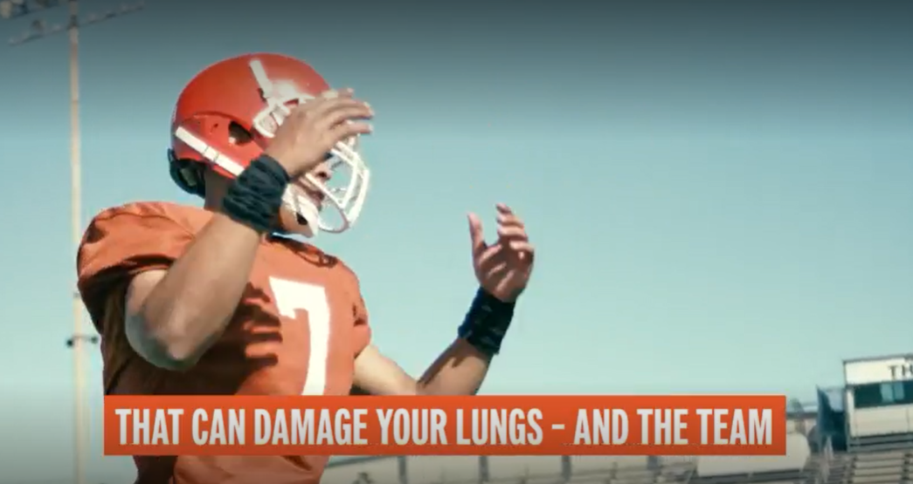

Text on screen: Vaping can expose you to toxic chemicals that can damage your lungs and the team.
“When one of us comes up short, we all come up short.”
Text on screen: There’s no vape in team.

1B_7 _POST (Addiction Isn’t Pretty - Toilet)
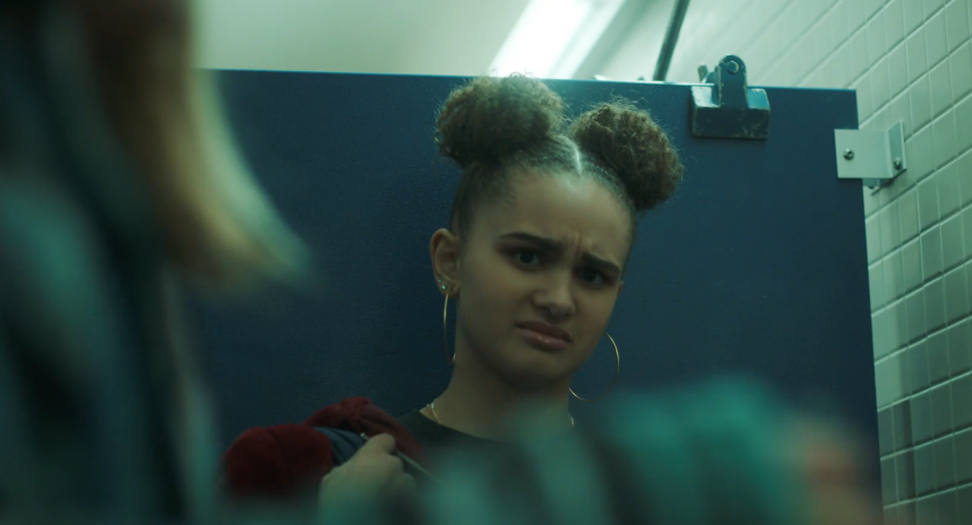
Description: Two teens chatting in bathroom stall at school. One teen drops vape into toilet. Other teen: “Ewww…” First teen fishes it out of toilet and takes a hit.
Text: Most vapes contain seriously addictive levels of nicotine.

1B_8_POST (Macroscopic Metals)
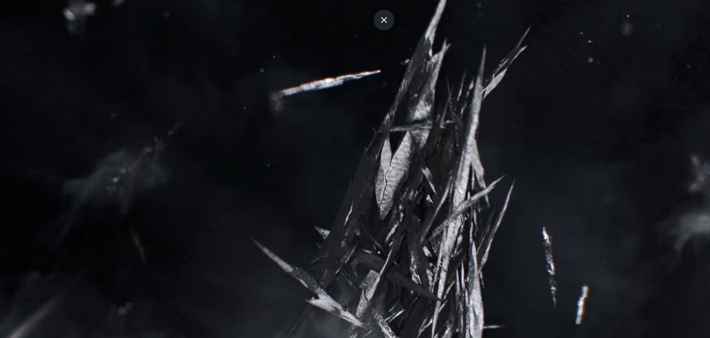
Description: The ad uses a visual depiction of shards of metal particles hurtling through the air into a cloud of smoke. The shards are revealed to be toxic metals found in vapes.
V/O: If you vape nicotine, you could be inhaling toxic chemicals like nickel, chromium and lead that can damage your lungs.

2A Ads (Pre-Production Cigarettes)
2A_1_PRE (Said Every Smoker Ever)
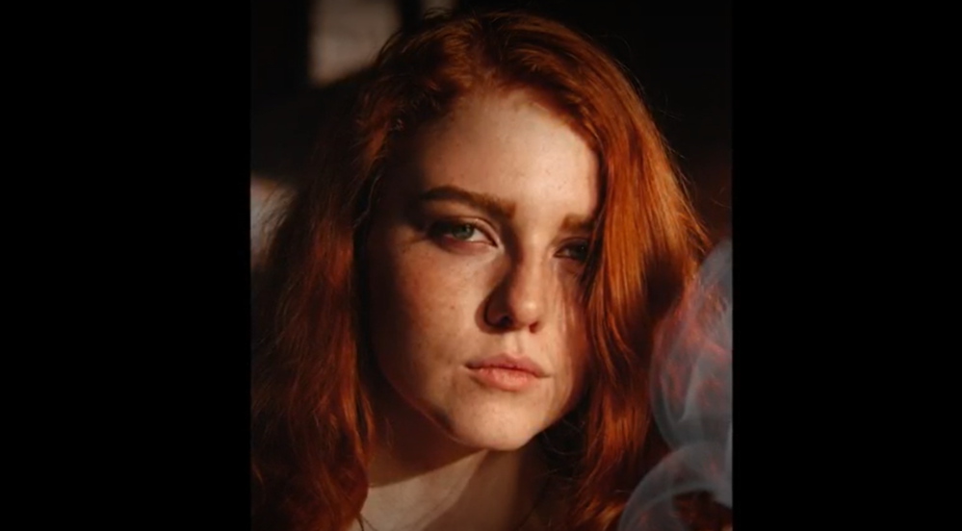
V/O: This commercial begins with a teen, cigarette in hand, speaking defiantly to camera. But something strange will happen halfway through as her voice will change into different voices.
“My parents got hooked on cigs, but the thing is I’m not my –”
“Parents. I’m way more aware of all of the –”
“Dangers and stuff.”
“And definitely won’t make their mistake.”
“Said every –”
“Smoker—”
“Ever.”
And now we see why her voice changed halfway through. Her dialogue was finished by older smokers who kind of knew what she going to say. An announcer says:
“3 out of 4 smokers will smoke well into adulthood.”

2A_2_PRE (Auctioneer)
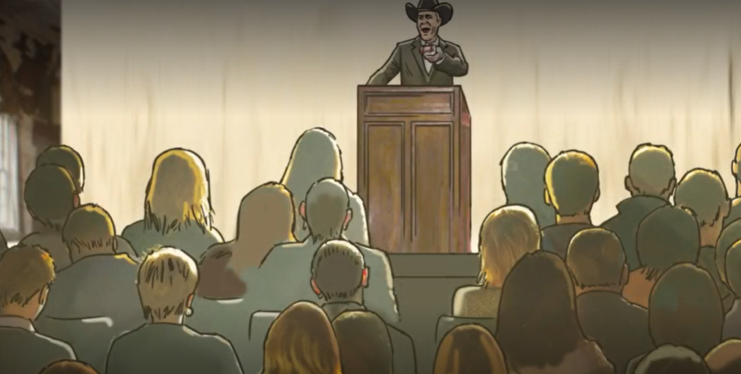
V/O: This commercial opens on an auction house. The audience is made up of teens. They don’t seem happy to be there. An auctioneer stands at the podium.
“What do we pay for this bad boy right here?”
We can’t make out what the audience is bidding on.
“We’re going to start the bidding at a good night’s sleep. Good night, good night sleep. Who wants to pay with a good night’s sleep?”
A girl reluctantly raises her hand. Two girls watching look concerned.
“Hey now, who will pay with their ability to concentrate? Who wants to give up their ability to concentrate?”
Another teen slowly raises his hand to make a bid, and the crowd reacts with more sadness as the price gets steeper.
“The gentlemen parts with his ability to concentrate. Who wants to pay with their piece of mind? Who wants to offer up their piece of mind?”
Another boy slowly raises his hand.
“Anybody want to top piece of mind? Going once… twice… sold.”
We finally see what the audience has been bidding on – cigarettes. What’s the price of a pack of cigarettes? Your mental health. Smoking cigarettes as a teen can have long-lasting effects, like anxiety.

2A_3_PRE (Little Lungs - Snowboarding)
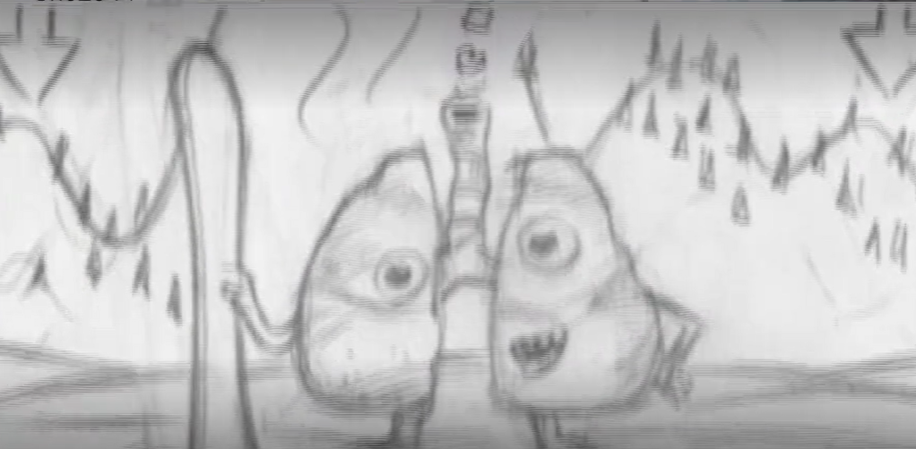
Jingle: Little lungs in a great big world.
V/O: This is a story about a pair of little lungs that smoked as a teen and never grew to normal size.
“Hey little lungs – want to come snowboarding with us?”
“Sounds great! Count me in…. my little lungs can’t get enough air. Ahhhhhh….[falls]”
Smoking as a teen can stunt your lungs. Leaving them little forever.

2A_4_PRE (Little Lungs - Celebrity)
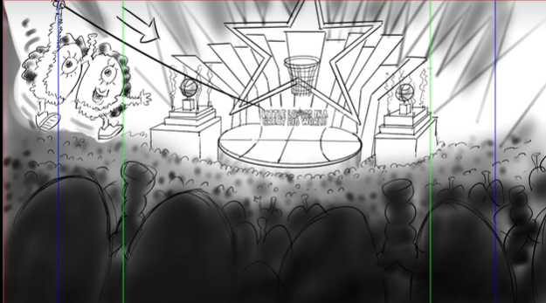
“Little lungs in a great big world… with me, Sky Katz.
Alright little lungs, who smoked as a teen and never grew to normal size, you ready to get saucy with our big duet?”
“Oh yeah.”
Singing: “Who got the drip? Sky’s got the drop. I’m saucy…”
Little Lungs: “My little lungs can’t handle the sauce.”
V/O: Smoking as a teen can stunt your lungs, leaving them little forever.
“You killed it Little Lungs.”
Little Lungs: “…In a great big world..”

2A_5_PRE (Gift)
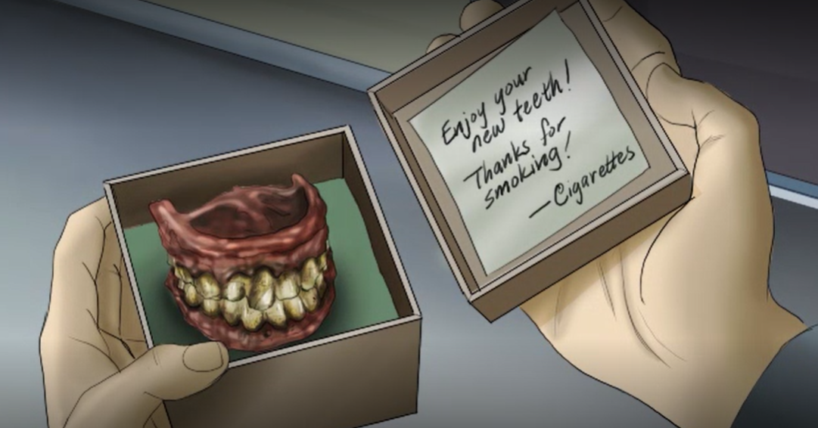
V/O: This commercial begins outside an ordinary house where a teen is hanging out on his front porch. There’s a puff of smoke floating away from him like he’s just finished smoking.
A delivery man approaches, holding a package. There’s something slightly off about him, and his package has a red ribbon around it as if it’s a gift.
“Package for James McCoy”
“Yeah, that’s me. Who is it from?”
It doesn’t say. The teen takes the package with a mix of curiosity and suspicion. He looks back up but the delivery man is gone. When he opens the box, he sees a tiny note written to him saying: “Enjoy your new teeth! Thanks for smoking! -Cigarettes”
He looks in the box and realizes that it’s a set of ugly, disgusting, yellow-stained teeth. He recoils in horror, realizing what smoking is doing to him. We hear an announcer say:
“Once you start smoking, the consequences aren’t far behind. Cigarettes may leave you with stained teeth, wrinkled skin and more. Know the real cost.”

2A_6_PRE (Contract)
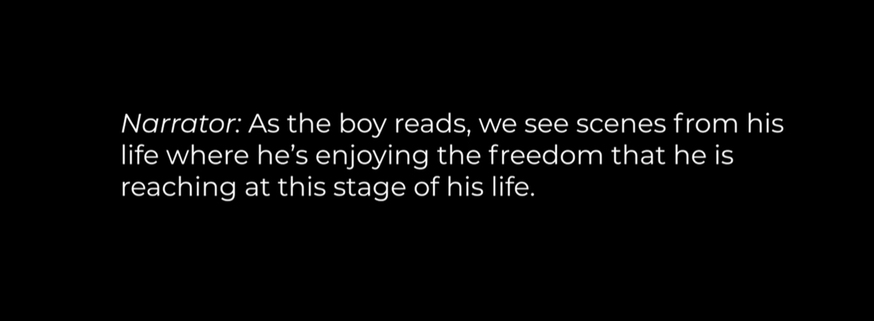

Text and V/O only.
V/O and Text: We see words scrolling by on a wall. As the camera rolls from top to bottom, we hear the voice of a young man reading what seems like some sort of contract.
As the boy reads, we see scenes from his life where he’s enjoying the freedom that he is reaching at this stage of his life.
For example: We see the kid coming out of a barber shop with a brand new mohawk. We see him locking the door to his bedroom. We see him driving his dad’s car with his friends.
V/O: I, Steve Ryan Jordan, at this stage of my life where I finally have control over my actions, Where I can lock the door to my bedroom, I can dress as I please, manage my time, and have my own transportation.
As the boy reads this part, we see him losing part of his freedom.
V/O: With my life under complete control, I agree by this contact, to be bound to you for a indefinite period of time. To let you have my money to your liking, to leave any place, reunion or party, the minute you tell me to. To put a halt to anything I’m doing and go outdoors, whether its pouring or snowing, day or night. In this simple act, I give you control of a big part of my life.
At that moment, the camera zooms out and we see that the contract was inside a cigarette all along. The camera keeps on zooming out and we see that the cigarette is in between the fingers of the boy. Then words on the screen appear:
“EVERY TIME YOU LIGHT UP YOU SIGN UP FOR THIS. DON’T LET TOBACCO CONTROL YOU. 3 out of 4 teens who think they will stop smoking in 5 years don’t. therealcost.gov.”

2A_7_PRE (Smoke Army)
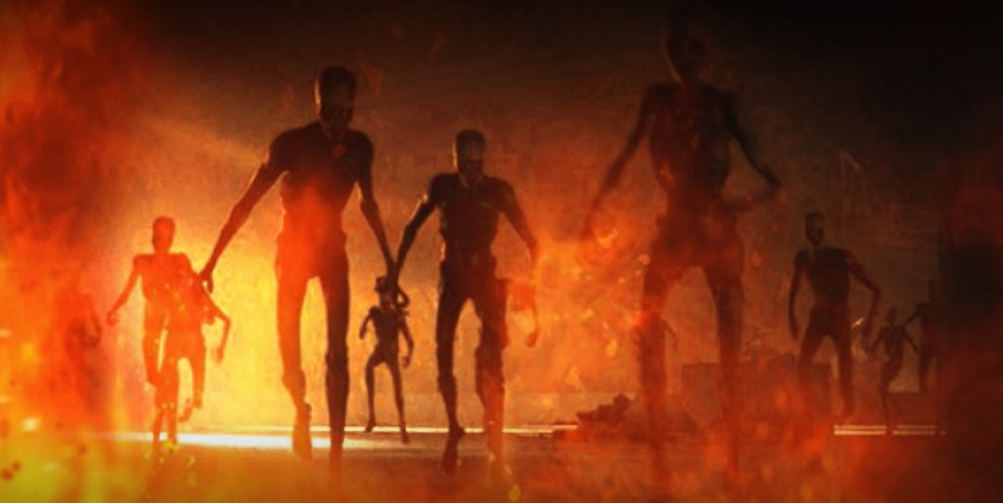
V/O: This commercial begins with a teenage boy leaving his house and walking to the woods behind it. He stops and reaches into his pockets to pull out a pack of cigarettes. And then something strange happens: In the woods, horrifying creature begin to stir, rising from the tarry muck. They look unhuman, evil, toxic. More and more of them stir and rise and begin to lurch in direction, like an army gearing for battle. Meanwhile, the boy is unaware of the activity. He strikes a match to light his cigarette. And now the creatures are running, charging. The boy now sees them coming and is scared, frozen. As more and more of the creatures charge the boy, something weird happens. They turn to smoke and enter the boy’s mouth and lungs in one long stream. And suddenly, the world is back to normal as the boy exhales cigarette smoke. A voice says:
“Every time you smoke, over 7,000 chemicals are coming for you. So before you smoke one, find out what’s in one.”

2A_8_PRE (Tooth)
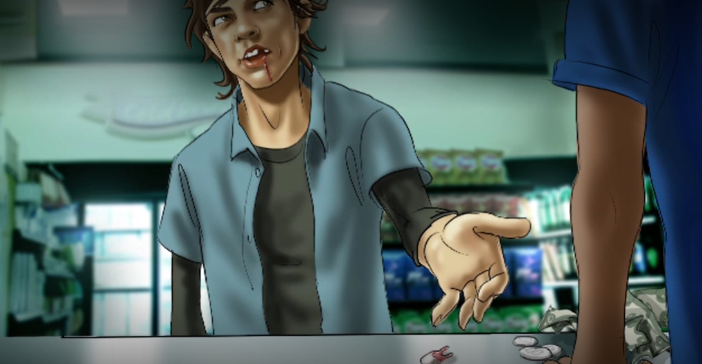
V/O: This commercial begins as a young man walks towards a convenience store. He enters and places some money on the counter. But the cashier just stares at the money – it’s apparently not enough. The young man sighs, he looks nervous. He grips one of his teeth with pliers and struggles to yank it out. An announcer says:
“What does a pack of smokes cost? Your teeth. Smoking can cause serious gum disease that makes you more likely to lose your teeth than someone who doesn’t smoke.”
The boy places the bloody tooth on the counter next to the money. Now he’s paid enough, and we hear him rung up. The announcer continues, saying:
“Cigarettes. What are they costing you?”

2B Ads (Post-Production Cigarettes)
2B_1_POST (Said Every Smoker Ever)
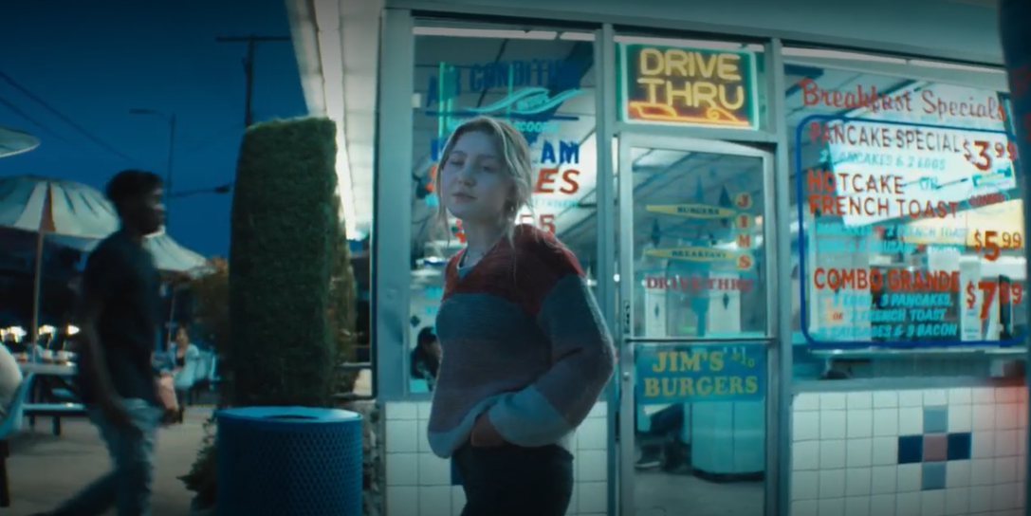
Teen: Look, I only do it with friends. Every now and then, and only while I’m young. My parents got hooked on cigs, but –”
(an older voice synced to her talking) “the thing is, I’m not my parents.”
(a different older voice synced to her talking) “I’m way more aware of the dangers of smoking –”
(a different older voice synced to her talking) “And definitely won’t make their mistake.”
Teen: You saw what smoking did to Jesse’s mom –"
(a different older voice synced to her talking) “You can’t be smoking those things while you’re older.”
(a different older voice synced to her talking) “Gotta stop before you’re hooked.”
Older adults: “Said every smoker ever.”
Text: 3 out of 4 teenage smokers stay smokers.

2B_2_POST (Auctioneer)
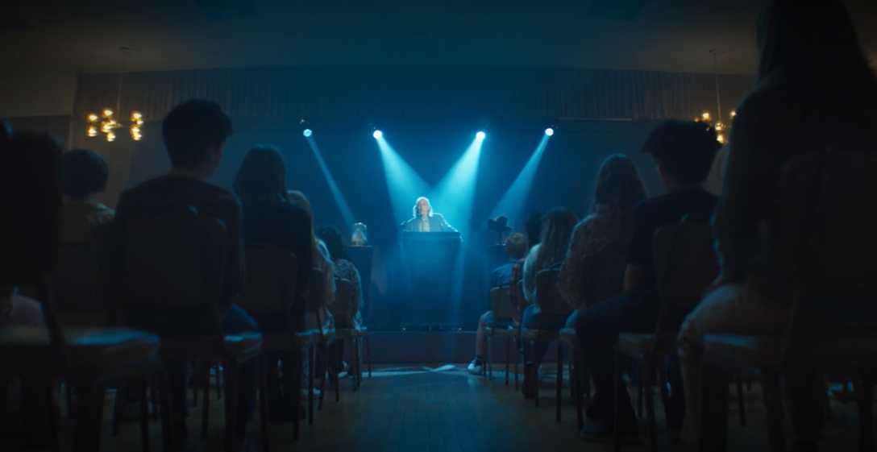
Auctioneer: Let’s start the bidding with a good night’s sleep. Are you willing to give up a good night’s sleep? Who is willing to give up a good night’s sleep? Thank you sir, for giving up a good night’s sleep.
Who will pay with their ability to concentrate? Thank you sir, for parting with your ability to concentrate.
Who is willing to pay with their piece of mind? Thank you, young lady, for paying with your piece of mind.
Going once.. going twice… sold.
V/O: What’s the price for a pack of cigarettes? Your mental health. Cigarette cravings can lead to anxiety.

2B_3_POST (Little Lungs - Snowboarding)
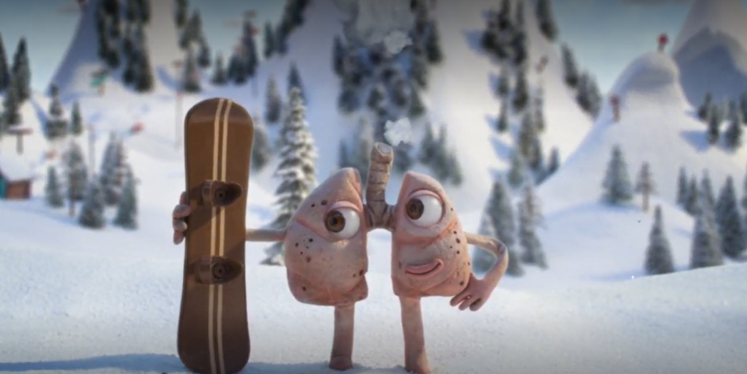
Jingle: Little lungs in a great big world.
V/O: This is a story about a pair of little lungs that smoked as a teen and never grew to normal size.
“Hey little lungs – want to come snowboarding with us?”
“Sounds great! Count me in….
“Speed up!”
“My little lungs can’t get enough air. Ahhhhhh….[falls]”
Smoking as a teen can stunt your lungs. Keeping them little forever.
“Ah, poor little lungs.”

2B_4_POST (Little Lungs - Celebrity)
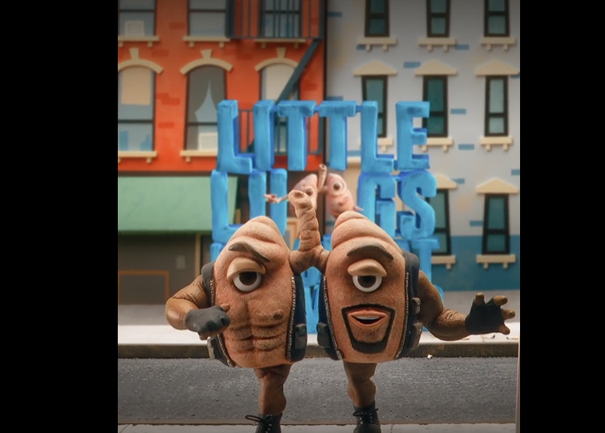
Terry: Little lungs in a great big world – with me, Terry Crews.
LL: My stunted lungs can’t handle the stunt. That was close!
Smoking as a teen can stunt your lungs, keeping them little forever.

2B_5_POST (Gift)
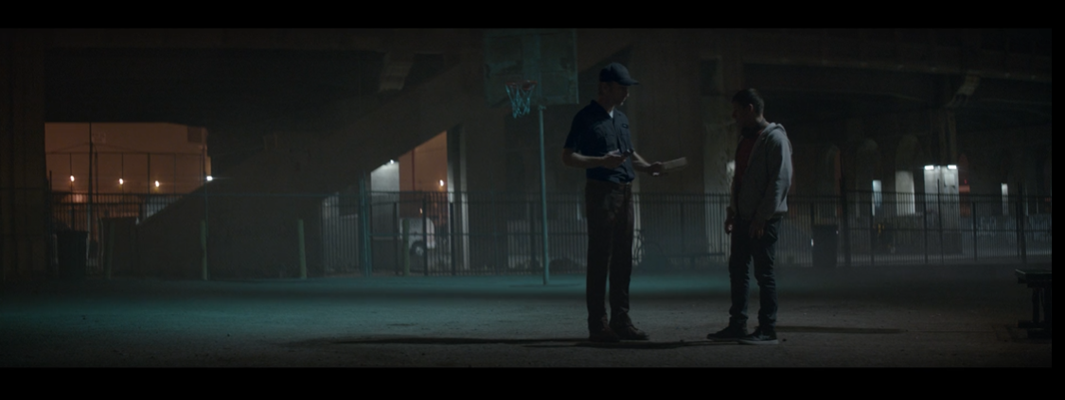
Description: Delivery man approaches boy:
“Delivery for James Meisner.”
Description: He opens the package to see disgusting teeth.
“Once you start smoking, the consequences will find you.”
Description: He looks back and sees the package is empty. It is now in his mouth.
“Cigarettes may leave you with stained teeth, gum disease, and more.”

2B_6_POST (Contract)
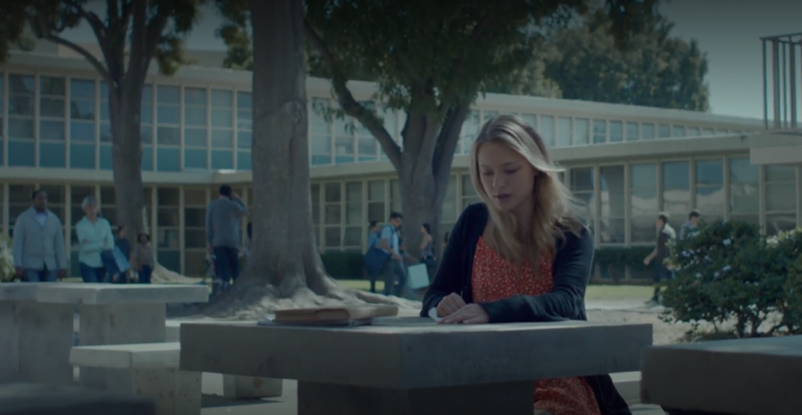
“I, Amanda Green, at the point of my life when I’m not a kid anymore. Now that I finally have freedom to define who I am, I hereby agree to be bound to you, to let you decide how I spend my money, to let you set my boundaries, and to come running the instant you snap your fingers. With this contract, I relinquish part of my freedom to you.”
V/O: There’s a contract in every cigarette. When you light up, you sign up. Don’t let tobacco control you.

2B_7_POST (Smoke Army)

2B_8_POST (Teeth)
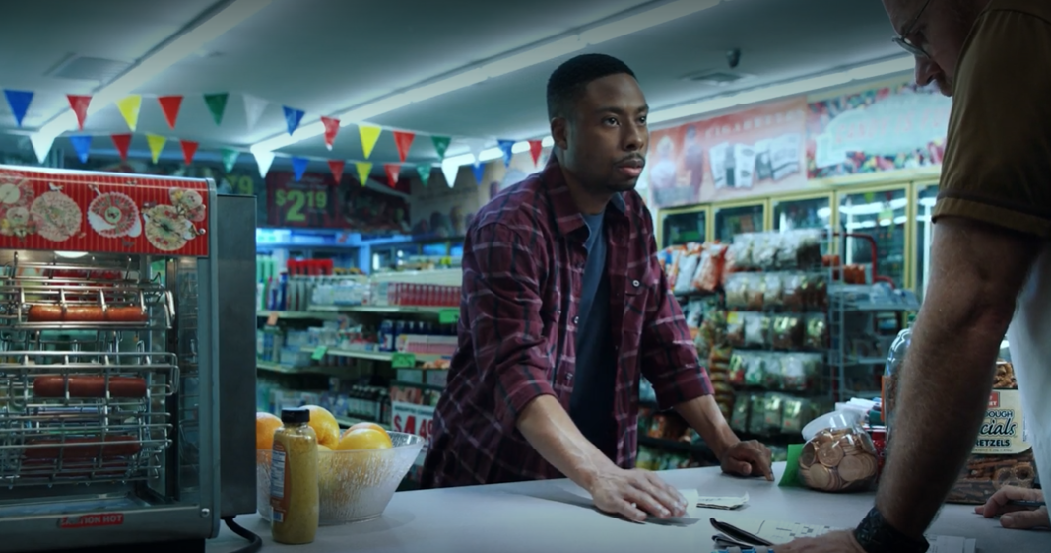
Teen: Pack of cigarettes please.
Cashier: It’s not enough.
Description: Teen takes pliers out and removes a bloody tooth and puts on the counter.
V/O: What’s a pack of smokes cost? Your teeth. Smoking can cause serious gum disease that makes you more likely to lose them.
Cashier: See you again.
V/O: What are cigarettes costing you?

