Ryan White HIV/AIDS Program (RWHAP) Tree Testing Script (Test Instrument)

Welcome Message
Thank you for participating in the study for HRSA’s Ryan White HIV/AIDS Program website.
This activity will take you 20 to 25 minutes to complete.
Your response will help us understand how to organize the content on our website and make it more useful for you.

Instructions
Here's how it works:
You will be asked to find a certain item and presented with a list of links.
- Click through the list until you arrive at one that you think helps you complete the task.
- If you take a wrong turn, you can go back by clicking one of the links above.
- This is not a test of your ability, there are no right or wrong answers.
That's it, let's get started!

According to the Paperwork Reduction Act of 1995, no persons are required to respond to a collection of information unless it displays a valid OMB control number. The valid OMB control number for this information collection is 0990-0379. The time required to complete this information collection is estimated to average 30 minutes per response, including the time to review instructions, search existing data resources, gather the data needed, and complete and review the information collection. If you have comments concerning the accuracy of the time estimate(s) or suggestions for improving this form, please write to: U.S. Department of Health & Human Services, OS/OCIO/PRA, 200 Independence Ave., S.W., Suite 336-E, Washington, DC 20201, Attention: PRA Reports Clearance Officer.

Tasks
To ensure unbiased results, the tasks will be presented in a random order. This will prevent participants from approaching later tasks differently based on their experience with earlier ones, leading to more accurate insights.
ID | User Journey | Task | Success Metric
1. | Find available HIV care and support | You want to learn what support and care services the Ryan White HIV/AIDS Program offers for people living with HIV/AIDS. Where would you expect to find information? | HIV Care > Available Care & Services
2. | Learn about the Ryan White Program | You would like to learn more about how the Ryan White HIV/AIDS Program is structured. Specifically, you are interested in Special Projects of National Significance (SPNS), which is included in Part F of the Ryan White HIV/AIDS Program. Where would you expect to find more details about SPNS? | About the Program > Program Parts and Initiatives > Part F > Special Projects of National Significance (SPNS)
3. | Find available HIV care and support | You want to find an HIV/AIDS service provider in your area. Where would you expect to find that information? | HIV Care > Find a provider  Or  Home Page > Find a Ryan White HIV/AIDS Program Medical Provider
4. | Contact for support | You want to contact the Division of Metropolitan HIV/AIDS Programs of the Ryan White HIV/AIDS Program (Part A). Where would you expect to find this contact information? | About the Program > Contact > Division of Metropolitan HIV/AIDS Programs  Or  Home Page > Contact Us
5. | Find available HIV care and support | You need to call the HIV/AIDS hotline in your state. Where would you expect to find this contact information? | HIV Care > State HIV/AIDS Hotlines  Or  Home Page > State Hotlines
6. | Find Funding Opportunities | Your organization is planning to apply for a Ryan White HIV/AIDS Program grant. Where would you go to find grants currently accepting applications? | Grants > Find Funding  Or  Home Page > Find Funding
7. | Manage and maintain RWHAP grant | Your organization is a current Ryan White HIV/AIDS Program grant awardee, and you want to know who to contact for technical assistance with your grant management. Where would you expect to find this information? | Grants > Manage Your Grant > Grant Recipient Resources
8. | Build skills and knowledge on RWHAP/HIV | You are interested in exploring the impact of the Ryan White HIV/AIDS Program. You are looking for journal articles on HIV/AIDS topics funded and authored by HRSA. Where would you expect to find a list of journal articles? | Resources > eLibrary
9. | Build skills and knowledge on RWHAP/HIV | You are looking for data on how the Ryan White HIV/AIDS Program responded to the coronavirus disease 2019 (COVID-19) pandemic. Where would you expect to find that data report? | Data > Data Reports and Slide Decks > COVID-19 Data Report
10. | Find Funding Opportunities | You are interested in learning about organizations that were awarded Ryan White HIV/AIDS Program Part C grants in FY 2021. Where would you expect to find the list of grant awards? | About the Program > Program Parts and Initiatives > Part C
11. | Manage and maintain RWHAP grant | As a public health professional, you are seeking guidelines on HIV-related protocols and clinical practices that the Ryan White HIV/AIDS Program grantees should adhere to. Where would you expect to find these guidelines? | Grants > Clinical Care Guidelines and Resources
12. | Manage and maintain RWHAP grant | You are looking for a new policy notice that was released by the Ryan White HIV/AIDS Program. Where would you expect to find it? | Grants > Policy Notices
13. | Build skills and knowledge on RWHAP/HIV | You are interested in finding data on the number of people served by the Ryan White HIV/AIDS Program by race/ethnicity and age in 2020. Where would you expect to find this information? | Data > Data Reports and Slide Decks > RWHAP Annual Client-Level Data Report  Or  Data > Compass Data Dashboard
14. | Learn about the Ryan White Program | You are looking for information on the funding allocations for each part of the Ryan White Program in FY 2020. Where would you expect to find that information? | About the Program > Budget

Pre-Test Question
These questions will appear before the tasks to gather key demographic information for each participant.
- How would you describe or classify your organization?
  - RWHAP Grant or Cooperate Agreement Recipient
  - RWHAP Partner and/or Stakeholder Organization
  - Other [Please specify]

- Is your organization in an urban, rural, or tribal area?
  - Urban
  - Rural
  - Tribal

- How often do you typically visit the Ryan White website?
  - Multiple times per day
  - Once a day
  - Several times per week
  - Once a week
  - A couple times per month
  - Once a month
  - Less than once a month

- What is your typical reason for visiting the Ryan White website?
  - Check news about the Ryan White Program
  - Find available HIV care and support
  - See open funding opportunities
  - Find support for managing and maintaining RWHAP grants
  - Find contact information
  - Find reports and data
  - Other [Please specify]

Post-Task Question
- How confident are you that you completed the task correctly?
- Very confident
- Somewhat confident
- Not confident at all
- Other [Please specify]

Post-Study Questions
- Can you identify a task that you found challenging during the test?

- Can you identify a task that you found easy?

- Were there any parts of the test that were confusing or unclear to you?
  - The menu structure was unclear.
  - The labeling was unclear.
  - The terminology or language used in the tasks was confusing.
  - The instructions for the tasks were unclear.
  - No, everything was clear and easy to understand.
  - Other [Please specify]
- We would greatly appreciate any additional feedback.

Thanks
All done, awesome! Thanks again for your participation. Your feedback is incredibly useful in helping to determine how our content should be organized, so we can make our website easier to use.
You may now close this window or navigate to another webpage.

Sitemap
- About the Program
  - Who Was Ryan White?
  - Programs Parts & Initiatives
    - Part A
    - Part B
    - Part C
    - Part D
    - Part F
      - AIDS Education and Training Center (AETC) Program
      - Special Projects of National Significance (SPNS)
      - Dental Programs
      - Minority AIDS Initiative
  - Legislation
  - National Strategies
  - Budget
  - History
      - 30th Year Anniversary
      - Living History
  - Contact
    - HHS Employee Directory
    - Key Staff
    - Office of the Associate Administrator
    - Office of Program Support
    - Office of Operations and Management
    - Division of Community HIV/AIDS Programs
    - Division of Metropolitan HIV/AIDS Programs
    - Division of Policy and Data
    - Division of State HIV/AIDS Programs
- HIV Care
  - State HIV/AIDS Hotlines
  - Available Care & Services
  - Find a Provider
  - National Clinician Consultation Center
- Grants
  - Find Funding
  - Manage Your Grant
    - Grant Recipient Resources
    - CAREWare
    - Reporting Requirements
  - Coronavirus (COVID-19)
  - Policy Notices
  - Program Letters
  - Clinical Care Guidelines and Resources
  - Quality of Care
  - Performance Measure Portfolio
  - Audit Reports
- Data
  - Data Reports and Slide Decks
    - Slide Decks
    - RWHAP Annual Client-Level Data Report
    - Ending the HIV Epidemic in the U.S. Initiative Data Report
    - COVID-19 Data Report
    - AIDS Drug Assistance Program (ADAP) Data Report
    - Oral Health Data Report
    - AIDS Education and Training Centers (AETC) Reports
    - Special Population Reports
  - Biennial Reports
  - Compass Data Dashboard
- Resources
  - Mpox Information
  - Videos
  - Fact Sheets
  - Infographics
  - Expert Panel Summaries
  - eLibrary
  - Newsletters
  - Provider Resources
    - Access Trainings and Curriculum
    - Get Clinical Advice
    - Follow Clinical Guidelines
  - Webinars
- Home Page
  - Search
  - Bureaus and Offices
  - Newsroom
  - Sitemap
  - Contact Us
  - Who Was Ryan White?
  - State Hotlines
  - Find Funding
  - TargetHIV
  - Find a Ryan White HIV/AIDS Program Medical Provider

Test Screenshots
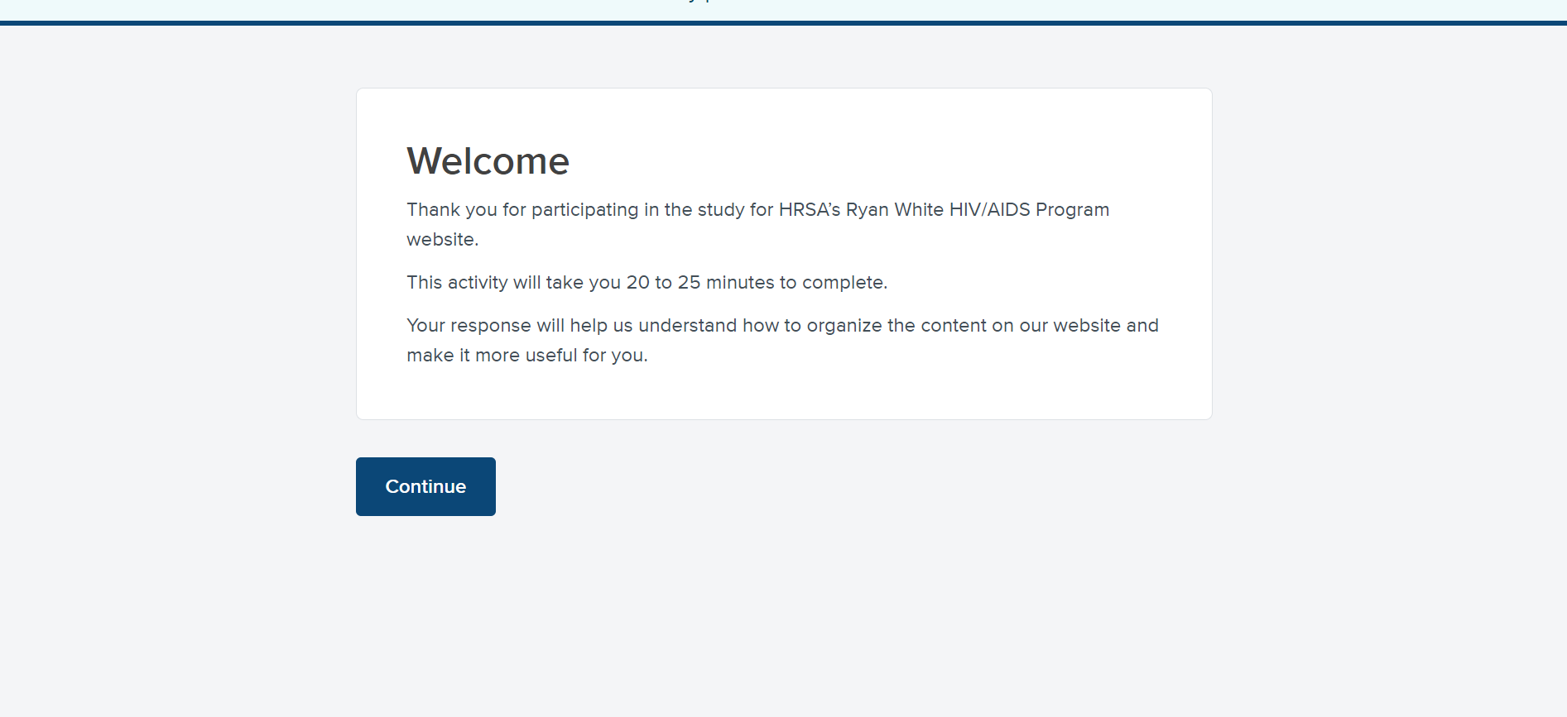Image 1: Welcome
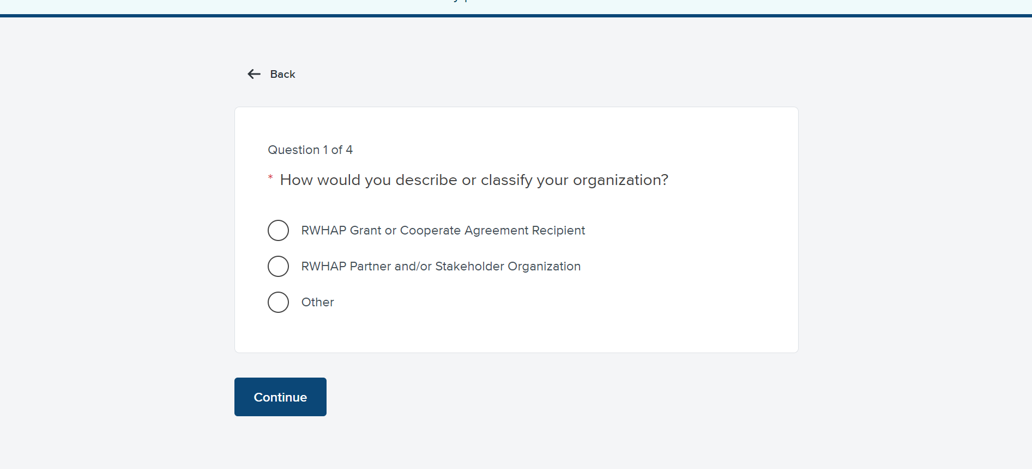Image 2: Pre-test question 1
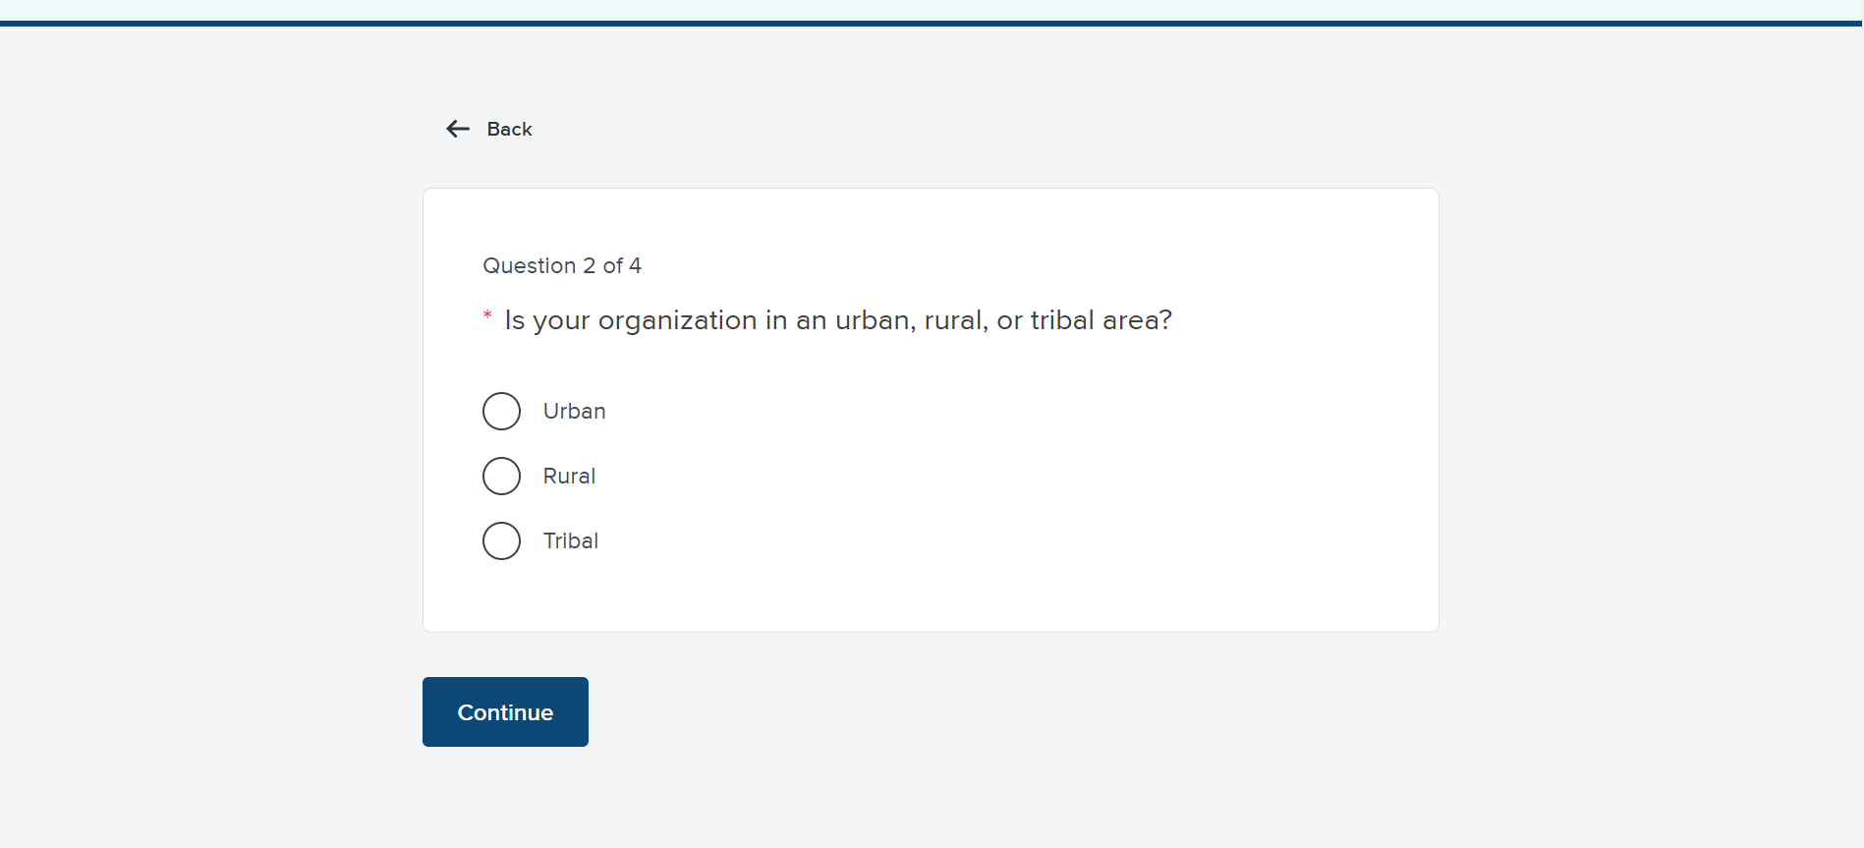Image 3: Pre-test question 2
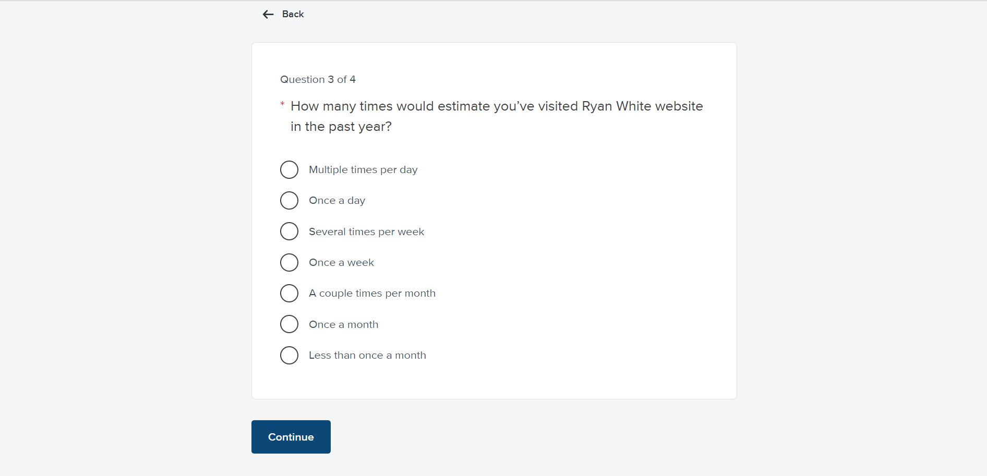Image 4: Pre-test question 3
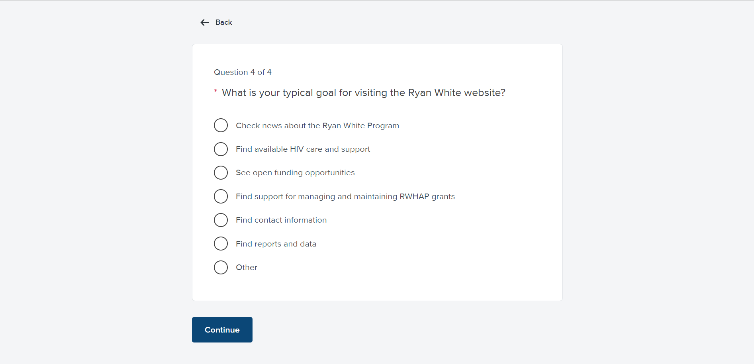 Image 5: Pre-test question 4
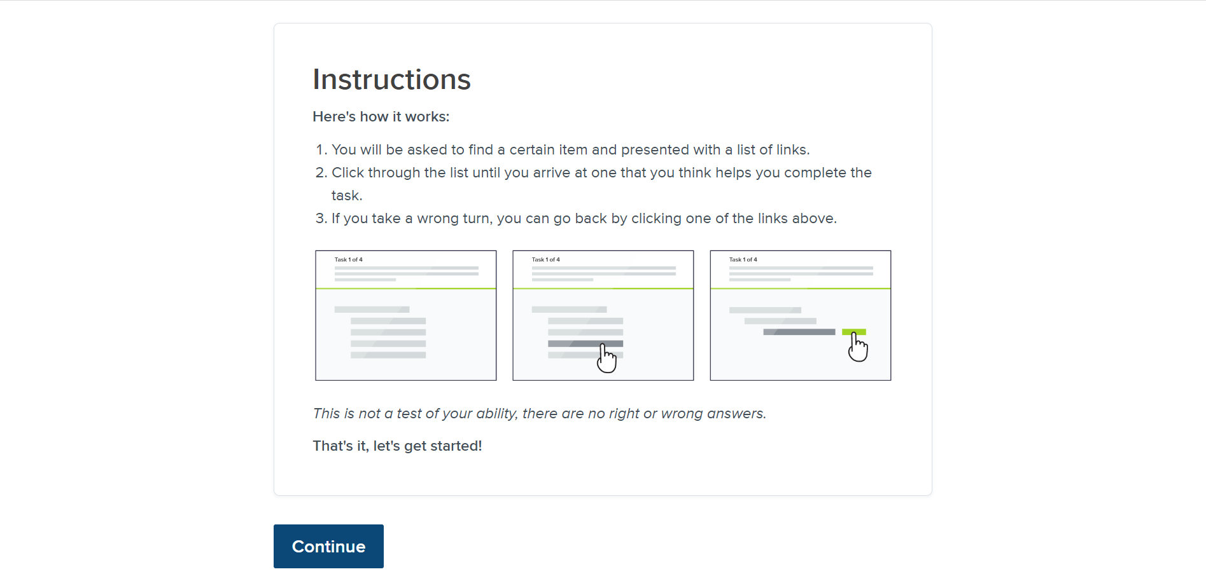Image 6: Introduction
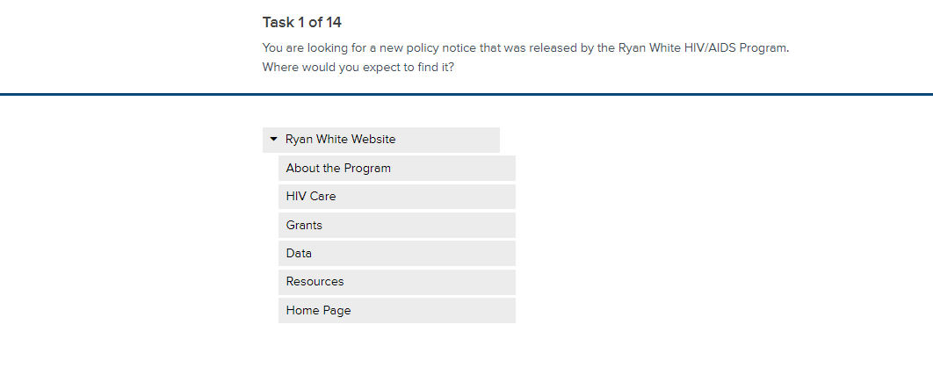
Image 7: Task 1
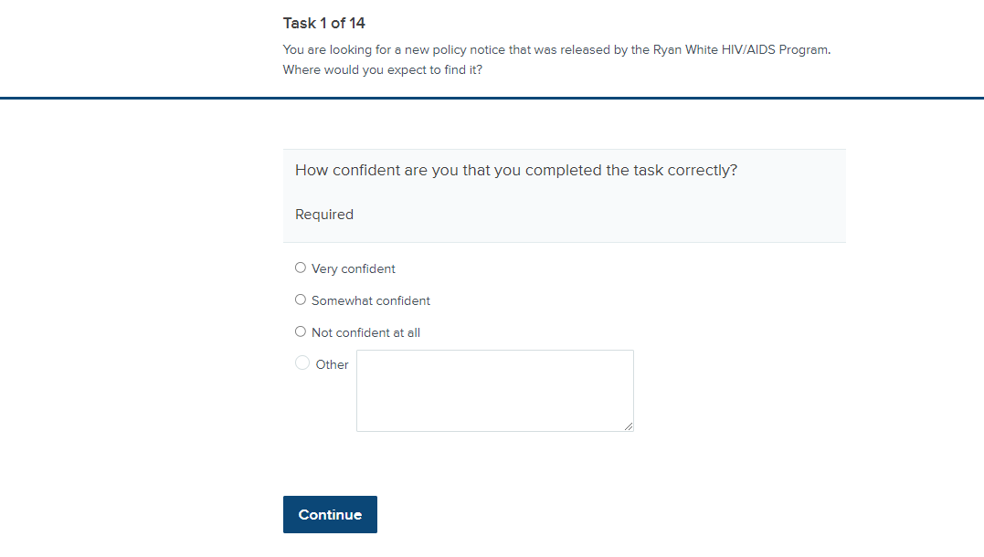
Image 8: Task 1 post-task question
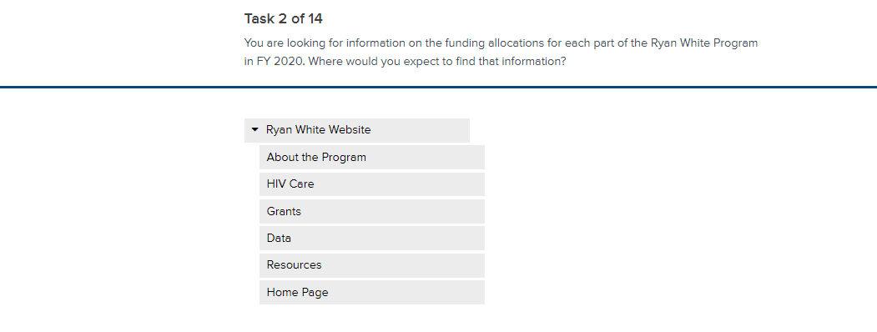
Image 9: Task 2
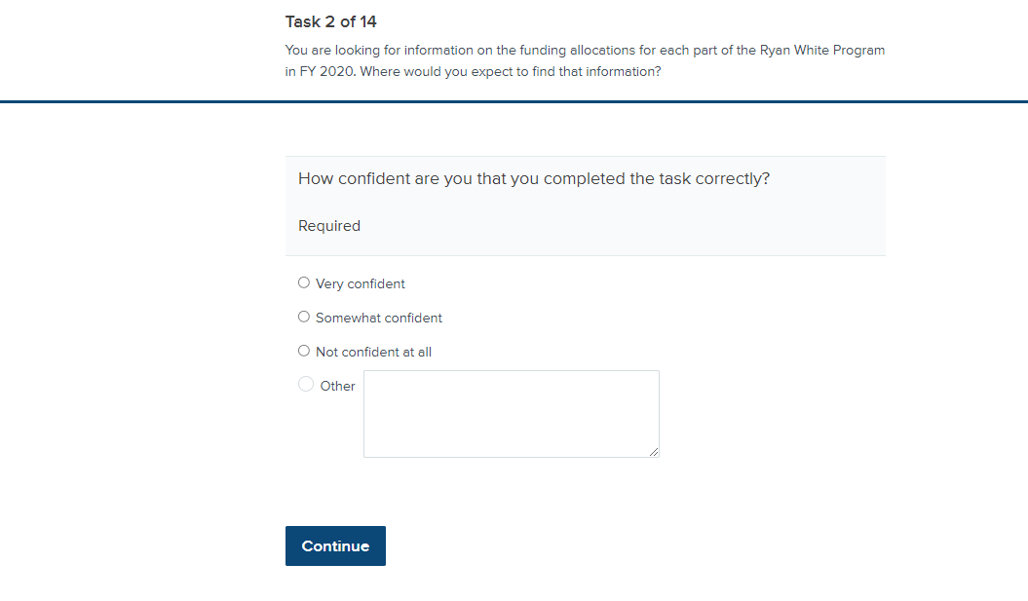
Image 10: Task 2 post-task question
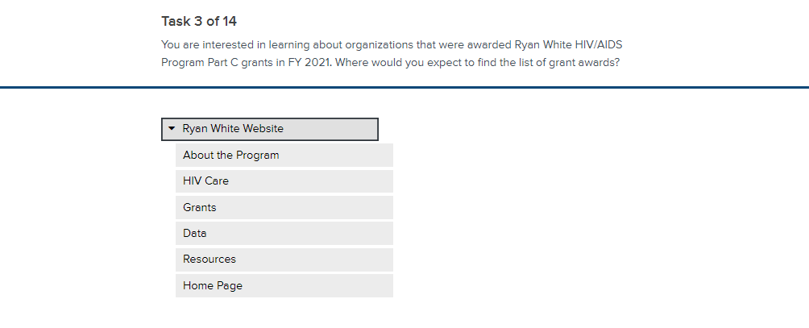 Image 11: Task 3

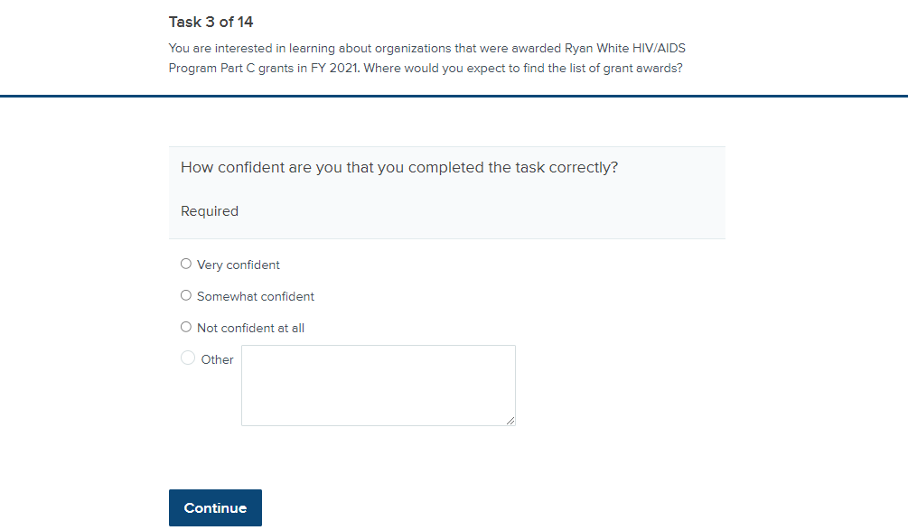Image 12: Task 3 post-task question
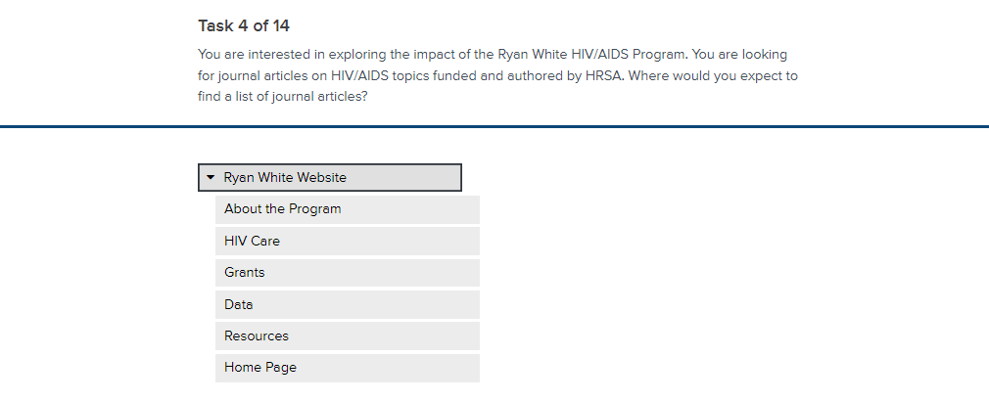Image 13: Task 4
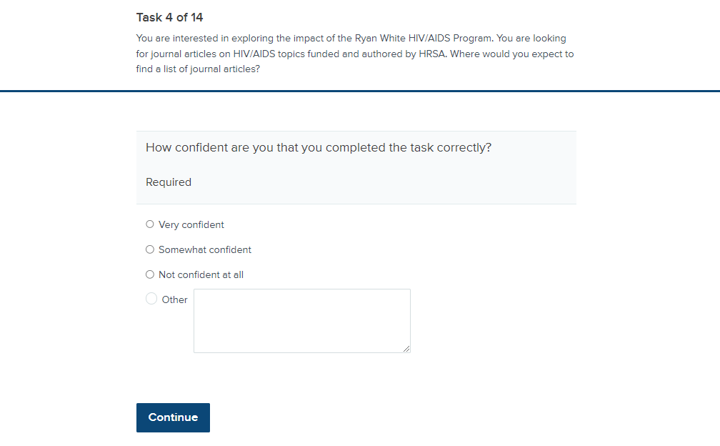Image 14: Task 4 post-task question
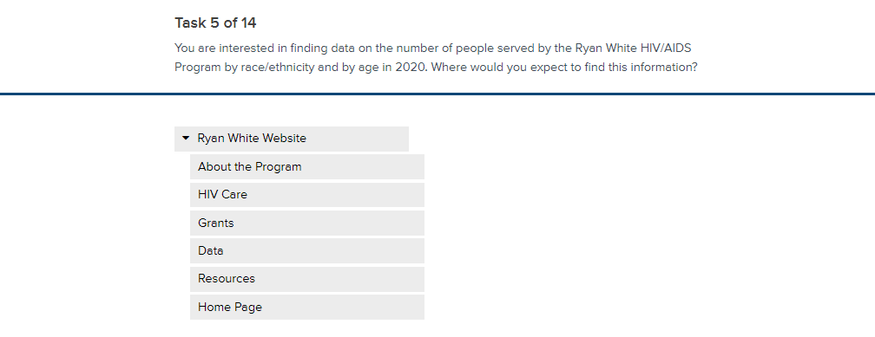Image 15: Task 5

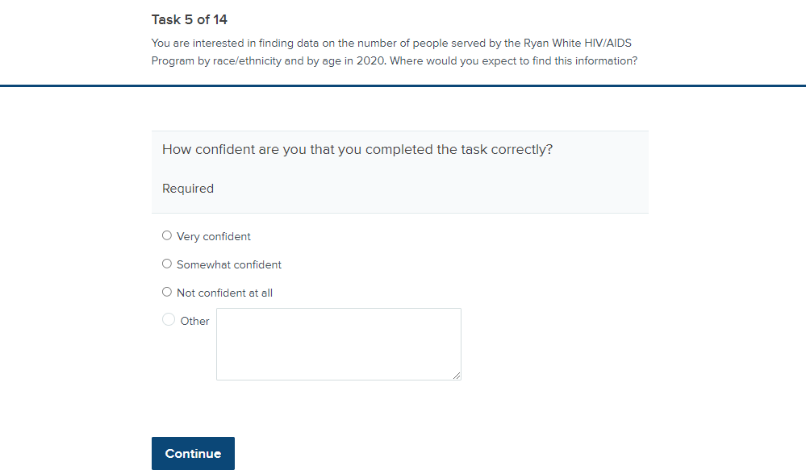Image 16: Task 5 post-task question
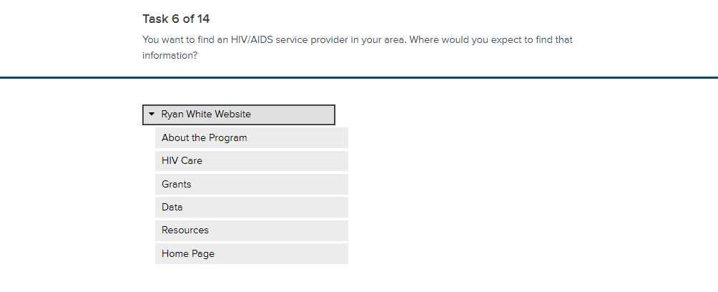Image 17: Task 6

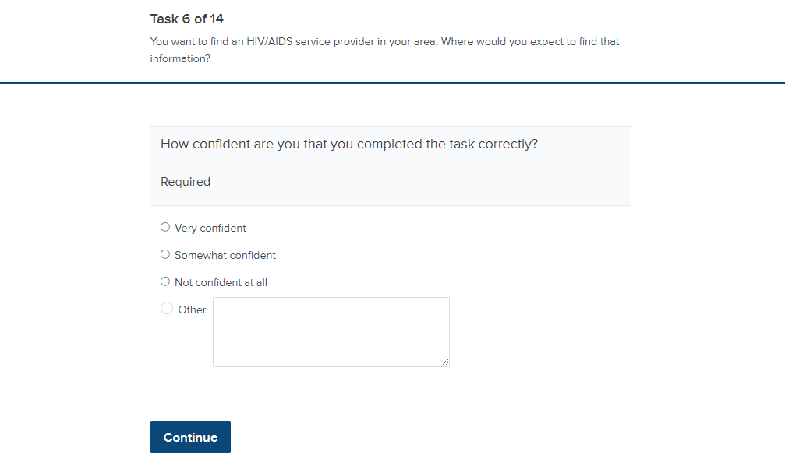Image 18: Task 6 post-task question
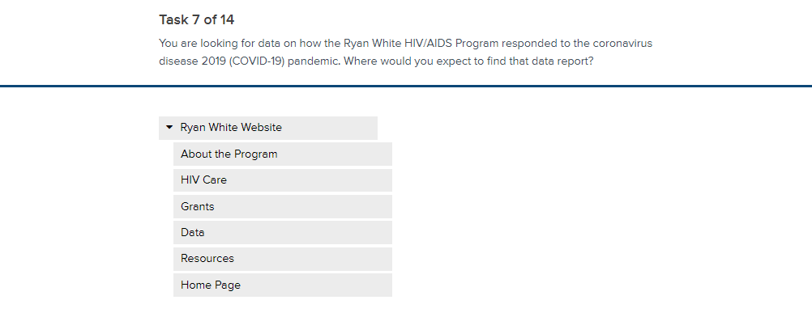Image 19: Task 7
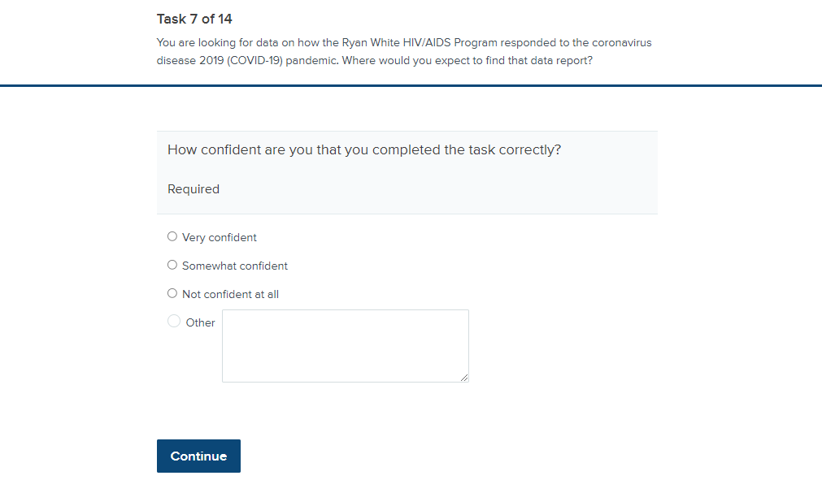Image 20: Task 7 post-task question
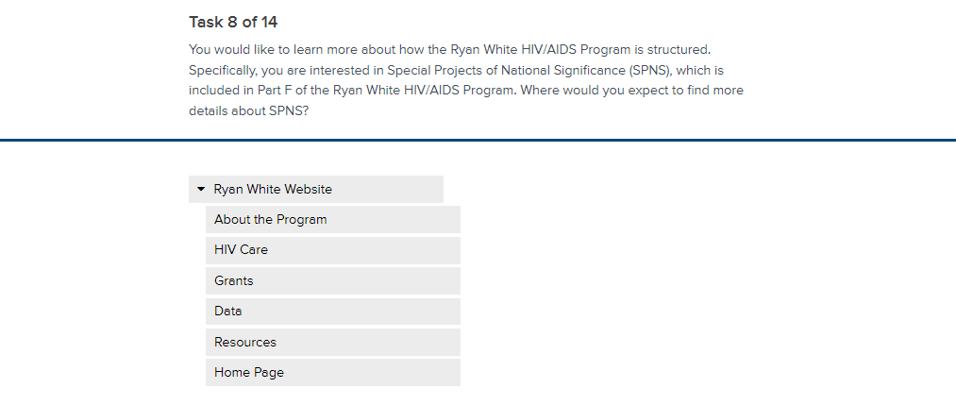Image 21: Task 8

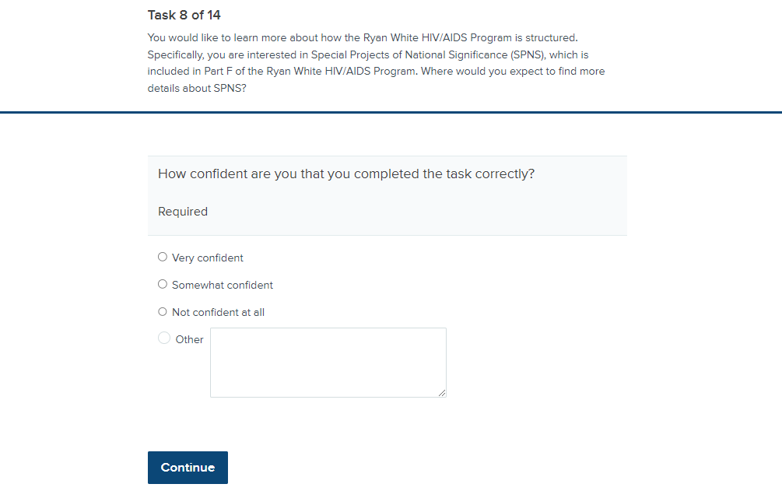Image 22: Task 8 post-task question
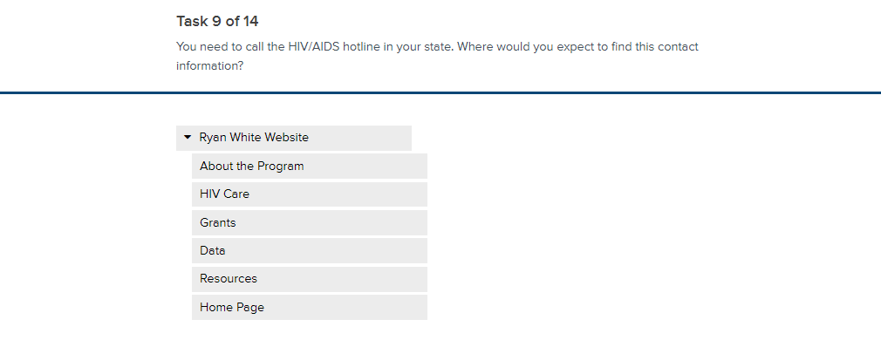Image 23: Task 9

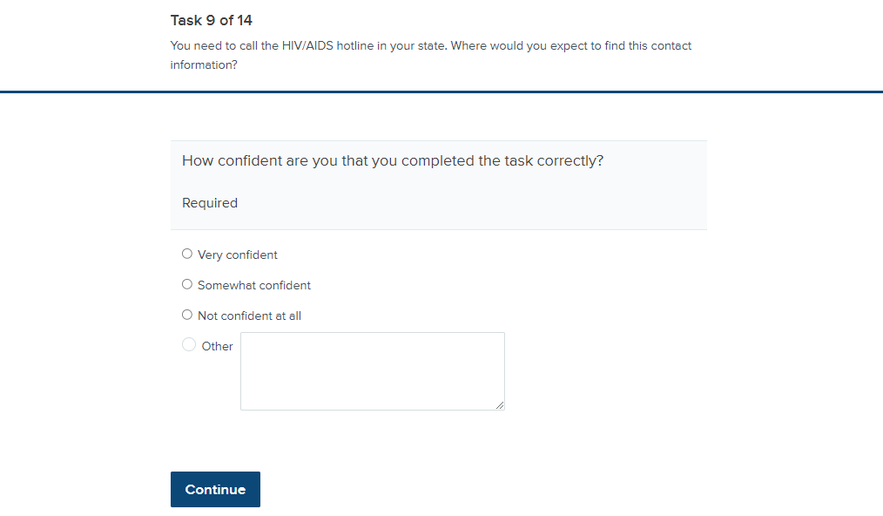Image 24: Task 9 post-task question
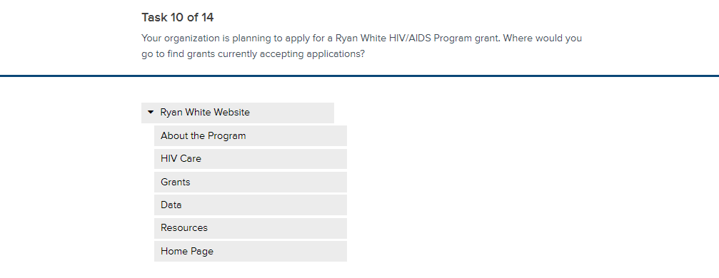Image 25: Task 10

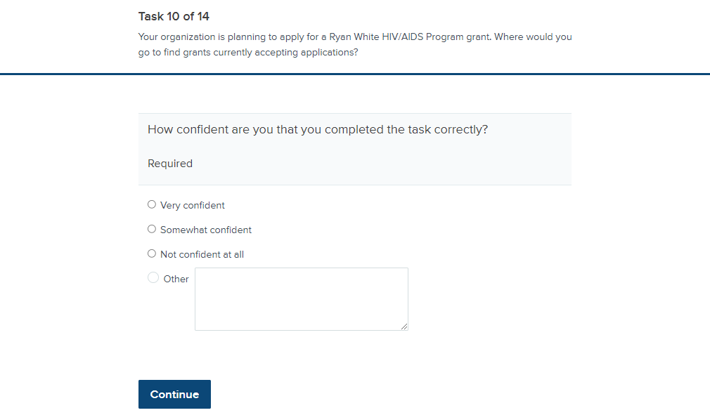Image 26: Task 10 post-task question
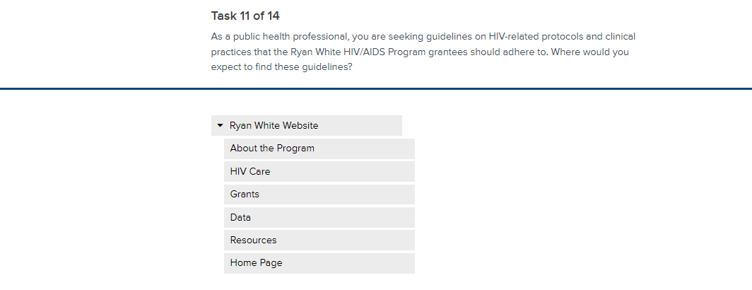
Image 27: Task 11
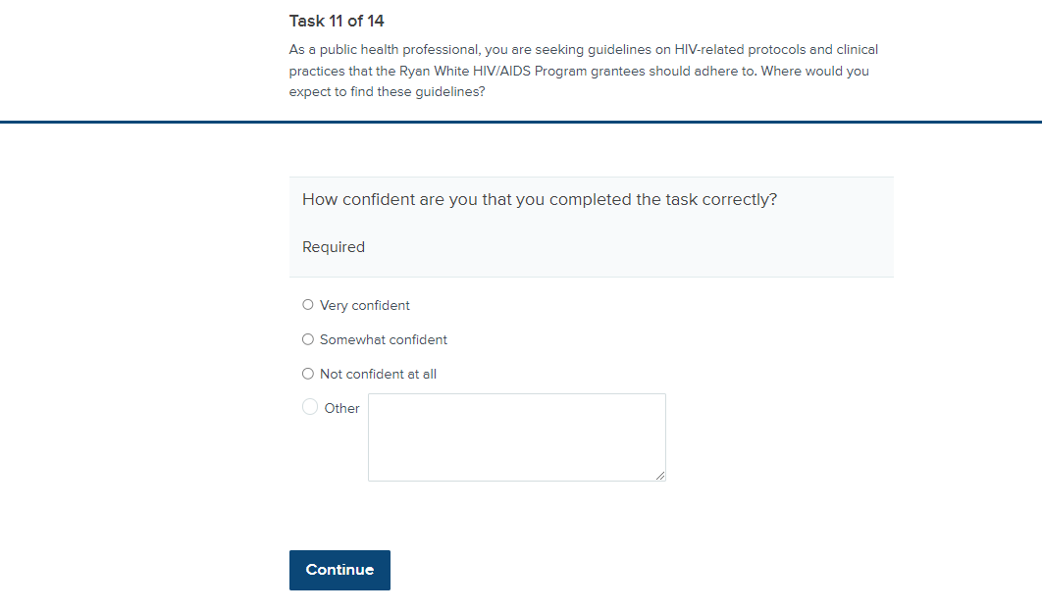
Image 28: Task 11 post-task question
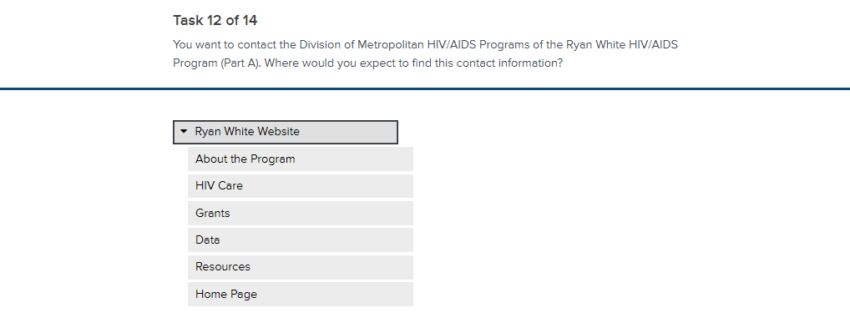Image 29: Task 12

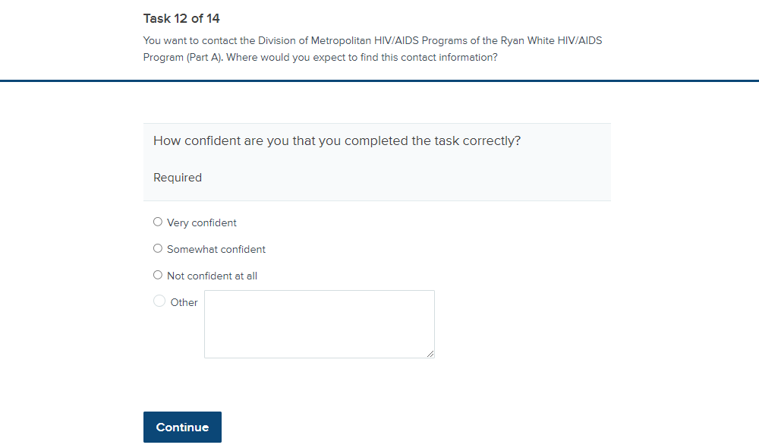Image 30: Task 12 post-task question
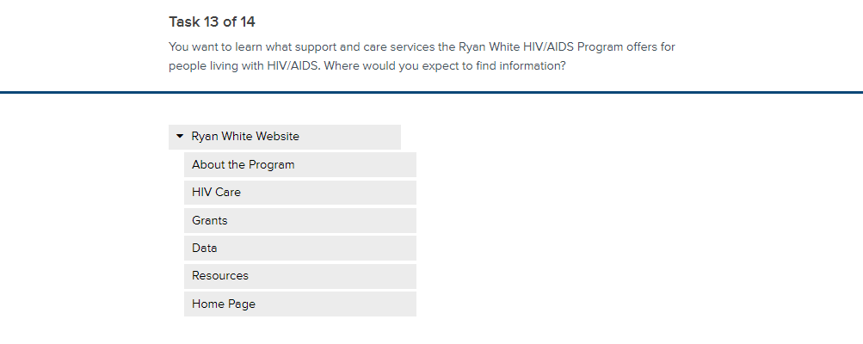Image 31: Task 13

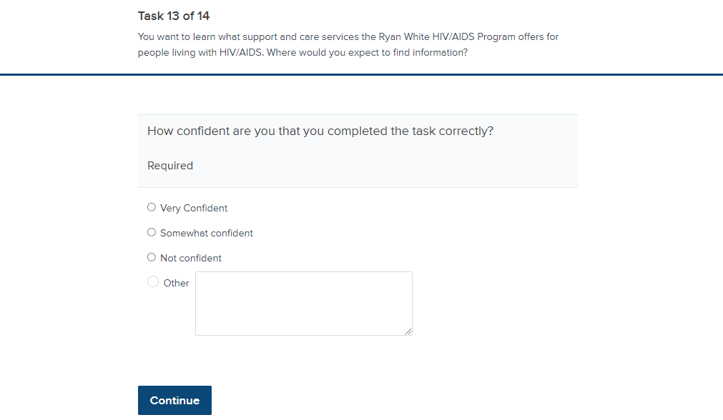Image 32: Task 13 post-task question
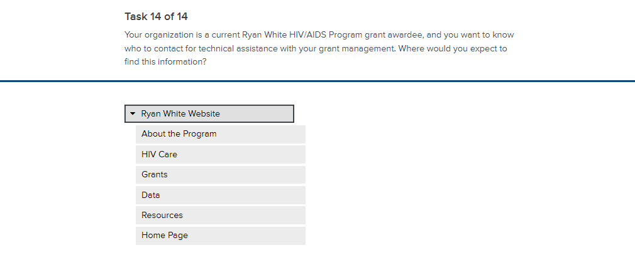Image 33: Task 14

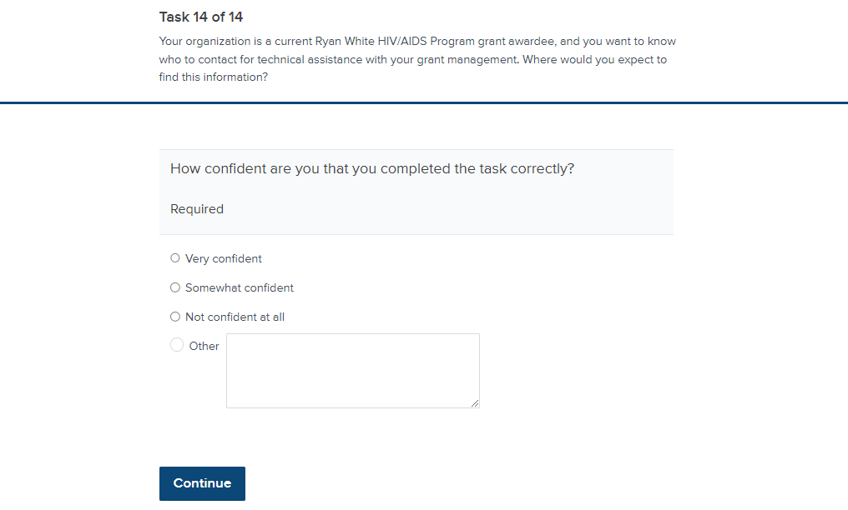Image 34: Task 14 post-task question

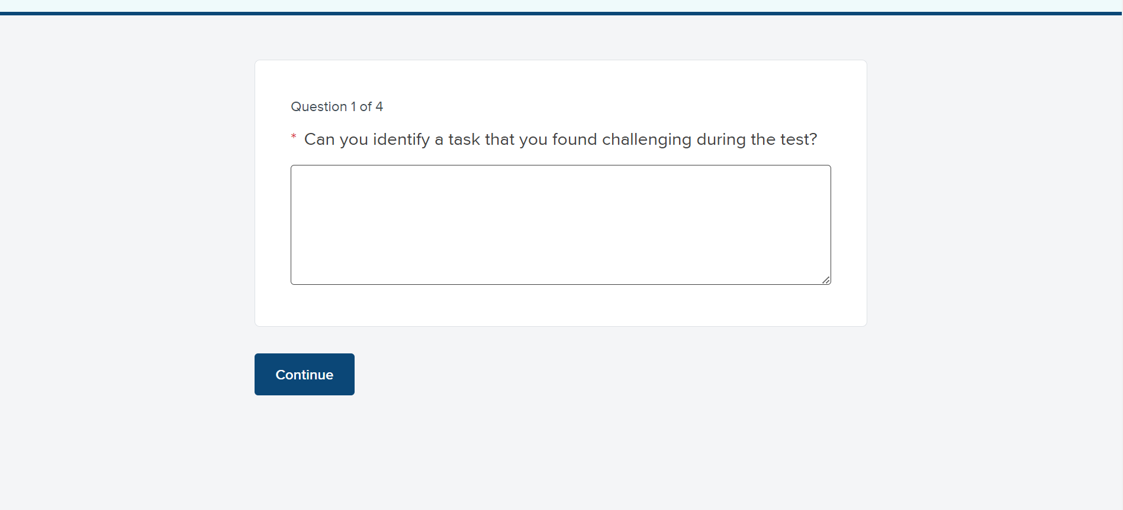Image 35: Post-test question 1

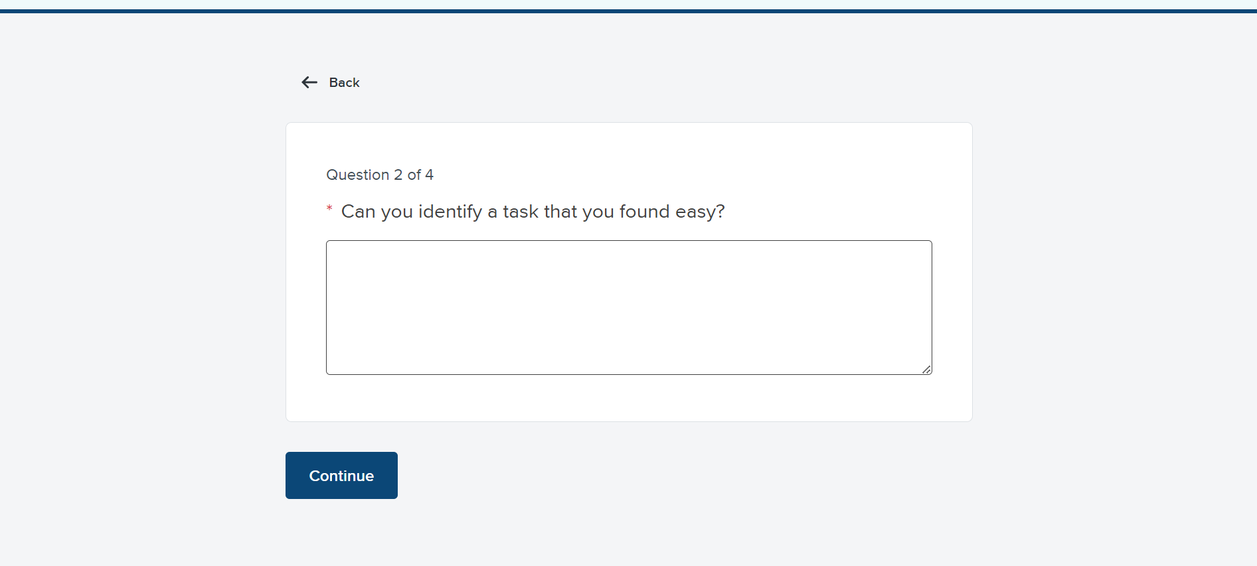Image 36: Post-test question 2

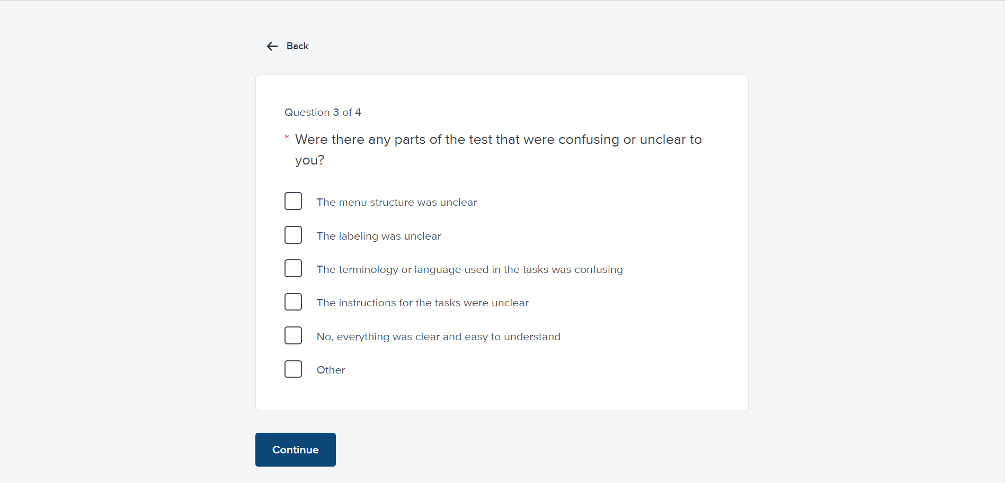Image 37: Post-test question 3

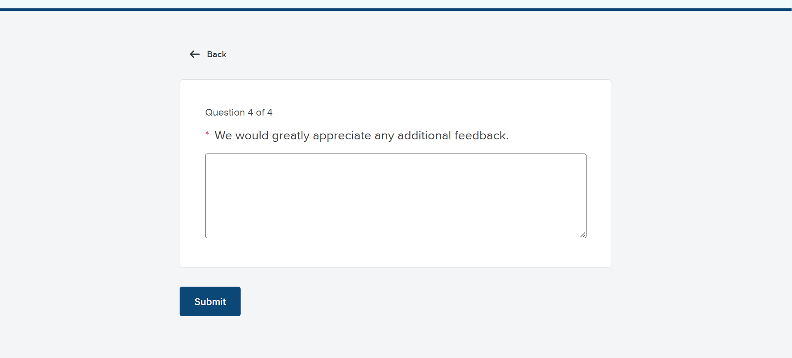Image 38: Post-test question 4

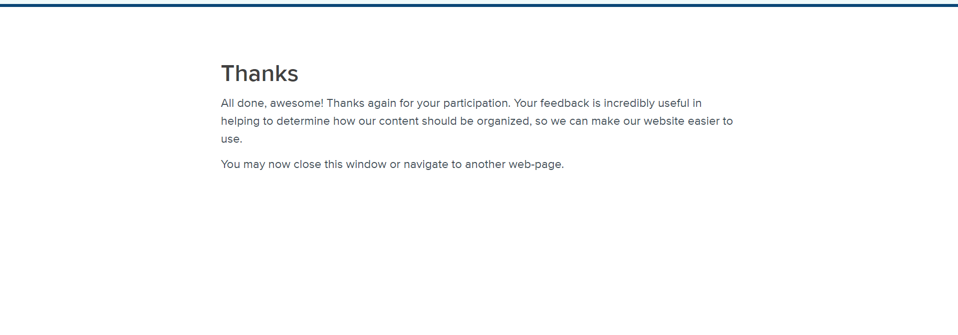Image 39 – Thank you message

