External eNewsletter Questions for Qualtrics Survey
Intro
HRSA’s Bureau of Primary Health Care (BPHC) seeks your feedback on our weekly Primary Health Care Digest newsletter (Digest) to help us identify opportunities for improvement and innovation. The Digest includes key information and upcoming training and technical assistance events for health centers and other stakeholders interested in the Health Center Program.
Thank you in advance for your participation!
For reference, here’s an example of what the Digest looks like. The mobile version is on the left, the desktop version on the right:
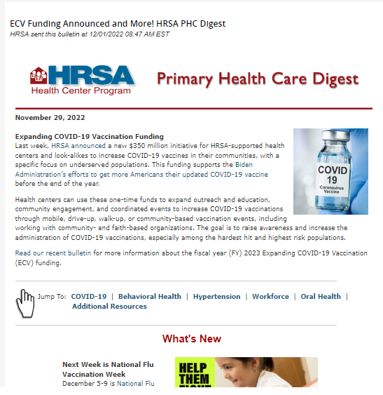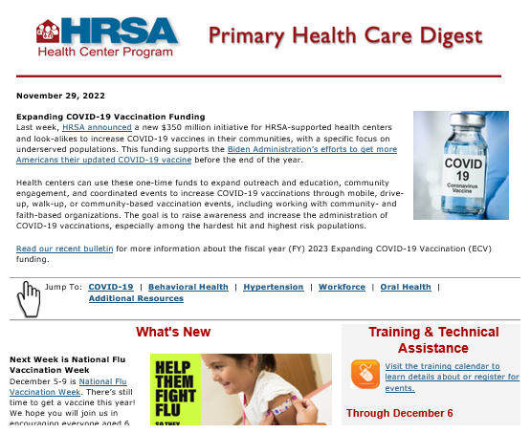
.
- Do you work at a health center? [YES/NO]
  - If YES: In which area of your health center do you primarily work? [CLINICAL, ADMINISTRATIVE, FINANCIAL, OTHER (text box)]
  - If NO: Do you work at an organization that works with health centers (e.g., Primary Care Association, National Training and Technical Assistance Partner, Health Center Controlled Network)? If you are a federal employee, select that option. [YES/NO/I’M A FEDERAL EMPLOYEE]

- How do you read the Digest most of the time? [MOBILE DEVICE (e.g., cell phone) /DESKTOP OR LAPTOP/TABLET (e.g., iPad, Surface)]
- How do you receive the Digest?
Directly in my email
Someone forwards it to me

- How often do you read the Digest? By read, we mean that you open the issue and at least skim it for relevant content. [ALWAYS, MOST OF THE TIME, ABOUT HALF THE TIME, SOMETIMES, NEVER]
- What are your thoughts on the length of the Digest? You may also include a comment in the text box: [TOO SHORT/JUST RIGHT/TOO LONG/Optional text box]

- Is it easy to find the information you need in the Digest? You may provide additional context in the text box. [YES/NO w/TEXT BOX]
Here is a general overview of how we organize the Digest:
- Top stories: Timely health center or HHS priority content
- What’s New (BPHC news; HRSA news; HHS or other federal news)
- Priority topic sections (clinical topics, health observances (e.g., American Heart Month), Workforce, Telehealth)
- Additional resources
- Calendar list of technical assistance webinars
- How useful is content on these topics? [EXTREMELY USEFUL, VERY USEFUL, MODERATELY USEFUL, SLIGHTLY USEFUL, NOT AT ALL USEFUL]

- BPHC updates
- Other HRSA updates
- Updates from elsewhere in HHS or other federal agencies
- How useful is it to have special sections for these priority topics? [EXTREMELY USEFUL, VERY USEFUL, MODERATELY USEFUL, SLIGHTLY USEFUL, NOT AT ALL USEFUL]

- Clinical topics (e.g., COVID-19, Behavioral Health, HIV, Hypertension, Oral Health)
- Health observances (e.g., American Heart Month)
- Workforce
- Telehealth
- Use the text box if you have additional priority topics or would like to share your thoughts on finding what you need in the Digest. [TEXT BOX]

- How far in advance do you prefer to know about upcoming training and technical assistance webinars? [1 WEEK OR LESS/2 WEEKS/1 MONTH/MORE THAN A MONTH IN ADVANCE/I AM NOT INTERESTED IN WEBINARS]

- Where do you learn about upcoming training/TA opportunities offered by HRSA or by our National Training and Technical Assistance Partners? Select all that apply.
[IN THE MAIN SECTION OF THE DIGEST – HAVING A FULL DESCRIPTION IS HELPFUL; IN THE TRAINING AND TA SECTION OF THE DIGEST; IN THE TA CALENDAR ON BPHC’S WEBSITE; SOMEWHERE ELSE (provide details) [TEXT BOX]]

- We supplement the Digest as needed with BPHC Bulletins that provide time-sensitive updates (see example). How do you feel about the frequency of BPHC Bulletins? You may add a comment in the text box to provide additional context, including about the relevance of BPHC Bulletins to your work: [TOO FREQUENT, ABOUT RIGHT, NOT FREQUENT ENOUGH]

If you do not currently subscribe to the Digest, you can sign up on our subscription page.

