Attachment E- Fact Sheet

Fact sheet for participants in the NIOSH Research Study:
Noise Exposures and Hearing Loss in the Oil and Gas Extraction Industry

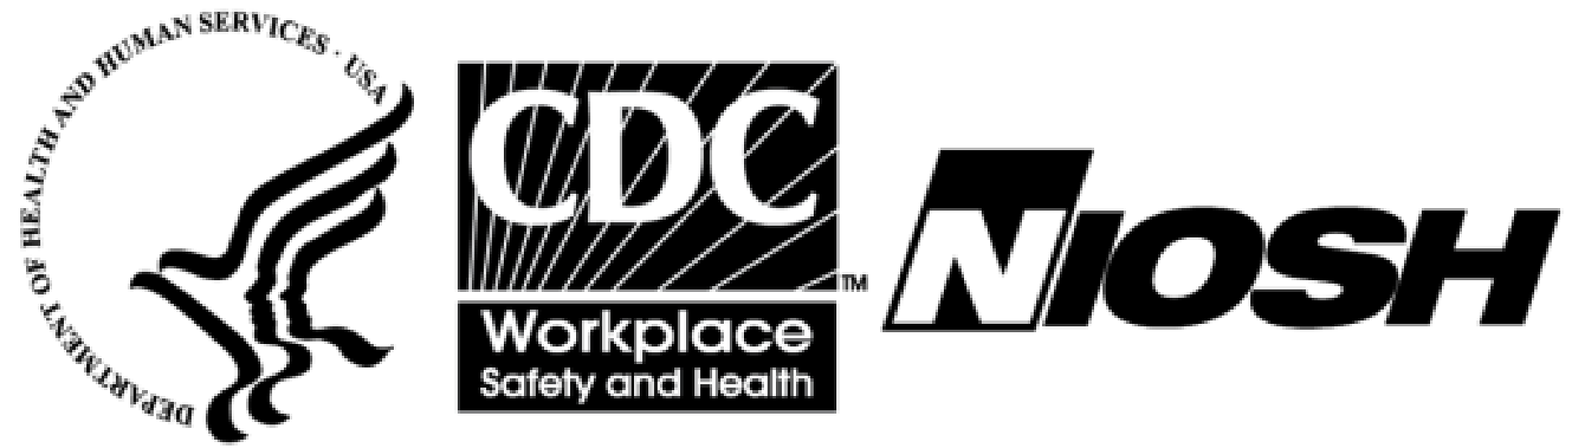
U.S. Department of Health and Human Services
Centers for Disease Control and Prevention
National Institute for Occupational Safety and Health
Denver, CO

May 2022

Why is this study being done?

The National Institute for Occupational Safety and Health (NIOSH) is leading a study at oil and gas industry work sites. The goal is to measure noise and chemical exposures and hearing loss among workers. As part of the study, we will measure noise levels that workers have at your work. We would also measure exposures to chemicals that have a toxic effect on the ear or its nerves. These are called ototoxic chemicals. They include hexane, toluene, xylene, ethylbenzene, and n-propylbenzene in the air as well as lead on skin surfaces. A questionnaire will be used to learn more about work history, noise exposures, controls, and hearing loss. Hearing exams will be used to study levels of hearing loss. This study will help to better understand these exposures and health effects. It will allow NIOSH to make recommendations to the industry to better protect workers.

What is NIOSH and what does NIOSH do?

NIOSH is a federal agency that studies worker safety and health. We are part of the Centers for Disease Control and Prevention (CDC). Our mission is to develop new knowledge in about worker safety and health and to use what we learn into improve practices at worksites.

What does participating in this study involve?

The study is voluntary. You do not have to participate if you don’t want to. You may participate in some or all parts of the study: a worker questionnaire, hearing exam, and exposure assessment. Most workers will only be asked to fill out the questionnaire.
- For the questionnaire, NIOSH researchers will ask you to complete a short questionnaire about your work history, current and past exposures, and any hearing loss that you report that you think you have. This questionnaire will be filled out on an electronic tablet or on paper. If you choose not to fill out the written questionnaire, a NIOSH researcher can ask you the survey questions out loud in private. The questionnaire will take approximately 20 minutes to complete.
- For the hearing exams, NIOSH researchers will visit your work location with a mobile trailer. The hearing exam can be completed in a sound-proof booth inside the trailer. We will ask you to sit in the booth with headphones on to hear certain sounds at different volumes. The exam will take approximately 20 minutes.
- To measure noise and chemical exposures, NIOSH researchers will visit your worksite for 4–5 business days. NIOSH researchers will measure noise and chemical levels during day shift work hours. For this part of the study, workers will wear sampling equipment for noise and airborne chemicals during each of the days we are at the site. NIOSH researchers will watch worker tasks as they are done throughout each day. Putting on and taking off the sampling equipment will take 10 minutes of the worker’s day. If working with lead-containing compounds, we may wipe the skin on your hands to evaluate if lead has gotten on them.

Do I have to participate?

Even if your company works with NIOSH on this study, your participation is voluntary. You can choose to join or not join in the study. Workers may choose to join in some or all parts of the study. You may drop out of the study at any time for any reason without consequences.

Are there any risks involved?

There is low risk of discomfort associated with wearing one or more sampling monitors. We will utilize the lightest monitors possible. We will place them on workers in ways that the workers say is most comfortable. There is a slight risk of psychological, reputational, or informational harm if there is an accidental release of personal information for participants such as individual results and records. Individual information such as name and address may be collected if the participant wants to receive their individual results in the mail. We will minimize these risks by using a unique code to identify questionnaire and exposure data We only use non-identifying, summary data in the company reports or future publications. There is the potential of getting COVID-19 from a NIOSH researcher. Steps are being taken to reduce this risk as much as possible.

Are individual results confidential?

Yes, individual participant results will be confidential. We collect personal information such as name and address for mailing you your individual results. Contact information will only be collected only if the participant wants to receive their results. NIOSH is authorized to collect your personal information and will protect it to the extent allowed by law.

Will participants receive study results?

If the participant wants them, the NIOSH research team will send individual results to participants after we complete the site visits. Individual results will be mailed to the participants and not the employer. The company will receive a report that summarizes all results in a way that does not identify any individual participant. The analyses may take 6–9 months to be completed. There may be a delay before the company and individual participants receive their results. Your results will be compared to safety and health guidelines to determine safe levels of exposures.

Principal investigator contact information:

Bradley King, PhD, MPH, CIH
Senior Industrial Hygienist
CDC/NIOSH Western States Division
P.O. Box 25226
Denver, CO 80225
(bradley.king@cdc.hhs.gov; 303-236-5933)

