CDC Traveler-based Genomic Surveillance (TGS):

Program Overview and Test Taker Consent
The following document is an update to current program overview and test consent language.

Program Overview
[To be shown to participant on first digital page before they fill out a questionnaire]
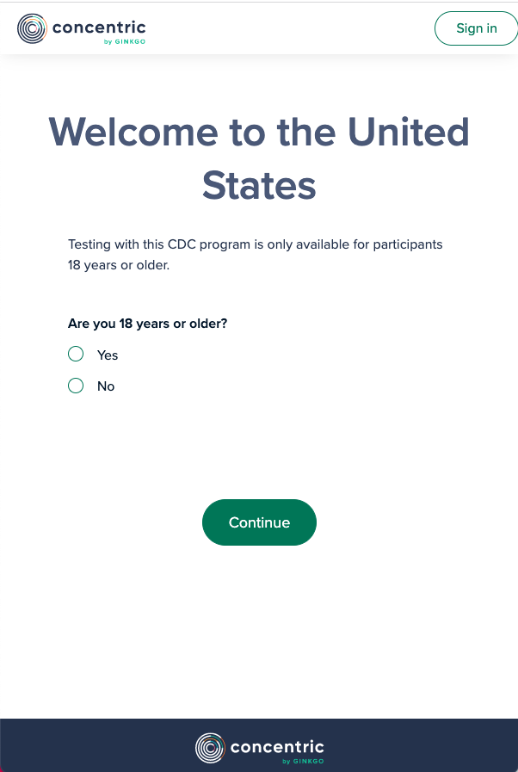
Help the US Centers for Disease Control and Prevention (CDC) combat new variants of the virus (SARS-CoV-2) that causes COVID-19 by participating in our Traveler-based SARS-CoV-2 genomic surveillance (TGS) program to detect new and rare SARS-CoV-2 variants and follow trends over time. As COVID-19 global testing and reporting declines, this program helps provide information about the variants from other countries and potential risks to the United States.

Participation in this program is free and voluntary. All you have to do is provide lower nasal swab samples in accordance with the instructions provided to you by the program staff. Your sample will be sent to our labs for testing of SARS-CoV-2, the virus that causes COVID-19. We will not be collecting your personal identifying information. We will be asking for your information that will help contextualize any unique variants we detect, including certain demographic, travel history, COVID-19 infection history, and COVID-19 vaccination information. As part of this TGS program you will not receive any test results, however the results of your test will help CDC detect new COVID -19 variants that may enter the country through travelers.
ILLUSTRATIVE
Help the U.S. Centers for Disease Control and Prevention (CDC)
detect new variants of the virus that causes COVID-19 (SARS-CoV-2) by participating in the Traveler-based SARS-CoV-2 Genomic Surveillance (TGS) program. Getting tested helps CDC detect new and rare SARS-CoV-2 variants and follow trends over time. As testing for and reporting COVID-19 decrease globally, this program helps provide information about the variants infecting travelers from other countries and potential risks to the United States.

Participation in this program is free, voluntary, and anonymous. If you decide to participate, you will be asked to provide 2 swab samples from the lower 1/3 of your nostrils as instructed by the program staff. Your samples will be sent to our labs for testing for SARS-CoV-2, the virus that causes COVID-19. One swab will be used for pooled testing, meaning it will be tested together with swabs of other participants. The second sample may be tested if we need to look more closely at any positive pooled sample. Some positive samples may be sent to CDC for additional testing.

We will not collect your personal identifying information and your sample will not be linked back to you. We will ask for some information about your demographics, countries where you traveled, prior history of COVID-19, and your most recent COVID-19 vaccination date. This information can help us understand factors that might be associated with variants we identify. You can refuse to answer any questions and still participate by providing a sample. If you agree to provide samples for this program you will not receive your test results because testing is anonymous and not linked to your contact information. The results of your test can help CDC combat spread of COVID-19.

Consent
[To be shown to participant after they have filled out questionnaire, this is final step before they can submit a sample]
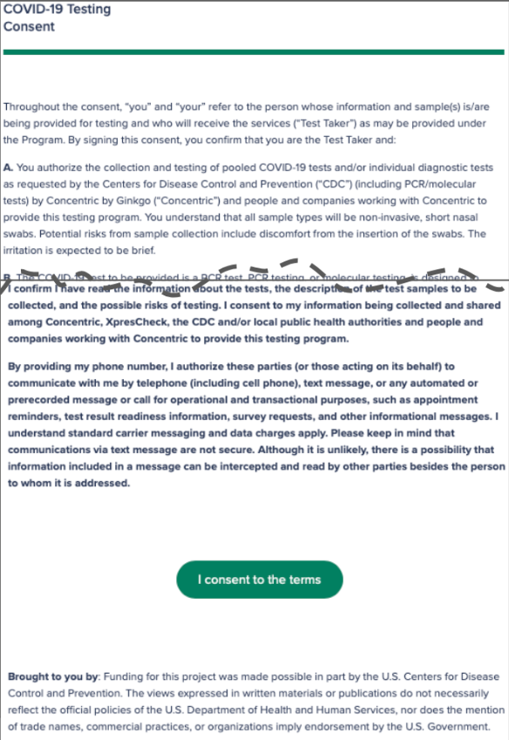
ILLUSTRATIVE
To participate in the program, please read and agree to this consent. Throughout the consent, “you” and “your” refer to the person whose information and sample(s) are being provided for testing. By signing this consent, you confirm that you are the sample provider and:

A. You authorize the collection and testing of samples for microbes including SARS-CoV-2, the virus that causes COVID-19. You understand that all sample collections will be lower nasal swabs either self-collected or collected by program staff. Potential risks from collecting a sample may include slight discomfort.
B. You understand that the types of testing we use for this surveillance program (pooled and individual) may not be approved, cleared, or authorized by the Food and Drug Administration (FDA), and are not for use as a clinical diagnostic test. You will not receive the results of this test. The results are for public health surveillance purposes only.
C. You understand that you will not receive or be notified of any test results. You understand that CDC will receive your test results, but no personal identifiers will be used to link you to your sample.
D. You understand that neither Concentric by Gingko, LLC (Concentric), XpresCheck, nor the CDC is acting as your medical provider and this testing does not replace treatment by your medical provider. You should not make medical decisions without consulting a healthcare provider, disregard medical advice from your healthcare provider, or delay seeking such advice based on participation in this program.

E. You understand that CDC and Concentric may do genomic sequencing on any SARS-CoV-2 virus found in a sample, and molecular testing and genomic sequencing for other microbes that may be present in your samples. These tests are being conducted for public health purposes. You will not receive results for these tests and any results will not be linked to you. No human genetic sequencing will be performed.

F. You understand that you are providing your data and samples to Concentric and XpresCheck and authorizing the use of data and samples as described in this document. Additional terms and conditions, Concentric’s privacy policy, and release authorizations for Concentric testing can be found here: https://www.concentricbyginkgo.com/consent.

I have read and understand the terms of the program including the risks and benefits to me and I consent to participate in the program.
- [Participant to select button to proceed]
___________________________________________________________________________
Funding for this project was made possible by the U.S. Centers for Disease Control and Prevention (CDC). The views expressed in written materials or publications do not necessarily reflect the official policies of the Department of Health and Human Services nor does the mention of trade names, commercial practices, or organizations imply endorsement by the U.S. Government. For more information about the US CDC’s Traveler-based Genomic Surveillance Program, please visit concentricbyginkgo.com/travel or https://wwwnc.cdc.gov/travel/page/travel-genomic-surveillance

