OMB Document Updated
eAccess July 2023 Release

Table of Contents
1.ROME 3
1.1 Legacy Transition Prompt 3
1.2 SMAC 4
1.3 RIM Updates 5
1.4 RIM- Provide your new cell phone number 6
1.5 RIM Update- Attempts Limit Reached 7
2.6 RIM Update – Code Does not Match 8
2.RCS 9
2.1. RCS_ACMGMT - Account Summary Page-in person 9
2.2. RCS_ACMGMT - Account Summary Page-on phone 10
2.3. RCS_ACMGMT - Account Summary Page – Standard account in person 11
2.4. RCS_ACMGMT - Account Summary Page -standard account on phone 12
2.5.RCS_ACMGMT - Account Summary Page-in person 13
2.6.RCS_ACMGMT - Account Summary Page – on phone 14
3.IRES 15
3.1. IRES CI 15

1.ROME

1.1 Legacy Transition Prompt
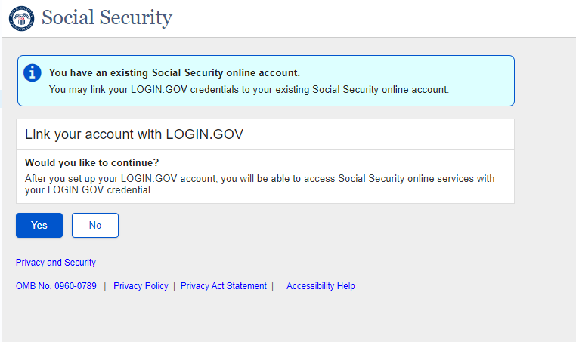

User trying to create an account with an existing legacy account will view this screen after CAVI.

1.2 SMAC
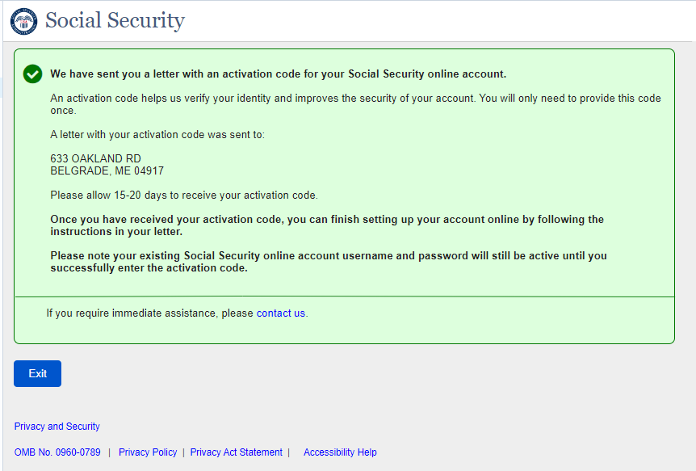
Dynamic SMAC page for hybrid users creating an account with login.gov who opts to receive activation code via mail.

1.3 RIM Updates
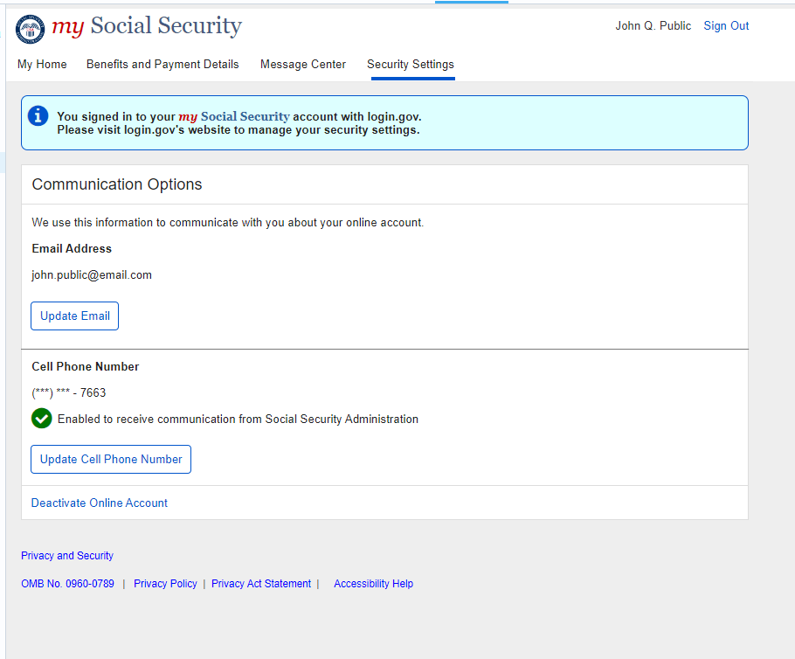
New section for cell phone is added to the screen for hybrid users who creates an account with logi.gov.

1.4 RIM- Provide your new cell phone number
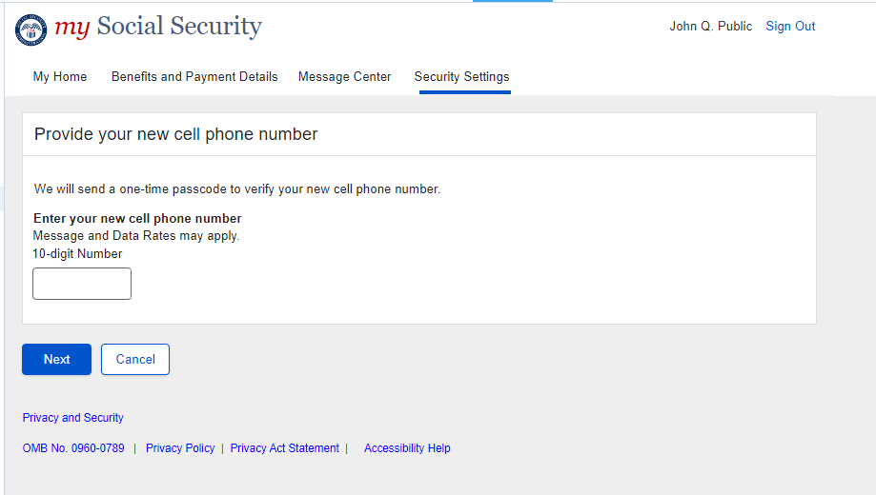

Language updated to implement more generic terms.

1.5 RIM Update- Attempts Limit Reached
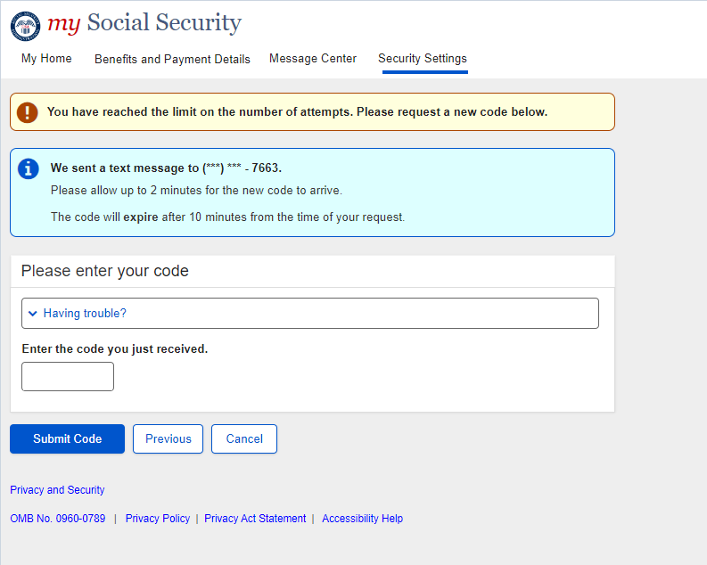
Language updated to implement more generic terms.

RIM Update – Code Does not Match
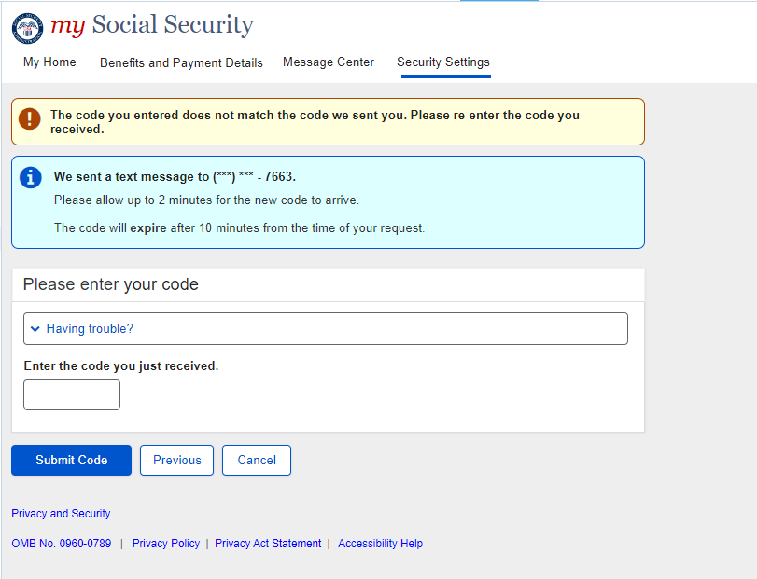
Language updated to implement more generic terms.

2.RCS

2.1. RCS_ACMGMT - Account Summary Page-in person

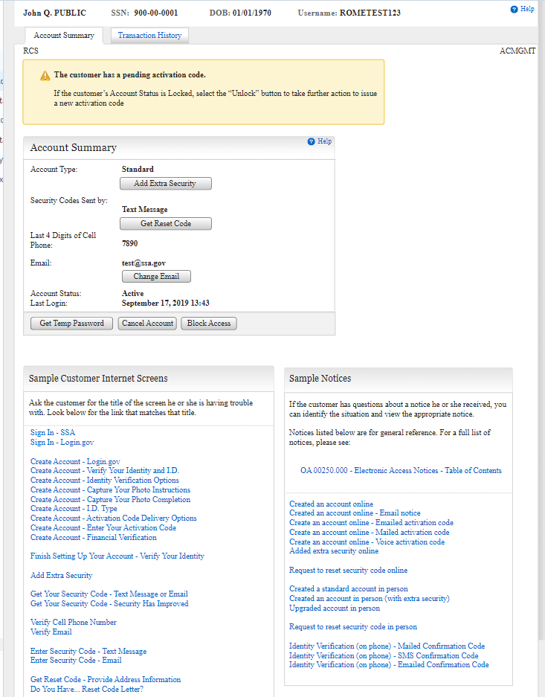

Screen updated with the banner. For a user who has a Legacy account and an activation code at the same time the system needs to display the account details and the activation code pending banner in RCS.

2.2. RCS_ACMGMT - Account Summary Page-on phone
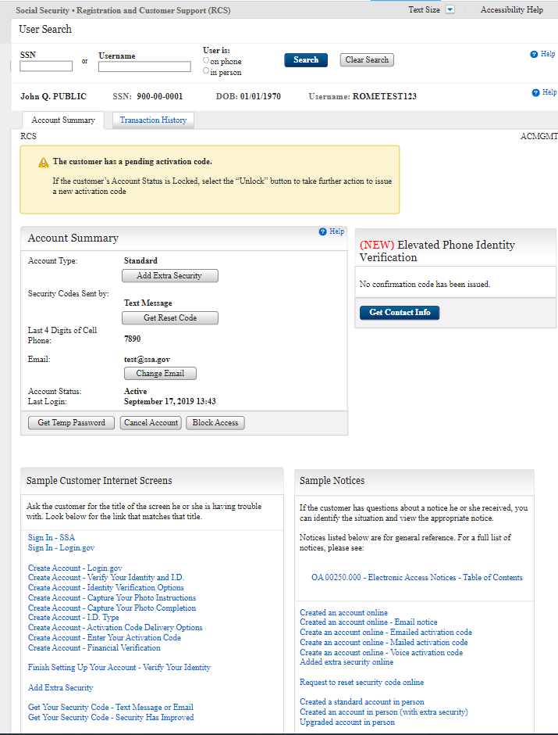
Screen updated with the banner. For a user who has a Legacy account and an activation code at the same time the system needs to display the account details and the activation code pending banner in RCS.

2.3. RCS_ACMGMT - Account Summary Page – Standard account in person
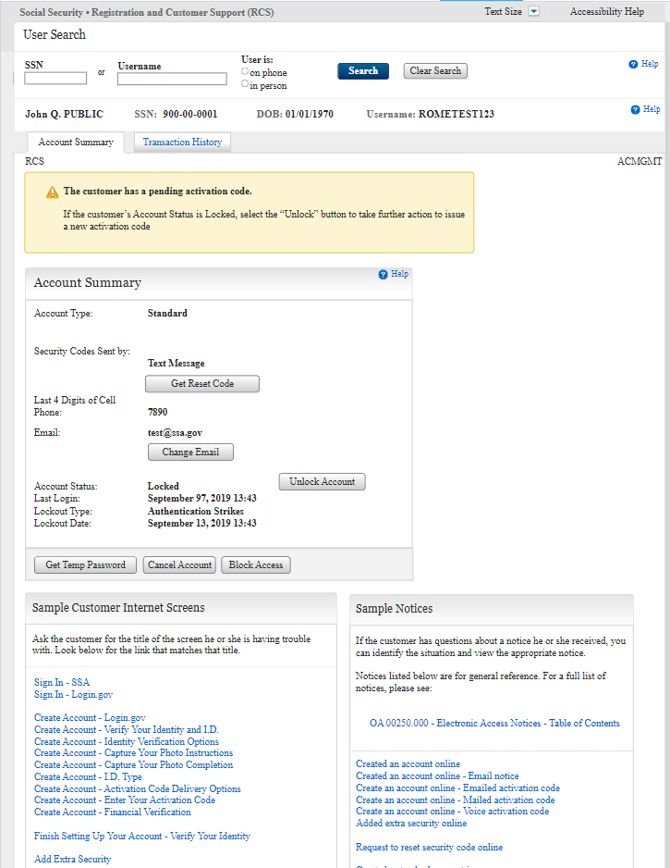
Screen updated with the banner. For a user who has a Legacy account and an activation code at the same time the system needs to display the account details and the activation code pending banner in RCS.

2.4. RCS_ACMGMT - Account Summary Page -standard account on phone
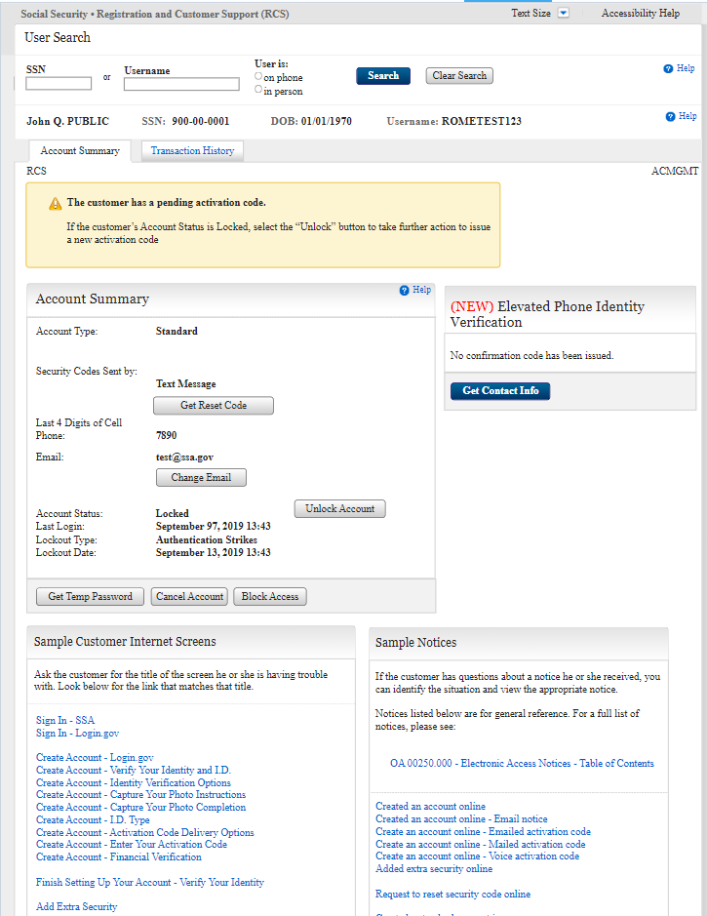
Screen updated with the banner. For a user who has a Legacy account and an activation code at the same time the system needs to display the account details and the activation code pending banner in RCS.

2.5.RCS_ACMGMT - Account Summary Page-in person
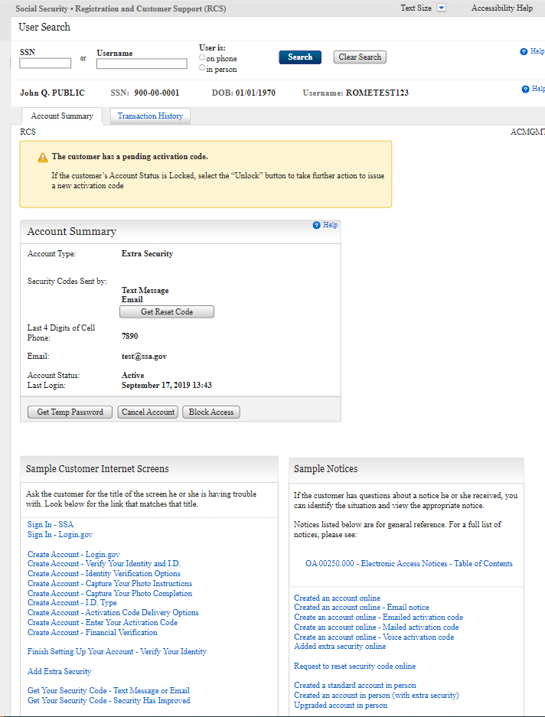

Screen updated with the banner. For a user who has a Legacy account and an activation code at the same time the system needs to display the account details and the activation code pending banner in RCS.

2.6.RCS_ACMGMT - Account Summary Page – on phone
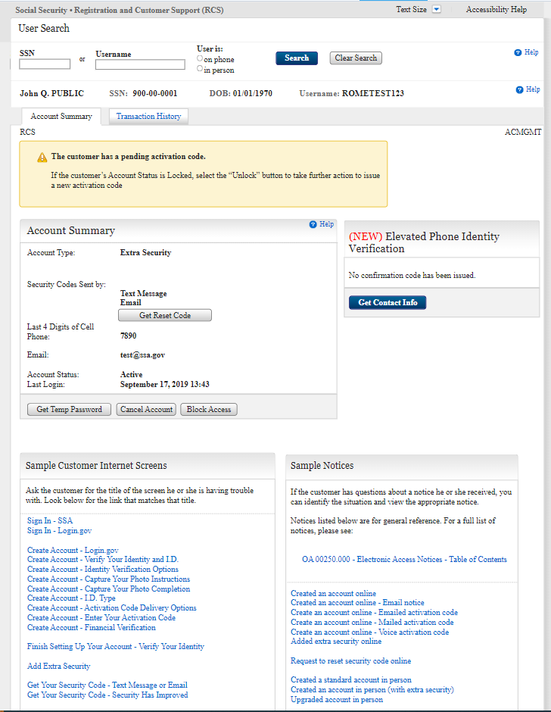
Screen updated with the banner. For a user who has a Legacy account and an activation code at the same time the system needs to display the account details and the activation code pending banner in RCS.

3.IRES

3.1. IRES CI
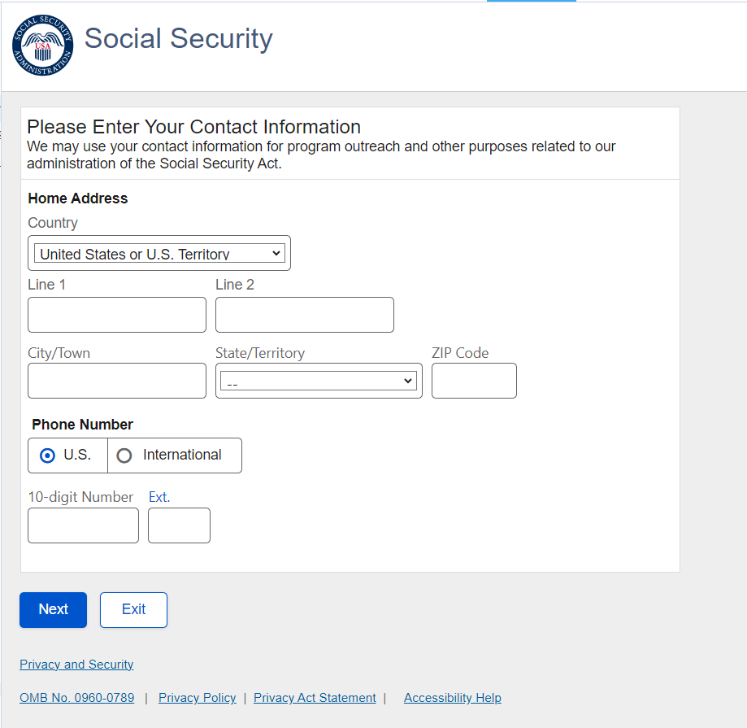
Functionality added for entering international address

