SSI Claim System-Real Property page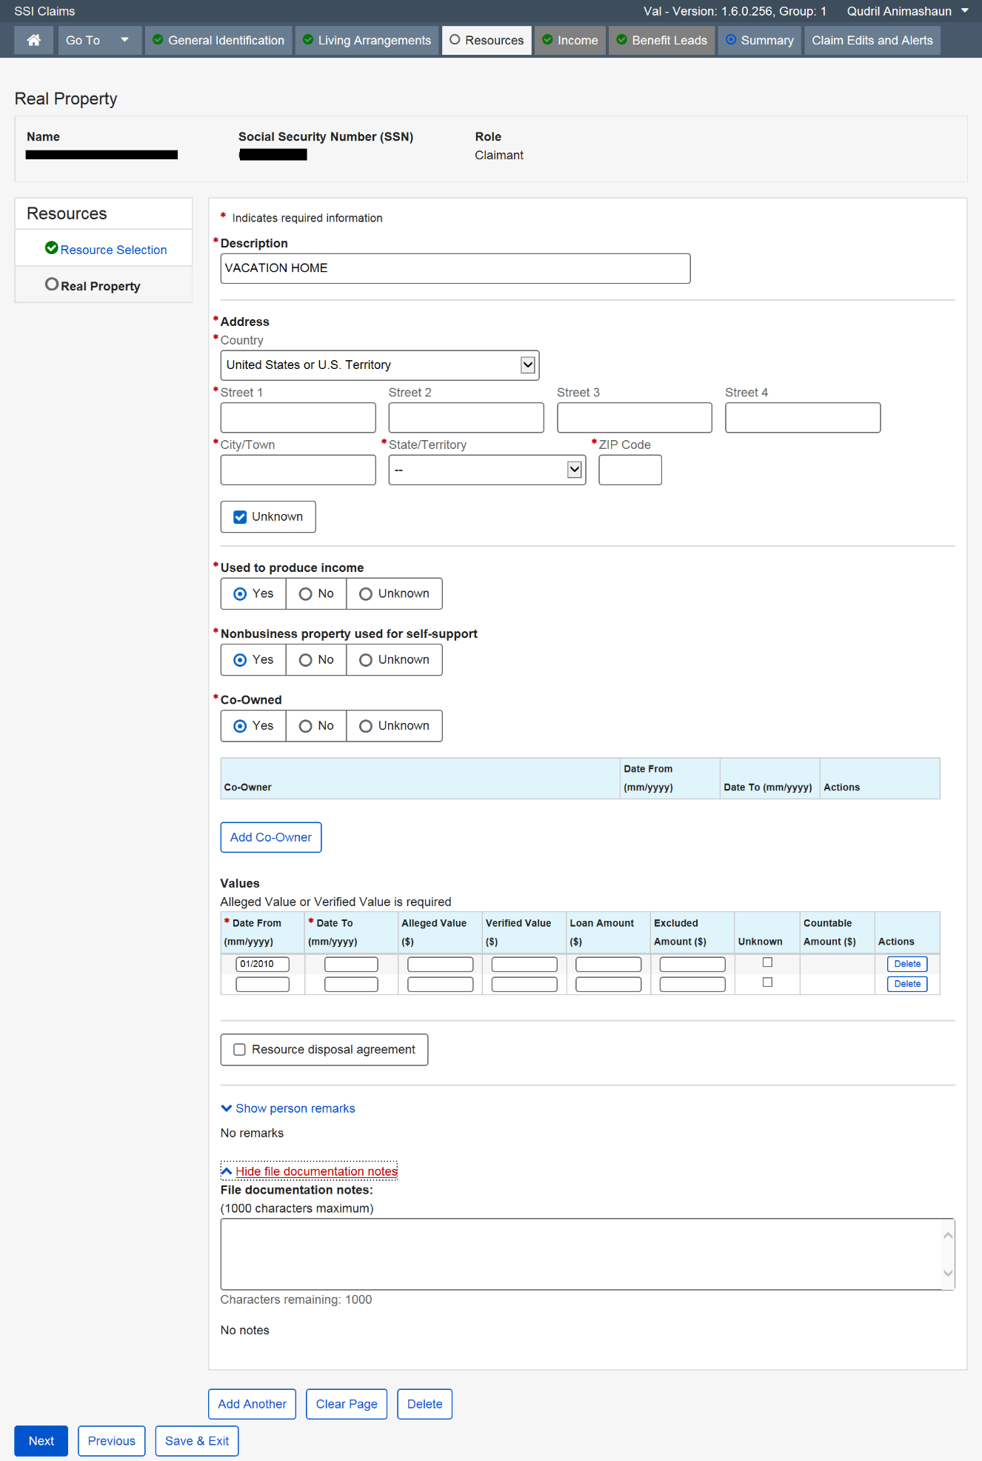
The Real Property page in the SSI Claim System is one example for which collection information is entered. This field appears on all non-liquid resource screens that could be subject to a conditional benefits agreement.

SSI Claim System-Property/Cash Given or Sold
