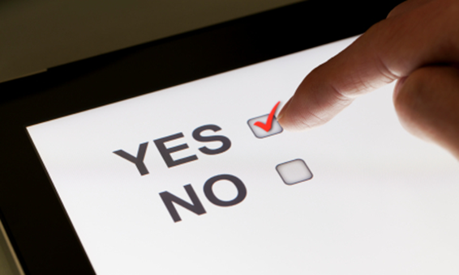 | 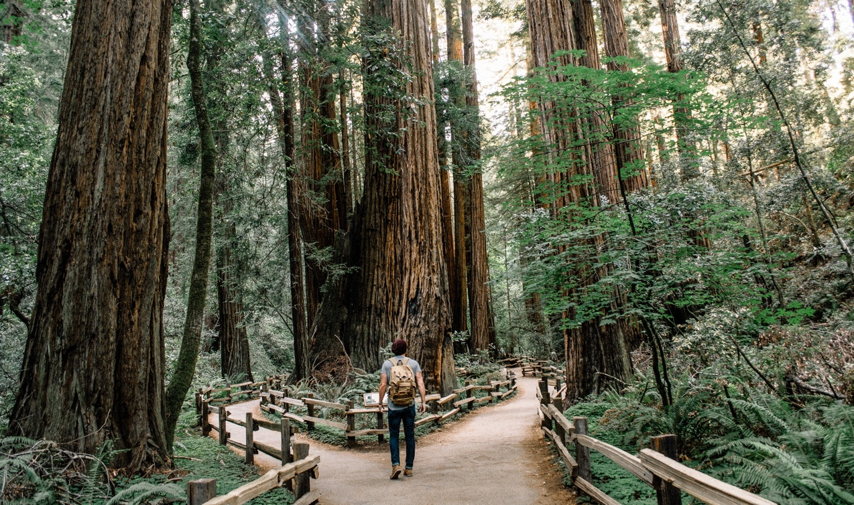

55 Railroad Row  White River Junction, VT 05001  802.295.4999  www.rsginc.com | prepared for:
 | National Park Service
 | Submitted By:
 | rsg

Paperwork Reduction and Privacy Act Statements: The Paperwork Reduction Act requires us to tell you why we are collecting this information, how we will use it, and whether or not you have to respond. This information will be used by the National Park Service as authorized by 54 USC 100702. We will use this information to evaluate visitors’ experiences using NPS digital resources. Your responses are voluntary and anonymous. Your name and address will not be collected. At the completion of this collection all personal information will be destroyed and in no way be connected with the results of this survey. A Federal agency may not conduct or sponsor and you are not required to respond to, a collection of information unless it displays a currently valid OMB Control Number.

Burden Estimate: We estimate that it will take an average of 15 minutes to complete this questionnaire. You may send comments concerning the burden estimates or any aspect of this information collection to the Social Science Program Chief, National Park Service, 1201 Oakridge Drive, Fort Collins, CO, 80525-5596; nps_nrss_social_science@nps.gov (email).

Notes for ICR Reviewers
Throughout the questionnaire NOTES for REVIEWERS will be added to provide additional explanations for ICR reviewers regarding the format and structure of the questionnaire.

For the purposes of this review:
- Italicized text within <angled brackets> indicates survey branching logic and/or instructions for the programmers of this online survey. This text will not appear in the final, online questionnaire. The text will be dynamically replaced contingent on the respondent’s previous answers or the platform/social media account the respondent was recruited from.
- The term “reference resource” will be dynamically replaced with text specific to the platform and the park (e.g., “Yellowstone National Park’s Instagram page” or “Lake Clark National Park’s Twitter page).
- Any time the phrase “NPS units” appears in questions or answer sets, the definition will be visible on hover or click.

Virtual Visitor Survey
Thank you for your help! By visiting National Park Service (NPS) websites and social media accounts or using a mobile app, you are a virtual visitor and we want to hear from you.
The questions in this survey will ask you about your virtual visit to <reference resource> today. Please complete your visit to <reference resource> before proceeding. Once you have completed your visit, please proceed to the start of the survey by clicking “Next.”

Thank you for participating! This survey aims to collect your thoughts on NPS digital resources to help the NPS better manage these digital resources for all virtual visitors. Your answers will be anonymous and cannot be traced back to you (for more information, read our data privacy policies here: https://rsginc.com/privacy-policy/).

Directions:
- To review and change a previous answer, use “Previous.” Use “Next” to go forward.

Definitions:
- Virtual visit: each time you visit/use an NPS website, social media page, or mobile app.
- Physical visit: each time you visit an NPS unit in person.
- NPS units: There are over 400 National Park Service (NPS) units, including areas such as national parks, monuments, battlefields, military parks, historical parks, historic sites, lakeshores, seashores, recreation areas, scenic rivers and trails, and the National Mall in Washington D.C.

Questionnaire
NOTE FOR REVIEWERS: This block of questions will be seen by all respondents.
Some questions in this survey will be about your VIRTUAL visit to <reference resource> today. If you haven’t already, we encourage you to complete your virtual visit before taking this survey.
- First, what is your age? ________ years old

NOTE for Reviewers: If response to Question 1 is <18, the survey will terminate with the following message: “Thank you for your interest in the survey. Unfortunately, you are not eligible to participate in this survey. Have a great day!”

- How often do you PHYSICALLY visit NPS units (in person)?

Never | Less than once a year | About once a year | 2-5 times a year | 6-10 times a year | More than 10 times a year
1 | 2 | 3 | 4 | 5 | 6

- Where were you PHYSICALLY when you were recruited for this survey on <reference resource>?
  - At an NPS unit <SKIP to Question 5>
  - On my way to an NPS unit <SKIP to Question 5>
  - Leaving an NPS unit <SKIP to Question 5>
  - At home
  - At work
  - Somewhere else (Please specify) ____________________

- Are you planning to PHYSICALLY visit an NPS unit within the next 12 months?
Yes | No
1 | 2

- What type of electronic device are you using to take this survey?
- Smartphone
- Tablet
- Laptop
- Desktop
- Other (Please specify_______________)
- On average, how often do you VIRTUALLY visit or use <reference resource> on any device?
- This was my first time < SKIP Question 8>
- Several times per day
- Several times per week
- Several times per month
- Every few months
- A few times per year
- Less than a few times per year

- On this VIRTUAL visit, about how much time did you spend on <reference resource>?
- Less than 5 minutes
- 5-10 minutes
- 11-20 minutes
- 21-30 minutes
- 31-40 minutes
- 41-50 minutes
- 51-60 minutes
- 61-90 minutes
- 91-120 minutes
- More than 120 minutes

- On average, how much time do you spend on <reference resource>?
- Less than 5 minutes
- 5-10 minutes
- 11-20 minutes
- 21-30 minutes
- 31-40 minutes
- 41-50 minutes
- 51-60 minutes
- 61-90 minutes
- 91-120 minutes
- More than 120 minutes
- On this VIRTUAL visit, what were you specifically looking for?
Please select all that apply.
- Maps/directions
- Multimedia (e.g., audio, images/pictures, video, virtual tours, webcams, etc.)
- Operating hours
- Current conditions (e.g., weather, news, alerts, closures)
- Places to stay (e.g., camping, lodging)
- Things to do (e.g., hiking, canoeing)
- Scheduled events and programs
- Fees/passes
- Reservations/permits (e.g., campsites, lodging, backpacking permits)
- Park merchandise
- Contact information
- Job and volunteer opportunities
- Lesson plans and curricula
- Information about park management
- Information about natural resources
- Information about cultural resources and history
- General browsing about national parks
- Other (Please specify ____________)

NOTE for Reviewers: Response options in Question 10 will be populated with responses selected in Question 9
- Of the items you were looking for, which did you find?
Please select all that apply.
- [answer option 1]
- [answer option 2]
- [answer option 3]
- …

- Overall, how easy was it to find the information you were looking for?
Extremely easy | Moderately easy | Neither easy nor difficult | Moderately difficult | Extremely difficult/impossible
1 | 2 | 3 | 4 | 5

- On this VIRTUAL visit, did you view or browse any content that you were not originally looking for?
  - Yes
  - No <SKIP to NPS.gov 1, Twitter 1, Facebook 1, Instagram 1, or HFC 1 depending on the reference resource being used>

- What content did you view or browse that you were not originally looking for?
Please select all that apply.
- Multimedia (audio, images, videos, webcams, virtual tours, etc.)
- Educational information (information about nature, history, culture, science, etc.)
- Logistical information about visiting an NPS unit (maps, operating hours, directions, fees/passes, etc.)
- Things to do (activities, events, tours, etc.)
- Places to stay (lodges, campsites, etc.)
- Other (please specify) _______________

NOTE for Reviewers: The next sections are platform/social media-specific. The questions in each section will only be seen by respondents coming from the <reference resource>.

NPS.gov

NPS.gov 1. How often do you share content from NPS.gov with others?
- Never
- Several times per day
- Several times per week
- Several times per month
- Every few months
- A few times per year
- Less than a few times per year

NPS.gov 2. How likely are you to use NPS.gov for trip planning to an NPS unit?

Very likely | Somewhat likely | Neutral | Somewhat unlikely | Very unlikely
1 | 2 | 3 | 4 | 5

NPS.gov 3. How often do you use NPS.gov to find contact information for NPS units?
- Several times per day
- Several times per week
- Several times per month
- Every few months
- A few times per year
- Less than a few times per year
- Never

NPS.gov 4. Do you think NPS.gov needs to improve any of the following?
Please select all that apply.
- Nothing needs improvement
- Visual appearance
- Organization of information
- Quality of information
- Speed (i.e. how fast pages load)
- Consistency of information across different parks
- Other (please specify ______)

<SKIP to Question 16>

Twitter

The next set of questions will ask about your typical usage of <reference resource>.

Twitter 1. How often do you retweet tweets from <reference resource>?
- Several times per day
- Several times per week
- Several times per month
- Every few months
- A few times per year
- Less than a few times per year
- Never (SKIP to Twitter 3)

Twitter 2. What is the typical subject of the tweets that you retweet from <reference resource>?

Please select all that apply.
- Park news or other current events
- Park information or alerts (e.g., weather, road closures, parking.)
- Park announcements (e.g., upcoming events or policies)
- Photographs of landscapes, plants and animals, landmarks, etc.
- Videos of landscapes, plants and animals, landmarks, etc.
- Other (Please specify_______________)

Twitter 3. How often do you reply to tweets from <reference resource>?
- Several times per day
- Several times per week
- Several times per month
- Every few months
- A few times per year
- Less than a few times per year
- Never

Twitter 4. How often do you tweet at <reference resource>?
- Several times per day
- Several times per week
- Several times per month
- Every few months
- A few times per year
- Less than a few times per year
- Never

Twitter 5. How often do you Direct Message (DM) <reference resource>?
- Several times per day
- Several times per week
- Several times per month
- Every few months
- A few times per year
- Less than a few times per year
- Never

<SKIP to Question 14>

Facebook
The next set of questions will ask about your typical usage of <reference resource>.

Facebook 1. How often do you leave comments on <reference resource>?
- Several times per day
- Several times per week
- Several times per month
- Every few months
- A few times per year
- Less than a few times per year
- Never

Facebook 2. How often do you react (e.g., use the like, love, wow reaction) to posts or photos on <reference resource>?
- Several times per day
- Several times per week
- Several times per month
- Every few months
- A few times per year
- Less than a few times per year
- Never <SKIP to Facebook 4>.

Facebook 3. What are the typical subjects of the posts that you react to on <reference resource>?

Please select all that apply.
- Weather or seasonality
- Landscapes
- Plants or vegetation
- Animals
- Landmarks
- Built environment (e.g., trails, buildings, roads, kiosks)
- Rangers
- Park visitors
- Park announcements (e.g., road closures, special events)
- Park information (e.g., reminders about park policies, helpful information for visiting)
- News or other current events
- Other (Please specify_______________)

Facebook 4. How often do you use Facebook Messenger to contact <reference resource>?
- Several times per day
- Several times per week
- Several times per month
- Every few months
- A few times per year
- Less than a few times per year
- Never
Facebook 5. How often do you share posts made by <reference resource>?
- Several times per day
- Several times per week
- Several times per month
- Every few months
- A few times per year
- Less than a few times per year
- Never

<SKIP to Question 14>

Instagram

The next set of questions will ask about your typical usage of <reference resource>.

Instagram 1. How often do you “Like” photos or videos posted by <reference resource>?
- Several times per day
- Several times per week
- Several times per month
- Every few months
- A few times per year
- Less than a few times per year
- Never <SKIP to Instagram 3>

Instagram 2. What are the typical subjects of the posts that you “Like” on <reference resource>?

Please select all that apply.
- Weather or seasonality
- Landscapes
- Plants or vegetation
- Animals
- Landmarks
- Built environment
- Rangers
- Park visitors
- Other (Please specify_______________)

Instagram 3. How often do you comment on photos or videos on <reference resource>?
- Several times per day
- Several times per week
- Several times per month
- Every few months
- A few times per year
- Less than a few times per year
- Never

Instagram 4. How often do you view Instagram Stories from <reference resource>?
- Several times per day
- Several times per week
- Several times per month
- Every few months
- A few times per year
- Less than a few times per year
- Never

Instagram 5. How often do you share, repost or mention Instagram posts from <reference resource> with people you know by tagging them in a comment or sending them a Direct Message?
- Several times per day
- Several times per week
- Several times per month
- Every few months
- A few times per year
- Less than a few times per year
- Never

Instagram 6. How often do you Direct Message <reference resource>?
- Several times per day
- Several times per week
- Several times per month
- Every few months
- A few times per year
- Less than a few times per year
- Never

<SKIP to Question 14>

HFC Apps

HFC 1. Why did you download <reference resource>?
- To plan an upcoming trip
- To navigate during a trip
- To get up-to-date information about closures during a trip
- To get times of tours/events during a trip
- To take an audio tour during a trip
- Other (please specify _____)

HFC 2. How satisfied are you with the ease of use of <reference resource>?

Extremely  satisfied | Very satisfied | Moderately satisfied | Slightly satisfied | Not at all satisfied
1 | 2 | 3 | 4 | 5

HFC 3. How satisfied are you with the offline features of <reference resource>?

Extremely  satisfied | Very satisfied | Moderately satisfied | Slightly satisfied | Not at all satisfied | Do not know/have not used
1 | 2 | 3 | 4 | 5 | 6

HFC 4. Do you think <reference resource> needs to improve any of the following?
Please select all that apply.
- Nothing needs improvement
- Visual appearance
- Organization of information
- Quality of information
- Speed (i.e. how fast pages load)
- Impact on battery life
- Other (please specify ______)

<SKIP to Question 16>

NOTE for Reviewers: The following two questions will only be seen and completed by respondents who were recruited on Twitter, Facebook, or Instagram.

- Do you follow or “Like” <reference resource>?
            - Yes
            - No <SKIP to Question 16>

- Why did you decide to follow or “Like” this account?

Please select all that apply.
- I like the information they share
- I live near the associated NPS location and like to stay informed
- I enjoy nature/the outdoors
- I started following this account after a park visit
- I plan to visit a park and want to get more information
- I follow many National Park Service accounts
- Other (Please specify_______________)

NOTE for Reviewers: The next sections will be seen and completed by all respondents.

- How satisfied are you with the content and information on <reference resource>?
Extremely satisfied | Very satisfied | Moderately satisfied | Slightly satisfied | Not at all satisfied
1 | 2 | 3 | 4 | 5

- Please rate <reference resource> compared to other <“websites,” “apps,” or “social media accounts” depending on type of reference resource> that you use or visit.
Much better | Somewhat better | About the same | Somewhat worse | Much worse
1 | 2 | 3 | 4 | 5

- How satisfied are you with this <reference resource> overall?
Extremely satisfied | Very satisfied | Moderately satisfied | Slightly satisfied | Not at all satisfied
1 | 2 | 3 | 4 | 5

- As a result of visiting or using this <reference resource>, has your likelihood of PHYSICALLY visiting an NPS unit in the next 12 months increased, remained the same, or decreased?
Increased | Remained the same | Decreased
1 | 2 | 3

- What was your primary reason for visiting or using this <reference resource>?
- To obtain necessary information
- To save time
- To be inspired
- To spend my leisure time
- To learn more about national parks in general
- Other (Please specify_______________)

- Which of the following other platforms have you used to view NPS content in the past?
<Response option that is the reference resource currently in use should be removed from list>
Please select all that apply.
- NPS.gov
- Facebook
- Instagram
- Twitter
- Official NPS apps
- Other (Please specify _________)
- None of the above <SKIP to Question 23>

- Of the platforms you’ve used to view NPS content, which do you prefer to use <insert selected response from Question 20 here>?
NOTE for Reviewers: Response options in Question 22 will be populated with responses selected in Question 21

- [answer option 1]
- [answer option 2]
- [answer option 3]
- […]

- How did you find out about <reference resource>?
- Followed a link from Facebook or other social media
- Used a search engine, such as Google
- Followed a link from another webpage
- National Park Service publication or exhibit
- Recommendation
- Word of mouth
- Other (please specify_____)

- Do you have any suggestions for what the National Park Service could do with <reference resource>?
open-ended response ____________________________

Demographics
You are almost done! Thank you for your thoughtful answers so far.

- What is your gender?
Male | Female | I prefer not to answer
1 | 2 | 3

- Including yourself, how many people live in your household?
_________ Number of people

- How many children under the age of 18 live in your household?
_________ Number of children under 18

- What is the highest level of formal education you have completed?
- Less than high school
- Some high school
- High school graduate or GED
- Some college, business, or trade school
- College, business, or trade school graduate
- Some graduate school
- Master’s, doctoral, or professional degree
- I prefer not to answer

- Are you Hispanic or Latino?
Yes | No | I prefer not to answer
1 | 2 | 3

- What is your race?
Please select all that apply.
- American Indian or Alaska Native
- Asian
- Black or African American
- Native Hawaiian or another Pacific Islander
- White
- I prefer not to answer

- Please enter your U.S. ZIP code or country (other than U.S.) of your primary residence?
_____________country or U.S. ZIP code
- What is your employment status?
Full time | Part time | Retired | Not working currently | I prefer not to answer
1 | 2 | 3 | 4 | 5

- Which category best represents your annual household income?
- Less than $24,999
- $25,000-$34,999
- $35,000-$49,999
- $50,000-$74,999
- $75,000-$99,999
- $100,000-$149,999
- $150,000-$199,999
- $200,000 or more
- I prefer not to answer <SKIP to END>

- How many people contribute to this income?
_________ Number of people

The NPS thanks you for your participation! Have a wonderful day.
55 Railroad Row
White River Junction, VT 05001
802.295.4999
www.rsginc.com
 |  | 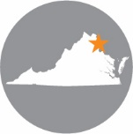
 | White River Junction & Burlington, VT | Arlington, VA | Chicago, IL | Evansville, IN | Portland, OR | Salt Lake City, UT | San Diego, CA
RSG promotes sustainable business practices that minimize negative impacts on the environment. We print all proposals and reports on recycled paper that utilizes a minimum of 30% postconsumer waste. RSG also encourages recycling of printed materials (including this document) whenever practicable.
For more information on RSG’s sustainability practices, please visit www.rsginc.com.

