Travel Diary Questionnaire
NOTE TO REVIEWER: This document presents the text of the travel diary questionnaire. This questionnaire language and its question structures and maps will be formatted on a series of cards that for distribution to respondents. Cards containing questions and maps appropriate for visitors’ planned trips will be packaged for respondents in an envelope with a pencil.

Introductory Text

NOTE TO REVIEWER: Information in the “Introductory Text” section will be presented to respondents following recruitment by Wilderness Center staff.

Thank you for agreeing to participate in this important research study for Yosemite National Park.

Every year tens of thousands of campers have outstanding wilderness experiences in Yosemite National Park. To ensure that campers can continue to have outstanding experiences, the park periodically surveys visitors about their camping experiences.

This questionnaire asks about your group, your trip plan, and the places where you camp during your upcoming wilderness trip. Your responses are vital to the sustained stewardship of Yosemite Wilderness.

PAPERWORK REDUCTION and PRIVACY ACT STATEMENT: The Paperwork Reduction Act requires us to tell you why we are collecting this information, how we will use it, and whether or not you have to respond. We are authorized by the National Park Service Protection Interpretation and research in System (54 USC §100702) to collect this information. The routine uses of this information will be for the benefit of NPS Managers and Planning staff in Yosemite National Park (YOSE) in future initiatives related to the visitor use and resource management within the site. The data collected will be summarized to evaluate visitor uses and expectations during their visit at YOSE. Your responses to this collection are completely voluntary and will remain anonymous. You can end the process at any time and will not be penalized in any way for choosing to do so. All contact information collected for the purpose of the follow-up survey will be destroyed at the end of the collection period and no personal identifiable records will be maintained or stored for any purposes. Data collected will only be reported in aggregates and no individually identifiable responses will be reported. A Federal agency may not conduct or sponsor, and you are not required to respond to, a collection of information unless it displays a currently valid OMB Control Number (1024-0224).

Burden Estimate Statement: We estimate that it will take about 12 minutes to complete this questionnaire. You may send comments concerning the burden estimates or any aspect of this information collection to: Nathan Reigner, Pennsylvania State University, nathanreigner@psu.edu (email); or Phadrea Ponds NPS Information Collection Clearance Officer at pponds@nps.gov (email).

recorded by Wilderness Center Staff Data

NOTE TO REVIEWER: The information in this section will be asked by Wilderness Center staff and recorded. Once the questions are recorded, Wilderness Center staff will administer the Travel Diary Questionnaire, below this section.

We ask for information about your permit so we can understand how the characteristics of your trip and the quality of your wilderness experience are related to the numbers and types of wilderness permits issued in
Yosemite National Park.

All permit data will be anonymized, with all personally identifying information removed.

Which of the following management units or organizations issued your wilderness camping permit? (select one)
Yosemite National Park
Inyo National Forest
Sierra National Forest
Sequoia and Kings Canyon National Parks
Humboldt-Toiyabe National Forest
Stanislaus National Forest
Eldorado National Forest
Lake Tahoe Basin Management Unit
Pacific Crest Trail Association (i.e., PCT long-distance permit)
I have no permit
Other (please specify): _______________________________

What is the ID number of your permit? _____________________________ (enter your permit ID, which may contain both numbers and letters)

Introductory Text

NOTE TO REVIEWER: Information in the “Introductory Text” section will be presented to respondents at the beginning of questionnaire administration.

This questionnaire is designed to provide park managers with information about where visitors camp in Yosemite Wilderness. The questionnaire begins with a brief series of questions about you, your group, and your trip plans. This section is followed by one or more maps that correspond to the parts of Yosemite Wilderness through which you are planning to travel on which we will ask you to mark the locations of your campsites. More detailed instructions for this are presented in the map section of the questionnaire. The maps section is followed by a brief set of questions about your trip as a whole and experience responding to this questionnaire. Please complete these questions at the end of your time wilderness camping in Yosemite.

Return Instructions
When you exit the wilderness, please return the map by leaving it in your rental food storage canister (if you have one), or by dropping it in the marked box outside the Wilderness Center closest to where you exit, or by handing it to an Entrance Station ranger when you leave the park. This information will help park managers protect the Yosemite Wilderness. Please also answer the two questions below and thank you for your assistance and cooperation!

NOTE TO REVIEWER: The following sections contain the questionnaire language, question structures, and maps that will be formatted onto customizable cards for distribution to respondents.

Group Characteristics & Trip Plans

The first two questions of this questionnaire ask about your permit group. Your permit group is the personal group (i.e., friends and family) with whom you are traveling on your wilderness permit during this trip in Yosemite National Park.

1. How many people, including yourself, are in your permit group (i.e., the friends and family with whom you are camping in the wilderness)?: _________________ (number of people).

2. Will you be using the services of a commercial guide or outfitter on this trip (excluding the services of the High Sierra Camps)? (select one)
Yes
No

NOTE TO REVIEWER: Question text for questions 3 and 6 will be customized for two versions of the questionnaire based on whether respondents hold a wilderness permit from Yosemite National Park or a permit issued by a neighboring unit (e.g., Inyo National Forest, Sequoia – Kings Canyon National Park.

3. Please list the trailhead in Yosemite National Park where you plan to start your wilderness trip. ________________________________(trailhead name)

4. What is the date of the first night you plan to camp in the wilderness in Yosemite National Park? (select one)
mm/dd/yy | Date of the first night you plan to wilderness camp in Yosemite National Park.
 | Don’t know / Not sure

5. Do you plan to end your wilderness camping trip in Yosemite National Park? (select one)
Yes, I plan to end my wilderness camping trip someplace in Yosemite National Park.
No, I plan to end my wilderness camping trip someplace outside of Yosemite National Park.

6. Please list the trail on which you will end your time wilderness camping in Yosemite National Park by either ending your trip or traveling out of the park and into a neighboring national forest? ________________________ (trail name)

7. How many nights do you plan to camp in the wilderness in Yosemite National Park during your wilderness trip? ___________________ (number of nights)

8. Approximately how far, in miles, do you plan to travel in Yosemite National Park on this trip?
________ | miles
OR
 | Don’t know/not sure
9. How would you describe your planned route for this wilderness camping trip? (select one)
 | My route is entirely within Yosemite National Park.
 | My route is along the John Muir Trail (i.e., traveling mostly along the JMT).
 | My route is part of a Pacific Crest Trail long-distance trip (i.e., traveling more than 500 miles along the PCT).
 | Other, please specify: ____________________

Map Section

We’d like you to please trace your hiking route with a solid line, and mark the location of each of your campsites with a circled number corresponding to the night of your trip. If you’re carrying a GPS or using a smart phone to navigate we encourage you to record the approximate coordinates of your campsite, however this information is not required.

We only need you to trace your camp-to-camp route. You don’t need to mark the route of any day hikes or side trips you may take. Please remember to mark each of your campsites with a circled number corresponding to the night of your trip.
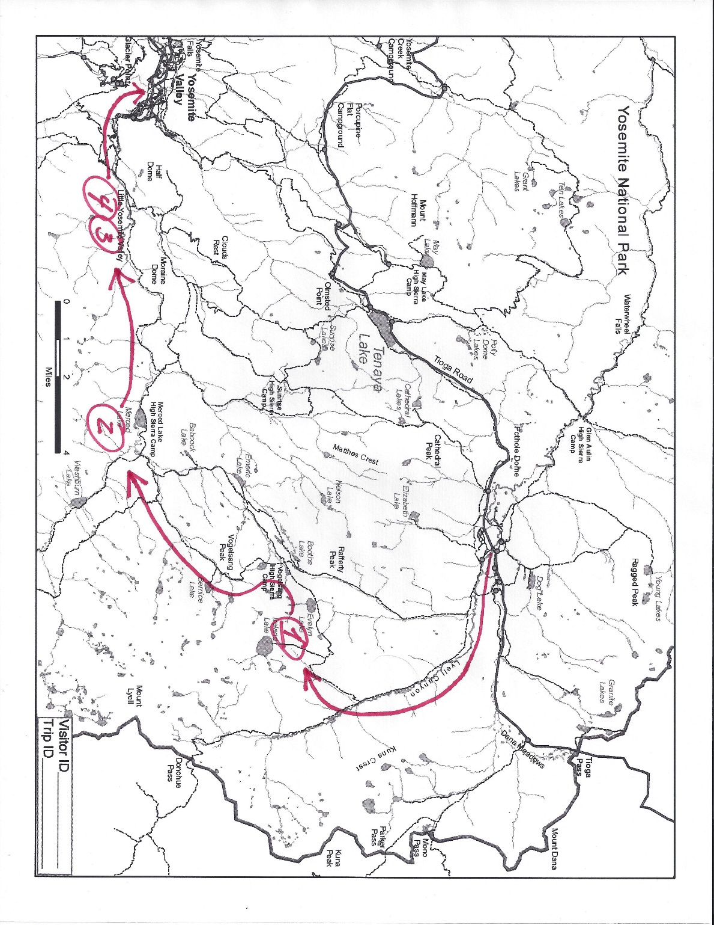
The example below demonstrates a camp-to-camp route for a four-night backpacking trip from Tuolumne Meadows to Yosemite Valley. This camping group began their wilderness trip at the Lyell Canyon trailhead. They camped their first night at Ireland Lake. They camped at Merced Lake High Sierra Camp backpackers’ campground on their second night. The group spent their third and fourth nights camping in Little Yosemite Valley. On the fourth day of their trip they summitted Half Dome, which is not depicted because only overnight camping locations are to be marked on the map.

Map Key
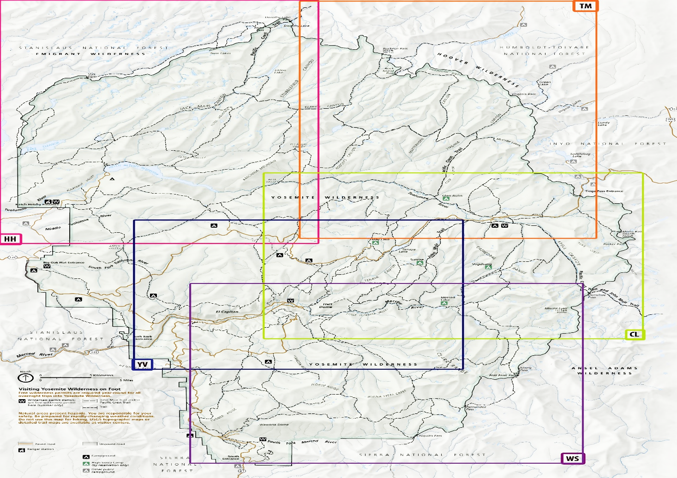
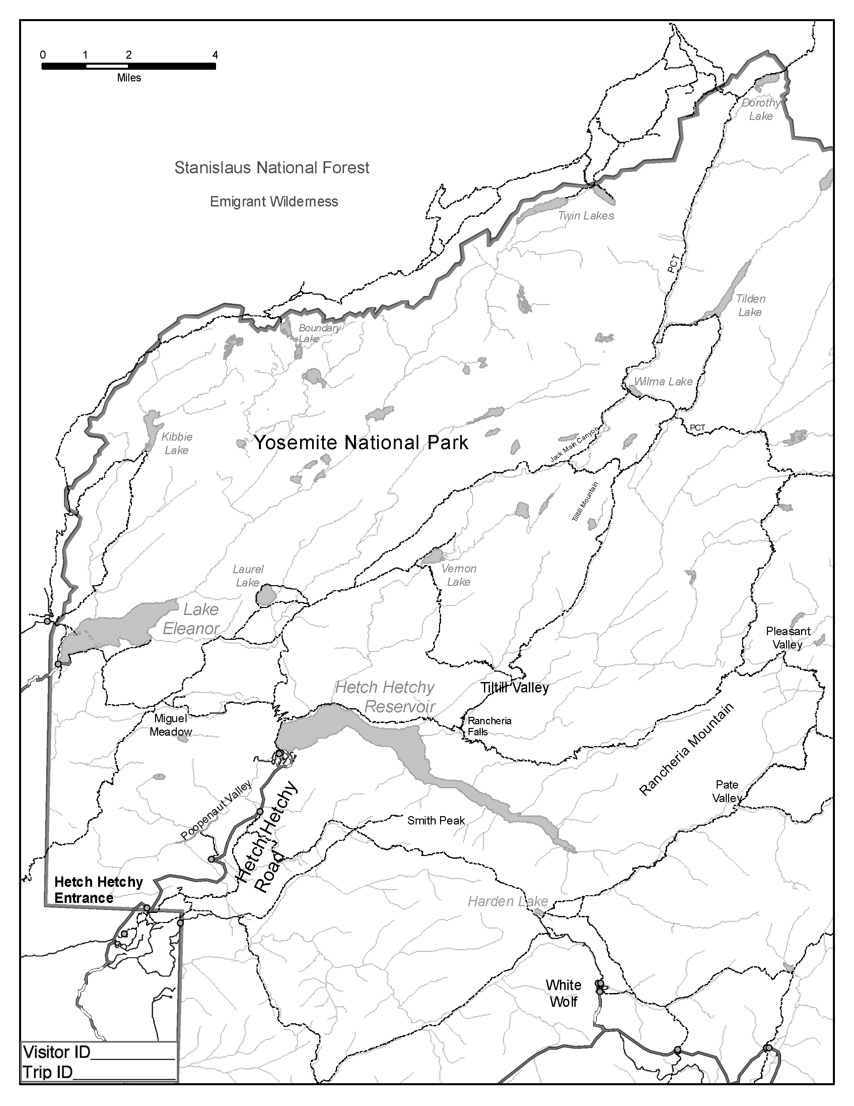
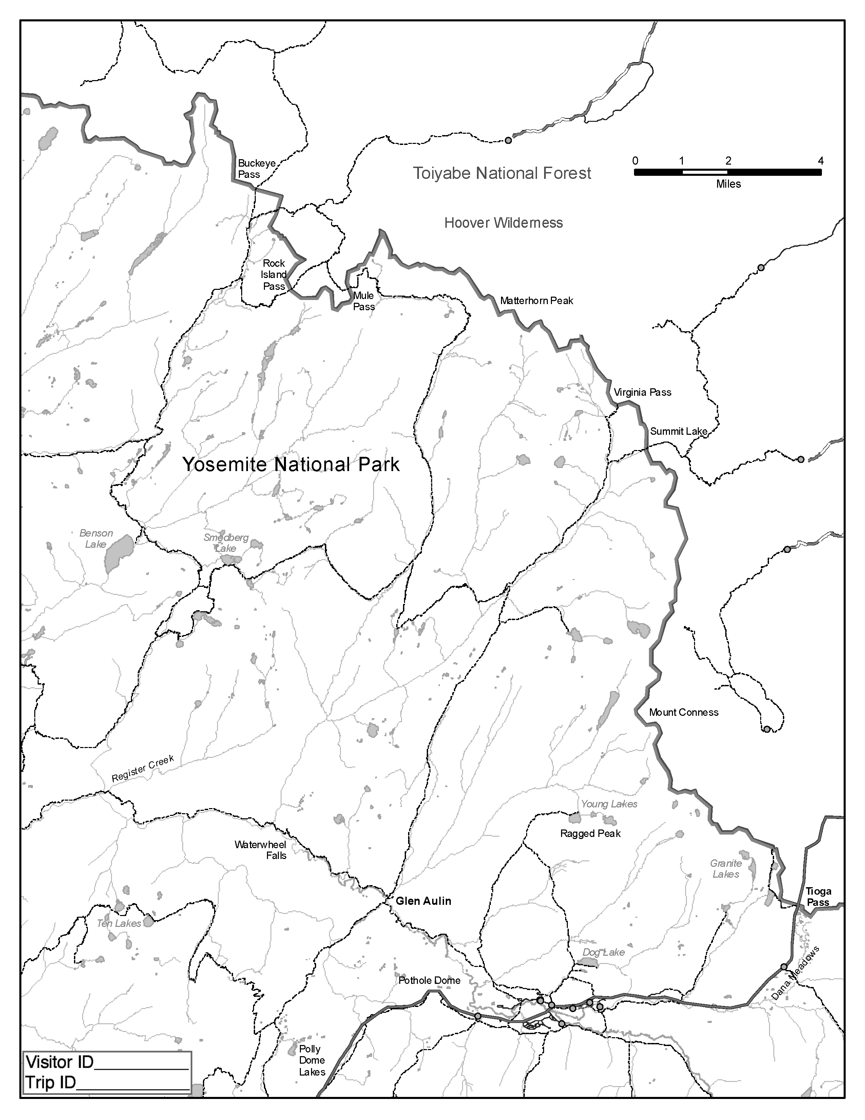
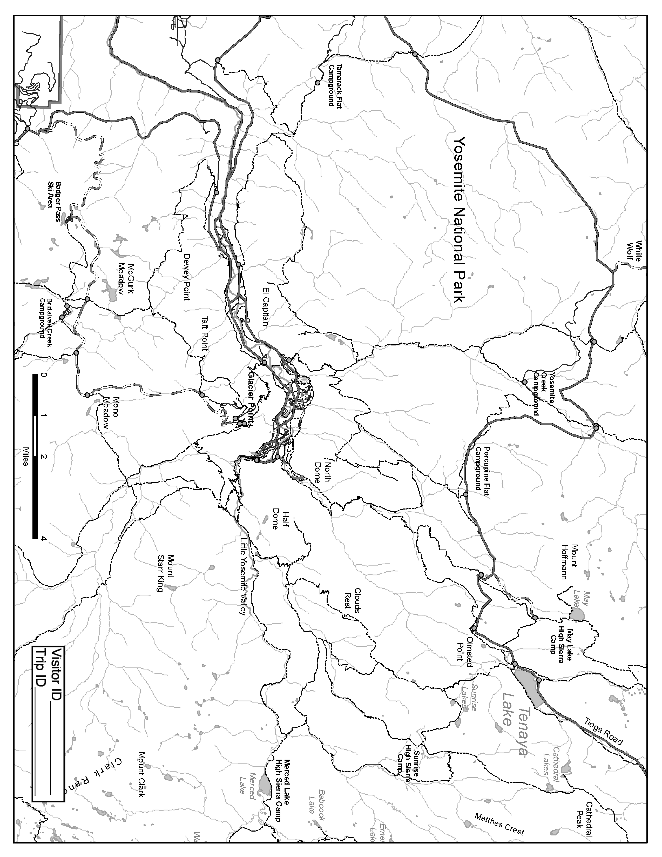
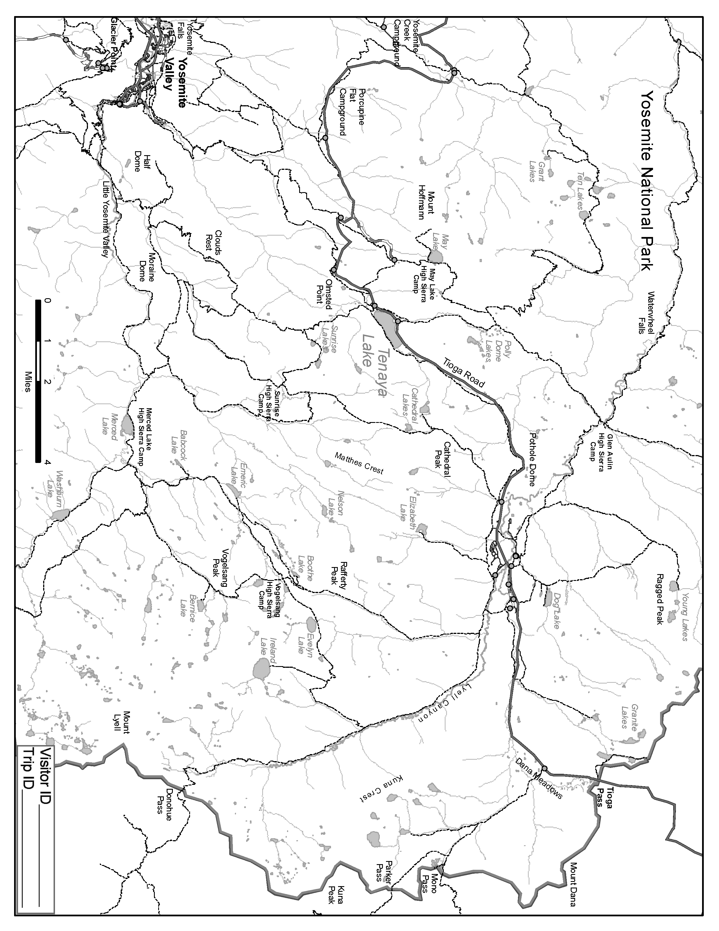
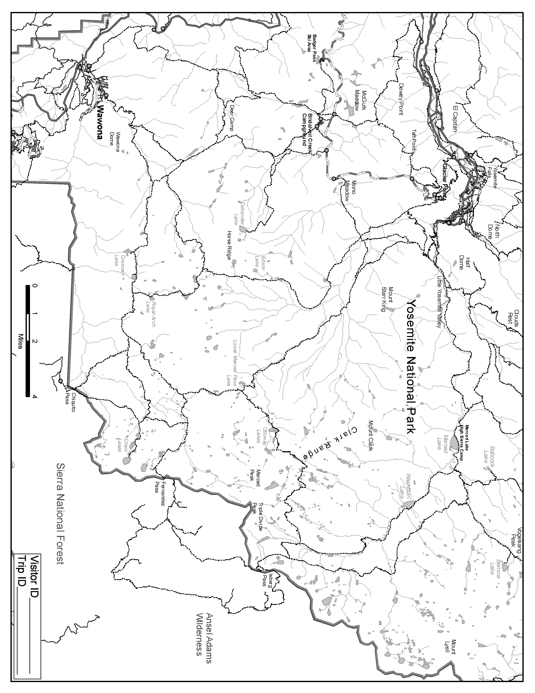

Trip End

NOTE TO REVIEWER: Respondents will be asked to complete “Trip End” questions at the conclusion of their wilderness camping trip in Yosemite National Park. This conclusion could be the end of their wilderness trip in its entirety or departure from Yosemite Wilderness into an adjacent unit (e.g., Inyo National Forest).

Thank you for recording your camp-to-camp route, the information will be very help to Yosemite National Park managers.

Upon ending your wilderness camping trip in Yosemite (i.e., either ending your trip entirely or leaving Yosemite and entering a neighboring national forest, please respond to the following questions about your wilderness camping experience in Yosemite.

10. Please list the trail on which you ended your time wilderness camping in Yosemite National Park by either ending your trip in the park or traveling into a neighboring national forest? ________________________ (trail name)

11. Did your permit group end your trip or exit the wilderness in Yosemite National Park earlier than, later than, or on the same day as originally planned?
Yes, I ended my trip or exited Yosemite Wilderness earlier than originally planned. | No, I ended my trip or exited Yosemite Wilderness on the same day as originally planned. | Yes, I ended my trip or exited Yosemite Wilderness later than originally planned.
 | Go to Q. 13

12. We would like to know why you ended your wilderness camping trip or exited Yosemite Wilderness earlier than planned. How important was each of the following factors for ending your wilderness camping trip or exiting Yosemite Wilderness earlier or later than originally planned? (check one box per item)
 |  |  |  | Not at all important | Slightly important | Moderately important | Very important | Extremely important
We traveled at a different pace than planned.
A group member became injured, ill, or physically exhausted.
To avoid environmental conditions like weather, flooded rivers, snow, or fire.
Our motivations for the trip changed.
External factors (e.g., at home, work, school, etc.) prompted us to end our trip.
Our original trip plan was too ambitious or difficult.
We got lost or disoriented.
We had a problem with equipment or supplies.
An emergency.

13. We would like to know about how the time you spent wilderness camping in Yosemite National Park, as a whole, compared with your expectations. Thinking about your wilderness camping trip in Yosemite National Park as a whole, please indicate how your experience of each of the following items compared with your expectations. (select one for each item)
 |  |  | I had no expectations | A lot less than expected | Less than expected | About as expected | More than expected | A lot more than expected
The number of other camping groups you could see or hear from your campsites.
The number of campers from other groups entering or walking near your campsite.
The amount of litter or trash in and around your campsite.
The amount of improperly disposed of human waste or toilet paper in and around your campsites.
The number of campfire rings or evidence of campfires in and around your campsites.
The amount of camp furniture like rocks or logs arranged for seats, tables, etc. in and around your campsites.
Human alterations to vegetation or soil in and around your campsites.
Wildlife habituation (e.g., animals approaching you in search of food) in and around your campsites.

14. Please indicate to what extent you agree or disagree with the following statements about your participation in this wilderness camping study. (select one for each item)
 |  |  | Strongly disagree | Disagree | Neutral | Agree | Strongly agree | Don’t know
Participating in this study negatively impacted my wilderness experience. |  |  | □ | □ | □ | □ | □ | □
Participating in this study contributed to the stewardship of Yosemite National Park. |  |  | □ | □ | □ | □ | □ | □
I would participate in this study again if I had the chance. |  |  | □ | □ | □ | □ | □ | □

Return Instructions

NOTE TO REVIEWER: Return instructions will be printed in on the outside of the envelope in which questionnaire cards are provided to respondents.

When you exit Yosemite wilderness, either by ending your trip entirely or leaving Yosemite and entering a neighboring national forest, please return the questionnaire cards, sealed in this envelope, by one of the following mechanisms:
- leaving it in your rental food storage canister, if you have one, when you return it
- by dropping it off at a Wilderness Center in Yosemite National Park or one of the surrounding national forests or parks
- by handing it to an entrance station ranger when you leave the park
Alternatively, you can return your responses by taking photographs of your completed questionnaire cards and emailing them to YosemiteWildernessStudy2021@gmail.com.

Thank you for completing this Yosemite Wilderness Study questionnaire. Your responses are very much appreciated and will help to inform park Wilderness stewardship.

