OMB CONTROL NUMBER: 1024-0224

SAGU VISITOR SURVEY: Intercept survey

Intercept opening script
“Hello, I am working with Saguaro National Park conducting a 5-minute survey to improve visitor experiences in the park. May I ask you some questions about your Saguaro National Park experience?
➔ If the visitor says YES, read the following script:
Before we begin, I would like to let you know that this survey has been approved by the Office of Management and Budget. It is important to note that a Federal agency may not conduct or sponsor, and you are not required to respond to, a collection of information unless it has a valid OMB control number. TheOMB Control number for this collection is 1024-0224. Secondly, your participation is voluntary, and your name will never be connected with your individual responses. This survey will only take about five minutes of your time today.
➔ If the visitor says NO, read the following script:
Ok, would you please answer just three short questions for us?
➔ If the visitor says NO, thank them for their time.
➔ If the visitor says YES, ask the non-response bias questions:
1. “Are you a permanent or seasonal resident of the local area around Saguaro National Park?”
2. “Do you currently live in the United States?”
3. “On this trip away from home, have you stayed, or will you stay overnight away from your permanent/seasonal residence in Saguaro National Park and/or within the local area? (Show map)”

PAPERWORK REDUCTION ACT STATEMENT: The National Park Service is authorized by the NPS Research Mandate (54 USC 100702) to collect this information. This information will be used by NPS Managers and Planning staff in Saguaro National Park in future initiatives related to the visitor use and resource management within the site.. Response to this request is voluntary. No action may be taken against you for refusing to supply the information requested. The permanent data will be anonymous. An agency may not conduct or sponsor, and a person is not required to respond to, a collection of information unless it displays a currently valid OMB control number.
BURDEN ESTIMATE Public reporting burden for this form is estimated to average 5 minutes per response. Please direct comments regarding the burden estimate or any other aspect of this form to: Dr. Jake Jorgenson, RRC Associates, jake@rrcassociates.com (email); or Bret Meldrum, Chief of the Social Science Program at bret_meldrum@nps.gov (email).

Local Area Map
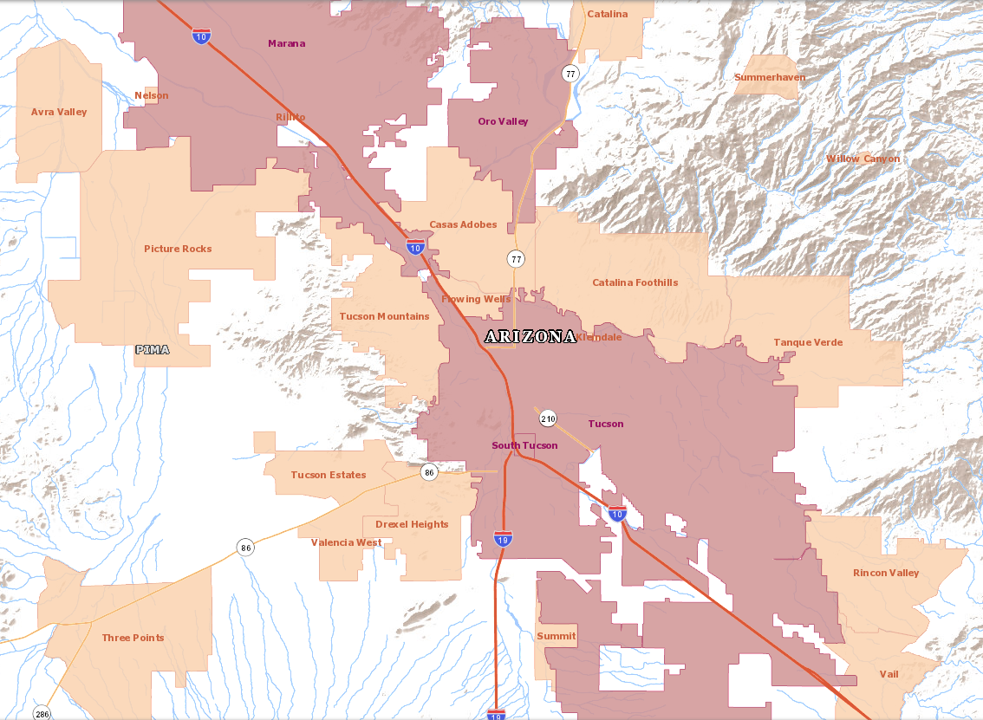
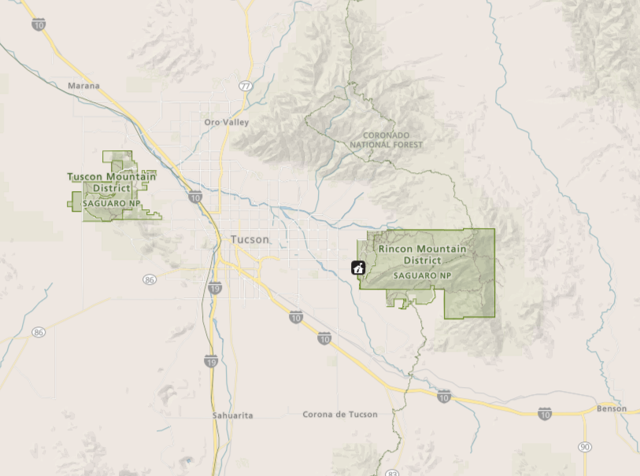
Park Map(s) to be shown on laminated sheet
SURVEYOR TO COMPLETE: Interview site
East (Rincon Mountain District)
- Rincon Visitor Center
- Trailhead 1
- Trailhead 2
West (Tucson Mountain District)
- Red Hills Visitor Center
- Trailhead 1
- Trailhead 2
Surveyor name:
- Name
- Name

First, we’d like to ask some questions about your trip away from home during this visit to Saguaro National Park and the time you might have spent/will spend in the local area. (Interviewer provide maps of both the local area and the park -- 2–sided and laminated)
- Before we began talking, were you aware that [current Intercept Location / Trailhead Name] is in Saguaro National Park?
  - Yes
  - No
  - Not sure
- Are you a permanent or seasonal resident of the local area around Saguaro National Park?
  - Yes, I am a permanent resident
  - Yes, I am a seasonal resident
  - No
- (If seasonal or permanent resident) What is your zip code in the local area? ________zip code
- (If not seasonal or permanent resident) Do you currently live in the U.S.?
  - Yes What is your zip code? _________zip code
  - No What is your country of origin?__________ (Drop Down)

- (If not seasonal or permanent resident) Was your visit to Saguaro the primary purpose for your overall trip away from home?
  - Yes
  - No
- (If primary purpose=no) Was your visit to Saguaro…?
  - The primary reason you came to the greater Tucson area
  - One of two or more equally important reasons you came to the greater Tucson area
  - An incidental or spontaneous stop while in the greater Tucson area
- On this trip away from home, have you stayed, or will you stay overnight away from your permanent residence in Saguaro National Park and/or within the local area? (Show Map).
  - Yes
  - No
- (If Overnight = YES) On this trip, what type of accommodations do you expect to use while in Saguaro and/or the local area? Please select all that apply.
  - Backcountry Camping in Saguaro National Park
  - Camping outside Saguaro National Park in the local area
  - Lodging outside Saguaro National Park in local area (e.g., hotels, cabins, vacation rentals)
  - Unpaid accommodations (e.g., family and friends)
- (For each accommodation type selected above) How many nights have you spent or do you plan to spend [accommodation type]?
________ nights
- (IF BACKCOUNTRY CAMPING IN SAGU) What time did you arrive in Saguaro National Park on your first day of your stay?
______Hour (1-12)
  - AM
  - PM

- (IF BACKCOUNTRY CAMPING IN SAGU) What time do you plan to leave Saguaro National Park on the last day of your stay?
______Hour (1-12)
  - AM
  - PM
- Including yourself, how many people are in your personal group as you visit Saguaro?
Note: Your personal group is you and companions with whom you visited Saguaro National Park on this trip, such as a spouse, family, friends, etc. This does not include the larger group that you might have traveled with, such as a school, church, scout, or tour group.
______ Children/teenagers (under 18 years)
______ Adults (18 years to 64 years)
______ Older adults (65 and older)
- (If not alone, per prior question) Which one of the following best describes the group you are traveling with? [Single Response]
  - Myself with family (including spouse/partner and/or other family members/relatives)
  - Myself with friends
  - Myself with family and friends
  - Outfitter/guide
  - Club/organization/other organized group (e.g tour group, scout group, etc.)
  - Other ________________________
- (If Club or other organized group) Which of the following best describes the type of group you are with today? [Single Response]
  - Commercial guided tour group
  - Club/special interest organization (e.g. hiking club)
  - School/educational group
  - Other organized group (scouts, HOA, business group, church group, etc.)
  - None of the above

- Does anyone in your personal group have a physical condition that made it difficult to access or participate in park activities or services during your visit to Saguaro?
  - Yes
  - No
- (If yes) Because of the physical condition, which specific difficulty(ies) did the person(s) have? Please select all that apply.
  - Hearing (difficulty hearing ranger programs, audio-visual exhibits or programs, or information desk staff even with hearing aid)
  - Visual (difficulty in seeing exhibits, directional signs, visual aids that are part of programs even with prescribed glasses or due to blindness)
  - Mobility (difficult in accessing facilities, services, or programs even with walking aid and/or wheelchairs)
  - Other (Please specify)
- On this trip, do you plan to visit Saguaro National Park for more than one day? . Note: Please consider visits to both districts of Saguaro National Park in your response.
  - Yes
  - No
- (If visit for more than 1 day=NO) How many hours do you plan to spend within each district of Saguaro National Park today?
______ hours spent in Saguaro East (Rincon Mountain District) today
______ hours spent in Saguaro West (Tucson Mountain District) today
- (If visit for more than 1 day=YES) How many days do you plan to spend in either district of the park on this trip?
______ Days
- (If visit for more than 1 day=YES) On how many different days do you expect to enter either district of the park?
______ Different Days Entered Saguaro National Park
- (If intercepted in RMD) Did you, or do you plan to, leave and re-enter Saguaro East (Rincon Mountain District) today?
  - Yes
      - How many times?_______
  - No
- (If intercepted in RMD) Did you, or do you plan to, leave Saguaro East (Rincon Mountain District) and enter Saguaro West (Tucson Mountain District) today?
  - Yes
  - No
- (If intercepted in TMD) Did you, or do you plan to, leave and re-enter Saguaro West (Tucson Mountain District) today?
  - Yes
      - How many times?_______
  - No
- (If intercepted in TMD) Did you, or do you plan to, leave Saguaro West (Tucson Mountain District) and enter Saguaro East (Rincon Mountain District) today?
  - Yes
  - No
- Considering your visit today, have you been to or do you plan to visit any of the following locations within Saguaro National Park? Please select all that apply
List of locations within East (RMD)
  - Cactus Forest Loop Drive (via the one-way road)
  - Javelina Picnic Area (via two-way road)
  - Douglass Springs Trail
  - Broadway Trail
  - Loma Alta Trail
  - Wildhorse Trail
  - Miller Creek Trail
  - Turkey Creek Trail
  - Other______
List of locations within West (TMD)
  - Red Hills Visitor Center
  - Golden Gate Road (off Sandario Road)
  - Hohokam Road (off Kinney Road)
  - Cam-Boh Picnic Area
  - Pictured Rocks Road east of Cam-Boh Picnic Area
  - El Camino Del Cerro Trail
  - Ringtail Trail
  - Belmont / Abbington Trail
  - Scenic Trail
  - Cactus Wren Trail
  - Golden Gate Multi-Use Trail
  - King Canyon Trail
  - Other_______

- Which of the following forms of transportation did you personally use to enter Saguaro National Park today? Please select all that apply.
- Car, truck, or SUV (e.g., standard private vehicle)  - Recreational vehicle or motorhome  - Commercial tour bus  - Commercial tour van  - Shuttle  - School bus or church bus/van  - City bus  - Bicycle | - Electric Bicycle  - Motorcycle  - Walk/hike  - Horse/Equestrian  - Other (Please specify: __________)
- (If car, truck, or SUV; RV or motorhome; or motorcycle selected) How many people were traveling in your vehicle today, including yourself? ________

- (If seasonal or permanent resident) How long did it take you to get here today?
_________ minutes (one-way)
- Are you a first-time visitor to Saguaro National Park?
  - Yes
  - No
- (If respondent is not a first time visitor and is not a seasonal/permanent resident) Including this visit, how many visits have you made to Saguaro over the past 12 months? ____________visits
- (If respondent is not a first time visitor and is not a seasonal/permanent resident) Including this visit, how many visits have you made to Saguaro over the past five years? ____________visits

- (If respondent is not a first time visitor and is a local/seasonal resident) How many times do you typically visit Saguaro in an average month?
____________visits

- (If respondent is not a first time visitor and is a local/seasonal resident) When you visit Saguaro, how often do you use this entry [or visit this location] in Saguaro?
  - Always
  - Most of time
  - Sometimes
  - Seldom
  - It is my first time at this location
- How many visits have you made to other NPS sites over the past 12 months?
_____visits

Interviewer script:
Thank you for your time. To record a more complete picture of your Saguaro National Park visit, we ask you to please take this mail-back survey and complete it after your trip. You can participate either by completing the paper form and mailing it in the postage-paid envelope, or online through a password-protected website. The website information is provided on a slip of paper inside the survey packet.

Because your opinion is important to us, we send replacement surveys if you lost your survey and reminders if you forgot to complete it when you returned home. Would you be willing to share your home address or email to send a reminder or replacement survey in the following weeks? Your information is confidential, and your results will be only reported in the aggregate.

First name: __________________________________________
Address:_____________________________________________
Email: ______________________________________________

