Dark sky recreationists’ experiences
in Utah National Parks

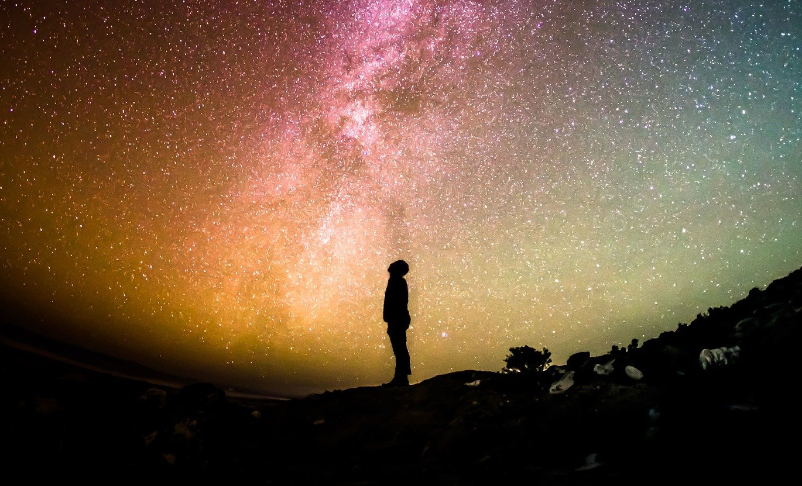

PAPERWORK REDUCTION and PRIVACY ACT STATEMENT: The Paperwork Reduction Act requires us to tell you why we are collecting this information, how we will use it, and whether or not you have to respond. We are authorized by the National Park Service Protection Interpretation and Research in System (54 USC §100702) to collect this information. The routine uses of this information will be for the benefit of NPS Managers and Planning staff in future initiatives related to the management of night sky recreation. The data collected will be summarized to evaluate visitor experiences, expectations, and support for management actions during their visit to this National Park unit. Your responses to this collection are completely voluntary and will remain anonymous. You can end the process at any time and will not be penalized in any way for choosing to do so. Your participation poses only minimal risks. Data collected will only be reported in aggregates and no individually identifiable responses will be reported. A Federal agency may not conduct or sponsor, and you are not required to respond to, a collection of information unless it displays a currently valid OMB Control Number (1024-0224).

BURDEN ESTIMATE: We estimate that it will take about 20 minutes to complete and return this short survey. You may send comments concerning the burden estimates or any aspect of this information collection to: Dr. Jordan Smith, Associate Professor, Jordan.smith@usu.edu; or Phadrea Ponds NPS Information Collection Clearance Officer at pponds@nps.gov.

1. Was this trip to [PARK NAME]...
- ...the primary purpose for your trip? [SKIP TO Q3]
- ...one of several equally important destinations on your trip? [IF SELECTED, SKIP TO TRIP2]
- ...just an incidental or spur of the moment stop on your trip? [IF SELECTED, SKIP TO DEST5-modified]

2. What were the other destinations that were of equal importance as visiting [PARK]
- Arches National Park | - Grand Canyon National Park
- Bryce Canyon National Park | - Grand Parashant National Monument
- Canyonlands National Park | - Hovenweep National Monument
- Capitol Reef National Park | - Monument Valley Navajo Tribal Park
- Dead Horse Point State Park | - Natural Bridges National Monument
- Fremont Indian State Park | - Rainbow Bridge National Monument
- Glen Canyon National Recreation Area | - Zion National Park
- Goblin Valley State Park | - Other: ________________________
- Goosenecks State Park

3. Is your current trip more than one day?
- Yes [SKIP TO Q5]
- No

4. What is the total length of your trip to [PARK] in hours?
________________________________________________________________

5. What is the total length of your trip to [PARK] in days?
________________________________________________________________

6. Are you a permanent resident or citizen of the United States? (Please respond “yes” or “no”)
- Yes
- No (skip to Q8)

7. What is your primary zip code?
________________________________________________________________

8. What is your country of origin?
________________________________________________________________

9. Below is a list of activities. Please indicate all activities you have or plan to participate in on this trip to [PARK].
Have, or plan to, participate in during this trip
Scenic driving
Developed camping
Backcountry camping
Wildlife observation during the day
Wildlife observation at night
Night sky photography
Night sky viewing/astronomy
Hiking
Mountain biking
Road cycling
Horseback riding
Hunting [DISPLAY ONLY IN Antelope Island SP]
Fishing [DISPLAY ONLY IN Antelope Island SP]
Visiting historic or cultural sites
Rock climbing
Rafting or canoeing
Other: __________________

10. From the list above Please indicate your primary activity during this trip to the park: _________________________

11. To what extent do you agree or disagree with the following statements?
 | Strongly disagree | Somewhat disagree | Neutral | Somewhat agree | Strongly agree
[PARK] is the best place for my night-time activity. | -2 | -1 | 0 | 1 | 2
I get more satisfaction out of my night-time activity at [PARK] than any other place | -2 | -1 | 0 | 1 | 2
My night-time activity at [PARK] is more important to me than doing it at any other place | -2 | -1 | 0 | 1 | 2
I wouldn't substitute any other area for my night-time activity at [PARK] | -2 | -1 | 0 | 1 | 2

12. We would like to know about how much you spent in the local area on your trip. When providing estimates, please include only expenses in the area shown below.

(*A map of the area surrounding the park the survey is being conducted in will appear here. An example is provided)
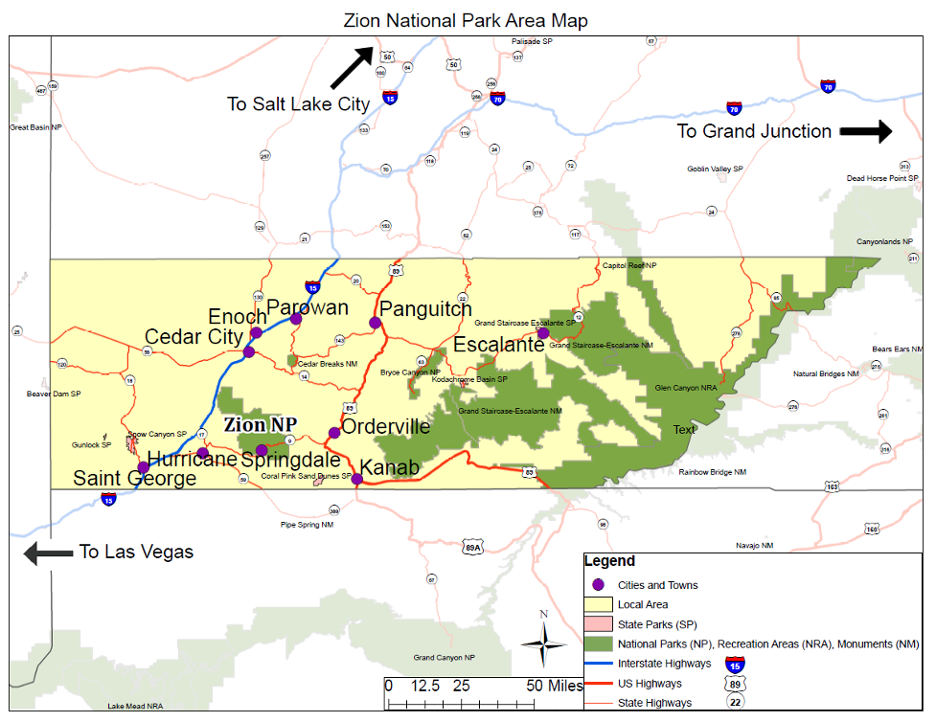

13. Have you or do you plan to spend money in the region indicated on the map above?
- Yes
- No [Skip to Q 17]

14. Please estimate how much you and those with whom you shared expenses (e.g., other family members, traveling companions) spent or plan to spend both inside [PARK] and within the nearby area on this trip.
Estimate expenditures as closely as you can. Please enter 0 if you did/will not spend any money in a particular category. If you don't know how much you spent in any category, please mark the "Don't Know" box.

 | Amount spent in [PARK] and nearby area (in US$) | Don't Know
Park entrance fees | ____________
Gas and oil (auto, RV, boat, etc.) | ____________
Rental cars | ____________
Restaurants and bars | ____________
Groceries and convenience foods | ____________
Hotels, motels, resorts, lodges | ____________
Specialty lodging (e.g., B&Bs, hostels, cabins, vacation rentals) | ____________
Camping fees (tent, RV) | ____________
Recreation and entertainment expenses (e.g., movies, bowling, miniature golf, etc.) | ____________
Souvenirs, clothing, supplies, other retail | ____________
Equipment rental | ____________
Guides and tour fees | ____________
Other (please list below) | ____________

15. How many people, including yourself, did you include in the estimates provided above?

 | Number
Adults (18 years or over) | ______
Children (under 18 years) | ______

16. Please estimate your non-trip expenditures in Utah related to night sky recreation in the past 12 months. For example, did you purchase any equipment such as telescopes, cameras, camping gear, etc.? Please only include expenditures that you paid within Utah.
________________________________________________________________

17. To be better informed on future visits, I would like to learn more about:

 | Strongly disagree | Somewhat disagree | Neutral | Somewhat agree | Strongly agree
Night sky viewing/astronomy | -2 | -1 | 0 | 1 | 2
Viewing wildlife at night | -2 | -1 | 0 | 1 | 2
Native American connections to the night skies | -2 | -1 | 0 | 1 | 2
Ways to improve night sky viewing | -2 | -1 | 0 | 1 | 2
Other: __________ | -2 | -1 | 0 | 1 | 2

18. How would you prefer to learn about the following activities? Please select all that apply.

 | Ranger-led programs | Programs organized by local clubs | Interpretive displays | Smartphone applications | Other (please describe)
Night sky viewing/astronomy |  |  |  |  | _________
Viewing wildlife at night |  |  |  |  | _________
Native American connections to the night skies |  |  |  |  | _________
Ways to improve night sky viewing |  |  |  |  | _________
Other |  |  |  |  | _________

19. Please indicate the degree to which you oppose or support the following management actions designed to protect the night sky quality at [PARK]

 | Completely oppose | Somewhat oppose | Neither oppose nor support | Somewhat support | Completely support
Setting lights to the minimum necessary brightness | -2 | -1 | 0 | 1 | 2
Reducing the number of outdoor lights in the park | -2 | -1 | 0 | 1 | 2
Restricting the number of lights visitors can use at night | -2 | -1 | 0 | 1 | 2
Creating shields on lights that direct light only to intended areas | -2 | -1 | 0 | 1 | 2
Adjusting hues of lights to be wildlife friendly | -2 | -1 | 0 | 1 | 2
Adjusting hues of lights to preserve human's night vision | -2 | -1 | 0 | 1 | 2
Installing sensors/timers that turn lights on only when needed | -2 | -1 | 0 | 1 | 2

Email Survey – skip to Q 22
On-site Activity (Only)
LOOK UP! Now, we would like you to take 30-seconds to look up at the night sky and then answer a set of questions.
20. Please indicate the degree to which you disagree or agree with the following statement about the experience you just had viewing the night sky.
 | Completely disagree | Disagree | Slightly disagree | Neither | Slightly agree | Agree | Completely agree
I sensed things momentarily slow down | -3 | -2 | -1 | 0 | 1 | 2 | 3
I noticed time slowing | -3 | -2 | -1 | 0 | 1 | 2 | 3
I felt my sense of time change | -3 | -2 | -1 | 0 | 1 | 2 | 3
I felt my sense of self become somehow smaller | -3 | -2 | -1 | 0 | 1 | 2 | 3
I felt small compared to everything else | -3 | -2 | -1 | 0 | 1 | 2 | 3
I felt my sense of self shrink | -3 | -2 | -1 | 0 | 1 | 2 | 3
I had the sense of being connected to everything else | -3 | -2 | -1 | 0 | 1 | 2 | 3
I felt closely connected to humanity | -3 | -2 | -1 | 0 | 1 | 2 | 3
I had a sense of complete connectedness | -3 | -2 | -1 | 0 | 1 | 2 | 3
I felt that I was in the presence of something grand | -3 | -2 | -1 | 0 | 1 | 2 | 3
I experienced something greater than myself | -3 | -2 | -1 | 0 | 1 | 2 | 3
I perceived vastness | -3 | -2 | -1 | 0 | 1 | 2 | 3
I felt in the presence of greatness | -3 | -2 | -1 | 0 | 1 | 2 | 3
I felt challenged to mentally process what I was experiencing | -3 | -2 | -1 | 0 | 1 | 2 | 3
I found it hard to comprehend the experience in full | -3 | -2 | -1 | 0 | 1 | 2 | 3
I struggled to take in all that I was experiencing at once | -3 | -2 | -1 | 0 | 1 | 2 | 3
I felt my eyes widen | -3 | -2 | -1 | 0 | 1 | 2 | 3
I felt myself smile | -3 | -2 | -1 | 0 | 1 | 2 | 3
It gave me the chills | -3 | -2 | -1 | 0 | 1 | 2 | 3

21. Viewing the night sky can be affected by artificial light. We would like to know your opinion about how the night sky should look for stargazing or viewing. Please take a moment to look at the conditions of the night sky and answer the following question:

 | Completely unacceptable | Unacceptable | Slightly unacceptable | Neutral | Slightly acceptable | Acceptable | Completely acceptable
How unacceptable or acceptable do you think the current conditions are in [PARK] for stargazing or viewing the night sky? | -3 | -2 | -1 | 0 | 1 | 2 | 3

22. Prior to this trip to [PARK], were you aware that this park is certified as an International Dark Sky Park/Place?
- Yes
- No [Skip to Q 24]

23. Please select one answer below.

 | Not important at all | Slightly important | Somewhat important | Very important | Extremely important
How important was it for you to visit a park certified as an International Dark Sky Park/Place? | 1 | 2 | 3 | 4 | 5

Socio-demographics
24. What is your age?
________________________________________________________________

25. What is the highest level of formal education you have completed?
- Less than high school
- Some high school
- High school graduate
- Vocational/trade school certificate
- Some college
- Associate degree (AA, AS, etc)
- Bachelor's degree (BA, AB, BS, etc.)
- Master's degree (MA, MS, MEd, MSW, MBA etc.)
- Professional degree (MD, DDS, DVM, LLB, JD, etc.)
- Doctorate degree (PhD, EdD, etc.)
26. What is your gender?
- Male
- Female
- Self-Identify ____________________

27. For you only, are you Hispanic or Latino?
- Yes
- No

28. Which of these categories best indicates your race? Answer only for yourself. Please select all that apply.
- American Indian or Alaska Native
- Asian
- Black or African American
- Native Hawaiian or other Pacific Islander
- White

29. Which category best represents your annual household income?
- Less than $25,000
- $25,000 to $34,999
- $35,000 to $49,999
- $50,000 to $74,999
- $75,000 to $99,999
- $100,000 to $149,999
- $150,000 to $199,999
- $200,000 or more

30. How many people are in your group, including you?
________________________________________________________________

Thank you for completing this survey. We appreciate your time and responses

