**Web Collection Instrument Screens**

Login Screen

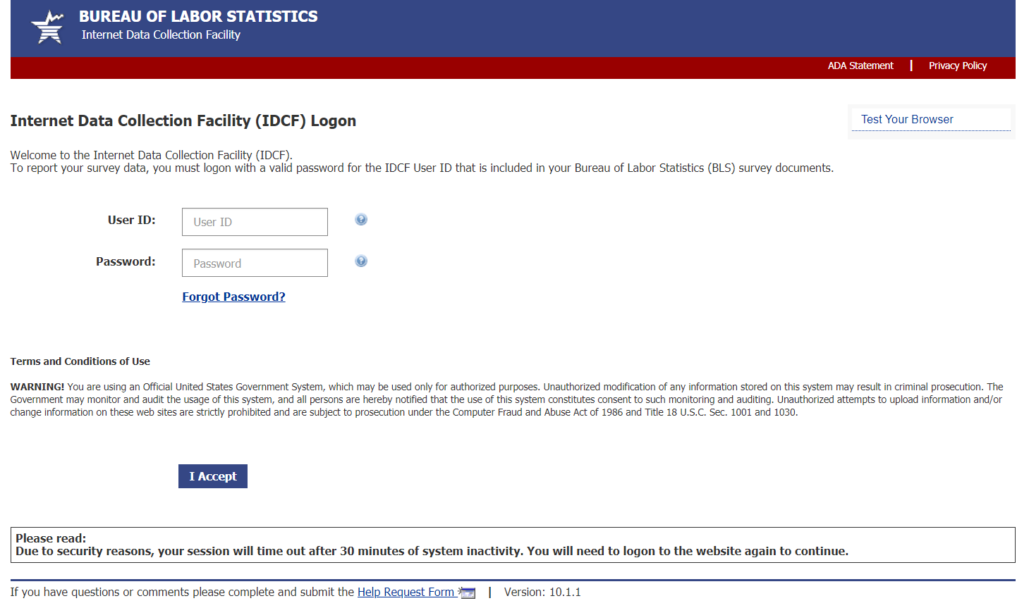

Survey Selection Screen

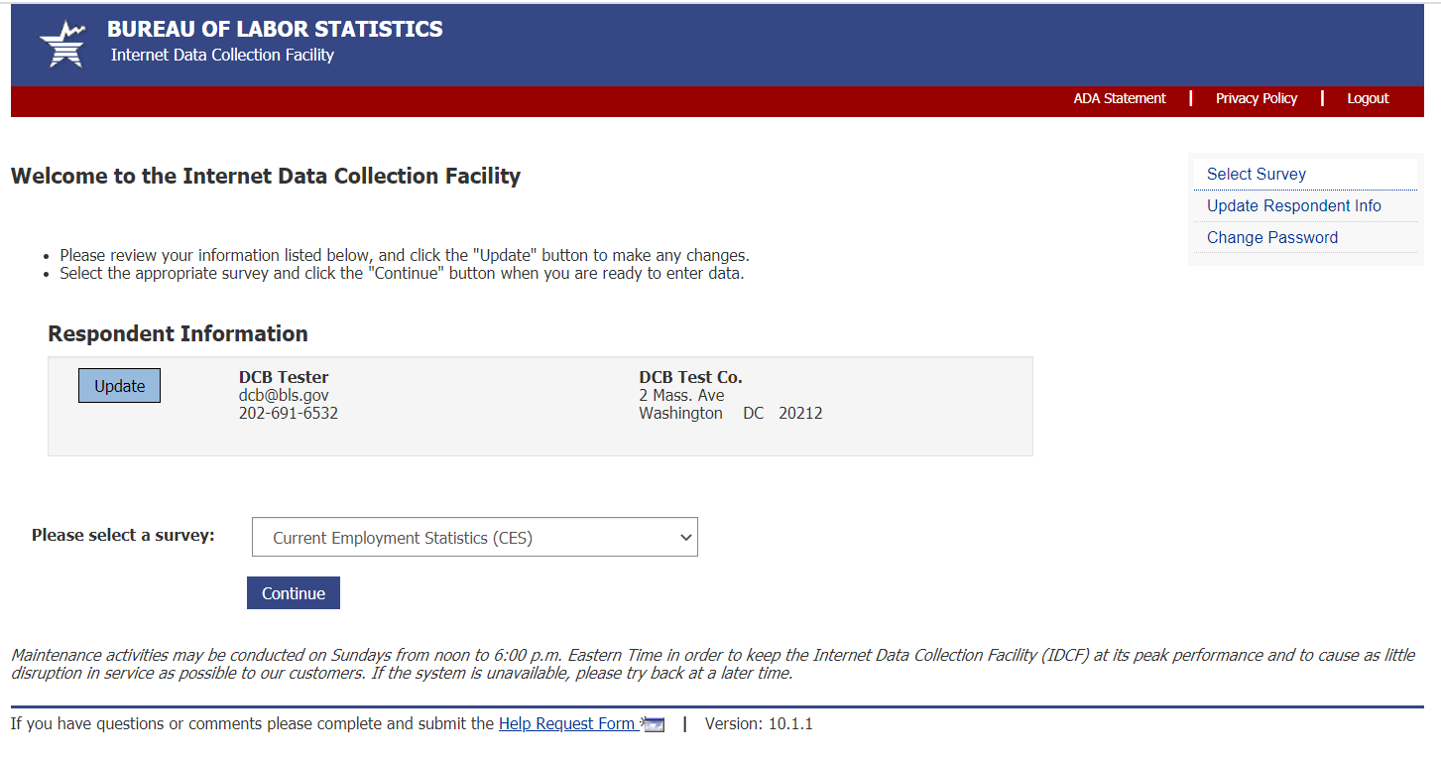

Dear Employer Screen

Data Entry Screen

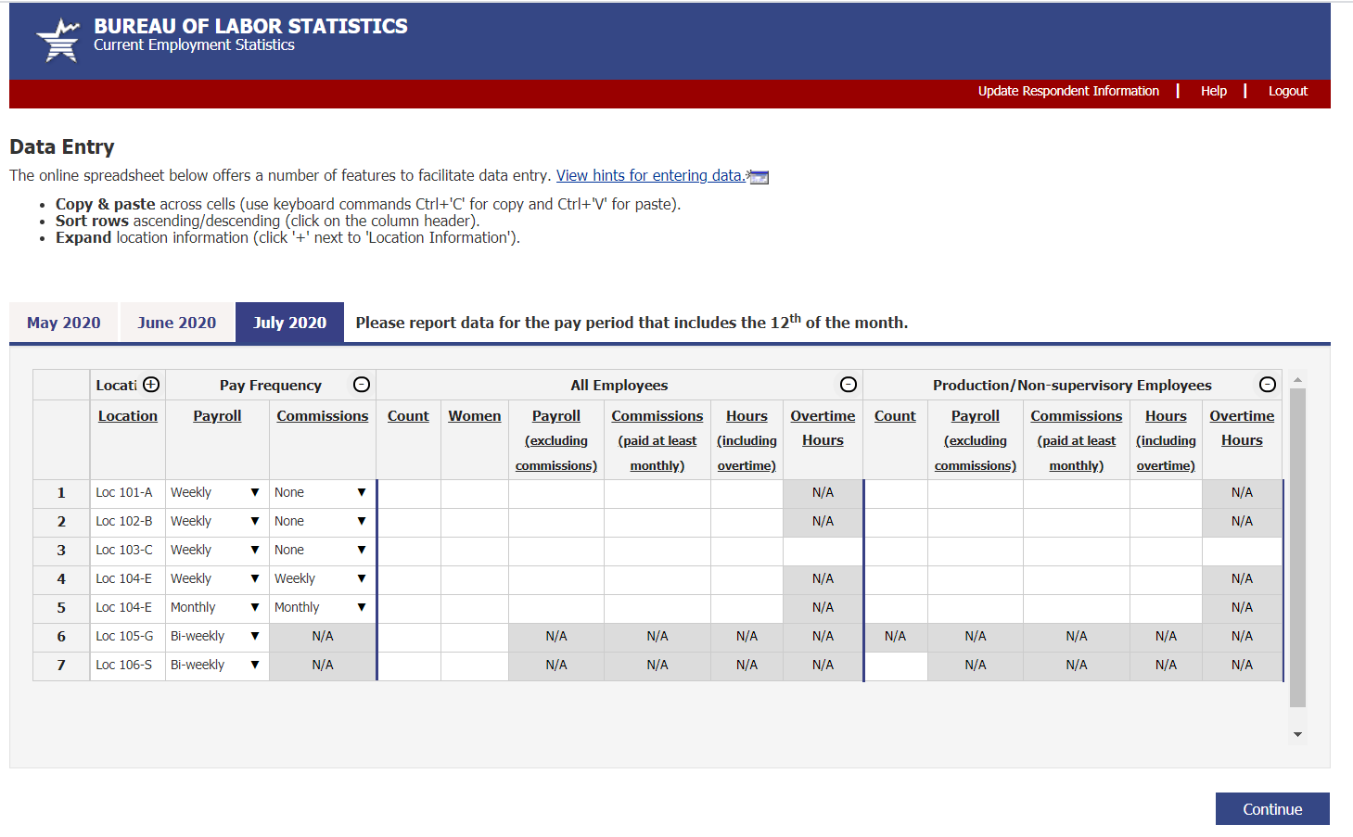

Thank You Screen

