U.S. Department of Labor | Bureau of Labor Statistics  JOLTS Data Collection Center  61 Forsyth Street SW, Suite 7T50  Atlanta, Georgia 30303  800-341-4620

October 24, 2011

«contactname»
«Title»
«FIRM»
«Address1»
«Address2»
«City», «St» «zipcode»

Dear «PREFIX» «LNAME»:

The Bureau of Labor Statistics would like to thank you for your contribution to the Job Openings and Labor Turnover Report. You have diligently reported your firm’s data for some time, and your participation is now complete. A new sample of establishments has been selected, and your firm is no longer in the sample. You will no longer be asked to report JOLTS data for the following location(s):

Report # Location
«unitnum» «Location»

Your firm’s reported data were essential for calculation of the monthly statistics on U.S. labor demand and turnover. These statistics have enabled additional analysis of the U.S. labor market and the economy in general. Without cooperation from firms such as yours, these valuable statistics would not have been possible.

On the reverse side of this letter is a summary of our latest release. You can obtain the entire news release and future news releases at www.bls.gov/jlt/home.htm.

Once again, thank you for your participation that helped get this new statistical program off the ground.

Best regards,

Michelle Kilgore

Michelle Kilgore
JOLTS Data Collection Center Manager
Bureau of Labor Statistics

Technical information: (202) 691-5870 USDL-11-1468
http://www.bls.gov/jlt/
For release: 10:00 a.m. EDT
Media contact: (202) 691-5902 Wednesday, October 12, 2011

JOB OPENINGS AND LABOR TURNOVER: AUGUST 2011

There were 3.1 million job openings on the last business day of August, the U.S. Bureau of Labor Statistics reported today. The hires rate (3.1 percent) and separations rate (3.0 percent) were essentially unchanged over the month. The job openings rate has trended upward slowly since the end of the recession in June 2009 (as determined by the National Bureau of Economic Research). This release includes estimates of the number and rate of job openings, hires, and separations for the nonfarm sector by industry and by geographic region.

View Entire Release at: http://www.bls.gov/jlt/home.htm
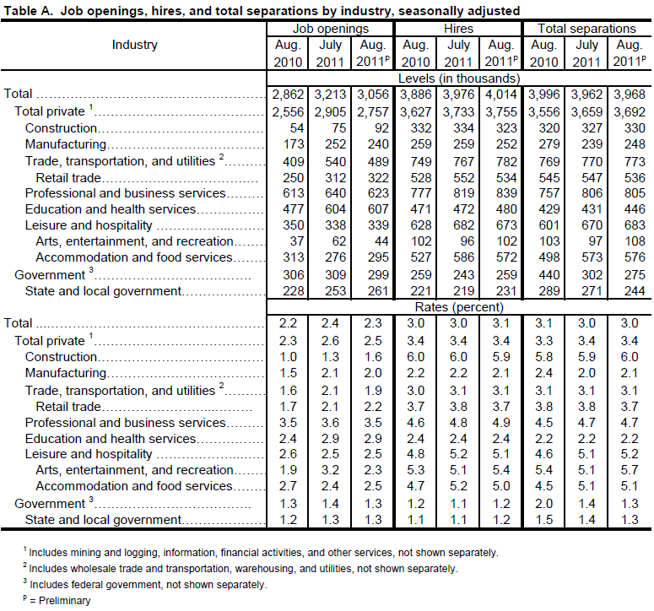
Net Change in Employment
Large numbers of hires and separations occur every month. Over the 12 months ending in August 2011, hires totaled 47.9 million and separations totaled 46.7 million, yielding a net employment gain of 1.2 million based on not seasonally adjusted data. These figures include workers who may have been hired and separated more than once during the year.

