Form 366 – Licensee Event Report
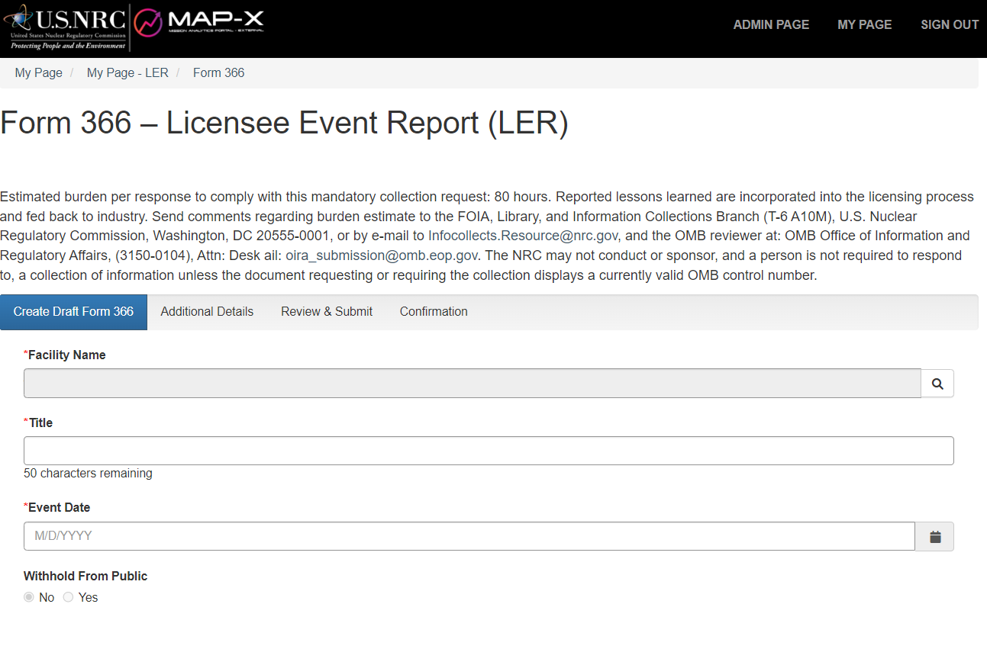
Top of Form
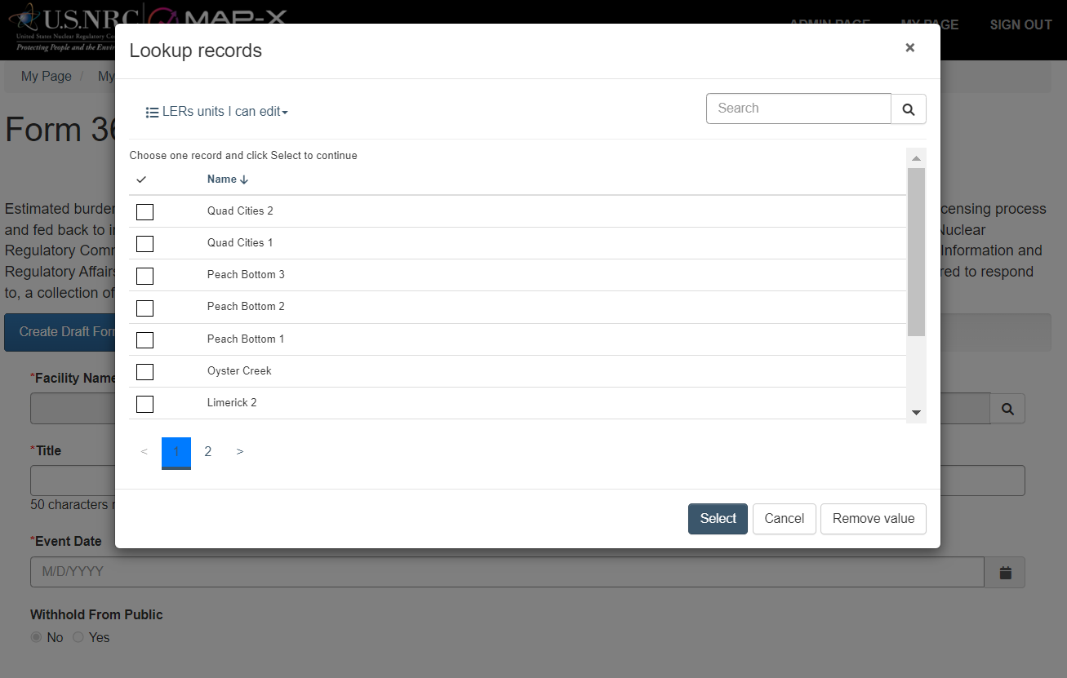
Lookup for Facility Name Expanded

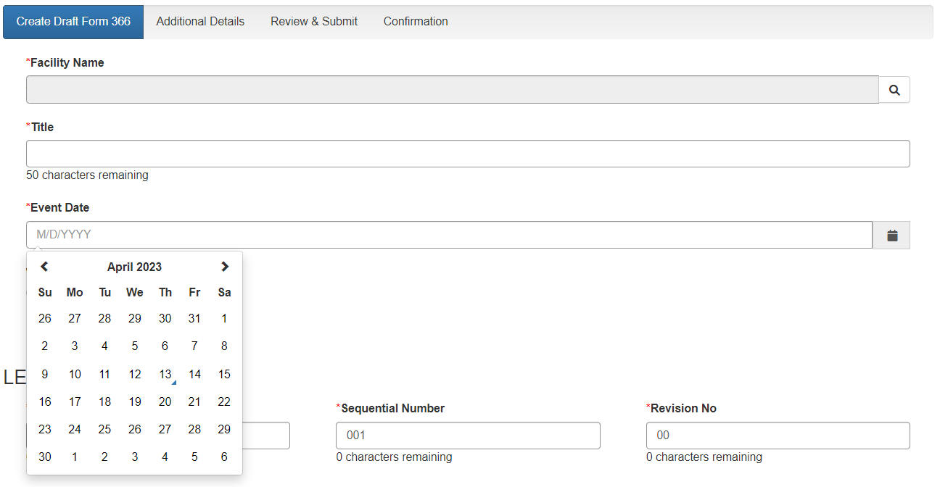
Event Date with Calendar Expanded

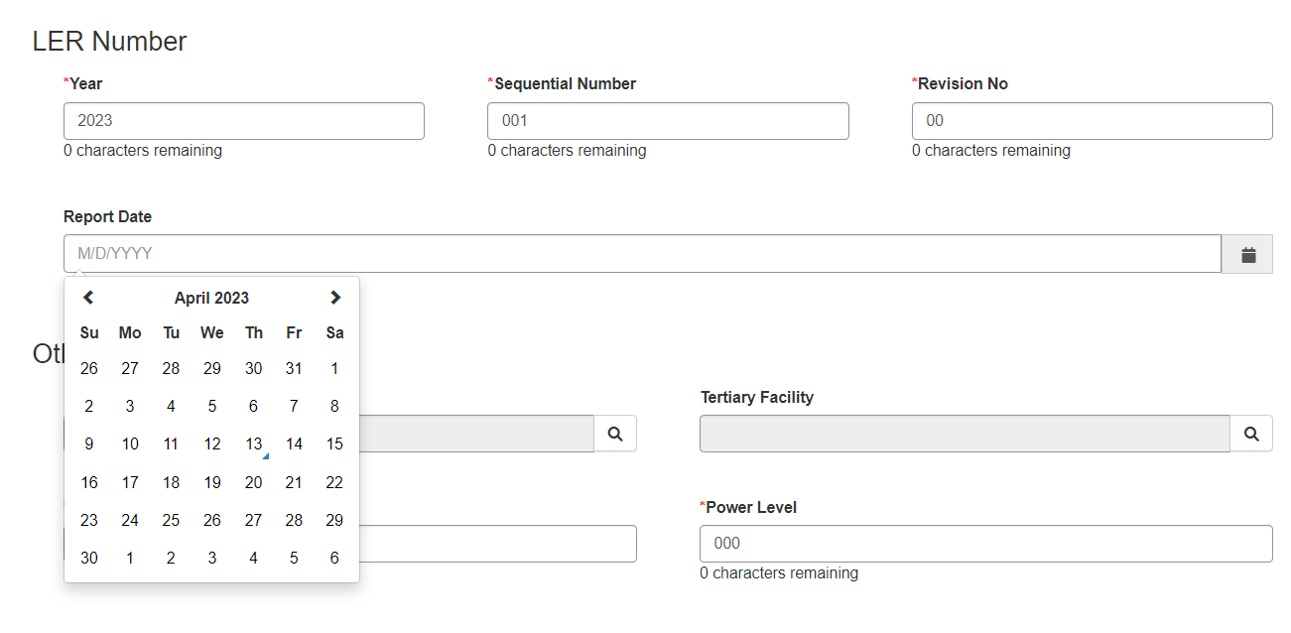
LER Number Defaults and Report Date with Calendar Expanded

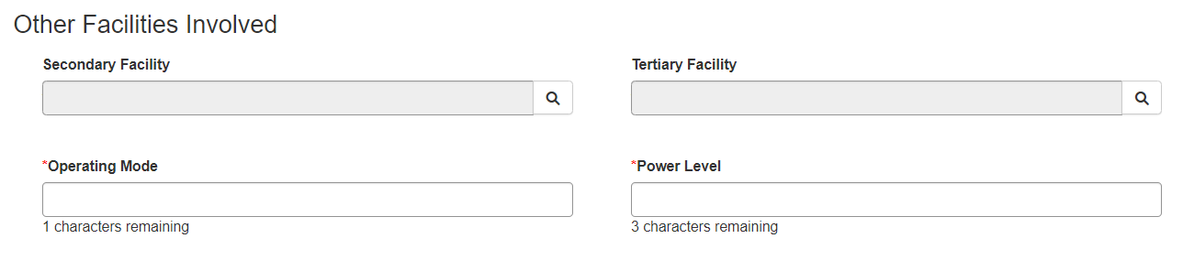
Other Facilities Involved before Lookup
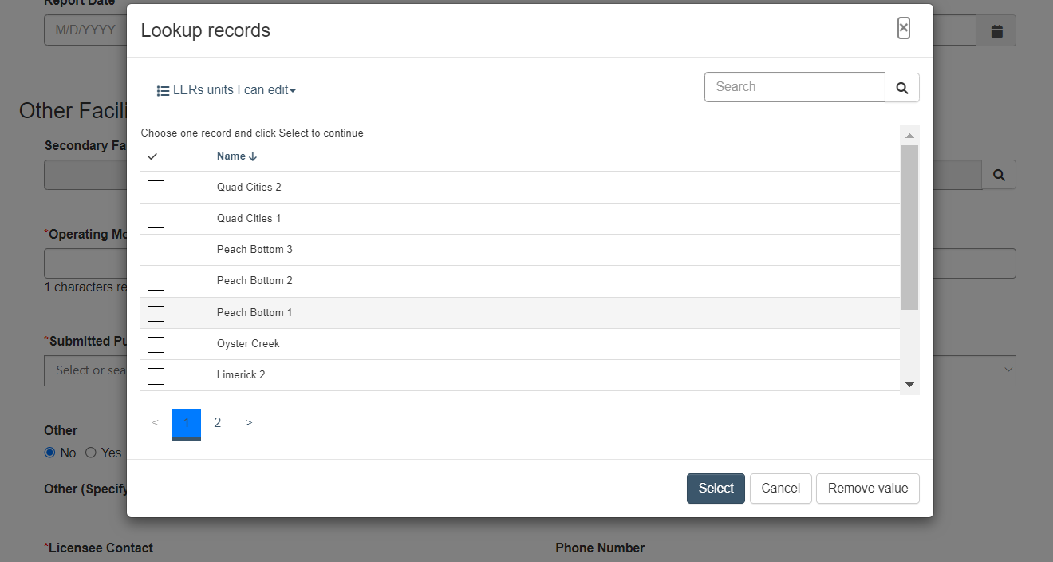
Other Facilities Involved with Lookup

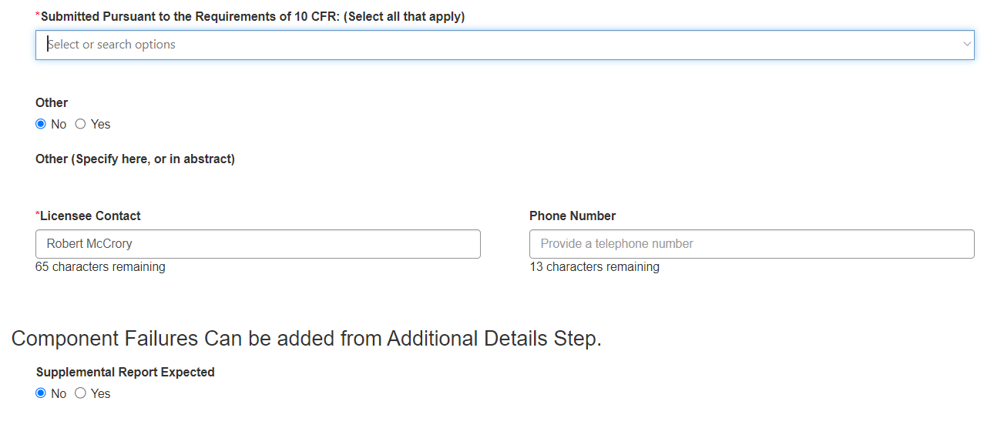
10 CFR Section Collapsed with Defaults for “Other” and “Supplemental Report Expected”

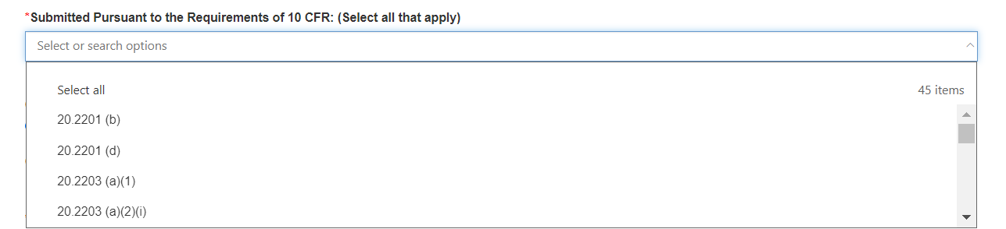
Lookup for 10 CFR

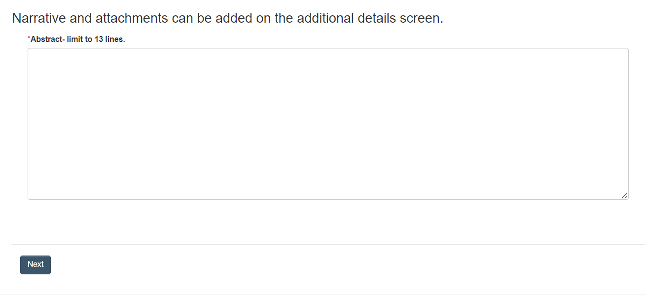
Abstract Section

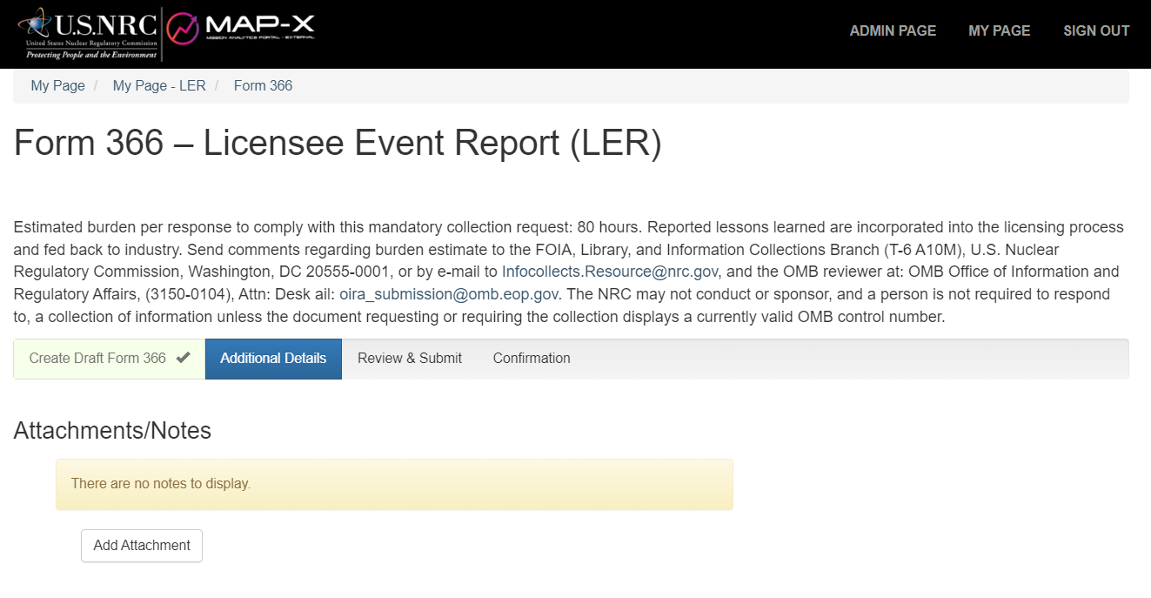
Add Attachments

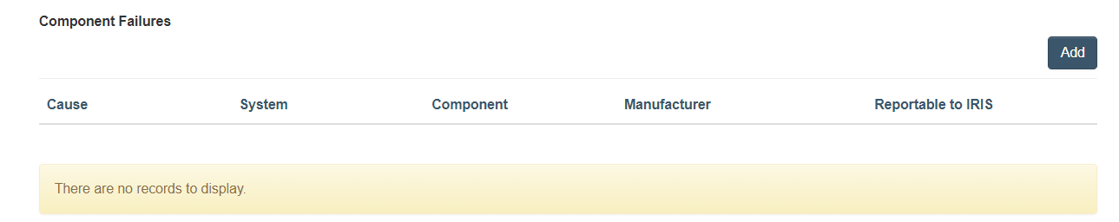
Component Failures Collapsed

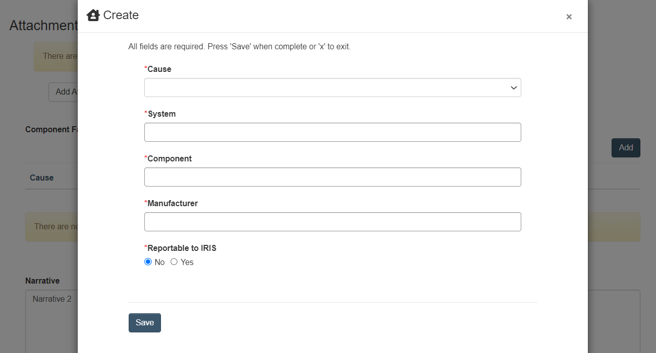
Component Failures Lookup

Additional Narrative Section

