**Manage Contact Officials Screen** – When user selects Manage Contact Officials from the menu, the Employer BA Number associated with their account will be used to retrieve all Contact Officials listed under that BA Number.

**New Contact Official Screen** – A blank editor page will be opened if the user clicks on the Add New panel in the Manage Contact Officials Page.

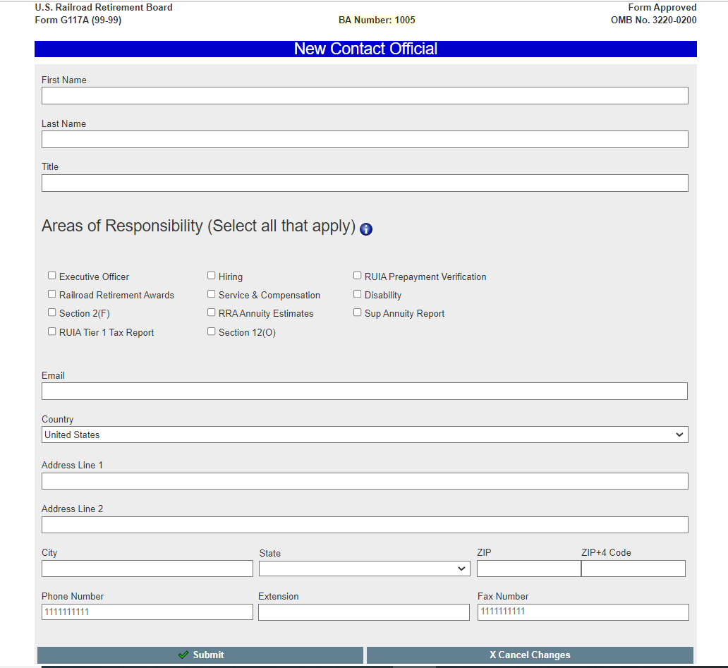

**Edit Contact Official Screen** – If the user clicks the Edit button on a existing Contact Official, the editor page will open prefilled with the existing information for that Contact Official.

**Special Note** – US and Foreign addresses will generate different entry formats for City, State, ZIP and City, State/Province, and Postal Code. The two above examples for Add Contact Official and Edit Contact Official demonstrate the different field layouts.

**Admin Employer Selection Screen** – This screen allows RRB administrators to select any railroad/labor employer, and view their Manage Contact Officials Screen. This feature will be used for testing and troubleshooting purposes.

