Email Reminder
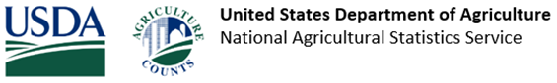
Your response is due by May 30, 2024!
The United States Department of Agriculture (USDA) recently mailed you a form for the 2023 Irrigation and Water Management Survey. Everyone who receives a form is required by law to respond (Title 7 USC 2204(g) Public Law 105-113). If you are not farming or ranching, please respond promptly so we can update our records.
If you have already responded, thank you! If not, please respond by May 30, 2024, in one of the following ways:
- Online at www.agcounts.usda.gov and enter your unique survey code found on the front of the Census of Agriculture form mailed to you.
- Mail your completed form back using the prepaid envelope.
Questions: Please see the Frequently Asked Questions for Completing the Irrigation Survey. If you need other assistance completing your Census form, please call toll free 888-424-7828. Please do not reply to this email as the email box is not currently monitored.
In accordance with federal law, your responses will be kept confidential and will not be disclosed in identifiable form. All information you provide is confidential, protected by federal law. For more information, visit www.nass.usda.gov/AgCensus.
Thank you for responding and for your support of U.S. agriculture. The 2022 Census of Agriculture is Your Voice, Your Future, Your Opportunity.

United States Department of Agriculture | National Agricultural Statistics Service
National Operations Division, 9700 Page Avenue, Suite 400, St. Louis, MO 63132-1547
OMB No. 0535-0226 | Approval Expires: 9/30/2024 | Confidentiality Policy
USDA is an equal opportunity provider, employer, and lender.
Unsubscribe to email reminders from USDA NASS

