Non-substantive Change Request

0535-0234 – Irrigation and Water Management Survey

SSB Section 1: Updated Sampling methodology

The 2023 Irrigation and Water Management target population consists of all US operations that irrigate agricultural crops. The 2023 Irrigation and Water Management sampling frame comprises all 2022 Census of Agriculture operations – excluding institutional, experimental and research type operations and including Indian Reservation operations - that reported irrigated acreage or acreage equipped for irrigation. Based on previous Irrigation and Water Management sampling frames, the 2023 Irrigation and Water sampling frame is expected to have approximately 200,000 sampling elements.

The national level total irrigated acres target coefficient of variation is 1.5%; the state level total irrigated acres target coefficient of variation for states with at least 2.0 million irrigated acres is 4.0%, states with at least 100,000 irrigated acres and less than 2.0 million irrigated acres is 6.0%, and states with less than 100,000 irrigated acres is 10.0%.

The 2023 Irrigation and Water Management sampling frame will be grouped by State and type of crops (horticulture crops grown and not grown under protection and field crops) and stratified using irrigation acreage as a measure of size. A Neyman technique will be used to allocate the total sample size to strata; and a sequential interval Poisson technique will be used to select the sample (~35,500) will be selected after explicitly sorting the sampling frame on state and irrigation type and implicitly sorting on county. The sample size was increased by 500 to hit target CVs.

Updated SSA Section 12

The time required to complete the Irrigation and Water Management Survey questionnaire is expected to be similar to that of previous years, which averaged about 60 minutes. Time will vary since farms vary in acreage irrigated, number of crops irrigated, and inventory of irrigation facilities and equipment.

Total response is estimated to be approximately 28,425, which is based on using a sample size of 35,500 with an estimated response rate of 80 percent. Total response burden hours are 29,707 hours.

The initial mailings will contain the questionnaire, a cover letter, a questionnaire instruction booklet, and a return envelope. For non-respondents, the follow up mailing will contain another copy of the questionnaire, a cover letter, and a return envelope. There will be a phone follow up for those who do not respond to the mail requests.

Cost to the public for completing the questionnaire is assumed to be comparable to the hourly rate of those requesting the data. Reporting time of 29,707 hours are multiplied by $40.51 per hour for a total cost to the public of $ 1,203,430.57

NASS uses the Bureau of Labor Statistics’ Occupational Employment Statistics (most recently published on April 25, 2023 for the previous May) to estimate an hourly wage for the burden cost. The May 2022 mean wage for bookkeepers was $22.81. The mean wage for farm managers was $40.29. The mean wage for farm supervisors was $28.28. The mean wage of the three is $30.46. To calculate the fully loaded wage rate (includes allowances for Social Security, insurance, etc.) NASS will add 33% for a total of $40.51 per hour.

From:
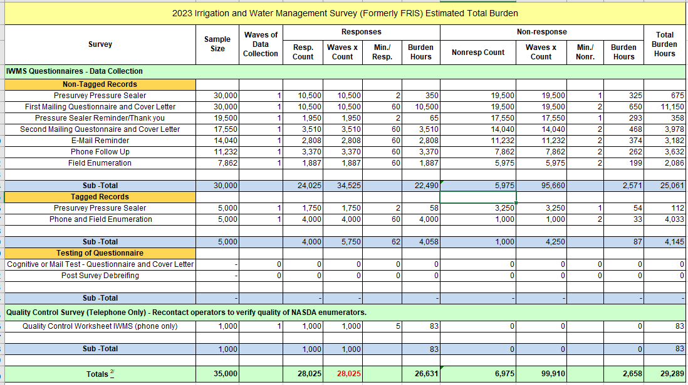

To:
