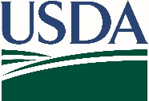
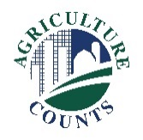
United States Department of Agriculture
National Agricultural Statistics Service

October 18, 2021
What should I do next?
Complete your survey in one of the following ways:
Online at agcounts.usda.gov. Online reporting is fast and secure. All you need is the unique survey code on the enclosed form to begin.

By mail or fax. Complete the questionnaire and mail it back in the envelope provided or fax it to 855-415-3687.

Why am I getting this letter?

You have been selected for the 2020 Hemp Acreage and Production Survey. As one of only 20,000 producers receiving this survey, your response is vital to ensure accurate data are available. Please take a few minutes to respond by following the directions on the right.

How will the data be used?

The information and results from this survey will:
- Allow hemp producers, the U.S. Department of Agriculture, and other interested parties to analyze data on a state-by-state basis.
- Provide a statistical benchmark on hemp production.
- Be used for statistical purposes only. In accordance with federal law, your responses will be kept confidential.
- Be published by NASS on its website in a report in early 2022.

If we do not receive your completed questionnaire, we may attempt to contact you to arrange a telephone interview.

Thank you for participating and for your support of agricultural statistics and U.S. agriculture. If you have any questions or need assistance completing your questionnaire, please call 888-424-7828. For more information, visit nass.usda.gov.
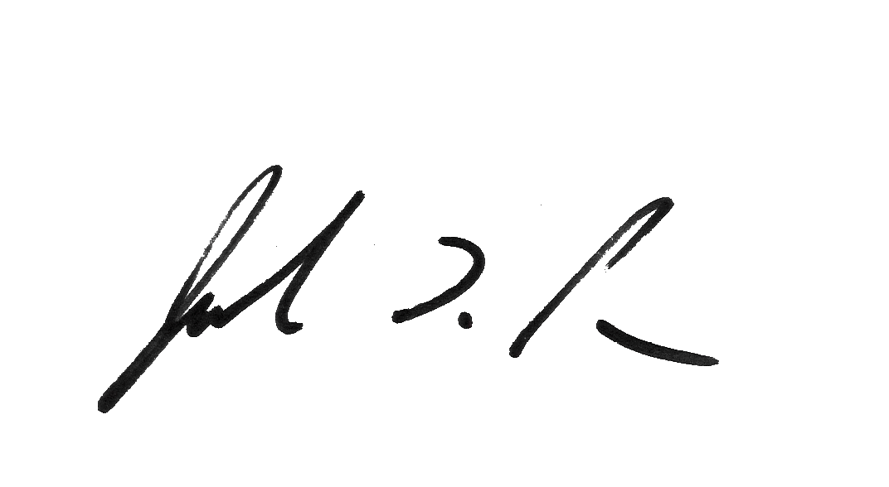
Sincerely,

,

Joseph L. Parsons
Chair, Agricultural Statistics Board

Enclosure

