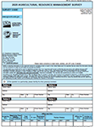  
December 27, 2022  
Enclosed is your U.S. Department of Agriculture’s **2022 Agricultural Resource Management Survey**. Please complete the survey at your earliest convenience. Your participation helps to ensure that the ag industry decisions affecting you, your family, business, and community are based on facts.  
  
You may receive an email reminder to complete your questionnaire. **If you do not respond by January 17, 2023, a USDA representative may contact you to arrange an interview.**

**What should I do next?**

Please complete your survey in one of the following ways:

**Online** at [agcounts.usda.gov](http://www.agcounts.usda.gov). **Online reporting is fast and secure.**All you need is the survey code located in the top left corner of your questionnaire to log in.

By **mail or fax**. Complete the questionnaire and mail it back  
in the prepaid envelope provided or fax it to 812-218-2232.

**Completing this survey fulfills your 2022 Census of Agriculture requirement.**

**Your response is confidential by FEDERAL law.**

The information you provide will be used for statistical purposes only and will not be published in identifiable form.

**Why is your response important?**

Your response will help your state department of agriculture, local banks, and input suppliers with decisions that affect you and other farmers and ranchers nationwide. This year, the survey includes questions to help us measure the impacts of COVID on your farm, farm and household finances, and off-farm employment. We will publish the data in the annual *Farm* *Production Expenditures* report on July 21, 2023, at [nass.usda.gov](http://www.nass.usda.gov)/Publications as well as in other reports at ers.usda.gov/arms.

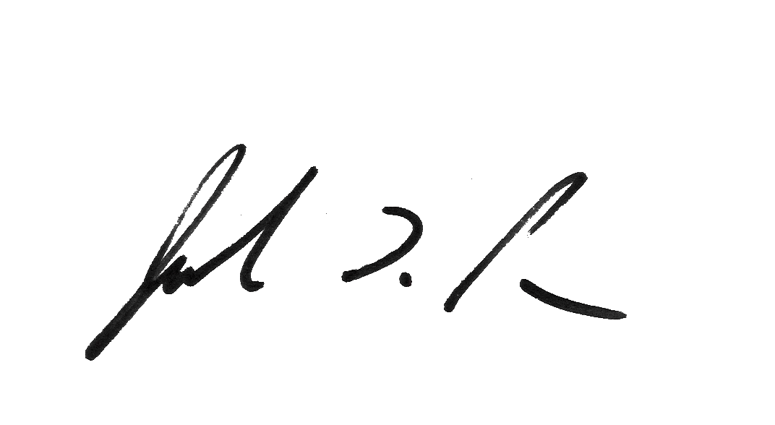Thank you for your participation and support of agricultural statistics. If you have any questions, please contact us at 888-424-7828.

Sincerely,

Joseph L. Parsons

Chairman, Agricultural Statistics Board

Enclosure