February 7, 2023
You should have recently received your 2022 Agricultural Resource Management Survey. Thank you if you have already responded. If not, there is still time.

Your information is important, as it will ensure that U.S. Department of Agriculture data accurately represent America’s farmers and ranchers. If we do not receive your completed survey, a USDA representative will call to schedule an interview. The interview can take over an hour; it can be completed all at once or in multiple appointments.
Please complete your survey:

Online at agcounts.usda.gov. Online reporting is fast and secure.
All you need is the survey code in the top left corner of your questionnaire to begin.

By mail or fax. Complete the questionnaire and mail it back in the prepaid envelope provided or fax it to 812-218-2232.

Completing this survey fulfills your 2022 Census of Agriculture requirement.

Why is your response important?
- This survey measures the financial well-being of U.S. farms and farm households and can greatly impact all aspects of U.S. agriculture.
- Results of this survey help inform evaluations of financial impacts of numerous programs, including crop insurance, dairy margin protection, and local payments. The results also provide information on farm income, conservation practices, and farm technologies.
- This year, the survey includes questions to help us measure the impacts of COVID on your farm, farm and household finances, and off-farm employment.
The information you provide will be used for statistical purposes only. In accordance with federal law, your responses will be kept confidential and will not be disclosed in identifiable form. We will publish the survey data in the annual Farm Production Expenditures report on July 21, 2023, at nass.usda.gov/Publications as well as in other reports at ers.usda.gov/arms.

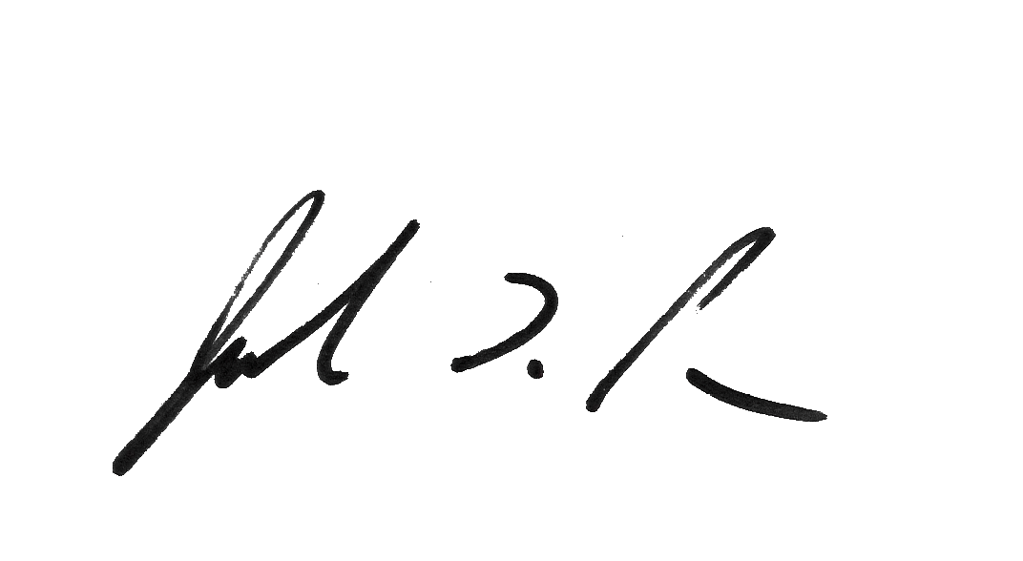
Thank you for your participation. Your response helps to ensure that the ag industry decisions affecting you, your family, and business are based on facts. If you have questions, please contact us at 888-424-7828.
Sincerely,

Joseph L. Parsons
Chairman, Agricultural Statistics Board
Enclosure

