Non-substantive Change Request
0535-0140 – List Frame Docket
National Agricultural Classification survey - January, 2024
Prior to each Census of Agriculture (OMB Control Number 0535-0226), NASS goes through a thorough list building process to make sure our list of known farmers is as complete as possible. NASS collects information from various sources to add to our List Frame, one such example is the National Agricultural Classification survey (NACS). Data collected from these surveys will not be published, but will be used to improve our list of known farmers.
The non-substantive change request affects the 2023 NACS version 1 questionnaire. The changes to the questionnaire are described below.
Screener Section
From:
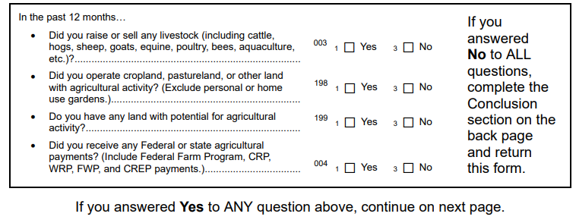
To:
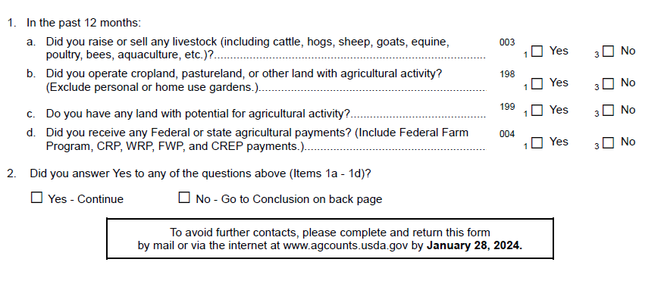
Acres Operated and Land Usage Section
From: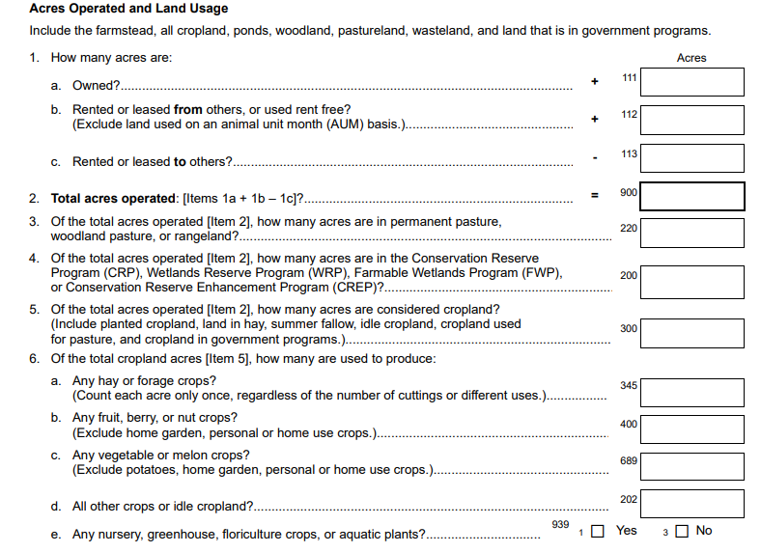
To:
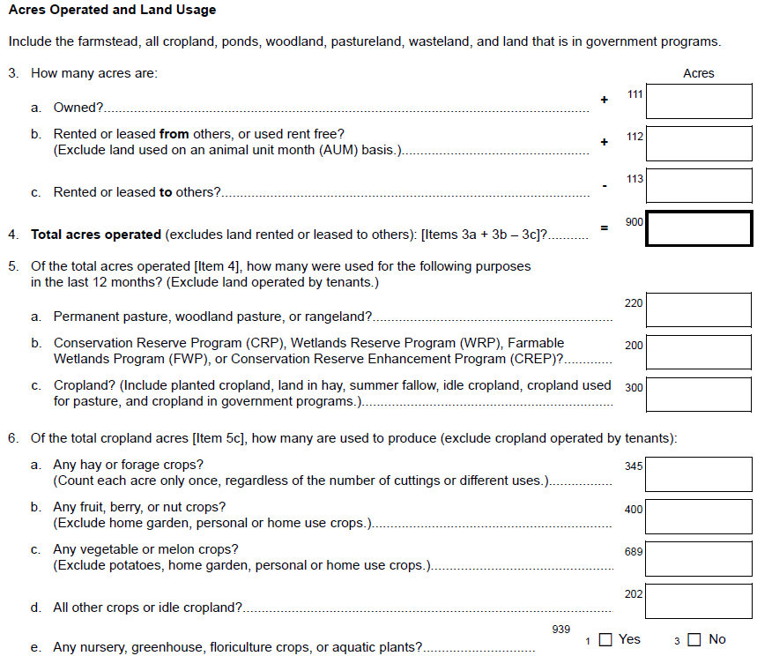
Conclusion
From:
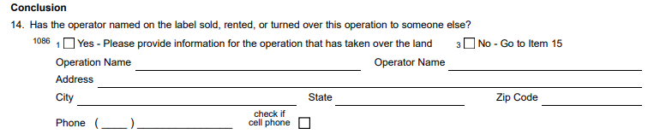
To:
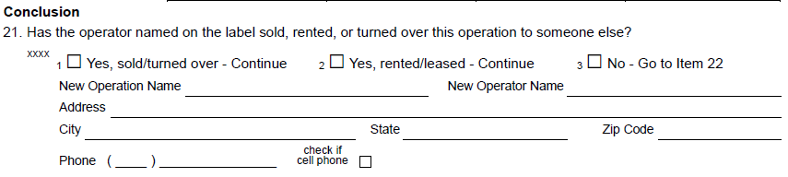

The revised NACS version 1 questionnaire has been loaded to ROCIS.

