OMB Control Number:  0560-XXXX, OMB Expiration Date:  XX/XX/XXXX

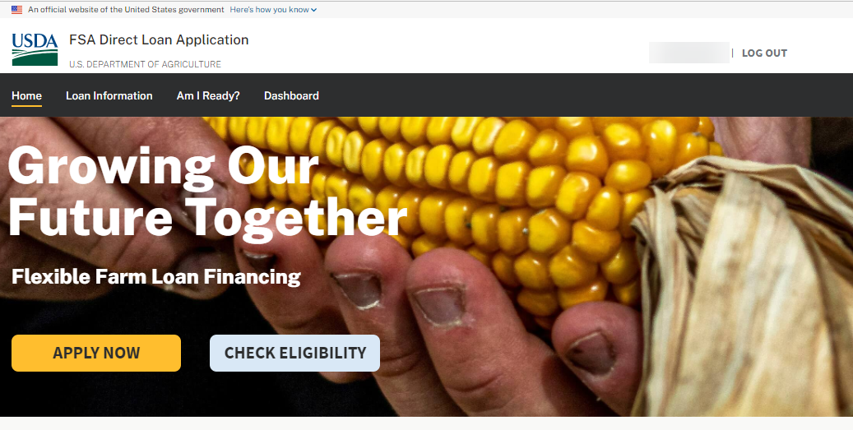

**ONLINE LOAN APPLICATION PROCESS FLOW**

Paperwork Reduction Act Review Package

Prepared: September 21, 2023

***Note: Label on all screenshots shown as “FSA Direct Loan Application”. However, this has been changed to “FSA Online Loan Application”.***

**DASHBOARD**

**OPERATOR CERTIFICATION**

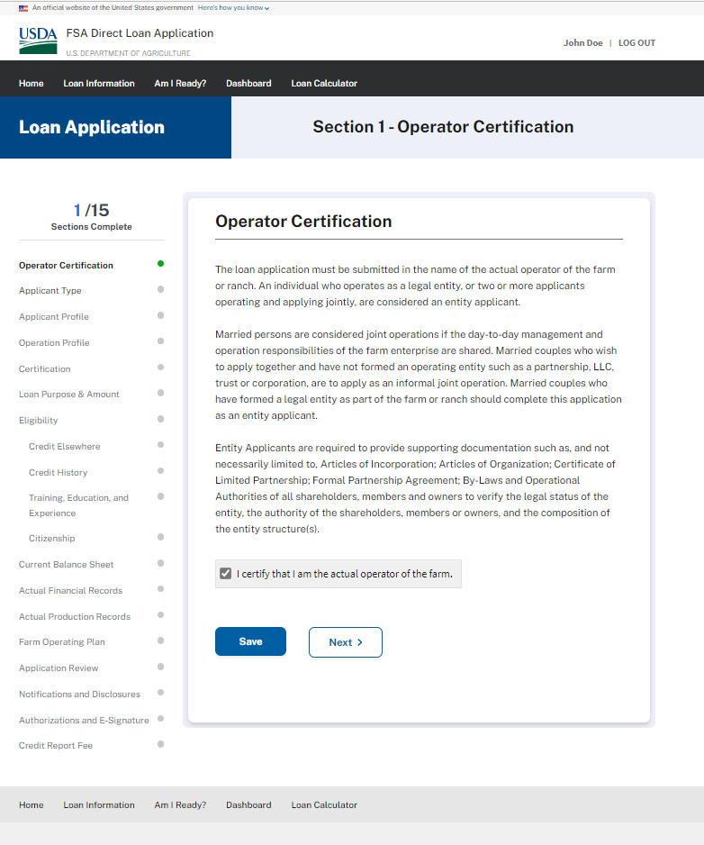

**APPLICANT IDENTIFICATION**

**APPLICANT PROFILE**

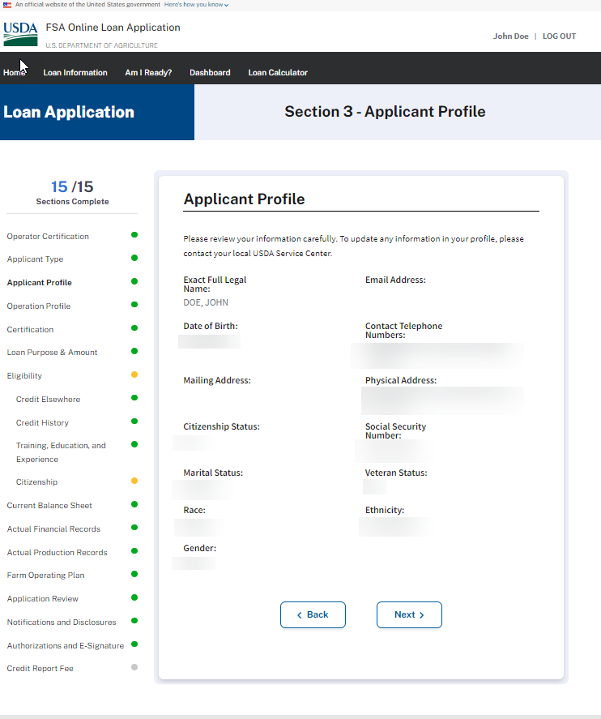

**OPERATION PROFILE**

CERTIFICATION (Minimized)

CERTIFICATION (Expanded)

**LOAN PURPOSE & AMOUNT**

**LOAN PURPOSE & AMOUNT (Operating Type Loans)**

**LOAN PURPOSE & AMOUNT (Operating Type Loans – Annual Inputs)**

**LOAN PURPOSE & AMOUNT (Operating Type Loans – Minor real estate repairs or “Other”)**

**LOAN PURPOSE & AMOUNT (Operating Type Loans – Purchase a farm vehicle, Purchase farm machinery and/or equipment)**

**LOAN PURPOSE & AMOUNT (Operating Type Loans – Purchase breeding livestock, Purchase feeder livestock)**

**LOAN PURPOSE & AMOUNT (Operating Type Loans – Refinance existing farm operating debts with another creditor)**

**LOAN PURPOSE & AMOUNT (Ownership Loans)**

**LOAN PURPOSE & AMOUNT (Ownership Loans – Pay for capital improvements, construction, development & Other)**

**LOAN PURPOSE & AMOUNT (Ownership Loans – Purchase farm real estate)**

**Eligibility (Credit Elsewhere)**

**ELIGIBILITY – CREDIT HISTORY**

**ELIGIBILITY – CREDIT HISTORY – Question 1 & 1a - Expanded**

**ELIGIBILITY – CREDIT HISTORY – Question 2 - Expanded**

**ELIGIBILITY – CREDIT HISTORY – Question 3 & 4 - Expanded**

**ELIGIBILITY – TRAINING, EDUCATION, & EXPERIENCE (Wireframe - Expanded)**

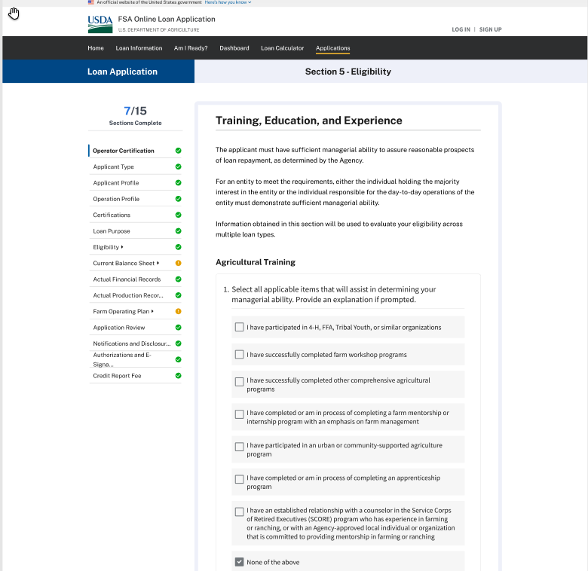

**ELIGIBILITY – TRAINING, EDUCATION, & EXPERIENCE (Wireframe - Expanded)**

**ELIGIBILITY – TRAINING, EDUCATION, & EXPERIENCE (Expanded – “I have operating my own farm” subsequent question)**

**ELIGIBILITY – TRAINING, EDUCATION, & EXPERIENCE (Expanded – All other selections except for “I have operating my own farm” provide same explanation box)**

**ELIGIBILITY – TRAINING, EDUCATION, & EXPERIENCE (Supporting Documents upload)**

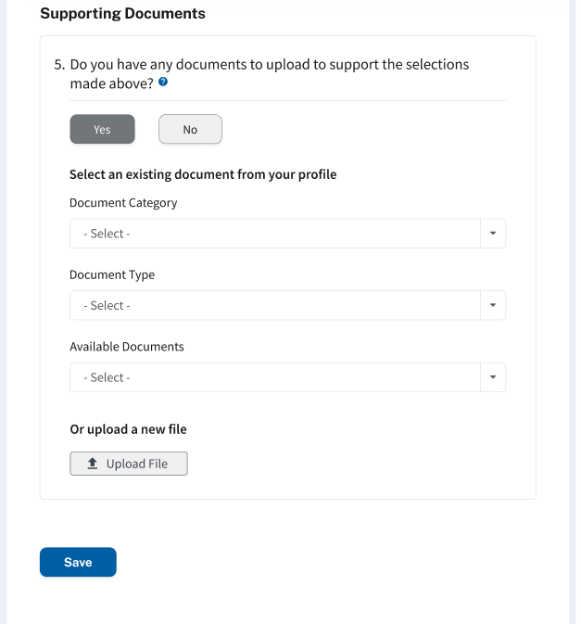

**ELIGIBILITY – CITIZENSHIP**

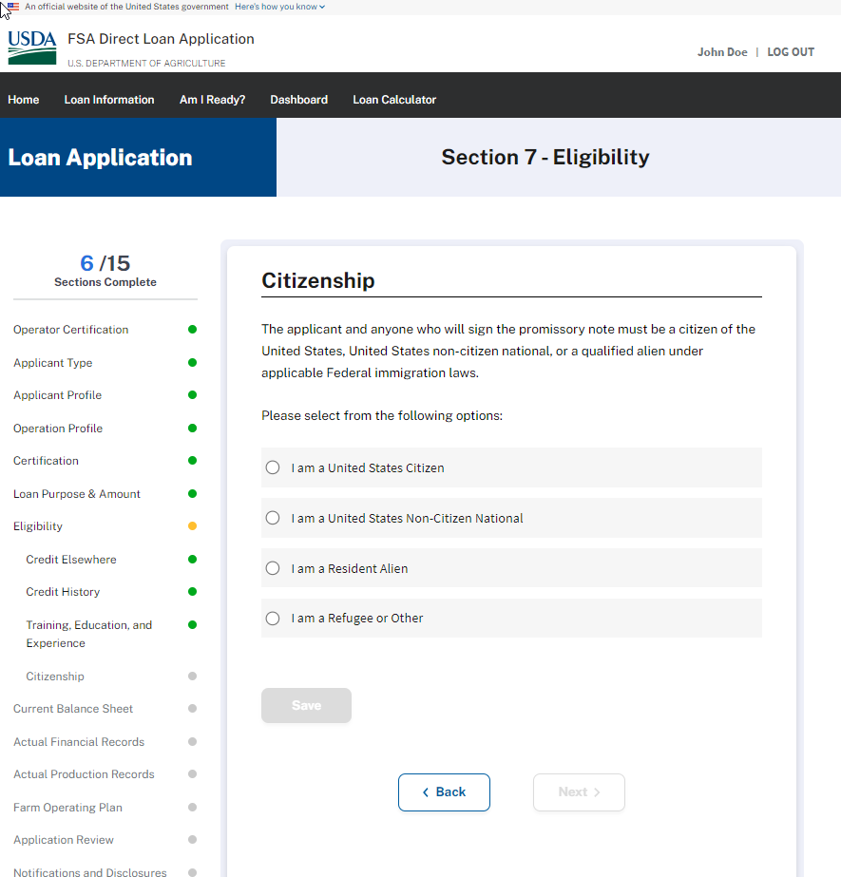

**ELIGIBILITY – CITIZENSHIP**

If anything besides United States Citizen is selected, the applicant wil be provided ability to upload supporting documents:

**CURRENT BALANCE SHEET – Question 1 – Answered “Yes” – Fully Expanded**

**CURRENT BALANCE SHEET – Question 1 – Answered “No”**

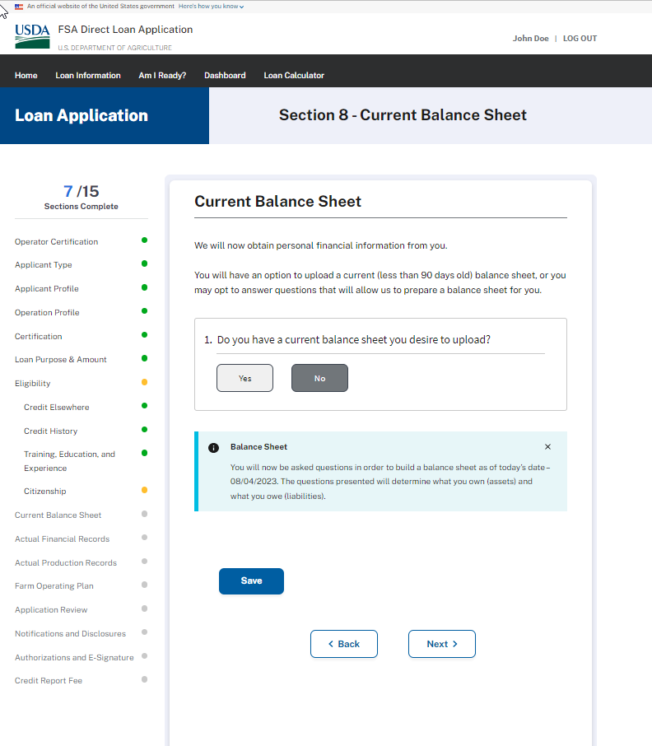

**CURRENT BALANCE SHEET – Wireframe - Assets - Question 1**

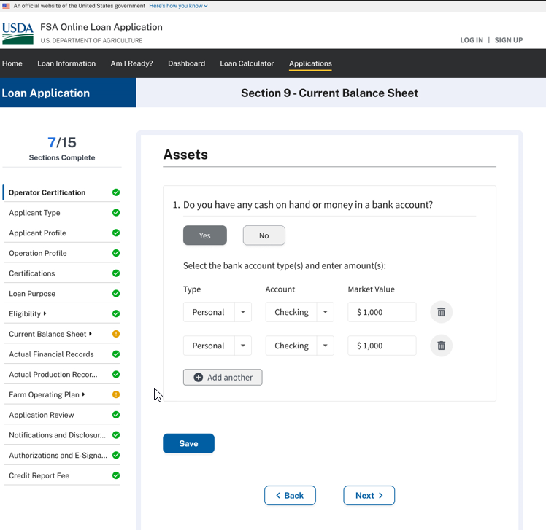

**CURRENT BALANCE SHEET – Assets - Question 2**

**CURRENT BALANCE SHEET – Assets - Question 3**

**CURRENT BALANCE SHEET – Assets - Question 4**

**CURRENT BALANCE SHEET – Assets - Question 5**

**CURRENT BALANCE SHEET – Assets - Question 6**

**CURRENT BALANCE SHEET – Assets - Question 7**

**CURRENT BALANCE SHEET – Assets - Question 8**

**CURRENT BALANCE SHEET – Assets - Question 9**

**CURRENT BALANCE SHEET – Assets - Question 10**

**CURRENT BALANCE SHEET – Assets - Question 11**

**CURRENT BALANCE SHEET – Assets - Question 12**

**CURRENT BALANCE SHEET – Assets - Question 13**

**CURRENT BALANCE SHEET – Assets - Question 14**

**CURRENT BALANCE SHEET – Assets - Question 15**

**CURRENT BALANCE SHEET – Assets - Question 16**

**CURRENT BALANCE SHEET – Assets - Question 17**

**CURRENT BALANCE SHEET – Liabilities - Question 18**

**CURRENT BALANCE SHEET – Liabilities - Question 19**

**CURRENT BALANCE SHEET – Liabilities - Question 20**

**CURRENT BALANCE SHEET – Liabilities - Question 21**

**CURRENT BALANCE SHEET – Liabilities - Question 22**

**CURRENT BALANCE SHEET – Liabilities - Question 23**

**CURRENT BALANCE SHEET – Liabilities - Question 24**

**CURRENT BALANCE SHEET – Liabilities - Question 25**

**CURRENT BALANCE SHEET – Liabilities - Question 26**

**ACTUAL FINANCIAL RECORDS**

**ACTUAL PRODUCTION RECORDS**

**FARM OPERATING PLAN – Wireframe**

**FARM OPERATING PLAN (1a) – Wireframe - When applicant chooses to upload a prepared farm operating plan**

**FARM OPERATING PLAN – Wireframe – When the applicant chooses to build a farm operating plan**

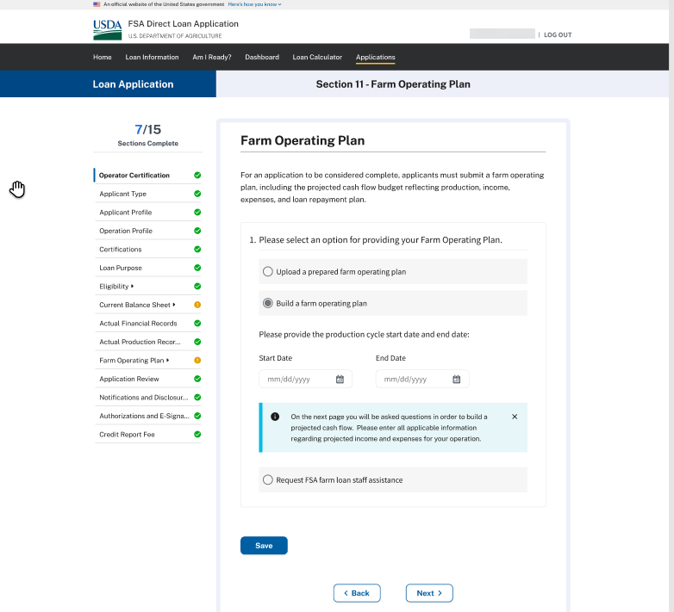

**FARM OPERATING PLAN – Wireframe – When the applicant chooses to build a farm operating plan – Farm Income Question #1**

**FARM OPERATING PLAN – Wireframe – When the applicant chooses to build a farm operating plan Farm Income Question #2**

**FARM OPERATING PLAN – Wireframe – When the applicant chooses to build a farm operating plan Farm Income Question #3**

**FARM OPERATING PLAN – Wireframe – When the applicant chooses to build a farm operating plan Farm Income Question #4**

**FARM OPERATING PLAN – Wireframe – When the applicant chooses to build a farm operating plan Farm Income Question #5**

**FARM OPERATING PLAN – Wireframe – When the applicant chooses to build a farm operating plan Farm Income Question #6**

**FARM OPERATING PLAN – Wireframe – When the applicant chooses to build a farm operating plan Farm Income Question #7**

**FARM OPERATING PLAN – Wireframe – When the applicant chooses to build a farm operating plan Farm Income Question #8**

**FARM OPERATING PLAN – Wireframe – When the applicant chooses to build a farm operating plan**

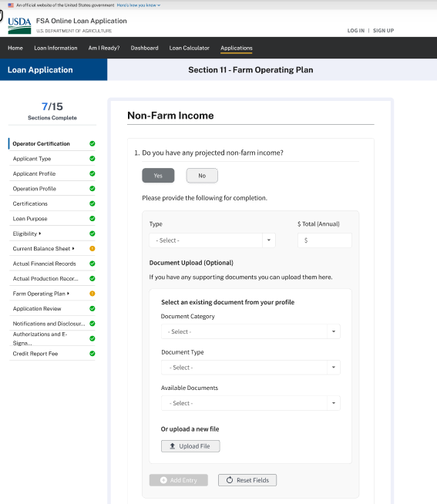

**FARM OPERATING PLAN – Wireframe – When the applicant chooses to build a farm operating plan**

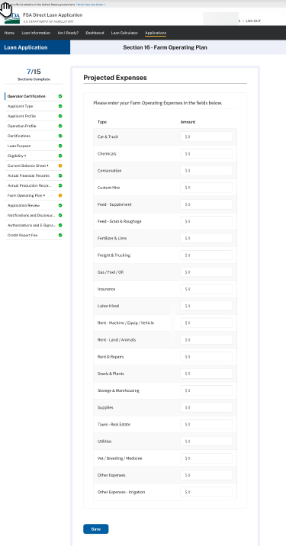

**FARM OPERATING PLAN – Wireframe – When the applicant chooses to build a farm operating plan**

**FARM OPERATING PLAN – Wireframe – When the applicant chooses to build a farm operating plan**

**FARM OPERATING PLAN – Wireframe – When the applicant requests FSA farm loan staff assistance**

**APPLICATION REVIEW**

**NOTIFICATION & DISCLOSURES - Minimized**

**NOTIFICATION & DISCLOSURES - Maximized**

**AUTHORIZATIONS AND E-SIGNATURE**

**CREDIT REPORT FEE & SUBMISSION**

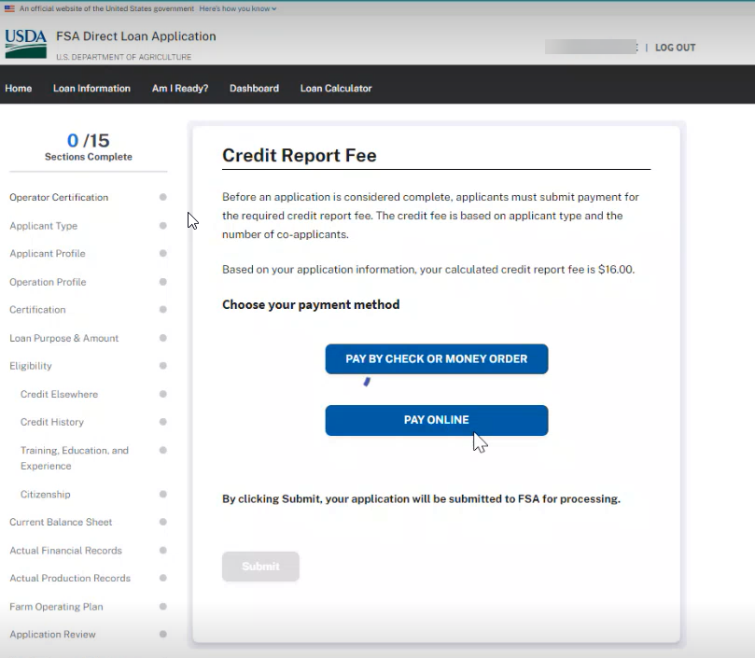

**Payment of Credit Report Fee Online**

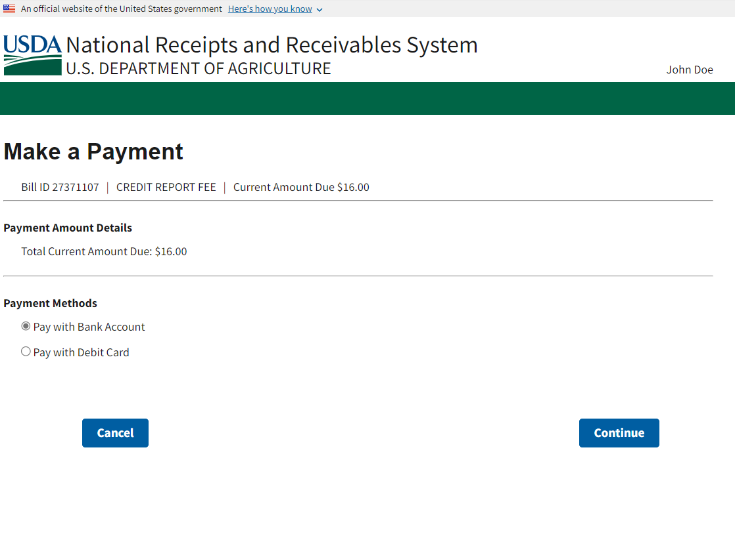

**Payment of Credit Report Fee Online (continued - ACH Bank Account option)**

**Payment of Credit Report Fee Online (continued – Debt Card option)**

Public Burden Statement (Paperwork Reduction Act): Public reporting burden for this collection is estimated to average 1.51 hours per response, including reviewing instructions, gathering and maintaining the data needed, completing (providing the information), and reviewing the collection of information. You are not required to respond to the collection or FSA may not conduct or sponsor a collection of information unless it displays a valid OMB control number of 0560-XXXX.