Appendix C – Materials
Consumer Labeling Research Focus Groups

Four test labels

Labels are under development.

Handout for Thermometer Icon



Handout for Ranking Exercise - Labels

Participant ID: _______

Task 1. Please rank order the alert words by putting a 1 by the alert word that most attracts your attention, a 2 by the second best, a 3 by the one that is least effective at attracting attention. There is also a space to write in and rank other suggestions you have for an alert word.

Alert words
___ Attention
___ Caution
___ Important
___ _______________________________________

Task 2. Please rank order the titles by putting a 1 by the title that most attracts your attention, a 2 by the second best, a 3 by the third best, and a 4 by the one that is least effective at attracting attention. There is also a space to write in and rank other suggestions you have for a title.

Titles
___ Food Safety Handling Instructions
___ Food Safety Steps
___ How to Handle Raw Meat Products Safety
___ Avoid Illness

___ _______________________________________________________

Task 3. Please rank order the messages by putting a 1 by the message that does the best job of encouraging you to follow the recommended instructions, a 2 by the second best, a 3 by the third best, and a 4by the one that is least effective at encouraging you to follow the recommended instructions. There is also a space to write in and rank other suggestions you have for a motivating message.

Messages
___ Follow these instructions to prepare raw meat products safely.
___ Reduce your risk of illness when preparing raw meat products by following these steps.
___ Follow these instructions to prevent foodborne illness.
___ This raw meat product may contain bacteria. Follow these steps to avoid illness.

___ ________________________________________________________

___________________________________________________________

___________________________________________________________

Task 4. The labels had two different sets of instructions that varied in terms of length. Please circle the option—short vs. long—that you think is most useful.

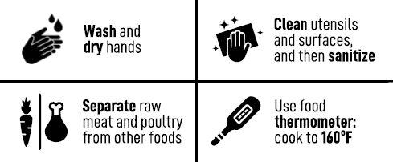
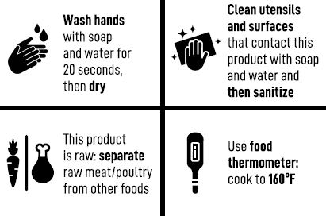

Visual Cues

Visual cures are under development.

Participant ID: _______

Handout for Ranking Exercise – Visual Cues

Task 1. Please rank order the visual cues by putting a 1 by the one that most attracts your attention, a 2 by the second best, a 3 by the third best, and so on

____ Visual Cue A

____ Visual Cue B

____ Visual Cue D

____ Visual Cue E

____ Visual Cue F

