SNAS/WIC 360: Modernize the WIC Shopping Experience at the Grocery Store Program Non competitive Business
Fiscal Year Request for Applications (RFA)

Catalog for Federal Domestic Assistance Number (CFDA):

Release Date: DATE
Application Due Date: 11:59 PM, Eastern Standard Time (EST), DATE
Anticipated Award Date: DATE

OMB Burden Statement: The valid OMB control number for this information collection is 0584-0512. The estimated average time required to complete this information collection is 39 hours per response, including time for reviewing instructions, searching existing data sources, gathering and maintaining the data needed, and completing and reviewing the collection of information. An agency may not conduct or sponsor, and a person is not required to respond to, a collection of information unless it displays a currently valid OMB control number. Send comments regarding this burden estimate or any other aspect of this collection of information, including suggestions for reducing this burden, to: U.S. Department of Agriculture, Food and Nutrition Services, Office of Policy Support, 1320 Braddock Place, 5th Floor, Alexandria, VA 22314 ATTN: PRA (0584-0512). Do not return the completed form to this address.

A46

Use of Template

Application Checklist

This Application Checklist provides applicants with a list of the required documents. However, FNS expects that applicants will read the entire RFA prior to the submission of their application and comply with all requirements outlined in the solicitation. The Application Checklist is for applicant use only and should not be submitted as part of the Application Package.
Complete the following at least four weeks prior to submission:
- Obtain a Dun & Bradstreet Data Universal Numbering System (DUNS) number;
- Register the DUNS number in the System for Award Management (SAM); and,
- Register in Grants.gov.
When preparing your application, ensure:
- Application format and narrative meet the requirements included in Section X “Application and Submission Information.” This includes page limits, priorities outlined in Section X, and all necessary attachments.
When preparing your budget, ensure the following information is included:
- All key staff proposed to be paid by this grant.
- The percentage of time the Project Director will devote to the project in full-time equivalents (FTEs).
- Your organization’s fringe benefit rate and amount, as well as the basis for the computation.
- The type of fringe benefits to be covered with Federal funds.
- Itemized travel expenses (including type of travel), travel justifications and basis for lodging estimates.
- Types of equipment and supplies, justifications, and estimates, ensuring that the budget is in line with the project description.
- Information for all contracts and justification for any sole-source contracts.
- Justification, description and itemized list of all consultant services.
- Indirect cost information (either a copy of a Negotiated Indirect Cost Rate Agreement (NICRA) or if no agreement exists and the applicant has never been approved for a NICRA, they may charge up to 10% de minimis). If applicant is requesting the de minimis rate or indirect costs are not requested, please indicate this in the budget narrative.

When submitting your application, ensure you have submitted the following:
- SF-424 – Application for Federal Assistance (fillable PDF in Grants.gov)
- SF-424A – Budget Information and Instruction Form (fillable PDF in Grants.gov)
- SF-424B – Assurances for Non-Construction Programs (fillable PDF in Grants.gov)
- SF-LLL – Disclosure of Lobbying Activities
- FNS-906 – Grant Program Accounting System & Financial Capability Questionnaire (Appendix X)
- Negotiated Indirect Cost Rate Agreement (PDF - Upload using the “Add Attachments” button under SF-424 item #15)

Application Checklist (continued)

When applicable, application packages are required to include the following documents:
- AD-3030 – Representations Regarding Felony Conviction and Tax Delinquent Status for Corporate Applicants (fillable PDF in Grants.gov)
- AD-1047 – Certification Regarding Debarment, Suspension, and Other Responsibility Matters Primary Covered Transactions
- AD-1048 – Certification Regarding Department, Suspension, Ineligibility and Voluntary Exclusion Lower Tier Covered Transactions
- AD-1049 – Certification Regarding Drug-Free Workplace Requirements (Grants) Alternative I – For Grantees Other Than Individuals
- AD-1052 – Certification Regarding Drug-Free Workplace State and State Agencies, Federal Fiscal Year
- AD-3031 – Assurance Regarding Felony Conviction or Tax Delinquent Status For Corporate Applicants

Table of Contents
Application Checklist 3
I. PROGRAM DESCRIPTION & OBJECTIVES 7
Program Description 7
Key Objectives 7
II. FEDERAL AWARD INFORMATION 7
Allowable Costs 7
III. ELIGIBILITY INFORMATION 8
Eligible Applicants 8
Cost Sharing or Matching Considerations 8
Other Eligibility Criteria 8
Pre-Award Screening Requirements 8
Acknowledgement of USDA Support 8
IV. APPLICATION AND SUBMISSION INFORMATION 9
Address to Request Application Package 9
Content and Form of Application Submission 9
Submission Date 11
Preparing for Electronic Application Submission through Grants.gov 11
How to Submit an Application via Grants.gov 12
Grants.gov Receipt Requirements and Proof of Timely Submission 13
Intergovernmental Review 14
Funding Restrictions 14
V. APPLICATION REVIEW INFORMATION 14
Evaluation of Grant Application Criteria 14
1. REVIEW CRITERIA 14
2. EVALUATION FACTORS AND CRITERIA 14
3. Review and Selection Process 14
Anticipated Announcement and Federal Award Dates 14
VI. FEDERAL AWARD ADMINISTRATION INFORMATION 14
1. FEDERAL AWARD NOTICE 15
2. ADMINISTRATIVE AND NATIONAL POLICY REQUIREMENTS 15
Confidentiality of an Application 15
Conflict of Interest and Confidentiality of the Review Process 16
Administrative Regulations 16
Code of Federal Regulations and Other Government Requirements 18
3. REPORTING REQUIREMENTS 18
Financial Reports 18
Performance Progress Report (PPR) 18
VII. FEDERAL AWARDING AGENCY CONTACTS 18
VIII. OTHER INFORMATION 19
Debriefing Requests 19
APPENDIX 20
RFA Budget Narrative Checklist 20
FNS-908 Performance Progress Report (PPR) – For Reference Only 24

PROGRAM DESCRIPTION & OBJECTIVES

Enter information here

Program Description
- Enter information here

Key Objectives
Below is a list of the Program Objectives. As noted in the section below, within “Activities/Indicators Tracker”, proposed activities should be clearly aligned to these Objectives and their associated Activities and Indicators.

# | Objectives
E.G. 1 | Assist schools/districts administering NSLP and SBP programs in providing: 1) appealing and nutritious school meals, 2) nutrition education, and 3) school environments that promote healthy eating; ultimately encouraging students to follow healthy eating patterns that align with the recommendations set forth in the 2015-2020 Dietary Guidelines for Americans.
2 | Enter text here

FEDERAL AWARD INFORMATION
The following information is intended to provide applicants with information to help applicants make informed decisions about proposal submissions.
- Total amount of funding expected to award:
- Anticipated number of awards:
- Anticipated award announcement date:
- Expected amounts of individual Federal awards:
- Anticipated start dates and period of performance:
- Anticipated amounts and/or numbers of individual awards:
- Estimated funding per award:
- Application due date: :
- .
Please note:
- Grant awards are subject to the availability of funding and/or appropriations of funds.
- FNS reserves the right to use this solicitation and competition to award additional grants this year or the subsequent fiscal year, should additional funds become available.

Allowable Costs
Equipment and Supplies: Expenditures for both equipment (i.e., items of personal property having a useful life of more than one year and a cost of $5,000 or more) and supplies are allowable expenses.
Food Expenses: No more than 10 percent of the grant funds may be used for necessary food purchases in the grant budget regardless of funding source. Food purchases must be necessary for the purpose of the grant and should be limited to educational purposes, including sample tables, taste tests, or promotional use. Food costs related to conducting a test run of a new product are considered an appropriate use of funds.

ELIGIBILITY INFORMATION

Eligible Applicants
- Enter here

Cost Sharing or Matching Considerations
- Cost sharing requirements here or state “There are no cost sharing or matching requirements for this program.”

Other Eligibility Criteria
- Enter other eligibility criteria here

Pre-Award Screening Requirements
In reviewing applications in any discretionary grant competition, prior to making a Federal award, Federal awarding agencies, in accordance with 2 CFR 200.205, are required to review information available through any OMB-designated repositories of government-wide eligibility qualifications or financial integrity information. Additionally, Federal awarding agencies are required to have a framework in place for evaluating the risks posed by applicants before they receive Federal awards. The FNS review of risk posed by applicants will be based on the following:
- SAM.gov, the System for Award Management, the Official U.S. Government system that consolidated the capabilities of CCR/FedReg, ORCA, and EPLS
- FAPIIS, the Federal Awardee Performance and Integrity Information System that has been established to track contractor misconduct and performance
- Dun & Bradstreet, the system where applicants establish a DUNS number that is used by the Federal government to better identify related organizations that are receiving funding under grants and cooperative agreements
- U.S. Department of Agriculture, AD-3030, Representations Regarding Felony Conviction and Tax Delinquent Status for Corporate Applicants
- FNS Risk Assessment Questionnaire
  - Applicants must complete the Grant Program Accounting System & Financial Capability Questionnaire that allows FNS to evaluate aspects of the applicant’s financial stability, quality of management systems, and history of performance, reports and findings from audits. The questionnaire contains a number of questions that may be an indicator of potential risk.
The evaluation of the information obtained from the designated systems and the risk assessment questionnaire may result in FNS imposing special conditions or additional oversight requirements that correspond to the degree of risk assessed.

Acknowledgement of USDA Support
As outlined in 2 CFR 415.2, grant recipients shall include acknowledgement of USDA Food and Nutrition Service support on any publications written or published with grant support and, if feasible, on any publication reporting the results of, or describing, a grant-supported activity. Recipients shall include acknowledgement of USDA Food and Nutrition Service support on any audiovisual which is produced with grant support and which has a direct production cost of over $5,000.
- When acknowledging USDA support, use the following language: "This material is based upon work that is supported by the Food and Nutrition Service, U.S. Department of Agriculture.” Grantees should follow the USDA Visual Standards Guide when using the USDA logo.
- Grant recipients may be asked to host USDA officials for a site visit during the course of their grant award. All costs associated with the site visit will be paid for by USDA and are not expected to be included in grant budgets.

APPLICATION AND SUBMISSION INFORMATION

Content and Form of Application Submission
FNS strongly encourages eligible applicants interested in applying to this program to adhere to the following applicant format. The proposed project plan should be presented on 8 ½” x 11” white paper with at least 1-inch margins on the top and bottom. All pages should be single-spaced, in 12-point font. The project description with relevant information should be captured on no more than pages, not including the cover sheet, table of contents, resumes, letter of commitment(s), endorsement letter(s), budget narrative(s), appendices, and required forms. All pages, excluding the form pages, must be numbered.
Special Instructions:
- Late application submission will not be considered in this competition. FNS will not consider additions or revisions to applications unless they are submitted via Grants.gov by the deadline. No additions or revisions will be accepted after the deadline.
- Applications submitted without the required supporting documents, forms, certification will not be considered.
- Applications missing a written proposal or budget narrative will not be considered.
- FNS reserves the right to request clarification on any application submitted in response to this solicitation.
- Applications not submitted via Grants.gov will not be considered.
- If multiple application packages are submitted through Grants.gov by the same applicant in response to this solicitation, FNS will accept the latest application package successfully submitted. All other packages submitted by the applicant will be removed from this competition.

Cover Sheet
The cover page should include, at a minimum:
- Applicant’s name and mailing address
- Primary contact’s name, job title, mailing address, phone number and e-mail address
- Grant program title and subprogram title (if applicable)

Table of Contents
The Table of Contents should include relevant sections, subsections and associated page numbers.
Application Project Summary
The application should clearly describe the proposed project activities and anticipated outcomes that would result if the proposal were to be funded.
Project Narrative
The project narrative should clearly identify what the applicant is proposing and how it will address a solution, the expected results and/or benefits once the solution is achieved, and how it will meet the RFA program scope and objectives. The proposed project methodology should describe the project design, address program specific methodology needs, procedures, timetables, monitoring/oversight, and the organization’s project staffing.
Activities/Indicators Tracker
Proposed Activities and indicators measuring success must be mapped to Program Objectives (as described in Section I – PROGRAM DESCRIPTION) in the below format (note that additional Activities/Indicators can be added as needed). Note: Indicators are defined as any metric you anticipate will be able to be tracked during the period of performance of the grant. Common examples include Number of People Attended, Number of People Impacted, Number of Conferences Delivered, Number of Materials Created, Number of Trainings, Number of People Trained.

(Example)
Objective # | 1
Activity | Grant-funded activities or trainings
Indicator(s) | No. Trained
Activity | Measuring Students’ Nutrition Knowledge, Attitudes, and Behaviors
Indicator(s) | No. Impacted
--

Objective #
Activity
Indicator(s)

Objective #
Activity
Indicator(s)

Application Budget Narrative
The budget narrative should correspond with the proposed project narrative and application budget. The narrative must justify and support the bona fide needs of the budget’s direct cost. If the budget includes indirect costs, the applicant must provide a copy of its most recently approved Federal indirect cost rate agreement. All non-profit organizations must include their 501(c)(3) determination letter issued by the Internal Revenue Service (IRS). All funding requests must be in whole dollars.
Indirect Cost Rate
A current Negotiated Indirect Cost Rate Agreement (NICRA), negotiated with a Federal negotiating agency, should be used to charge indirect costs. Indirect costs may not exceed the negotiated rate. If a NICRA is used, the percentage and base should be indicated. If the applicant does not have, and has never been approved for, a NICRA, they may charge up to 10% de minimis. In this instance, the applicant must indicate they are requesting the de minimis rate. An applicant may elect not to charge indirect costs and, instead, use all grant funds for direct costs. If indirect costs are not charged, the phrase "none requested" should be stated in the budget narrative. For questions related to the indirect cost rate, please work with the Grant Officer as noted in Section VII of this RFA.
Required Grant Application Forms
Please refer to the Application Checklist for a list of required grant forms.

Letter of Intent
The eligible applicant who intends to apply should submit a Letter of Intent notice by (insert the date). This notice does not obligate the applicant to submit an application but provides FNS with useful information in preparing for the review and selection process. The notice should include the potential applicant’s name and address, organization’s name, telephone number, and e-mail address of the primary point of contact. The applicant can send the letter via mail or e-mail to the FNS Grant Officer identified in Section VII of this RFA.

Submission Date
Complete grant applications must be uploaded to www.grants.gov by 11:59 PM EST on the due date listed on the cover page.
- Applications must be submitted via Grants.gov. Mailed, e-mailed or hand-delivered application packages will not be accepted. For further instructions, go here.
- Late or incomplete applications will not be considered.
- FNS will not consider additions or revisions to applications unless they are submitted via Grants.gov by the deadline. No additions or revisions will be accepted after the deadline.
- If multiple application packages are submitted through Grants.gov by the same applicant in response to this solicitation, FNS will accept the latest application package successfully. submitted. All other packages submitted by the applicant will be removed from this competition.
FNS strongly encourages applicants to begin the registration process at least four weeks before the due date and to submit applications to Grants.gov at least one week before the deadline to allow time to troubleshoot any issues, should they arise. Please note that upon submission, Grants.gov may send multiple confirmation notices; applicants should ensure receipt of confirmation that the application was accepted. Applicants experiencing difficulty submitting applications to Grants.gov should contact the Grant Officer noted in the Agency Contacts (Section VII) of this RFA. FNS will evaluate submission issues on a case-by-case basis.

Preparing for Electronic Application Submission through Grants.gov
Applicants must register with Grants.gov, Dun and Bradstreet and Sam.gov in order to submit an application to FNS via Grants.gov, as required. FNS strongly encourages applicants to begin the registration process at least four weeks before the due date.

In order to submit an application, you must:
- Obtain a DUNS number
- If your organization does not have a DUNS number, or if you are unsure of your organization’s DUNS, contact Dun & Bradstreet at https://fedgov.dnb.com/webform or by calling 1-888-814-1435, Monday thru Friday, 8am-9pm ET. There is no fee associated with obtaining a DUNS number.
- It may take 2-3 business days to obtain a DUNS number.
- Register in the System for Award Management (SAM.gov)
  - SAM.gov combines Federal procurement systems and the Catalog of Federal Domestic Assistance into one system. For additional information regarding SAM.gov, see the following link: https://www.sam.gov/SAM
  - Must have your organization’s DUNS, entity’s Tax ID Number (TIN), and taxpayer name (as it appears on last tax return). It may take 3-5 business days to register in SAM.gov; however, in some instances the SAM process to complete the migration of permissions and/or the renewal of the entity record will require 5-7 days or more.
  - All applicants must have current SAM status at the time of application submission and throughout the duration of a Federal Award in accordance with two CFR Part 25.
  - We strongly encourage applicants to begin the process at least 3 weeks before the due date of the grant solicitation.
- Create a Grants.gov Account:
The next step in the registration process is to create an account with Grants.gov. Applicants must know their organization's DUNS number to complete this process. Completing this process automatically triggers an email request for applicant roles to the organization's E-Business Point of Contact (EBiz POC) for review. The EBiz POC is a representative from your organization who is the contact listed for SAM.gov. To apply for grants on behalf of your organization, you will need the Authorized Organizational Representative (AOR) role.
For more detailed instructions about creating a profile on Grants.gov, refer to
https://www.grants.gov/web/grants/grantors/grantor-registration.html
- Authorize Grants.gov Roles:
After creating an account on Grants.gov, the EBiz POC receives an email notifying them of your registration and request for roles. The EBiz POC will then log in to Grants.gov and authorize the appropriate roles, which may include the AOR role, thereby giving you permission to complete and submit applications on behalf of the organization. You will be able to submit your application online any time after you have been approved as an AOR.
For more detailed instructions about creating a profile on Grants.gov, refer to
https://www.grants.gov/web/grants/applicants/workspace-overview/workspace-roles.html
- Track Role Status: To track your role request, refer to
https://www.grants.gov/web/grants/applicants/workspace-overview/workspace-roles.html
Electronic Signature: When applications are submitted through Grants.gov, the name of the organization's AOR that submitted the application is inserted into the signature line of the application, serving as the electronic signature. The EBiz POC must authorize individuals who are able to make legally binding commitments on behalf of the organization as an AOR; this step is often missed and it is crucial for valid and timely submissions.

How to Submit an Application via Grants.gov
Grants.gov applicants can apply online using Workspace. Workspace is a shared, online environment where members of a grant team may simultaneously access and edit different web forms within an application. For each funding opportunity announcement (FOA) or RFA, you can create individual instances of a workspace.
For additional training resources, including video tutorials, refer to: https://www.grants.gov/web/grants/applicants/applicant-training.html
Applicant Support: Grants.gov provides applicants 24/7 support via the toll-free number 1-800-518-4726 and email at support@grants.gov. If you are experiencing difficulties with your submission, it is best to call the Grants.gov Support Center and get a ticket number. The Support Center ticket number will assist the Center with tracking your issue and understanding background information on the issue.
For questions related to the specific grant opportunity, please contact the Grant Officer noted in the Agency Contacts (Section VII) of this RFA.

Grants.gov Receipt Requirements and Proof of Timely Submission
All applications must be received by 11:59 PM EST on the due date listed on the cover page, as detailed here. Proof of timely submission is automatically recorded by Grants.gov. An electronic date/time stamp is generated within the system when the application is successfully received by Grants.gov. The applicant AOR will receive an acknowledgement of receipt and a tracking number (GRANTXXXXXXXX) from Grants.gov with the successful transmission of their application. Applicant AORs will also receive the official date/time stamp and Grants.gov Tracking number in an email serving as proof of their timely submission.
When FNS successfully retrieves the application from Grants.gov and acknowledges the download of submissions, Grants.gov will provide an electronic acknowledgment of receipt of the application to the email address of the applicant with the AOR role. Again, proof of timely submission shall be the official date and time that Grants.gov receives your application. Applications received by Grants.gov after the established due date for the program will be considered late and will not be considered for FNS funding.
Applicants using slow internet, such as dial-up connections, should be aware that transmission could take some time before Grants.gov receives your application. Again, Grants.gov will provide either an error or a successfully received transmission in the form of an email sent to the applicant with the AOR role. The Grants.gov Support Center reports that some applicants end the transmission because they think that nothing is occurring during the transmission process. Please be patient and give the system time to process the application.
Additional Information on Grants.gov and the Registration Process:
NOTICE: Special Characters and Naming Conventions
All applicants MUST follow Grants.gov guidance on file naming conventions. To avoid submission issues, please follow the guidance provided by Grants.gov (per the Grants.gov Frequently Asked Questions (FAQ):
Are there restrictions on file names for any attachment I include with my application package?
File attachment names longer than approximately 50 characters can cause problems processing packages. Please limit file attachment names. Also, do not use any special characters (examples: & – * % / # ’ -). This includes periods (.) and spacing followed by a dash in the file. To separate words in naming a file, use underscore, as in the following example: Attached_File.pdf.
Please note that if these guidelines are not followed, your application will be rejected. FNS will not accept any application rejected from www.grants.gov portal due to incorrect naming conventions.
Additional information and applicant resources are available at: https://www.grants.gov/web/grants/applicants/workspace-overview.html

Intergovernmental Review
This funding opportunity is subject to the requirements of EO 12372, “Intergovernmental Review of Federal Programs”. This Executive Order was issued with the desire to foster the intergovernmental partnership and strengthen federalism by relying on State and local processes for the coordination and review of proposed Federal financial assistance and direct Federal development. The Order allows each State to designate an entity to perform this function.
If you are located within a State that does not have a SPOC, you may send application materials directly to a Federal awarding agency.
For a list of State Agency contacts, please visit the Office of Management website at: https://www.whitehouse.gov/wp-content/uploads/2018/07/SPOC-July2018.pdf

Funding Restrictions

APPLICATION REVIEW INFORMATION

Evaluation of Grant Application Criteria

1. REVIEW CRITERIA
Review criteria
FNS will pre-screen all applications to ensure the applicants are eligible entities and are in compliance with all Program regulations. FNS will not approve any waivers from Program regulations for any projects submitted in response to this solicitation.

EVALUATION FACTORS AND CRITERIA
The following selection criteria will be used to evaluate applications for this RFA.
- Selection criteria

Review and Selection Process
Following the initial screening process, FNS will assemble a panel group to review and determine the technical merits of each application. The panel will evaluate the proposals based on how well they address the required application components and array the applications from highest to lowest score. The panel members will recommend applications for consideration for a grant award based on the evaluation scoring. The Selecting Official reserves the right to accept the panel’s recommendation or to select an application for funding out of order to meet agency priorities, program balance, geographical representation, or project diversity. FNS reserves the right to use this solicitation and competition to award additional grants in the next fiscal year should additional funds be made available.
NOTE: If a discrepancy exists between the total funding request (submitted on SF-424, SF-424A, and budget or budget narrative) within the application package in response to this solicitation, FNS will only consider and evaluate the estimated funding request contained on SF-424.

FEDERAL AWARD ADMINISTRATION INFORMATION

1. FEDERAL AWARD NOTICE
The Government is not obligated to make any award as a result of this RFA. Unless an applicant receives a signed award document with terms and conditions, any contact from a FNS Grants or Program Officer should not be considered as a notice of a grant award. No pre-award or pre-agreement costs incurred prior to the effective start date are allowed unless approved and stated on FNS’ signed award document (FNS-529). Only the recognized FNS authorized signature can bind the USDA, Food and Nutrition Service to the expenditure of funds related to an award’s approved budget.

2. ADMINISTRATIVE AND NATIONAL POLICY REQUIREMENTS

Confidentiality of an Application
When an application results in an award, it becomes a part of the record of FNS transactions, available to the public upon specific request. Information that the Secretary determines to be of a confidential, privileged, or proprietary nature will be held in confidence to the extent permitted by law. Therefore, any information that the applicant wishes to have considered as confidential, privileged, or proprietary should be clearly marked within the application. Any application that does not result in an award will be not released to the public. An application may be withdrawn at any time prior to the final action thereon.

Safeguarding Personally Identifiable Information
Personally Identifiable Information (PII) is any information that can be used to distinguish or trace an individual’s identity, such as name, social security number, date and place of birth, mother’s maiden name, or biometric records, and any other information that is linked or linkable to an individual, such as medical, educational, financial, and employment information (National Institute of Standards and Technology (NIST) SP 800-122, Guide to Protecting the Confidentiality of Personally Identifiable information, April 2010).
Applicants submitting applications in response to this RFA must recognize that confidentiality of PII and other sensitive data is of paramount importance to the USDA Food and Nutrition Service. All federal and non-federal employees (e.g., contractors, affiliates, or partners) working for or on behalf of FNS are required to acknowledge understanding of their responsibilities and accountability for using and protecting FNS PII in accordance with the Privacy Act of 1974; Office of Management and Budget Memorandum M-06-15, Safeguarding Personally Identifiable Information; M-06-16, Protection of Sensitive Agency Information; M-07-16, Safeguarding Against and Responding to the Breach of Personally Identifiable Information; and the NIST Special Publication (SP) 800-122, Guide to Protecting the Confidentiality of Personally Identifiable Information.
By submitting an application in response to this RFA, applicants are assuring that all data exchanges conducted throughout the application submission and pre-award process (and during the performance of the grant, if awarded) will be conducted in a manner consistent with applicable Federal laws. By submitting a grant application, applicants agree to take all necessary steps to protect such confidentiality, including the following: (1) ensuring that PII and sensitive data developed, obtained or otherwise associated with UDSA FNS funded grants is securely transmitted. Transmission of applications through Grants.gov is secure; (2) ensuring that PII is not transmitted to unauthorized users, and that PII and other sensitive data is not submitted via email; and (3) Data transmitted via approved file sharing services (WatchDox, ShareFile, etc.), CDs, DVDs, thumb drives, etc., must be encrypted.

Conflict of Interest and Confidentiality of the Review Process
The agency requires all panel reviewers to sign a conflict of interest and confidentiality form to prevent any actual or perceived conflicts of interest that may affect the application review and evaluation process. Names of applicants, including States and tribal governments, submitting an application will be kept confidential, except to those involved in the review process, to the extent permitted by law. In addition, the identities of the reviewers will remain confidential throughout the entire process. Therefore, the names of the reviewers will not be released to applicants.

Administrative Regulations
Federal Tax Liabilities Restrictions
None of the funds made available by this or any other Act may be used to enter into a contract, memorandum of understanding, or cooperative agreement with, make a grant to, or provide a loan or loan guarantee to, any corporation that has any unpaid Federal tax liability that has been assessed, for which all judicial and administrative remedies have been exhausted or have lapsed, and that is not being paid in a timely manner pursuant to an agreement with the authority responsible for collecting the tax liability, where the awarding agency is aware of the unpaid tax liability, unless a Federal agency has considered suspension or debarment of the corporation and has made a determination that this further action is not necessary to protect the interests of the Government.
Felony Crime Conviction Restrictions
None of the funds made available by this or any other Act may be used to enter into a contract, memorandum of understanding, or cooperative agreement with, make a grant to, or provide a loan or loan guarantee to, any corporation that was convicted of a felony criminal violation under any Federal law within the preceding 24 months, where the awarding agency is aware of the conviction, unless a Federal agency has considered suspension or debarment of the corporation and has made a determination that this further action is not necessary to protect the interests of the Government.
Debarment and Suspension 2 CFR Part 180 and 2 CFR Part 417
A recipient chosen for an award shall comply with the non-procurement debarment and suspension common rule implementing Executive Orders (E.O.) 12549 and 12669, “Debarment and Suspension,” codified at 2 CFR Part 180 and 2 CFR Part 417. This common rule restricts sub-awards and contracts with certain parties that are debarred, suspended or otherwise excluded from or ineligible for participation in Federal assistance programs or activities. The approved grant recipient will be required to ensure that all sub-contractors and sub-grantees are neither excluded nor disqualified under the suspension and debarment rules prior to approving a sub-grant award by checking the System for Award Management (SAM) at www.sam.gov.
Universal Identifier and Central Contractor Registration 2 CFR Part 25
Effective October 1, 2010, all grant applicants must obtain a Dun and Bradstreet (D&B) Data Universal Numbering System (DUNS) number as a universal identifier for Federal financial assistance. Active grant recipients and their direct sub-recipients of a sub-grant award also must obtain a DUNS number. To request a DUNS number visit: http://fedgov.dnb.com/webform.
The grant recipient must also register its DUNS number in SAM.gov. If you were registered in the CCR, your company’s information should be in SAM and you will need to set up a SAM account. To register in SAM you will need your entity’s DUNS and your entity’s Tax ID Number (TIN) and taxpayer name (as it appears on your last tax return). Registration should take 3-5 days. If you do not receive confirmation that your SAM registration is complete, please contact SAM.gov at https://www.fsd.gov/app/answers/list.
FNS may not make an award to an applicant until the applicant has complied with the requirements described in 2 CFR 25 to provide a valid DUNS number and maintain an active SAM registration with current information.
Reporting Sub-award and Executive Compensation Information 2 CFR Part 170
The Federal Funding Accountability and Transparency Act (FFATA) of 2006 (Public Law 109–282), as amended by Section 6202 of Public Law 110–252, requires primary grantees of Federal grants and cooperative agreements to report information on sub-grantee obligations and executive compensation. FFATA promotes open government by enhancing the Federal Government’s accountability for its stewardship of public resources. This is accomplished by making Government information, particularly information on Federal spending, accessible to the general public.
Primary grantees, including State agencies, are required to report actions taken on or after October 1, 2010, that obligates $25,000 or more in Federal grant funds to first- tier sub-grantees. This information must be reported in the Government-wide FFATA Sub-Award Reporting System (FSRS). In order to access FSRS a current SAM registration is required. A primary grantee and first-tier sub-grantees must also report total compensation for each of its five most-highly compensated executives. Every primary and first-tier grantee must obtain a DUNS number prior to being eligible to receive a grant or sub-grant award. Additional information will be provided to grant recipients upon award.
Duncan Hunter National Defense Authorization Act of Fiscal Year 2009, Public Law 110-417
Section 872 of this Act requires the development and maintenance of a Federal Government information system that contains specific information on the integrity and performance of covered Federal agency contractors and grantees. The Federal Awardee Performance and Integrity Information System (FAPIIS) is designed to address these requirements. FAPIIS contains integrity and performance information from the Contractor Performance Assessment Reporting System, information from SAM.gov, and suspension and debarment information from the SAM. FNS will review and consider any information about the applicant reflected in FAPIIS when making a judgment about whether an applicant is qualified to receive an award.

Freedom of Information Act (FOIA) Requests
The Freedom of Information ACT (FOIA), 5 U.S.C. 552, provides individuals with a right to access records in the possession of the Federal Government. The Government may withhold information pursuant to the nine exemptions and the three exclusions contained in the Act.
Application packages submitted in response to this grant solicitation may be subject to FOIA by requests by interested parties. In response to these requests, FNS will comply with all applicable laws and regulations, including departmental regulations.
FNS will forward a Business Submitter Notice to the requested applicant’s point-of-contact. Applicants will need to review requested materials and submit and submit any recommendations within 10 days from the date of FNS notification. FNS will redact Personally Identifiable Information (PII).
For additional information on the Freedom of Information (FOIA) process, please contact Jennifer Weatherly, FNS Freedom of Information Act officer at FOIA@.usda.gov.
Privacy Policy
The USDA Food and Nutrition Service does not collect any personal identifiable information without explicit consent. To view the Agency’s Privacy Policy, visit: https://www.usda.gov/privacy-policy. https://www.usda.gov/privacy-policy. https://www.usda.gov/privacy-policy.

Code of Federal Regulations and Other Government Requirements
This grant will be awarded and administered in accordance with the following regulations 2 Code of Federal Regulations (CFR), Subtitle A, Chapter II. Any Federal laws, regulations, or USDA directives released after this RFA is posted will be implemented as instructed.
Government-wide Regulations
- 2 CFR Part 25: “Universal Identifier and System for Award Management”
- 2 CFR Part 170: “Reporting Sub-award and Executive Compensation Information”
- 2 CFR Part 175: “Award Term for Trafficking in Persons”
- 2 CFR Part 180: “OMB Guidelines to Agencies on Government-wide Debarment and Suspension (Non-Procurement)”
- 2 CFR Part 200: “Uniform Administrative Requirements, Cost Principles, and Audit Requirements for Federal Awards”
- 2 CFR Part 400: USDA’s implementing regulation of 2 CFR Part 200 “Uniform Administrative Requirements, Cost Principles, and Audit Requirements for Federal Awards”
- 2 CFR Part 415: USDA “General Program Administrative Regulations”
- 2 CFR Part 416: USDA “General Program Administrative Regulations for Grants and Cooperative Agreements to State and Local Governments”
- 2 CFR Part 417: USDA “Non-Procurement Debarment and Suspension”
- 2 CFR Part 418 USDA “New Restrictions on Lobbying
- 2 CFR Part 421: USDA “Requirements for Drug-Free Workplace (Financial Assistance)”
- 7 CRR Part 16: “Equal Opportunity for Religious Organizations”
- 41 U.S.C. Section 22 “Interest of Member of Congress”
- Freedom of Information Act (FOIA). Public access to Federal Financial Assistance records shall not be limited, except when such records must be kept confidential and would have been excepted from disclosure pursuant to the “Freedom of Information” regulation (5 U.S.C. 552)

General Terms and Conditions (T&Cs) of FNS grant awards may be obtained electronically in advance of an award. For a copy of T&Cs, please contact the Grant Officer noted in the Agency Contacts (Section VII) of this RFA.

3. REPORTING REQUIREMENTS

Financial Reports
The award recipient will be required to enter the SF-425 (Financial Status Report) into the FNS Food Program Reporting System (FPRS) on a quarterly basis. In order to access FPRS, the grant recipient must obtain USDA e-authentication certification and access to FPRS. For additional information on FPRS, visit: www.fprs..usda.gov.

Performance Progress Report (PPR)
Grantees will be required to submit progress reports to FNS 30 days following the end of each quarterly period, using the FNS-908 PPR form that will be sent to grantees at the time of award. The reports should cover the preceding period of activity. A final report identifying the accomplishments and results of the project will be due 90 days after the end date of the award. For reference, sample of the PPR form can be found in the Appendix. Please note: the FNS-908 PPR form specific to this opportunity will be sent to grantees at the time of award. Use of the FNS-908 PPR form for progress reports is required.

FEDERAL AWARDING AGENCY CONTACTS
For questions regarding this solicitation, please contact the Grant Officer at:
Grant Officer
Grant Officer, Grants and Fiscal Policy Division
U.S. Department of Agriculture, FNS
1320 Braddock Place, Suite 620
Alexandra, VA 22314
E-mail:

OTHER INFORMATION

Debriefing Requests
Non-selected applicants may request a debriefing to discuss the strengths and weaknesses of submitted proposals. This information may be useful when preparing future grant proposals. Additional information on debriefing requests will be forwarded to non-selected applicants. FNS reserves the right to provide this debriefing orally or in written format.

APPENDIX

RFA Budget Narrative Checklist
FOR GRANT APPLICANT USE ONLY. DO NOT RETURN THIS FORM WITH THE APPLICATION.

This checklist will assist you in completing the budget narrative portion of the application. Please review the checklist to ensure the items below are addressed in the budget narrative.

NOTE: The budget and budget narrative, as well as forms SF-424 and SF-424A must be in line with the proposal project description (statement of work) bona fide need. FNS reserves the right to request information not clearly addressed. All funding requests must be in whole dollars.

IIIITEM | YES | NO
Personnel
Did you include all key employees paid for by this grant under this heading?
Are employees of the applicant’s organization identified by name and position title?
Did you reflect percentage of time the Project Director will devote to the project in full-time equivalents (FTE)?
Fringe Benefits
Did you include your organization’s fringe benefit amount along with the basis for the computation?
Did you list the type of fringe benefits to be covered with Federal funds?
Travel
Are travel expenses itemized? For example origination/destination points, number and purpose of trips, number of staff traveling, mode of transportation and cost of each trip.
Are the Attendee Objectives and travel justifications included in the narrative?
Is the basis for the lodging estimates identified in the budget? For example, include excerpt from travel regulations.
Equipment
Is the need for the equipment justified in the narrative?
Are the types of equipment, unit costs, and the number of items to be purchased listed in the budget?
Is the basis for the cost per item or other basis of computation stated in the budget?
Supplies
Are the types of supplies, unit costs, and the number of items to be purchased reflected in the budget?
Is the basis for the costs per item or other basis of computation stated?
Contractual: (FNS reserves the right to request information on all contractual awards and associated costs after the contract is awarded.)
Has the bona fide need been clearly identified in the project description to justify the cost for a contract or sub-grant expense(s) shown on the budget?
A justification for all Sole-source contracts must be provided in the budget narrative prior to approving this identified cost.
Other
Consultant Services –
Has the bona fide need been clearly identified in the project description to justify the cost shown on the budget? The following information must be provided in the justification: description of service, the consultant’s name and an itemized list of all direct cost and fees, number of personnel including the position title (specialty and specialized qualifications as appropriate to the costs), number of estimated hours and hourly wages per hour, and all expenses and fees directly related to the proposed services to be rendered to the project.
For all other line items listed under the “Other” heading –
List all items to be covered within “Other” along with the methodology on how the applicant derived the costs to be charged to the program.
Indirect Costs
Has the applicant obtained a Negotiated Indirect Cost Rate Agreement (NICRA) from an Federal Agency? If yes, a copy of the most recent and signed negotiated rate agreement must be provided along with the application.
2 CFR 200 allows any non-Federal entity (NFE) that has never received a negotiated indirect cost rate to charge a de Minimis rate of 10% of modified total direct costs (MTDC), which the NFE may use indefinitely as a Federally-negotiated rate.

Purpose
Recipients of Federal funds must maintain adequate accounting systems that meet the criteria outlined in 2 CFR §200.302 Standards for Financial and Program Management. The responses to this questionnaire are used to assist in the Food and Nutrition Service Agency’s (FNS) evaluation of your accounting system to ensure the adequate, appropriate, and transparent use of Federal funds. Failure to comply with the criteria outlined in the regulations above may preclude your organization from receiving an award. This form applies to FNS’ competitive and noncompetitive grant programs. Please submit this questionnaire along with your application package.
Organization Information
Legal Organization Name:

DUNS Number:

Financial Stability and Quality of Management Systems

Requirement | Yes | No
- Has your organization received a Federal award within the past 3 years? | ☐ | ☐
- Does your organization utilize accounting software to manage your financial records? | ☐ | ☐
- Does your accounting system identify the receipt and expenditure of program funds separately for each grant? | ☐ | ☐
- Does your organization have a dedicated individual responsible for monitoring organizational funds, such as an accountant or a finance manager? | ☐ | ☐
- Does your organization separate the duties for staff handling the approval of transactions and the recording and payment of funds? | ☐ | ☐
- Does your organization have the ability to specifically identify and allocate employee effort to an applicable program? | ☐ | ☐
- Does your organization have a property /inventory management system in place to track location and value of equipment purchased under the award? | ☐ | ☐
Audit Reports and Findings
Requirement |  | Yes | No
- Has your organization been audited within the last 5 fiscal years? (If the answer is “Yes” and this report was issued under the Single Audit Act please note this in the box below marked “Additional Information” and if not issued under the “Single Audit Act”, please attach a copy or provide a link to the audit report in the Hyperlink space below). |  | ☐ | ☐
- If your organization has been audited within the last 5 fiscal years, was there a “Qualified Opinion” or an “Adverse Opinion”? |  | ☐ | ☐
- If your organization has been audited within the last 5 fiscal years, was there a “Material Weakness” disclosed? |  | ☐ | ☐
- If your organization has been audited within the last 5 fiscal years, was there a “Significant Deficiency” disclosed? |  | ☐ | ☐
Hyperlink (if available):
Additional information including expanding on responses in previous sections:
Applicant Certification
I certify that the above information is complete and correct to the best of my knowledge.
Signature of Authorized Representative |  | Date

Name of Authorized Representative:
Phone Number:
Email:

FNS-908 Performance Progress Report (PPR) – For Reference Only
The following pages contain screenshots of the PPR form that grantees are required to use for progress and final reports submitted to FNS. Upon award, a PPR form (Adobe PDF), customized for the specific FNS program, will be included in award packages.

FNS-908 Performance Progress Report (PPR) – For Reference Only

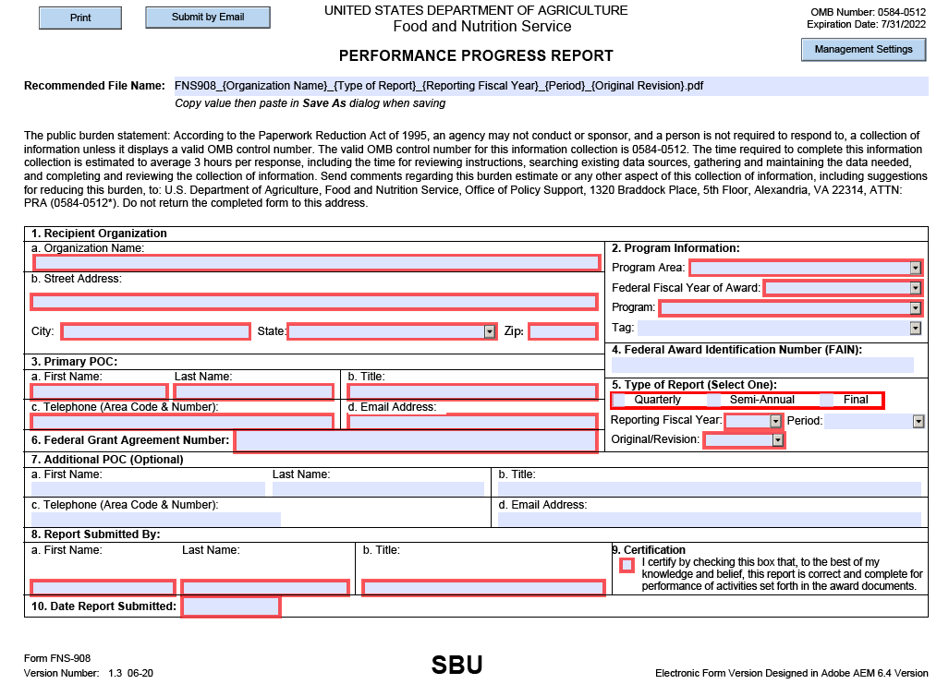

FNS-908 Performance Progress Report (PPR) – For Reference Only (Continued)
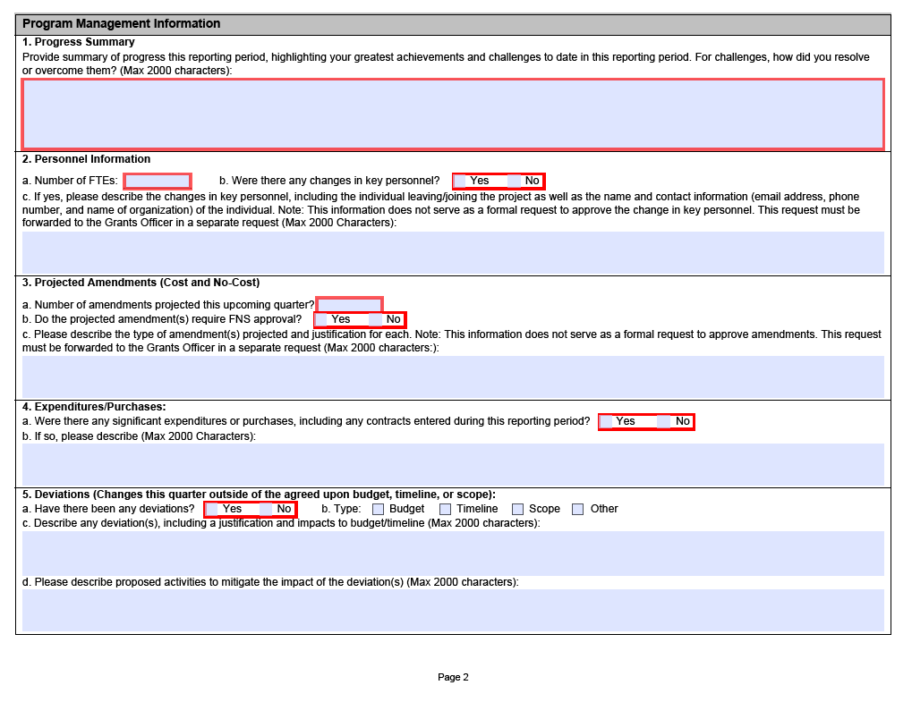

FNS-908 Performance Progress Report (PPR) – For Reference Only (Continued)
